EGRE 426 homework due 11/3/09 SOLUTIONS
1. Rework example 2 with the last instruction changed as shown: Assume no forwarding.
 | ADD | R1, R2, R3
 | ADD | R4, R1, R5
 | ADD | R5, R1, R4
 | ADD | R6, R4, R5
 | IF |  | ID |  |  |  | EX |  |  |  |  | DM |  |  |  | WB
ADD  R1,R2,R3 | IR ← IM(PC)  PC ← PC+4
ADD  R4,R1,R5 | IR ← IM(PC)  PC ← PC+4 |  | PCX ← PC  A ← R2, B ← R3  IRX ← IR
ADD  R5,R1,R4  can’t do! | IR ← IM(PC)  PC ← PC+4  STALL |  | PCX ← PC  A ← R1 NO! |  |  |  | ALUM ← A + B  IRM ← IRX
 | STALL |  | STALL |  |  |  | Bubble |  |  |  |  | ALUW ← ALUM  IRW ← IRM
 | STALL |  | STALL |  |  |  | Bubble |  |  |  |  | Bubble |  |  |  | R1 ← ALUW
ADD  R5,R1,R4 | IR ← IM(PC)  PC ← PC+4 |  | PCX ← PC  A ← R1, B ← R5  IRX ← IR |  |  |  | Bubble |  |  |  |  | Bubble |  |  |  | Bubble
ADD  R6,R1,R7  can’t do! | IR ← IM(PC)  PC ← PC+4  STALL |  | PCX ← PC  A ← R1, B ← R4  NO! STALL |  |  |  | ALUM ← A + B  IRM ← IRX |  |  |  |  | Bubble |  |  |  | Bubble
 | STALL |  | STALL |  |  |  | Bubble |  |  |  |  | ALUW ← ALUM  IRW ← IRM |  |  |  | Bubble
 | STALL |  | STALL |  |  |  | Bubble |  |  |  |  | Bubble |  |  |  | R4 ← ALUW
ADD  R6,R4,R5 | IR ← IM(PC)  PC ← PC+4 |  | PCX ← PC  A ← R1, B ← R4  IRX ← IR |  |  |  | Bubble |  |  |  |  | Bubble |  |  |  | Bubble
 |  |  | PCX ← PC  A ← R4, B ← R5  NO! STALL |  |  |  | ALUM ← A + B  IRM ← IRX |  |  |  |  | Bubble |  |  |  | Bubble
 |  |  | STALL |  |  |  | Bubble |  |  |  |  | ALUW ← ALUM  IRW ← IRM |  |  |  | Bubble
 |  |  | STALL |  |  |  | Bubble |  |  |  |  | Bubble |  |  |  | R5 ← ALUW
 |  |  | PCX ← PC  A← R4, B← R5 |  |  |  | Bubble |  |  |  |  | Bubble |  |  |  | Bubble
 |  |  |  |  |  |  | ALUM ← A + B  IRM ← IRX |  |  |  |  | Bubble |  |  |  | Bubble
 |  |  |  |  |  |  |  |  |  |  |  | ALUW ← ALUM  IRW ← IRM |  |  |  | Bubble
 |  |  |  |  |  |  |  |  |  |  |  |  |  |  |  | R6 ← ALUW

Complete the modified Example 3. Assume forwarding. When a register with the wrong value is loaded into A or B use a lower case r. When forwarding is used in the EX stage use the register that contains the correct data.
SECOND TRY
ADD | R1, R2, R3
ADD | R4, R1, R5
ADD | R5, R1, R4
ADD | R6, R4, R5
ADD | R6, R6, R4

 | IF | ID | EX | DM | WB
ADD  R1,R2,R3 | IR ← IM(PC)  PC ← PC+4
ADD  R4,R1,R5 | IR ← IM(PC)  PC ← PC+4 | PCX ← PC  A ← R2, B ← R3  IRX ← IR
ADD  R5,R1,R4 | IR ← IM(PC)  PC ← PC+4 | PCX ← PC  A ← r1, B ←R5  IRX ← IR | ALUM ← A + B  IRM ← IRX
ADD  R6,R4,R5 | IR ← IM(PC)  PC ← PC+4 | PCX ← PC  A ← r1, B←r4  IRX ← IR | ALUM←ALUM+B  IRM ← IRX | ALUW←ALUM  IRW ← IRM
ADD  R6,R6,R4 | IR ← IM(PC)  PC ← PC+4 | PCX ← PC  A ← r4, B ← r5  IRX ← IR | ALUM←ALUW  +ALUM  IRM ← IRX | ALUW←ALUM  IRW ← IRM | R1 ↵ ALUW
 |  | PCX ← PC  A ← r6, B ← R4  IRX ← IR | ALUM←ALUW  +ALUM  IRM ← IRX | ALUW←ALUM  IRW ← IRM | R4 ↵ ALUW
 |  |  | ALUM←ALUM+B  IRM ← IRX | ALUW←ALUM  IRW ← IRM | R5 ↵ ALUW
 |  |  |  | ALUW←ALUM  IRW ← IRM | R6 ↵ ALUW
 |  |  |  |  | R6 ↵ ALUW
Rule for EX stage: If operand (such as rs or rt) is contained in ALUM then use ALUM for that operand. If operand is not contained in ALUM, but contained in ALUW then use ALUW for operand, else use A or B for operand. In other words, use the freshest (newest) version of the operand.

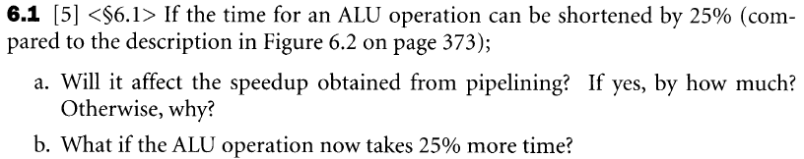
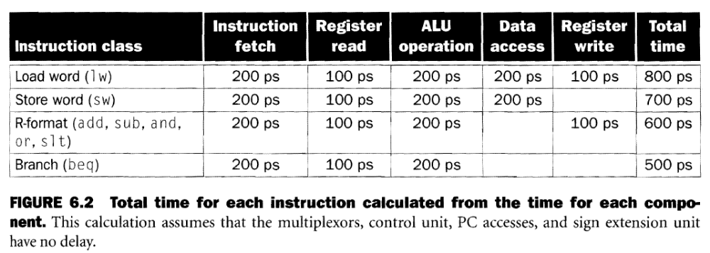
- Making only the ALU time shorter will not help. Memory access takes 200 ns; therefore, the clock can’t be made faster.
- If the ALU takes 25% more time, it becomes the bottleneck and the clock must be increased to 250 ps.

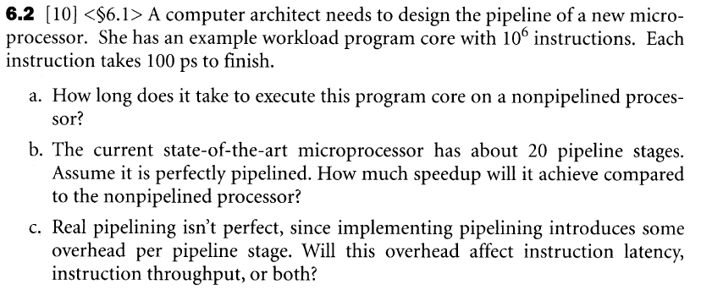
- 100 ps/instructin * 10⁶ instructions = 100 usec.
- A perfect 20-stage pipeline would provide a speedup of 20.
- Both.

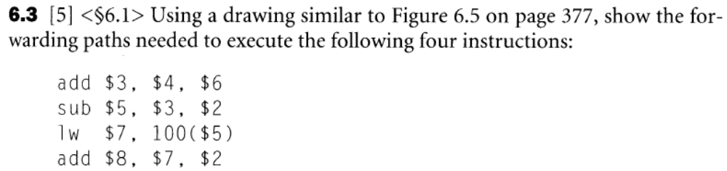

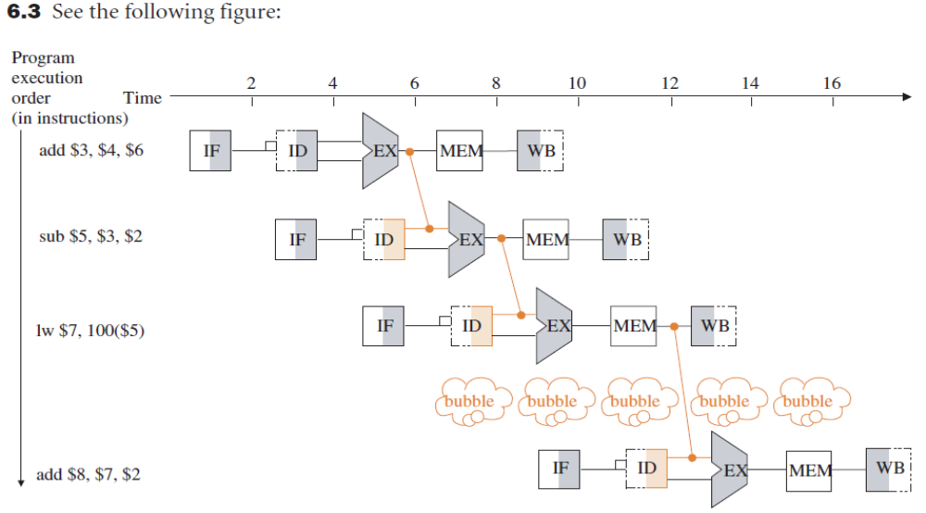
$3 ALUM
$5 ALUM
$7 ALUW

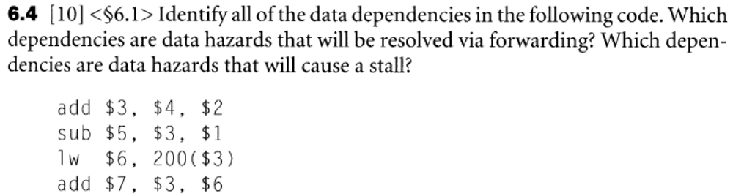

There is a data dependency through $3 between the first instruction and each subsequent instruction. There is a data dependency through $6 between the lw and the last instruction. For our five-segment pipeline, the $3 data dependency for the sub and lw is resolved by forwarding. The correct value of $3 is available in the GPR when needed by the last instruction. The $6 data dependency cannot be resolved by forwarding.

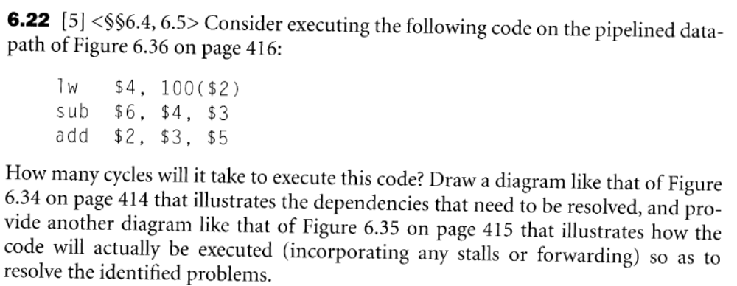
It will take a total of 8 cycles (counting the pipeline startup time) or an effective time of 4 cycles since a bubble must be generated while waiting for the lw data to be available.
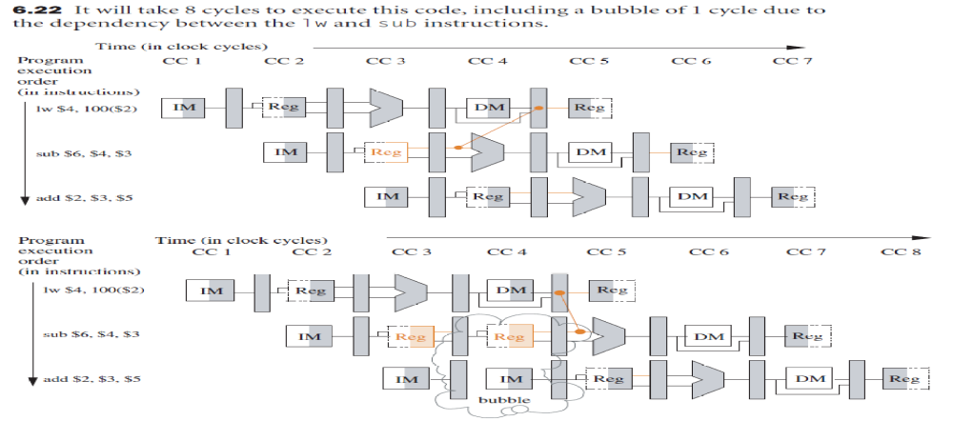

A is loaded with wrong value!
ALUM will be loaded with the correct value of R1.
A is loaded with wrong value!
B is loaded with wrong value!
ALUM contains the correct value of R1.

