EGRE 426
Homework
Due
Monday 9/29/09
Solutions
. Using a combination of CSA and CLA show the fastest way to add 16 partial products. You do not have to be concerned with minimizing the size of the adders, and you should assume that the propagation delay of the CLA is significantly longer that the CSA.

P1 | P2 | P3 | P4 | P5 | P6 | P7 | P8 | P9 | P10 | P11 | P12 | P13 | P14 | P15 | P16
 | CSA |  |  | CSA |  |  | CSA |  |  | CSA |  |  | CSA
 |  | CSA |  |  | CSA |  |  |  |  | CSA
 |  |  |  | CSA |  |  |  | CSA
 |  |  |  |  | CSA |  |  |  |  | CSA
 |  |  |  |  |  |  | CSA
 |  |  |  |  |  |  |  |  |  | CSA
 |  |  |  |  |  |  |  |  |  | CLA
Worst case 6 CSA delays and 1 CLA delay.

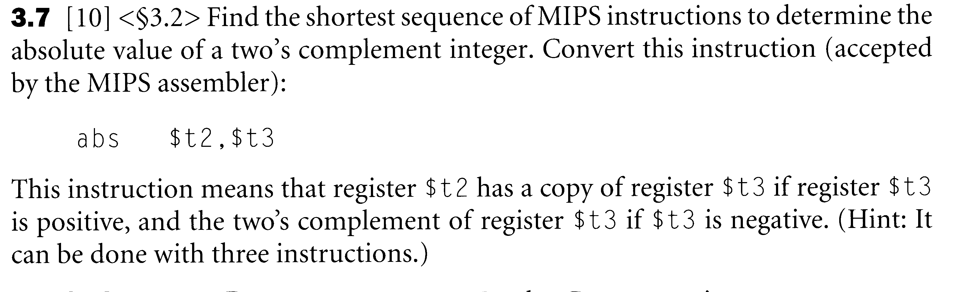
Answer:
add $t2,$t3,$0 # Move $t3 to $t2
bgtz $t2,OK # If positive done
sub $t2,$0,$t2 # If negative make positive
OK: …

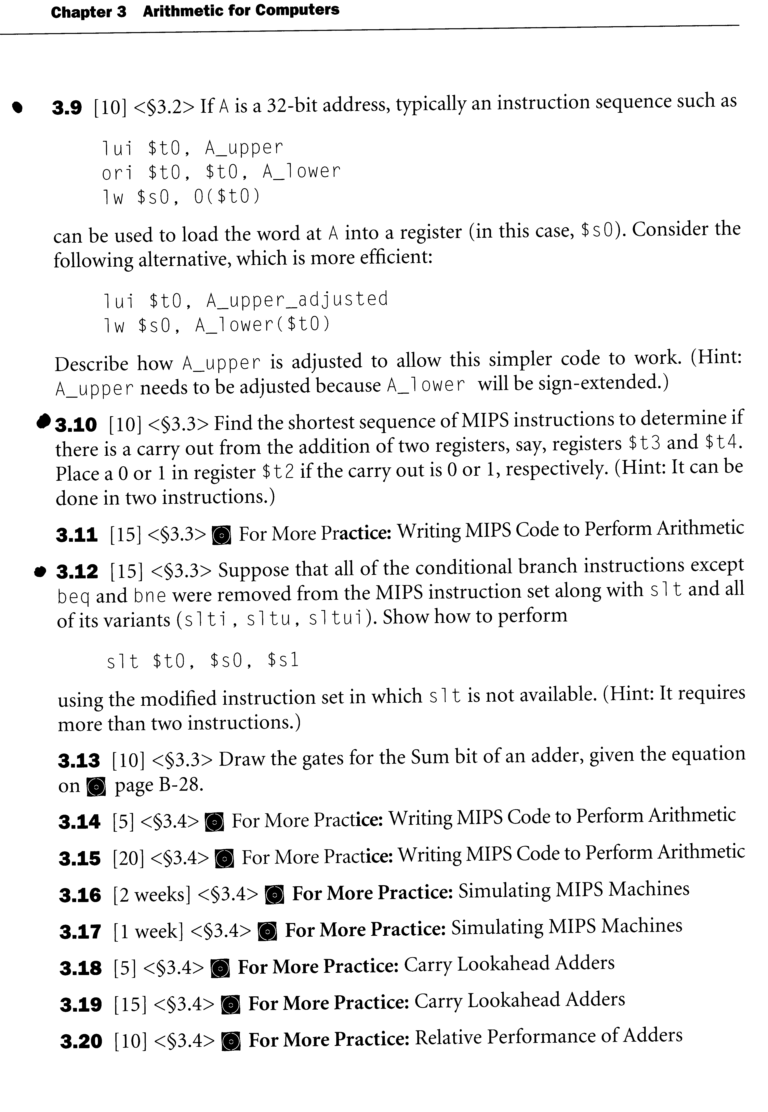
Solution: Recall that
lw | rt,ofst(rs) | rt ← M(rs + ±ofst)
If A_lower(15) = 0 then A_upper_adjusted = A_upper. If A_lower(15) = 1 then A_upper_adjusted = A_upper + 1 then
$t0 = A_upper_adjusted|0000_0000_0000_0000 = A_upper|0000_0000_0000_0001
A_lower($t0) = $t0 + 1111_1111_1111_1111|A_lower =
= (A_upper + 1)|0000_0000_0000_0000 + 1111_1111_1111_1111|A_lower
= [A_upper + (1111_1111_1111_1111 + 1)] |A_lower = A_upper|A_lower

Solution: Refer to the Four Bit Two’s Complement Addition Table in the Chapter 3 slides and observe that when the two numbers added and the result is treated as unsigned integers carry out occurs iff abd only ig $t3 + $t4 < $t3 and $t4. The sltu instruction compares registers treating the registers as unsigned integers. (See footnote 8 of MIPS instruction set handout). Therefore, the solution is:
addu $t2,$t3,$t4
sltu $t2,$t2,$t4 or sltu $t2,$t2,$t3

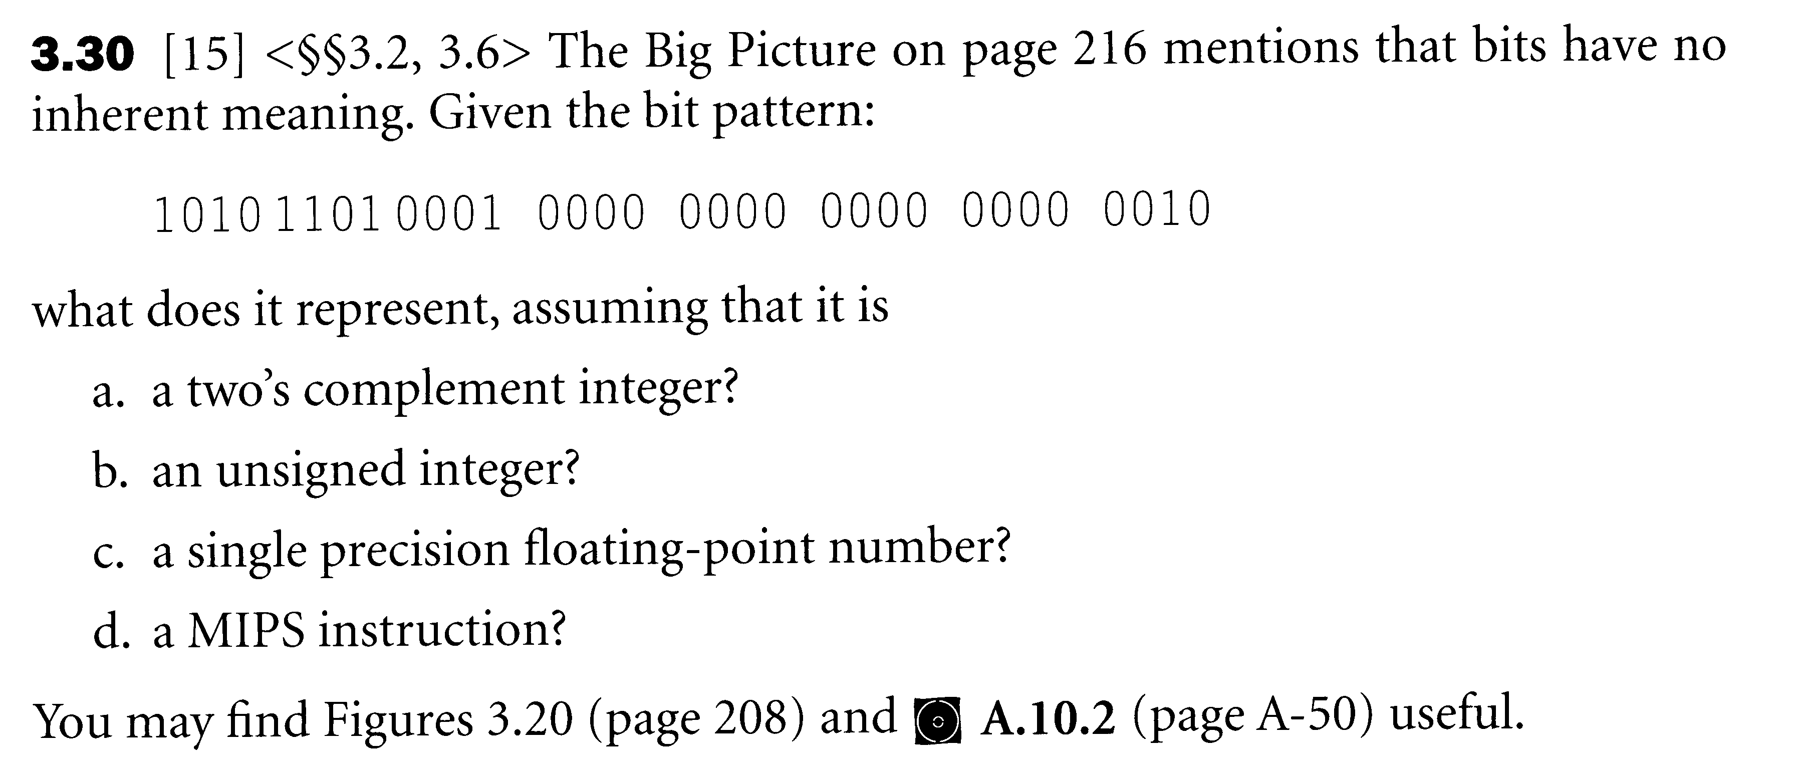
Solution:
- –1,391,460,350
- 2,903,506,946
- –8.18545 x 10⁻¹²
- sw $r16, $r8(16)

3.37 Show the IEEE 745 binary representation for the floating-point number 20₁₀ in single precision.
Solution: 20₁₀ = 10100₂ = 1.0100 x 2⁴
Sign = 0, Significan = .010…, Exponent = 127 + 4 = 131₁₀ = 10000011
0_10000011_01000000000000000000000

