Chapter 5 Version 3.2
The KIPS a simple MIPS containing the following:

A program counter register that contains the address of the instruction to be executed.

PC = PC(31..0)
32 general purpose 32 bit registers.

GPR = GPR(0..31) = GPR(0..31; 31..0)
A byte addressable memory with 32 bits of address.

MB = MB(0..0FFFFFFFFH) = MB(0..0FFFFFFFFH; 0..7)

For convenience we will define the following registers and memory in terms of the above.

Ri = GPR(i), Note: R0 ≡ 0
Note: In place of Ri the MIPS assembler uses $i.
Thus, to add the contents of R8 to R9 and put the result in R10 the assembly language instruction is: add $10,$8,$9

MH(n₀) = MH(n₀; 15..0) = MB(n₀)||MB(n₀+1)
where 0 ≤ n₀ ≤ 0FFFFFFFEH and n₀ is even.

M(n₀₀) = M(n₀₀; 31..0) = MB(n₀₀)||MB(n₀₀+1)||MB(n₀₀+2)||MB(n₀₀+3)
where 0 ≤ n₀₀ ≤ 0FFFFFFFCH and n₀₀ is a multiple of 4
(i.e. n₀₀ addresses a word boundary).

I - Type instruction
31 6 | 5 | 5 | 16 0
Opcode | rs | rt | n/offset
R - Type
6 | 5 | 5 | 5 | 5 | 6
Opcode | rs | rt | rd | shamt | func
J - Type
6 | 26
Opcode | raddr

DEFINITIONS
op = op(5..0) = IR(31..26) | rs = rs(4..0) = IR(25..21) | rt = rt(4..0) = IR(20..16)
rd = rd(4..0) = IR(15..11) | n = n(15..0) = IR(15..0) | ofst = ofst(15..0) = IR(15..0)
shamt=shmat(4..0)=IR(10..6) | func = func(5..0)=IR(5..0) | addr = addr(25..0) = IR(25..0)
When referring to bits in the IR, rs, rt, and rd to represent the bits that address GPR'r. Otherwise rs, rt, and rd will be used to represent the contents of particular GPR's. Specifically: rs = GPR(IR(25..21)), rt = GPR(IR(20..26)), and rd = GPR(IR(15..11). The proper interpretation should be obvious form the context. When we need to make the distinction we will use R_{S}, R_{T}, and R_{D} for the contents of the GPR.
The KIPS Instruction Set
lw | rt,ofst(rs) |  | rt ← M(rs + ±ofst)
100011 | rs | rt |  | ofst
sw | rt,ofst(rs) |  | M(rs + ±ofst) ← rt
101011 | rs | rt |  | ofst
beq | rs,rt,ofst |  | if rs=rt then PC←PC +±ofst||00 else PC ← PC+4
000100 | rs | rt |  | ofst
add | rd,rs,rt |  | rd ← rs + rt
000000 | rs | rt |  | rd | 00000 | 000000
sub | rd,rs,rt |  | rd ← rs – rt
000000 | rs | rt |  | rd | 00000 | 010010
and | rd,rs,rt |  | rd ← rs & rt
000000 | rs | rt |  | rd | 00000 | 000100
or | rd,rs,rt |  | rd ← rs | rt
000000 | rs | rt |  | rd | 00000 | 010101
slt | rd,rs,rt |  | If rs < rt then rd ←1 else rd ←0
000000 | rs | rt |  | rd | 00000 | 011010
j | addr |  | PC ← PC(31..28)||addr||00
100000 | addr

A Register Transfer Notation for KIPS
Notation:
A = B means A and B are the same object.
A := B means that A is the output of a combinational circuit that assumed the value of B; therefore, A assumes the value of B immediately after B prorogates through the combinational logic. The assignment does not wait for a clock transition to occur.
A ← B means that A is the output of a resister that assumes the value B after a transition of the system clock. The only exception is that for a memory write the data is "clocked" into memory by a memory write signal. We will make the reasonable assumption that the memory write signal is synchronized with the system clock. Therefore, the memory behaves as if the write occurred on the clock transition and we do not need to be concerned with the distinction.
The 32 bit registers: | Symbol
Program counter | PC
Instruction register | IR
Memory data register | MDR
General purpose registers | GPR(31..0)
Register A | A
Register B | B
ALUOut register | ALUout
Memory | M(0..0xFFFFFFFFFFFFFFFC)
Definitions:
Op = IR(31..26) | Rs = GPR(rs)
rs = IR(25..21) | R_{T} = GPR(rt)
rt = IR(20..16) | R_{D} = GRP(rd)
rd = IR(15..11)
n = ofst = IR(15..0)
addr = IR(25..0)

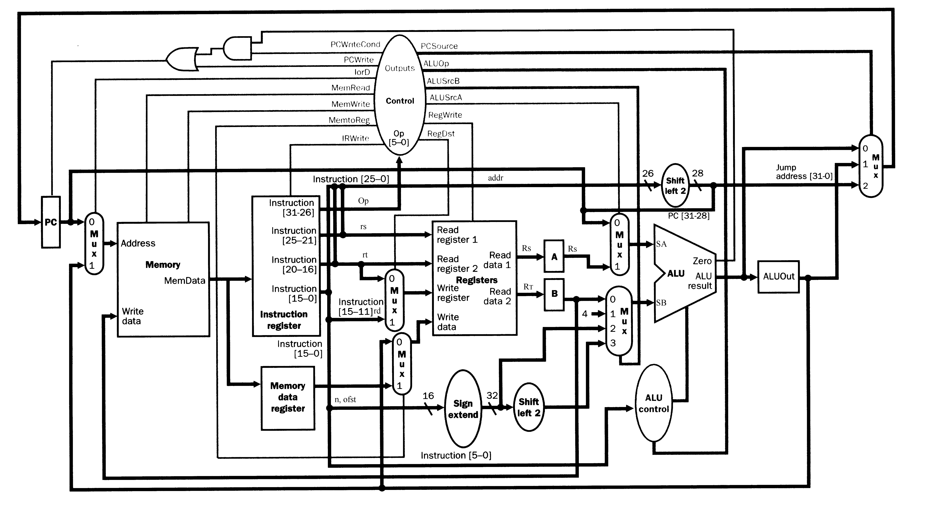
KIPS register transfer operations
Version 3.4
ALU related combinational logic
SA := A | ALU := SA + SB
SA := PC | ALU := SA - SB
SA := 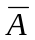 | ALU := SA & SB
SB := B | ALU := SA | SB
SB := 4 | ALU := 0
SB := ±n | ALU := 1
SB := ±ofst||00 | ALU := SA
SB := 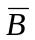 | ALU := SB
Register transfer operations Version 3.4
PC ← PC | IR ← IR | R_{S} ← R_{S}
PC ← 0 | IR ← M(PC)$ | R_{T} ← R_{T}
PC ← PC + 4 |  | R_{D} ← R_{D}
PC ← ALU | ALUout ← ALUout | R_{T} ← MDR
PC ← ALUout | ALUout ← ALU | R_{D} ← MDR
PC ← PC(31..28)||addr||00 |  | R_{T} ← ALUout
MDR ← MDR | M(ALUout) ← B? | R_{D} ← ALUout
MDR ← M(ALUout)$ |  | B ← B
MDR ← ALU~ | A ← A | B ← R_{T}
MDR ← ALUout~ | A ← R_{S} | B ← MDR
MDR ← M(PC) | A ← MDR~ | $31 ← MDR
 |  | $31 ← ALUout
The above defines are the lowest level register transfer operations. To describe the operations of the control unit using a state diagram, we will specify register operations at a slightly higher level. For example if no specification is entered for a certain register it is understood that the register retains its value. i.e. We will not enter IR ← IR this is understood. As another example, suppose we want to put the contents of the B register into the MBR register, we will write MDR ← B, instead of writing MDR ← ALU, ALU := SB, and SB := B. There may be certain operations that cannot be performed during the same clock cycle. Identify which of the following cause hardware conflicts.
- MDR ← B, PC ← PC(31..28)||addr||00
- MDR ← B, PC ← PC + 4
- MDR ← B, PC ← PC + ±ofst||00
- MDR ← A, PC ← PC + ±ofst||00
- MDR ← A, A ← MDR
- MDR ← A, A ← MDR, IR ← M(PC), PC ← PC+4, B ← R_{T}, ALUout ← A,
R_{T} ← ALUout.

MDRSB
IR

See Figure 5.38 on page 323

Operation | Memory addr Mux | Memory  Read  Write | write register Mux | Write Data Mux | SA  Mux | SB  Mux | ALU control operation | PC  Mux
ALUout ← PC + ±ofst||00 | x | n | x | x | 0 | 3 | + | x
PC ← PC(31..28)||addr||00 | x | n | x | x | x | x | x | 2
PC ← ALUout | x | n | x | x | x | x | x | 1
PC ← PC + 4
IR ← M(PC)
ALUout ← A + ±ofst||00
ALUout ← A + ±n
MDR ← M(ALUout)
RT ← MDR
RD ← ALUout
M(ALUout) ← B
ALUout ← PC
ALUout ← A - B
x – don’t care. R, W, n – Memory read, write, neither read nor write.
Finite State Machine for Control Unit
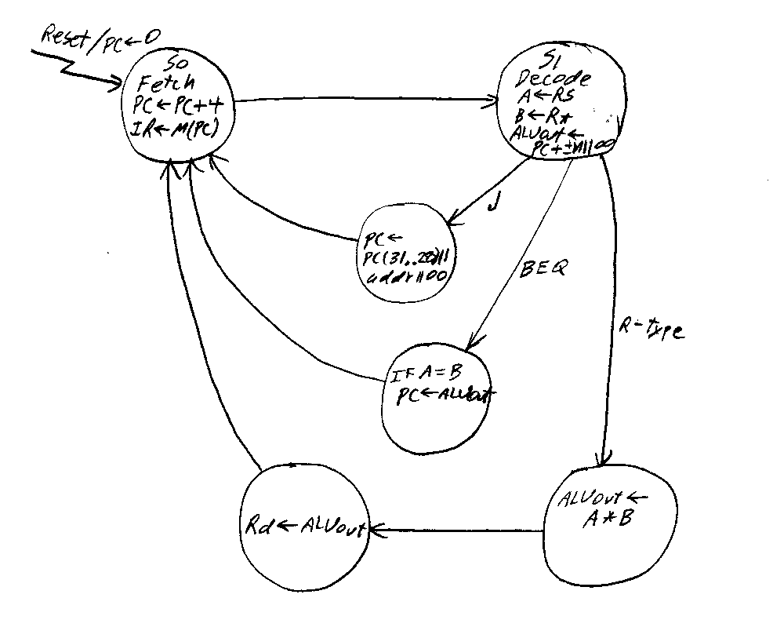

H is for hexadecimal, B for binary.
These 5 bits specify which register is rs.
rs and rt are treated as signed integers.
Assume I have added the new capability to reset the PC.
Assume I have added the new capability to increment the PC by 4 without using the ALU.
? This is a Memory write it cannot be done at the same time as a memory read.
$ This is a Memory read it cannot be done at the same time as a memory write.
~ Assume I have added this new capability to the design in the book

