Chapter 6 Handout Notes
10/20/09 Version 3.0

- Pipelining
- Pipelining the control unit allows the execution of multiple instructions to be overlapped.
- Instructions are overlapped to improve effective execution time.
- Key factor in making today's computers faster.
- See Figure 6.1 Laundry example.
- A pipeline consists of several stages or segments.
- Break instruction executions into steps (Book uses 5 - 4 or 5 typical some computers have more or less)
- IF - Instruction fetch
- ID - Instruction decode
- EX - Execute (perform required ALU operation)
- DM - Memory (access data memory during load or store)
- WB - Write result into GPR
- Ideally the throughput (how often an instruction exits the pipeline) is one instruction per segment time or machine cycle.
- This translates into a speedup of k where k is the number of segments.
- This is the ideal. In practice the speedup is less than k since the minimum time required by each stage will not be exactly balanced.
- We must slow everything down to match the slowest stage.
- In addition there is an overhead associated with each stage.
- Pipelining is almost invisible to the programmer.

Additions and changes are required to pipeline the processor.
1. The PC must be capable of being incremented on each clock cycle. This requires an incrementer circuit that is independent of the ALU.
PC ← PC
PC ← PC + 4
2. Latches are needed to hold values that are required later in pipeline. IR, ALU, next PC, etc.

HAZARDS
- Hazards prevent pipeline from achieving ideal performance.
- Much of this chapter will deal with eliminating hazards.
- There are three types of hazards.
1. Structural Hazard - Resource conflicts.
Memory is needed to load data and fetch instruction at the same time.
Typically processor will have separate cache memories for instruction and data.
with 95% or better hit rate.
2. Data Hazard - Instruction depends on result of previous instructions that has not been stored.
ADD R1,R2,R3
SUB R4,R5,R1
3. Control Hazard - Branches and other instructions that change the PC.
ADD R1,R2,R3
BEQZ R1,NEW
ADD R4,R5,R6
Hazards cause pipeline to stall.
Version 1.1
I - Type instruction
31 6 | 5 | 5 | 16 0
Opcode | rs | rt | n/offset
R - Type
6 | 5 | 5 | 5 | 5 | 6
Opcode | rs | rt | rd | shamt | func
J - Type
6 | 26
Opcode | raddr

DEFINITIONS
op = op(5..0) = IR(31..26) | Rs = Rs(4..0) = IR(25..21) | Rt = Rt(4..0) = IR(20..16)
Rd = Rd(4..0) = IR(15..11) | n = n(15..0) = IR(15..0) | ofst = ofst(15..0) = IR(15..0)
shamt=shmat(4..0)=IR(10..6) | func = func(5..0)=IR(5..0) | addr = addr(25..0) = IR(25..0)
When referring to bits in the IR, Rs, Rt, and Rd to represent the bits that address GPR'r. Otherwise rs, rt, and rd will be used to represent the contents of particular GPR's. Specifically: rs = GPR(IR(25..21)), rt = GPR(IR(20..26)), and rd = GPR(IR(15..11). The proper interpretation should be obvious form the context.
The MIPS (KIPS) Instruction Set
lw | rt,ofst(rs) |  | rt ← M(rs + ±ofst)
sw | rt,ofst(rs) |  | M(rs + ±ofst) ← rt
beq | rs,rt,ofst |  | if rs=rt then PC←PC +±ofst||00 else PC ← PC+4
add | rd,rs,rt |  | rd ← rs + rt
sub | rd,rs,rt |  | rd ← rs - rt
and | rd,rs,rt |  | rd ← rs & rt
or | rd,rs,rt |  | rd ← rs | rt
slt | rd,rs,rt |  | If rs < rt then rd ←1 else rd ←0
addi | rt,rs,n |  | rt ← rs + ±n
andi | rt,rs,n |  | rt ← rs & ±n
j | addr |  | PC ← PC(31..28)||addr||00
jr | rs |  | PC ← rs

The pipeline V1.3
IF
ID | IR | PC
EX | IRX | PCX | ALU | A | B
DM | IRM |  | ALUM |  |  | SMDR
WB | IRW |  | ALUW |  |  |  | LMDR

Pipelined Micro Operations Version 1.0
IR ← IR | IR ← IM(PC)
IRX ← IRX | IRX ← IR
IRM ← IRM | IRM ← IRX
IRW ← IRW | IRW ← IRM
ALUM ← ALUM | ALUM ← SA op SB
ALUW ← ALUW | ALUW ← ALUM
PC ← PC | PC ← PC + 4 | PC ← PCX + ±IRX.n||00
PCX ← PCX | PCX ← PC | PC ← PCX(31..28)||IRX.addr||00
A ← A | A ← rs
B ← B | B ← rt
Ri ← Ri | Ri ↵ ALUW | Ri ↵ LMDR
SMDR ← SMDR | SMDR ← B | Data memory write
LMDR ← LMDR | LMDR ← DM(ALUW) | DM(ALUW) ← SMDR
ZERO ← 0 | ZERO ← 1
SA := 0 | SB := 0
SA := 1 | SB := 1
SA := 4 | SB := 4
SA := A | SB := B
 | SB := ±IRX.n
SA := ALUM | SB := ALUM
SA := ALUW | SB := ALUW

THE MIPS CONTROL UNIT
INITIAL VERSION
V 1.03
IF: | - / IR ← IM(PC), - / PC ← PC + 4
ID: | - / PCX ← PC, - / IRX ← IR, - / A ← GPR(IR.Rs), - / B ← GPR(IR.Rt)
EX: | (IRX.OP = ADD) / ALUM ← A + B  (IRX.OP = AND) / ALUM ← A & B  (IRX.OP = ADDI) / ALUM ← A + ±IRX.n  (IRX.OP = ANDI) / ALUM ← A & ±IRX.n  (IRX.OP = SW) / ALUM ← A + ±IRX.n, SMDR ← B  (IRX.OP = LW) / ALUM ← A + ±IRX.n  (IRX.OP = J) / PC ←PCX(31..28)||IRX.addr||00₂  (IRX.OP = JR) / PC ← A  (IRX.OP = SLT) & (A < B) / ALUM ← 1  (IRX.OP = SLT) & (A ≥ B) / ALUM ← 0  (IRX.OP = BEQ) & (A = B) / PC ← PCX + ±IRX.n||00, ZERO←1  (IRX.OP = BEQ) & (A ≠ B) / ZERO ← 0  - / IRM ← IRX
MEM: | - / ALUW ← ALUM, - / IRW ← IRM  (IRM.OP = SW) / M(ALUM) ← SMDR  (IRM.OP = LW) / LMDR ← M(ALUM)  (IRM.OP = J) / -  (IRM.OP = JR) / -  (IRM.OP = BEQ)/-
WB: | (IRW.OP = ADD) / GPR(IRW.Rd) ← ALUW  (IRW.OP = AND) / GPR(IRW.Rd) ← ALUW  (IRW.OP = ADDI) / GPR(IRW.Rt) ← ALUW  (IRW.OP = ANDI) / GPR(IRW.Rt) ← ALUW  (IRX.OP = SLT) / GPR(IRW.Rd) ← ALUW  (IRW.OP = LW) / GPR(IRW.Rt) ← LMDR  (IRW.OP = SW or J or JR or BEQ) / -

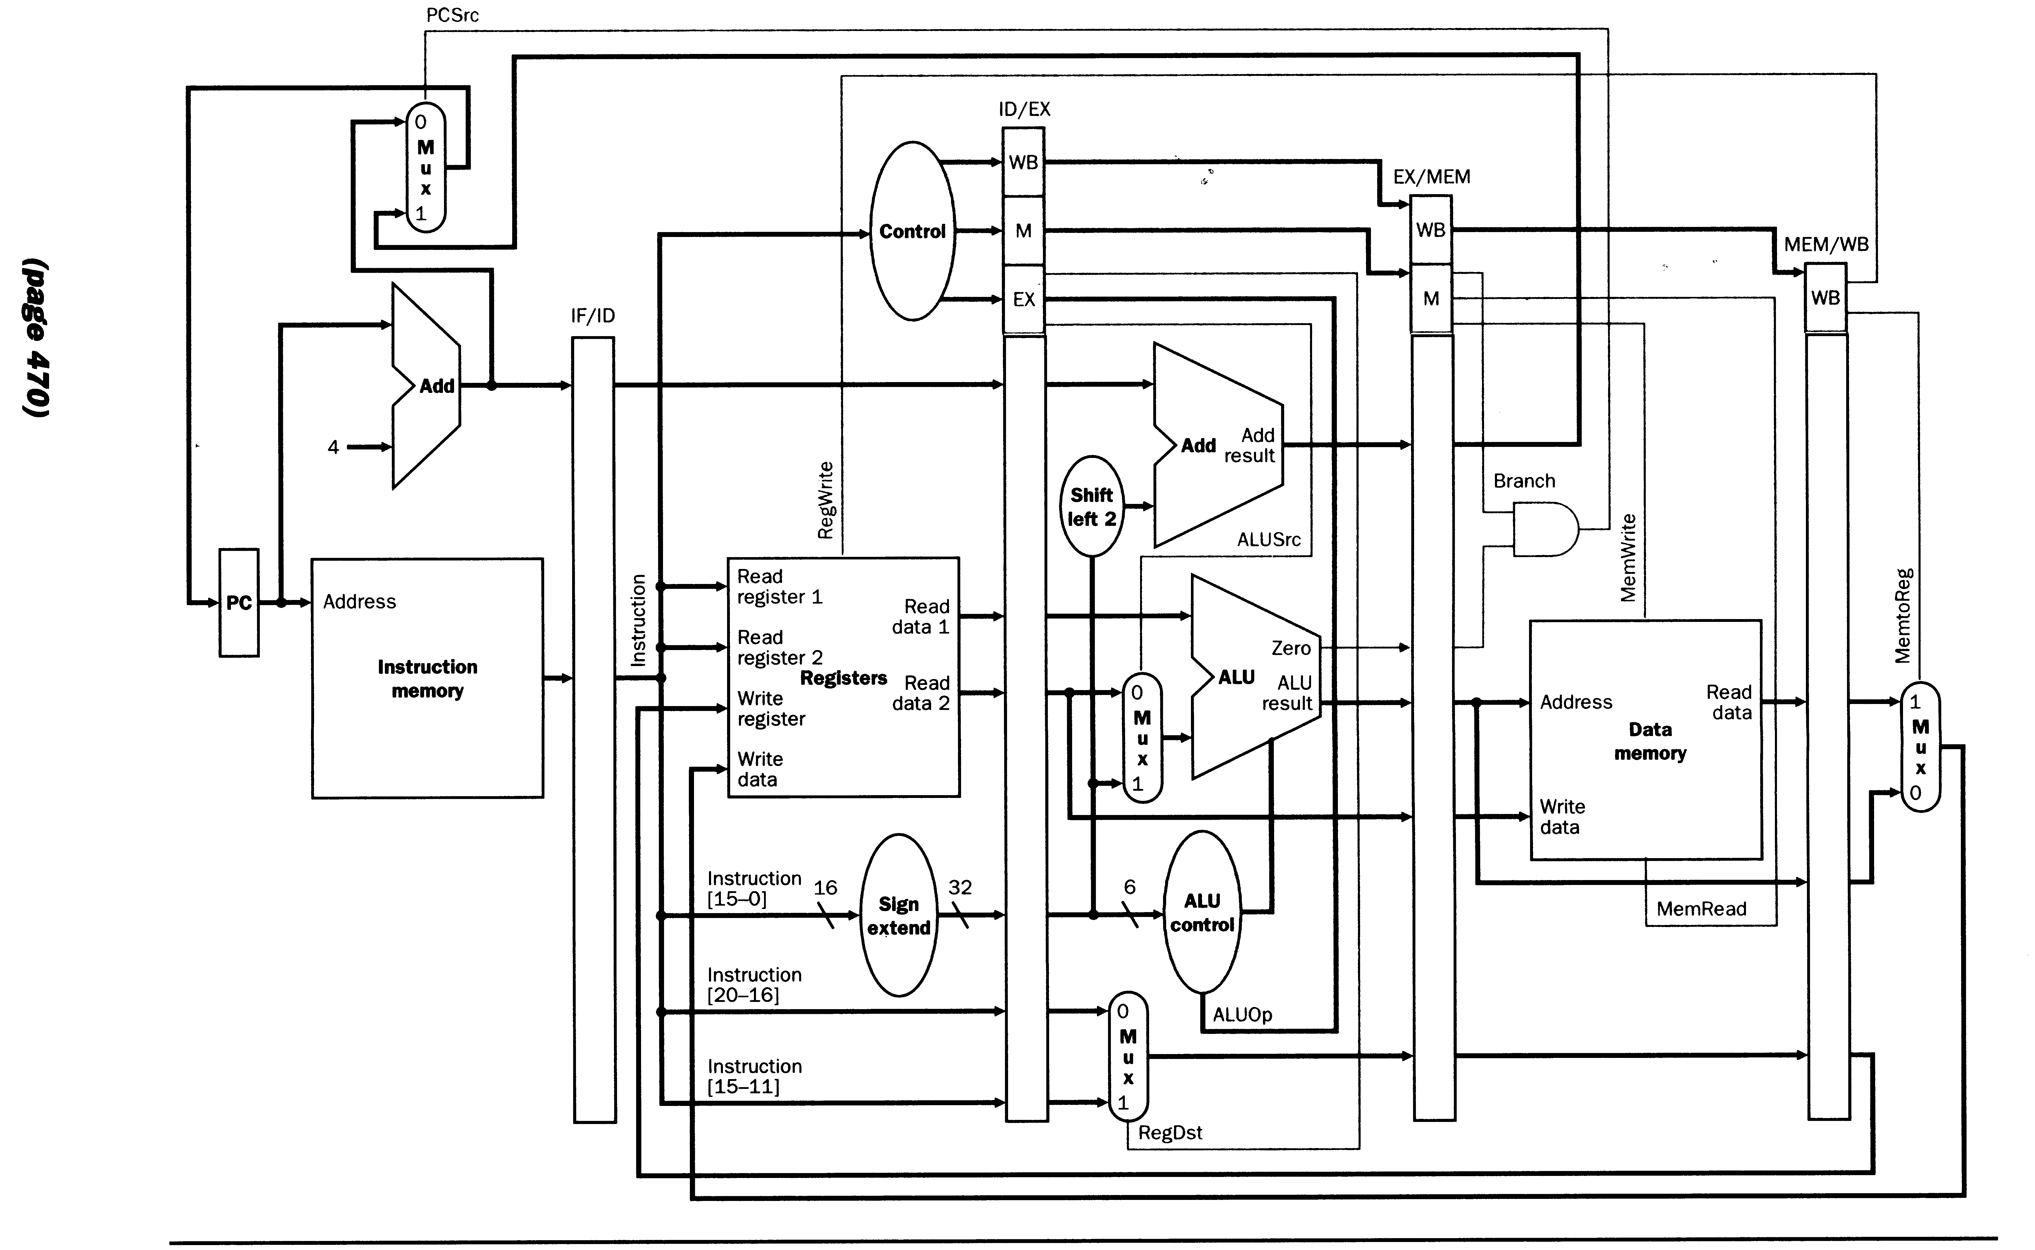
Example 1
ADD | R1, R2, R3
ADD | R4, R5, R6
ADD | R7, R8, R9
Note: For simplicity I will use R1, R2, etc for $S1, $S2, etc. Not all micro operations will be shown.
 | IF | ID | EX | DM | WB
ADD  R1,R2,R3 | IR ← IM(PC)  PC ← PC+4
ADD  R4,R5,R6 | IR ← IM(PC)  PC ← PC+4 | PCX ← PC  A ← R2, B ← R3  IRX ← IR
ADD  R7,R8,R9 | IR ← IM(PC)  PC ← PC+4 | PCX ← PC  A ← R5, B ← R6  IRX ← IR | ALUM ← A + B  IRM ← IRX
 |  | PCX ← PC  A ← R8, B ← R9  IRX ← IR | ALUM ← A + B  IRM ← IRX | ALUW ← ALUM  IRW ← IRM
 |  |  | ALUM ← A + B  IRM ← IRX | ALUW ← ALUM  IRW ← IRM | R1 ← ALUW
 |  |  |  | ALUW ← ALUM  IRW ← IRM | R4 ← ALUW
 |  |  |  |  | R7 ← ALUW

Example 2 RAW (read after write) Data Hazard Cases Pipeline to Stall
 |  |  |  | 1 | 2 | 3 |  | 4 | 5 | 6 | 7 |  | 8 | 9 | 10 | 11 | 12 | 13 | 14
 | ADD | R1, R2, R3 |  | IF | ID | EX |  | DM | WB
 | ADD | R4, R1, R5 |  |  | IF | ID |  | ID | ID | ID | EX |  | DM | WB
 | ADD | R5, R1, R4 |  |  |  | IF |  | IF | IF | IF | ID |  | ID | ID | ID | EX | DM | WB
 | ADD | R6, R1, R7 |  |  |  |  |  |  |  |  | IF |  | IF | IF | IF | ID | EX | DM | WB
 | IF |  | ID |  |  |  | EX |  |  |  |  | DM |  |  |  | WB
ADD  R1,R2,R3 | IR ← IM(PC)  PC ← PC+4
ADD  R4,R1,R5 | IR ← IM(PC)  PC ← PC+4 |  | PCX ← PC  A ← R2, B ← R3  IRX ← IR
ADD  R5,R1,R4  can’t do! | IR ← IM(PC)  PC ← PC+4  STALL |  | PCX ← PC  A ← R1 NO!  Data hazard stall |  |  |  | ALUM ← A + B  IRM ← IRX
 | STALL |  | STALL |  |  |  | Bubble |  |  |  |  | ALUW ← ALUM  IRW ← IRM
 | STALL |  | STALL |  |  |  | Bubble |  |  |  |  | Bubble |  |  |  | R1 ← ALUW
ADD  R5,R1,R4 | IR ← IM(PC)  PC ← PC+4 |  | PCX ← PC  A ← R1, B ← R5  IRX ← IR |  |  |  | Bubble |  |  |  |  | Bubble |  |  |  | Bubble
ADD  R6,R1,R7  can’t do! | IR ← IM(PC)  PC ← PC+4  STALL |  | PCX ← PC  A ← R1, B ← R4  NO! STALL |  |  |  | ALUM ← A + B  IRM ← IRX |  |  |  |  | Bubble |  |  |  | Bubble
 | STALL |  | STALL |  |  |  | Bubble |  |  |  |  | ALUW ← ALUM  IRW ← IRM |  |  |  | Bubble
 | STALL |  | STALL |  |  |  | Bubble |  |  |  |  | Bubble |  |  |  | R4 ← ALUW
ADD  R6,R1,R7 | IR ← IM(PC)  PC ← PC+4 |  | PCX ← PC  A ← R1, B ← R4  IRX ← IR |  |  |  | Bubble |  |  |  |  | Bubble |  |  |  | Bubble
 |  |  | PCX ← PC  A ← R1, B ← R7  IRX ← IR |  |  |  | ALUM ← A + B  IRM ← IRX |  |  |  |  | Bubble |  |  |  | Bubble
 |  |  |  |  |  |  | ALUM ← A + B  IRM ← IRX |  |  |  |  | ALUW ← ALUM  IRW ← IRM |  |  |  | Bubble
 |  |  |  |  |  |  |  |  |  |  |  | ALUW ← ALUM  IRW ← IRM |  |  |  | R5 ← ALUW
 |  |  |  |  |  |  |  |  |  |  |  |  |  |  |  | R6 ← ALUW
Example 3 RAW (read after write) Data Hazard
SECOND TRY
ADD | R1, R2, R3
ADD | R4, R1, R5
ADD | R5, R1, R4
ADD | R6, R1, R7

 | IF | ID | EX | DM | WB
ADD  R1,R2,R3 | IR ← IM(PC)  PC ← PC+4
ADD  R4,R1,R5 | IR ← IM(PC)  PC ← PC+4 | PCX ← PC  A ← R2, B ← R3  IRX ← IR
ADD  R5,R1,R4 | IR ← IM(PC)  PC ← PC+4 | PCX ← PC  A ← r1, B ←R5  IRX ← IR | ALUM ← A + B  IRM ← IRX
ADD  R6,R1,R7 | IR ← IM(PC)  PC ← PC+4 | PCX ← PC  A ← r1, B←r4  IRX ← IR | ALUM←ALUM+B  IRM ← IRX | ALUW←ALUM  IRW ← IRM
 |  | PCX ← PC  A ← R1, B ← R7  IRX ← IR | ALUM ←  ALUW + ALUM  IRM ← IRX | ALUW←ALUM  IRW ← IRM | R1 ↵ ALUW
 |  |  | ALUM ← A + B | ALUW←ALUM  IRW ← IRM | R4 ↵ ALUW
 |  |  |  | ALUW ← ALUM  IRW ← IRM | R5 ↵ ALUW
 |  |  |  |  | R6 ↵ ALUW
Rule for EX stage: If operand (such as rs or rt) is contained in ALUM then use ALUM for that operand. If operand is not contained in ALUM, but contained in ALUW then use ALUW for operand, else use A or B for operand. In other words, use the freshest (newest) version of the operand.
THE MIPS CONTROL UNIT V 2.03
MODIFIED TO USE FORWARDING TO PREVENT RAW DATA HAZARD FORM STALLING PIPELINE
IF: | - / IR ← IM(PC), - / PC ← PC + 4
ID: | - / PCX ← PC, - / IRX ← IR, - / A ← GPR(IR.Rs), - / B ← GPR(IR.Rt)
EX: | IF IRX.Rs = IRM.Rd THEN α := ALUM  ELSE  IF IRX.Rs = IRW.Rd THEN α := ALUW ELSE α := A  IF IRX.Rt = IRM.Rd THEN β := ALUM  ELSE  IF IRX.Rt = IRW.Rd THEN β := ALUW ELSE β := B  (IRX.OP = ADD) / ALUM ← α + β  (IRX.OP = AND) / ALUM ← α & β  (IRX.OP = ADDI) / ALUM ← α + ±IRX.n  (IRX.OP = ANDI) / ALUM ← α & ±IRX.n  (IRX.OP = SW) / ALUM ← α + ±IRX.n, SMDR ← β  (IRX.OP = LW) / ALUM ← α + ±IRX.n  (IRX.OP = J) / PC ←PCX(31..28)||IRX.addr||00₂  (IRX.OP = JR) / PC ← α  (IRX.OP = SLT) & (α < β) / ALUM ← 1  (IRX.OP = SLT) & (α ≥ β) / ALUM ← 0  (IRX.OP = BEQ) & (α = β) /PC ← PC ← PCX + ±IRX.n||00, ZERO←1  (IRX.OP = BEQ) & (α ≠ β) / ZERO ← 0  - / IRM ← IRX
DM: | - / ALUW ← ALUM, - / IRW ← IRM  (IRM.OP = SW) / M(ALUM) ← SMDR  (IRM.OP = LW) / LMDR ← M(ALUM)  (IRM.OP = J) / -  (IRM.OP = JR) / -  (IRM.OP = BEQ) & ZERO / -
WB: | (IRW.OP = ADD) / GPR(IRW.Rd) ↵ ALUW  (IRW.OP = AND) / GPR(IRW.Rd) ↵ ALUW  (IRW.OP = ADDI) / GPR(IRW.Rd) ↵ ALUW  (IRW.OP = ANDI) / GPR(IRW.Rd) ↵ ALUW  (IRX.OP = SLT) / GPR(IRW.Rd) ↵ ALUW  (IRW.OP = LW) / GPR(IRW.Rt) ↵ LMDR  (IRW.OP = SW or J or JR or BEQ) / -  NOTE: X ↵ Y means that Y is transferred into X on the clock edge that occurs before the edge that causes A ← B.

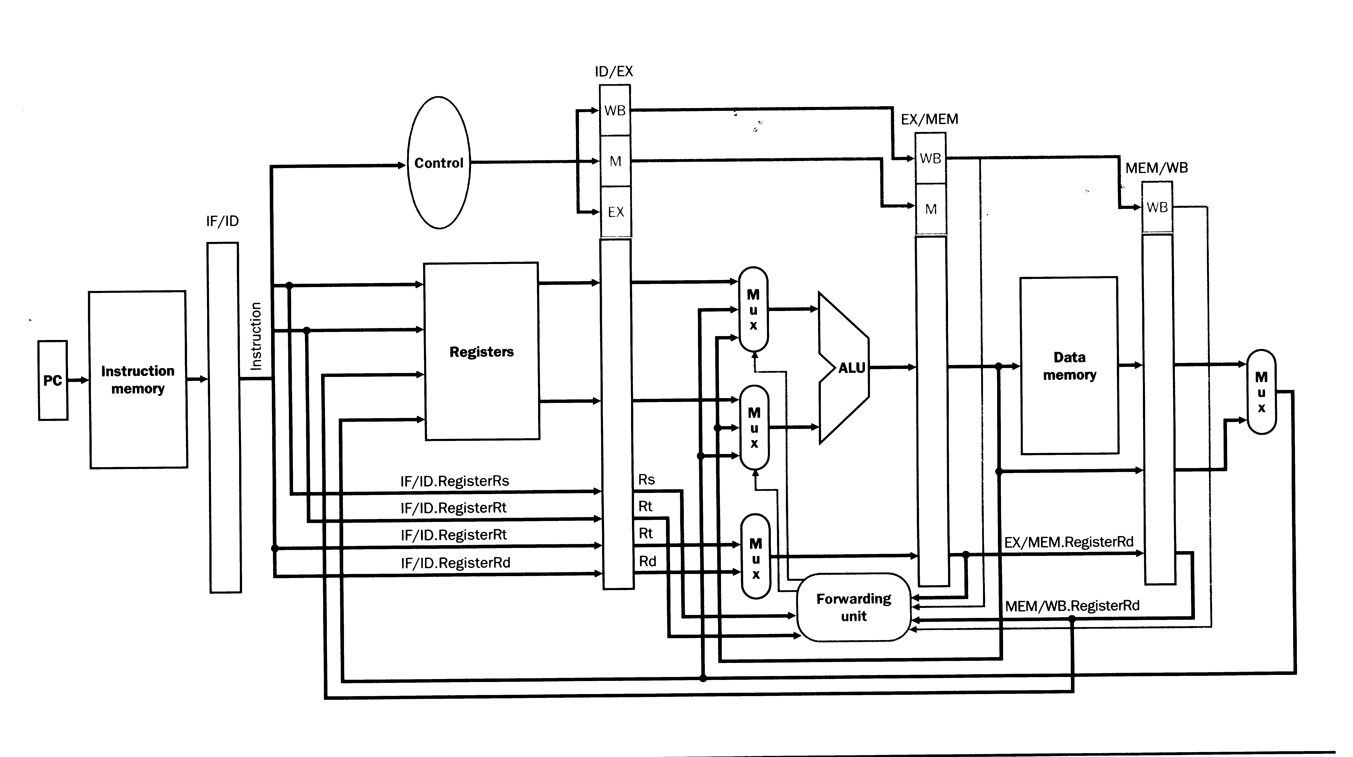
Fig 6.40
Example 4a. Consider JUMP
 | ADD | R1, R2, R3
 | J | NEXT
 | ADD | R4, R5, R6
 | ADD | R7, R8, R9
NEXT: | SUB | R3, R4, R5
Note: For simplicity I will use R1, R2, etc for $S1, $S2, etc. Not all micro operations will be shown.
 | IF | ID | EX | DM | WB
ADD  R1,R2,R3 | IR ← IM(PC)  PC ← PC+4
J  NEXT | IR ← IM(PC)  PC ← PC+4 | PCX ← PC  A ← R2, B ← R3  IRX ← IR
ADD  R4,R5,R6 | IR ← IM(PC)  PC ← PC+4 | PCX ← PC  A ← R_{U}, B ← R_{U}  IRX ← IR, J! | ALUM ← A + B  IRM ← IRX
ADD  R7,R8,R9 | STALL | ABORT! | ALUM ← PCX(31..28)||IRX.addr||00  IRM ← IRX | ALUW ← ALUM  IRW ← IRM
 | STALL | BUBBLE | BUBBLE | PC ← ALUM | R1 ↵ ALUW
NEXT:  SUB  R3, R4, R5 | IR ← IM(PC)  PC ← PC+4 | BUBBLE | BUBBLE | BUBBLE | DONE
 |  | PCX ← PC  A ← R4, B ← R5  IRX ← IR | BUBBLE | BUBBLE | BUBBLE
 |  |  | ALUM ← A - B  IRM ← IRX | BUBBLE | BUBBLE
 |  |  |  | ALUW ← ALUM  IRW ← IRM | BUBBLE
 |  |  |  |  | R3 ↵ ALUW

How can we improve this?
Example 4b Improved JUMP
 | ADD | R1, R2, R3
 | J | NEXT
 | ADD | R4, R5, R6
 | ADD | R7, R8, R9
NEXT: | SUB | R3, R4, R5
Note: For simplicity I will use R1, R2, etc for $S1, $S2, etc. Not all micro operations will be shown.
 | IF | ID | EX | DM | WB
ADD  R1,R2,R3 | IR ← IM(PC)  PC ← PC+4
J  NEXT | IR ← IM(PC)  PC ← PC+4 | PCX ← PC  A ← R2, B ← R3  IRX ← IR
ADD  R4,R5,R6 | IR ← IM(PC)  PC ← PC+4 | PCX ← PC  A ← R_{U}, B ← R_{U}  IRX ← IR, J! | ALUM ← A + B  IRM ← IRX
ADD  R7,R8,R9 | STALL | ABORT! | PC ← PCX(31..28)||IRX.addr||00  IRM ← IRX | ALUW ← ALUM  IRW ← IRM
NEXT:  SUB  R3, R4, R5 | IR ← IM(PC)  PC ← PC+4 | BUBBLE | BUBBLE | DONE | R1 ↵ ALUW
 |  | PCX ← PC  A ← R4, B ← R5  IRX ← IR | BUBBLE | BUBBLE | DONE
 |  |  | ALUM ← A - B  IRM ← IRX | BUBBLE | BUBBLE
 |  |  |  | ALUW ← ALUM  IRW ← IRM | BUBBLE
 |  |  |  |  | R3 ↵ ALUW

Can we improve this?
Example 4c JUMP Best we can do with hardware.
 | ADD | R1, R2, R3
 | J | NEXT
 | ADD | R4, R5, R6
 | ADD | R7, R8, R9
NEXT: | SUB | R3, R4, R5
Note: For simplicity I will use R1, R2, etc for $S1, $S2, etc. Not all micro operations will be shown.
 | IF | ID | EX | DM | WB
ADD  R1,R2,R3 | IR ← IM(PC)  PC ← PC+4
J  NEXT | IR ← IM(PC)  PC ← PC+4 | PCX ← PC  A ← R2, B ← R3  IRX ← IR
ADD  R4,R5,R6 | IR ← IM(PC)  PC ← PC+4 | PCX ← PC  A ← R_{U}, B ← R_{U}  IRX ← IR, J!  PC ← PC(31..28)||  IR.addr||00 | ALUM ← A + B  IRM ← IRX
NEXT:  SUB  R3, R4, R5 | IR ← IM(PC)  PC ← PC+4 | ABORT! | DONE | ALUW ← ALUM  IRW ← IRM
 |  | PCX ← PC  A ← R4, B ← R5  IRX ← IR | BUBBLE | DONE | R1 ↵ ALUW
 |  |  | ALUM ← A - B  IRM ← IRX | BUBBLE | DONE
 |  |  |  | ALUW ← ALUM  IRW ← IRM | BUBBLE
 |  |  |  |  | R3 ↵ ALUW
Note: That for a branch we could not update the PC in the ID stage since we do not have enough time to decode the instruction and determine if the branch is taken.
Shorthand notation:
 | ADD | R1, R2, R3 | IF | ID | EX | DM | WB
 | J | NEXT |  | IF | ID | EX | DM | WB
 | ADD | R4, R5, R6 |  |  | IF | A | B | B | B
NEXT: | SUB | R3, R4, R5 |  |  |  | IF | ID | EX | DM | WB

Example 4d JUMP. A software solution.
Delayed branch of 1 (May have to use NOP).
 | ADD | R1, R2, R3
 | J | NEXT
 | ADD | R4, R5, R6
 | ADD | R7, R8, R9
NEXT: | SUB | R3, R4, R5
Solution: Always executed instruction following branch.
 | …
 | J | NEXT
 | ADD | R1, R2, R3
 | ADD | R4, R5, R6
 | ADD | R7, R8, R9
NEXT: | SUB | R3, R4, R5
 | IF |  | ID |  | EX | DM | WB
J  NEXT | IR ← IM(PC)  PC ← PC+4
ADD  R1,R2,R3 | IR ← IM(PC)  PC ← PC+4 |  | PCX ← PC  A ← R2, B ← R3  IRX ← IR, J!  PC ← PCX(31..28)||  IRX.addr||00
NEXT:  SUB  R3, R4, R5 | IR ← IM(PC)  PC ← PC+4 |  | PCX ← PC  A ← R2, B ← R3  IRX ← IR |  | DONE
 |  |  | PCX ← PC  A ← R4, B ← R5  IRX ← IR |  | ALUM ← A + B  IRM ← IRX | DONE
 |  |  |  |  | ALUM ← A - B  IRM ← IRX | ALUW ←ALUM  IRW ← IRM | DONE
 |  |  |  |  |  | ALUW ← ALUM  IRW ← IRM | R1 ↵ ALUW
 |  |  |  |  |  |  | R3 ↵ ALUW

Note: If machine was implemented as in example 4b. It would have a delayed branch of 2.
Delayed Branch
There are several methods for reducing branch penalties.
- Stall pipeline till branch destination is known. – Simple and slow.
- Predict branch not taken. – Fetch next instruction. If branch is taken stop execution and fetch new instruction.
- Predict branch taken. – Does not help till destination is known.
- Delayed Branch – Always execute n instructions before branch is taken. This is a software rather than a hardware solution.
Example using delayed branch of 2.
The program
 | ADD | R1,R0,R7
 | ADD | R1,R2,R3
 | AND | R4,R5,R6
 | BEQ | R7,R6,NEXT
 | ADD | R1,R1,R4
NEXT: | …
The program implemented on a delayed branch of two machine using a bad compiler.
 | ADD | R1,R0,R7
 | ADD | R1,R2,R3
 | AND | R4,R5,R6
 | BEQ | R7,R6,NEXT
 | NOP
 | NOP
# Now branch if R7 = R6
 | ADD | R1,R1,R4
NEXT: | …

The program implemented on a delayed branch of two machine using a good compiler.
 | ADD | R1,R0,R7
 | BEQ | R7,R6,NEXT
 | ADD | R1,R2,R3
 | AND | R4,R5,R6
# Executing the two instructions above
# produces same result.
 | ADD | R1,R1,R4
NEXT: | …

Delayed branch of two example.
Unoptimized |  |  |  | Optimized
 | ADD | R5,R1,R4 |  | ADD | R5,R1,R4
 | ADD | R1,R2,R3 |  | AND | R4,R5,R6
 | AND | R4,R5,R6 |  | BEQ | R4,R6,XYZ
 | BEQ | R4,R6,XYZ |  | ADD | R1,R2,R3
 | NOP |  |  | NOP
 | NOP
 | …

Concise detalils
ADD | R5,R1,R4 | IF | ID | EX | DM | WB
ADD | R1,R2,R3 |  | IF | ID | EX | DM | WB
AND | R4,R5,R6 |  |  | IF | ID | EX | DM | WB
BEQ | R4,R6,XYZ |  |  |  | IF | ID | EX | DM | WB
NOP |  |  |  |  |  | IF | ID | EX | DM | WB
NOP |  |  |  |  |  |  | IF | ID | EX | DM | WB

THE MIPS CONTROL UNIT V 3.03
MODIFIED TO Minimize branch stalls using method in example 4b.
IF: | - / IR ← IM(PC), - / PC ← PC + 4
ID: | not J / PCX ← PC, - / IRX ← IR, - / A ← GPR(IR.Rs), - / B ← GPR(IR.Rt)
EX: | IF IRX.Rs = IRM.Rd THEN α := ALUM  ELSE  IF IRX.Rs = IRW.Rd THEN α := ALUW ELSE α := A  IF IRX.Rt = IRM.Rd THEN β := ALUM  ELSE  IF IRX.Rt = IRW.Rd THEN β := ALUW ELSE β := B  (IRX.OP = ADD) / ALUM ← α + β  (IRX.OP = AND) / ALUM ← α & β  (IRX.OP = ADDI) / ALUM ← α + ±IRX.n  (IRX.OP = ANDI) / ALUM ← α & ±IRX.n  (IRX.OP = SW) / ALUM ← α + ±IRX.n, SMDR ← β  (IRX.OP = LW) / ALUM ← α + ±IRX.n  (IRX.OP = J) / PC ←PCX(31..28)||IRX.addr||00₂  (IRX.OP = JR) / PC ← α  (IRX.OP = SLT) & (α < β) / ALUM ← 1  (IRX.OP = SLT) & (α ≥ β) / ALUM ← 0  (IRX.OP = BEQ) & (α = β) /PC ← PCX + ±IRX.n||00, ZERO←1  (IRX.OP = BEQ) & (α ≠ β) / ZERO ← 0  - / IRM ← IRX
DM: | - / ALUW ← ALUM, - / IRW ← IRM  (IRM.OP = SW) / M(ALUM) ← SMDR  (IRM.OP = LW) / LMDR ← M(ALUM)  (IRM.OP = J) / -  (IRM.OP = JR) / -  (IRM.OP = BEQ) & ZERO / -
WB: | (IRW.OP = ADD) / GPR(IRW.Rd) ↵ ALUW  (IRW.OP = AND) / GPR(IRW.Rd) ↵ ALUW  (IRW.OP = ADDI) / GPR(IRW.Rt) ↵ ALUW  (IRW.OP = ANDI) / GPR(IRW.Rt) ↵ ALUW  (IRX.OP = SLT) / GPR(IRW.Rd) ↵ ALUW  (IRW.OP = LW) / GPR(IRW.Rt) ↵ LMDR  (IRW.OP = SW or J or JR or BEQ) / -  NOTE: X ↵ Y means that Y is transferred into X on the clock edge that occurs before the edge that causes A ← B.

Load and store example

 |  |  |  | 1 |  | 2 | 3 |  | 4 | 5 |  | 6 | 7 | 8 |  | 9 | 10
EX: | LW |  | R1,N(R0) | IF |  | ID | EX |  | DM | WB
 | ADD |  | R2,R1,R4 |  |  | IF | ID |  | EX | EX |  | DM | WB
 | ADD |  | R1,R1,R2 |  |  |  | IF |  | ID | ID |  | EX | DM | WB
 | SW |  | R1,Z(R0) |  |  |  |  |  | IF | IF |  | ID | EX | DM |  | WB
 |  |  |  |  |  |  |  |  | Stall
 |  | IF |  |  | ID |  |  | EX |  |  | DM |  |  |  | WB
LW R1,N(R0) |  | IR ← IM(PC)  PC ← PC+4
ADD  R2,R1,R4 |  | IR ← IM(PC)  PC ← PC+4 |  |  | PCX ← PC  A ← R0, B ← R1  IRX ← IR,
ADD  R1,R1,R2 |  | IR ← IM(PC)  PC ← PC+4 |  |  | PCX ← PC  A ← r1, B ← R4  IRX ← IR |  |  | ALUM←A+±n  IRM ← IRX
SW  R1,Z(RO) |  | STALL |  |  | STALL |  |  | STALL |  |  | LMDR← M(ALUM)
SW  R1,Z(RO) |  | IR ← IM(PC)  PC ← PC+4 |  |  | PCX ← PC  A ← R1, B ← r2  IRX ← IR |  |  | ALUM ← LMDR + B |  |  | BUBBLE |  |  |  | R1 ↵ LMDR
 |  |  |  |  | PCX ← PC  A ← R0, B ← r1  IRX ← IR |  |  | ALUM ← A + ALUM |  |  | ALUW ← ALUM  IRW ← IRM |  |  |  | BUBBLE
 |  |  |  |  |  |  |  | ALUM←A+±n  SMDR ← ALUM |  |  | ALUW ← ALUM  IRW ← IRM |  |  |  | R2 ↵ ALUW
 |  |  |  |  |  |  |  |  |  |  | M(ALUM)←SMDR |  |  |  | R1 ↵ ALUW
Stall can not be avoided when destination of LW is used by next instruction.
LMDR can be replaced by ALUW.
Software may be able to avoid stalls.

Two stalls |  | No stalls
LW | R1,N(R0) | LW | R1,N(R0)
ADD | R2,R1,R4 | LW | R3,X(R7)
LW | R3,X(R7) | ADD | R2,R1,R4
ADD | R2,R2,R3 | ADD | R2,R2,R3
Two stalls (note error in handout)
LW R1,N(R0)
IF | ADD R2,R1,R4
ID | IF | LW R3,X(R7)
EX | ID | IF | ADD R2,R2,R3
DM | EX | ID | IF
WB | EX | ID | IF
 | DM | EX | ID
 | WB | DM | EX
 |  | WB | EX
 |  |  | DM
 |  |  | WB

No stalls
LW R1,N(R0)
IF | LW R3,X(R7)
ID | IF | ADD R2,R1,R4
EX | ID | IF | ADD R2,R2,R3
DM | EX | ID | IF
WB | DM | EX | ID
 | WB | DM | EX
 |  | WB | DM
 |  |  | WB

THE MIPS CONTROL UNIT V 4.02
MODIFIED TO replace LMDR with ALUW.
IF: | - / IR ← IM(PC), - / PC ← PC + 4
ID: | not J / PCX ← PC, - / IRX ← IR, - / A ← GPR(IR.Rs), - / B ← GPR(IR.Rt)
EX: | IF IRX.Rs = IRM.Rd THEN α := ALUM  ELSE  IF IRX.Rs = IRW.Rd THEN α := ALUW ELSE α := A  IF IRX.Rt = IRM.Rd THEN β := ALUM  ELSE  IF IRX.Rt = IRW.Rd THEN β := ALUW ELSE β := B  (IRX.OP = ADD) / ALUM ← α + β  (IRX.OP = AND) / ALUM ← α & β  (IRX.OP = ADDI) / ALUM ← α + ±IRX.n  (IRX.OP = ANDI) / ALUM ← α & ±IRX.n  (IRX.OP = SW) / ALUM ← α + ±IRX.n, SMDR ← β  (IRX.OP = LW) / ALUM ← α + ±IRX.n  (IRX.OP = J) / PC ←PCX(31..28)||IRX.addr||00₂  (IRX.OP = JR) / PC ← α  (IRX.OP = SLT) & (α < β) / ALUM ← 1  (IRX.OP = SLT) & (α ≥ β) / ALUM ← 0  (IRX.OP = BEQ) & (α = β) /PC ← PCX + ±IRX.n||00, ZERO←1  (IRX.OP = BEQ) & (α ≠ β) / ZERO ← 0  - / IRM ← IRX
DM: | (IRW.OP ≠ LW) / ALUW ← ALUM, - / IRW ← IRM  (IRM.OP = SW) / M(ALUM) ← SMDR  (IRM.OP = LW) / ALUW ← M(ALUM)  (IRM.OP = J) / -  (IRM.OP = JR) / -  (IRM.OP = BEQ) / -
WB: | (IRW.OP = ADD) / GPR(IRW.Rd) ↵ ALUW  (IRW.OP = AND) / GPR(IRW.Rd) ↵ ALUW  (IRW.OP = ADDI) / GPR(IRW.Rt) ↵ ALUW  (IRW.OP = ANDI) / GPR(IRW.Rt) ↵ ALUW  (IRX.OP = SLT) / GPR(IRW.Rd) ↵ ALUW  (IRW.OP = LW) / GPR(IRW.Rt) ↵ ALUW  (IRW.OP = SW or J or JR or BEQ) / -  NOTE: X ↵ Y means that Y is transferred into X on the clock edge that occurs before the edge that causes A ← B.

The new pipeline Version 2.03
IF
ID | IR | PC
EX | IRX | PCX | ALU | A | B
DM | IRM |  | ALUM |  |  | SMDR
WB | IRW |  | ALUW |  |  |  | LMDR

Pipelined Micro Operations Version 1.0
IR ← IR | IR ← IM(PC)
IRX ← IRX | IRX ← IR
IRM ← IRM | IRM ← IRX
IRW ← IRW | IRW ← IRM
ALUM ← ALUM | ALUM ← SA op SB
ALUW ← ALUM | ALUW ← ALUW
PC ← PC | PC ← PC + 4 | PC ← α
PCX ← PCX | PCX ← PC | PC ← PCX + ±IRX.n||00
A ← A | A ← rs | PC ←PCX(31..28)||IRX.addr||00₂
B ← B | B ← rt
Ri ← Ri | Ri ↵ ALUW | Ri ↵ LMDR
SMDR ← SMDR | SMDR ← B | Data memory write
 | ALUW ← DM(ALUW) | DM(ALUW) ← SMDR
ZERO ← 0 | ZERO ← 1
SA := 0 | SB := 0
SA := 1 | SB := 1
SA := 4 | SB := 4
SA := α | SB := β
SA := PCX | SB := ±IRX.n
SA := ALUM | SB := ALUM
SA := ALUW | SB := ALUW
α := A | β := A
α := ALUW | β := ALUW
α := ALUM | β := ALUM

Example: Sec 6.4 page 485.

SUB R2, R1, R3
AND R4, R2, R5
OR R4, R4, R2
ADD R9, R4, R2
If the value in Rn is not correct, then use rn.
 | IF | ID | EX | DM | WB
SUB  R2,R1,R3 | IR ← IM(PC)  PC ← PC+4
AND  R4,R2,R5 | IR ← IM(PC)  PC ← PC+4 | PCX ← PC  A ← R1, B ← R3  IRX ← IR
OR  R4,R4,R2 | IR ← IM(PC)  PC ← PC+4 | PCX ← PC  A ← r2, B ←R5  IRX ← IR | ALUM ← A - B  IRM ← IRX
ADD R9,R4,R2 | IR ← IM(PC)  PC ← PC+4 | PCX ← PC  A ← , B←  IRX ← IR | ALUM←  IRM ← IRX | ALUW←ALUM  IRW ← IRM
 |  | PCX ← PC  A ← , B ←  IRX ← IR | ALUM ←  IRM ← IRX | ALUW←ALUM  IRW ← IRM | R2 ↵ ALUW
 |  |  | ALUM ←  IRM ← IRX | ALUW←ALUM  IRW ← IRM | R4 ↵ ALUW
 |  |  |  | ALUW ← ALUM  IRW ← IRM | R4 ↵ ALUW
 |  |  |  |  | R9 ↵ ALUW
Example: Sec 6.4 page 485.
Solution
SUB R2, R1, R3
AND R4, R2, R5
OR R4, R4, R2
ADD R9, R4, R2
If the value in Rn is not correct, then use rn.
 | IF | ID | EX | DM | WB
SUB  R2,R1,R3 | IR ← IM(PC)  PC ← PC+4
AND  R4,R2,R5 | IR ← IM(PC)  PC ← PC+4 | PCX ← PC  A ← R1, B ← R3  IRX ← IR (IR.Rd=R2)
OR  R4,R4,R2 | IR ← IM(PC)  PC ← PC+4 | PCX ← PC  A ← r2, B ←R5  IRX ← IR | ALUM ← A - B  IRM ← IRX  (IRX.Rd=R2)
ADD R9,R4,R2 | IR ← IM(PC)  PC ← PC+4 | PCX ← PC  A ← r4 , B← r2  IRX ← IR | ALUM←  ALUM & B  IRM ← IRX (Rs=R2) | ALUW←ALUM  IRW ← IRM  (IRM.Rd=R2)
 |  | PCX ← PC  A ← r4, B ← R2  IRX ← IR | ALUM ←  ALUM | ALUW  IRM ← IRX  (Rs=R4, Rt=R2) | ALUW←ALUM  IRW ← IRM  (IRM.Rd=R4) | R2 ↵ ALUW  (IRW.Rd=R2)
 |  |  | ALUM ←  ALUM + B  IRM ← IRX  (Rs=R4, Rt=R2) | ALUW←ALUM  IRW ← IRM  (IRM.Rd=R4) | R4 ↵ ALUW  (IRW.Rd=R4)
 |  |  |  | ALUW ← ALUM  IRW ← IRM | R4 ↵ ALUW
 |  |  |  |  | R9 ↵ ALUW

Chapter 6 part 2
Example: SW preceded by LW. Forwarding prevents stalls. Version 0
See V 5.03

lw | rt,ofst(rs) | rt ← M(rs + ±ofst)
sw | rt,ofst(rs) | M(rs + ±ofst) ← rt

I - Type instruction
31 6 | 5 | 5 | 16 0
Opcode | rs | rt | n/offset
R - Type
6 | 5 | 5 | 5 | 5 | 6
Opcode | rs | rt | rd | shamt | func
J - Type
6 | 26
Opcode | raddr

IF IRX.Rt = IRM.Rd THEN β := ALUM
ELSE
IF IRX.Rt = IRW.Rd THEN β := ALUW ELSE β := B

 | IF | ID | EX | DM | WB
LW  R2,X(R5) | IR ← IM(PC)  PC ← PC+4
SW  R2,X(R6) | IR ← IM(PC)  PC ← PC+4 | PCX ← PC  A ← R5, B ← R2  IRX ← IR
 |  | PCX ← PC  A ← R6, B ← r2  IRX ← IR | ALUM←A+±IRX.n  IRM ← IRX
 |  |  | ALUM←A+±IRX.n  SMDR ← β= trash  IRM ← IRX  STALL | ALUW ← M(ALUM)  IRW ← IRM  (IRM.Rd=?)
 |  |  | ALUM←A+±IRX.n  SMDR←ALUW!!! | BUBBLE | R2 ↵ ALUW
 |  |  |  | M(ALUM)  ←SMDR  IRW←IRM | BUBBLE
 |  |  |  |  | DONE
β = M(ALUM)
Example: SW preceded by LW. Forwarding prevents stalls. Version 1

lw | rt,ofst(rs) | rt ← M(rs + ±ofst)
sw | rt,ofst(rs) | M(rs + ±ofst) ← rt

I - Type instruction
31 6 | 5 | 5 | 16 0
Opcode | rs | rt | n/offset
R - Type
6 | 5 | 5 | 5 | 5 | 6
Opcode | rs | rt | rd | shamt | func
J - Type
6 | 26
Opcode | raddr

IF IRX.Rt = IRM.Rd THEN β := ALUM
ELSE
IF IRX.Rt = IRW.Rd THEN β := ALUW ELSE β := B

 | IF | ID | EX | DM | WB
LW  R2,X(R5) | IR ← IM(PC)  PC ← PC+4
SW  R2,X(R6) | IR ← IM(PC)  PC ← PC+4 | PCX ← PC  A ← R5, B ← R2  IRX ← IR
 |  | PCX ← PC  A ← R6, B ← r2  IRX ← IR | ALUM←A+±IRX.n  IRM ← IRX
 |  |  | ALUM←A+±IRX.n  SMDR ← β=M(AL..  IRM ← IRX | ALUW ← M(ALUM)  IRW ← IRM
 |  |  |  | M(ALUM) ← SMDR  IRW ← IRM | R2 ↵ ALUW
 |  |  |  |  | DONE
β = M(ALUM)
Example: SW preceded by LW. Forwarding prevents stalls. Version 2

lw | rt,ofst(rs) | rt ← M(rs + ±ofst)
sw | rt,ofst(rs) | M(rs + ±ofst) ← rt

I - Type instruction
31 6 | 5 | 5 | 16 0
Opcode | rs | rt | n/offset
R - Type
6 | 5 | 5 | 5 | 5 | 6
Opcode | rs | rt | rd | shamt | func
J - Type
6 | 26
Opcode | raddr

IF IRX.Rt = IRM.Rd THEN β := ALUM
ELSE
IF IRX.Rt = IRW.Rd THEN β := ALUW ELSE β := B

 | IF | ID | EX | DM | WB
LW  R2,X(R5) | IR ← IM(PC)  PC ← PC+4
SW  R2,X(R6) | IR ← IM(PC)  PC ← PC+4 | PCX ← PC  A ← R5, B ← R2  IRX ← IR
 |  | PCX ← PC  A ← R6, B ← r2  IRX ← IR | ALUM←A+±IRX.n  IRM ← IRX
 |  |  | ALUM←A+±IRX.n  SMDR ← M(ALUM)  IRM ← IRX | ALUW ← M(ALUM)  IRW ← IRM
 |  |  |  | M(ALUM) ← SMDR  IRW ← IRM | R2 ↵ ALUW
 |  |  |  |  | DONE
(IRX.OP = SW) / If (IRM.OP = LW) then
IF (IRX.Rt = IRM.Rt) and (IRX.Rt <> 0) then γ := ALUW

lw | rt,ofst(rs) |  | rt ← M(rs + ±ofst)
sw | rt,ofst(rs) |  | M(rs + ±ofst) ← rt

THE MIPS CONTROL UNIT V 5.03
Needs to be MODIFIED for SW preceded by LW.
IF: | - / IR ← IM(PC), - / PC ← PC + 4
ID: | not J / PCX ← PC, - / IRX ← IR, - / A ← GPR(IR.Rs), - / B ← GPR(IR.Rt)
EX: | IF IRX.Rs = IRM.Rd THEN α := ALUM  ELSE  IF IRX.Rs = IRW.Rd THEN α := ALUW ELSE α := A  IF IRX.Rt = IRM.Rd THEN β := ALUM  ELSE  IF IRX.Rt = IRW.Rd THEN β := ALUW ELSE β := B  (IRX.OP = ADD) / ALUM ← α + β  (IRX.OP = AND) / ALUM ← α & β  (IRX.OP = ADDI) / ALUM ← α + ±IRX.n  (IRX.OP = ANDI) / ALUM ← α & ±IRX.n  (IRX.OP = SW) / ALUM ← α + ±IRX.n, SMDR ← β  (IRX.OP = LW) / ALUM ← α + ±IRX.n  (IRX.OP = J) / PC ←PCX(31..28)||IRX.addr||00₂  (IRX.OP = JR) / PC ← α  (IRX.OP = SLT) & (α < β) / ALUM ← 1  (IRX.OP = SLT) & (α ≥ β) / ALUM ← 0  (IRX.OP = BEQ) & (α = β) /PC ← PCX + ±IRX.n||00, ZERO←1  (IRX.OP = BEQ) & (α ≠ β) / ZERO ← 0  - / IRM ← IRX  Note: Loading PC in this stage disables PC ← PC + 4 in IF stage.
DM: | (IRM.OP ≠ LW) / ALUW ← ALUM, - / IRW ← IRM  (IRM.OP = SW) / M(ALUM) ← SMDR  (IRM.OP = LW) / ALUW ← M(ALUM)  (IRM.OP = J) / -  (IRM.OP = JR) / -  (IRM.OP = BEQ) & ZERO / -
WB: | (IRW.OP = ADD) / GPR(IRW.Rd) ↵ ALUW  (IRW.OP = AND) / GPR(IRW.Rd) ↵ ALUW  (IRW.OP = ADDI) / GPR(IRW.Rt) ↵ ALUW  (IRW.OP = ANDI) / GPR(IRW.Rt) ↵ ALUW  (IRX.OP = SLT) / GPR(IRW.Rd) ↵ ALUW  (IRW.OP = LW) / GPR(IRW.Rt) ↵ ALUW  (IRW.OP = SW or J or JR or BEQ) / -  NOTE: X ↵ Y means that Y is transferred into X on the clock edge that occurs before the edge that causes A ← B.

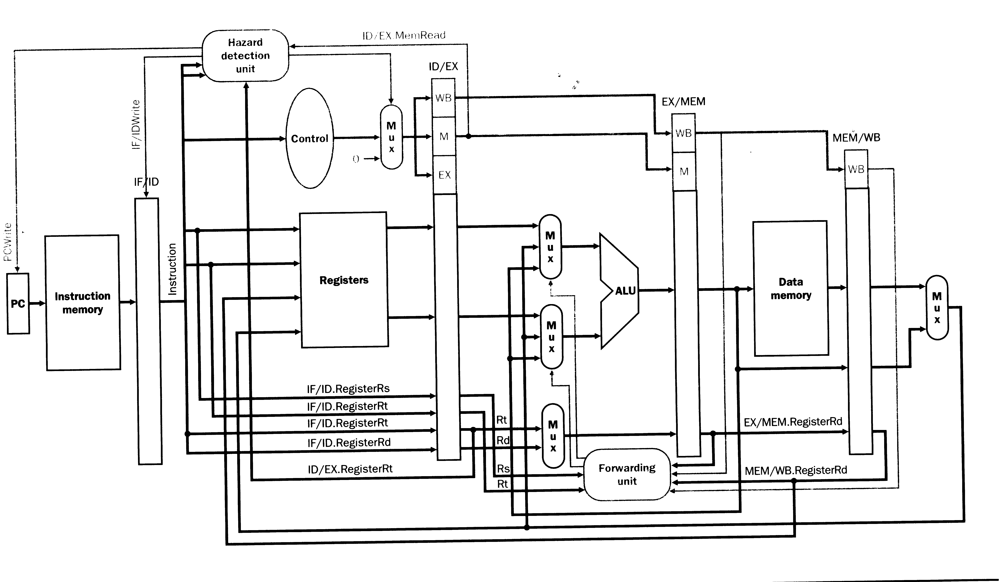
Slide 14 – Forwarding prevents stalls

 |  | TIME | 1 | 2 | 3 | 4 | 5 | 6 | 7 | 8 | 9
 | SUB | $2, $1, $3 | IF | ID | EX | DM | WB
 | ADD | $12, $2, $5 |  | IF | ID | EX | DM | WB
 | OR | $13,$6,$2 |  |  | IF | ID | EX | DM | WB
 | ADD | $14,$2,$2 |  |  |  | IF | ID | EX | DM | WB
 | SW | $15,100($2) |  |  |  |  | IF | ID | EX | DM | WB

For longer code segments it is convenient to us an alternative representation of the above diagram.

TIME
 | SUB $2, $1, $3
1 | IF | ADD $12, $2, $5
2 | ID | IF | OR $13,$6,$2
3 | EX | ID | IF | ADD $14,$2,$2
4 | DM | EX | ID | IF | SW $15,100($2)
5 | WB | DM | EX | ID | IF
6 |  | WB | DM | EX | ID
7 |  |  | WB | DM | EX
8 |  |  |  | WB | DM
9 |  |  |  |  | WB

Q1. When is the result of SUB $2, $1, $3 stored in $2?
A1. During time 5.
Q2. When can the result of SUB $2, $1, $3 be read from $2?
A2. At the end of time 5.
Q3. In which stage of the pipeline is A and B loaded?
A3. ID
Q4. Which instruction is the first to load the correct value for $2 into the A or B registers?
A4. ADD $14, $2, $2
Slide 17

TIME
 | lw $2, 20($1)
1 | IF | and $4, $2, $5
2 | ID | IF | or $8,$2,$6
3 | EX | ID | IF
4 | DM | S | S | S | add $9,$4,$2
5 | WB | EX | ID |  | IF | slt $1, $6, $7
6 |  | DM | EX |  | ID | IF
7 |  | WB | DM |  | EX | ID
8 |  |  | WB |  | DM | EX
9 |  |  |  |  | WB | DM
 |  |  |  |  |  | WB

 | IF | ID | EX | DM | WB
lw $2,20($1) | lw $2,20($1)
and $4,$2,$5 | and $4,$2,$5 | lw $2,20($1)
or $8,$2,$6 | or STALL | and STALL | lw $2,20($1)
 | or $8,$2,$6 | and $4,$2,$5 | BUBBLE | lw $2,20($1)
add $9,$4,$2 | add $9,$4,$2 | or $8,$2,$6 | and $4,$2,$5 | BUBBLE | lw $2,20($1)
slt $1, $6, $7 | slt $1, $6, $7 | add $9,$4,$2 | or $8,$2,$6 | and $4,$2,$5 | BUBBLE | lw $2,20($1)
 |  | slt $1, $6, $7 | add $9,$4,$2 | or $8,$2,$6 | and $4,$2,$5 | BUBBLE
 |  |  | slt $1, $6, $7 | add $9,$4,$2 | or $8,$2,$6 | and $4,$2,$5
 |  |  |  | slt $1, $6, $7 | add $9,$4,$2 | or $8,$2,$6
 |  |  |  |  | slt $1, $6, $7 | add $9,$4,$2
 |  |  |  |  |  | slt $1, $6, $7

Summary: Elimination of hazards:
Type | Eliminate | Improve | Software
Data | Forwarding
LW/SW | Forwarding
Branch | No | Forwarding  delay of 1 or 2 | Delayed branch
LW | No | 1 stall | Rearrange instructions

These 5 bits specify which register is rs.
rs and rt are treated as signed integers.
This is the combinational logic associated with the ALU. The output of the combinational ALU is normally transferred into the register ALUM on a clock transition.
When pipeline stalls
op ∈ {+, - , &, …}
i ∈ {0, 1, …,31}
"↵" means that the transfer takes place on the clock edge before the transfer caused by "←". The reason for this will be explained later.
ZERO is a one bit register that contains the zero output of the ALU.
Since R1 does not contain the correct value the ID stage can not proceed and must stall. Since the ID stage is stalled the IF stage cannot proceed and must also stall.
R1 now contains the correct value so the ID, and IF may proceed.
A is loaded with wrong value!
ALUM will be loaded with the correct value of R1.
A is loaded with wrong value!
B is loaded with wrong value!
ALUM contains the correct value of R1.
R1 has the correct value because it was loaded from ALUW a half clock cycle early.
ALUM contains the correct value of R4.
ALUM contains R5.
Let LMDR be the same register as ALUW.
This is the combinational logic associated with the ALU. The output of the combinational ALU is normally transferred into the register ALUM on a clock transition.
When pipeline stalls
op ∈ {+, - , &, …}
i ∈ {0, 1, …,31}
"↵" means that the transfer takes place on the clock edge before the transfer caused by "←". This will be explained later.
ZERO is a one bit register that contains the zero output of the ALU.
The five bits that specify rd are part of the offset X and therefore in general unknown. The equations for β must be modified. Our previous view was too simplistic.

