VHDL Tutorial #1
Using VHDL on the Digilent Spartan 3 board
Version 2.2 based on ISE 9.2
Developed at Virginia Commonwealth University
for
EGRE 254 – Digital Logic Design Spring 08
By
Dr. Jerry H. Tucker

This lab will introduce using VHDL with the Xilinx Foundation software version 9.2 on the Digilent Spartan-3 board. For this lab you will work with a partner. No lab report is necessary, but to receive credit for the lab you must demonstrate successful operation of your Spartan-3 board to the instructor or TA.
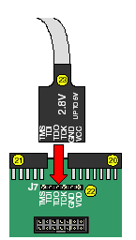
- Connect the J-Tag cable to the Spartan-3 board.
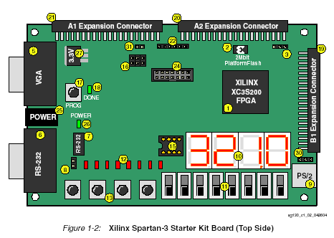

- Connect power to the Spartan-3 board then connect the other end of the J-Tag cable to the printer port of your PC.

- Create a directory to contain your projects. ( I used C:\spartan3.) Then open the Xilinx project navigator. If a shortcut has not been created you may typically use Start → Programs → Xilinx ISE 9.2i → Project Navigator.
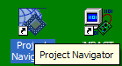

- Select File – New Project
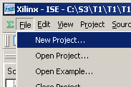

- For project name enter “tutorial1”. For Project location enter your directory, c:\spartan3. Be sure HDL is selected for Top-Level Module Type. Then click on Next.
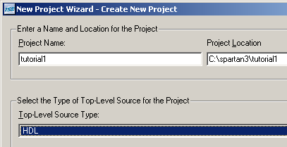

- In the next window specify the device we are using by entering the values Spartan3, XCS200, FT256 and -4 as shown below. Be sure VHDL is selected as the preferred Language.
- Then click on next.
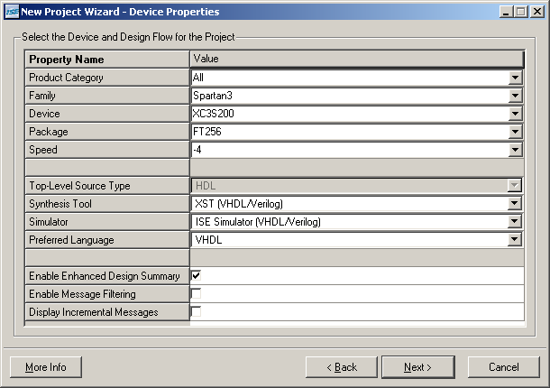

- In the next window click on New Source. In the New Source window select “VHDL Module” and for the File Name enter “MyLab”. Click on Next.
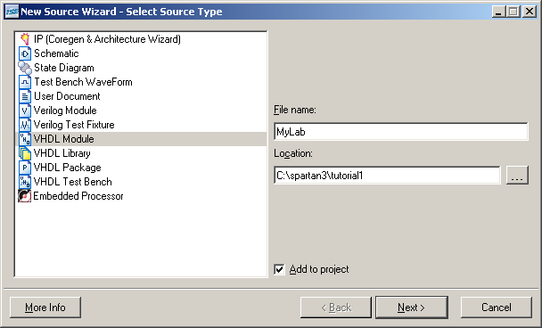

- Fill in the Define VHDL Source window as shown.
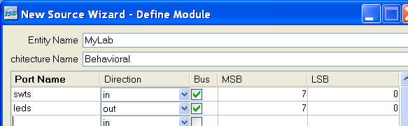

- Click on Next and then Finish.
- In the New Project window click on Next. In subsequent windows continue to click on Next and then click on Finish. If asked to create directory click on Yes.

- Double click on MyLab.
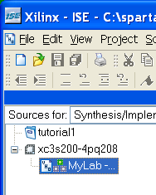
- Your MyLab.vhd file that you created should appear as shown below.
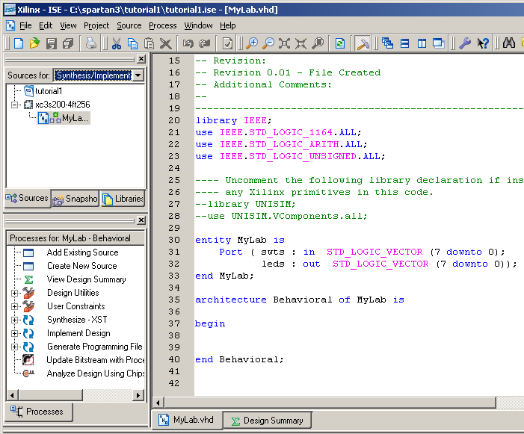

- Edit the Lab.vhd by entering the line “leds <= swts;” as shown below:
…
library IEEE;
use IEEE.STD_LOGIC_1164.ALL;
use IEEE.STD_LOGIC_ARITH.ALL;
use IEEE.STD_LOGIC_UNSIGNED.ALL;

---- Uncomment the following library declaration if instantiating
---- any Xilinx primitives in this code.
--library UNISIM;
--use UNISIM.VComponents.all;

entity MyLab is
Port ( swts : in STD_LOGIC_VECTOR (7 downto 0);
leds : out STD_LOGIC_VECTOR (7 downto 0));
end MyLab;

architecture Behavioral of MyLab is
begin
leds <= swts;
end Behavioral;

- Click on Project – New Source.
- In the New Source window select “Implementation Constraints File”, for File_Name enter My_Pins. Changes are not necessary in the Location window. Click on Next and then Finish
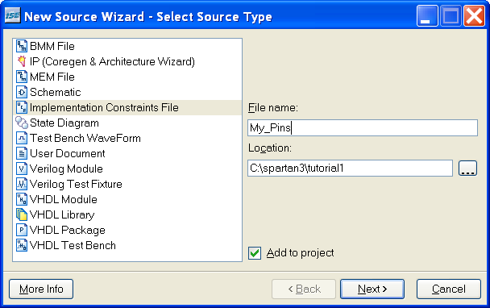

- In Project Navigator expand MyLab and select My_Pins.ucf. Expand “User Constraints” and then double click on “Edit Constraints (Text)”. Answer Yes if necessary.
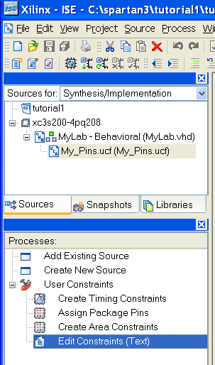

- Enter the following into the My_Pins.ucf file. (Hiny: Copy and paste from this document).
# leds
NET "leds<7>" LOC = "P11";
NET "leds<6>" LOC = "P12";
NET "leds<5>" LOC = "N12";
NET "leds<4>" LOC = "P13";
NET "leds<3>" LOC = "N14";
NET "leds<2>" LOC = "L12";
NET "leds<1>" LOC = "P14";
NET "leds<0>" LOC = "K12";
# swts
NET "swts<7>" LOC = "K13";
NET "swts<6>" LOC = "K14";
NET "swts<5>" LOC = "J13";
NET "swts<4>" LOC = "J14";
NET "swts<3>" LOC = "H13";
NET "swts<2>" LOC = "H14";
NET "swts<1>" LOC = "G12";
NET "swts<0>" LOC = "F12";

After editing save the My_Pins.ucf file.
- Select by clicking once “mylab-behavioral (MyLab.vhd)” in the “Sources for” window and then select and expand “Generate Programming File”. 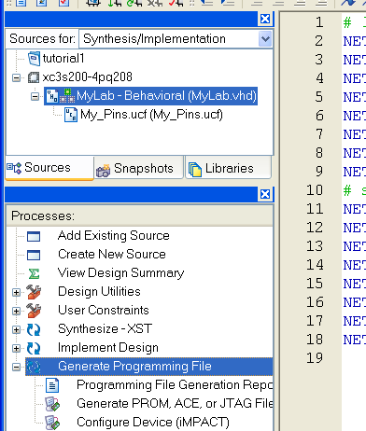

- Right click on “Generate Programming File” and select properties or as an alternative select from the Project Navigator menu: Process → Properties to open the “Process Properties” window. Select Startup Options and for the start-up clock select JTAG Clock and click on OK.
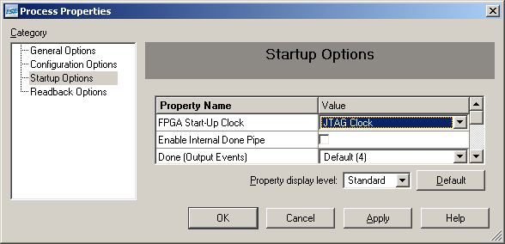
- Now double click on Generate Programming File to compile and synthesize the design. Wait till you see the green check on “Programming File Generation Report”. If there are errors correct them and repeat this step.
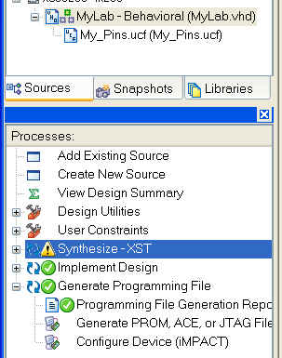

18. You are now ready to programming the Spartan-3 FPGA. Double click on Configure Device (iMPACT).
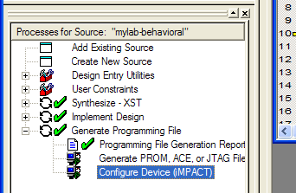

- Wait for iMPACT to start and click on finish.
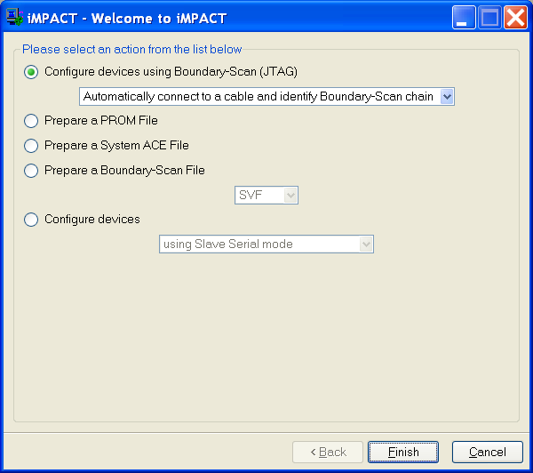
- Select mylab.bit and click on open.
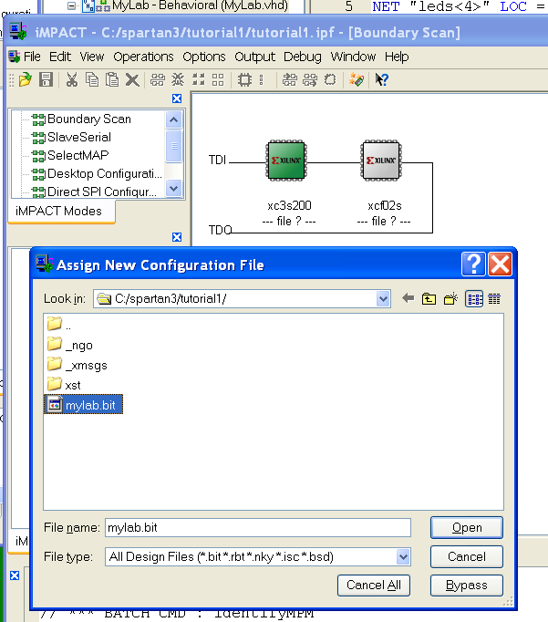

- Click on Bypass.
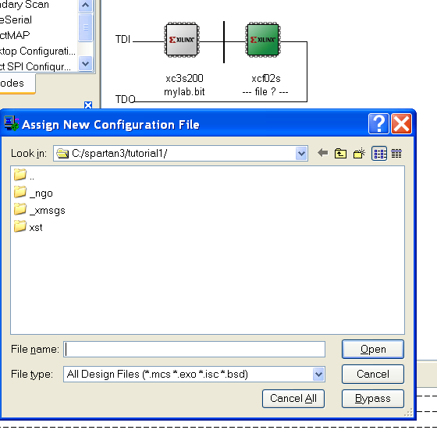
- Select the xc3s200 and right click on the xc3s200 icon and select program.
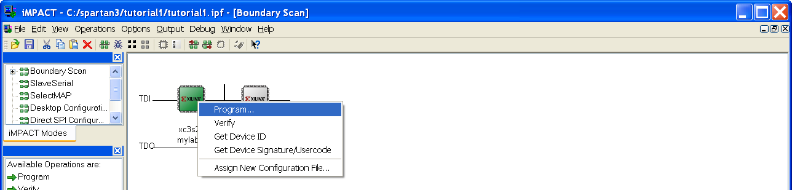

- Click on OK.
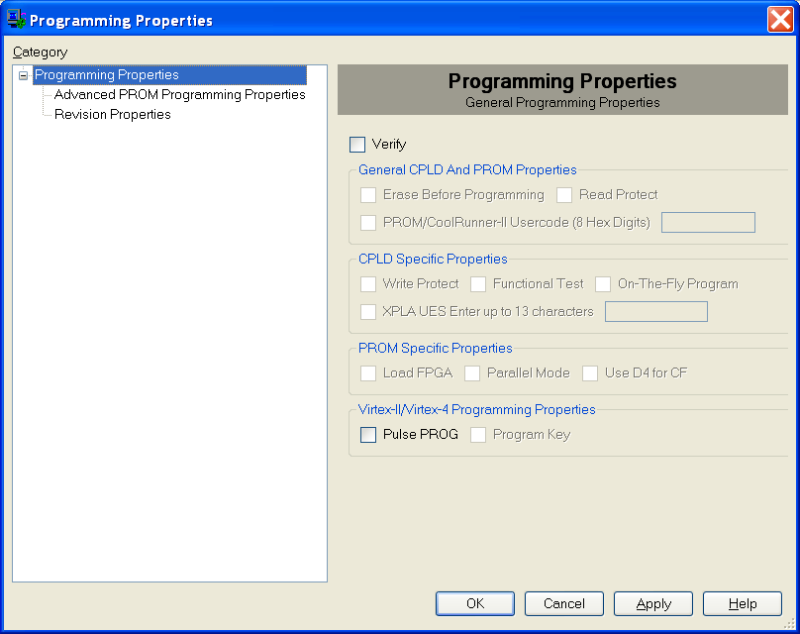

- You should see the blue Program Succeeded icon.
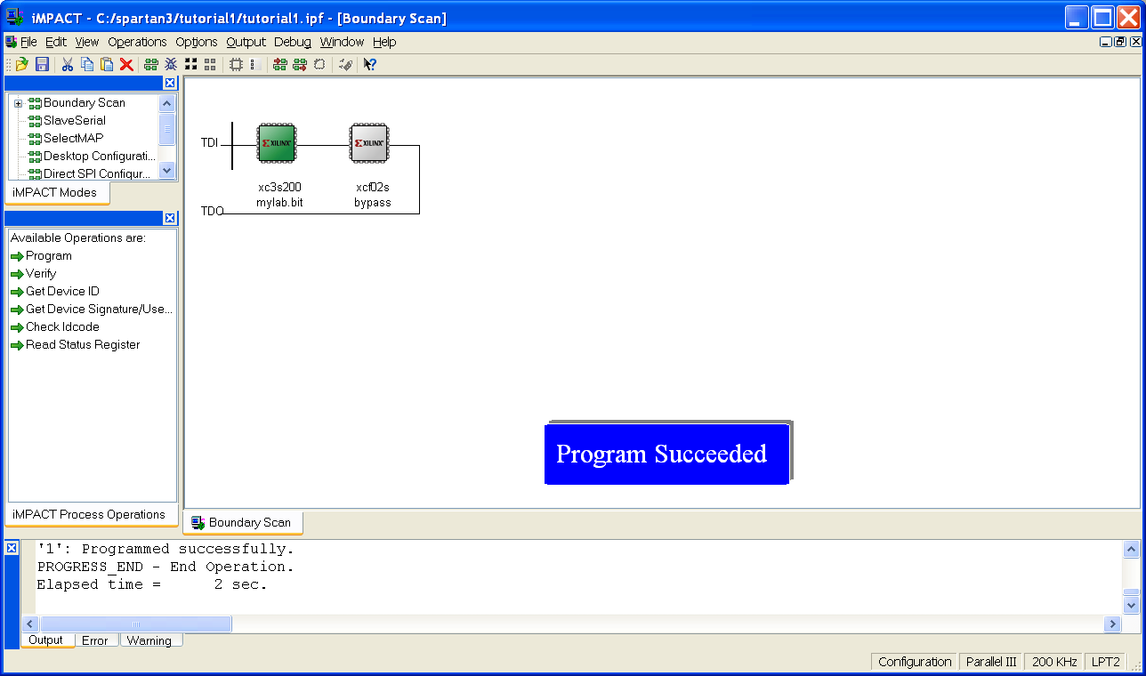

- The FPGA should now be programmed so that when a switch is placed in the up position the corresponding LED comes on.
Have the instructor or TA certify that you have completed this portion of the lab.

Follow these steps to change the operation so that when a switch is put in the down position the LED will be turned on.
- Close Impact. Click on Yes when asked to save project.
- Edit MyLab.vhd so that
leds <= swts;
reads
leds <= not swts;

- Save the file and double click on Generate Programming File.
- Configure the device using IMPACT.
- Verify correct operation.
Have the instructor or TA certify that you have completed this portion of the lab.

We will now demonstrate the convenience and power of VHDL by modifying our design so that the value of the four push buttons is added to value of the eight switches and the result displayed on the eight LEDs.
31. First we must add the push buttons pin outs to the .ucf file. To do this select the My_Pins.ucf file, expand the User Constraints and double click on Edit Constraints (Text) or just click on the My_Pins.ucf tab.
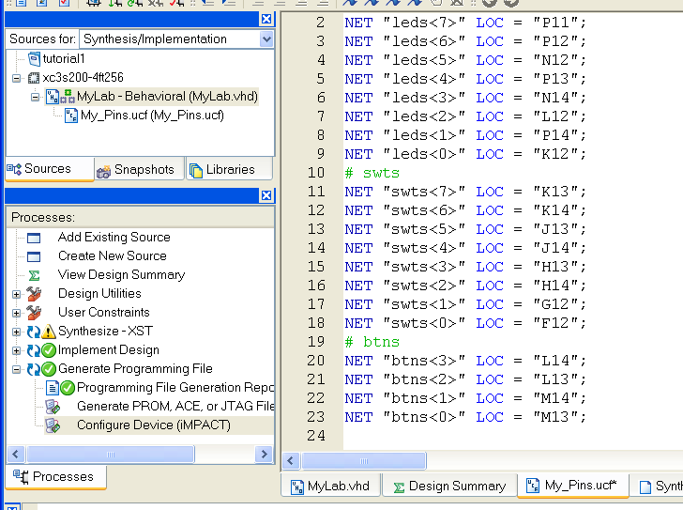

- Add the following to the My_Pins.ucf file:
# btns
NET "btns<3>" LOC = "L14";
NET "btns<2>" LOC = "L13";
NET "btns<1>" LOC = "M14";
NET "btns<0>" LOC = "M13";

- Save the .ucf file and open the file MyLab.vhd.

- Edit the lab.vhd file so the btns are added to the entitie’s port signals, and add the line leds <= swts + btns; to the architecture. This is shown below:
…
entity MyLab is
Port ( swts : in STD_LOGIC_VECTOR (7 downto 0);
btns : in STD_LOGIC_VECTOR (3 downto 0);
leds : out STD_LOGIC_VECTOR (7 downto 0));
end MyLab;
…
architecture Behavioral of MyLab is
begin
leds <= swts + btns;
end Behavioral;

- Double click on Generate programming File. Notice that warnings occur. Ignore these warnings and use impact to program the FPGA,
- Perform sufficient test to convince yourself that the circuit functions correctly.

Demonstrate correct operation to the instructor or the TA.

One use of the .ucf file is to specify to which FPGA pins signals connect.

