Tutorial
Introduction to using schematic capture with Xilinx ISE Version 8.1 for the Digilent S3 board.
Jerry H. Tucker

This tutorial provides the first time step-by-step instructions for creating and downloading a schematic based design to the Digilent S3 board. It also illustrates the important basic features of using the Xilinx ISE.

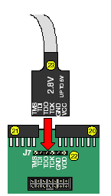
- Connect the J-Tag cable to the Spartan-3 board.
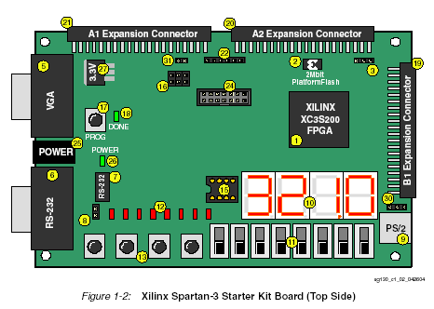

- Connect power to the Spartan-3 board then connect the other end of the J-Tag cable to the printer port of your PC.

- Create a directory to contain your files. I used C:\S3. If you use a different directory, substitute it wherever C:\S3 is used.

- Open the Xilinx Project navigator either by clicking on the shortcut icon or using Start → Programs → Xilinx ISE → Project Navigator

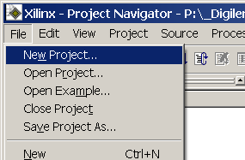
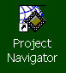

- In Project Navigator select File → New Project

- Enter the information shown below in the New Project window. Be sure to select Schematic for the Top-Level Model Type. Click on Next.
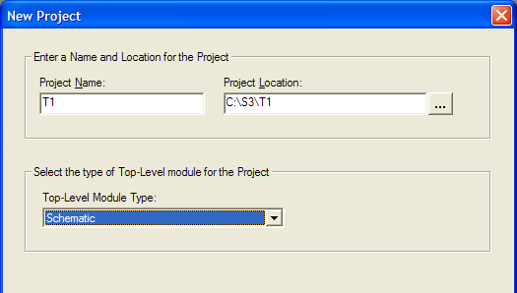
Be sure C:\S3\T1 is entered here. If you are using a different drive enter that drive letter in place of C.

- In the next window carefully make the selections shown below. Then click on next.
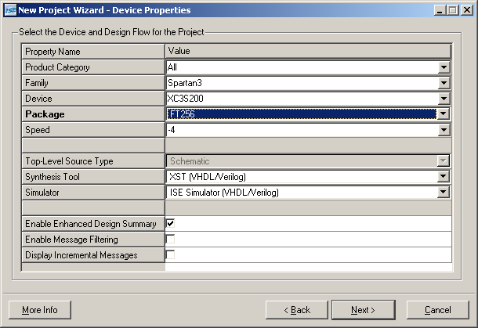
- In this window click on New Source.
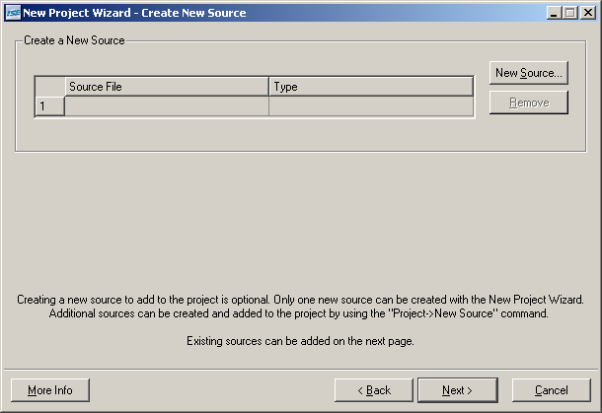

- Select Schematic, for file name enter T1top, and click on Next.
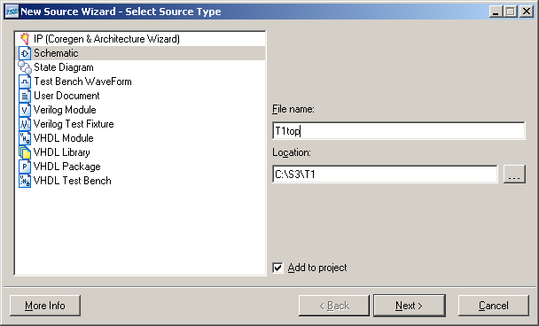
- Click on finish
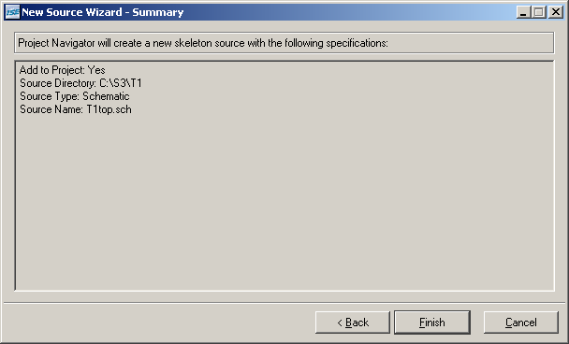

- Click on Next
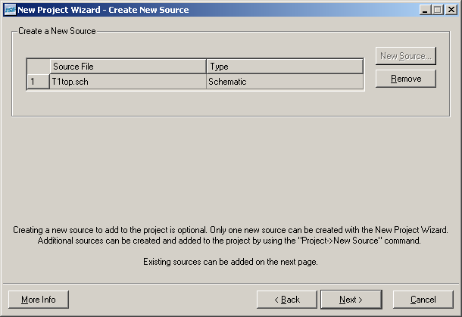
- Click on Next.
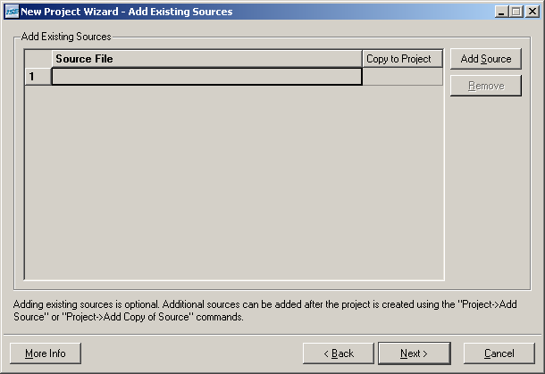

- Click on Finish
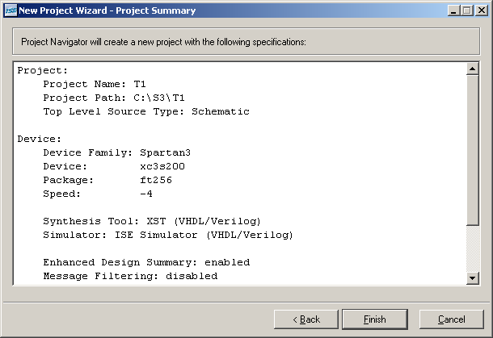
- After a delay you should see a screen similar to the one shown below.
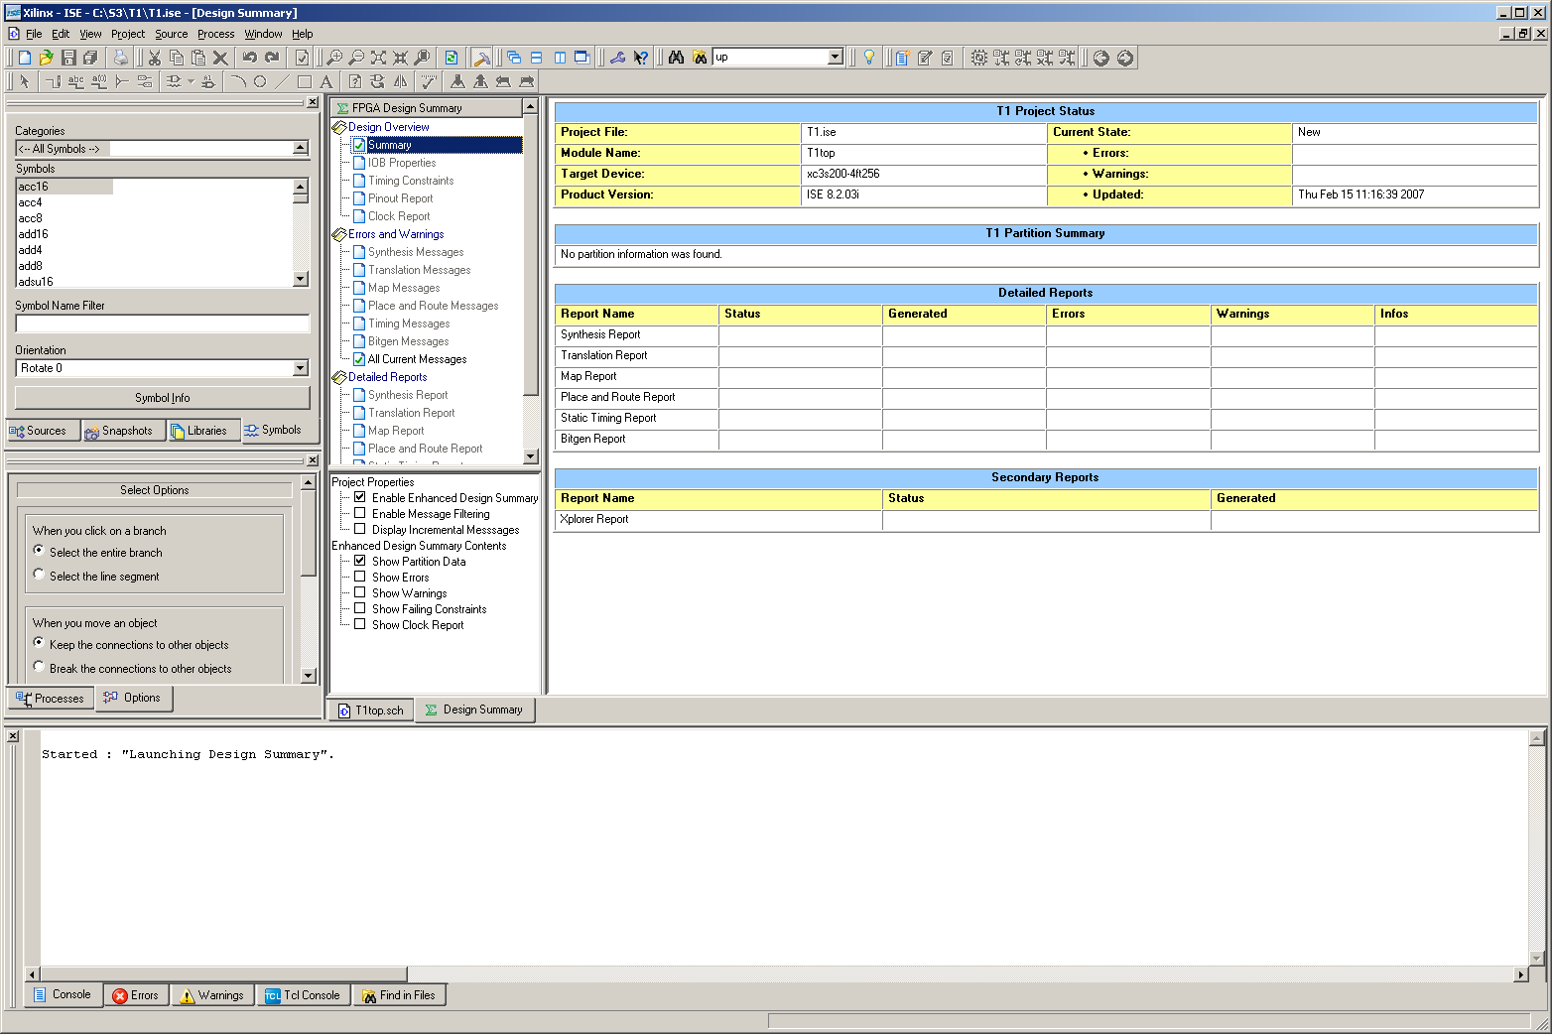

- Select the T1top.sch tab.

- On the schematic window in the symbols window under Categories select IO and then under Symbols select ibuf. Move (don’t drag) the cursor onto the schematic page. The ibuf symbol will appear. Position the ibuf and click to drop it. Use the 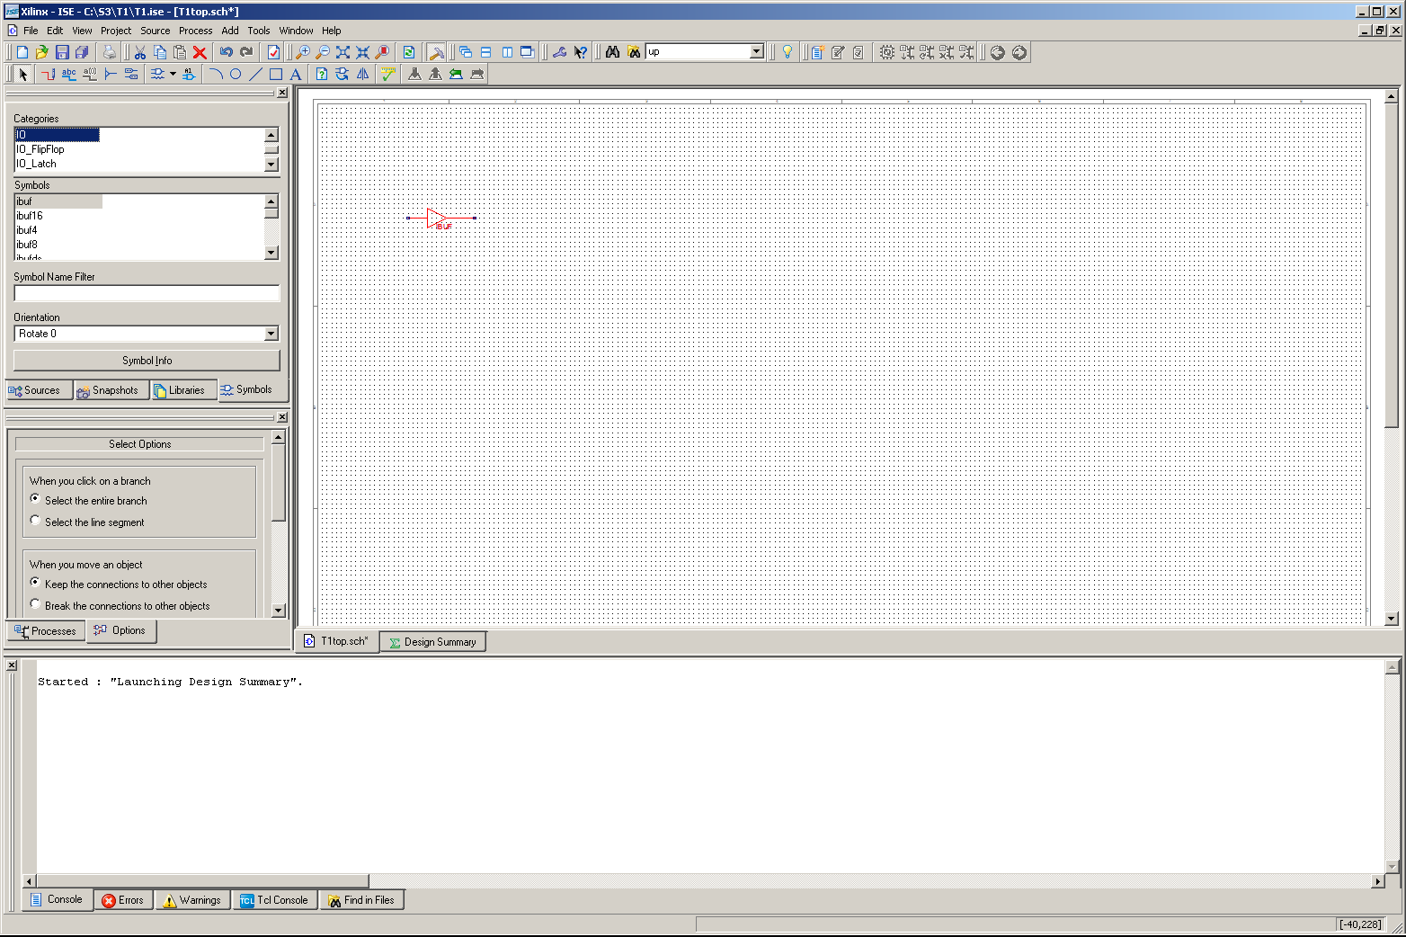 icons to zoom in and out as necessary.

- Drop two more of the ibufs and then select the “obuf” in the Symbols and drop three of these on the schematic. Notice that with a right click any of these symbols can be selected and moved. Also notice that by using F7 and F8 we can zoom in and out.
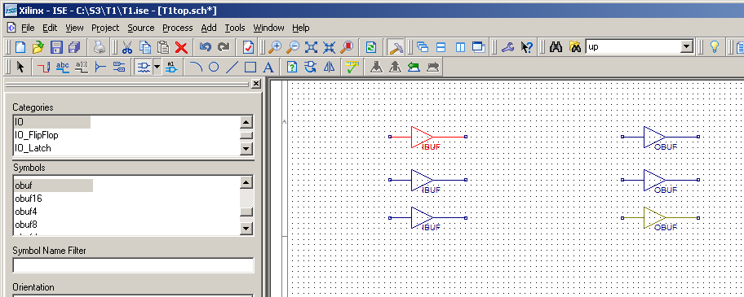

- Now add an input marker. This can be done by selecting on the top menu Add → I/O Marker.
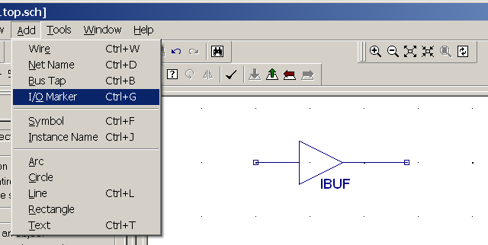

- Drop input markers on the input side of the other IBUF’s as shown below. Be sure the input marker connects with the IBUF. When finished use the “Ecs” key to get out of this mode.
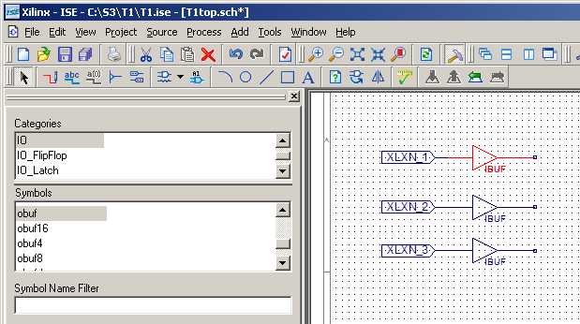

- Rename the input markers by selecting a marker, right clicking and selecting Rename port. In the window that pops up rename the port to “SW7”.

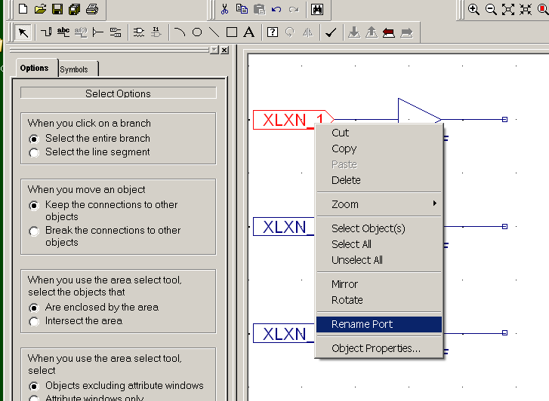

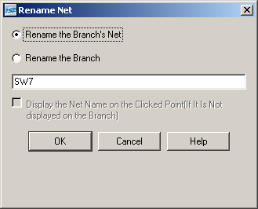

- Rename the other two input ports SW6 and SW5. Later we will create an .ucf file that will map these pins to be connected to the switches on the Digilent S3 board.
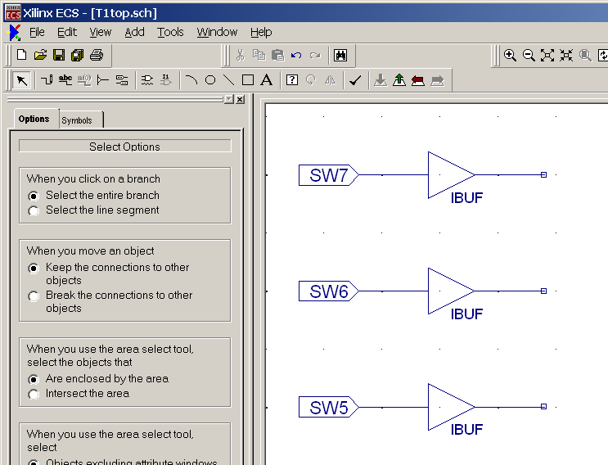

- In a similar way add output markers to each of the OBUF’s and name these LD7, LD6, and LD5. The drawing at this point should appear as shown below.
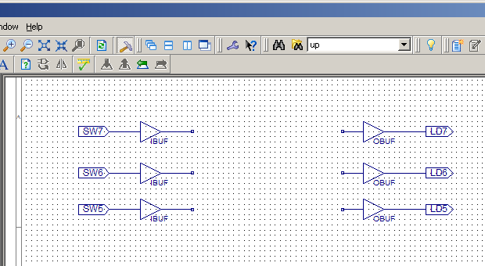
- Now add wires from the outputs of the IBUF’s to the inputs of the OBUF’s. This can be accomplished by selecting the pencil icon in the upper left or selecting Add → Wire. In either case use the mouse to make draw and connect the wires. When starting a wire make sure the start point connection is indicated. Otherwise you may not have a connection.
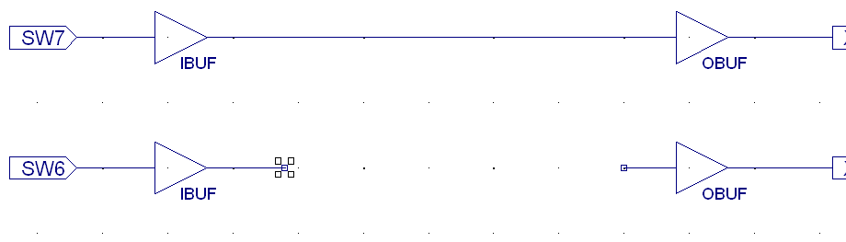
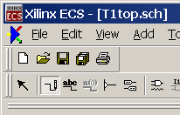

- The final drawing should appear as shown below.
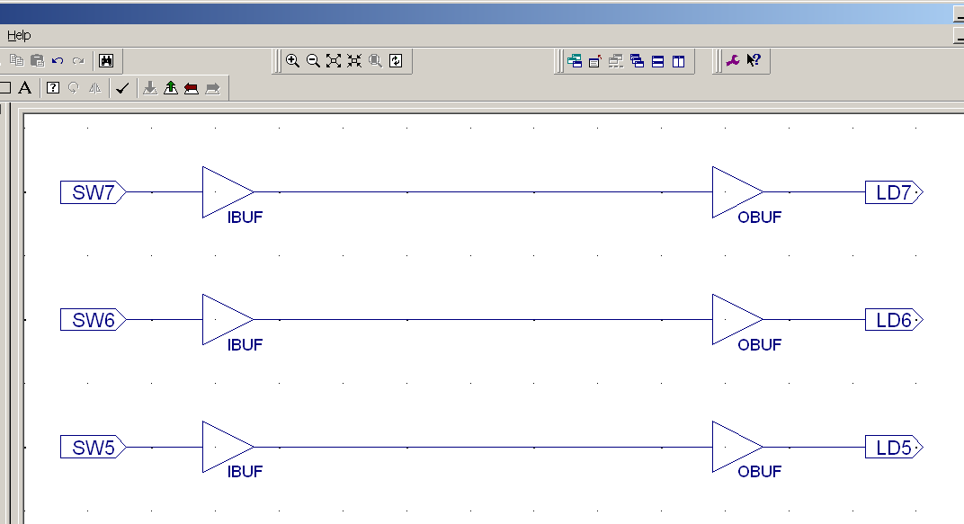
- Click on the check schematic icon.
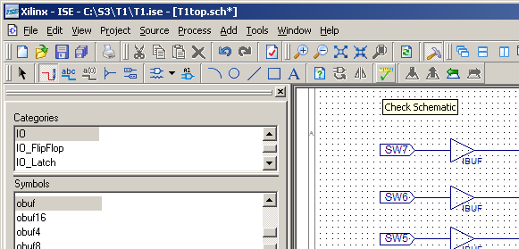

- If the window console window you should see a “No error or warnings is detected” message.
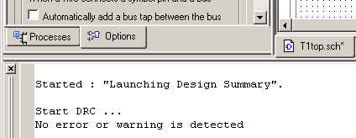

- You may close the schematic. Be sure to answer yes if a save changes message appears.

- We must now create an .ucf file to map the schematic ports to the FPGA pins that are connected to the switches and LED’s on the S3 board. In project Navigator select Project → New source. For the file name enter T1S3 and then select Implementation Constraints File. Click on Next for the current and next window. Then click on Finish.
The 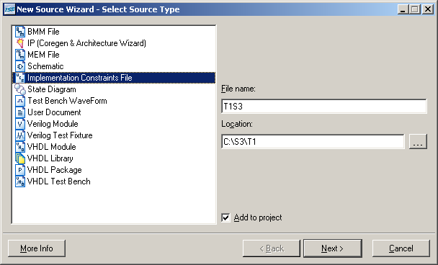

- Expand the T1top(T1top.sch) menu by clicking on the + box. Select the .ucf file.
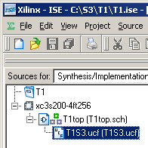
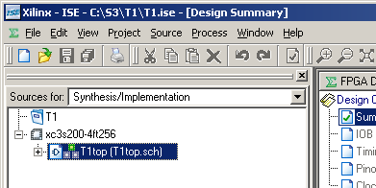

- Select T1S3.ucf. In the Processes for Source window expand User Constraints by clicking on the “+”. Then double click on Edit Constraints (Text).
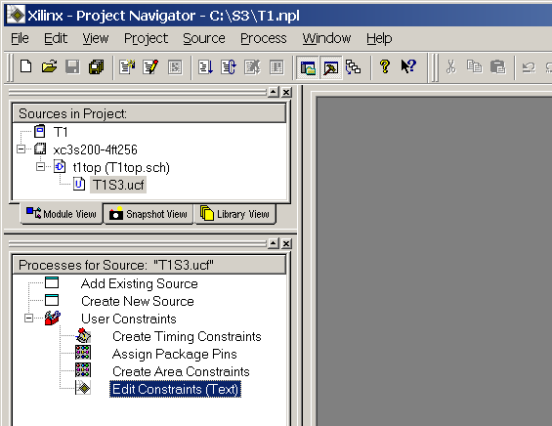

- Edit the T1S3.ucf file as shown below.
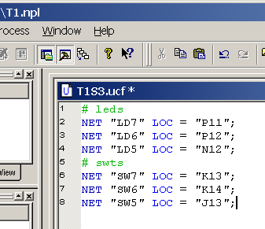
- In the Sources in Project window select t1top. Then select (don’t double click) Generate Programming File.
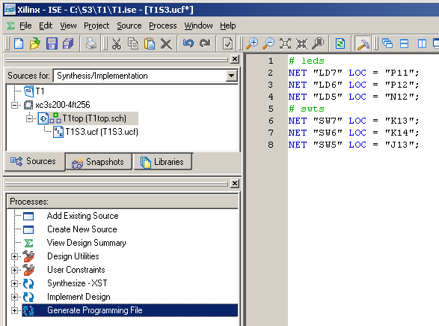

- Right click on Generate Programming File and select properties. In the pop up window select Startup Options and be sure JTAG Clock is selected. Then click on OK.
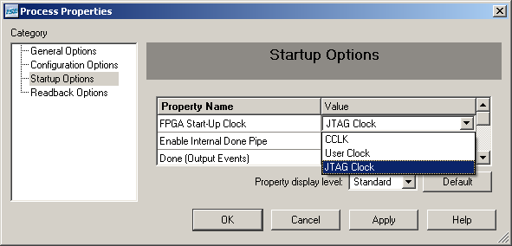
- Double click on Generate Programming File. If prompted to save a file answer “Yes”.
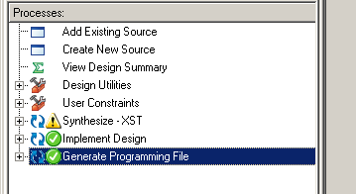

- After a delay a green check indicates that the .bit file that can be used to program the FPGA has been generated. Expand the Generate Programming File.
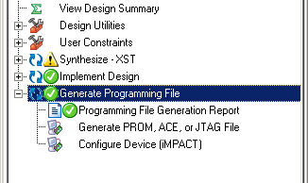
- Be sure the Spartan 3 board is powered up and the JTAG cable is connected. Double click on Configure Device (iMPACT). Then click on Next
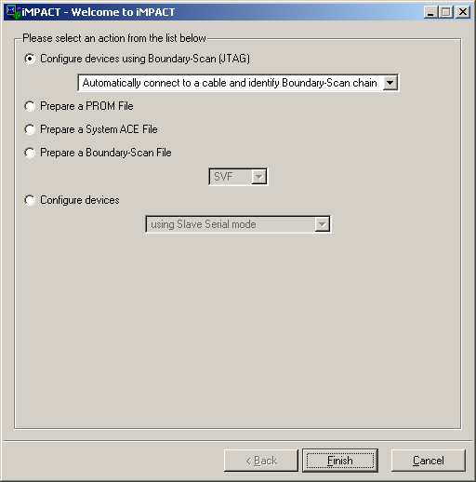
- Click on Finish.

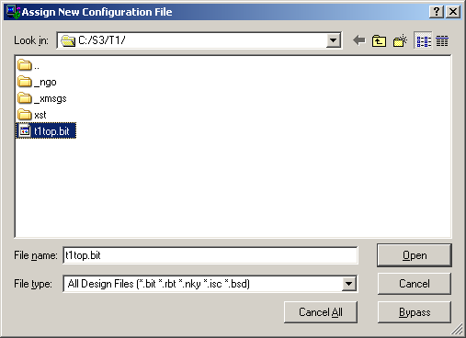
- If you see this window select t1top.bit and click on finish.
- In the next window hit cancel.
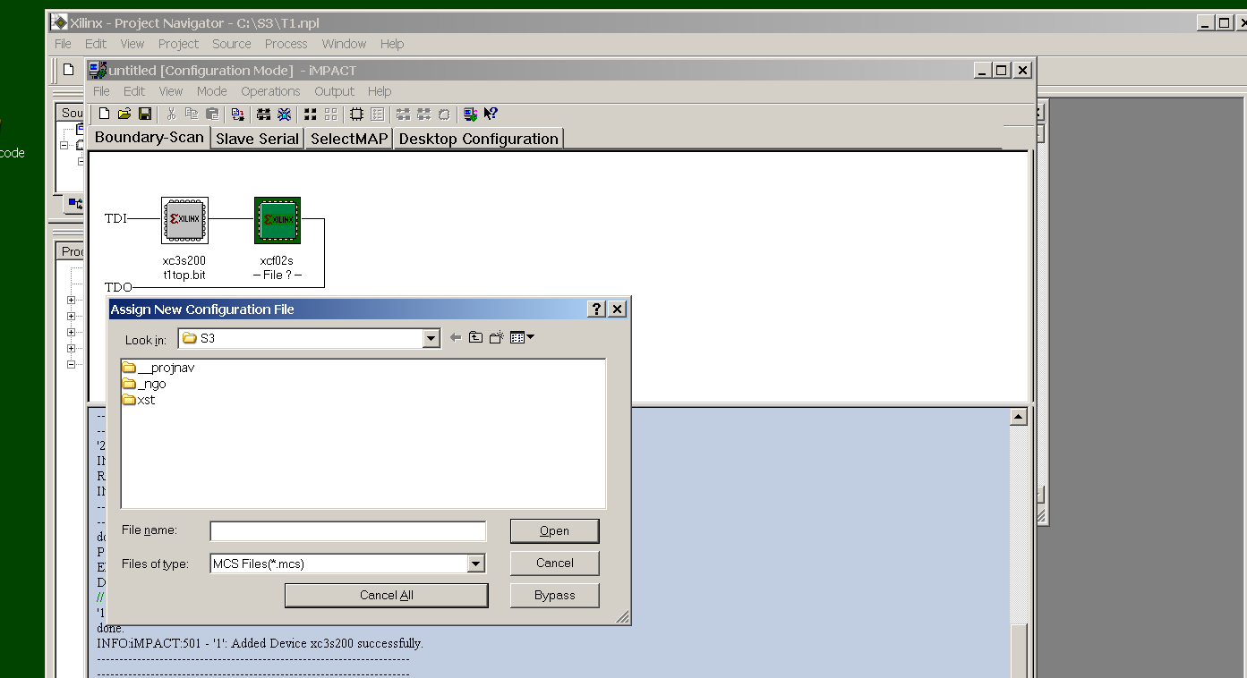

- Select the left most Xilinx chip (xcs200). Right click and select and click on Program. In the next window click on OK.

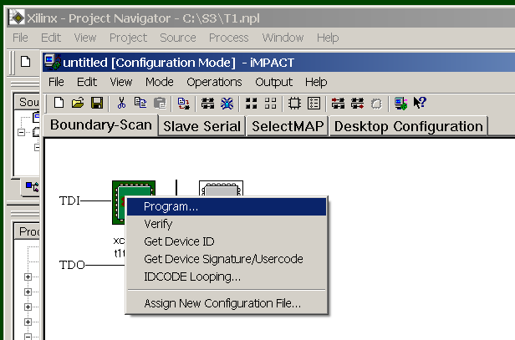

- If you see the window below the Spartan 3 board is successfully programmed. If not close iMPACT, power down the Spartan 3 board wait a few second, power the board up again are restart iMPACT.
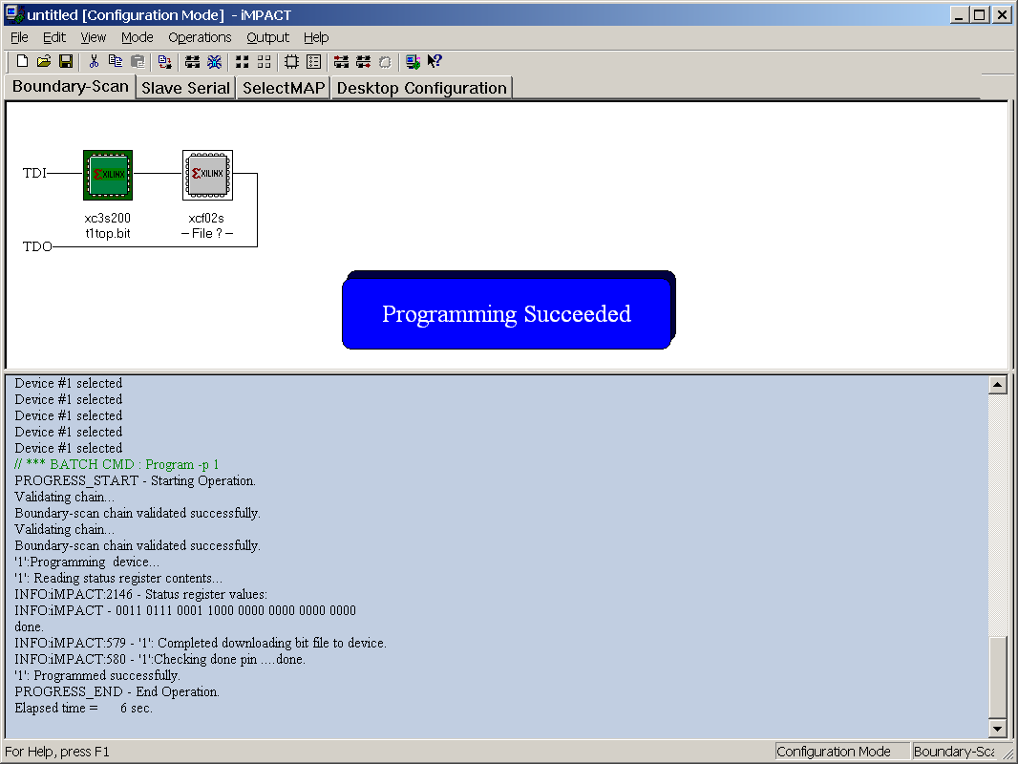

- Verify that flipping the three leftmost switches will change the three leftmost LED’s.
- You may now exit iMPACT (click yes when asked to save the file) and exit Project Navigator.
Part 2 – Adding a Majority circuit

We will now add the logic for a majority circuit to the previous design. This circuit could be added to the original schematic; however, we will create the majority circuit on a separate schematic and then add it as a component to the original schematic.

- Open the Project Navigator and the previous design. Select Project → New Source.
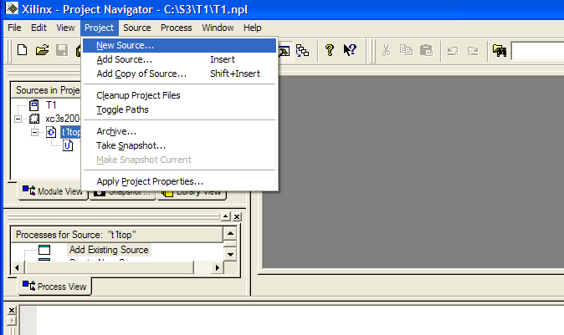

- With Schematic selected enter Majority for the File Name. Click on Next and then Finish.
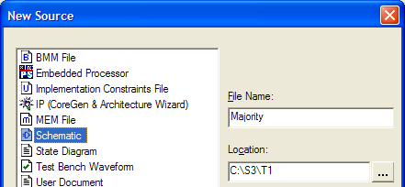
- Selecting and2 and or3 under Logic draw the schematic shown below.
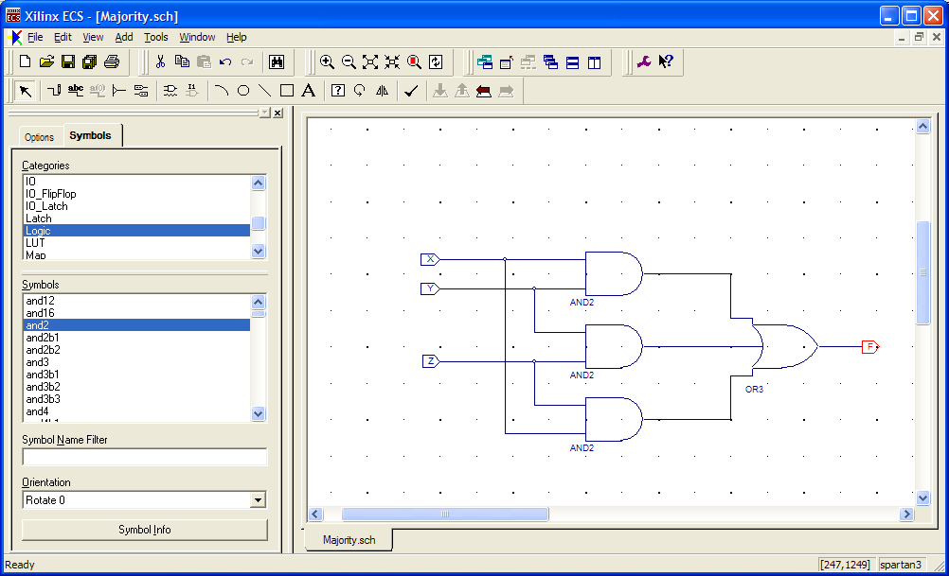

- Be sure the input markers are renamed to X, Y, and Z and the output marker is renamed to F. You do not need to add ibuf and obuf components.
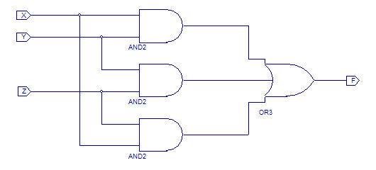
- Click on check schematic.
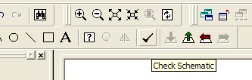
- If there are no errors, close the schematic and return to the Project Navigator window. In the Sources in project window select majority.sch. In the Processes for Source window expand Design Entry Utilities and double click on Create Schematic Symbol.
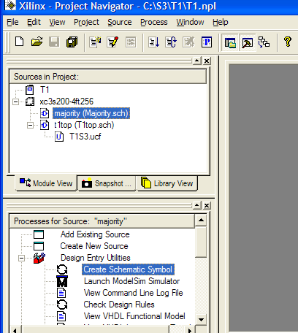

- Open the t1top schematic by double clicking on it in the Sources in Project window.
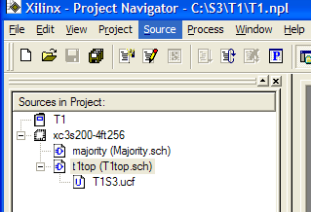

- Using the Symbols tab select majority and place this component on the schematic.
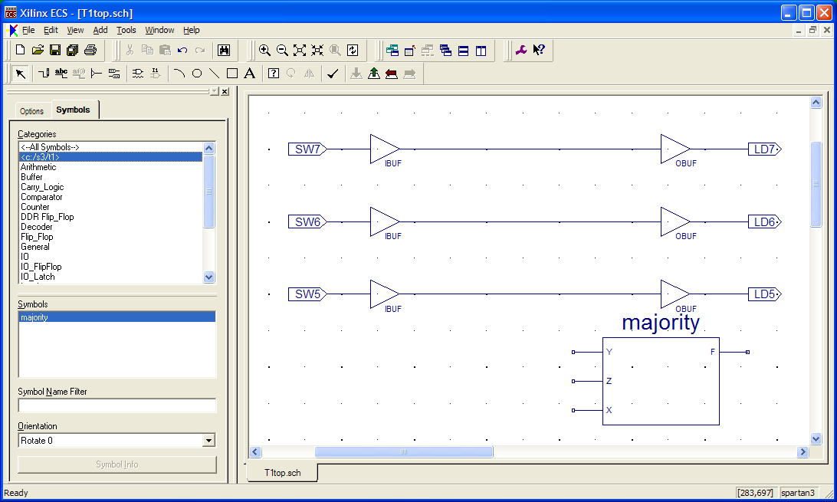

- Complete the schematic as shown below. Be sure to add the new port LD0 as an output marker.
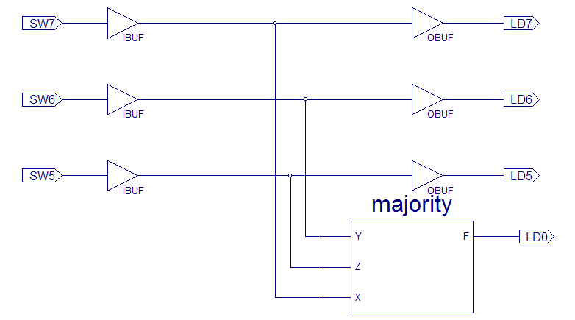
- Check, exit, and save the schematic
- We must now update the .ucf file so that LD0 will connect to the corresponding LED on the Spartan 3 board. In Project Navigator click on T1S3.ucf and double click on Edit Constraints (Text). Add the line
NET "LD0" LOC = "K12";

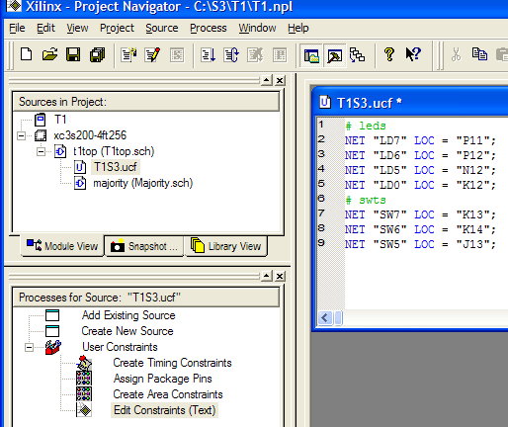

- Click to select t1top and then double click on Generate Programming File.
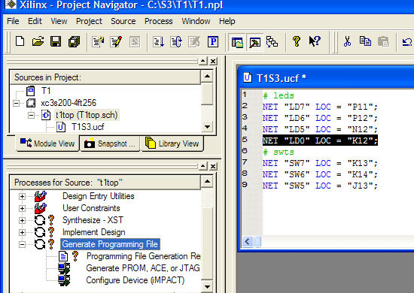

- Using the steps outlined previously, use iMPACK to program the FPGA.

We are using SW as the name of the switches on the Spartan 3 board.
We are using LD as the name of the LED’s on the Spartan 3 board.

