THE ROLE OF DESMOPLAKIN DURING EPIDERMAL DEVELOPMENT

I. Significance:
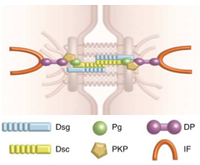
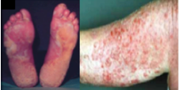
Cellular adhesion, particularly in the skin, is vital to human life. The skin is the body’s largest organ and it serves as protection against potential threats from the surrounding environment (Stalder, 2014 et al). It is comprised of three primary layers known as the epidermis, dermis and hypodermis (Human Skin, 2016). Of particular interest is the epidermis, which is the outermost layer of the skin. The epidermis is responsible for the creation of new skin cells and acts as the skin’s primary layer of defense (Forni & Trombetta-Lima, 2012). Embryonic development in particular, relies heavily on the epidermis as a barrier from the outside world. It also requires the epidermis to help promote growth and cell differentiation, including the formation of appendages, such as sweat glands and hair follicles (Liu et al, 2013). The diverse function of the epidermis is correlated to its capability to modify cellular adhesion. Without proper cell adhesion in the epidermis, the skin would fail to maintain its protective state, ultimately leading to disease (Stalder, 2014 et al). One important type of intracellular adhesive is known as the desmosome (Garrod & Chigdey, 2008). The desmosome is a structural adhesive that can be found in between epithelial cells (Figure 1). Its structural components are thought to help maintain tissue integrity and provide resistance to mechanical stress (El-Amraoui & Petit, 2010). Several diseases have been associated with disruption of desmosome function during embryogenesis, such as palmoplantar keratoderma, skin fragility, wooly hair, and pemphigus vulgaris (Figure 2).
Figure 1: The structure of the desmosome. Desmosomes are the link between cells that contribute structural support and integrity to surrounding tissues. Taken from (Green & Simpson, 2007)
Figure 2: Diseases associated with disruption of desmosome function: Palmoplantar Keratoderma (left) and Pemphigus Vulgaris (right). Taken from (Whittock 2002, et al) and (Stanley & Amagai, 2006)
Goal: The goal of this experiment is to determine how disrupting desmosome function affects the differentiation of the epidermal cells during development.

II. Background:
a) What is a Desmosome?
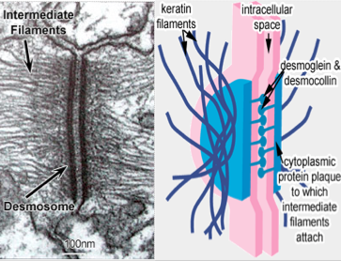
The desmosome is made up of three main protein groups-desmocollins, desmogleins, and desmoplakin (Figure 1). Of these three proteins, this investigation focuses on desmoplakin and its role in cell differentiation during development. Desmoplakin contains three critical protein domains-the rod domain, plakin domain, and the tail domain (Figure 5). The tail region of desmoplakin is particularly important because it directly associates itself with the intermediate filament keratin (Garrod & Chigdey, 2008). Due to its association with keratin, desmoplakin serves as an important structural link to the cytoskeleton (Figure 3) Without it, the desmosome fails to function properly with the rest of the cell (Garrod & Chigdey, 2008).
Figure 3: An EM picture of the desmosome and its interaction with the intermediate filaments in an epithelial cell (left) and a more simplistic drawing of the desmosome with its labeled counterparts (right). Taken from (The University Of Leeds, Faculty of Biological Sciences).
b) The use of Xenopus laevis in studying desmosome function during development
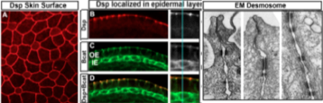
Xenopus laevis, also known as the African clawed frog, is a tractable system, with free-living embryos and an epidermis that is very similar to the epidermis of mammalian skin (Schmitt, 2014 et al). It is a widely used species in the area of developmental research due to its cost efficiency and easy embryonic manipulation (James-Zorn, 2015 et al). Many desmosomal genes of Xenopus, including desmoplakin, have been annotated and are described on Xenbase (Bowes et al, 2010). Also, it is structurally similar to humans, which makes it an ideal model organism for this investigation (James-Zorn, 2015 et al). A graduate student in the Dickinson lab, Navaneetha Krishnan Bharathan has previously characterized the desmosome structure and formation. It was observed that the desmosome is present in the outer epidermal cell layer starting at the first day of development (Figure 4).
Figure 4: Confocal microscopy images (shown in color) and an EM picture capturing the desmosome. Current graduate student Navaneetha Krishnan Bharathan characterized the desmosome structure and formation of epithelial cells within the first day of development. Taken from (Bharathan & Dickinson lab, unpublished).

Hypothesis: The desmosome requires proper function of desmoplakin during development of the epidermis in the embryo.

III Experiment:
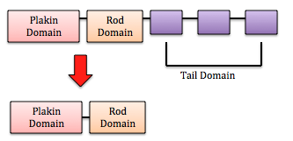
In order to test this hypothesis, an experiment will be performed in which the effects of dysfunctional desmoplakin will be observed. A mutant desmoplakin gene containing a deletion in the tail region will be expressed in the developing Xenopus embryo (Figure 5). The purpose of doing this is to see how a deletion in the tail domain affects the affinity of desmoplakin to bind with keratin. It has been previously noted that if this particular domain is missing, there will be no structural link to keratin (Garrod & Chigdey, 2008). Without this cellular linkage, proper cell organization should not exist, ultimately affecting the structural support of the epithelial cells that make up the epidermis.
Figure 5: The three major protein domains of desmoplakin (top) and desmoplakin missing the tail domain (bottom).

a) Expressing a mutant desmoplakin
To perform this experiment, a tailless desmoplakin construct will be obtained. The mutant construct is not something that will not be made by this lab. Instead, it can be premade and purchased. The construct will be subcloned into a Xenopus expression vector. Meaning, the gene will be cleaved using restriction enzymes and then ligated into the new plasmid. The Xenopus plasmid contains GFP (green fluorescent protein) and a polyA tail. Both will be incorporated into the mutant desmoplakin. The mutant gene with the GFP and polyA tail will be transcribed in vitro to make mRNA. This mRNA will then be microinjected into the embryo in order to make a mutant desmoplakin protein. The mutant protein is tagged with GFP in order to be visualized in the embryo. After the microinjection, the embryos will be left to develop for 24 hours in order to allow for the epidermis to differentiate. Below describes how the embryos will then be processed.

b) Assay of epidermal development
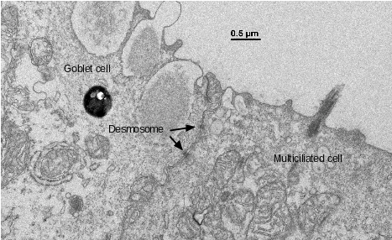
Once the mutant desmoplakin is expressed, electron microscopy (EM) will be used to observe if the cells of the embryo’s epidermis are developing correctly. Electron microscopy uses a beam of electrons to capture an image of the sample, but prior preparation must be completed first. The embryos will be fixed using 2% glutaraldehyde in 0.1 M cacodylate buffer and will be processed in collaboration with the VCU Microscopy Facility, using their protocol. Thin sections will be obtained using the Leica EM UC6i Ultramicrotome. The purpose of EM is to visualize the normal markers of the developing epidermis, such as cilia and secretory vesicles (labeled goblet cell), as shown in Figure 6 (Dubaissi 2014, et al).
Figure 6: An EM photograph taken by graduate student Navaneetha Krishnan Bharathan that characterizes normal cell differentiation of the epidermis in Xenopus. Taken from (Bharathan & Dickinson Lab, unpublished).

IV Discussion:
Cell adhesion in the epidermis relies heavily on the desmosome to function properly. Many diseases relating to the proteins that make up the desmosome have been described, but it is not understood why these defects occur. The overall goal of this work is to gain more insight on the role that the desmosome plays during embryological development. Previous studies have noted that a lack of the tail region of desmoplakin has lead to the failure in its attachment to keratin, ultimately disrupting cellular function (Garrod & Chigdey, 2008).
I expect that the mutant desmoplakin embryos will contain epithelial cells that do not differentiate correctly due to the disruption of normal cell function. If this is the case, failure of cell differentiation will be easily visualized using electron microscopy. Without proper cell differentiation, I predict that the issues within the embryo will be very distinct. One thought is that the embryos will not be able to sustain any form of mechanical stress because of poor function of the desmosome in the epidermis. Also, I think that there will be issues with the shaping of the embryo due to failure of cell differentiation during morphogenesis. Currently, the Dickinson lab is developing experiments to test this. As previously mentioned, humans with desmosomal defects have a variety of skin related disorders (Whittock 2002, et al) that are consistent with my expectations.
Alternatively, epidermal differentiation may not require desmosome function at all. If this is the case, I predict that I will see cells that have differentiated correctly. This may mean that the desmosome is not necessary during early development but is only be necessary during the later adult stages od development. The overall goal of this work is to better understand the role of the desmosome during embryonic development, despite either outcome. Further investigation includes understanding how defects in the desmosome lead to the various human diseases.

References

1. Bowes, J.B., Snyder, K.A., Segerdell, E., Jarabek, C.J., Azam, K., Zorn, A.M., and
Vize, P.D., (2010), Xenbase: gene expression and improved integration, Nucleic Acids Research, Volume 38 (suppl) 1, pp. D607-D612, doi:10.1093/nar/gkp953.

2. Choi, H., & Weis, W. I. (2016). Chapter eleven - purification and structural analysis of
desmoplakin. Methods in Enzymology, 569, 197-213.
doi:http://dx.doi.org.proxy.library.vcu.edu/10.1016/bs.mie.2015.05.006

3. Dubaissi, E., Rousseau, K., Lea, R., Soto, X., Nardeosingh, S., Schweickert, A., et al. (2014). A secretory cell type develops alongside multiciliated cells, ionocytes and goblet cells, and provides a protective, anti-infective function in the frog embryonic mucociliary epidermis. Development, 141(7), 1514-1525. doi:10.1242/dev.102426

4. El-Amraoui A, Petit C. Cadherins as Targets for Genetic Diseases. Cold Spring
Harbor Perspectives in Biology. 2010;2(1):a003095.
doi:10.1101/cshperspect.a003095.

5. Faculty of Biological Sciences, & University of Leeds. Adhering junctions.Retrieved 05/05,2016, from: http://www.histology.leeds.ac.uk/cell/cell_junctions.php

6. Forni, M. F., Trombetta-Lima, M., & Sogayar, M. C. (2012). Stem cells
in embryonic skin development. Biological Research, 45(3), 215-222.

7. Garrod, D., Chidgey, M. (2008) Desmosome structure, composition and function, Biochimica et Biophysica Acta (BBA) - Biomembranes, 1778(3), 572-587.
(February 4, 2016)

8. Garrod, D., Berika, M., Bardsley, W., Holmes, D., Tabernero, L. Hyper-adhesion in
desmosomes: its regulation in wound healing and possible relationship to cadherin crystal structure. Journal of Cell Science 2005 118: 5743-5754; doi: 10.1242/jcs.02700

9. Green, K. J., & Simpson, C. L. (2007). Desmosomes: New perspectives on a classic. Journal of Investigative Dermatology, 127(11), 2499-2515. doi:http://dx.doi.org/10.1038/sj.jid.5701015

10. Human skin. (2016). In Encyclopaedia Britannica. Retrieved from
http://academic.eb.com.proxy.library.vcu.edu/EBchecked/topic/547591/huma n-skin

11. James-Zorn, C., Ponferrada, V.G., Burns, K.A., Fortriede, J.D., Lotay, V.S., Liu, Y., Karpinka, J.B., Karimi, K., Zorn, A.M, Vize, P.D. (2015) Xenbase; core features, data acquisition and data processing, genesis, The Journal of Genetics and Development, 53:486-497.

12. Kowalczyk AP, Bornslaeger EA, Borgwardt JE, et al. The Amino-terminal Domain of
Desmoplakin Binds to Plakoglobin and Clusters Desmosomal Cadherin–
Plakoglobin Complexes . The Journal of Cell Biology. 1997;139(3):773-784.

13. Morgan, K., & Juchheim, M. (2014). Plasmids 101: The promoter region - let's go!
Retrieved 5/1, 2016, from http://blog.addgene.org/plasmids-101-the-promoter region

14. Schmitt, S. M., Gull, M., & Brändli, A. W. (2014). Engineering xenopus embryos for phenotypic drug discovery screening. Advanced Drug Delivery Reviews, 69–70, 225-246. doi:http://dx.doi.org/10.1016/j.addr.2014.02.004

15. Stalder, J.F., Tennstedt, D., Deleuran, M., Fabbrocini, G., de Lucas, R., Haftek, M., Taieb, C., Coustou, D., Mandeau, A., Fabre, B., Hernandez-Pigeon, H., Aries, M.F., Galliano, M.F., Duplan, H., Castex-Rizzi, N., Bessou-Touya, S., Mengeaud, V., Rouvrais, C., Schmitt, A.M., Bottino, R., Cottin, K. and Saint Aroman, M. (2014), Fragility of epidermis and its consequence in dermatology. Journal of the European Academy of Dermatology and Venereology, 28: 1–18. doi: 10.1111/jdv.12509

16. Stanley, J. R., & Amagai, M. (2006). Pemphigus, bullous impetigo, and the staphylococcal scalded-skin syndrome. N Engl J Med, 355(17), 1800-1810. doi:10.1056/NEJMra061111

17. Whittock, Neil V.Morley, Susan M. et al. Compound Heterozygosity for Non-
Sense and Mis-Sense Mutations in Desmoplakin Underlies Skin Fragility/Woolly
Hair Syndrome, 2002, Journal of Investigative Dermatology, Volume 118 , Issue 2 , 232 - 238

