Vaginal TM7 and the absorption of amino acids.
Introduction
Bacterial Vaginosis is an abnormal condition, in which naturally occurring bacteria is depleted resulting in an unbalanced microbiome. It has been shown to affect up to 36% of women, with half of these cases being asymptomatic, where the other half reported a “fishy-smelling” discharge (Hay). Bacterial Vaginosis occurs when there is a depletion of Lactobacillus, and an overgrowth of anaerobes which results in a loss of acidity. Lactobacillus has a protective role over the microbiome, by lowering the environmental pH. The disappearance of this key species and overgrowth of potentially harmful bacteria is the main marker for Bacterial Vaginosis (Ravel). One such anaerobic microbes is the vaginal TM7 strand. TM7 is a division of the bacteria domain, which has been associated with other human mucosal inflammatory diseases in addition to vaginosis, such as; inflammatory bowel disease and periodontitis (He).
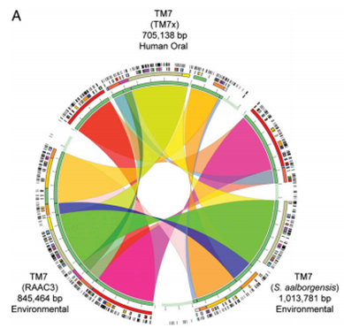
TM7 is characterized by its environmental 16s ribosomal DNA sequence (Hugenholtz). Using this sequence, researchers are able to tag the bacteria in order to observe if it is present in a sample or not. As a phylum, TM7 appears to be unable to synthesize any essential amino acids (He). TM7 is an even more unique division because it has an atypical base substitution, which makes it streptomycin resistant. Atypical base substitution occurs when a single nucleotide, in this case, the positions 911 and 912 have adenosine and uracil (Hugenholtz). In this case, it alters the point in which Streptomycin, a widely used antibiotic, would normally bind to the sequence, making the bacteria resistant. TM7 has been found in many different environments, such as, peat bog, termite gut, and wastewater, as well as having multiple strands being found within the human body (Barton). One such strand is the Oral TM7 bacteria, denoted TM7x. TM7x has been fully sequenced and studied more thoroughly than other human TM7 strands, thus it will be a frame of reference in comparison to vaginal TM7.
TM7x is an obligate epibiont, which means it is an organism that can only live on the surface of another organism, in this case another bacteria; Actinomyces odontolyticus (He). Through this parasitic relationship, TM7x is able to absorb key substances it can’t naturally produce, of interest is its need to absorb amino acids. In He’s experiment it was shown that there is a large range of conserved genes, in comparison to the oral and two other non-human TM7 strands (Figure 2). This could indicate that the two human TM7’s would have an even larger range of conserved genes. It’s been shown that Oral TM7 only has genetic codes to create Arginine, but no other nucleotide (Barton). This would mean that the organism has to get other amino acids from an outside source, which may be the host cell in this case. Therefore it may be likely that Vaginal Tm7 and Oral Tm7 could have the same type of parasitic relationships, and have the same type of need for amino acid acquisition.
Figure 1: Comparative gene analysis of TM7x, to other non-human TM7 sequences.
He, fig. 2.

Experiment
The purpose of this experiment is to determine if TM7 extracts amino acids from the environment, or from its host cell. The first step in this process, it to determine what the host of Vaginal TM7 is. This is done by first identifying which bacteria is present in the samples collected from vaginal secretions. Bacterial colonies are collected from women using swabs and analyzed using the protocol described in Lindau et al (2008). These samples are then analyzed to determine which bacteria is present and in what quantity. Based on this data, the correlation can be tested, between TM7 and any other bacteria. The correlation is based on the ratio between how much of the potential host is actually found in the sample versus the expected amount. The higher this ratio is, the more probable it is be the host for TM7.
The second step, is to determine how the TM7 actually absorbs the amino acids. This can be done, by first growing the host cell in a solution of 14C labeled amino acids, this is marked in figure 2A. Once a sufficient enough time has passed for the host to absorb the labeled amino acids, the host is removed and put in a normal solution, marked in figure 2B. To this, is added TM7 so it can naturally bind to the host again then these combined cells are immediately put into a solution of 15N labeled amino acids (Gaudin), shown in figure 2C. Again, enough time is allotted for the TM7 to absorb the necessary amino acids. After this time, the TM7 is separated and analyzed to see the amino acid content. 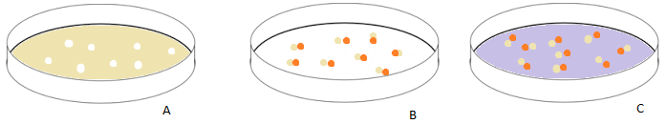
Figure 2. A) Host cell, determined in step 1, grown in a solution of 14C labeled amino acids. B) 14C labeled host cells with TM7 attached in a natural solution. C) TM7 attached to host cells in a solution of 15N amino acids.
Comparing the two amount, through mass spectrometry, will show where the TM7 is getting its amino acids. This is because the two different sources are both labeled differently weighted tags.
Results
Either of the results would lead to interesting discoveries and possibilities for future research. If it’s found to contain more of the environmental amino acids, we know that there is some sort of mechanism on the cell membrane that allows for the absorption. On the other hand, if there is more of the C14 labeled amino acids, then there is some sort of transporter between the two cells. There could be some mingling between the two labeled amino acids, in which there was some leakage of C14 into the environment, or some absorption of N15 by the host. But this can be ignored, in part, because it will be in such a small amount in comparison to where the bacteria is absorbing the most amount of amino acids. Both of these cases can be further studied once this experiment takes place to determine the types of mechanism that could be at play.
This information is of interest, because TM7 has such a high level of conserved DNA. Meaning that this one discovery could be linked to other TM7 strands.

References
Barton, D (2010) Uncultivated Environmental TM7 Model To Study Human Disease-Associated
TM7 Bacteria. SJSU ScholarWorks, Master’s Theses.
Gaudin, Z., et al (2014) Robust Method for Investigating Nitrogen Metabolism of 15N Labeled
Amino Acids Using AccQ•Tag Ultra Performance Liquid Chromatography-Photodiode
Array-Electrospray Ionization-Mass Spectrometry: Application to a Parasitic Plant−Plant
Interaction. American Chemical Society, 86, 1138 – 1145.
Hay, P., (2010) Bacterial Vaginosis. Medicine, 38:6, 281-285. He, X., et al, (2015) Cultivation of
a human-associated TM7 phylotype reveals a reduced genome and epibiotic parasitic
lifestyle. PNAS, 112, 244-249.
He, X., et al (2015) Cultivation of a human-associated TM7 phylotype reveals a reduced genome
and epibiotic parasitic lifestyle. PNAS, 112, 244-249.
Hugenholtz, P., et al, (2000) Investigation of Candidate Division TM7, a Recently Recognized
Major Lineage of the Domain Bacteria with No Known Pure-Culture Representatives.
Applied and Environmental Microbiology, 67, 411-419.
Lindau, S., (2008), Vaginal Self-Swab Specimen Collection in a Home-Based Survey of Older
Women: Methods and Applications. Journal of Gerontology, 106-118.
Ravel, J., et al, (2016) Vaginal microbiome of reproductive-age women. PNAS, 108, 4680-4687.

