Understanding the role of the PACE/Furin site and Apoptosis in terms of Factor 8 production in regards to Hemophilia A Therapy

Herleen Mokha
BNFO 300 Spring 2016
Introduction

Hemophilia A is an X-linked genetic disease that affects 1 in 5000 individuals, which is characterized by a delayed or incomplete ability to successfully clot blood vessels that have sustained a lesion (Roth). This is caused by a deficiency in a clotting protein cofactor called Factor VIII (F8) within the bloodstream. F8 is a crucial protein that performs an important function; the recruitment of various coagulation factors. These coagulation factors ultimately result in proper blood clotting. Prior to the secretion of F8 into the bloodstream, F8 undergoes many obstacles, such as strong holds by chaperone proteins like BiP, protein misfolding, and low expression of F8 mRNA. A combination of these obstacles collectively result in poor expression of cofactor protein F8 in hemophilia A patients. (Lenting).
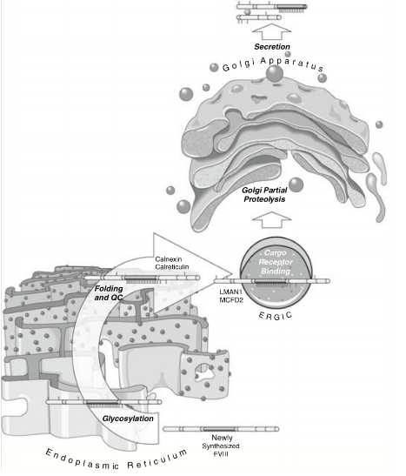
Understanding the process behind the regulation and secretion of F8 aids in the understanding of why current treatment therapy of Hemophilia A revolves around the creation of more efficient F8 processing. Once F8 is synthesized, it is immediately translocated to the Lumen of the ER, or Endoplasmic Reticulum (Greene, Understanding). Then, a single chain peptide is cleaved to become F8 protein. Modifications occur in the ER such as the addition of residues within the B domain of F8 among other things. Following this, F8 then interacts with a variety of chaperone proteins of the ER, namely immunoglobulin binding proteins, or BiP (Dorner, Increased). BiP causes a fraction of F8 molecules to bind to said chaperone protein, and dissociation cannot occur unless much ATP is used (Dorner, The Relationship). It is because of interactions such as this that a large portion of F8 that is synthesized remains within the ER, never to be secreted. It is important to note that too much accumulation of F8 within an endothelial cell will lead to apoptosis of that cell (Greene, Understanding). The remaining amount of F8 that does make it through the ER travels to the Golgi, where F8 undergoes more regulation, processing and cleavage. Finally, lysis within the aforementioned B domain occurs through the Paired Amino-acid Cleavage Enzyme (PACE/furin). Exiting through this PACE/Furin site is the final step; now secretion from the cell occurs (Siner). Figure 1 explains the steps prior to secretion of F8 from an endothelial cell.
Figure 1: F8 is synthesized and sent to the Lumen of the ER where the single chain receives additions to its B domain, shown in dark grey. Once in the Golgi, cleavage of F8 occurs at the B domain through the PACE/Furin site. F8 is then secreted.
All of these steps lead to an even more minute yield of F8 in Hemophilia A patients as compared to normal individuals. Because of this, enhancing the secretion of F8 has been a major focus of research. Currently, treatment of Hemophilia A involves plasma injection into patients of recombinant F8 (Greene, in vivo). However, complications from this arise in the form of high cost to patients, short half-life of protein, and the 20-30% possible chance of the development of F8 inhibitors (Lynch). To get around this, an abundance of research has gone into effect. In 1989, F8 secretion was first reportedly improved by deletion of the B domain in F8, called hFVIII-BDD (Kaufman). However, it was later noted in 2001 that deletion of the B domain did not lengthen the half life of F8 to any great extents, nor did it increase secretion by much. Also, it lead to the same percentage of individuals who developed inhibitors during treatment (Courter). Next, a study was done involving a point mutation in the A1 domain of F8, leading to a decrease in BiP binding to F8, which resulted in more secretion (Swaroop). A vital part of all of these studies involved the measurement of the degree of apoptosis involved with all of these changes in F8, seeing as prevention of apoptosis goes hand in hand with ensuring increased efficacy of F8 secretion.
The most recent study done in an attempt to increase F8 production was conducted in 2014 involved the deletion of the 4 amino acids of the PACE/Furin site in the Golgi Body of canine models. As previously mentioned, passage through this site is the final step for F8 prior to secretion. Human F8 sequence (hF8) contains a PACE/Furin site made up of the amino acids RHQR. Within the species of Canine, Canine F8 sequence (cF8) contains a PACE/Furin site made up of HHQR. The two differ in only one amino acid, from arginine to lysine (Greene, Understanding). In this experiment conducted in 2014, all results were measured solely on a mechanistic level. After deletion of the PACE/Furin site in canine, what was found was that A 3-fold increase in F8 secretion occurred (Siner). Injection of cF8 with PACE/Furin site deleted corrected the hemophilia coagulopathy in 2 Hemophilia A dogs. Prior to this experiment, it was believed that cF8 have increased stability because it is predominantly expressed as a single chain, likely involving the R¹⁶⁴⁵H substitution at a conserved PACE/furin site, which is not present in F8 species other than dog (Greene, Understanding).
Though a 3 fold increase in F8 secretion is quite preferential for Hemophilia A patients, apoptosis of endothelial cells still occurring will render this study to a halt. Because of this, the question is now posed; can the deletion of the PACE/Furin site subsequently aid in lowering the amount of apoptosis?

Experiment

The following experiment allows for comparative analysis of levels of apoptosis between endothelial cells of canine between wild type cells with normal functioning PACE/Furin sites within the Golgi Body and cells that are constructed following deletion of the PACE/Furin site. Entrusting the previous work conducted by Siner in 2014, there would be no reason to determine if levels of F8 after PACE/Furin deletion increase within a canine model. However, using an ELISA as described in Sabatino will help with that portion of this study (Sabatino 2).
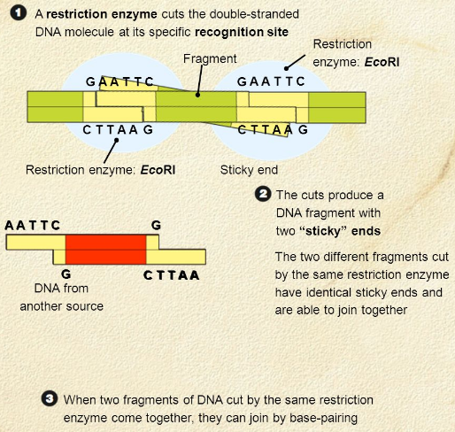
Prior to conducting comparative analysis of apoptotic levels, construct cloning must to be performed in order to create endothelial cells with PACE/Furin deletion. This process is adapted from the process used by Greene during the creation of F8 variants in 2010. Essentially, a gene of interest is expressed in a vector that is easily purchased (Greene, Understanding 35). The vector being used would be a canine endothelial cell, which the deletion of PACE/Furin site must ensue. The goal of this portion of the experiment was to conduct restriction enzyme mapping using restriction digest in attempt to create a FVIII variant where the PACE/Furin site at residues 1645-1648 was deleted (Siner). Restriction digest enzymes are able to open up a vector in certain places that they can bind to. An enzyme will be able to open up the vector and generate an overhang. This means that rather than the enzyme creating a blunt cut across both strands of DNA, it is cut in a way that leaves overhang on one of the strands of DNA, better allowing for re-annealing of the base pairs (Greene, Understanding). Figure 2 explains the creation of an overhang using an example restriction enzyme, EcoR1. The idea behind this is that the hydrogen bonds between complementary base pairs of an overhang DNA will be more chemically favorable to re-anneal as opposed to phosphodiester bonds between adjacent nucleotides attempting to reanneal after a blunt cleavage. Re-annealing is crucial following the deletion of the 4 amino acids of the PACE/Furin site. Discovery of a pertinent restriction site near the PACE/Furin site has been found, however information regarding location of the site has not been released by previous experimenters (Siner).
Figure 2: 3 steps to generation of an overhang within a DNA vector
After the overhangs are produced, ligation is the next step in the experiment that must occur in order for both sides of the vector to reanneal. After this is complete, these newly created construct will be transformed into canine endothelial cells. Following this, the next steps may occur.
In order to measure the degree of apoptosis, Terminal deoxynucleotidyl transferase (dUTP Nick-end Labeling assay (TUNEL) will be used. This technique involves measuring for breaks in DNA strands, indicating severe DNA damage as a result of apoptosis (Gavrieli).
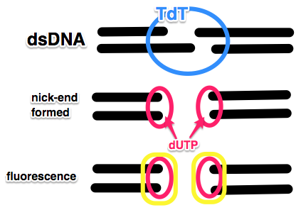
TUNEL begins with collection of cells and embedding them into paraffin and then washing them (Gavrieli). Following this, centrifugation occurs, accompanied by another washing. The solution is then resuspended in DNA labeling solution of terminal deoxynucleotide transferase (TdT) enzyme and is incubated. The enzyme TdT will bind to an DNA strand that is broken. If there is any overhang as described earlier, TdT will nick then end, creating a blunt end to the double stranded DNA (Darzynkiewicz). The 1st and 2nd panel within Figure 1 provides a visual of this. Once the blunt end is created as previously mentioned, TdT will add dUTP to these terminal ends. TdT is template independent and is able to add dUTP to any strand. dUTP is a chain of Uracils. After incubation, cells are rinsed with a buffer and resuspended in staining solution which will mark damaged DNA (Gavrieli). This staining solution is actually staining dUTP. dUTP is tagged with fluorescence. It is possible to measure the fluorescence to determine which cells are undergoing apoptosis. Now, comparative analysis regarding the amount of cells undergoing apoptosis in regards to wild type canine endothelial cells vs. canine endothelial cells with PACE/Furin deletion can be recorded through use of flow cytometry as described in Darzynkiewicz and Hawley.
Figure 3: TdT generates blunt ends through cleavage of overhangs, allowing for dUTPs to attach on which will later be labeled with fluorescent staining.

Discussion

The results from this finding may harbor many possibilities. One disappointing finding may be that although release of F8 is increased due to lack of PACE/Furin, the cofactors being released may not have gone through proper regulation due to the deletion of the PACE/Furin site, resulting in secretion of many F8 proteins that will play no real role in coagulation seeing as they may not be viable, functioning proteins.
The most favorable finding involves the discovery that lacking PACE/Furin allows for F8 that would usually build up and cause apoptosis to actually be released, subsequently preserving the endothelial cell from apoptosis.
Preservation of endothelial cells and increased secretion of F8 by Hemophilia A patients will affect society remarkably. Increasing the efficacy of F8 would lead to Hemophilia A patients to need less medical care, lower the cost of treatment due to less need of recombinant F8 injection, and improve the quality of life for those suffering with this genetic disease.

Works Cited

Courter SG, Bedrosian CL. 2001. Clinical evaluation of B-domain deleted recombinant factor VIII in previously treated patients. Semin Hematol 38 (2 Suppl 4): 44-51.

Darzynkiewicz, Z., Galkowski, D., & Zhao, H. 2008. Analysis of apoptosis by cytometry using TUNEL assay. Methods (San Diego, Calif.), 44(3), 250–254.

Dorner AJ, Wasley LC, Kaufman RJ. 1989. Increased synthesis of secreted proteins induces expression of glucose-regulated proteins in butyrate-treated Chinese hamster ovary cells. J Biol Chem 264 (34): 20602-7.

Dorner AJ, Bole DG, Kaufman RJ. 1987. The relationship of N-linked glycosylation and heavy chain-binding protein association with the secretion of glycoproteins. J Cell Biol;105:2665.

Gavrieli Y, Sherman Y, Ben-Sasson SA. 1992. Identification of programmed cell death in situ via specific labeling of nuclear DNA fragmentation. J Cell Biol;119:493.

Greene, TK et al. 2010. In vivo efficacy of platelet-delivered, high specific activity factor VIII variants. Blood.

Greene, TK. 2010. Understanding and Improving Platelet-Delivered Factor (F) VIII Hemostatic Efficacy In Hemophilia A Mice (Doctoral Dissertation). Publicly accessible Penn Dissertations. Paper 280.

Hawley, Teresa S., Hawley, Robert G. 2011. Flow Cytometry Protocols. Humana Press.

Lenting PJ, van Mourik JA, Mertens K. 1992. The life cycle of coagulation factor VIII in view of its structure and function. Blood (11): 3983-3996.

Lynch, Carmel M. et al. 1993. Human Gene Therapy. March 2008, 4(3): 259-272. doi:10.1089/hum.4.3-259

Kaufman RJ, et al. Effect of vonWillebrand factor coexpression on the synthesis and secretion of factor VIII in Chinese hamster ovary cells. Mol Cell Biol 9 (3): 1233-42, 1989.

Pipe SW, Kaufman RJ. 1997. Characterization of a genetically engineered inactivation-resistant coagulation factor VIIIa. Proc Natl Acad Sci U S A 94 (22): 11851-6.

Roth, David A. et al. 2001. Nonviral Transfer of the Gene Encoding coagulation Factor VIII in Patients with Severe Hemophilia A. New England Journal of Medicine.
Sabatino, DE. et al. 2009. Recombinant canine B-domain-deleted FVIII exhibits high specific activity and is safe in the canine hemophilia A model. Blood 114 (20): 4562-5.
*Siner, Joshua I et al. 2014. Unexpected Role of PACE/Furin Cleavage Site in FVIII Biology: Implications for Hemophilia a Therapy. Blood: 124.
Swaroop, M et al. 1997. Mutagenesis of a potential immunoglobulin-binding protein-binding site enhances secretion of coagulation factor VIII. J Biol Chem 272 (39): 24121-4.

Full paper release TBD.

