Michael Livingston

BPTF role in PI3K-AKT pathway in breast cancer
Intro

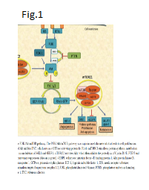
It is estimated that one in eight women will be diagnosed with breast cancer during their lifetime. Advances in therapies in the past few decades have led to improved survival rates, however, still more than 40,000 patients die from breast cancer annually in the USA. ¹⁵ Cancer is a group of diseases characterized by normal cells acquiring tumor promoting traits, such as uncontrolled cell growth, avoiding detection by the immune system, and overriding DNA damage checkpoints. Avoiding antitumor immunity response requires cancerous cells to deregulate gene expression in part through epigenetic mechanisms such as chromatin remodelling. ⁸ Chromatin remodeling is correlated with the control of gene expression by condensing DNA through changes in the position and occupancy of nucleosomes to regulate DNA access to transcriptional machinery proteins. There are specific protein complexes whose role it is to regulate chromatin structure, called nucleosome remodeling complexes.

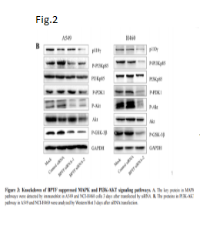
These nucleosome remodeling complexes are diverse class of enzymes grouped into four families, SWI/SNF, ISWI, CHD, and INO80 based on sequence homology of ATPase. Nucleosome remodeling complexes are largely controlled through interaction with specific ATPase subunits, making the majority of the nucleosome remodeling complexes ATP-dependent.⁸ These nucleosome remodeling complexes are triggered by very specific ATPase subunits makes these enzymes potential novel therapeutic targets. One particular nucleosome remodeling complex, Nucleosome Remodeling Factor (NURF), part of the ISWI family has been well documented as a key ATP-dependent regulator for the development of many model organisms. The NURF complex consists of three subunits BPTF, SNFL, and RBAP46/48. In this research approach the focus will be on the the largest main subunit Bromodomain PHD finger transcription factor (BPTF), which is located on chromosome 17 and is 158,855 bases long. ⁸ BPTF is the primary unit which is responsible for binding to chromatin and regulating transcription.

This subunit plays an important role in chromatin remodeling, but its functional role in tumor progression is incompletely understood. Dai et al (2015) examined the effects of BPTF on lung cancer proliferation and reported that BPTF regulates PI3K-AKT signaling pathway along with other cancerous pathways in lung cancer. ⁴ Phosphoinositide 3-kinase (PI3K) is a major signaling component downstream of growth factor receptor tyrosine kinases (RTKs). PI3K catalyzes the production of the lipid second messenger phosphatidylinositol-3,4,5-triphosphate (PIP3) at the cell membrane. PIP3 activates a wide range of downstream targets, including the serine-threonine protein kinase Akt (Fig.1). The PI3K-Akt signaling pathway regulates many normal cellular processes including cell proliferation, survival, growth, motility, and metabolism —processes that are critical for tumorigenesis.¹⁵ Dai et al (2015) tested the effects of BPTF on cancer proliferation by knocking down the gene, inserting the knockdown gene in lung cancer cell lines, and observed the expression of proteins related PI3K-AKT pathway.
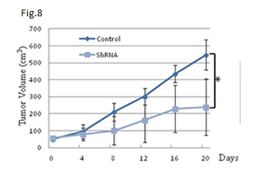
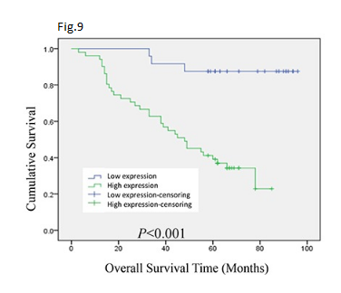
The gene’s were knocked down using short hairpin RNA (shRNA) which is an artificial RNA molecule that can be used to silence target gene expression via RNA interference (RNAi). RNAi interferes with the expression of specific genes with complementary nucleotide sequences by degrading mRNA after transcription, resulting in no transcription of the gene.The RNAi sequences used were: BPTF-siRNA-1 (BPTF-homo-1550): 5′-GGUCCAACUUGCAGAAUUATT-3′ and 5′-UAAUUC UGCAAGUUGGAC CTT-3′; BPTF-siRNA-2 (BPTF-homo-6959): 5′-GACCCA AACAACUGUUUCATT-3′ and 5′-UGAAACAGUUGUUUGGGUCTT-3′. ⁴ These sequences were transiently transfected into tissue culture plates using Lipofectamine® RNAiMAX Transfection Reagent, which contain lipid subunits that can form liposomes in an aqueous environment. These liposomes enclose the siRNA and are able to cross a cell membrane due to the neutral co-lipid mediating fusion of the liposome with the cell membrane. ² The results, western blot, shows a decreased expression in phospho-p85, p110γ, phospho-PDK1, phospho-Akt and phospho-GSK-3β proteins when the BPTF gene is knocked down (Fig.2). Dai et al (2015) suggests that the decrease in expression of these proteins is correlated to the decrease in tumor volume in lung cancer (Fig.8). A decrease in tumor volume should also correlate to increased survival of samples due to knock down of BPTF (Fig.9). In this research approach a slightly different method to knockdown the BPTF will be explored.
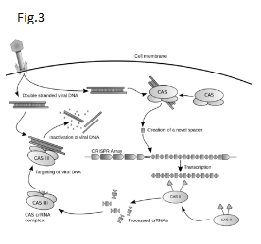
The CRISPR/Cas9 (Clustered regularly-interspaced short palindromic repeats) system is a state of the art genome editing tool that can efficiently knockout a specific gene, in this case, BPTF. The CRISPR/Cas9 system is a naturally occurring adaptive immune system in prokaryotic cells against invading bacteriophage DNA and other exogenous DNA. The CRISPR name refers to short palindromic repeats of DNA that are separated by the foreign DNA called “spacers”.² This system works by recording foreign DNA sequences, targeting the sequence, and degrading the invading sequence so that the gene cannot be expressed (Fig.3). Using a guide RNA and a protein called Cas9, researches have shown that the CRISPR/Cas9 system can hone in on and cleave a specific sequence of DNA. This system has created a platform for researchers to edit genomic data and create novel molecular therapies for families in need. How will the knockout and overexpression of the BPTF gene affect expression of proteins related to the PI3K-AKT signaling pathway in normal and breast cancer cell lines?

Experiment

The aim of this experiment is determine if BPTF knockout and overexpression affects cancerous molecular pathway PI3K-AKT in breast cancer cell lines. I hypothesize that the knockout of BPTF will decrease the expression of proteins related to the PI3K-AKT pathway in breast cancer cell lines and the overexpression will result in an increase in proteins expressed related to PI3K-AKT pathway.

gRNA design

To use the CRISPR/Cas9 system a design strategy for a guide RNA (gRNA) must be created to target the BPTF gene. When choosing a target sequence for the leading DNA oligo (short sequence of DNA) the range of length should be from 19 to 25 nucleotides in length. It is vital that this oligo is adjacent to an NGG proto-spacer adjacent motif (PAM) sequence on the 3’ end of the target sequence, PAM is essential for target gene recognition. ² The gRNA should not contain significant homology to other genes, as this can increase off-target effects to unintended genes. CHOPCHOP web tool was used to select the optimum target sites for CRISPR/Cas9 mutagenesis. The resulting sequence for targeting BPTF is “AGAGGAGGACATGGTCTCCGAGG”, located on chr17:65822200-65822222, and no predicted off targets for this guide sequence are reported.² Once design of the target DNA oligos are finished they must be annealed and ligated into a CRISPR/Cas9 nuclease vector.

Insert gRNA target sequence into CRISPR/Cas9 nuclease vector (Fig.4).
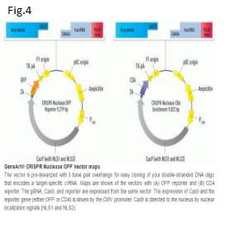
Plasmids are used to facilitate the cloning of the guide sequence in the CRISPR/Cas9 nuclease vector (Fig.4). E. coli plasmids are cleaved with restriction enzymes and the target DNA oligos are annealed together by first denaturing them by heating the strands and then slowly cool them. This process of nucleic acid thermodynamics joins the two DNA oligos together with high accuracy.² The resulting double stranded DNA oligo are then ligated into the E. coli plasmids using T4 DNA ligase which produces recombinant DNA. The recombinant plasmids are then transferred into E. coli using electroporation. Electroporation uses mild pulses of electricity to disrupt the cell wall of E. coli and create small pores, the plasmids are small enough to pass through.

Screening for successful recombinants

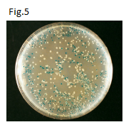
The colonies are then screened using amp^{R} (ampicillin resistance) and lacZ gene (β-galactosidase protein) in order to differentiate between colonies that have successfully taken in the recombinant plasmid (Fig.5). The recombinant E.coli are grown in an ampicillin media, only the cells with the amp^{R} gene will survive. Furthermore,the blue-white screening tests for interruption of the beta-galactosidase coding sequence by introduction of another piece of DNA (BPTF target sequence). Most inserts will disrupt beta-gal expression by shifting the reading frame and introducing stop codons and therefore remove the enzymatic activity required to cleave X-gal and produce the blue color.¹¹ Recombinants are white, whereas non-recombinants are blue (Fig.3). After the recombinants are located and isolated they can be packaged into a virus and transfect in cell lines.

Viral facilitated transfection of cell lines

After the correct sequence is chosen the Cas9/gRNA plasmid vector are packaged into adenovirus and are introduced to cell lines to infect the host cell line’s genome, the DNA is integrated into the the host genome by homologous recombination. This packaged viral transfection method is used to observe knockout and overexpression in cell lines. In order to observe overexpression of BPTF, promoter cytomegalovirus (CMV) is used to drive gene expression.¹⁷ Promoters have a specific DNA sequence that help recruit RNA polymerase and other transcription factors to facilitate transcription of a gene. After normal, knockout, and overexpression cell lines mature we can analyze the proteins that were expressed using Western blot (Immunoblotting).

Western blot (immunoblotting)

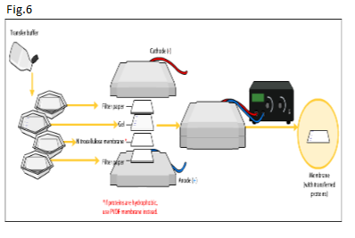
Immunoblotting procedure will analyze individual proteins expressed by the cell lines. The protein mixture obtained from cell lines are separated using sodium dodecyl sulfate polyacrylamide gel electrophoresis (SDS-PAGE) which sorts proteins by size.¹⁸ The proteins are loaded into the polyacrylamide gel and exposed to an extended period of electrical flow (Fig.6). The movement of proteins is facilitated by SDS buffer which denatures and binds to proteins to make them negatively charged, proteins then move through the gel toward the positively charged cathode. Smaller proteins travel more quickly through the gel than larger proteins because of the pore size of the gel, which can be manipulated.¹⁸ Following electrophoresis, the proteins are electrophoretically transferred again but this time from the gel to a nitrocellulose membrane, a matrix used in protein blotting due to its high protein-binding affinity.

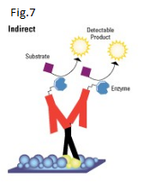
When an electric field is applied, the proteins move out of the polyacrylamide gel and onto the surface of the nitrocellulose membrane, where the proteins become tightly attached. After the proteins have been transferred to a secondary matrix antibodies that target specific proteins can be introduced to analyze the degree of expression of proteins by the various cell lines. BPTF Antibody-2F10 (Thermofisher, USA) and Phospho-AKT pathway antibodies can be purchased to detect there specific proteins, a key characteristic for antibodies. Most primary antibodies are unreadable, therefore indirect detection can be implemented where tagged secondary antibodies are introduced and bind with the primary antibodies to help visualize the expression of proteins (Fig.7). Visualization occurs when a tagged an enzyme on the secondary antibody, horseradish peroxidase (HRP), catalyzes a HRP detectable substrate and produces light as a by-product (Fig.7). The light signal can be captured on X-ray film.¹⁸ The result of this reaction are bands with various degrees of density of black lines, the denser the line the more proteins that are expressed (Fig.2). Proteins phospho-p85, p110γ, phospho-PDK1, phospho-Akt and phospho-GSK-3β will be targeted due to their strong connection with the PI3K-AKT pathway. This method will show the various degrees of protein expression in sample cell lines.

Discussion

As the largest unit of NURF, BPTF plays a role in chromatin remodelling which is a key factor in gene expression. In many cases normal cells transition into cancerous cells in large part due to abnormal gene expression. Over the past decades chromatin remodeling complexes have been shown to establish and maintain abnormal gene expression in cancerous cells.⁴ In addition, with so many cancerous genomes being sequenced it has been found that subunits of chromatin remodeling complexes are frequently mutated in in cancer, suggesting that these mutations can drive cancerous phenotypes. Dai et al (2015) suggests that the decrease in expression of PI3K-AKT related proteins is correlated to a decrease in tumor volume and increased survival samples, which is good indicator that targeting NURF could be a novel cancer therapy target.

Besides the cost of all the components of the study a limitation of this research would be that cell line and western blot methods are tedious processes so screening as outlined should be done to ensure expected results. Because only a subset of the cellular processes regulated by the PI3K-Akt pathway are involved in tumorigenesis, the choice of drug targets must take into account the adverse effects resulting from the inhibition of other PI3K-Akt-dependent cellular processes. For example, insulin's effects on metabolism are mediated through the PI3K-Akt pathway.³ It would be desirable, therefore, to target components of branches further downstream in the PI3K-Akt pathway, such as mTOR or Bad. An unexpected result would be to observe no change or increase of PI3K-AKT related protein expression in knockdown samples.
Chromatin remodeling complexes have shown great potential to become novel targets for cancer therapies. We must first fully understand the mechanisms that are affected by targeting these complexes such as PI3K-Akt pathway in order to benefit future populations.
References

Tessa G. Montague; Jose M. Cruz; James A. Gagnon; George M. Church; Eivind Valen. (2014). CHOPCHOP: a CRISPR/Cas9 and TALEN web tool for genome editing. Nucleic Acids Res. 42. W401-W407

- "GeneArt CRISPR Products and Services." Thermo Fisher Scientific. N.p., n.d. Web. 30 Apr. 2016.

- Luo, Ji, Brendan D. Manning, and Lewis C. Cantley. "Targeting the PI3K-Akt pathway in human cancer: rationale and promise." Cancer cell 4.4 (2003): 257-262.

- Dai, M., Lu, J. J., Guo, W., Yu, W., Wang, Q., Tang, R., ... & Sun, X. (2015). BPTF promotes tumor growth and predicts poor prognosis in lung adenocarcinomas. Oncotarget, 6(32), 33878-33892.

- Liu, B., Yip, R. K., & Zhou, Z. (2012). Chromatin Remodeling, DNA Damage Repair and Aging. Current Genomics, 13(7), 533–547. http://doi.org/10.2174/138920212803251373

- Raab, J. R., Resnick, S., & Magnuson, T. (2015). Genome-Wide Transcriptional Regulation Mediated by Biochemically Distinct SWI/SNF Complexes. PLoS Genet, 11(12), e1005748.

- -Kim, K. H., Kim, W., Howard, T. P., Vazquez, F., Tsherniak, A., Wu, J. N., ... & Orkin, S. H. (2015). SWI/SNF-mutant cancers depend on catalytic and non-catalytic activity of EZH2. Nature medicine, 21(12), 1491-1496.

- ATP-dependent chromatin remodeling complexes as novel targets for cancer therapy Mayes, Kimberly ; Qiu, Zhijun ; Alhazmi, Aiman ; Landry, Joseph W Advances in cancer research, 2014, Vol.121, pp.183-233

- The Nucleosome Remodeling Factor. Alkhatib, Suehyb G. ; Landry, Joseph W.
FEBS Letters, 2011, Vol.585(20), pp.3197-3207

- Examination of Epigenetic and other Molecular Factors Associated with mda-9/Syntenin Dysregulation in Cancer Through Integrated Analyses of Public Genomic Datasets Bacolod, Manny D ; Das, Swadesh K ; Sokhi, Upneet K ; Bradley, Steven ; Fenstermacher, David A ; Pellecchia, Maurizio ; Emdad, Luni ; Sarkar, Devanand ; Fisher, Paul B. Advances in cancer research, 2015, Vol.127, pp.49-121

- Automatic Detection of Blue-White Veil by Discrete Colour Matching in Dermoscopy Images In Medical Image Computing and Computer-Assisted Intervention – MICCAI 2013, Vol. 8151 (2013), pp. 453-460, doi:10.1007/978-3-642-40760-4_57 by Ali Madooei, MarkS Drew, Maryam Sadeghi, Atkins edited by Kensaku Mori, Ichiro Sakuma, Yoshinobu Sato, Christian Barillot, Nassir Navab

- Landry, J. W., Banerjee, S., Taylor, B., Aplan, P. D., Singer, A., & Wu, C. (2011). Chromatin remodeling complex NURF regulates thymocyte maturation. Genes & development, 25(3), 275-286.

- Wang, G. G., Allis, C. D., & Chi, P. (2007). Chromatin remodeling and cancer, Part I: Covalent histone modifications. Trends in molecular medicine, 13(9), 363-372

- Carré, Clément, et al. "The Drosophila NURF remodelling and the ATAC histone acetylase complexes functionally interact and are required for global chromosome organization." EMBO reports 9.2 (2008): 187-192.

- Li, Haitao, et al. "Molecular basis for site-specific read-out of histone H3K4me3 by the BPTF PHD finger of NURF." Nature 442.7098 (2006): 91-95.

- Paplomata, Elisavet, and Ruth O’Regan. “The PI3K/AKT/mTOR Pathway in Breast Cancer: Targets, Trials and Biomarkers.” Therapeutic Advances in Medical Oncology 6.4 (2014): 154–166. PMC. Web. 6 May 2016.

- Hurteau, G. J., Carlson, J. A., Spivack, S. D., & Brock, G. J. (2007). Overexpression of the microRNA hsa-miR-200c leads to reduced expression of transcription factor 8 and increased expression of E-cadherin. Cancer research, 67(17), 7972-7976.

- Gallo, D., Diggs, J. L., Shell, G. R., Dailey, P. J., Hoffman, M. N., & Riggs, J. L. (1986). Comparison of detection of antibody to the acquired immune deficiency syndrome virus by enzyme immunoassay, immunofluorescence, and Western blot methods. Journal of clinical microbiology, 23(6), 1049-1051.

