Epigenetic Effects of the Krüppel-Like Transcription Factor 1 on DNA Methylation
Introduction
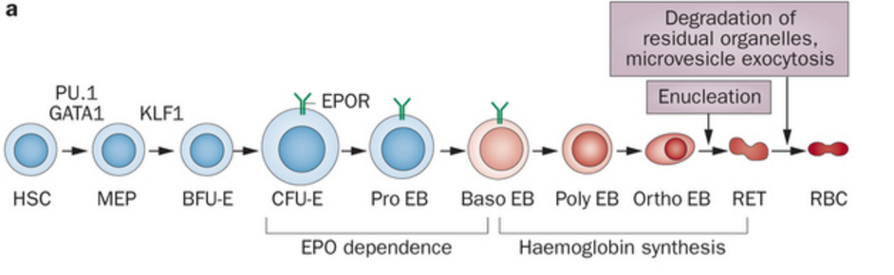
Red blood cells are the most common cell type in the human body, and play a crucial role in embryonic development. So the proper development of these cells is of interest in scientific research. Krüppel-like Transcription Factor 1 (KLF1) is a Zinc fingered transcription factor necessary for the maturation of erythroid cells (red blood cells) (fig. 1). KLF1’s role in erythroid maturation makes the protein important for proper embryonic development. Epigenetics is the study of chemical changes to the genome, there are two sides to epigenetics DNA methylation or histone modifications. These changes can affect the way genes are read, they can even shut off genes completely. The epigenome is a record of these changes that are heritable (Bernstein et al, 2007). This proposal will investigate how KLF1 is able to change the epigenome in embryonic development by comparing the difference between cells with KLF1 protein shut off, using gene knock out, and normal cells during embryonic development, and examining the changes epigenetic changes in DNA methylation. Recently an article has published showing the importance of KLF1 in histone modification (Alhashem). They proved that when KLF1 is knocked out, the Histones are less acetylated. This research proposal will study KLF1’s role in the second half of epigenetics, DNA methylation.
Fig.1 KLF1 is a transcription factor necessary for RBC development. Here are the steps of RBC maturation starting with the stem cells and ending with the mature RBCs, notice KLF1 role in the maturation of the MEP cell into the BFU-E cell. (Koury et al 2015)

DNA methylation is the process of the addition of methyl groups to the five carbon group of the cytosine in a CpG region of DNA. The CpG (5'—C—phosphate—G—3') is the site where DNA methylation typically occurs. These methyl groups can affect the transcription of genes. The role of KLF1’s in DNA methylation is important because the full extent of how KLF1 affects the genome is still unknown. KLF1 originally was thought to only affect the B-globin gene, however it has recently been discovered to affect expression of the human embryonic ϵ- and fetal γ-globin genes. This experiment will examine the effects of DNA methylation to find if there are any additional genes whose expression is affected by KLF1, if the methylation is different on a certain gene, this gene’s expression could be associate with KLF1. The exact association of the genes found (if any) could then be examined in a future experiment.
The complete understanding of KLF1’s full role in epigenetics can provide valuable information due to the importance of KLF1 in embryonic development. While one half of KLF1’s epigenetic role is known, the other half still needs to be studied. This research proposal will attempt to find direct epigenetic modifications of the genome caused by KLF1 through the use of embryonic mice. The goal is to find direct epigenetic modifications in the DNA caused by KLF1. Knowledge of the epigenetics effects of KLF1 will improve our understanding of the maturation of erythroid cells, which will be useful in understanding the embryonic development of RBCs.

Experiment
This experiment will be performed on embryonic mice. There will be two groups of mice, one with the KLF1 gene functioning normally, and another with the KLF1 gene knocked out (KO). The mice liver cells will be extracted at the 15th day mark of development (in previous experiments where the KLF1 gene has been shut off the mice end up dying due to severe β-thalassemia (Perkins), at day 15 they should still be alive (Tallack)). The liver cells are chosen because due to their association with blood development, they are also associated with KLF1. The difference in the DNA methylation between the KLF1 normal control mice and KLF1 KO mice will hopefully help us gain insight into the epigenetic effects of KLF1.

Gene Knock Out
The first step of this procedure is to obtain mice with knock out the KLF1 gene. Previous studies have knocked out genes in the KLF1 already, one used a lacZ gene from E. coli to knock out the genes that code KLF1 (Nuez). Since the procedure has already been performed, there is no need to create our own KO mice, heterozygotes mice for the KO gene already exist. These mice will be used in the experiment. The mice can be purchased from Jackson research labs (https://www.jax.org/strain/002474).
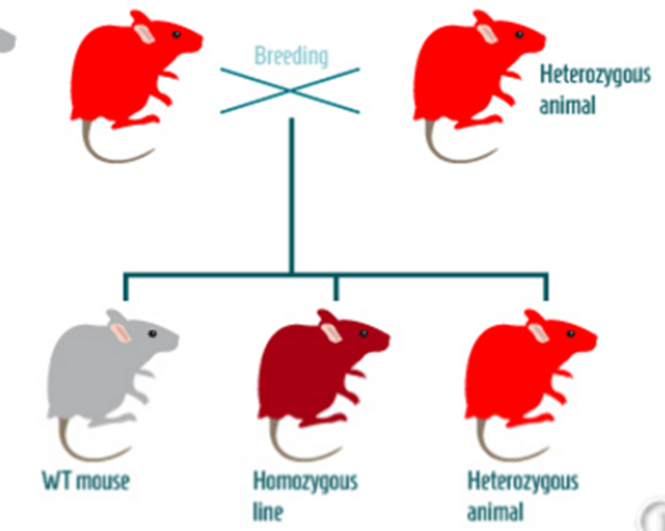
The heterozygotes mice then need to be breed to obtain the homozygous mice. These mice will be grown until day 15, where their liver cells will be extracted. These liver cells will be used in to the next stage of the experiment, anti-body tagging to methylated DNA by MeDIP-chip.
Fig. 2. Mice heterozygous with the KLF1 knock out can be breed to produce homozygous with the knock out, these mice do not produce the KLF1 gene.
(from http://paperv.com/story/2415/gene-targeted-mouse-model-tool-creator-creative-animodel/

MeDIP-chip

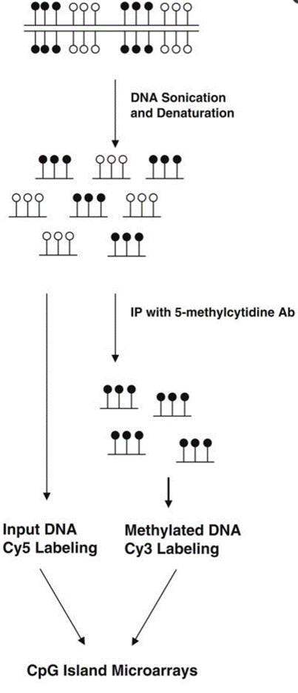
To isolate the methylated DNA from the two samples (KO mice and controll mice), the methylated DNA immunoprecipitation microarray (MeDIP-chip) technique (fig. 2) will be used. There are different versions of the ChIP techniques, this experiment will take deploy the MeDIP-chip version due to its ability to analyze an entire genome and due to its specialization in DNA methylation. MeDIP-chip works by first randomly shearing the DNA (cutting into small fragments) in the nucleus with by exposing the target cells (liver cells in this experiment) to sonication (soundwaves). The DNA fragment are then denatured (separating the strands by heat). Then anti-bodies that specified for the directed against 5-methylcytidine (binds to the methyl group) are added to the lysed cell (Weng). Before the antibody addition a small sample will be collected to provide the input DNA (which will be used as a control in the microarray procedure). Once the anti-bodies are added the cell material is precipitated, the target proteins are heavier due to the antibodies, allowing them to be isolated and collected. It is isolated though centrifugation, the supernatant is discarded and then the sample is washed by proteinase K, which digests proteins and removes contaminations to purify the samples. (Weinmann). The Non-methylated DNA and methylated DNA will then be labeled with Cy5 (red) and Cy3 (green) cyanine fluorescent dyes and then will chemically linked as a dual-color experiment on DNA microarrays. Cy5 and Cy3 are chemically linked to the DNA by their nitrogen side chains. The dyes link to any DNA indiscriminately, since the methylated and non-methylated DNA is already separated each sample gets its own dye. These procedures will be performed twice, once on the control mice and once on KLF KO mice.
Fig. 3 In the MeDIP-chip procedure the methylated DNA is separated by antibody tagging and centrifugation. The separated and input DNA is then labeled with fluorescent dyes. (Weng et al, 2009)

CpG Island Microarray
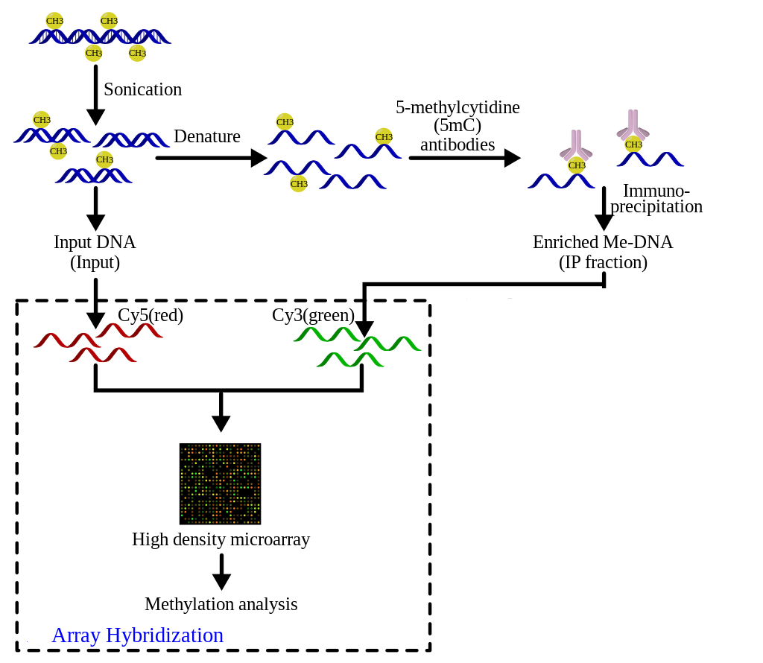
DNA microarrays will then be used to examine the newly tagged DNA samples (fig. 3). To compare the differences in DNA methylation and find what genes are altered. Specifically, a Probe CpG microarray (fig. 4). The CpG (Shorthand for 5'—C—phosphate—G—3') is the site where DNA methylation typically occurs. This technique is performed by taking a pair of DNA samples from immunoprecipitation samples which uses the green Cy3 dye, and input DNA with the red Cy5 dye. The microarray itself is a small silicon slide containing thousands of spots, called wells, that house the DNA samples (Lee). Then the two Cy-labeled DNA samples will be mixed and hybridized to a single microarray. Hybridization works by heating up the DNA causing it to denature (separate into single strands), the wells in the slides contain complementary DNA strands to the CpG regions of the genome, after the DNA is denature, it will be cooled down allowing it to bind to its complementary strand (probe) within the well. CpG island microarray slide contain 195,000 probes covering a total of 27,800 human CpG islands as its complementary strands. The slide will then will be scanned by the microarray scanner which will visualize the fluorescence of the Cy-labeled samples. This is preformed after samples have been subjected to laser excitation. The methylated DNA will glow green, and the input DNA will glow red, because the red Cy5 was added to the input DNA and green Cy3 was added to the methylated DNA. The ratio of each sample can then be measured by ratio-based analysis to find the difference in the DNA methylation (Weinmann). Any gene with a different methylation between the two groups can be identified with the Microarray analysis as the probes within the well have known promoter regions.
Figure 4. An example of the CpG Island Microarray procedure. Fluorescently labeled tags added to the target and control DNA which is then mixed. The mix is then hybridized onto microarray’s, scanned and analyzed. (From https://commons.wikimedia.org/wiki/File:MeDIP.svg#globalusage)

Overall Procedure
These two techniques, MeDIP-ChIP and CpG Island Microarray combined should provide sufficient data to measure the difference in methylation between control mice and KLF1 knock out mice’s DNA. The DNA genes of the KO mice with alterations in its methylation regions not found in the control mice will then be identified using the probe sequences in the CpG Island Microarray.

Discussion
DNA methylation is the process of the addition of methyl groups to 5 carbon group of the cytosine in a CpG region of DNA. These methyl groups can affect the transcription of genes. KLF1, as a transcription factor also affects the transcription of genes. Therefore, there is a good chance that KLF1 has some effect on DNA methylation. Analyzing the difference in methylation can find how out by how much KLF1 affects methylation and which specific genes are affected. KLF1 could only affect the methylation of DNA from genes already proven to have an association with the protein (such as β-goblin genes, y-globin genes or BCL11A) however, a genome wide analysis will also allow the discovery of other genes associated with KLF1, if the methylation differs in a certain gene with KLF1 knocked out, it potentially could be another gene associated with the protein.
This experiment will hopefully further our understanding of KLF1’s role in epigenetics. The information gained from this experiment can help expand our understanding of the development of red blood cells in the embryo. The impact that KLF1 has on the methylation of DNA could further demonstrate the importance of this transcription factor to the globin genes it transcribes, possibly find new genes associated with it, and the see its effect on the epigenome overall. Knowledge of the epigenetics effects of KLF1 will improve our understanding of the maturation of erythroid cells, which will be useful in understanding the embryonic development of RBCs.

Bibliography

Han, Y., & Garcia, B. A. (2013). Combining genomic and proteomic approaches for epigenetics research. Epigenomics, 5(4), 439–452. http://doi.org/10.2217/epi.13.37https://www.ncbi.nlm.nih.gov/pmc/articles/PMC4055025/
Tallack, M. R., Magor, G. W., Dartigues, B., Sun, L., Huang, S., Fittock, J. M., … Perkins, A. C. (2012). Novel roles for KLF1 in erythropoiesis revealed by mRNA-seq. Genome Research, 22(12), 2385–2398. http://doi.org/10.1101/gr.135707.111
Nuez, Beatriz, Dave Michalovich, Anne Bygrave, Rob Ploemacher, and Frank Grosveld. "Defective Haematopoiesis in Fetal Liver Resulting from Inactivation of the EKLF Gene." Nature 375.6529 (1995): 316-18. http://www.ncbi.nlm.nih.gov/pubmed/7753194/
Alhashem, Y. N., D. S. Vinjamur, M. Basu, U. Klingmuller, K. M. L. Gaensler, and J. A. Lloyd. "Transcription Factors KLF1 and KLF2 Positively Regulate Embryonic and Fetal -Globin Genes through Direct Promoter Binding." Journal of Biological Chemistry 286.28 (2011): 24819-4827. http://www.jbc.org/content/286/28/24819.long
Weng, Y.-I., Huang, T. H.-M., & Yan, P. S. (2009). Methylated DNA Immunoprecipitation and Microarray-Based Analysis: Detection of DNA Methylation in Breast Cancer Cell Lines. Methods in Molecular Biology (Clifton, N.J.), 590, 165–176. http://doi.org/10.1007/978-1-60327-378-7_10
Weinmann, A. S. "Isolating Human Transcription Factor Targets by Coupling Chromatin Immunoprecipitation and CpG Island Microarray Analysis." Genes & Development 16.2 (2002): 235-44. Web. http://www.ncbi.nlm.nih.gov/pubmed/11799066?dopt=Abstract
Andrew Perkins, Xiangmin Xu, Douglas R. Higgs, George P.Patrinos, Lionel Arnaud, James J. Bieker, Sjaak Philipsen. "Krüppeling" erythropoiesis: an unexpected broad spectrum of human red blood cell disorders due to KLF1 variants unveiled by genomic sequencing. Blood Jan 2016, DOI: 10.1182/blood-2016-01-694331 http://www.bloodjournal.org/content/early/2016/02/22/blood-2016-01-694331.long?sso-checked=true
Lee, T. I., Johnstone, S. E., & Young, R. A. (2006). Chromatin immunoprecipitation and microarray-based analysis of protein location. Nature Protocols, 1(2), 729–748. http://doi.org/10.1038/nprot.2006.98
Bernstein, Bradley E., Alexander Meissner, and Eric S. Lander. "The Mammalian Epigenome." Cell 128.4 (2007): 669-81. https://www.ncbi.nlm.nih.gov/pubmed/17320505
Koury, Mark J., and Volker H. Haase. "Anaemia in Kidney Disease: Harnessing Hypoxia Responses for Therapy." Nat Rev Nephrol Nature Reviews Nephrology 11.7 (2015): 394-410. http://www.nature.com/nrneph/journal/v11/n7/full/nrneph.2015.82.html

