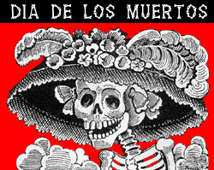

Día de los muertos translates to the Day of the Dead. That may sound scary to us but the holiday is actually a very important one to many people. Let’s investigate the meaning of the Day of the Dead and find out about some of the traditions and culture around this very special day!

(You may have to actually read into the article or link that is associated with each question. Not all the answers will be in the very first paragraph.)

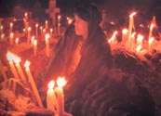

1. When and where is Día de los Muertos celebrated?

_____________________________________________________

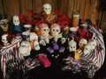

2. What are the origins of the original holiday? What happened during that celebration?

_____________________________________________________

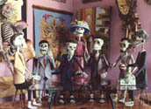

3. What official Catholic holiday corresponds with Day of the Dead?

_____________________________________________________

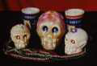

4. According to century’s old beliefs, what happens on the Day of the Dead?

___________________________________________________

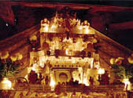

5. What is the purpose of the altars? What are some of the things that these altars might include?

_____________________________________________________

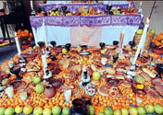

6. What are some of the foods that a traditional Day of the Dead celebration might include?

____________________________________________________

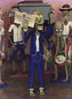

7. Describe what the calacus, or handmade skeleton figurines, look like. Do they seem sad? Active? Joyful? Silly? Macabre? Why?

____________________________________________________

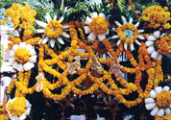

8. What other decorations are used to make this day special?

_____________________________________________________

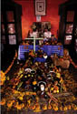

9. What does this article offer as an explanation of why the Day of the Dead is becoming more popular and respected in the United States?

__hhfdhfhhdhfkhsfkhdkds___________________________________________________

Vocabulario : essential vocabulary for understanding the Day of the Dead.

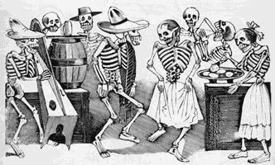

Appropriate SOL

Cultural Perspectives, Practices, and Products

SIII.6 The student will discuss the interrelationship among the perspectives, practices, and products of Spanish-speaking cultures.
1. Examine how and why products such as natural and manufactured items, the arts, recreation and pastimes, language and symbols reflect practices and perspectives in Spanish-speaking cultures.
2. Discuss how the viewpoints of Spanish-speaking people are reflected in their practices and products, such as political systems, art and architecture, music, and literature.
3. Investigate the role of geography in the history and development of Spanish-speaking cultures.

