NAME: Solutions_

EGRE 426
Quiz 1
Open book / Open notes
October 13, 2009

- 15 points: Consider the expression 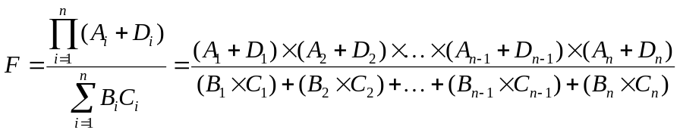
Assume all data is available as needed, and each type of operation requires one unit of time. Obtain general expression in terms of n for the fastest time to compute F using:
a) A SISD computer.
ANS: T = T_{MUL BxC’s} + T_{ADD A+D’s} + T_{MUL Top} + T_{ADD Bottom}+ T_{DIV}
= n + n + (n-1) + (n-1) + 1 = 4n - 1

b) A MIMD computer with unlimited processors.
ANS: 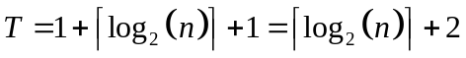 Note: During the first clock cycle we can complete all A+D’s and BXC’s. At the second unit of time we can start both 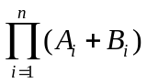and 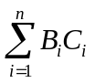this will take 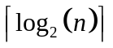 additional units of time to complete. The division will be done last, and take one unit of time.
c) A SIMD computer with unlimited processors.
ANS: All A+D’s can be computed in the first unit of time. Then multiply the top terms. This will take 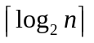. During this time the BXD’s can also be computed without requiring additional time. Then sum the bottom term. This will take . Finally do the division requiring one additional unit of time.

- 15 points: Assume we are multiplying two unsigned 32-bit integers together.
  - What is the maximum number of bits required to represent the product?
64
  - How many partial products must be summed to obtain the product?
32
  - If the partial products are to be summed, in the fastest possible way, using only carry look ahead adders (CLA’s), how many levels of CLA’s must be used? (This is same as asking what is the maximum delay when each CLA has a delay of one.)
Ans: 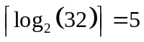
  - In c) how many CLA’s must be used in the first level?
32/2 = 16
  - Suppose the partial products are summed using several levels of carry save adders (CSA’s) with a single carry look ahead adder (CLA) in the last level. This is done in the fastest possible way. How many CSA’s must be used at the first level?
Ans: 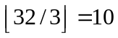
  - How many CSA’s must be used at the second level?
Level 1 generates 2*10 = 20 outputs. There were two inputs to level 1 that were not processed. Therefore, the total number of inputs to level 2 is 22. The number of 3 input CSA required is 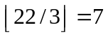
- 10 points: Consider the mips program fragment shown below.
start: add $4, $0, $0
add $9, $0, $0
loop: lb $1, 0($4)
addu $9, $9, $1
addiu $4, $4, 1
bne $4, $0, loop
done: nop
- How many times does the “lb” instruction at location loop: execute?
Answer: 2³²
- Concisely describe what the program does.
Answer: Sums all bytes in memory and puts result (truncated to 32 bits) in $9.

- 10 points: Write a single mips instruction for each of the following:
a). Take the two’s compliment of the value in register $4. (You do not need to be concerned with overflow).
subu $4,$0, $4
b). Take the one’s compliment of the value in register $4.
nor $4,$4,0
c). Decrement the value in register $4. (You do not need to be concerned with overflow).
addi $4,$4,-1

- 10 points: A certain computer with a clock rate of 500 MHz has three classes of instructions. The clocks per instruction (CPI) for the three classes are shown below.
Instruction Class | CPI for the class
A | 1
B | 2
C | 4
  - What is the time to execute the fastest instruction? 2 nsec
  - What is the time to execute the slowest instruction? 2x4 = 8 nsec
  - What is the peak or best-case MIPS for this machine? 500 MIPS
For a certain program, the number of instructions executed is divided equally between each of the three classes. If the program executes in 100 seconds, how many instructions are executed? 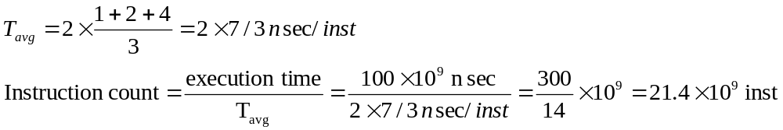
- 10 points: Circle the operations below that are required in order to compute PC ← PC – 4 in a single clock cycle.

SA := A | ALU := SA + SB
SA := PC | ALU := SA - SB
SB := B | ALU := SA & SB
SB := 4 | ALU := SA | SB
SB := ±n | ALU := 0
SB := ±ofst||00 | ALU := 1
 | ALU := SA
 | ALU := SB

PC ← PC | IR ← IR | R_{S} ← R_{S}
PC ← 0 | IR ← M(PC) | R_{T} ← R_{T}
PC ← PC + 4 |  | R_{D} ← R_{D}
PC ← ALU | ALUout ← ALUout | R_{T} ← MDR
PC ← ALUout | ALUout ← ALU | R_{D} ← MDR
PC ← PC(31..28)||addr||00 |  | R_{T} ← ALUout
MDR ← MDR | M(ALUout) ← B | R_{D} ← ALUout
MDR ← M(ALUout) |  | if no conflicts
MDR ← ALU | A ← A | B ← B
MDR ← ALUout | A ← R_{S} | B ← R_{T}
MDR ← M(PC) | A ← MDR | $31 ← MDR
 |  | $31 ← ALUout

- 10 points: The attached state diagram shows how to implement the “where am I” instruction. defined by:
wai rt # rt ← PC.

Show on the table below the control values for each state (refer to Figure 5.33 and Figure 1 handout for the names of the control signals). Use an “x” to indicate a don’t care, and “+”, “-“ etc. for the ALU operation. Use 0, 1, 2, etc. to indicate a mux input that must be selected.
State | Control
 | ALUcontrol | IorD mux | SrcA mux | SrcB mux | RegDstmux | MtoRegmux | PC srcmux
S0  Fetch | + | 0 | 0 | 1 | x | x | 0
S1  Decode | + | x | 0 | 3 | x | x | x
S10 | - | x | 0 | 1 | x | x | x
S11 | x | x | x | x | 0 | 0 | x

In the above table:
ALU control specifies the ALU operation.
IorD mux is the mux that connects to the Memory Address lines.
SrcA mux is the mux that connects to the SA input of the ALU.
SrcB mux is the mux that connects to the SB input of the ALU.
RegDstmux is the mux that connects to the Write Register input of the GPR.
MtoRegmux is the mux that connects to the Write data input of the GPR.
Pcsrcmux is the mux that connects to the input of the PC.
State diagram showing how to implement the wai, “where am I”, instruction. The wai instruction puts the instructions locations of the wai instruction (the value of the PC used to fetch the instruction) into the Rt register.
Using our register transfer notation the wai instruction is defined by: wai rt # rt ← PC

ALUout ←PC-4
Rt ←ALUout
wai

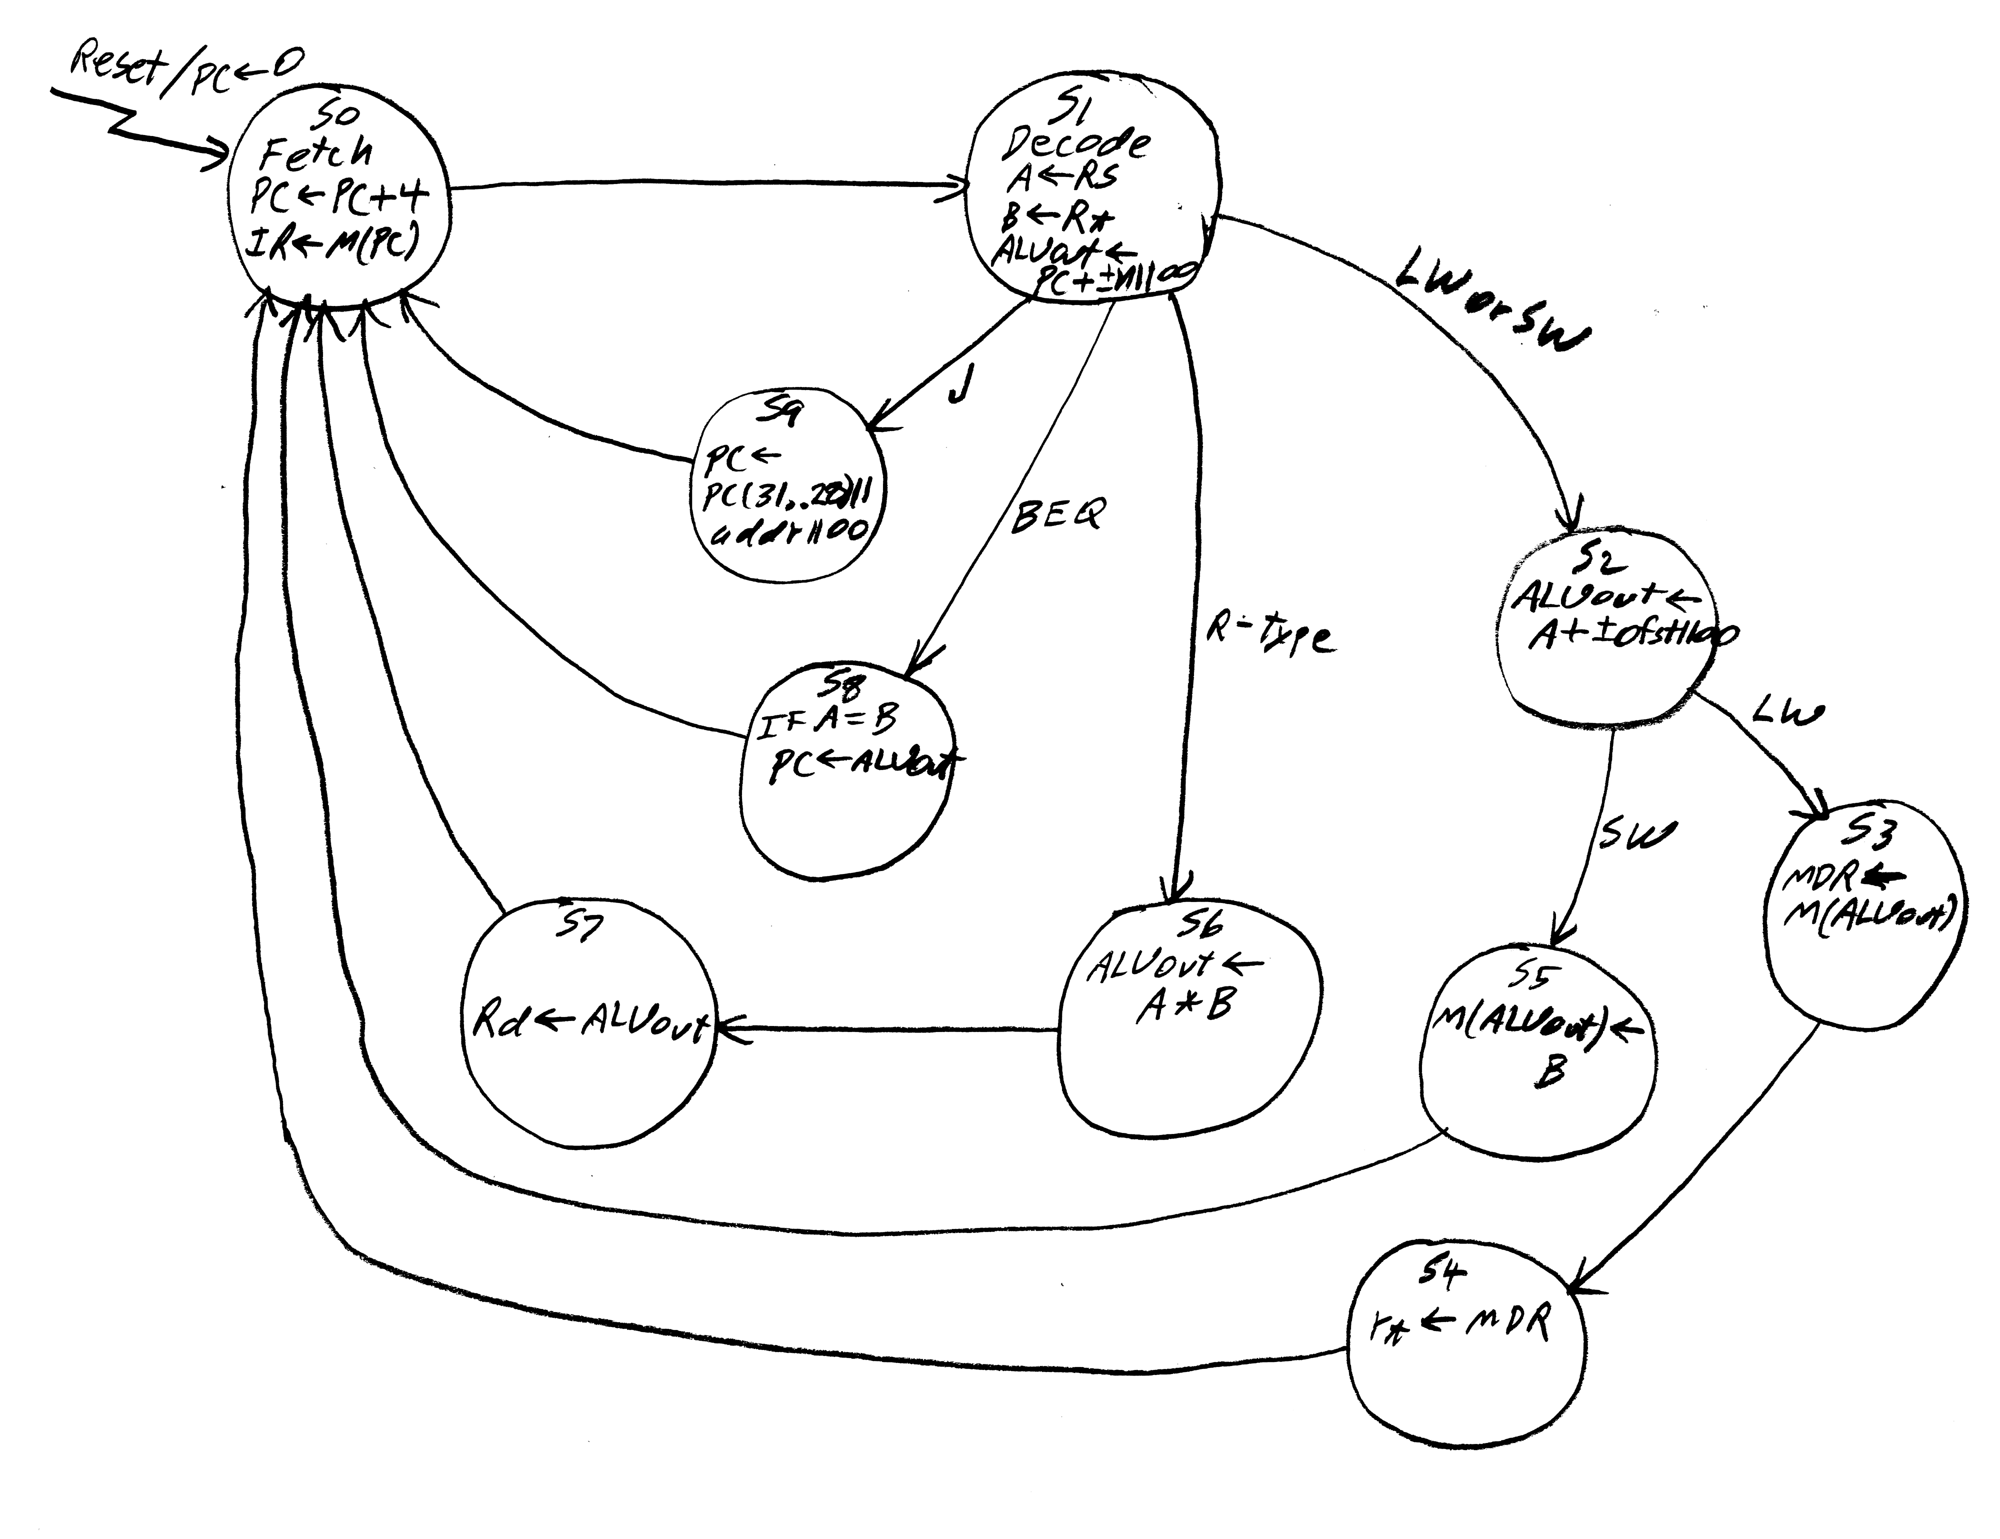

- 10 points: Consider the micro operation PC ← PC(31..28)||addr||00. On the figure below, circle the MUX that is used in this operation.



