HW 02
Due 9/8/09

- Consider case when n = 16. Show how to compute in the least time 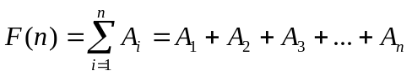using a four-segment pipeline.

Seg
Time | Input | S1 | S2 | S3 | S4 | Output
0 | A1,A2 | A1+A2
1 | A3,A4 | A3+A4 | A1+A2
2 | A5,A6 | A5+A6 | A3+A4 | A1+A2
3 | A7,A8 | A7+A8 | A5+A6 | A3+A4 | A1+A2
4 | A9,A10 | A9+A10 | A7+A8 | A5+A6 | A3+A4 | A1+A2 = P1
5 | A11,A12 | A11+A12 | A9+A10 | A7+A8 | A5+A6 | A3+A4 = P2
6 | A13,A14 | A13+A14 | A11+A12 | A9+A10 | A7+A8 | A5+A6 = P3
7 | A15,A16 | A15+A16 | A13+A14 | A11+A12 | A9+A10 | A7+A8 = P4
8 | P1,P2 | P1+P2 | A15+A16 | A13+A14 | A11+A12 | A9+A10 = P5
9 | P3,P4 | P3+P4 | P1+P2 | A15+A16 | A13+A14 | A11+A12 = P6
10 | P5,P6 | P5+P6 | P3+P4 | P1+P2 | A15+A16 | A13+A14 = P7
11 | P7,P8 | P7+P8 | P5+P6 | P3+P4 | P1+P2 | A15+A16 = P8
12 |  |  | P7+P8 | P5+P6 | P3+P4 | P1+P2 = Q1
13 | Q1,Q2 | Q1+Q2 |  | P7+P8 | P5+P6 | P3+P4 = Q2
14 |  |  | Q1+Q2 |  | P7+P8 | P5+P6 = Q3
15 | Q3,Q4 | Q3+Q4 |  | Q1+Q2 |  | P7+P8 = Q4
16 |  |  | Q3+Q4 |  | Q1+Q2
17 |  |  |  | Q3+Q4 |  | Q1+Q2 = R1
18 |  |  |  |  | Q3+Q4
19 | R1,R2 | R1+R2 |  |  |  | Q3+Q4 = R2
20 |  |  | R1+R2
21 |  |  |  | R1+R2
22 |  |  |  |  | R1+R2
23 |  |  |  |  |  | F = R1+R2
24
25
26
27
T(16) = 23

For the next two problems, show your work and answer each problem for N = 5 and N = 8.
- Using a four segment pipeline with the restriction that the pipeline must empty before a new type of operation begins, show how to compute 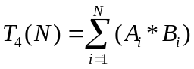 in the fastest possible time.
- Repeat 2 without the restriction that all segments must do the same operation.

Solutions to #2:
T₄(5) = 20
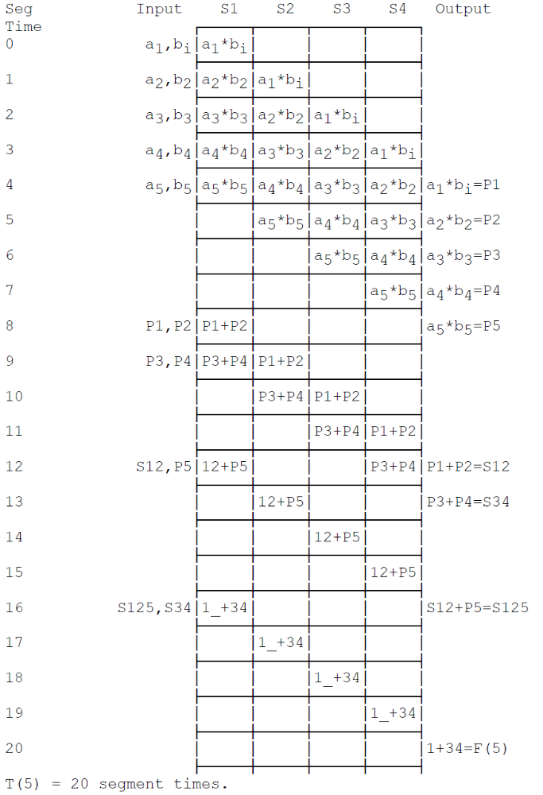
T₄(8) = 26
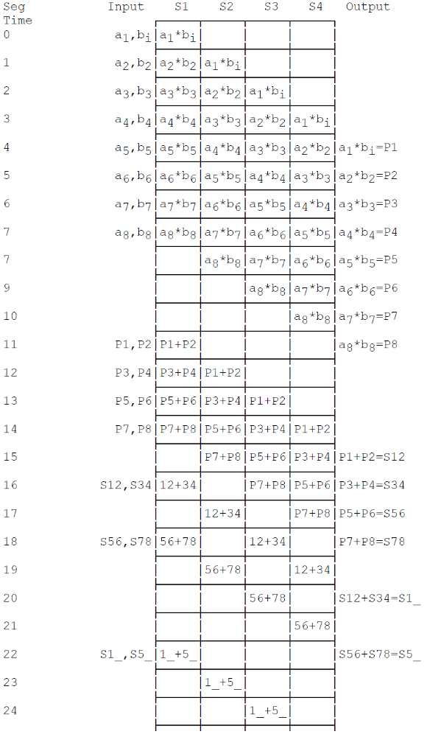
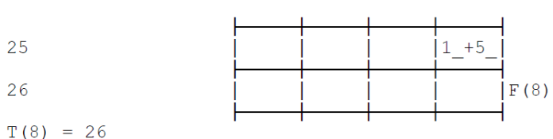
Repeating the above for various values of n, I obtained,
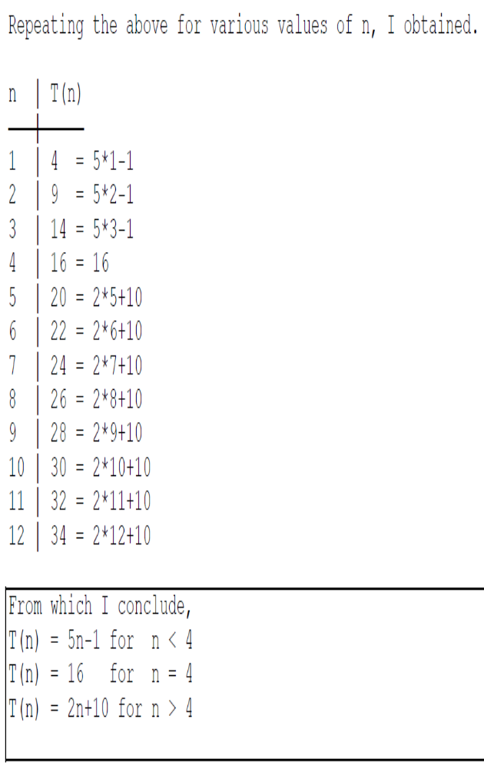

Solutions to #3:
T₄(5) = 17 segment times
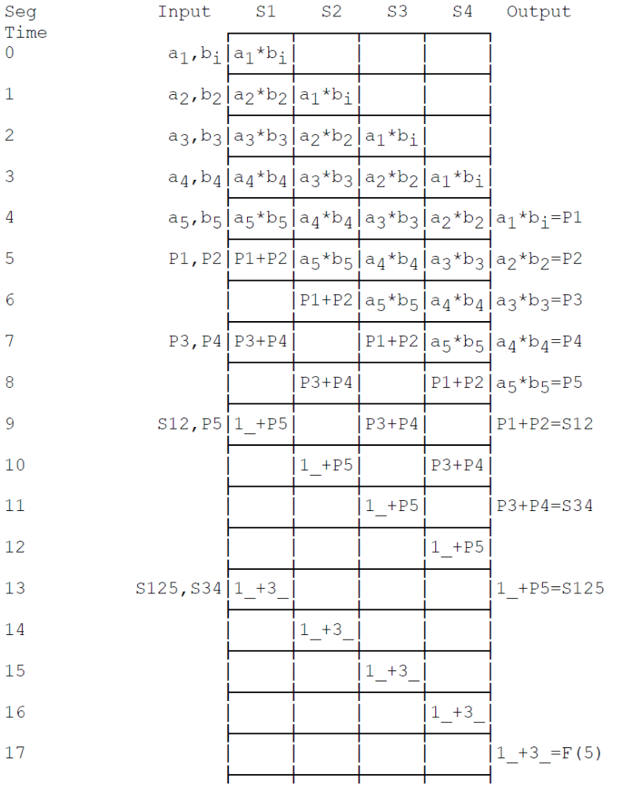
T₄(8) = 23 segment times.
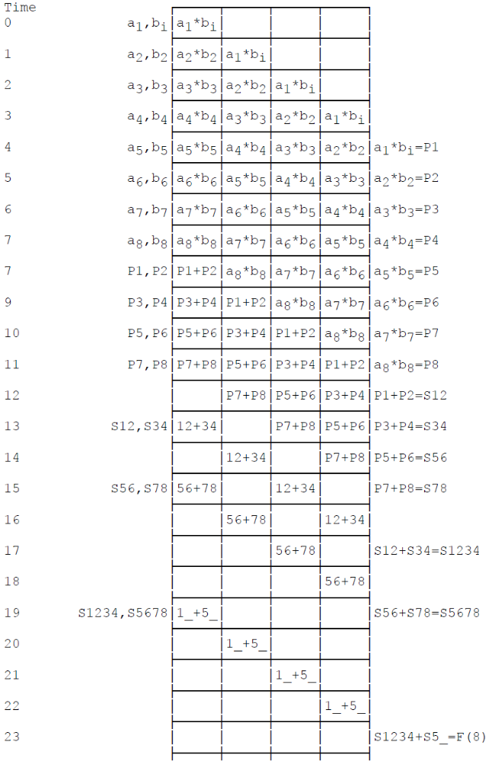

The general solution for 2 is the upper bounds for 3, since 2 will never be faster than 3. The best problem 3 times I obtained for various values of n are:

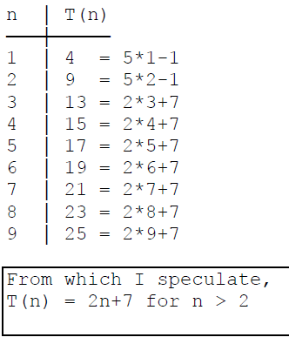

For problems 4 through 6 write a single Mips instructions to perform the following operations.

- Set all bits of $a0 to ‘0’.
Solutions include:
addi $a0, $0, 0
add $a0,$0,$0
and $a0,$0,$0
addi $a0,$0,0
etc.

- Set all bits of $a0 “1'.
Solutions include:
addi $a0,$0,-1
nor $a0,$0,$0

- Set the most significant bit of $a0 to ‘1’ and set all other bits of $a0 to ‘0’;
Solutions include:
lui $a0, 0x8000

- Set the least significant bit of $a0 to ‘1’ and set all other bits of $a0 to ‘0’.
Solutions include:
slti $a0,$0,1
addi $a0,$0,1
ori $a0,$0,1

- Fill in below the two instructions required to complete the MIPS program to compute the sum 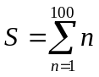.

main:
and $s0,$0,$0 #Set sum to 0
addi $t0,$0,100 #Put count in $t0
loop: add $s0,$s0,$t0 #Increase sum by count
addi $t0,$t0,-1 #Decrement count
bne $t0,$0,loop #Loop till count = 0.
DONE: jr $32 #Return with sum in $s0

Enter pipeline at beginning of T=0.

