Protein Splicing in Bacteriophage Clusters
Introduction:
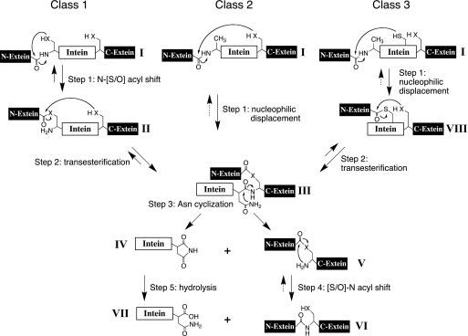
Protein splicing is a post translational process that results in the removal of inteins from a protein strand followed by the litigation of extiens. During this process, the inteins self-catalytically remove themselves from the protein¹, so there are no enzymes needed for this process to occur.⁶ It has been seen in many studies that protein splicing is the most efficient way for organisms to adopt to new conditions.² Protein splicing is also crucial to maintaining the function of the cell. The actual mechanism of protein splicing takes four steps.² In the first step, a nucleophile attacks the peptide bond linking the N-extein and intein forming an ester. The next step is a transesterfication in which the N-extein is shifted to the C-extein. The intein is then cleaved in the next step. The final step involves the ester bond between the extiens becoming peptide bonds in order to join them together.⁴ There are four different types of inteins including alanine inteins, mini-inteins, maxi-inteins, and trans-splicing inteins.³Intein sizes vary in length from about 134 amino acids reaching up to 650 amino acids.⁶ Protein splicing has been synthesized in a lab setting using such processes as phosphorylation, lipidation, acetylation, glycosylation, and ubiqitination.⁷ There are 550 genes registered in intein database due to characterized sequence motif, but only a few dozen actually been tested.⁴ One of these inteins is from the mycobacteria phage, Bethlehem. Bethlehem is considered to be part of Class 3 inteins since they contain N-terminal splice junctions but do not begin with The, Cys, or Ser, instead, they begin with a non-nucleophilic N-terminus.(Figure 1)⁵ Phages are split into cluster based upon similarities in genome sequences and thus protein functions. The purpose of this experiment is to see if this is the case in splice junctions and inteins in phages that are in the same pham and possibly cluster as Bethlehem.
Figure 1:
The three intein classes differ in mechanisms. Class 1 contain N-terminal Ser or Cys allowing an acyl shift initiating the splicing reaction. Class 2 contains a Cys⁺¹ located near the C-terminal that attacks the amide bond at the N-terminal splice junction. Class 3 mechanisms occur when a cis from the intein attacks the N-terminus junction.
Experiment:
The aim of this experiment is to look at protein splicing inteins in cluster A bacteriophages and phams that contain Bethlehem to determine if it is similar among all other phages in the pham/cluster. A previous study ran an experiment on an A1 cluster phage, Bethlehem, was ran to examine the lack of N-terminal inteins that make up the third class and begin with Pro. In this experiment, I want to see if other mycobacterial phages within the same pham and cluster as Bethlehem have the same mechanism for protein splicing, if one at all. In order to determine that, an experiment similar to the one run for Bethlehem will be implemented to determine if the same motifs can be used.
PCR is used in order to amplify DNA that encodes for the desired intein which is separated from the phage’s DNA using the primers
5′-ATGTTTCTCGAGGTCTCCCAGGACCAGCCT-3′ and 5′AATGAAACTAGTGAACGTGTTCTTCGTGTT-3′. Mutations are then introduced to the DNA in order to examine the class three mechanism and its working. The DNA is then overexpressed in E. coli and then separated off into a buffer solution. The proteins then get denatured and ran through gel electrophoresis and analyzed to look at the bands of the proteins to determine if they are similar or different from the results of Bethlehem.
Discussion:
If the experiment turns out as predicted by phams, the resulting gels should be similar in bands within the phams and possibly the cluster. Of course, there may not be any splicing that occurs since the DNA may not contain an intein, or it could and the intein just be different than that of Bethlehem’s. This could show that the intein is somewhere else in the gene or that the same particular one as Bethlehem’s does not exist. I am not quite sure how to test if the phages will have the same class mechanism as Bethlehem or if it is one of the other classes since they all result in an intein being spliced.

References:
- Ellila, Simo, Jaana Maria Jurvansuu, and Heido Iwai. "Evaluation and Comparison of Protein
Splicing by Exogenous Inteins with Foreign Exteins in Escherichia Coli." FEBS Letters 585.21 (2011): 3471-477. Web.
- Heyd, Florian, and Kristen W. Lynch. "Degrade, Move, Regroup: Signaling Control of
Splicing Proteins." Trends in Biochemical Sciences 36.8 (2011): 397-404. Web.
- Kajoina, Florence. "Intein Structure." Intein Structure. N.p., n.d. Web. <http://www.cs.stedwards.edu/chem/Chemistry/CHEM43/CHEM43/Inteins/inteinstructure.html>.
- O’Brien, Kevin M., Ann K. Schufreider, Melissa A. McGill, Kathryn M. O’Brien, Julie N. Reitter,
and Kenneth V. Mills. "Mechanism of Protein Splicing of the Pyrococcus Abyssi Lon Protease Intein." Biochemical and Biophysical Research Communications 403.3-4 (2010): 457-61. Web.
- Tori, K., B. Dassa, M. A. Johnson, M. W. Southworth, L. E. Brace, Y. Ishino, S. Pietrokovski, and
F. B. Perler. "Splicing of the Mycobacteriophage Bethlehem DnaB Intein: Identification of a New Mechanism Class of Inteins that contain an Obligate Block F Nucleophile." Journal of Biological Chemistry 285.4 (2010): 2515-526. Web.
- Starokadomskyy, P. L. "Protein Splicing." Molecular Biology 41.2 (2007): 278-93. Web.
- Vila-Perelló, Miquel, and Tom W. Muir. "Biological Applications of Protein Splicing." Cell 143.2
(2010): 191-200. Web.

