December 2012
Analysis of Apoptosis Levels in Erythroid Cells of KLF1-/-KLF2-/-,
Day 10.5 Mouse Embryos
By: Kristen Wade
- Introduction
Beta-thalassemia and sickle cell anemia are two of the most common hemoglobinopathies, or genetic disorders that affect hemoglobin⁴. Hemoglobin is an oxygen carrying protein found in red blood cells. It is composed of four iron-containing heme molecules and four protein subunits: two chains of alpha globin and two chains of beta globin³. The beta globin protein is specifically coded for by the hemoglobin, beta gene, or HBB gene³. Both of these diseases are the result of defective production of the beta globin protein due to nucleotide variations within the HBB gene^{6,11}.
Sickle cell anemia is the result of a single amino acid substitution, where a glutamic acid is replaced with valine. This then increases the rigidity of the beta globin proteins, which alters the hemoglobin molecules, causing them to bend the normally round RBCs (red blood cells) into stiff, crescent-shaped cells. These “sickle” cells often die earlier than normal and those that survive have difficulty travelling through blood vessels. These phenotypes can lead to anemia and other problems associated with poor blood flow³.
Beta-thalassemia, however, can be caused by any of over 200 possible point mutations within the beta globin gene⁹. Because of this wide variety of potential genotypes, there are several levels of severity, ranging from carrier, intermediate and major. Phenotypes are characterized by either a decrease in production of beta globin, or by inhibiting its production entirely³. Since hemoglobin requires both alpha and beta globin to function, this limits the amount that can be produced. A decrease in hemoglobin means that less oxygen is distributed to the body through RBCs, which keeps organs from functioning properly³.
Since both of these extremely common diseases are a direct result of a defective beta-globin gene, it then becomes important to understand how this gene could be manipulated in ways to combat these symptoms. There are various studies being done, focusing on different aspects of potential treatments. The majority of the treatments currently available focus on managing the symptoms. However, one of the areas that offer the most likely possibility for effective genetic therapy involves the re-expression of fetal hemoglobin, which, if re-expressed in adults, can ameliorate the effects of the mutant beta globin¹⁰. During erythropoiesis, or the development of RBCs, globin gene expression goes through several stages of expression. Embryonic globin is the initial stage of expression and is produced in the yolk sac of the embryo. It then transitions to fetal globin (HbF), which is produced in the fetal liver. The fetal globin then switches to adult globin as production starts happening in the adult bone marrow¹⁰. All of these genes are found on the same loci (Fig. 1).
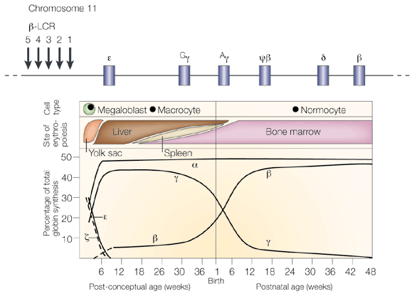
Figure 1. Expression pattern of beta globin from embryonic to adult. A) Locus of beta globin genes. Locus Control Region (LCR) is upstream of all six beta globin genes. B) Progression of beta globin through the developmental stages. € is embryonic, Gᵧ, Aᵧ are fetal and β is adult globin. Shows the location, age and transition of expression from embryonic to adult beta globin. Adapted from ref 9.
A.
B

Since the genes for the various stages of beta globin are all found on the same locus of the chromosome, they can often be controlled by the same regulatory elements. These are known as transcription factors, proteins that bind to the promoter region, upstream of a set of genes. The relationship of a specific type of transcription factor, called Kruppel-Like Factors (KLFs), to the expression of both embryonic and fetal globin genes is examined by Alhashem, et al (2011)¹. They analyzed the levels of beta-globin across wild type (KLF1+/+KLF2+/+), single knock-out (KLF1-/-, KLF2+/- or KLF1+/+, KLF2-/-) and double-knock out (KLF1-/-JLF2-/-) in transgenic mice containing the human beta locus. The results showed that the single knock out models, which contained only one of the two KLF genes, expressed decreased levels of globin as compared to the wild type, and that the double knock out model, in which both genes are removed, showed even less globin expression than the single knockout (Fig. 2). Other phenotypes include severe anemia, misshapen cells, an overall decrease in RBC count and death before day 10.5 of embryonic development (E10.5) in the double knockouts. The single-knockout genotypes also display similar phenotypes, but to a diminished extent and die later than the double knockout⁵. This proved that both KLF1 and KLF2 have synergistic roles in the positive regulation of beta globin genes and are necessary for the normal expression of both embryonic and fetal globin genes in primitive erythroid cells. It is interesting to note that while KLF1 is a positive regulator of fetal globin, it has an indirect, inhibitory effect on fetal globin in definitive, or adult, RBCs⁵.
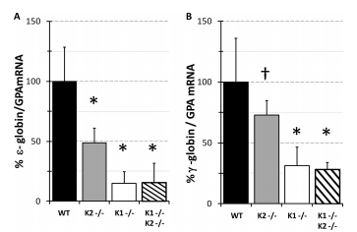
Figure 2. mRNA expression levels of embryonic (ε) globin and fetal (γ) globin in knockout models. (Adapted from ref 1)
A related study was performed by Pang, et al.⁵ in which expression profiling was performed on E9.5 embryos, to better understand the functional roles of KLF1 and KLF2 in erythropoiesis. A microarray analysis revealed a set of genes which are down-regulated, or exhibit decreased expression, in the absence of the two KLFs. This revealed that the two KLFs have roles in regulating genes involved in such categories as cell proliferation, hematopoiesis, cell differentiation and apoptosis (Fig. 3). Among the most prominent of these functional categories was that of genes which were involved in negatively regulating, or inhibiting, apoptosis, or programmed cell death. Since it has already been determined that there are less RBCs in KLF1-/-KLF2-/- genotypes, in combination with this functional annotation, it seems plausible that the decrease is due to the lessened expression of genes that inhibit apoptosis. This study will aim to confirm, that there are in fact, more RBCs undergoing apoptosis in KLF1-/-KLF2-/- than in the wild type. This will help to confirm the role of KLF1 and KLF2 as positive regulators of genes involved in restricting apoptosis.
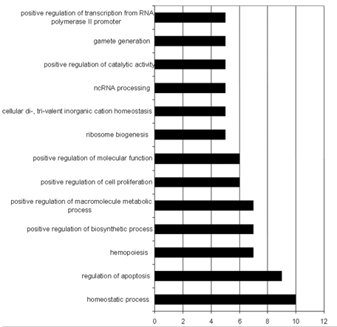
Figure 3. Functional annotation categories of genes exhibiting significant decrease in expression in KLF1-/-KLF2-/- genotype. Y-axis describes functional categories. X-axis indicates number of genes per category. Adapted from ref 5.
- Experiment
The purpose of this experiment is to determine whether apoptosis is increased in KLF1/KLF2 double knockout, transgenic mouse day 10.5 embryos. Mice that are heterozygous for KLF1 and KLF2 (+/-) will mated together and embryos will be harvested on the tenth day of development, before the double knockout genotypes die.
The protocol used for preparing and staining samples will be TACS® TdT In Situ Apoptosis Detection Kit – DAB, by Trevigen, Inc⁸. The blood from the harvested embryos will be prepared on slides so that they can be stained. The procedure is known as a TUNEL assay and is used to identify apoptotic cells.
When a cell becomes apoptotic, several changes take place. First, the membrane begins to lose its form and take on an abnormal shape, known as blebbing A later, more significant result is that the cell’s DNA begins to fragment. Where the nucleotides are cleaved, it leaves a free, 3’ OH group exposed. This nick is identified by a terminal deoxynucleotidyl transferase (TdT) enzyme, which catalyzes the incorporation of a nucleotide (dNTP) that has been attached to a biotin molecule (Fig. 4). This molecule can be either radiolabeled for identification by flow cytometry, or can be identified by colormetic substances, in this case diaminobenzidine (DAB), for use in light microscopy (Fig. 5). Once the cells have been labeled, they will be quantified manually.
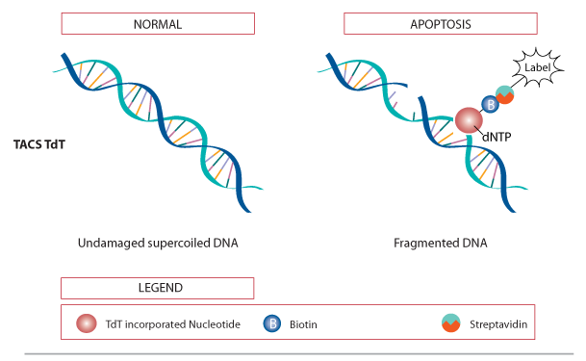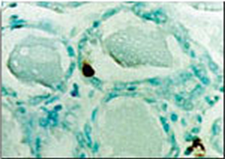
Figure 4. TdT enzyme incorporation of biotinylated marker molecule in fragmented DNA of apoptotic cells. Adapted from ref 8.
Figure 5. Diaminobenzidine(DAB) staining of apoptotic cell. Brown blob indicates location of fragmented DNA. Adapted from ref 8.

This protocol has been used previously in many contexts. However, none seem to have been used on erythroid cells specifically. Also, most of the available sources use samples that have been paraffin embedded, rather than cell suspensions, which will be used in this procedure. One example relatively close to the goal of this experiment is a study done by Reuter, et al (2002)⁷. They used this TUNEL kit to identify apoptotic cells in colon tumors of cancerous mice. Their samples were paraffin embedded and not of erythrocytes though. Therefore, there is a degree of uncertainty as to how well the experiment will perform. However, the kit does include a protocol specifically for use with cell suspensions, so it seems that it should be successful.
This protocol will be performed first on embryos that are KLF1-/-KLF2-/-, then on wild type embryos as a control. Harvested embryos will be placed in a 10x PBS wash and let to bleed. Blood cells will then be separated from the suspension by centrifugation and either spotted onto a slide or prepared as a cytospin. The samples will then be stained using the kit protocol. After staining, labeled cells will be counted using light microscopy.

- Discussion
If the experiment succeeds, the best results would show that there is at least a two-fold increase of apoptotic erythroid cells in KLF1-/-KLF2-/- embryos over the KLF1+/+KLF2+/+ wild type embryos. If this is the case, it would confirm that the increase in apoptosis due to the decreased expression of anti-apoptosis genes is a significant factor in the decreased cell count of double KLF1/2 knockouts. This makes sense, since, according to Pang, et al (2012), many of the key genes involved in the KLF1/2 regulated pathways have roles in inhibiting apoptosis. However, it is not plausible to claim that this is the only cause of the lowered RBC count. Another functional category that exhibited a significant decrease in expression was of genes involved in positive regulation of cell proliferation. The decrease in cells could also potentially be due to the lack of proliferative gene expression in eryrthroid progenitors. An additional area that could benefit from further investigation would be to perform a microarray analysis for genes that are up-regulated, or experience increased expression, in the absence of KLF1 and KLF2. This would identify if there are any pro-apoptotic genes which are normally held back by the two transcription factors. In which case, these would also be contributing factors to the decrease of RBCs.
In the event that the experiment is not successful, there are a few places where it could have gone wrong. For one thing, it has not been possible to find a previous experiment that uses this TUNEL protocol in the exact capacity of this experiment. That is, using a suspension of erythroid cells. However, the protocol does include a specific procedure to use on cells in suspension, so it should work. It also does not seem likely that it would be less effective on RBCs than any other type of cell. Another potential issue comes up in the process of dissection. Embryos at day 10.5 are small, delicate and difficult to remove intact. There is the possibility that not enough blood will be able to be collected from the samples to run a sufficient experiment on. This will hopefully be compensated for by performing several practice dissections on wild type embryos so that the dissector will be properly prepared when it comes time for running the actual experiment.
The confirmation of increased erythroid apoptosis due to the absence of KLF1 and KLF2 offers a new set of genes by which to identify the functions of these transcription factors and will lead to a better understanding of how KLF1 and KLF2 regulate embryonic and fetal beta globin genes. This knowledge would contribute to the potential for manipulating globin at the gene level, which could lead to further development of therapies for hemoglobinopathies such as beta-thalassemia and sickle cell anemia.

References
1. Alhashem YN, Vinjamur DS, Basu M, Klingmüller U, Gaensler KM, Lloyd JA (2011). Transcription Factors KLF1 and KLF2 Positively Regulate Embryonic and Fetal -Globin Genes through Direct Promoter Binding. J Biol Chem 286:24819-27.
2.Cao, A, Galanello, R (2010). Beta-thalassemia. Genetics in Medicine. 12:61-76.
3.HBB (2009). Genetics Home Reference. US National Library of Medicine: http://ghr.nlm.nih.gov/gene/HBB
4.Mitchell, R (1999). Sickle cell anemia. American J of Nursing. 99:36-37.

5.Pang CJ, Lemsaddek W, Alhashem YN, Bondzi C, Redmond LC, Ah-Son N, Dumur CI, Archer KJ, Haar JL, Lloyd JA, Trudel M (2012). Kruppel-like factor 1 (KLF1), KLF2, and Myc control a regulatory network essential for embryonic erythropoiesis. Mol Cell Biol 32:2628-44.

6.Rund, D (2005). β-Thalassemia. N Engl J Med 353:1135-1146.
7.Reuter BK, Jang X, Miller JSM (2002).Therapeutic utility of aspirin in the ApcMin/+ murine model of colon carcinogenesis. BMC Cancer 2: 1-8.

8.TdT In Situ Apoptosis Detection Kit – DAB:
http://www.trevigen.com/featured/3/13/118/502/TACS_2_TdT_DAB_diaminobenzidine_Kit/
9.Weatherall D (1997). The thalassemias. British Medical J. 314: 1675-78.

10.Wilber A, Nienhuis, A, Persons, D (2011).Transcriptional regulation of fetal to adult hemoglobin switching: new therapeutic opportunities. Blood 117:3945-53.
11.Wu, DY, Ugozzolit, L, Palt, BK, Wallace, RB (1989). Allele-specific enzymatic amplification of f8-globin genomic DNA for diagnosis of sickle cell anemia. Proc Natl Acad Sci USA. 86: 2757-60.

