December 2012
Role of KLF1 and KLF2 in mouse erythroid apoptosis pathways
By: Kristen Wade
- Introduction
Erythropoiesis is the development of red blood cells (RBCs). It takes place in two, main stages: primitive and definitive⁵. In mammals, primitive refers to the early stages of development, during which erythroblasts (early red blood cells) exist as large, nucleus-containing cells that are found in the yolk sac of the embryo⁵. These can then take one of two developmental paths. One path involves entering the blood stream from the yolk sac where they enucleate (expulsion of nucleus from cell) and there continue to develop into fetal definitive and adult definitive cells. The other path involves a transition to the fetal liver for enucleation and then on to the bone marrow for development into adult definitive erythrocytes⁵. Both paths, however, originate in the yolk sac. This stage of development is crucial for the continued, successful development of these burgeoning red blood cells.
There are many factors that must fall into place in order for RBCs to achieve developmental success. However, one of the most basic requirements is the proper expression of genes involved in erythropoietic pathways. Correct gene expression is regulated by proteins known as transcription factors (TFs)⁹. Often, successful regulation is combinatorial, or requires the proper combination of multiple TFs⁸. They can be classified based on their structure. Some of the most common TFs contain zinc-finger domains (Figure 1). The C-terminus of these domains consists of two cysteine residues and two histidine residues which, together, bind a zinc molecule. The N-terminus contains the activation/repression site, which recognizes and binds to specific sequences in the DNA¹². This can serve to either inhibit or activate the expression of a gene, though activation is the more common form of regulation⁸. On its own, eukaryotic RNA polymerase cannot begin mRNA transcription. However, when the right combination of TFs binds to the DNA in the promoter region, upstream of the actual genes, it allows for the RNA polymerase to bind and begin transcribing⁷. Therefore, without transcription factors, mRNA cannot be synthesized and genes cannot be expressed.
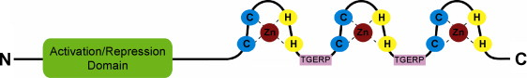
Figure 1. Zinc finger binding domain of KLF1/2 transcription factors. On the C-terminus side are 3 C₂H₂ zinc fingers which arrest a zinc molecule. Adapted from ref 7.

Two transcription factors in particular play essential roles in embryonic erythropoiesis: Kruppel-like factor 1 (KLF1/EKLF) and Kruppel-like factor 2 (KLF2)². These are examples of zinc finger binding proteins and recognize CACCC sequences in the DNA. It has been previously observed that KLF1 is essential for definitive erythropoiesis, specifically for expression of beta globin, and that KLF2 is essential in primitive development, though both can affect each stage. It has also been noted, based on knockout gene studies, that the two have compensatory, or overlapping, roles in regulation or erythropoiesis².
The relationship of KLF1 and KLF2 to the expression of embryonic globin genes was recently studied by Alhashem, et al (2011)¹. They analyzed the levels of beta-globin across wild type (KLF1^{+/+} KLF2^{+/+}), single knock-out (KLF1^{-/-}, KLF2^{+/+} or KLF1^{+/+}, KLF2^{-/-}) and double-knock out (KLF1^{-/-} KLF2^{-/-}) in transgenic mice containing the human beta locus. The results showed that the single knock out models, which contained only one of the two KLF genes, expressed decreased levels of globin as compared to the wild type, and that the double knock out model, in which both genes are removed, showed even less globin expression than the single knockout (Fig. 2). Other phenotypes due to the absence of KLF1/2 include severe anemia, misshapen cells, an overall decrease in RBC count and death before day 10.5 of embryonic development (E10.5) in the double knockouts² (Figure 2). The single-knockout genotypes also displayed similar phenotypes, but to a diminished extent and died later than the double knockout⁶. This showed that both KLF1 and KLF2 have essential, synergistic roles in the positive regulation of beta globin genes and are necessary for the normal expression of globin, as well as genes involved in essential cell pathways in primitive erythroid cells.
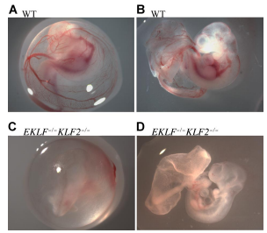
Figure 2. E10.5 wild type and KLF1(EKLF)^{-/-} KLF2^{-/-} embryos. Pictures A and B are wild type, C and D are double knockout, exhibiting anemia. Pictures A and C depict embryo inside of yolk sac, B and D depict the same embryos with yolk sac removed. . Adapted from ref. 2.

A related study was performed by Pang, et al.⁶ in which expression profiling was performed on day 9.5 embryos, to better understand the functional roles of KLF1 and KLF2 in erythropoiesis. A microarray analysis revealed a set of genes that are down-regulated, or exhibit decreased expression, in the absence of the two KLFs. This analysis revealed that the two KLFs may have roles in regulating genes involved in such categories as cell proliferation, hematopoiesis, cell differentiation and apoptosis (Fig. 3). Among the most prominent of these functional categories was the class of genes that are involved in negatively regulating, or inhibiting, apoptosis (programmed cell death). This, combined with the earlier finding that there are fewer RBCs in mice with KLF1^{-/-} KLF2^{-/-} genotypes makes plausible the idea that the decrease is due to the lessened expression of genes that inhibit apoptosis. This study aims to determine, whether there are in fact, more RBCs undergoing apoptosis in KLF1^{-/-} KLF2^{-/-} than in wild type mice. Such a finding would support the idea that KLF1 and KLF2 play a role as positive regulators of genes involved in restricting apoptosis.
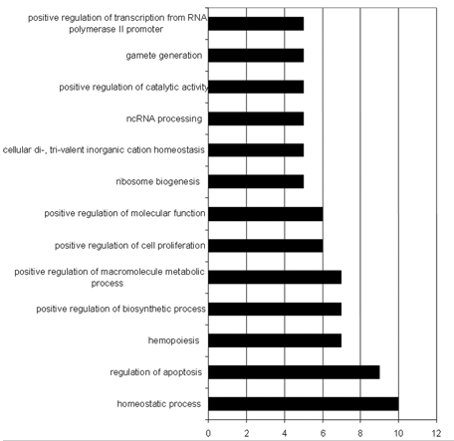
Figure 3. Functional annotation categories of genes exhibiting significant decrease in expression in KLF1^{-/-} KLF2^{-/-} genotype. Y-axis describes functional categories. X-axis indicates number of genes per category. Adapted from ref 6.
- Experiment
The purpose of this experiment is to determine whether apoptosis is increased in double knockout, transgenic mouse embryos. Mice that are heterozygous for KLF1 and KLF2 (+/-) will be mated together and embryos will be harvested on the tenth day of development, while production of erythroblasts is still in the yolk sac and before the embryos with double knockout genotypes die. The double knockout embryos should be distinguishable by their paleness due to anemia. However, to be certain, I will collect the blood from all the embryos of the litter, label them and prepare them according to protocol. Then, tissue from the actual embryos will be used to determine the genotype for each via PCR and subsequent gel electrophoresis.
The protocol used for preparing and staining samples will be TACS® TdT In Situ Apoptosis Detection Kit – DAB, by Trevigen, Inc¹¹. The blood from the harvested embryos will be prepared on slides so that they can be stained. The procedure is known as terminal deoxynucleotidyl transferase dUTP nick end labeling, or TUNEL, and is used to identify apoptotic cells.
When a cell becomes apoptotic, several changes take place. First, the membrane begins to lose its form and take on an abnormal shape, a process known as blebbing. A later, more unique characteristic is that the cell’s DNA begins to fragment. Wherever DNA is cleaved, a free, 3’ OH group is exposed. This nick is identified by a terminal deoxynucleotidyl transferase (TdT) enzyme, which catalyzes the incorporation of a nucleotide (dUTP) that has been attached to a biotin molecule¹¹ (Fig. 4). Biotin is bound very specifically by the protein streptavidin which can either be fluorescently labeled for identification by flow cytometry or labeled with the enzyme horseradish peroxidase. This enzyme reacts with diaminobenzidine (DAB) to form a colored compound detectable by light microscopy¹⁰ (Fig. 5). I will use the latter method to allow for quantitation by direct counting of cells.
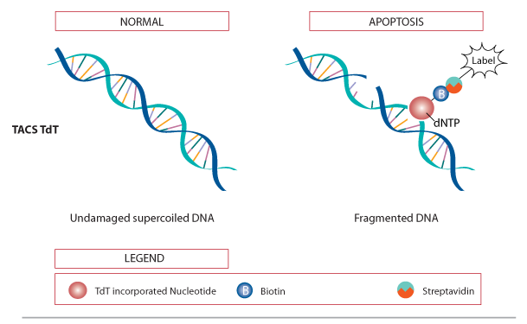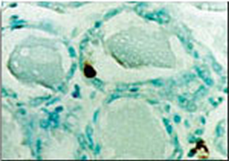
Figure 4. TdT enzyme incorporation of biotinylated marker molecule in fragmented DNA of apoptotic cells. Adapted from ref 11.
Figure 5. Diaminobenzidine(DAB) staining of apoptotic cell. Brown blob indicates location of fragmented DNA. Adapted from ref 11.

This protocol will be performed first on embryos that are KLF1^{-/-} KLF2^{-/-} . Then, since even in healthy embryos, there are always a few cells undergoing apoptosis at any given time, wild type embryos will be stained as a control to cancel out for these cells. Blood will be collected from harvested embryos and blood cells will then be separated from the suspension by centrifugation. The cells will then be prepared on glass slides. The samples will then be stained using the kit protocol. After staining, labeled cells will be counted using light microscopy.

- Discussion
My prediction is that there will be an increase of apoptotic erythroid cells in KLF1^{-/-} KLF2^{-/-} embryos over the KLF1^{+/+} KLF2^{+/+} wild type embryos. If this is the case, the significant increase in apoptosis would connect the previously observed decrease in expression of anti-apoptosis genes⁶ to the decrease in cell counts² in KLF1/2 double knockouts. This makes sense, since, according to Pang, et al (2012), many of the key genes involved in the KLF1/2 regulated pathways have roles in inhibiting apoptosis⁶. However, it is not plausible to claim that this is the only cause of the lowered RBC count. Another functional category that exhibited a significant decrease in expression was of genes involved in positive regulation of cell proliferation. The decrease in cells could also potentially be due to the lack of proliferative gene expression in eryrthroid progenitors. An additional area that could benefit from further investigation would be to perform a microarray analysis for genes that are up-regulated (experience increased expression) in the absence of KLF1 and KLF2. This would identify if there are any pro-apoptotic genes which are normally held back by the two transcription factors. If so, these could also be contributing factors to the decrease of RBCs.
The experiment may go wrong in one of several ways. For one thing, I have not been able to find a previous experiment that uses this TUNEL protocol to measure apoptosis in a suspension of erythroid cells. Though this protocol has been used previously in many contexts, none seem to have been used in this manner specifically. Most of the available sources use samples that have been paraffin embedded, rather than cell suspensions, which will be used in this procedure. One example of a study relatively close to the goal of this experiment is that performed by Reuter, et al (2002)⁹. They used this TUNEL kit to identify apoptotic cells in colon tumors of cancerous mice. However, their samples were paraffin embedded and the cells were not erythrocytes. Therefore, there is a degree of uncertainty as to how well the TUNEL procedure will perform. However, the kit does include a protocol specifically for use with cell suspensions, so it seems that it should be successful. Another potential issue comes up in the process of dissection. Embryos at day 10.5 are small, delicate and difficult to remove intact. It is the removal of the placenta from the embryo that causes the yolk sac to bleed, so it is essential that it does not get pulled off before being placed in collecting solution (10X PBS). If this does not happen, there is the possibility that not enough blood will be able to be collected from the samples for an experiment. This problem may be overcome by doing several practice dissections on wild type embryos so that I will be properly prepared when it comes time for performing the actual experiment.
The confirmation of increased erythroid apoptosis due to the absence of KLF1 and KLF2 may lead to a better understanding of how these two TFs regulate genes involved in apoptotic pathways, particularly those that are also involved in primitive erythropoiesis. Being able to draw connections between these two pathways, at opposite ends of the red blood cell life cycle, could provide useful insight into the mechanisms controlling the essential process of erythropoiesis.
References
1. Alhashem YN, Vinjamur DS, Basu M, Klingmüller U, Gaensler KM, Lloyd JA (2011). Transcription Factors KLF1 and KLF2 Positively Regulate Embryonic and Fetal -Globin Genes through Direct Promoter Binding. J Biol Chem 286:24819-27.

2. Basu P, Lung TK, Lemsaddek W, Sargent TG, Williams DC Jr, Basu M, Redmond LC, Lingrel JB, Haar JL, Lloyd JA (2007). EKLF and KLF2 have compensatory roles in embryonic beta-globin gene expression and primitive erythropoiesis. Blood. 210: 3417- 25.

3.Bieker JJ. Kru¨ppel-like factors: three ﬁngers in many pies. J Biol Chem. 2001;276:34355- 34358
4.HBB (2009). Genetics Home Reference. US National Library of Medicine: http://ghr.nlm.nih.gov/gene/HBB
5.Palis, James (2008). Ontogeny of erythropoiesis. Current Opinion in Hematology. 15:155-61.

6.Pang CJ, Lemsaddek W, Alhashem YN, Bondzi C, Redmond LC, Ah-Son N, Dumur CI, Archer KJ, Haar JL, Lloyd JA, Trudel M (2012). Kruppel-like factor 1 (KLF1), KLF2, and Myc control a regulatory network essential for embryonic erythropoiesis. Mol Cell Biol 32:2628-44.

7.Pearson R, Fleetwood J, Eaton S, CRossley M, Bao S (2008). Kruppel-like transcription factors: a functional family. Int’l Jrnl of Biochem & Cell Bio; 40: 1996-2001.

8.Philips, T (2008). Regulation and gene expression in eukaryotes. Nature education. 1:1

9.Reuter BK, Jang X, Miller JSM (2002).Therapeutic utility of aspirin in the ApcMin/+ murine model of colon carcinogenesis. BMC Cancer 2: 1-8.
10. Technical Information: detection and visualization of antibody binding. R&D systems. http://www.rndsystems.com/literature_antibody_binding.aspx

11.TdT In Situ Apoptosis Detection Kit – DAB:
http://www.trevigen.com/featured/3/13/118/502/TACS_2_TdT_DAB_diaminobenzidine_Kit/
12.Vaquerizas JM, Kummerfeld SK, Teichmann SA, Luscombe NM (2009) A census of human transcription factors: function, expression and evolution. Nature Reviews Genetics. 10:252-63.

