The pathway of TB using Biotin tagged Phages and Quantum Dots
Proposal by Abdallah Abdelmaksoud

Introduction

Latent Tuberculosis (LTB) is when a person is a carrier of Tuberculosis (TB) but does not have the disease active. What happens is that the LTB hides in almost any place in the body waiting for a significant decrease in the immune system to launch its attack. LTB was even found to have a protein that counteracts with the protein in the macrophage that disrupts the macrophage’s digestive enzymes production (Yossi et al). This makes the mycobacteria to reproduce and hide from antibodies formed by the body’s immune system until there is a sufficient amount of the mycobacteria to attack its target organ, the lungs. According to the World Health Organisation one third of the world’s population has LTB and 10% of those the disease becomes active sometime in their life.

Many mycobacteria phages isolated from the environment using mycobacteria Smegmatis as a host have been proven to infect and kill mycobacteria Tuberculosis (TB). TM4, a lytic bacteriophage will be chosen for this experiment as it is proven to infect mycobacteria Tuberculosis (Luiz et al). Phage’s lytic cycle involves one phage infecting the host bacteria’s cell machinery producing hundreds of new phages before bursting out and destroying the bacteria cell. Phage’s host specificity and the number of newly produced phages per infection (about 100) are going to be the two main important features in the phage to be used.

Fluorescent semiconductor Nano crystals, quantum dots (QDs) can be attached to phages to be able to detect any kind of bacteria if a phage can specifically infect it. The use of this method with samples of bacteria is very accurate and can detect the presence of a specific type of bacteria if it only ten are present per milliliter (Edgar et al 2006). This experiment has been only done in vitro and its use was to only check if this certain bacteria is present or not. Its purpose was to be used in the future for faster analysis rather than the older lab techniques that involve growing the bacteria culture for a few days.

In my experiment I’m attempting to take the phage with QDs attached from in vitro to in vivo. So instead I would like to be able to trace QDs of TB infecting phages in mice to check for where and when does the number of TB bacteria increase or decrease. I know that these bacteria are in the body (of the mouse) but I’m trying to find the path and what happens to the number and location of the TB bacteria since injection until it reaches its target organism, the lungs. This experiment alone is just a method of detection that can open the door for a lot more research in the future.

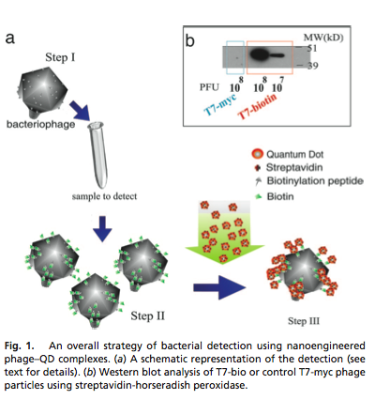
Experiment

The idea of the experiment is to be able to trace and estimate the number of bacteria. QDs will be our fluorescent source for us to detect and the phage will be what leads the QD to mycobacterium tuberculosis. The phage will be highly specific for its target that is TB. Since mice are the animals of choice for studying the immunology of mycobacterial infections they will also be our trial animals to be tested on. The mice will be infected with TB using a Glas-Col aerosol infection device containing TB sustentions. The plan is to infect the mouse with the TB and inject the phage at different time intervals that will be determined after the initial results of the experiment. The reason why we need to inject a phage into a different mouse every time instead of injecting it once in the beginning with the TB and just tracing it to the end is because the phage will infect and destroy some of the TB bacteria changing the results that would normally occur. So every mouse is only injected once from both the phage and the TB with an exception of one time to test what would happen if only the phage is used.

The first step is to attach a specific peptide to the capsid of a genetically engineered phage. As mentioned in the Edgar et al 2006 this can be done by an engineered phage to express the major capsid protein fused to the 15-aa biotinylation peptide GLN- DIFEAQKIEWHE. This biotinylation peptide when biotinylated will attach to streptavidin that can be coated on the QDs. This will basically means that all phages will have the QDs attached to them whether or not they have infected their host bacteria. This is not helpful as we are trying to detect the bacteria not the phage so to avoid this problem we will have to starve the engineered phage from biotin. This will make the QD not attach to the phage unless the biotinylation peptide is biotinylated. The progeny phage produced after the lytic cycle will be biotinylated from the host cell’s biotin-ligase protein making it bind to the streptavidin attached to the quantum dot.

For the detection of QDs in vivo a radioactive source has to be used. Various radioactive quantum dot cores can be used for in vivo detection such as copper, indium, zinc, selenium and tellurium (Jamal et al). The images can be detected with a Single Photon Emission Tomography (SPECT). Although SPECT methods cannot give very accurate measure of the amount of QD present it will show the relative estimate. An estimate should be enough in this experiment as we are searching for areas of TB groupings that will trigger phage production, thus gathering QDs. SPECT should be enough to notice the locations of such gatherings.
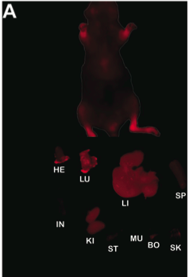

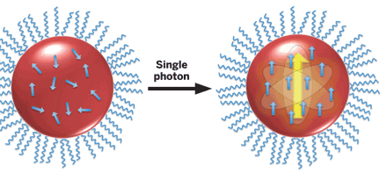

For determining the time periods of when to insert what by adding the phage, the bacteria and the streptavidin coated QD at the same time and from then we can estimate how long it takes for the phage to effectively infect the bacteria. Two control tests will be needed one will be adding the phage and the streptavidin coated QD without the bacteria, the other will be with the bacteria and without the phage.

Discussion

Knowing the exact pathway and when the bacteria start to rapidly increase can provide a key to a new treatment. There is no precise goal it is an experiment designed for potential discovery and further experiments. If there is a pattern or new discovery about how and where the TB lives in the body since it enters the body we might be able to understand further. The more an organism is studied the more likely you would get a treatment for it. Such an experiment is not time consuming and can provide sufficiently fast results.

If this method of detection was found to be functioning it can be a start of many new research on the reasons on what makes an infectious bacteria latent or active. This can be achieved by genetically modifying mice of different immune responses to test the different affects. Another thing that could be tested using this experiment would be injecting phagocytes from different humans into immune system compromised mice.

References
K. G. Papavinasasundaram, Bosco Chan, Ji-Hae Chung, M. Joseph Colston,Elaine O. Davis, and Yossi Av-Gay* Deletion of the Mycobacterium tuberculosis pknH Gene Confers a Higher Bacillary Load during the Chronic Phase of Infection in BALB/c Mice JOURNAL OF BACTERIOLOGY, Aug. 2005, p. 5751–5760 Vol. 187, No. 16 http://www.cmdr.ubc.ca/yossi/

Edgar R, McKinstry M, Hwang J, Oppenheim AB, Fekete RA, Giulian G, Merril C, Nagashima K,
Adhya S (2006). High-sensitivity Bacterial Detection Using Biotin-tagged Phage and Quantum-dot Nanocomplexes . Proc Natl Acad Sci USA 103:4841-4845. http://www.ncbi.nlm.nih.gov/pmc/articles/PMC1458757/.

Liandris E, Gazouli M, Andreadou M, Sechi LA, Rosu V, et al. (2011) Detection of Pathogenic Mycobacteria Based on Functionalized Quantum Dots Coupled with Immunomagnetic Separation. PLoS ONE 6(5): e20026. doi:10.1371/journal.pone.0020026
National Center for Biotechnology Information. U.S. National Library of Medicine, n.d. Web. 02 Dec. 2012. <http://www.ncbi.nlm.nih.gov/pubmed/16249122>.

Drew Smith (2010) Bacteriophage Amplification for Bacterial Identification | New bacteriophage technologies are being developed to create rapid tests for bacterial infections. <http://www.ivdtechnology.com/article/bacteriophage-amplification-bacterial-identification>.

Synchrotron-based X-ray fluorescence imaging of human cells labeled with CdSe quantum dots Silvia Corezzi, Lorena Urbanelli, Peter Cloetens, Carla Emiliani, Lukas Helfen, Sylvain Bohic, Fausto Elisei, Daniele Fioretto Volume 388, Issue 1, 1 May 2009, 33–39 http://www.sciencedirect.com.proxy.library.vcu.edu/science/article/pii/S0003269709000724

Lawrence Broxmeyer,1 Danuta Sosnowska,2 Elizabeth Miltner,2 Ofelia Chaco ́n,3,4 Dirk Wagner,2 Jeffery McGarvey,2 Rau ́l G. Barletta Killing of Mycobacterium avium and Mycobacterium tuberculosis by a Mycobacteriophage Delivered by a Nonvirulent Mycobacterium: A Model for Phage Therapy of Intracellular Bacterial Pathogens,JID 2002;186 (15 October) 1155-1160 http://www.ncbi.nlm.nih.gov/pubmed/12355367

Hölscher C, Atkinson RA, Arendse B, Brown N, Myburgh E, Alber G, Brombacher F
A protective and agonistic function of IL-12p40 in mycobacterial infection. J Immunol. 2001 Dec 15; 167(12):6957-66. http://www.ncbi.nlm.nih.gov/pubmed/11739515

Minghao Sun, David Hoffman, Gobalakrishnan Sundaresan, Likun Yang, Narottam Lamichhane, Jamal Zweit Synthesis and characterization of intrinsically radio- labeled quantum dots for bimodal detection, Am J Nucl Med Mol Imaging 2012;2(2):122-135 http://www.ncbi.nlm.nih.gov/pubmed/23133807

