Intergeneric Transfer of Panton-Valentine Leukocidin (PVL) via Helper Phage

- Introduction
Bacteriophages are viruses that attack a bacterial cell, take over its cellular processes and eventually kill its host via transduction. Bacteriophage can also be temperate – they sit inside the host’s genome by integrating their DNA and waiting for the opportune moment to kill its host. Generally, these phages are broadly classed together based upon which species of bacteria they infect, and until recently it was thought that they stay within their host range, being unable to infect different genera of bacteria. Besides its own DNA, phages also possess and pass on DNA that they have picked up in the process of hijacking its host cells. This particular element of phage-mediated transfer of genes is important in the diversity of the bacterial species Staphylococcus aureus. S. auereus contains mobile genetic elements, called virulence factors, that are passed between bacteria by transduction, propagation, or by horizontal gene transfer. These virulence factors make the bacteria more potent, and in some cases, resistant to medications. Panton-Valentine Leukocidin, or PVL, is a virulence factor that creates pores in cells and eventually breaks them down. PVL is a mobile genetic element that is passed to bacteria by bacteriophage transduction by a select few bacteriophage. In this experiment, ФSLT will be the phage mediator for transfer of PVL between different bacterial genera – from Staphylococcus aureus to Listeria monocytogenes. If the experiment is successful, it will demonstrate that not only can bacteriophage transfer harmful virulence factors between different genera of bacteria, we will not have a current treatment for the new strain since it has never occurred before.

Bacteriophage are currently researched for medical purposes, so that they may be used to lyse and kill harmful bacteria without affecting other human bodily functions. This is an issue since bacteriophage pick up and transfer new DNA from the host bacteria they lyse and transfer it to new bacteria. This is a major issue for bacterial colonies such as S. auereus, which have several different virulence factors that can be transferred by bacteriophage. These virulence factors are the cause of many deaths because they are difficult to treat and spread rapidly with every temperate phage infection. Bacteriophage are known to infect different species of bacteria, but now have been seen successfully infecting different genera. This poses a problem with medical research that was previously mentioned because now we must consider the phage’s ability to transfer virulence factors intergenically (Chen & Novick, 2009). Will the transfer of virulence factors between genera create a new super-bacteria?

- Experiment
The goal of the experiment is to utilize bacteriophage ФSLT to transfer PVL from Staphylococcus auereus to Listeria monocytogenes. Staphylococcus auereus and Listeria monocytogenes have similar integration sites (Figure 1) for pathogenic islands (small plasmids of virulence factors) that will contain the virulence factor PVL. The phage ФSLT, containing PVL, will be introduced to L. monocytogenes in a raw milk medium (where the bacteria are found naturally). After infection, known integration sites will be cut with restriction enzymes (enzymes that cut at a specific sequence on DNA), and amplified using PCR (polymerase chain reaction) which replicates the piece of DNA under speculation. An agarose gel will be electrophoresed, causing the DNA bands to travel down the gel according to size of fragments. The fragment size will determine if the virulence factor has integrated at one of the known sites on L. monocytogenes. To conclude that it has in fact integrated, the fragment should be sent to a facility to be sequenced.

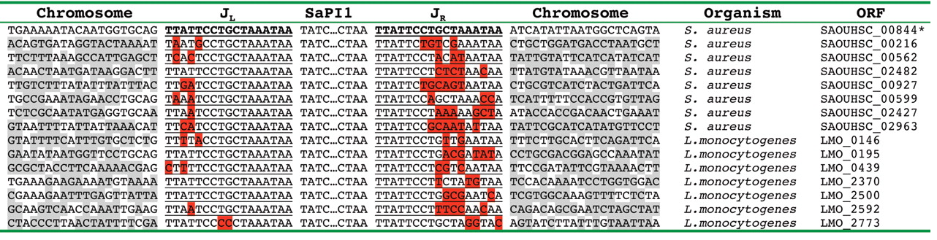
Figure 1: The wild-type primary SaPI1 attC is precisely duplicated upon integration and is indicated in bold. The left and right insertion junctions (J_{L} and J_{R}) are underlined and they indicate the hybrid SaPI1 attachment sites created from integration into a secondary attachment site. Red boxes indicate mismatches with the wild-type primary SaPI1 attC. Gray boxes indicate mismatches with the flanking chromosomal regions.

- Discussion
If the experiment is successful, integration of a pathogenic island containing the virulence factor Panton-Valentine Leukocidin will have integrated into a new genera of bacteria, Listeria monocytogenes. The virulence factor will be tested for the activity of PVL and its ability to create pores in the infected host’s cells. The introduction of such a potent virulence factor to a new genera poses several issues from lack of treatment to potential pandemic. Phage treatment for medical purposes will have to be re-examined for the threat of possible transduction of other potentially negative virulence factors between bacterial genera. As long as integration sites are similar, the possibilities of other genera of bacteria having the ability to pick up these virulence factors will be endless.
This experiment could prove that PVL be completely inactive in its new bacterial host, but this doesn’t mean that it couldn’t once again be transferred to yet another genera of bacteria, or encounter the right environmental conditions to evolve and become active.

- References

1. Phage-Mediated Intergeneric Transfer of Toxin Genes. John Chen and Richard P. Novick, 2009.
(http://www.sciencemag.org.proxy.library.vcu.edu/content/323/5910/139.short )

2. Fatal S. aureus Hemorrhagic Pneumonia: Genetic Analysis of a Unique Clinical Isolate Producing both PVL and TSST-1. Li et al, 2011. (http://www-ncbi-nlm-nih-gov.proxy.library.vcu.edu/pmc/articles/PMC3207839/ )

3. Phage conversion of Panton-Valentine leukocidin in Staphylococcus aureus: molecular analysis of a PVL-converting phage, phiSLT. Narita et al, 2001. (http://www.ncbi.nlm.nih.gov/pubmed/11368915 )

4. Staphylococcus aureus Panton-Valentine Leukocidin Is a Very Potent Cytotoxic Factor for Human Neutrophils. Löffler et al, 2010. (http://www.plospathogens.org/article/info:doi/10.1371/journal.ppat.1000715?imageURI=info:doi/10.1371/journal.ppat.1000715.g001 )

5. Identification of ORF636 in phage phiSLT carrying Panton-Valentine leukocidin genes, acting as an adhesion protein for a poly(glycerophosphate) chain of lipoteichoic acid on the cell surface of Staphylococcus aureus. Kaneko, et al, 2009. (http://www.ncbi.nlm.nih.gov/pubmed/19429614 )

6. Panton-Valentine Leukocidin. Venkata Meka, M.D. (http://www.antimicrobe.org/h04c.files/history/PVL-S-aureus.asp )

