Jordan Davis
BNFO 301
Research Project Rough Draft
Short dispersed palindromic repeats within Yersinia bacteriophages.

Introduction
It is imperative to understand Bacteria, as they are a very diverse domain filled with many beneficial and harmful species. In particular, most the species in the genus Yersinia are pathogenic to humans [1]. With increasing rise of resistance amongst ‘superbug’ bacteria using bacteriophages in novel Phage therapy is proving to be more efficient in the long run compared to antibiotics [1,2,3]. Most species in Yersinia contain Yersinia palindromic (YPALs) sequences are miniature DNA insertions that are spread across the chromosomes of Yersinia [2,3,4]. These sequences are about ~150 nucleotides in length and is significant for playing a role as RNA elements in posttranscriptional control [2,3,4]. The purpose of this study is to determine whether or not certain YPAL elements are present in Yersinia phages.
Methods
This study specifically focuses on subfamily 2 of Yersinia which includes a 167 nt YPAL [4]. This YPAL is included in Y. enterocolittica and Y. pestis [2,3,4]. These species are significant because they are extremely pathogenic to humans [4]. The analysis of phage sequences is required to obtain a better understanding as to similarities that the Yersinia phages share with their bacterial hosts Y. enterocolitica and Y. Pestis. Using BioBike, a tool must be created to find YPALs within the Yersinia phages.
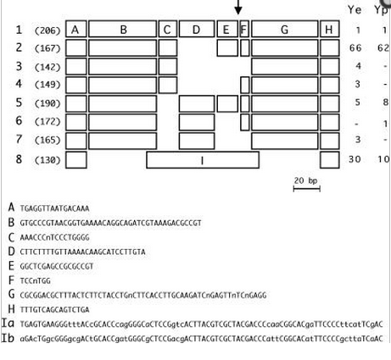
Fig 1. Structural organization of YPAL elements. This figure includes all 8 different types of YPALs currently known in Yersinia. Elements commonly found in subfamily 2 (Y. enterocolitica, Y. pestis) contain 167 nucleotides and include an A/H terminal sites. This will be the main criteria for searching for YPALs in Yersinia phage.
Degregio et al. (2006)
A subfamily 2 YPAL sequence can be pieced together by combining the various elements of nucleotides given from Fig. 1. To create a YPAL-finding tool for our Yersinia phage in BioBike, a search criteria must be constructed. To do so, using the A and H terminals as a window for a search function in BioBike may find instances of subfamily 2 YPALs in the Yersinia phages obtained.
In BioBike the MATCHES-OF-PATTERN is used to find patterns in Yersinia phage that include both the A and H terminals that are found in subfamily 2 Yersinia bacteria and should match the length of 167 nucleotides to be considered as a subfamily 2 YPAL sequence.
Phages to be analyzed for YPALs:

TGAGGTTAATGACAAAGTGCCCGTAACGGTGAAAACAGGCAGAATCGTAAAGACGCCGTAAACCCnTCCCTGGGGGGCTCGAGCCGCGCCGTTCCnTGGCGCGGACGTTTACTCTTCTACCTGnCTTCACCTTGCAAGATCnGAGTTnTCnGAGGTTTGTCAGCAGTCTGA
Fig 2. Subfamily 2 YPAL sequence. Yellow represents the A and H terminals, Green represents the B and G regions of the sequence. The blue and purple regions represent the inner core regions of the YPAL sequence. The smaller region of the YPAL, F, is represented in grey.

Y. Berlin
Y. L-413C
Y. phiA1122
Y. phiYeO3-12
Y. py54
Y. Yepe2

Window Frame to Search:
Subfamily 2 YPAL
TGAGGTTAATGACAAA……………………………….TTTGTCAGCAGTCTGA
(A Terminal)……………………………………………………………..(H Terminal)
Algorithm:
The MATCHES-OF-PATTERN in BioBike was used to find any instances of subfamily 2 YPALs in any of the six Yersinia phage obtained. Both A and H terminals were used to find a match in each phage through BioBike.
Results and Discussion
Out of the six phages that were analyzed for YPALs there were no matches of the A and H terminals in all of the Yersinia phages obtained. The MATCHES-OF-PATTERN function in BioBike did not detect any instances of subfamily 2 YPALs in Yersinia phage. This confirms that there aren’t any subfamily 2 YPALs that are of known existence in Yersinia phages Berlin, L-413C, phiA1122, phiYeO3-12, py54, and Yepe2.
For further study of YPALs, it would be imperative to analyze these phages and use a MATCHES-OF-PATTERN that encapsulates more Yersinia phages. Another pathway of progressive study would be to analyze any matches of YPALs in Yersinia plasmids. In conclusion, there are no instances of YPALs of any subfamily in the Yersinia phages tested because each subfamily of Yersinia includes an A and H terminal, and not one A or H terminal match could be found through BioBike in any of the Yersinia phage.

Works Cited

1. De Gregorio, Eliana, et al. "Enterobacterial repetitive intergenic consensus sequence repeats in yersiniae: genomic organization and functional properties."Journal of bacteriology 187.23 (2005): 7945-7954.
2. Delihas, Nicholas. "Enterobacterial small mobile sequences carry open reading frames and are found intragenically—evolutionary implications for formation of new peptides." Gene regulation and systems biology 1 (2007): 191.
3. Delihas, Nicholas. "Small mobile sequences in bacteria display diverse structure/function motifs." Molecular microbiology 67.3 (2008): 475-481.
4. De Gregorio, Eliana, et al. "Structural organization and functional properties of miniature DNA insertion sequences in Yersiniae." Journal of bacteriology 188.22 (2006): 7876-7884.

