Regulating Crp protein levels with the use of sRNA
Jada Wilson
Bnfo 300
2019
Introduction
Decades ago a plague caused by the bacterium Yersinia pestis emerged. This plague was known as the Bubonic plague which was responsible for the death of millions of people across Europe, Asia and Africa. This plague is spread by infected flea bites or by direct contract. Although there is wide access to antibiotics in the 21st century if left untreated death or serious illness could occur. 100 Just in the year 2010-2015 cases had reduced to less than 1000 but in the Africa were medicine isn’t as readily available more than 1,000 cases of plague were reported(CDC 2018) .

The infection ultimately leads to death because once the infection has broken into the respiratory tract an immune response is blocked in the lungs. This causes a transition into a phase of high inflammation. During infection Y. pestis survives in the varying conditions by making changes in the expression of the certain sets of genes. There is a protein known as the cyclic AMP receptor protein(CRP) which regulates transcription of many genes. One gene in particular that it activates is pla , a enzyme activator. This gene works in conjunction with a coactivator cAMP, which acts as a catalyst to increase transcription speed, to bind to the CRP promoter region. As stated by Zhan et. al. In E. coli the CRP is directly regulated by its cAMP-CRP complex which can directly repress its own genes. The gene that encodes for the small protein known as Hfq plays an important role in the post-transcriptional regulation of gene expression. This protein is a mRNA-binding protein that is said to help regulate CRP synthesis with help from a hfq-binding small non-coding RNA (sRNA).

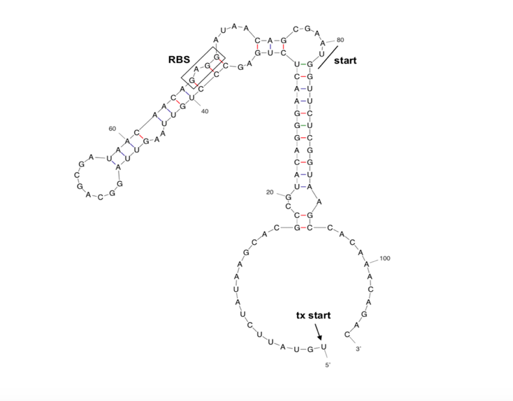
HFq is a homohexameric protein, ring shaped protein, with two recognition sites a proximal face, a distal face. The binding of Hfq and sRNA occurs due to the fact that Hfq binds to 3’ terminal uridine rich sequences of sRNAs on the proximal side, the distal face binds to arginine-rich motif sequences like ‘AAYAA’ where Y is pyrimidine and A is arginine. The specificity of this binding interaction is crucial to mRNA regulation because if the polyA tail is shortened in length the sRNA is unable to bind crippling the chaperone hfq. The importance of this interaction was proven in Otaka et. al. by shortening the 3’ uridine-rich sequence of sRNA from E. coli. Once bound to the Hfq protein the sRNA would bind to the complementary strand of the target mRNA sequence causing a silenced gene or enhanced gene expression. Not much is known about specific sRNAs that are directly related to CRP. This study will discuss an experiment that is aimed to answer the question of whether or not there is an sRNA in Y. pestis that is directly related to crp using co- immunoprecipitations to find an sRNA specific to crp using antibodies that will bind to proteins that are bound to crp.

Fig1. A prediction for what the structure of Y. pestis crp 5’ UTR and proximal coding regions would look like . RBS stands for ribosomal-binding site which would be bound by an hfq protein and an sRNA. Transcription start indicated by arrow and translation start indicated by black

Experiment
This experiment will prove whether sRNAs affect Crp synthesis by analyzing the interactions between the hfq and sRNAs. A northern blot will test will also help with the conclusion of whether the addition, or deletion of certain sRNAs would cause destabilization of the crp. protein synthesis.

RNA sequencing
The RNA is discovered by sequencing complementary DNA(cDNA) or by using total cellular RNA. In this case the RNA sequence of Cpr will come from Yersinia and it will be about 50-500 nt long. The RNA was then reverse transcribed into cDNA in order for the plasmid vector to be cloned resulting in 3000 cDNA plasmid inserts which were then analyzed using Sanger sequencing. Sanger sequencing is done by denaturing the strands, a primer is then annealed to template strand and distributed between 4 test tubes. In these tubes DNA polymerase was added and so was a mixture of 4 nucleotides. After that only one of each nucleotide goes in each tube. DNA polymerase uses nucleotides with 3 phosphates at the primer to form base pairs causing termination since a hydroxyl group on the 3’ end is missing. DNA fragments of different lengths are collected and then analyzed for mutations(Gomes and Korf 2018).
The mixtures then go through a process called Western Blot are then plated on a polyacrylamide gel electrophoresis.
Electrophoresis separates RNA molecules based on size, the larger RNA molecules will stay toward the top of the gel. Before this RNA was added to the gel a dye was added so that the different bands could be seen. The desired proteins are then extracted and plated on some type of cotton membrane. Biotin containing proteins are then detected and labeled(Wurtele, and Nikolau 2000). Fig 2 . give a visualization of how the charge will be sent through the gel causing the small particles (sRNA) to bottom of gel.
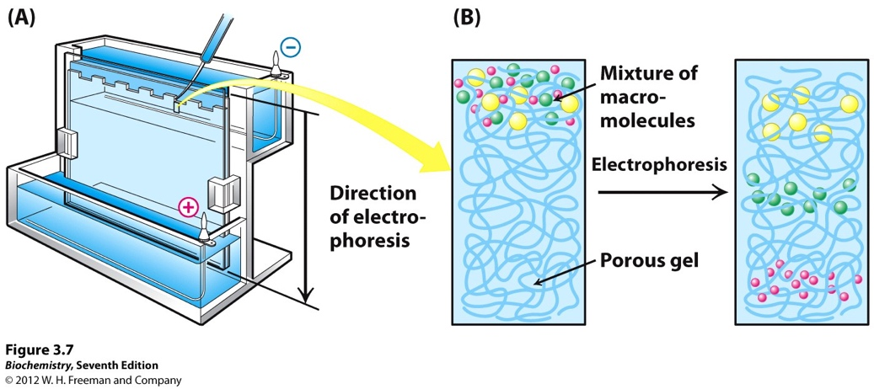
Figure 2 is showing how the molecules will separate based on size and in which direction the molecules will go based on electric current direction.

Co-Immunoprecipitations
Co- Immunoprecipitation can also be discussed as co-purification. This procedure follows closely to. The Ribosomal bind site for the cpr gene would have to be opened by the base pairing of an sRNA to the cDNA. Since the sRNA would be a small amount of nucleotides away from the ribosomal bind site it would be possible to sequence and extra 50 nucleotides upstream and downstream. Since there isn’t any prior knowledge of what the specific antibody would need to be used to find this unknown sRNA sequence a triple FLAG tag, polypeptide protein tag, was used on the crp gene of Yersinia. The RNA that was associated with the crp was tagged by an anti-FLAG antibody. This would allow analysis of cDNAS to be done by western blot as described above. (Sharma and Vogel 2009).

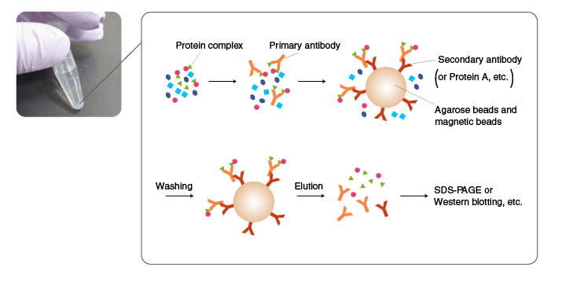
Figure 3. This figure is showing the process of co-Immunoprecipitation, using FLAG antibodies to find sRNA.

Discussion
There are known hfq binding sRNAs but nothing is known about if there are sRNAS specific to Y. pestis. This would further our knowledge on further regulating crp since it would be detrimental to the bacterium if this gene were to be mutated or knocked out(Berry and Hochschild 2018).
It would be expected that There is not an extensive knowledge on specific sRNAs but it is known that they are regulators of gene expression. This information could possibly contribute to helping alleviate this bacterium since we would know the specific sequence needed for a specific mRNA of cpr. More so this would help with furthering our understanding because this bacterium may have a slightly different regulation process so that maybe the different processes can be compared.

References

Lathem, W. W. et. al. “Posttranscriptional Regulation of the Yersinia pestis Cyclic AMP Receptor Protein Crp and Impact on Virulence”. mBio, 5(1), pp.e01038–13. (2014)

Salvail, H. et al., 2013. Antagonistic functions between the RNA chaperone Hfq and an sRNA regulate sensitivity to the antibiotic colicin. EMBO Journal, 32(20), pp.2764–2778.

Santiago-Frangos, A. et al., 2016. C-terminal domain of the RNA chaperone Hfq drives sRNA competition and release of target RNA. Proceedings of the National Academy of Sciences of the United States of America, 113(41), pp.E6089–E6096.

Fröhlich, Kathrin Sophie et al. “A small RNA activates CFA synthase by isoform-specific mRNA stabilization.” The EMBO journal vol. 32,22 (2013): 2963-79. doi:10.1038/emboj.2013.222

Sharma, C.M. et al., 2011. Pervasive post‐transcriptional control of genes involved in amino acid metabolism by the Hfq‐dependent GcvB small RNA. Molecular Microbiology, 81(5), pp.1144–1165.

Hironori Otaka et al., 2011. PolyU tail of rho-independent terminator of bacterial small RNAs is essential for Hfq action. Proceedings of the National Academy of Sciences, 108(32), pp.13059–13064.
Berry, Katherine E, and Ann Hochschild. "A Bacterial Three-hybrid Assay Detects Escherichia Coli Hfq-sRNA Interactions in Vivo." Nucleic Acids Research 46.2 (2018): E12. Web.

Gomes ,A, Korf, Br. Chapter 5 -Genetic Testing Techniques. Pediatric Cancer Genetics. 2018. Pg 47-64.

Wurtele, E. S., Nikolau, B. J,. [26] - Characterization of 3-Methylcrotonyl-CoA Carboxylase from Plant. Methods in Enzymology. 2000. Vol 324, pg 280-292.

