Disruption of Angiopoietin-1 and α_{v}β₃ Integrin Interaction in Tie1, Tie2, Ang-1 and α_{v}β₃ Integrin complexes
Color: Red- Jeff’s comments
Blue- Kyle’s comments
Bold: primary proteins that under investigations, or experiment steps
Italic: words that have definition or extra information in Glossary section

Introduction:
Cancer is the second leading cause of death worldwide. Estimation of 9.6 million deaths globally, 6 hundred-thousand deaths and 1.7 million new cases diagnosed in the US in 2018 ^{(34,35)}. At some point in their lives, 38.4% of the population will be diagnosed with cancer. Cancer care expenditures reached $147.3 billion in 2017 ³⁵.
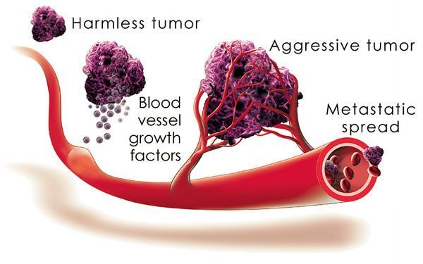
Fig.1. Angiogenesis in tumor cells
Cancer is a disease when cells in one’s own body has gone wrong. In the early development of cancer, a clump of cancer cells cannot grow larger than a certain size by diffusion. Absorption of nutrients from the environment and waste removing through their surface area are no longer sufficient. A different mass movement mechanism is required (Fig.1): inducing and maintaining blood and lymph vessels grown from nearby vessels (angiogenesis) and connected to the host circulation system ³⁶. An extensive molecular knowledge of main angiogenesis pathways is desired to control cancer angiogenesis, ultimately to limit the growth of tumor.

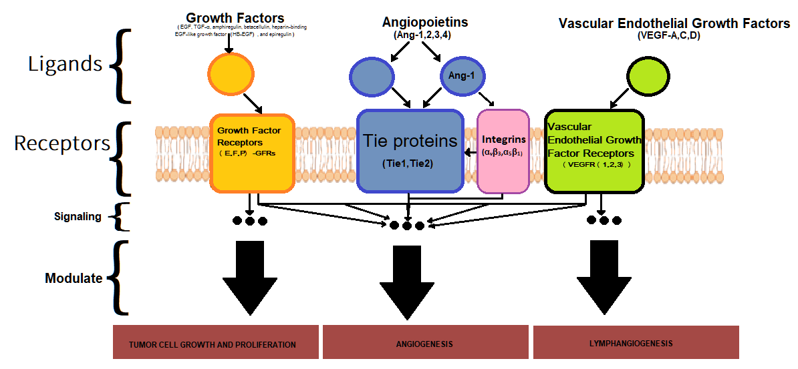
Fig.2. Schematic diagram of main angiogenesis pathways. Redrawn from ³⁷, with added information from ^{(3,39)}.
Tie receptors and their ligands Angiopoietins play a crucial role in regulating tumor-induced angiogenesis (Fig.2) ³². The receptor tyrosine kinase Tie2 (RTK-Tie2) is a transmembrane receptor protein. High expression of Tie2 receptor in endothelial cells is crucial for angiogenesis and vessels maintenance ²³. Angiopoietin-1 (out of 4) Tie2 protein ligands (Ang1-4), has been recognized as the primary activating ligand for Tie2, is a constitutive receptor agonist ^{(23,24)}. In endothelial cells, activation of Tie2 by binding of Ang-1 at the ectodomain causes auto-phosphorylation which subsequently leads to the activation of a number of intracellular signaling pathways; ultimately resulting in endothelial cell migration ^{(27,28)}, tube formation ³⁰, sprouting ²⁹ and cell survival ²⁸. Tie1, is a transmembrane protein and biological homologous to Tie2, however does not directly interact with any angiopoietins ²⁵. Studies in mice shows that subjects that have a lack of Tie1 likely suffer pulmonary edema, vessel integrity defects, localized hemorrhaging, and die in utero. Tie1 is speculated to play a role in vessel integrity. However, exact role of Tie1 in angiogenesis is still unknown.
Studies have shown that there is an association between Tie1 and Tie2 on the cell surface, prior to ligand recognition ⁴. In the presence of Tie1, Tie2 basal activation is drastically decreased (~50% compared to no Tie1) ⁴. Ang1 and Ang2 exhibit different roles when interacting with the Tie1/Tie2 complex. Ang-2 when bound to the heterodimer complex exhibits an antagonistic characteristic (Fig.3.C), compared to an agonist role without the presence of Tie 1 (Fig.3.A). The binding of Ang-1 to Tie2 in the heterodimer complex however promotes heterodimer dissociation, forming Tie2 cluster, and signaling initiation (Fig.3.B) ⁴.

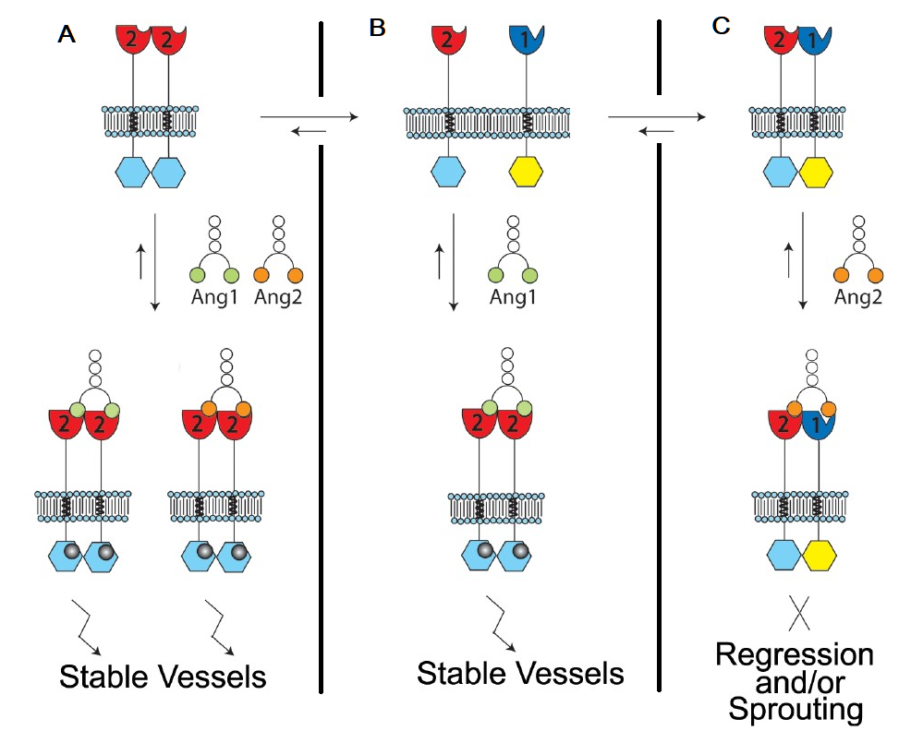
Fig.3. Model for Angiopoietin-mediated Tie2 signaling⁴
Ang-Tie system certainly is an important drug target to treat tumor. Drugs that are broad-spectrum inhibitors of RTKs (including Tie2) ^{(40,42)}: Cabozantinib, Lenalidomide, Regorafenib… Inhibiting Angiopoietin 1 & 2 interaction with their receptor Tie2 ⁴¹: Trebananib. Compound treatments target different pathways and interactions. Therefore, it is necessary to study and explore different potential drug targets.
Recent studies have revealed an association between Ang-Tie system and the Integrins. Tie1 and Tie2 are freely but mutually exclusive interact with the Integrins α₅β₁ and α_{V}β₃ through their ectodomains (i.e. they are competing for binding with integrin (Fig.5.row5.column 1 and 2) ³. The Integrins are membrane protein, that link actin inside the cell to the matrix protein outside of the cell ⁵².
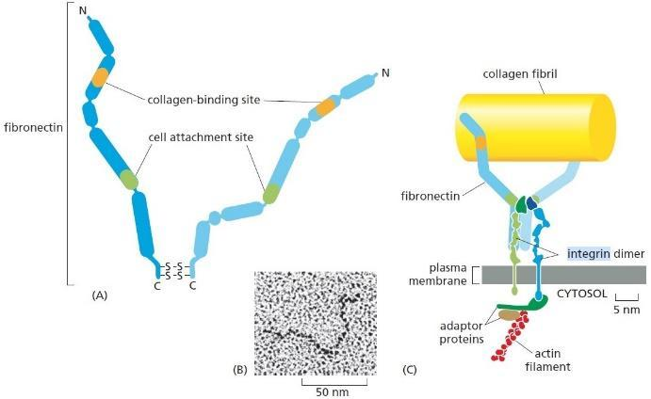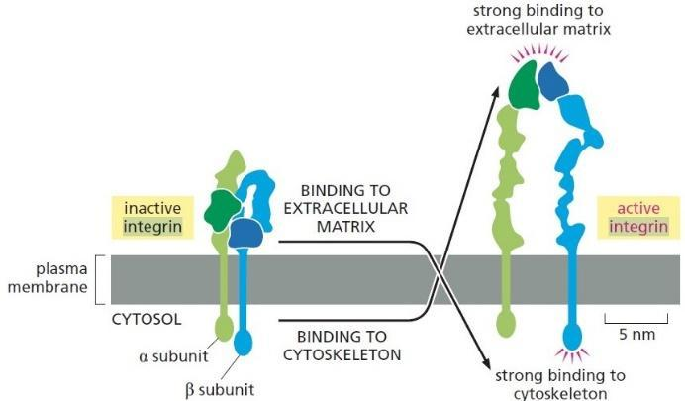
Fig.3.1. Integrins functions and different conformations
Integrin-Tie recognition may help split up the Tie1/Tie2 complex ³. Tie-integrin recognition is direct and independent of the presence of Ang ligands, only the Tie2 ligand Ang-1 receptor binding domain can interact with α₅β₁ and α_{V}β₃³. Association of Tie2-integrin complex is dramatically enhanced in the presence of the extracellular component and integrin ligand fibronectin. Furthermore, Ang1-RBD-Fc (receptor-binding domain-fragment crystallizable) is shown to be also capable to independently bind to integrin proteins (Fig.5.row 5.colum 3)regardless of Tie2 presence ³. Association with Integrin raise Tie2 sensitivity to of Ang1³ ⁽Fig.5.row 6).
Studies have also suggested a function for angiopoietin ligands that are dependent on integrin but independent of Tie2⁽¹⁷⁻¹⁹⁾. Angiopoietins induced effects also have been described in cardiomyocytes, breast cancer cells, and neurons that Tie2 is not expressed ⁽⁴³⁻⁴⁷⁾.
This proposal explores the potential of disrupting Integrin (α_{V}β₃) and Ang-1 association in altering and potentially (speculatively) lowering Tie2 autophosphorylation.
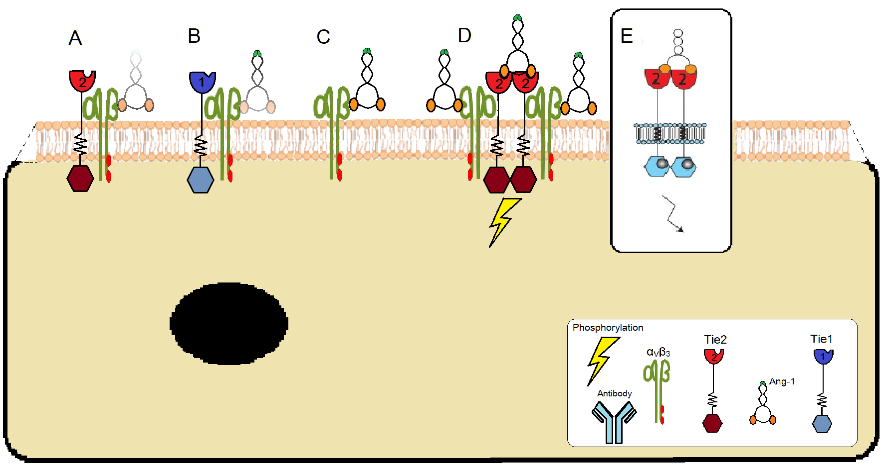
Fig.4. Model for associations of Tie1, Tie2, and Ang-1 with αVβ3 integrin.
(A) Tie2 does not affect ability of Ang-1 to bind to α_{V}ß₃
(A, B) Ang ligands do not affect Tie/integrin interactions, Tie1 and Tie2 compete for binding
(C) Ang1 can bind to the integrin proteins with or without the presence of Tie2
(D) & (E) Tie2 - integrin association promote activation of Tie2 to lower concentrations of Ang-1
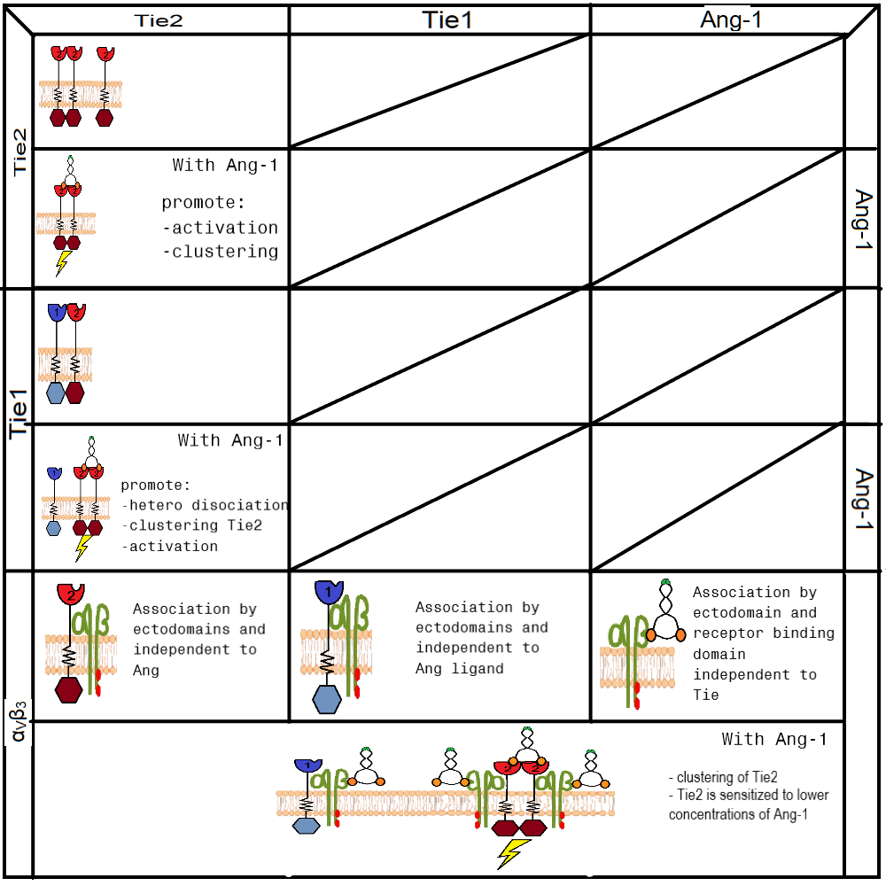
Fig.5. Summary

The Experiment:

Overview:
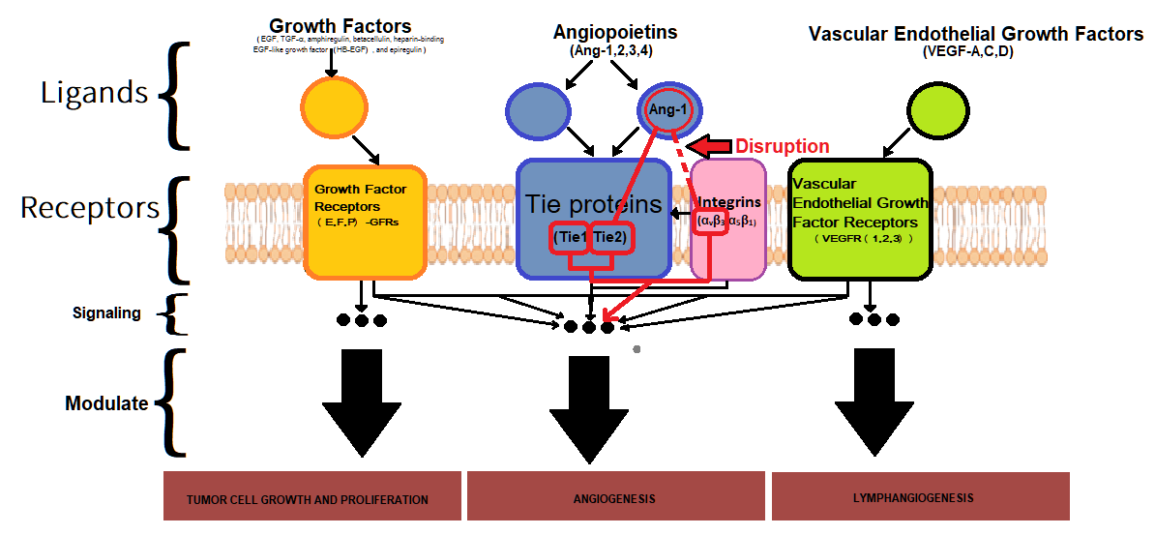
Fig.7. Schematic diagram of experiment
- Making antibody for Ang-1
- Test to the interactions between Tie2 – Ang-1 and α_{V}ß₃ - Ang-1 with antibodies:
  - Confirming Antibody – Ang1 Binding
  - Association between Tie2 – Ang-1 and αVß3 - Ang-1 with presence of antibodies.
- Select a specific antibody that blocks ONLY the association between α_{V}ß₃ and Ang-1,
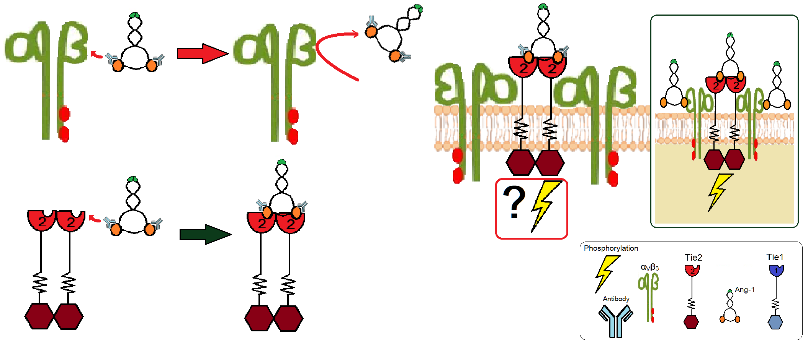
- Test the influences of selected antibody on Ang-1 activity, and Tie2 activity.

Fig.8. Model of disruption of Angiopoietin-1 and αvβ3 integrin interaction by antibodies

Step I: Making antibodies for Ang-1
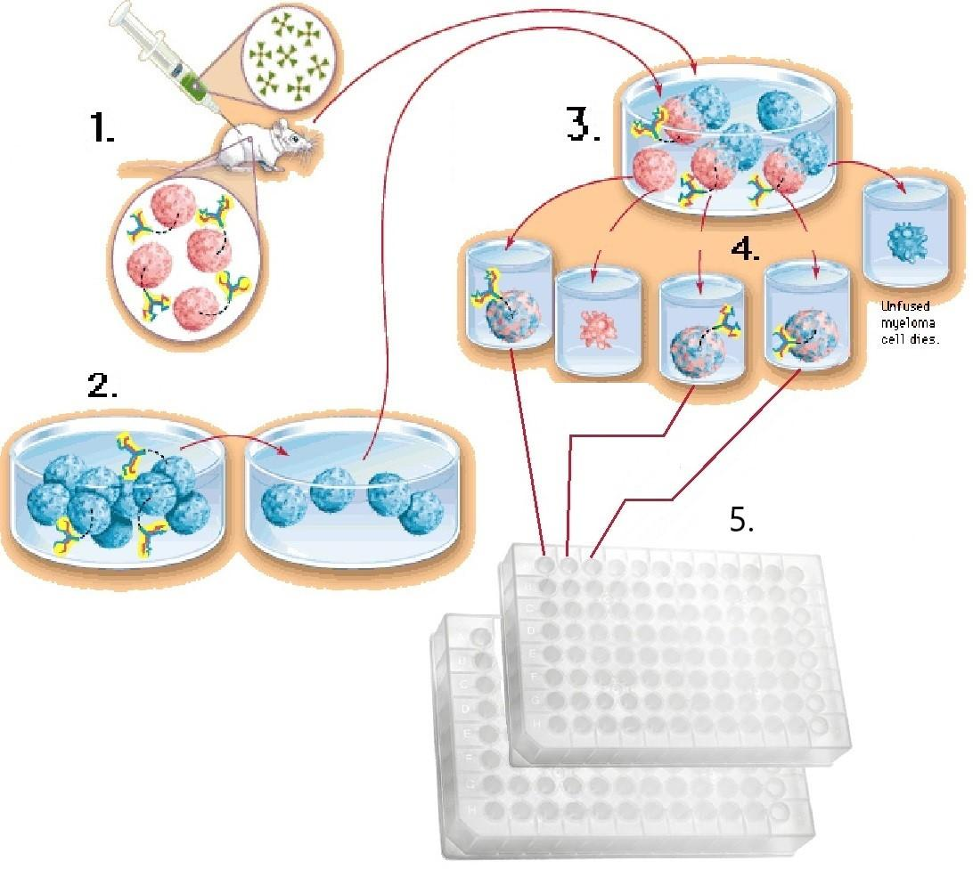
Fig.9. Making Antibodies: general steps ⁴⁸⁻⁴⁹.
1.Mouse is injected with Angiopoietin-1, mouse spleen produces plasma cell that product and secrete antibodies against Ang-1.
2. Select Myeloma cells (cancerous plasma cells) that can’t produce antibodies [See more, 4.1 Preparation of Myeloma Cells]
3. Plasma cells from the spleen are isolated and mixed with Myeloma cells to induce cell fusion, resulting in Hybridomas
4. Hybridomas are grown in HAT medium. Cells that successfully fused (once they are fused successfully, they are alive, producing and secreting antibodies) are selected and unfused cells are discarded.
5. Hybridomas that survived are then transferred to 96-well plates with HAT medium one cell in each well. Each plate acts as a monoclonal culture, each hybridoma in a well (inherit the longevity of Myeloma cells) replicates, produces and secretes monoclonal antibodies. THESE PLATES WILL SERVE AS THE ORIGINAL TEMPLATES.
6. Making copies of the original templates, the copy’s supernatants (which contain secreted antibodies) will be used for the rest of the experiment instead of the originals to conserve and prevent contamination in the original sources.
[If the cells are stuck to the wells, then you should be able to use copies of these plates for Steps II through IV, much simpler.]
I do not know if the cell will be stuck to the wells, to be safe I will follow the ELISA protocol to prepare the ELISA plates instead.

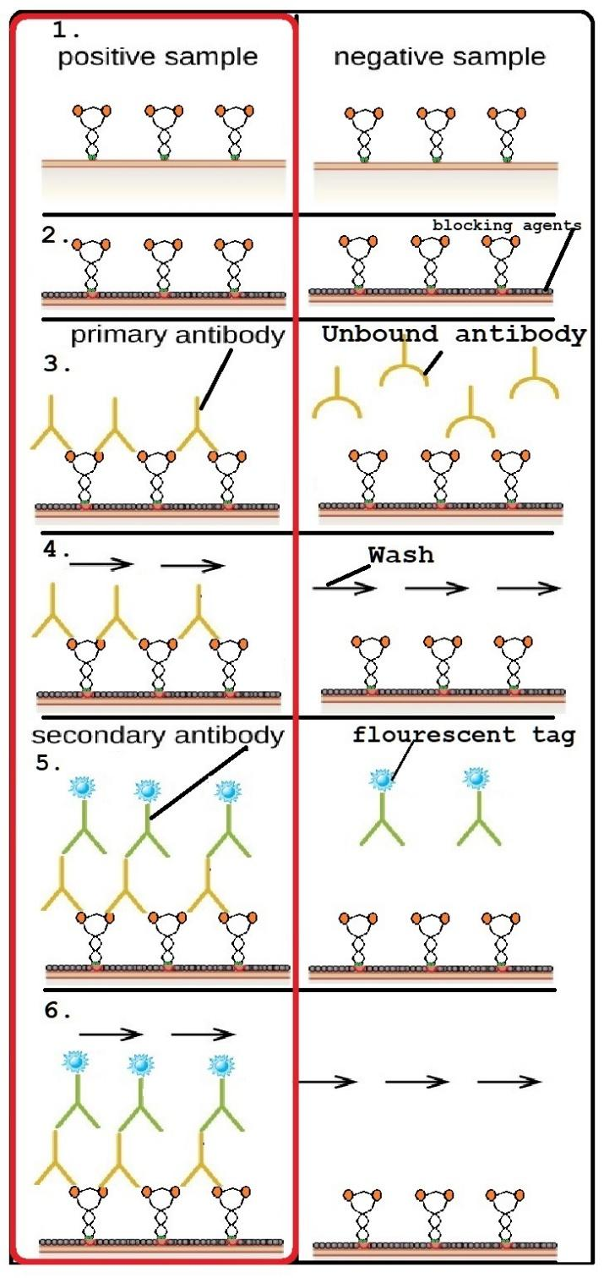
Step II: Confirming Antibody – Ang1 Binding
Fig.10. Confirming Antibody – Ang1 Binding by Indirect ELISA
      - Coating antigen to microplate:
ELISA fresh microplates (plates with protein-binding sites on the surface) are set up in the same arrangement as the original templates (96-well plates) from Step I to facilitate uniformity.
Angiopoietin-1 is added to coat the fresh plates
[following general protocol: Indirect-ELISA]
      - Blocking:
Blocking buffer and 5% non-fat dry milk (available in the ELISA kit) is added to cover the rest of the protein-binding sites on the plates’ surfaces; the coverage by blocking agents prevent any additional proteins in the following steps to adhere to the plate surface.
[following general protocol: Indirect-ELISA]
      - Adding primary antibody:
The supernatants from each well from the copy in Step I.6 (each contains monoclonal antibody) are individually pipetted into Step II.2 Ang-1 coated plates in the following fashion:
Step I.6. Well#1 supernatant to Step II. Well #1
Step I.6. Well#2 supernatant to Step II. Well #2
And so-forth
      - Wash:
Using Phosphate-buffered saline (PBS) buffer to wash away antibodies that don’t bind well to Ang-1 that anchored on the plates.
- Adding secondary antibody:
Secondary antibody with fluorescent tag (store-bought with green-fluorescent Alexa Fluor® 488 dye molecule: See more) is added to all Step II microplates. The secondary antibody binds to Fc region of primary antibody.
[see more]
- Wash:
Using PBS to wash all the wells, unbound secondary antibody, this step may be repeated.
- Visualization:
High energy light (UV) is used to read the ELISA plates. Plates emitting strong fluorescent light indicate the binding of primary antibody to Ang-1 (left panel in red), are selected. The copy plates in Step I.6 will be marked “Step II: selected” accordingly to the selected plates:
For example: if ELISA well #1 emit a strong fluorescent, Step I.6 well #1 is marked “Step II: selected”.

In vitro: Association between Tie2 – Ang-1 and α_{V}ß₃ - Ang-1 with presence of antibodies.

Step III: Tie2 – Ang-1
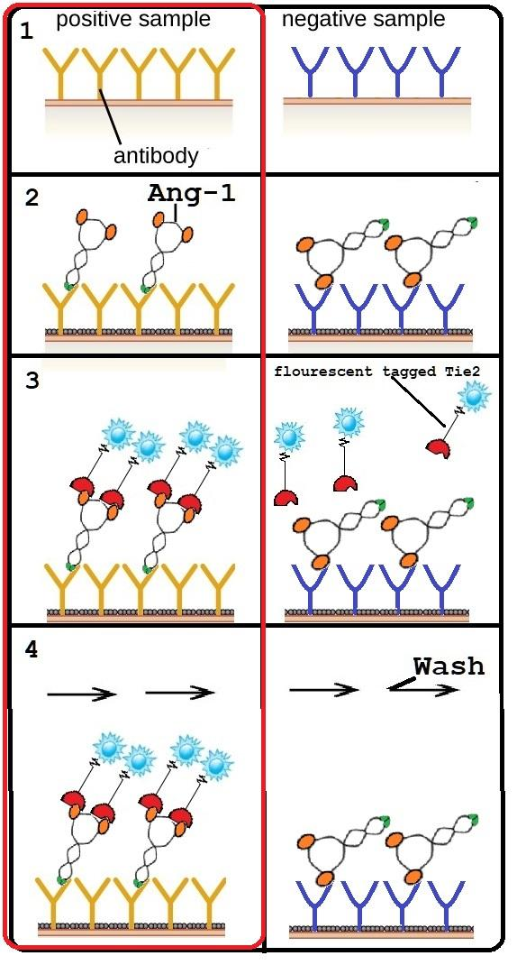
Fig.11. In vitro: Confirming Antibody – Ang1 Binding with Tie2 by modified ELISA
1. Coating antibody to microplate:
ELISA fresh microplates (plates with protein-binding sites on the surface) are set up in the same arrangement as the original templates (96-well plates) from Step I to facilitate uniformity.
Selected wells’ supernatants from step II.7 is added to coat the fresh plates.
NOTE: Step III and IV started with the same set up. This step is repeated to prepare for Step IV.1
For example:
Step I.6 marked “Step II: selected” well #1 supernatant is used to coat Step III.1 fresh well#1
Well #2 and #3 are not marked therefore skipped
Step I.6 marked “Step II: selected” well #4 supernatant is used to coat Step III.1 fresh well#4… and so forth
[following general protocol: Sandwich-ELISA]
2. Adding of Ang-1:
Ang-1 is added to all the coated wells in step III.1
3. Adding Ectodomain Fluorescent-tagged Tie2:
Ectodomain Fluorescent-tagged Tie2 [using Protein Labeling Kits store-bought with green-fluorescent Alexa Fluor® 488 dye molecule] to all the wells in step III.2. Left panel depicts antibody that bind Ang-1 in a way that the receptor binding domain of Ang-1 is still available for the binding of Tie2.
4. Wash:
Using PBS to wash all the plates, unbound Tie2 is washed away.
5. Visualization:

High energy light (UV) is used to read the ELISA plates. Plates emitting strong fluorescent light indicate the binding of Fluorescent-tagged Tie2 to Ang-1 (left panel in red), are selected. The copy plates in Step I.6 will be marked “Step III: selected” accordingly to the selected plates:
For example: if ELISA well #4 emits a strong fluorescence, Step I.6 well #4 is marked “Step III: selected”.

Step IV: α_{V}ß₃ – Ang-1
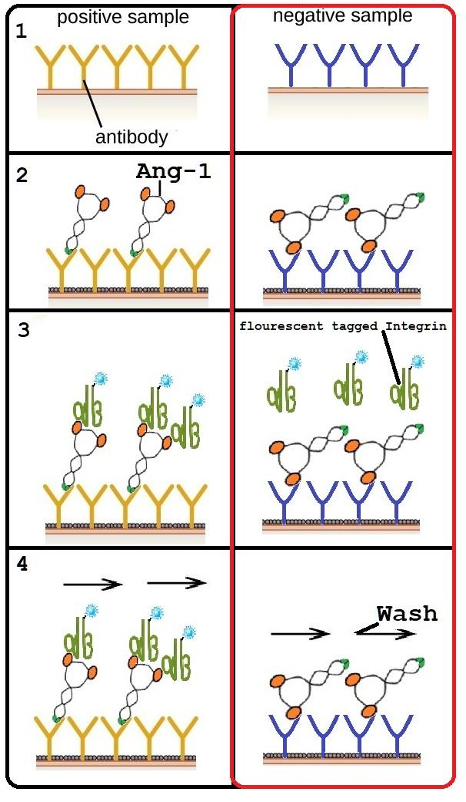
Fig.12. In vitro: Confirming Antibody – Ang1 Non-Binding with αVß3 integrin by modified ELISA
1. Coating antibody to microplate:
Copy plates are prepared in step III.1
2. Adding of Ang-1:
Ang-1 is added to all the coated wells in step IV.1
3. Adding Ectodomain Fluorescent-tagged Integrin α_{V}ß₃:
Ectodomain Fluorescent-tagged Integrin α_{V}ß₃ [using Protein Labeling Kits store-bought with green-fluorescent Alexa Fluor® 488 dye molecule] to all the wells in step IV.2. Left panel depict antibody that bind Ang-1 in a way that the receptor binding domain of Ang-1 is still available for the binding of Integrin α_{V}ß₃. However, in Step IV, the desirable result is depicted in the right panel: antibody that bind Ang-1 in a way that the receptor binding domain of Ang-1 is NOT available for the binding of Integrin α_{V}ß₃
4. Wash:
Using PBS to wash all the plates, unbound Integrin is washed away.
5. Visualization:

High energy light (UV) is used to read the ELISA plates. Plates emitting strong fluorescent light indicate the binding of Fluorescent-tagged Integrin to Ang-1 (left panel), are skipped. Plates that emit weak to no fluorescent light, which indicate the disruption of Fluorescent-tagged Integrin to Ang-1 (right panel), are selected. The copy plates in Step I.6 will be marked “Step IV: selected” accordingly to the selected plates:
For example: if ELISA well #4 does not emit fluorescent, Step I.6 well #4 is marked “Step IV: selected”.

Step III-IV: results comparison
Since the results of both step III and step IV are documented in the copy made in step I.6, this step is about selecting wells that are both selected by step III and step IV (i.e. samples that are marked “Step III: selected” and “Step IV: selected”). The wells that are qualified for both steps will be marked “III-IV: selected” and their monoclonal antibody will be used in step V, VI and VII.

(Optional) In vivo: Association between Tie2 – Ang-1 and α_{V}ß₃ - Ang-1 with presence of antibodies.

Step V: Tie2 – Ang-1
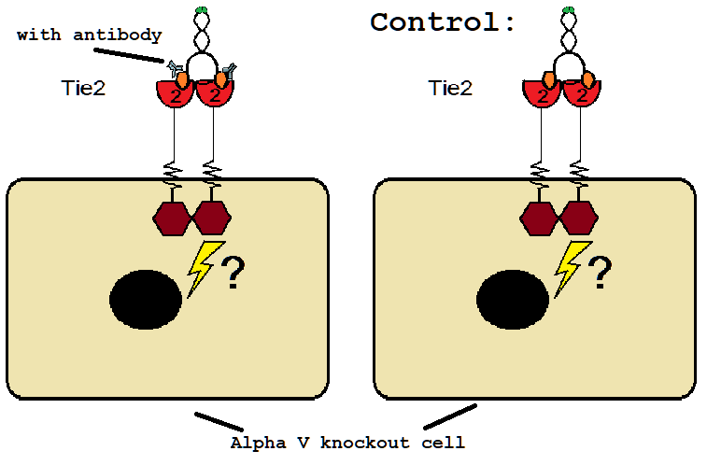
Goal: to ensure the activation of Tie2 by Ang-1 is not impaired by the antibody.
Using cell without α_{V}ß₃ expression to test Tie2 activation without integrin’s interference. Only knockout α_{V} is enough to bringdown α_{V}ß₃ complex
Knockout α_{V} can be ordered through a couple companies [similar products: See more]
Fig.13. In vivo: Confirming Antibody – Ang1 Binding with Tie2 in α_{V} knock off cells
In α_{V} knock out cells Subject: Ang-1 is added with the presence of one of the antibodies selected from steps III-IV.
Control: Ang-1 is added without the presence of antibody.

Phosphorylation of Tie2 in both samples are measured using Western Blotting with Anti-phosphotyrosine immunoprecipitates (described in step VII). Antibodies that give the same reading with control, meaning they don’t affect Tie2 phosphorylation activity, are selected.

Step VI: α_{V}ß₃ – Ang-1
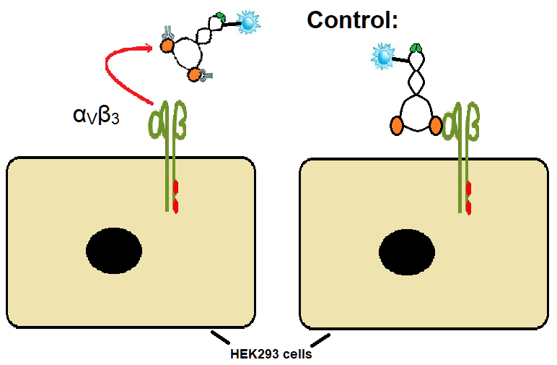
Fig.14. In vitro: Confirming Antibody – Ang1 Binding with αVß3 integrin in HEK293 cell line (lack of tie receptors)
In HEK293 cells:
Subject: fluorescent-tagged Ang-1 [using Protein Labeling Kits store-bought with green-fluorescent Alexa Fluor® 488 dye molecule] is added with the presence of antibody selected from steps III-IV.
Control: fluorescent-tagged Ang-1 is added without the presence of antibody
Washing the samples and using microscope to observe the fluorescent on the cell surface, antibodies that do not attach to integrin are selected (no fluorescent is observed in the cell).

Step V-VI: results comparison
Antibodies that were selected from both Step V and Step VI will qualify:
      - Bind to Ang-1 but don’t affect activation of Tie2
      - Unable to bind to Integrin α_{V}ß₃
And they are ready to go to step VII

Step VII: Measure Tie2 activity in presence of Ang-1 antibody and Integrin α_{V}ß₃
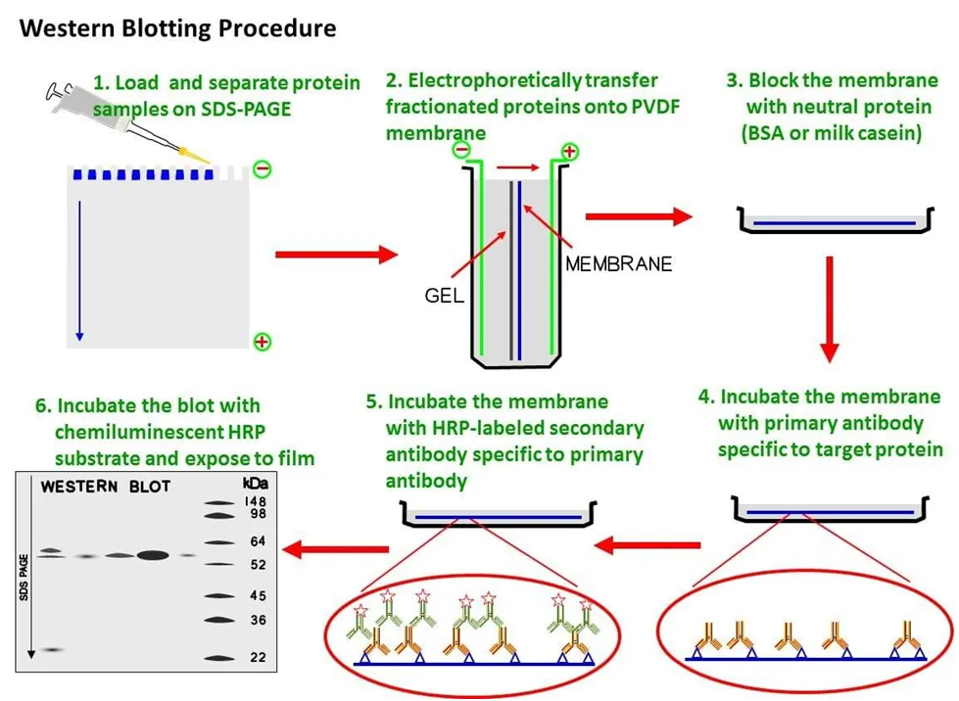
Fig.15. Western Blotting with Anti-phosphotyrosine immunoprecipitates as primary antibody⁵¹
      - Protein samples prepared and separation:
Each well column are loaded with the following compositions:
Reference columns:

Column 1: Tie2
Column 2: α_{V}ß₃
Column 3: α_{V}ß₃ + Tie2
Column 4: Ang-1
Column 5: Ang-1 + α_{V}ß₃
Column 6: Ang-1 + Tie2
Column 7: α_{V}ß₃ +Tie2 with Ang-1

Test column:
Column 8: Integrin+Tie2 with Ang-1 and the antibody selected from step V-VI (or step III-IV )
Using gel electrophoresis to separate protein by weight. Charged protein transported through the gel by an electric field.
      - Transfer to membrane:
Once separated, all the proteins are transferred to a membrane (by another electric field) which supports protein detection
      - Blocking:
Adding blocking agent to the membrane to prevent the antibody from sticking to the membrane
      - Addition of primary antibody:
00 (Ptyr) (store-bought: See more) is added as the primary antibody. Anti-phosphotyrosine antibody recognizes tyrosine phosphorylated proteins (Tie2 autophosphorylation in this experiment ⁵³. Then the membrane is washed off excess unbound primary antibodies by PBS buffer.
      - Addition of secondary antibody:
Secondary antibody tagged with fluorescent tag (store-bought with green-fluorescent Alexa Fluor® 488 dye molecule: See more) is added, then washed off any excess. This secondary antibody is specific to the primary antibody (like binding to the Fc region of the primary antibody)
      - Visualization:
Expose the membrane to UV light to get the reading

Discussion:

Predictions:
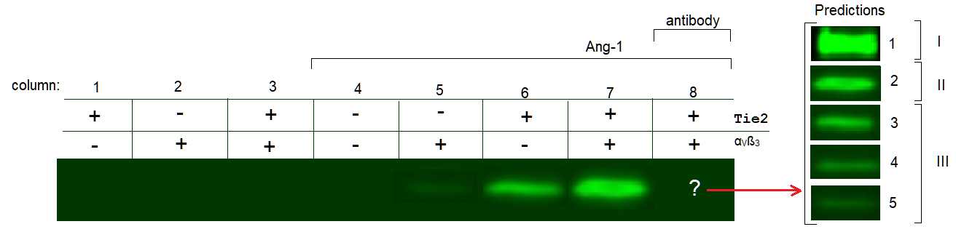

Fig.16. Predictions of Tie2 activities with/without presence of antibody that disrupts Integrin αVß3 -Ang1 association by Western blotting.
Prediction I: Higher level of Tie2 autophosphorylation
- Speculation:
  - Could be a result from more Ang-1 molecules available, since they don’t have to bind to Integrin, and the association of Ang-1 to Integrin doesn’t affect Tie2 clustering, and/or Tie2 more sensitive to Ang-1; i.e. Integrin by itself (without binding to Ang-1) can facilitate Tie2 clustering and/or Tie2 higher sensitivity to Ang-1.
  - Disrupting the Ang-1/ α_{V}ß₃ can’t be used as an inhibitory method to Tie2 activation.

Prediction II: Same level of Tie2 autophosphorylation
- Speculation:
  - Could be a result from more Ang-1 molecules available, since they don’t have to bind to Integrin. However, the association of Ang-1 to Integrin slightly lower Tie2 clustering, and/or Tie2 more sensitive to Ang-1; i.e. Integrin by itself (without binding to Ang-1) can facilitate Tie2 clustering and/or Tie2 higher sensitivity to Ang-1 but not effective, results in the same level of Tie2 autophosphorylation.
  - Disrupting the Ang-1/ α_{V}ß₃ can’t be used as an inhibitory method to Tie2 activation.
Prediction III: Lower level of Tie2 autophosphorylation
- Speculation:
  - Despite of higher level of Ang-1 molecules available (blocked from binding to Integrin), it could be that the association of Ang-1 to Integrin significantly lower Tie2 clustering, and/or Tie2 more sensitive to Ang-1; i.e. Integrin by itself (without binding to Ang-1) can’t facilitate Tie2 clustering and/or Tie2 higher sensitivity to Ang-1, and/or affect the ability to disrupt heterodimer tie2-tie1, results in the lower level of Tie2 autophosphorylation.
  - Disrupting the Ang-1/ α_{V}ß₃ can be used as an inhibitory method to Tie2 activation.

Final words:
The experiment only looks at the level of autophosphorylation of Tie2 in association with α_{V}ß₃ by its ligand Ang-1 (in which α_{V}ß₃ does not bind to Ang-1). The effects of Ang-1 on α_{V}ß₃ and how that affects Tie-2 activation is not in the scope of this experiment.
If by blocking Ang-1 binding to α_{V}ß₃ lowers Tie2 activation, it could become a new drug target. Thus, it can be coupled with other Tie2 inhibitors to create compounded medication.

Glossary:
α_{x}ß_{y}: integrin proteins, composed of α and ß peptide chains.
Agonist: a chemical that binds to a receptor and activates the receptor to produce a biological response.
Prefix: Angio-
relating to (blood) vessels.
Angiogenesis: Forming of blood vessels.
Angiopoietins: ligands of Tie receptors
Antibody: a blood protein produced in response to and counteracting a specific antigen
Auto-phosphorylation: is a biochemical process in which a phosphate group is added to a protein kinase by the action of the protein kinase itself
Cardiomyocyte: cells responsible for generating contractile force in the intact heart
Ectodomain: is the part of a membrane protein that extends into the space outside the cell
ELISA: enzyme-linked immunosorbent assay, a technique designed for detecting and quantifying substances such as peptides, proteins, antibodies and hormones. See more
Endogenous: within an organism
Endothelial: cells that line the interior surface of vessels
Fc region of antibody: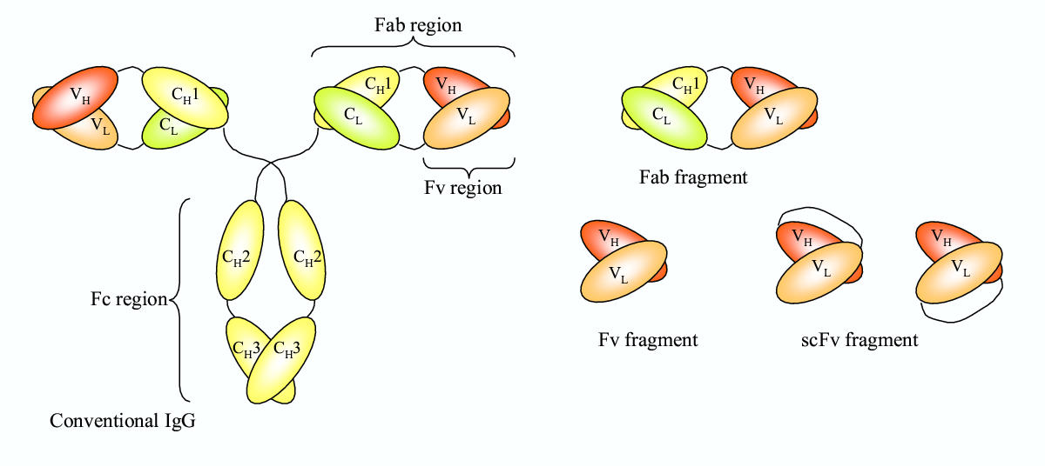
See more.
HAT medium: is a selection medium for mammalian cell culture. See more
Heterodimer dissociation: in this context, it means the dissociation of Tie1-Tie2 complex
Hybridoma: B cell, produces antibodies fused with immortal B cell cancer cells, a myeloma to produce a hybrid cell line called a hybridoma, which has both the antibody-producing ability of the B-cell and the longevity and reproductivity of the myeloma.
Monoclonal: clone that is derived asexually from a single individual or cell.
Phosphate-buffered saline (PSS): is a buffer solution commonly used in biological research. It is a water-based salt solution containing disodium hydrogen phosphate, sodium chloride and, in some formulations, potassium chloride and potassium dihydrogen phosphate. See more
Pulmonary edema: excess fluid swelling in the lungs.
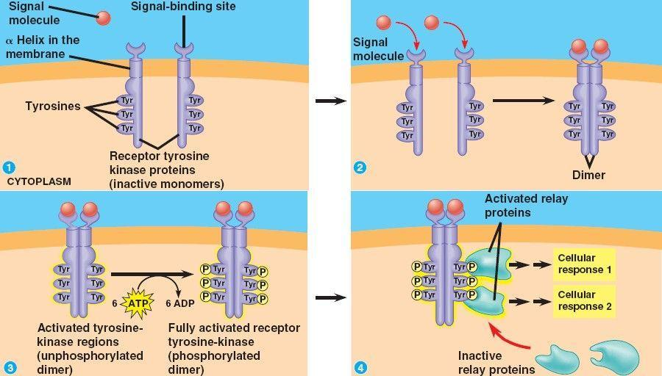
Receptor Tyrosine Kinases (RTKs): “Protein tyrosine kinases are enzymes that are capable of adding phosphate groups to specific tyrosines on target proteins. A receptor tyrosine kinase (RTK) is a tyrosine kinase located at the cellular membrane and is activated by binding of a ligand via its extracellular domain.”³⁸
Tie: primary receptor for angiopoietin ligands, a type of endothelial cells protein tyrosine kinase play a crucial role for angiogenesis and vascular maintenance
Utero: in the womb

References:
- Barton, William & Tzvetkova-Robev, Dorothea & Miranda, Edward & Kolev, Momchil & Rajashankar, Kanagalaghatta & Himanen, Juha & Nikolov, Dimitar. (2006). Crystal structures of the Tie2 receptor ectodomain and the angiopoietin-2-Tie2 complex. Nature structural & molecular biology. 13. 524-32. 10.1038/nsmb1101.
- Barton, William & Dalton, Annamarie & Seegar, Tom & Himanen, Juha & Nikolov, Dimitar. (2014). Tie2 and Eph Receptor Tyrosine Kinase Activation and Signaling. Cold Spring Harbor perspectives in biology. 6. 10.1101/cshperspect.a009142.
- Dalton, Annamarie & Shlamkovich, Tomer & Papo, Niv & Barton, William. (2016). Constitutive Association of Tie1 and Tie2 with Endothelial Integrins is Functionally Modulated by Angiopoietin-1 and Fibronectin. PLOS ONE. 11. 10.1371/journal.pone.0163732.
- Seegar, Tom & Eller, Becca & Tzvetkova-Robev, Dorothea & Kolev, Momchil & Henderson, Scott & Nikolov, Dimitar & Barton, William. (2010). Tie1-Tie2 Interactions Mediate Functional Differences between Angiopoietin Ligands. Molecular cell. 37. 643-55. 10.1016/j.molcel.2010.02.007.
- Yu, Xuehong & Seegar, Tom & Dalton, Annamarie & Tzvetkova-Robev, Dorothea & Goldgur, Yehuda & Rajashankar, Kanagalaghatta & Nikolov, Dimitar & Barton, William. (2013). Structural basis for angiopoietin-1-mediated signaling initiation. Proceedings of the National Academy of Sciences of the United States of America. 110. 10.1073/pnas.1216890110.
- Thermo Fisher, Antibody production and purification guide
- Adams RH, Alitalo K. Molecular regulation of angiogenesis and lymphangiogenesis. Nat. Rev. Mol. Cell. Biol. 2007; 8: 464±478. doi: 10.1038/nrm2183 PMID: 17522591
- Potente M, Gerhardt H, Carmeliet P. Basic and therapeutic aspects of angiogenesis. Cell. 2011; 146: 873±887. doi: 10.1016/j.cell.2011.08.039 PMID: 21925313
- Cascone I, Napione L, Maniero F, Serini G, Bussolino F. Stable interaction between alpha5beta1 integrin and tie2 tyrosine kinase receptor regulates endothelial cell response to ang-1. J. Cell. Biol. 2005; 170: 993±1004. doi: 10.1083/jcb.200507082 PMID: 16157706
- Felcht M, Luck R, Schering A, Seidel P, Srivastava K, Hu J, et al. Angiopoietin-2 differentially regulates angiogenesis through tie2 and integrin signaling. J. Clin. Invest. 2012; 122: 1991±2005. doi: 10.1172/ JCI58832 PMID: 22585576
- Thomas M, Felcht M, Kruse K, Kretschmer S, Deppermann C, Biesdorf A, et al. Angiopoietin-2 stimulation of endothelial cells induces alphavbeta3 integrin internalization and degradation. J. Biol. Chem. 2010; 285: 23842±23849. doi: 10.1074/jbc.M109.097543 PMID: 20519501
- Brooks PC, Clark RA, Cheresh DA. Requirement of vascular integrin alphav beta3 for angiogenesis. Science. 1994; 264: 569–571. doi: 10.1126/science.7512751 PMID: 7512751
- Tanjore H, Zeisberg EM, Gerami-Naini B, Kalluri R. Beta1 integrin expression on endothelial cells is required for angiogenesis but not for vasculogenesis. Dev. Dynam. 2008; 237: 75–82. doi: 10.1002/ dvdy.21385 PMID: 18058911
- van der Flier A, Badu-Nkansah K, Wittaker CA, Crowley D, Bronson RT, Lacy-Hulbert A, et al. Endo-thelial alpha5 and alphav integrins cooperate in remodeling of the vasculature during development.Development. 2010; 137: 2439–2449. doi: 10.1242/dev.049551 PMID: 20570943
- Seegar TCM, Eller B, Tzvetkova-Robev D, Kolev MV, Henderson SC, Nikolov DB, et al. Tie1-tie2 inter-actions mediate functional differences between angiopoietin ligands. Mol. Cell. 2010; 37: 643–655.doi: 10.1016/j.molcel.2010.02.007 PMID: 20227369
- Yu X, Seegar TCM, Dalton AC, Tzvetkova-Robev D, Goldgur Y, Rajashankar KR, et al. Structural basis for angiopoietin-1-mediated signaling initiation. P. Natl. Acad. Sci. USA. 2013; 110: 7205–7210. doi: 10.1073/pnas.1216890110 PMID: 23592718
- Carlson TR, Hu H, Braren R, Kim YH, Wang RA. Cell-autonomous requirement for beta1 integrin in endothelial cell adhesion, migration and survival during angiogenesis in mice. Development. 2008; 135: 2193–2202. doi: 10.1242/dev.016378 PMID: 18480158
- Tanjore H, Zeisberg EM, Gerami-Naini B, Kalluri R. Beta1 integrin expression on endothelial cells is required for angiogenesis but not for vasculogenesis. Dev. Dynam. 2008; 237: 75–82. doi: 10.1002/ dvdy.21385 PMID: 18058911
- Lee HS, Oh SJ, Lee KH, Lee YS, Ko E, Kim KE, et al. Gln-362 of angiopoietin-2 mediates migration of tumor and endothelial cells through association with alpha5beta1 integrin. J. Biol. Chem. 2014; 289: 31330–31340. doi: 10.1074/jbc.M114.572594 PMID: 25237190
- Porat RM, Gunewald M, Globerman A, Itin A, Barshtein G, Alhonen L, et al. Specific induction of tie1 promoter by disturbed flow in atherosclerosis-prone vascular niches and flow-obstructing pathologies. Circ. Res. 2004; 94: 394–401. doi: 10.1161/01.RES.0000111803.92923.D6 PMID: 14670840
- Woo KV, Baldwin HS. Role of tie1 in shear stress and atherosclerosis. Trends Cardiovas. Med. 2011; 21: 118–123. doi: 10.1016/j.tcm.2012.03.009 PMID: 22681967
- Woo KV, Qu X, Babaev VR, Linton MF, Guzman RJ, Gazio S, et al. Tie1 attenuation reduces murine atherosclerosis in a dose-dependent and shear stress-specific manner. J. Clin. Invest. 2011; 121: 1624–1635. doi: 10.1172/JCI42040 PMID: 21383501
- Bogdanovic E, Nguyen VP, Dumont DJ. Activation of Tie2 by angiopoietin-1 and angiopoietin-2 results in their release and receptor internalization. J Cell Sci. 2006 Sep 1;119(Pt 17):3551-60. doi: 10.1242/jcs.03077. Epub 2006 Aug 8. PubMed PMID: 16895971.
- Davis, S., Aldrich, T. H., Jones, P. F., Acheson, A., Compton, D. L., Jain, V., Ryan, T. E., Bruno, J., Radziejewski, C., Maisonpierre, P. C. et al. (1996). Isolation of angiopoietin-1, a ligand for the Tie2 receptor, by secretion-trap expression cloning. Cell 87, 1161-1169
- Maisonpierre, P. C., Suri, C., Jones, P. F., Bartunkova, S., Wiegand, S. J., Radziejewski, C., Compton, D., McClain, J., Aldrich, T. H., Papadopoulos, N. et al. (1997). Angiopoietin-2, a natural antagonist for Tie2 that disrupts in vivo angiogenesis. Science 277, 55-60.
- Valenzuela, D. M., Griffiths, J. A., Rojas, J., Aldrich, T. H., Jones, P. F., Zhou, H., McClain, J., Copeland, N. G., Gilbert, D. J., Jenkins, N. A. et al. (1999). Angiopoietins 3 and 4, diverging gene counterparts in mice and humans. Proc. Natl. Acad. Sci. USA 96, 1904-1909.
- Witzenbichler, B., Maisonpierre, P. C., Jones, P., Yancopoulos, G. D. and Isner, J. M. (1998). Chemotactic properties of angiopoietin-1 and –2, ligands for the endothelialspecific tyrosine kinase Tie2. J. Biol. Chem. 273, 18514-18521.
- Jones, N., Master, Z., Jones, J., Bouchard, D., Gunji, Y., Sasaki, H., Daly, R., Alitalo, K. and Dumont, D. J. (1999). Identification of Tek/Tie2 binding partners. J. Biol. Chem. 274, 30896-30905.
- Koblizek, T. I., Weiss, C., Yancopoulos, G. D., Deutsch, U. and Risau, W. (1998). Angiopoietin-1 induces sprouting angiogenesis in vitro. Curr. Biol. 8, 529-532.
- Hayes, A. J., Huang, W. Q., Mallah, J., Yang, D., Lippman, M. E. and Li, L. Y. (1999). Angiopoietin-1 and its receptor Tie-2 participate in the regulation of capillary-like tube formation and survival of endothelial cell. Microvasc. Res. 58, 224-237
- Puri MC, Rossant J, Alitalo K, Bernstein A, Partanen J. The receptor tyrosine kinase TIE is required for integrity and survival of vascular endothelial cells. The EMBO journal 1995;14:5884–5891.[PubMed: 8846781]
- Lin P, Polverini P, Dewhirst M, Shan S, Rao PS, Peters K. Inhibition of tumor angiogenesis using a soluble receptor establishes a role for Tie2 in pathologic vascular growth. The Journal of clinical investigation 1997;100:2072–2078. [PubMed: 9329972]
- Kim KL, Shin IS, Kim JM, Choi JH, Byun J, Jeon ES, Suh W, Kim DK. Interaction between Tie receptors modulates angiogenic activity of angiopoietin2 in endothelial progenitor cells. Cardiovasc Res 2006;72:394–402. [PubMed: 17054925]
- https://www.cancer.gov/about-cancer/understanding/statistics
- https://www.who.int/news-room/fact-sheets/detail/cancer
- Paweletz, N., & Boxberger, H. J. (1994). Defined tumor cell-host interactions are necessary for malignant growth. Critical Reviews in Oncogenesis, 5(1), 69–105. https://doi.org/10.1615/critrevoncog.v5.i1.40
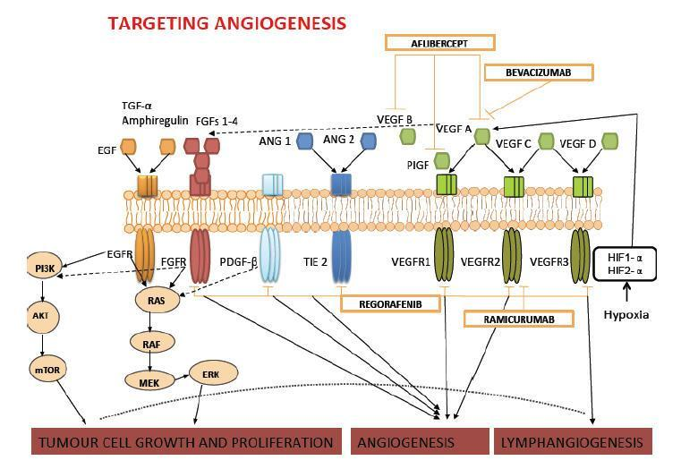
- Khan, K., Cunningham, D., & Chau, I. (2017). Targeting Angiogenic Pathways in Colorectal Cancer: Complexities, Challenges and Future Directions. Current Drug Targets, 18(1), 56–71. https://doi.org/10.2174/1389450116666150325231555

- Department of Neurosurgery, Division of Neuroscience, Graduate School of Medical Science, Kanazawa University, 13-1 Takara-machi, Kanazawa, Ishikawa, 920-8640, Japan. mnakada@med.kanazawa-u.ac.jp
- Nakada M. et al. (2013) Receptor Tyrosine Kinases: Principles and Functions in Glioma Invasion. In: Barańska J. (eds) Glioma Signaling. Advances in Experimental Medicine and Biology, vol 986. Springer, Dordrecht
- Fioramonti, M., Fausti, V., Pantano, F. et al. Cabozantinib Affects Osteosarcoma Growth Through A Direct Effect On Tumor Cells and Modifications In Bone Microenvironment. Sci Rep 8, 4177 (2018) doi:10.1038/s41598-018-22469-5
- Liontos M, Lykka M, Dimopoulos MA, Bamias A. Profile of trebananib (AMG386) and its potential in the treatment of ovarian cancer. Onco Targets Ther. 2014;7:1837–1845. Published 2014 Oct 4. doi:10.2147/OTT.S65522
- Garcia-Manero G, Khoury HJ, Jabbour E, et al. A phase I study of oral ARRY-614, a p38 MAPK/Tie2 dual inhibitor, in patients with low or intermediate-1 risk myelodysplastic syndromes. Clin Cancer Res. 2015;21(5):985–994. doi:10.1158/1078-0432.CCR-14-1765
- Chen X, Fu W, Tung CE, Ward NL. Angiopoietin-1 induces neurite outgrowth of pc12 cells in a tie2-independent, beta1-integrin-dependent manner. Neurosci. Res. 2009; 64: 348±354. doi: 10.1016/j.neures.2009.04.007 PMID: 19379779
- Dallabrida SM, Ismail NS, Pravda EA, Parodi EM, Dickie R, Durand EM, et al. Integrin binding angiopoietin-1 monomers reduce cardiac hypertrophy. FASEB J. 2008; 22: 3010±3023. doi: 10.1096/fj.07-100966 PMID: 18502941
- Imanishi Y, Hu B, Jarzynka MJ, Guo P, Elishaev E, Bar-Joseph I, et al. Angiopoietin-2 stimulates breast cancer metastasis through the alpha5beta1 integrin mediated pathway. Cancer Res. 2007; 67: 4254±4263. doi: 10.1158/0008-5472.CAN-06-4100 PMID: 17483337
- Taherian A, Li X, Liu Y, Haas TA. Differences in integrin expression and signaling within human breast cancer cells. BMC Cancer. 2011; 11: 293. doi: 10.1186/1471-2407-11-293 PMID: 21752268
- Lee EH, Woo JS, Hwang JH, Park JH & Cho CH. Angiopoietin 1 enhances the proliferation and differentiation of skeletal myoblasts. J. Cell. Phys. 2013; 228: 1038±1044. doi: 10.1002/jcp.24251 PMID: 23041942
- https://www.britannica.com/science/monoclonal-antibody
- https://www.creative-diagnostics.com/Custom-Antibody-Purification.htm
- Abidin, Rufika. (2016). Adapted from GE-Healthcare (2010)
- https://microbeonline.com/western-blot-technique-principle-procedures-advantages-and-disadvantages/
- Alberts, B., Bray, D., Hopkin, K., Johnson, A., Lewis, J., Raff, M., … Walter, P. (2013). Essential Cell Biology, 4th Edition [Hardcover].
- https://www.cytoskeleton.com/pdf-storage/datasheets/apy03-s.pdf

