The long-term effects of exposure to lipopolysaccharides on the epigenetic modifications to the CXCL-8 gene from chronic wound samples

I. Introduction

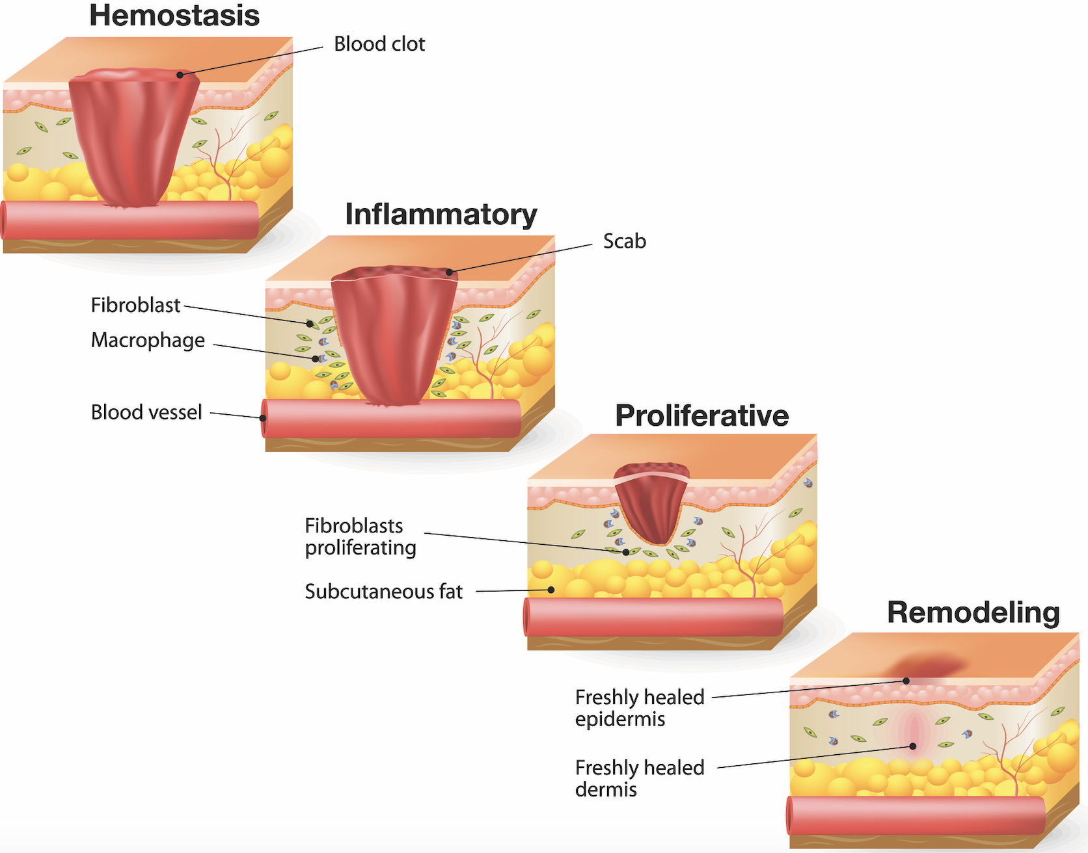
The four stages of normal wound healing are hemostasis, inflammation, proliferation, and remodeling ( Figure 1)². Chronic wounds are a type of wound that remain in the inflammatory stage for an extended period of time. In the inflammatory stage of wound healing, resident cells such as fibroblasts release inflammatory cytokines at the site of injury². These cytokines attract inflammatory cells such as neutrophils to the area whose function is to initiate phagocytosis of detritus and bacteria in the wound. This decontaminates the wound; however, it also causes tissue death². Chronic wounds are unable to transition from the inflammatory stage into the proliferation stage, where inflammation is resolved, thus leading to tissue damage. Wounds are classified as chronic if they persist for longer than 4 weeks to 3 months, because the normal healing time for a wound is typically 4-6 weeks^{2,3}. One factor that contributes to the prolonged response seen in chronic wounds is the extended expression of proinflammatory genes. In order to move into the proliferation stage, the largescale production of proinflammatory cytokines needs to be halted in order to prevent the migration of neutrophils to the wound site. Therefore, when proinflammatory cytokines are produced for longer than is necessary, then the inflammatory stage persists thus leading to further tissue damage⁴.
Figure 1: Stages of wound healing include hemostasis, inflammation, proliferation, and remodeling¹

Fibroblasts are the main type of resident cell present in connective tissue. This type of cell generates extracellular matrix proteins that provide structure to tissue⁵. Additionally, fibroblasts direct inflammation by producing proinflammatory cytokines such as Interleukin-8 (IL-8). Fibroblasts express a receptor called Toll-Like Receptor-4 (TLR4) which is activated upon exposure to lipopolysaccharides which are endotoxins found on gram negative bacteria⁶. This recognition of LPS causes the activation of a pathway that produces IL-8⁶. Fibroblasts isolated from chronic wounds produce a specific pattern of cytokines that differs from those of normally healing wounds thus indicating that these two types of fibroblasts display different phenotypes⁷. This difference is stable throughout time indicating that this change in phenotype might be permanent which could cause the amplification of inflammation for an extended period of time seen in chronic wounds. Because these changes appear to be permanent, it is possible that changes to the epigenetics of proinflammatory molecule genes might be involved⁷.
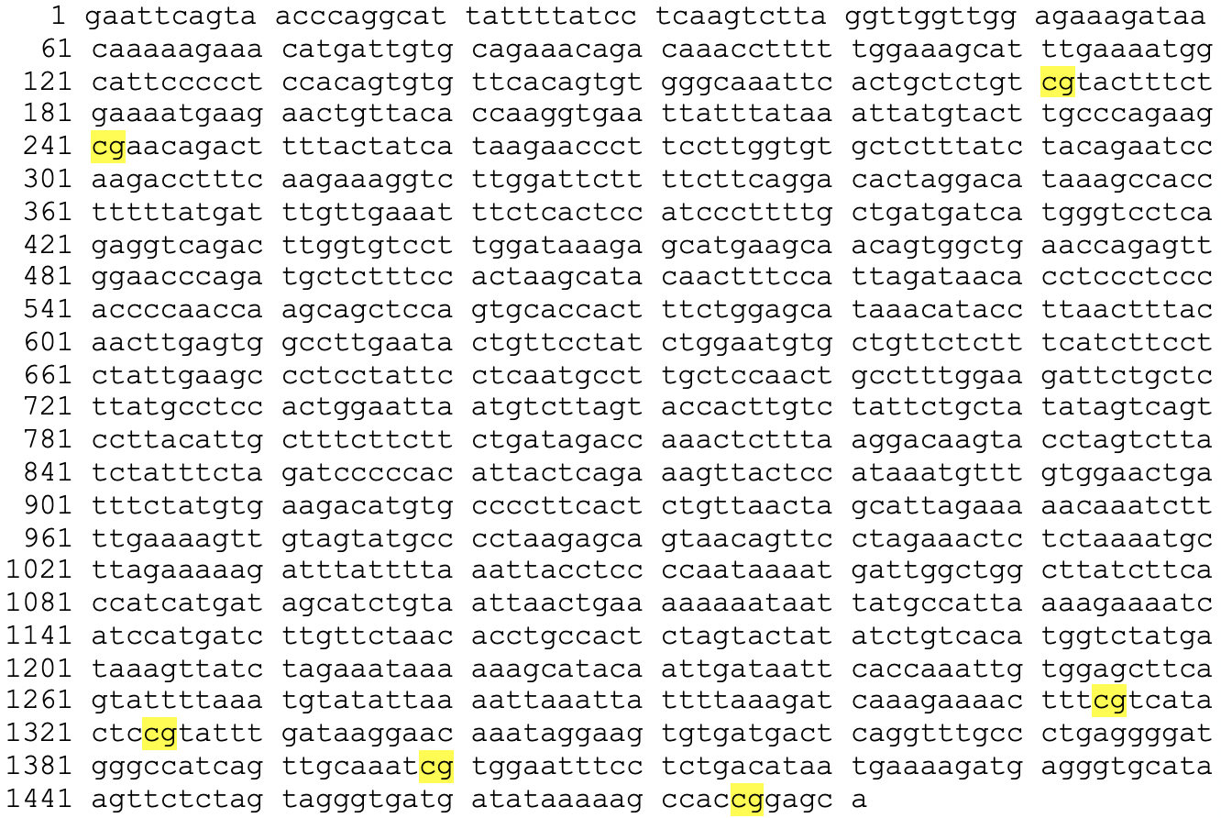
Interleukin-8 is a proinflammatory cytokine that causes neutrophils to migrate to the wound site. The neutrophils secrete granule enzymes which degrade connective tissue thus decontaminating the wound site by inducing cell death⁸. The gene that produces IL-8 is CXCL-8 and it is located on chromosome 4 in humans. This gene contains several CpG dinucleotides in its promoter region (Figure 2)⁹. CpG sites are where DNA methylation occurs which consequently decreases expression of that gene. It is possible that the CXCL-8 gene is being permanently hypomethylated in chronic wounds leading to the prolonged production of IL-8¹⁰.
Figure 2: The 6 CpG sites found in the promoter region of the CXCL8 gene are highlighted in yellow⁹

DNA methylation is when methyl groups are added to cytosines adjacent to guanine nucleotides, known as CpG sequences. These sites are commonly methylated because the methylase enzyme recognizes them and adds methyl groups to the cytosines of new DNA strands to maintain the pattern of silenced gene expression during DNA replication¹¹. The effect of DNA methylation is the silencing of a gene. When a sequence has been methylated, the methyl groups attract histone deacetylases which remove acetyl groups from the histone. When the histone is deacetylated, the DNA is packed too tightly, and transcription cannot occur because transcription factors cannot bind to the enhancer or promoter sequences, therefore gene expression is silenced¹¹.

Green and Kerr (2014) explored whether epigenetics had an effect on gene expression when bovine dermal fibroblasts were exposed to LPS¹⁰. In order to investigate this, fibroblasts were categorized based on the mount of IL-8 they produced after LPS exposure: high responder or low responder. The cells were exposed to 5-aza-2’deoxycytidine, an artificial demethylating agent, and the amount of LPS-induced IL-8 expression was measured¹⁰. With no artificial demethylation, there was a significant difference between the gene expression seen in low responders compared to high responders. The demethylation caused less of a difference in the IL-8 levels present¹⁰. Accordingly, Green and Kerr (2014) concluded that epigenetics affected the increase in expression due to the absence of differences in IL-8 levels in high responding versus low responding fibroblasts. Green and Kerr (2014) did not investigate the specific areas of the gene that might have been affected by changes in epigenetics.

As a result of the study conducted by Green and Kerr (2014), it was established that there is some correlation between DNA methylation and the fibroblast response to LPS in chronic wounds Specifically, the CXCL-8 gene, which produces IL-8, could be hypomethylated which would lead to the difference in fibroblast response when exposed to LPS. IL-8 is a proinflammatory cytokine, therefore the prolonged inflammatory response seen in chronic wound might be due to permanent hypomethylation of the CXCL-8 gene. The purpose of this experiment is to test if the epigenetic modification of hypomethylation to the CXCL-8 gene is permanent in fibroblasts exposed to LPS.

II. Experiment

The aim of this experiment is to determine whether there is permanent hypomethylation of proinflammatory cytokine genes such as CXCL-8 causes the prolonged inflammatory stage seen in chronic wounds when fibroblasts are exposed to LPS. If there is permanent hypomethylation of the CXCL-8 gene, then there should be detectable differences in methylation patterns when comparing normal, acute wound fibroblasts to chronic wound fibroblasts.

II. A. Obtaining Samples, Isolating Fibroblasts, and Exposing to LPS

Tissue biopsies will be taken from patients exhibiting chronic wounds and from patients exhibiting normal, acute wounds. Panuncialman et al. (2010) investigated whether this invasive procedure would be detrimental to the healing of chronic wounds and determined that the biopsy sites healed quickly and did not affect the healing process of the wound¹². Patients could undergo the tissue biopsy if the chronic wound lasted for greater than 3 months. Patients would be excluded from the study if they had diabetes or were on immunosuppressive medication as these factors could put the patient at high risk and would interfere with the inflammatory process¹³.

In order to isolate the fibroblasts, the dermal layer has to be separated from the epidermal layer. In order to do this, Dispase II should be added to the samples. This is a protease that hydrolyzes the N-terminus of non-polar amino acids, specifically at Leucine-Phenylalanine bonds and it targets collagen present in the epidermis¹⁴. Following this separation, the dermal layer samples will be digested using crude collagenase. This is a mixture of enzymes that cleaves the peptides in collagen thus releasing cells such as fibroblasts embedded in the extracellular matrix^{15, 16}. The released cells will be plated on a tissue culture plate. Following 24 hours, the plates will be washed with phosphate buffered saline to eliminate cells that did not adhere to the plates. The adherent cells, which are the fibroblasts, will be grown and cultured. Pandamooz et al. (2012) investigated the ideal method in which to isolate fibroblasts, therefore their protocol is what will be used for this experiment¹⁷.

Isolated fibroblasts will be exposed to an LPS treatment for 24 hours, 48 hours, and 72 hours. By varying the amount of time fibroblasts are exposed to LPS, it can be determined whether epigenetic modifications are permanent by comparing the bands present following MS-PCR. The LPS treatment will be growth media accompanied by LPS of Escherichia coli O111.B4 obtained from Sigma-Aldrich¹⁸. This LPS exposure protocol was used by Green and Kerr (2014)¹⁰.

II. B. DNA Extraction and Bisulphite Conversion

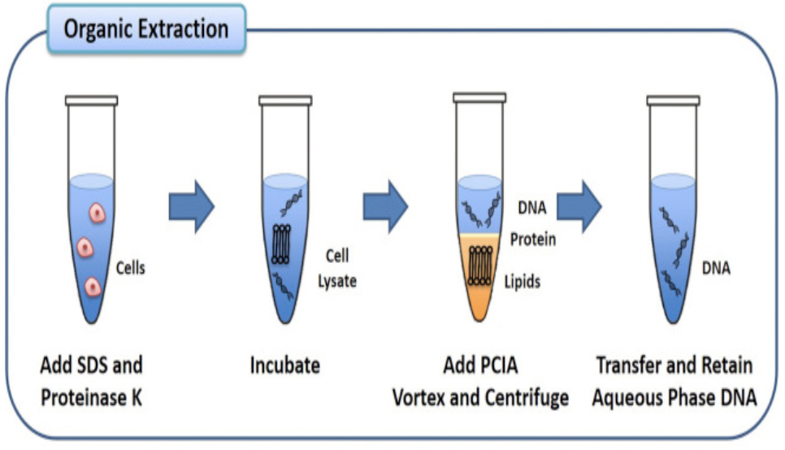
To extract the DNA, the fibroblasts will be exposed to sodium dodecylsulfate (SDS) and proteinase K. SDS works by breaking the noncovalent interactions in proteins such as hydrogen bonds thus denaturing the proteins and is used to disrupt cell membranes and inhibit RNase and DNase ¹⁹. Proteinase K is a serine protease that cleaves peptides at the carboxyl terminus of hydrophobic amino acids which targets proteins that might contaminate the sample and nucleases²⁰. Following this, the sample will be added to a mixture of phenol, chloroform in a 25:24 ratio. This mixture promotes the separation of hydrophobic lipids and cell remnants into the lower, less polar organic layer (chloroform and phenol) and the negatively charged DNA into the polar, aqueous layer as can be seen in Figure 3²¹. Next, the DNA must be precipitated. In order to do this, sodium acetate (NaOAc) must be added to the sample²¹. The sodium ion, which is positively charged, neutralizes the negatively charged sugar-phosphate backbone thus making the DNA less polar and more hydrophilic. Ethanol will then be added because it promotes the interaction between the sodium ion and the sugar phosphate thus allowing the DNA to drop out of solution²¹.
Figure 3:
This shows how DNA is extracted by separating it from the other cellular components²¹.
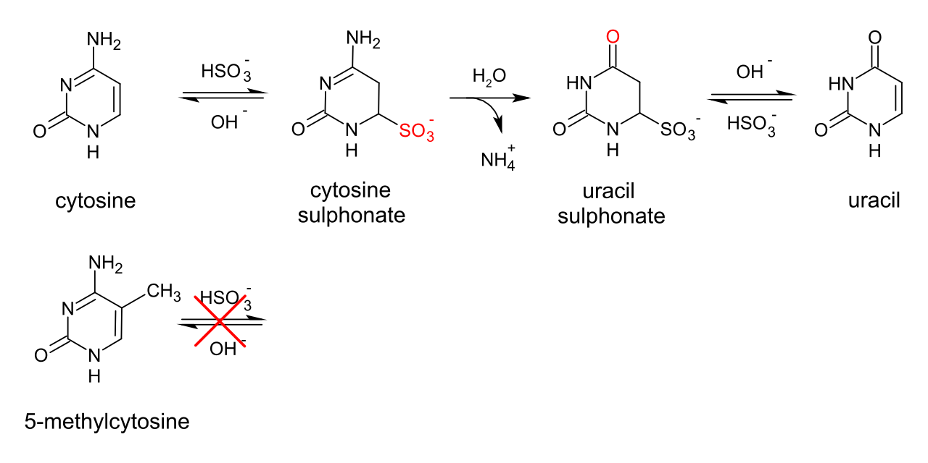
After DNA extraction, the purified DNA will be added to sodium bisulfite. Sodium bisulphite modifies cytosines bases and turns them into uracil bases as is shown in Figure 4¹³. Sodium bisulphite will only react with unmethylated cytosines whereas methylated cytosines will be unreactive (Figure 4). These differences will be detectable when MS-PCR is performed on the samples¹³.
Figure 4:
This shows the chemical reaction that occurs during bisulfite conversion to turn a cytosine into an uracil without the present of a 5’-methyl group¹³.

II. C. Methylation-Specific Polymerase Chain Reaction (MS-PCR)

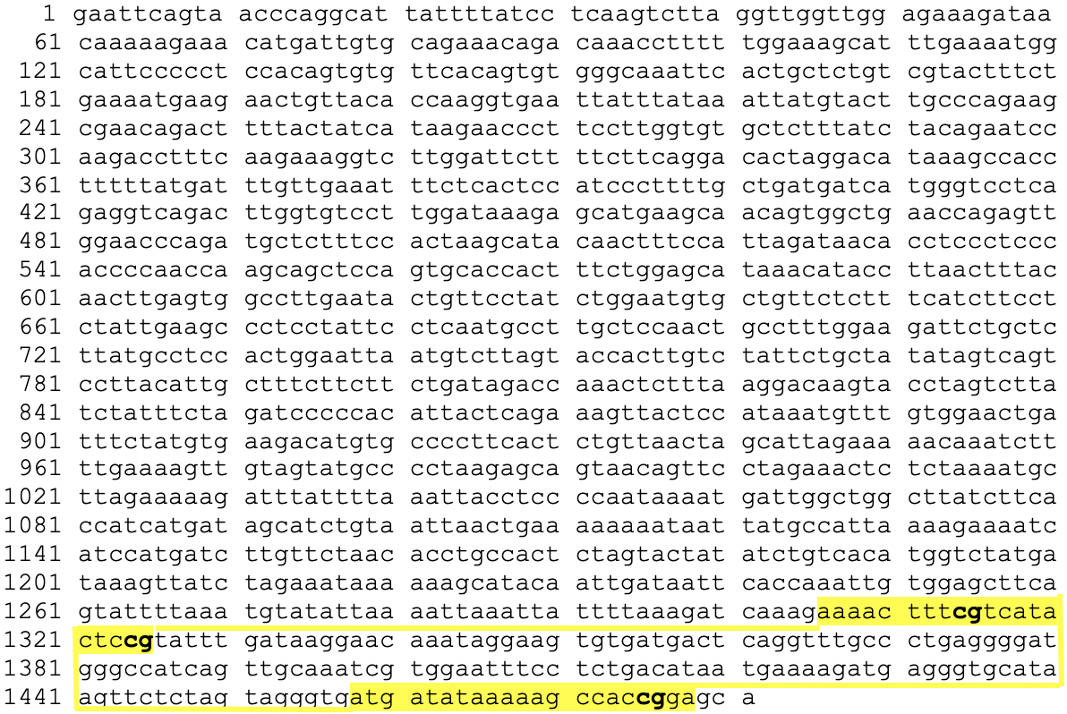
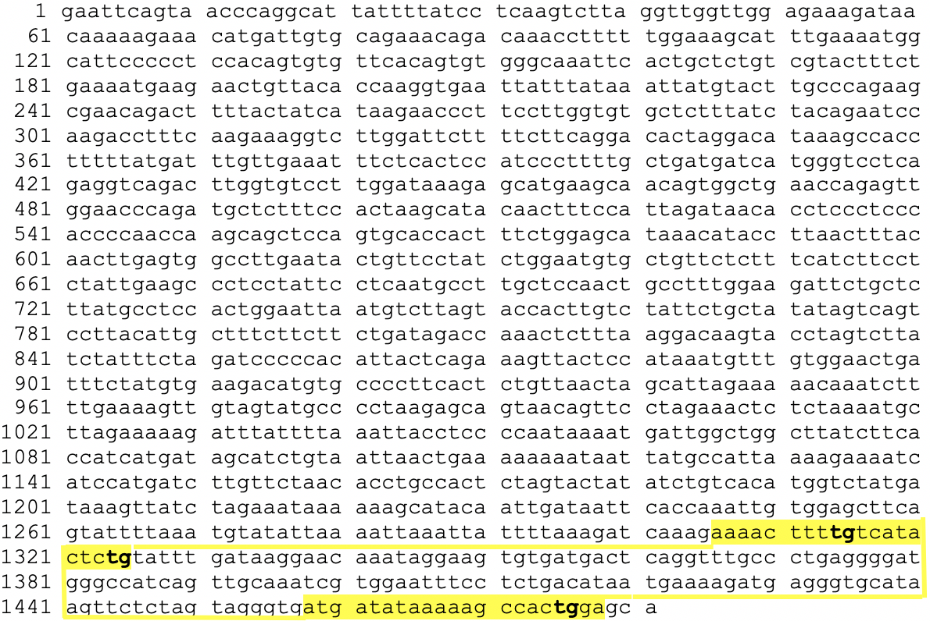
Primers specific for the unmethylated and methylated samples can be used to detect differences in methylation using MS-PCR. The primers for the unmethylated CXCL-8 gene were: forward 5’aaaatttttgttatattttg3’and reverse 5’tccaataactttttatatcat3’²³ (Figure 5). The primers for the methylated CXCL-8 gene were: forward 5’aaaattttcgttatatttcg3’ and reverse 5’tccgataactttttatatcat3’²³ (Figure 6). These primers were used by Andia et al. (2010) and Oliveira et al. (2009) to detect epigenetic modifications of the CXCL-8 gene^{13, 23}. This product is not the full gene, but a 173 bp segment of it containing regions that might be methylated²³. Once the primers are added to the samples, the PCR will be used to amplify the CXCL-8 gene and determine whether methylation is present. Electrophoresis will be run on the amplified samples and the DNA bands will be detected using SYBR Gold stain^{22,23}. SYBR gold stain fluoresces when it binds to DNA and is visible using 300 nm ultraviolet light²².
Figure 6:
This figure shows the region of the promoter of CXCL-8 that will be amplified by MS-PCR when bisulfite conversion does not work, meaning that the DNA sample is methylated. The PCR primers are highlighted in yellow with the CpG sites bolded. The entire PCR product (173 bp) is outlined in yellow⁹.
Figure 5:
This figure shows the region of the promoter of CXCL-8 that will be amplified by MS-PCR when bisulfite conversion works, meaning that the DNA sample is unmethylated. The PCR primers are highlighted in yellow with the CpG sites that would be converted to TpG sites bolded. The entire PCR product (173 bp) is outlined in yellow⁹.

III. Discussion
Figure 7:
Figure 7a shows the ideal results in which the control sample has methylated DNA which was used in the study by Andia et al. (2010)¹³. Over time, there is a permanent pattern of unmethylated CXCL-8 gene.
Figure 7b shows another possible result in which the initial response to LPS is hypomethylation of CXCL-8, however over time, the CXCL-8 returns to normal methylation patterns.
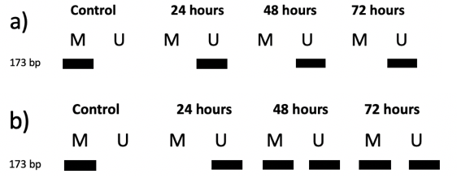
Possible results visualized from electrophoresis following MS-PCR would have two columns for each set of fibroblast DNA exposed to LPS for varying times. The two columns would be for methylated DNA and unmethylated DNA which are M and U respectively in Figure 7. If a band is present in the M column, this means that the DNA matched the methylated primers meaning that bisulfite conversion was not successful. If a band is present in the U column, then DNA matched the unmethylated DNA and bisulfite conversion was successful. There would also be a control present which would be from a normal, acute wound sample. This sample would contain a band of methylated DNA because cytokines are not overproduced in normal, acute wound samples. The ideal result from this experiment would be a constant band of unmethylated CXCL-8 PCR product present on the gel for 24, 48, and 72 hours (Figure 7). This would indicate that there is constant hypomethylation of the CXCL-8 gene over time. This might account for the prolonged inflammatory stage seen in chronic wounds when exposed to LPS. Another possible result would be that the bands remain the same as the control after a period of time (Figure 7). After immediate exposure to LPS, there would be a small amount of hypomethylation for the primary response which is seen in Figure 7b for the 24 hours band. This would indicate that while there is temporary hypomethylation, there is no permanent hypomethylation of the CXCL-8 gene. This would mean that permanent hypomethylation of the CXCL-8 gene does not contribute to the prolonged inflammatory stage seen in chronic wounds.

It is possible that permanent hypomethylation will occur, but it might not be enough to be distinctly different from the normal methylation patterns when viewing the PCR product bands. However, as long as there is a constant pattern of unmethylated bands over time, then that would be enough to determine that there is permanent hypomethylation.

While this experiment exposes fibroblasts to LPS for a longer amount of time to more accurately simulate the chronic wound environment, it is possible that 72 hours is not long enough to detect permanent epigenetic modifications to the CXCL-8 gene. Another possible experiment might be to expose the fibroblasts to LPS for a longer period of time to see whether the CXCL-8 gene has permanent hypomethylation. If hypomethylation is detected, then this indicates that exposure to LPS might prolong the inflammatory stage of chronic wounds because it means that proinflammatory cytokines are produced more frequently. If this is the case, then further studies might be conducted from a pharmacological standpoint targeting hypomethylated proinflammatory cytokine genes.

References

- Maynard, J. (2015). How Wounds Heal: The 4 Main Phases of Wound Healing. http://www.shieldhealthcare.com/community/popular/2015/12/18/how-wounds-heal-the-4-main-phases-of-wound-healing/
- Wallace, H. A., Basehore, B. M., & Zito, P. M. (2019). Wound Healing Phases. https://www.ncbi.nlm.nih.gov/books/NBK470443/
- de Moya, M. A., Phan, H. H., Montero, P. M., Stefanidis, D., & Cahalane, M. J. (n.d.) Non-healing wounds. American College of Surgeons Division of Education, 1-36. https://www.facs.org/-/media/files/education/core-curriculum/nonhealing_wounds.ashx
- Flavell, S. J., Hou, T. Z., Lax, S., Filer, A. D., Salmon, M., & Buckley, C. D. (2008). Fibroblasts as novel therapeutic targets in chronic inflammation. British Journal of Pharmacology, 153(SUPPL. 1), 241–246. https://doi.org/10.1038/sj.bjp.0707487
- Jordana M., Sarnstrand, B., Sime, P. J., Ramis, I. (1994) Immune-inflammatory functions of fibroblasts. European Respiratory Journal, 7(12), 2212-2222. doi: 10.1183/09031936.94.07122212
- Kandasamy, S., Green, B. B., Benjamin, A. L., & Kerr, D. E. (2011). Between-cow variation in dermal fibroblast response to lipopolysaccharide reflected in resolution of inflammation during Escherichia coli mastitis. Journal of Dairy Science, 94(12), 5963–5975. https://doi.org/10.3168/jds.2011-4288
- Buckley, C. D., Pilling, D., Lord, J. M., Akbar, A. N., Scheel-Toellner, D., & Salmon, M. (2001). Fibroblasts regulate the switch from acute resolving to chronic persistent inflammation. Trends in Immunology, 22(4), 199–204. https://doi.org/10.1016/S1471-4906(01)01863-4
- Bickel, M. (1993). The role of interleukin-8 in inflammation and mechanisms of regulation. Journal of Periodontology, 64(5), 456-460. https://www.ncbi.nlm.nih.gov/pubmed/8315568
- Mukaida, N., Shiroo, M., & Matsushima, K. (1989). Genomic structure of the human monocyte-derived chemotactic factor IL-8. Journal of Immunology, 143(4), 1366-1371. https://www.ncbi.nlm.nih.gov/nuccore/M28130
- Green, B. B. & Kerr, D. E. (2014). Epigenetic contribution to individual variation in response to lipopolysaccharide in bovine dermal fibroblasts. Veterinary Immunology and Immunopathology, 157(0), 49-58. doi:10.1016/j.vetimm.2013.10.015.
- Chan, S. W., Zilberman, D., Xie, Z., Johansen, L. K., Carrington, J. C., and Jacobsen, S.E., 2004 RNA Silencing Genes Control de Novo DNA Methylation. Science. 303: 1336.

Panuncialman, J., Hammerman, S., Carson, P., & Falanga, V. (2010). Wound edge biopsy sites in chronic wounds heal rapidly and do not result in delayed overall healing of the wound. Wound Repair Regeneration, 18(1), 21-25. doi: 10.1111/j.1524-475X.2009.00559.x
- Andia, D. C., de Oliveira, N. F. P., Casarin, R. C. V., Casati, M. Z., Line, S. R. P., & de Souza A. P. (2010). DNA Methylation Status of the IL8 Gene Promoter in Aggressive Periodontitis. Journal of Periodontology, 81(9), 1336-1341. doi: 10.1902/jop.2010.100082
- Dispase II. (n.d.). Retrieved November 30, 2019 from https://www.sigmaaldrich.com/catalog/product/sigma/d4693?lang=en&region=US
- Kanta, J. (2015). Collagen matrix as a tool in studying fibroblastic cell behavior, Cell Adhesion and Migration, 9(4), 308-316. http://dx.doi.org/10.1080/19336918.2015.1005469
- Collagenase from Clostridium histolyticum. (n.d.). Retrieved November 30, 2019 from https://www.sigmaaldrich.com/catalog/product/sigma/c0130?lang=en&region=US
- Pandamooz, S., Hadipour, A., Akhavan-Niaki, H., Pourghasem, M., Abedian, Z., Motevallizadeh Ardekani, A., Golpour, M., Hassan, Z. M., & Mostafazadeh, A. (2012). Short exposure to collagenase and coculture with mouse embryonic pancreas improve human dermal fibroblast culture. Biotechnology and Applied Biochemistry, 59(3), 254-261. DOI: 10.1002/bab.1020
- Lipopolysaccharides from Escherichia coli O111:B4. (n.d.) Retrieved November 30, 2019 from https://www.sigmaaldrich.com/catalog/product/sigma/l4391?lang=en&region=US
- Farrell, R. (2010). Resilient Ribonucleases. In RNA methodologies 4th edition (Chapter 7). https://doi.org/10.1016/B978-0-12-374727-3.00007-3
- Proteinase K. (n.d.). Retrieved November 30, 2019 from https://www.sigmaaldrich.com/life-science/metabolomics/enzyme-explorer/analytical-enzymes/proteinase-k.html
- McKiernan, H. E. and Danielson, P. B. (2017). Molecular Diagnostic Applications in Forensic Science. Molecular Diagnostics (Third Edition), 371-394. https://doi.org/10.1016/B978-0-12-802971-8.00021-3
- InvitrogenTM SYBR™ Gold Nucleic Acid Gel Stain (10,000X Concentrate in DMSO). (n.d.). Retrieved November 30, 2019 from https://www.thermofisher.com/order/catalog/product/S11494#/S11494
- Oliveira, N. F. P., Damm, G. R., Andia, D. C., Salmon, C., Nociti, F. H., Line, S. R. P., de Souza, A.P. (2009). DNA methylation status of IL8 gene promoter in oral cells of smokers and non- smokers with chronic periodontitis. Journal of Clinical Periodontology, 36, 719–725. doi: 10.1111/j.1600-051X.2009.01446.x.

