Measurement of TGIF1 expression levels due to TGF-β overexpression in pancreatic cells

I. Introduction:
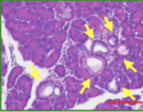
Pancreatic ductal adenocarcinoma (PDAC) is the most common type of pancreatic cancer and the fourth leading cause of cancer-related death. PDAC is identified by the formation of ducts in the cell lining of the pancreas. By the time patients are diagnosed, it has already metastasized to other parts of the body, contributing to the low survival rate. It’s estimated that the 5-year survival rate for PDAC is only 9%.

PDAC forms when a proto-oncogene, a normal cell is mutated, making it an oncogene that can cause cancer. Hingorani et al (2003)² sought to understand if Kras played a role in PDAC. Previous research has shown that mutations in Kras where amino acid glycine 12 is switched to aspartic acid are common among pancreatic carcinomas, a type of cancer that starts in the lining of organs. In this study, they identified that mice with Kras specific expression in the pancreas developed pancreatic intraepithelial neoplasia (panINs), a common characteristic of PDAC (Fig 1).
Fig 1. PDAC development
panINs are indicated by the yellow arrow.
Figure obtained from reference 1

In another study, Parash et al (2019)¹ sought to understand the role of MAPK mediated TGIF1 phosphorylation in Kras driven PDAC (Fig 2). This experiment used immunohistochemistry to see the specific localization of a protein within a tissue sample. They found that when TGIF1 (a transcription factor that regulates the activity of certain genes) is deleted and Kras is expressed there is an increase in the formation of PDAC, which is identified by the formation of PanINs (Fig 1), indicating that TGIF1 was a tumor suppressor. When Kras was activated, TGIF1 was phosphorylated by MAPK, repressing its tumor suppressor function. In another experiment they explored how TGF-β played a role in PDAC, TGF-β is a transcription factor that is involved in cell regulation. Their findings showed that TGF-β levels of expression were high during the final stages of PDAC, this indicated that it also interacted with TGIF1.
Fig 2. Activation of PDAC
Figure obtained from reference 1

II. Experiment:
The aim of this experiment is to measure the expression levels of TGIF1 in pancreatic cells of mice when there is an overexpression of TGF-β. This experiment will help determine if the overexpression of TGF-β inhibits the expression of TGIF1. If TGF-β overexpression effects TGIF1, a decrease in TGIF1 expression levels is to be expected.

II.A. PCR to obtain the gene of interest
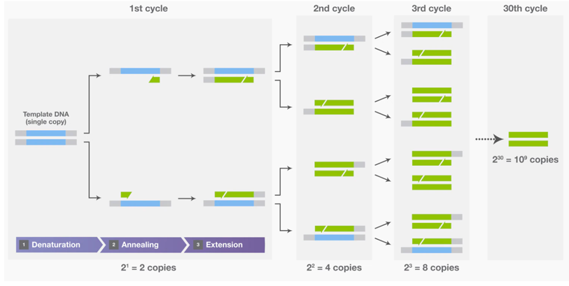
To obtain the gene of interest, TGF-β, PCR will be performed⁴. PCR (polymerase chain reaction) is a technique that can be used to isolate specific DNA fragments from DNA by selectively amplifying a specific region. There are three steps in this process (Fig 3):

Step 1 Denaturation: The two strands in DNA are separated by increasing the temperature of the mixture, breaking the hydrogen bonds between the two strands.
Fig 3. Polymerase chain reaction
Figure obtained from Thermo Fisher Scientific

Step 2 Annealing: Primers attach to each strand. The primers that can be used for this step are GCAGCCTGGATGGTTGTAGT (forward primer) and GGGTCACTGCCAGAGTACAG (reverse primer). These primers can be obtained by entering NC_000073.6, the reference sequence for TGF-β, into primer-BLAST. The forward primer then attaches to the start codon of the template DNA, while the reverse primer attaches to the stop codon of the complementary strand of DNA.

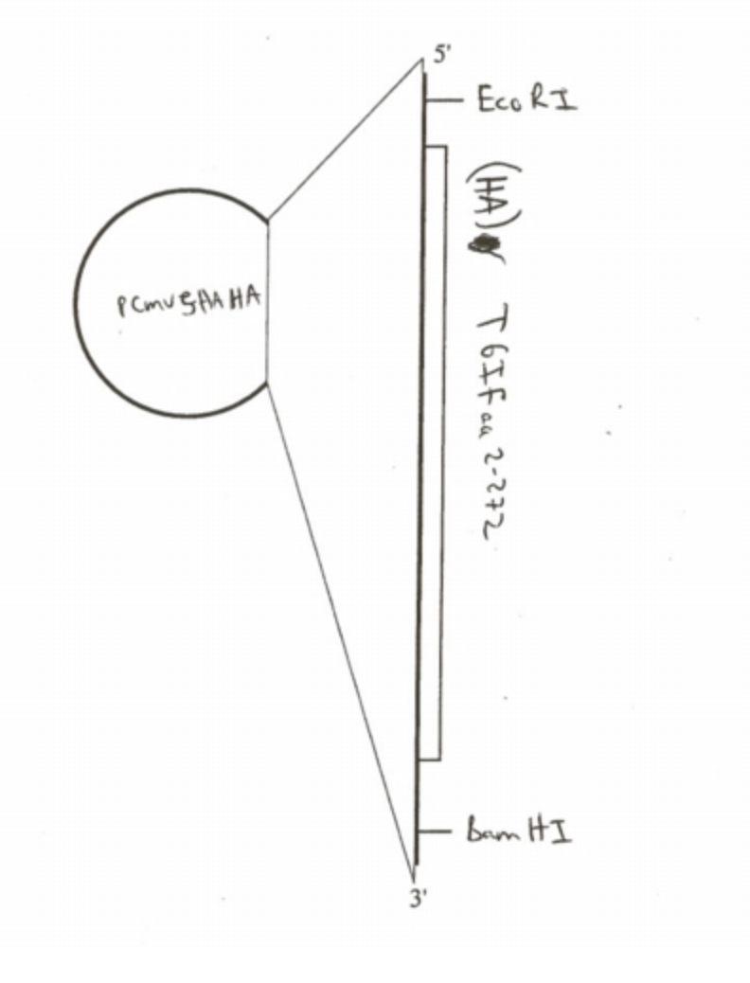
Step 3 Extension: DNA polymerase begins the process of DNA synthesis.

II.B. Inserting TGF-Beta into plasmids
In order to get clones of TGF-β, a plasmid needs to be constructed. A plasmid is a small circular double-stranded piece of DNA, where a target gene can be inserted in order to create recombinant DNA (DNA assembled out of fragments). It then can be introduced to a bacterium, where it divides quickly, this makes it so that large amounts of the gene of interest can be produced. In a research article Parash et al. (2019) ¹, used a plasmid, pCMV5 HA TGIF (Fig 4), to help promote overexpression of TGIF1 in pancreatic cells of mice. The plasmid was cut using restriction enzymes, EcoRI and BamHI. The gene of interest, TGIF, was then inserted into the plasmid by DNA ligase. In this experiment, using the plasmid, TGF-β will be inserted instead of TGIF and a TGF-β promoter will be used.
Fig.4 pCMV5 HA TGIF plasmid
Figure obtained from addgene

The plasmids then need to be introduced into bacteria through a process called bacterial transformation. During this process, the TGF-β plasmids are mixed into E. coli. This mixture is then given a heat shock, not all of the E. coli will take up a plasmid during this step (Fig 4). In order to see which E. coli takes up a plasmid, the mixture is put onto an antibiotic plate. All plasmids contain an antibiotic resistance gene, making it so that E. coli without a plasmid will not survive.

II.C. PCR to amplify TGF-Beta
Polymerase chain reaction (PCR) is a process where the DNA sequence of interest is amplified to make millions of copies⁴. The three steps mentioned before will need to be repeated multiple times to get millions of copies of TGF-β (Fig 3), leading to overexpression of TGF-β.

II.D. Measuring TGF-Beta overexpression
Once the PCR has been performed, a western blot needs to be employed to measure if there is overexpression of TGF-β. Western blot is a method that allows for the detection of a specific protein among a mixture of other proteins. It does this by employing antibodies and fluorophores that attach to the target protein of interest. After imaging the western blot, bands become visible to indicate the amount of protein content. In this experiment, the band for TGF-β should be the thickest and darkest among other bands, showing that overexpression of TGF-β has occurred.

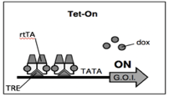
II.E Tet-On Doxycycline inducible system
The Tet-On doxycycline-inducible system was used by Das et al (2016)³ to express their gene of interest, HIV-1 in human cells. This system was used as a method to induce gene expression where the gene of interest was turned on in the presence of doxycycline. In the absence of doxycycline, the gene expression was turned off. Das et al created a system where the binding of doxycycline to the rtTA (reverse tetracycline transactivator) at the tetracycline response element (TRE) allowed for the region to interact with the RNA polymerase at the promoter, thereby transcribing the downstream gene, HIV-1 (Figure 5). With this system, they were able to turn off and on the expression of HIV-1.
Fig 5: Tet-On system
Figure obtained from reference 3

Using the Tet-On doxycycline-inducible system, the expression of TGF-β protein in pancreatic cells can be induced. The DNA plasmids containing TGF-β will be transfected into panc-1 cells (pancreatic cells). In order to see if the overexpression of TGF-β inhibits the expression of TGIF1, there will need to be two experimental groups. The first group will have a TGF-β plasmid and doxycycline (Dox +). The second group will have a TGF-β plasmid and no doxycycline (Dox -). Two control groups will be made, with one containing an empty plasmid and doxycycline (Dox +), the other group will have an empty plasmid without doxycycline (Dox -). The purpose of having two control groups with empty plasmids is to see whether or not the plasmids with TGF-β are working.

II.F Measuring expression levels of TGIF1
Parash et al (2019)¹ used a western blot to analyze the amount of TGIF1 protein expression. Protein samples were separated by molecular weight, this was done by gel electrophoresis⁵. Charged molecules were transported through an electrical field where the negatively charged proteins moved down towards the positive end. Proteins that were larger in size traveled down slowly in the electrical field. Due to how difficult it was to identify proteins while they are in a gel, the proteins were transferred to a membrane that allowed for protein detection. In order to prevent nonspecific antibody binding, blocking solution was applied. A primary anti-TGIF1 antibody then attached to TGIF1, in order to detect the protein of interest a secondary antibody connected to a fluorophore was attached to the primary anti-TGIF1 antibody. Since fluorophore-conjugated antibodies were being used, the membrane was scanned by special equipment that detected and documented the fluorophore signal, resulting in bands that showed the protein content of TGIF1 (Fig 6).
Fig. 6: Example western blot results
The imaging system scans for the presence of fluorophores, indicating where the target protein is. Black bands are shown as a result. If the band is dark, it indicates an increase in protein level. A light band indicates low protein level. Figure obtained from reference 1.

III. Discussion:
If this experiment is to be executed, the expression levels of TGIF1 between the two experimental groups should be significantly different when there is overexpression of TGF-β. For the experimental group where there are TGF-β plasmids and doxycycline (Dox+), we would expect a light band for TGIF1 for the western blot. The light band would indicate that in the presence of TGF-β overexpression, the expression of TGIF1 is inhibited. In the second experimental group with TGF-β plasmids and no doxycycline (Dox-), we would expect to have a dark band for TGIF1. This would indicate that when there is no overexpression of TGF-β, the expression of TGIF1 is not inhibited. Both control groups with empty plasmids that are Dox+ and Dox- are both expected to have dark bands for TGIF1 since expression of TGF-β is not being induced, the expression of TGIF1 is expected not to be inhibited. The results for the controls would indicate that the plasmids did work because a plasmid without TGF-β inserted should not express inhibit TGIF1. If both empty plasmids from the control groups exhibited light bands for TGIF1, that would mean that the plasmids did not work, results from the experimental groups would be invalid.

The problem is that a TGF-β plasmid hasn’t been created for overexpression. When experiments do mention a TGF-β plasmid, most of them use luciferase as the gene to insert. This means that light will be emitted if TGF-β is present. Hopefully, this pitfall can be addressed by using the pCMV5 HA TGIF plasmid and inserting a TGF-β promoter and TGF-β as the gene since previous research has shown that this plasmid does work in mouse pancreas cells.

It’s important to note that in this experiment the western blot targeted specific proteins that were in pancreas cells, among a mixture of other proteins. It’s difficult to interpret whether or not the overexpression of TGF-β is the reason why TGIF1 is inhibited. Overexpression of TGF-β can inhibit other genes that are upstream or downstream from either TGIF1 or TGF-β. Therefore, this experiment is just a small step towards understanding the mechanism of how pancreatic ductal adenocarcinoma forms.

References

1. Parajuli P, Singh P, Wang Z, Li L, Eragamreddi S, Ozkan S, Ferrigno O, Prunier C, Razzaque M, Xu K, Atfi A(2019). "TGIF1 Functions as a Tumor Suppressor in Pancreatic Ductal Adenocarcinoma." EMBO Journal 38.13
2. Hingorani S, Wang L, Multani A, Combs C, Deramaudt T, Hruban R, Rustgi A, Chang S, Tuveson D(2005). "Trp53 R172H and Kras G12D Cooperate to Promote Chromosomal Instability and Widely Metastatic Pancreatic Ductal Adenocarcinoma in Mice." Cancer Cell 7.5: 469-83. Web.
3. Das A, Tenenbaum L, Berkhout B (2016). Tet-On Systems For Doxycycline-inducible Gene Expression. Current gene therapy, 16(3), 156–167. doi:10.2174/1566523216666160524144041
4. Garibyan L, Avashia N (2013). Polymerase chain reaction. The Journal of investigative dermatology, 133(3), 1–4. doi:10.1038/jid.2013.1
5. Lee P., Costumbrado J., Hsu C., Kim Y. (2012). Agarose Gel Electrophoresis for the Separation of DNA Fragments. Journal of Visualized Experiments, (62), Journal of Visualized Experiments, 2012, Issue 62.

