Perraychudhan Saravanane
BNFO 300- Research Proposal
12/10/19

GRP78 inhibition by subtilase cytotoxin and interleukin-6 gene expression

Introduction
Finding a cure for cancer has been the Holy Grail for the scientific community the past several decades. It is the third leading cause of death worldwide, with one in four people developing the disease in their lifetime. Cancer is a group of diseases delineated by dysregulated cell growth that has the potential to metastasize to other parts of the body. Treating cancer today is done through therapies like radiation and chemotherapy which have several off-target effects. Severe damage to healthy cells and tissues near the treatment area is common in addition to skin problems, fatigue, diarrhea, and hair loss. Many patients, that have been diagnosed with cancer and have underwent traditional forms of treatment, experience long-term psychological consequences like depression, anxiety, insomnia, and anorexia.
Scientists are focusing on mechanisms that orchestrate cell death pathways like apoptosis, autophagy and necrosis as a method to cull cancer cells that are proliferating atypically (3). If the scientific community develops a profound understanding on how to specifically target and induce apoptosis in only cancer cells, a potential anticancer therapy might be created as an outcome. One specific pathway that leads to apoptosis in cells is the unfolded protein response (UPR) by the endoplasmic reticulum (ER) brought on by ER stress 9(2).
To cope with stress like a buildup of misfolded proteins, cells activate an intracellular cellular signaling cascade- the unfolded protein response. The UPR has tumorigenic properties in situations of temporary ER stress by attempting to restore ER stress through releasing protein folding chaperones. In situations of chronic or prolonged ER stress, the UPR initiates irreversible pathways that eventually lead to apoptosis of the cell (1). The protein GRP78, a molecular chaperone, is the master controller of the UPR and initiates either the survival or apoptotic pathway in response to ER stress (4). Presence of GRP78 in cells has been shown to correlate with a poor cancer prognosis, tumor progression and metastasis. An increase in ER stress or an aggregation of unfolded proteins will cause the dissociation of GRP78, and therefore release the three UPR mediators: activating transcription factor 6 (ATF6), inositol-requiring enzyme 1 (IRE1), and PKR-like ER kinase (PERK).
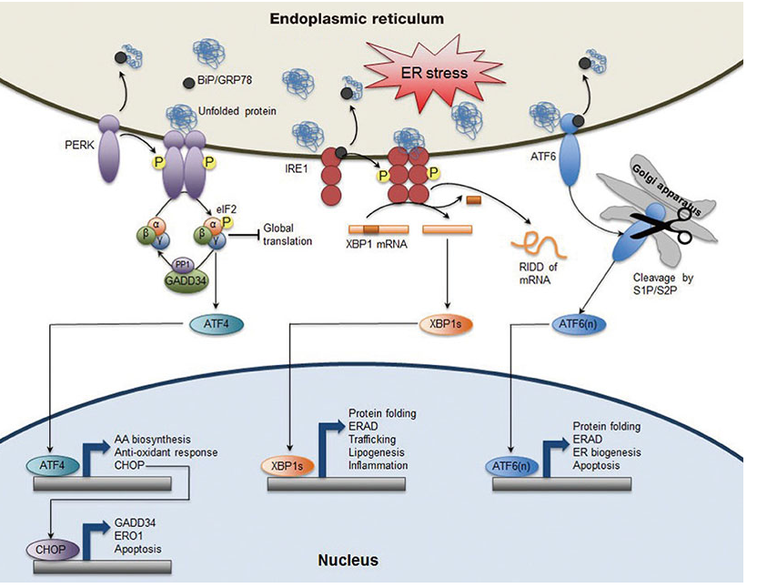
ATF6 is an ER transmembrane-activating transcription factor. Once GRP78 has been disassociated, ATF6 is transported to the Golgi apparatus where it is cleaved by two proteases, S1P and S2P, to result in ATF6(N). ATF6N travels to the nucleus to activate target genes of the UPR that can result in protein folding or apoptosis (5).
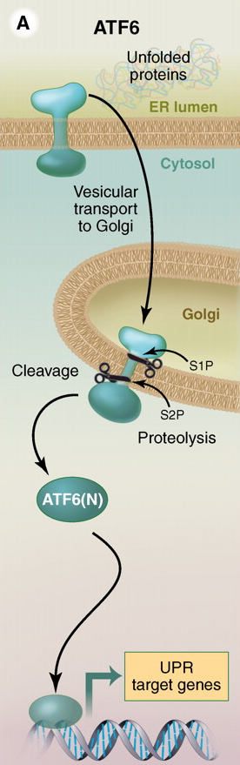
IRE1 is an ER transmembrane glycoprotein that is released once GRP78 has been titrated away due to ER stress. It is able to undergo autophosphorylation which activates its RNase function. The splicing of mRNA that encodes for XBP1, a UPR transcription factor, is done through the RNase ability of IRE. Once splicing has taken place, the resulting XBP1(s) travels to the nucleus where based on the ER stress situation can perform a plethora of functions (6).
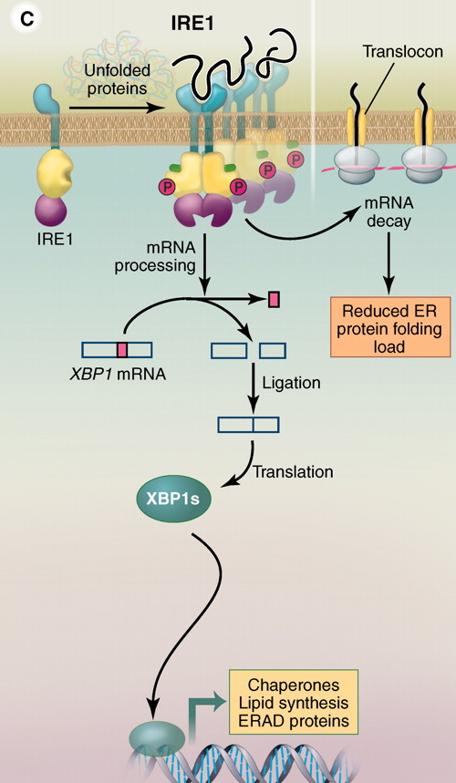
PERK is an ER transmembrane protein kinase that is activated upon ER stress induced disengagement of GRP78. PERK auto-phosphorylates itself and eIF2a, a translation initiation factor, that encodes ATF4, and activating transcription factor. ATF4 travels to the nucleus and allows for the transcription of GADD34 through the UPR and allows for apoptosis to occur (7).
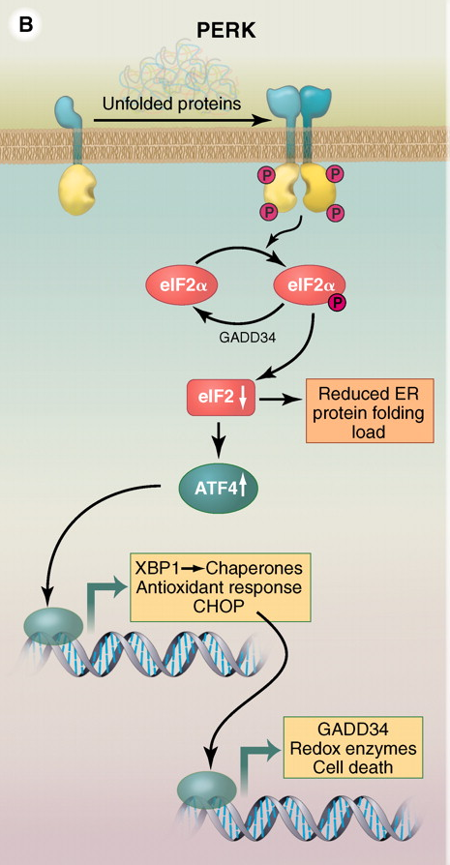
Apoptosis by the cell can therefore be caused by the release of the 3 UPR mediators by dissociation of GRP78. There are however only a few known molecules that can decrease GRP78 expression and degradation: subtilase cytotoxin (SubAB) and trichothecene mycotoxin deoxynivalenol (DON). SubAB is an AB5 toxin which contains toxin families that can result in diseases like cholera and pertussis. SubAB is comprised of two subunits: The A-subunit contains the catalytic triad of Asp-His-Ser and can cleave the GRP78 protein at Leu⁴¹⁶ and Leu⁴¹⁷ thus degrading the protein itself, the B-subunit binds to the glycan receptors on the surface of the cell and allows for the A-subunit to travel to the endoplasmic reticulum. SubAB has an extreme level of substrate specificity and its only known substrate so far is GRP78, therefore making it a prime candidate to induce a denaturating of GRP78 which will result in the UPR causing the programmed death of the cell (4).
DON is a mycotoxin that is prevalent in grains like wheat, barley, rye, and corn. It has been recorded in EL-4 cells that DON caused a downregulation of GRP78. The decreased expression of GRP78 induces ER stress and activates the UPR, however a side-effect of DON is the upregulation of interleukin-6 (IL-6), a proinflammatory cytokine (7). IL-6 is secreted by macrophages in response to pathogens and stimulates osteoclast formation. Osteoclasts are a type of a bone cell that breaks down bone tissue and causes osteoporosis. An upregulation of IL-6 is disadvantages for the body since it allows for the onset of autoimmune diseases.
Autoimmune diseases like systemic sclerosis and rheumatoid arthritis can be brought upon through increased expression of IL-6 which causes a disruption of immune homeostasis by upregulating the formulation of pro-inflammatory T-cells which disturbs the immune balance between regulatory and inflammatory T-cells. Upregulation of IL-6 can also cause more bone resorption cells like osteoclasts to be produced instead of bone formation, resulting in bone loss and cartilage degradation (8).
1.5 million people in the United States have rheumatoid arteritis (RA) which is an autoimmune disease where the immune system mistakenly attacks the joints. RA commonly attacks the joints of hands, feet, wrist, knees, elbows, ankles of the patient and causes inflammation inside the aforementioned joints. Swelling and pain around the joints results due to RA and severe irreversible joint damage can occur if the inflammation remains unchecked.
IL-6 upregulation can be caused through GRP78 inhibition, which is done through both SubAB and DON. It is currently unknown which of the three mediators of the UPR released by GRP78 causes the increase in IL-6, but if narrowed down it could allow for either SubAB or DON to become anticancer treatments. The purpose of this experiment is to figure out which specific UPR mediator (ATF6, IRE1, or PERK) causes an upregulation of IL-6 , and if done so SubAB or DON can be utilized to induce apoptosis in cancer cells and effectively cull them with minimal side-effects compared to traditional cancer treatments such as chemotherapy and radiation.

Research Proposal Purpose

The purpose of this study is to see if GRP78 inhibition by subtilase cytotoxin (SubAB) will induce interleukin-6 gene expression in peritoneal macrophages. The methods utilized to examine this plausible phenomenon are outlined below.
Experiment Protocol
Overview:
Peritoneal macrophages will be divided into two distinct major groups: the first group will be treated under the presumption of being a positive control for the experiment (will not undergo RNA interference), while the second group will be considered as the treatment group (will undergo RNA interference to inhibit gene expression of selected proteins). The treatment group will be split into three sub-groups: the first sub-group will utilize RNA interference (RNAi) to knock down the gene responsible for expressing IRE1, the second sub-group will utilize RNAi to knock down the gene responsible for expressing PERK, the third sub-group will utilize RNAi to knock down the gene responsible for expressing ATF6. In order to determine if upregulation of interleukin-6 (IL-6) has occurred, western blotting will be used to detect expression of GRP79 protein, ATF6 protein, IRE1 protein, PERK protein, and IL-6 cytokine.
Cell growth:
To test the hypothesis that in peritoneal macrophages SubAB is able to trigger an ER stress response capable of upregulating IL-6, peritoneal macrophages need to be properly grown and proliferated into 8 groups. Female B6C3F1 mice will be grown for 6 to 8 weeks and injected with 1.5 mL of sterile 3% thioglycolate broth (Shirato and Imaizumi 2015). After the broth injection, the mice will be euthanized and utilizing a peritoneal lavage the peritoneal macrophages will be collected. The macrophages will be cultured in the appropriate medium (FBS, 100 U/mL penicillin, 100 μg/mL streptomycin) in an incubator at 37℃ under 6% CO₂ for 24 hours. The cultured macrophages will be plated in 96-well plates with approximately 30,000 cells per well, and will be split into 8 groups with 12 wells pertaining to each treatment group.
RNA Interference treatment:
RNA interference uses short interfering RNA (siRNA) in order to start the specific degradation of targeted cellular mRNA to cause loss of protein expression. The siRNA is a double stranded RNA molecule with sense and antisense strands, with the antisense strand (complementary to the targeted mRNA sequence) part of the duplex specifically binding to an RNA-induced silencing complex (RISC). The siRNA initially enters the cell through the use of a liposome which carries the siRNA to the lipid-bilayer of the cell and fuses with it, thus allowing for the entrance of the siRNA. The antisense siRNA and RISC binds to the specific mRNA that translates for either the ATF6 protein, IRE1 protein, PERK protein based on the treatment group. Once the RISC has bound to the target mRNA strand it releases cleavage signals that degrade the bound mRNA, effectively resulting in the loss of expression of that specific protein (Shirato and Imaizumi 2015).
In this experiment, siRNA “cocktails” that specifically target mice ATF6 protein, IRE1 protein, PERK protein will be purchased from Dharmacon (Lafayette, CO). 72 wells of the 96 well plate will be utilized for the treatment groups and will be split into 3 distinct sub-groups pertaining to each of the 3 UPR response proteins (Ploegh 2014). The first group of 24 wells will be mixed with 5 μM siRNA targeting IRE1 protein and half will be labeled DNO_IRE1 and the other half will be labeled SubAB_IRE1. The second group of 24 wells will be mixed with 5 μM siRNA targeting ATF6 protein and half will be labeled DNO_ATF6 and the other half will be labeled SubAB_ATF6 (Ploegh 2014). The third group of 24 wells will be mixed with 5 μM siRNA targeting PERK protein and half will be labeled DNO_PERK and the other half will be labeled SubAB_PERK.
SubAB and DON treatment:
24 wells of the 96 well plate will be utilized in the positive control for the experiment in order to test if trichothecene mycotoxin deoxynivalenol (DON) and subtilase cytotoxin AB (SubAB) will inhibit the protein GRP78 which will induce the activation of ATF6, IRE1, and PERK proteins to start the unfolding protein response (UPR). No RNAi will be used on these 24 wells since there will not be any inhibition of the ATF6, IRE1, and PERK proteins (Buchkovich et al. 2007). The 24 wells containing peritoneal macrophages will be split into 2 groups: first group of 12 wells will be labeled as DON_N (normal) and be induced with 250 ng/mL of DON, the second group of 12 wells will be labeled as SubAB_N and be induced with 100 ng/mL of SubAB (Buchkovich et al. 2007).
The 72 wells that underwent the RNAi treatment will be split into half: the DNO_IRE1, DNO_ATF6, and DNO_PERK groups will be induced with 250 ng/mL of DON, while the SubAB_IRE1, SubAB_ATF6, SubAB_PERK groups will be induced with 100 ng/mL of SubAB.
Western Blotting:

Western blotting is a technique for protein detection by utilizing antibody-based probes to obtain information about a target protein from a complex mixture of proteins extracted from cells. Western blotting starts with using a lysing buffer to break the membranes of the cells in order to examine the presence of proteins. Inhibitors are added to the lysed cells to constrain unnecessary enzymes like protease and preserve protein purity (Lee 2007). The mixture of lysed cells undergoes centrifugation which results in the formation of a pellet and supernatant, which is ultimately kept since the targeted protein of interest is present in the supernatant. An SDS buffer is added to the supernatant. The SDS molecule consists of a carbon tail and a negatively charged sulfur tail. It causes disruptions to occur in the non-covalent bonds of proteins which denatures them and gives them a negative charge. The proteins bound to SDS buffer are loaded into a gel electrophoresis tank with transfer membrane, blotting paper, and pads (Lee 2007). A current is run through the gel electrophoresis tank which allows for the relocation of the proteins from the gel to the transfer membrane. The transfer membrane is stained using a mixture of primary antibodies that identify the epitope on the surface of the protein of interest. After the primary antibodies are bound to the targeted protein, a secondary antibody is utilized to bind to the primary antibody as a visualization method.
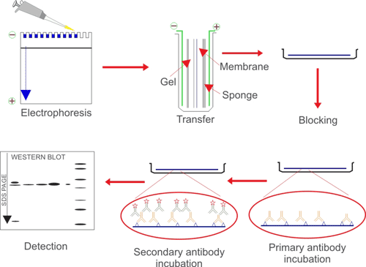
In this experiment, the peritoneal macrophages that have underwent cell culture, RNAi treatment, and have received either SubAB or DON treatment will be lysed in 10 mM of Tris buffer that contains sodium dodecyl sulfate (SDS) and a protease inhibitor cocktail. The lysed cells in the buffer will be subjected to centrifugation for approximately 15 minutes at 18,000 x g. Western blot treatment will be utilized using specific primary antibodies for GRP78, ATFG, IRE1, PERK, and IL-6 and visualization will be done through secondary antibodies (Paton 2010).
Discussion
There is a plethora of results that could emanate from this proposed experiment. The hypothesis of the experiment is that subtilase cytotoxin (SubAB) will cause an upregulation of the IL-6 cytokine through degradation of GRP78 protein which launches the UPR response of ATF6, PERK, and IRE1. The expected result for the cells that have underwent the positive control treatment is that inhibition of GRP78 will be executed by both DON and SubAB. The positive control will have low-none GRP78 indication on the Western blot, but a base-line expression of ATFG, PERK, IRE1, and IL-6 appearance on the Western blot. In the treatment group for the experiment, I am expecting when the ATF6 or IRE1 proteins are knocked down, there will be a significant reduction in IL-6 cytokine response. This is due to the regulation of IL-6 being controlled by the CREB protein, and both ATF6 and IRE1 are part of the same CREB/ATF family (Byrd and Brewer 2013).
If there were normal GRP78 relative intensity in the Western blot results for the positive control then it must indicate that the appropriate amounts of SubAB and DON were not utilized for the experiment. Previous literature has shown how SubAB and DON turn on the unfolded protein response by inhibiting GRP78, therefore there should be low levels of GRP78 protein as a result (Byrd and Brewer 2013). In the case the positive control fails, further trials with increasing levels of SubAB and DON can be tested with.
It will be intriguing to compare the resulting Western blots of the siRNA knockdown of the SubAB and DON treatments. The PERK pathway and its interaction with the IL-6 regulation has not been studied before previously, so it is hypothesized by the current experiment that SubAB will have a greater decrease in IL-6 upregulation when PERK is knocked out in comparison to DON.

Literature Cited
Buchkovich, N. J., Maguire, T. G., Yu, Y., Paton, A. W., Paton, J. C., & Alwine, J. C. (2007). Human cytomegalovirus Specifically controls the levels of the endoplasmic Reticulum Chaperone BiP/GRP78, which is required FOR VIRION ASSEMBLY. Journal of Virology, 82(1), 31-39. doi:10.1128/jvi.01881-07
Byrd, A. E., & Brewer, J. W. (2013). Micro(RNA)managing endoplasmic RETICULUM STRESS. IUBMB Life, 65(5), 373-381. doi:10.1002/iub.1151
Lee, A. S. (2007). GRP78 induction in CANCER: Therapeutic And PROGNOSTIC IMPLICATIONS. Cancer Research, 67(8), 3496-3499. doi:10.1158/0008-5472.can-07-0325
Paton, A. W., & Paton, J. C. (2010). Escherichia coli SUBTILASE CYTOTOXIN. Toxins, 2(2), 215-228. doi:10.3390/toxins2020215
Paton, A. W., Wang, H., & Paton, J. C. (2013). BiP (Grp78): A target for Escherichia COLI SUBTILASE CYTOTOXIN. Heat Shock Proteins Moonlighting Cell Stress Proteins in Microbial Infections, 309-322. doi:10.1007/978-94-007-6787-4_20
Ploegh, H. (2014). Faculty of 1000 evaluation for GRP78/BiP is required for cell proliferation and protecting the inner cell mass from APOPTOSIS during early mouse embryonic development. F1000 - Post-publication Peer Review of the Biomedical Literature. doi:10.3410/f.718441163.793496078
Shi, Y., Porter, K., Parameswaran, N., Bae, H. K., & Pestka, J. J. (2009). Role of Grp78/bip degradation and ER stress in deoxynivalenol-induced INTERLEUKIN-6 upregulation in the macrophage. Toxicological Sciences, 109(2), 247-255. doi:10.1093/toxsci/kfp060
Shirato, K., & Imaizumi, K. (2015). Mechanisms underlying the suppression of inflammatory responses in peritoneal macrophages of middle-aged mice. Physical Activity, Exercise, Sedentary Behavior and Health, 193-202. doi:10.1007/978-4-431-55333-5_16

