Suha Minai
BNFO 300
The effect of RNA splicing
on opioid tolerance
I. Introduction

Opioids are strong pain relieving drugs used widely in medicine. The branch of medicine known as pharmacology studies the properties of them and other drugs. However, the price for their pain relief is that they’re highly addictive and can lead to problems down the road, especially when the body (specifically the receptors) loses the ability to interact with opioids due to overexposure. This loss of opioid-interacting ability is known as opioid tolerance.

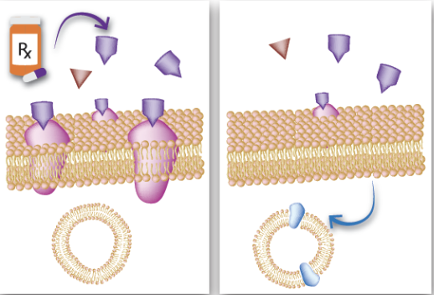
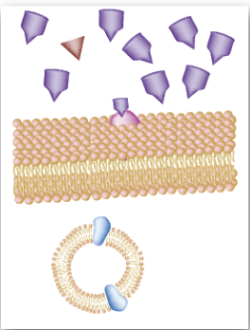
Opioid tolerance is regulated by a type of G-protein coupled receptors (GPCR) called opioid receptors, which are located on the surface of cells. Normally when opioids bind, the receptors send out a signal that initiates pain relief, the incentive to consume opioids. However, as more opioids bind over time, the receptors eventually become desensitized and begin to internalize into the cell, which eventually results in weaker pain relief, which leads to an increase in opioid intake, which leads to addiction (Allouche et al, 2014) (See Figure 1)

GPCRs, specifically opioid receptors, consist of an alpha, beta, and gamma subunit, and during desensitization, the alpha subunit uncouples from the conjoined beta and gamma subunits. But these receptors also proteins (Johnson), meaning that they are translated from RNA (specifically, mRNA). And due to their monitoring of opioid tolerance, it would stand to reason that splicing the mRNA of those opioid receptors in different ways, especially in the OPRM1 promoter region, could result in a variety of opioid receptors, thereby allowing tolerance to be manipulated (Xu).
Figure 1: The receptors’ contribution to opioid tolerance. The binding of an opioid to the GPCR results in the receptor becoming desensitized, internalizing, and either be degraded or recycled (Medium).

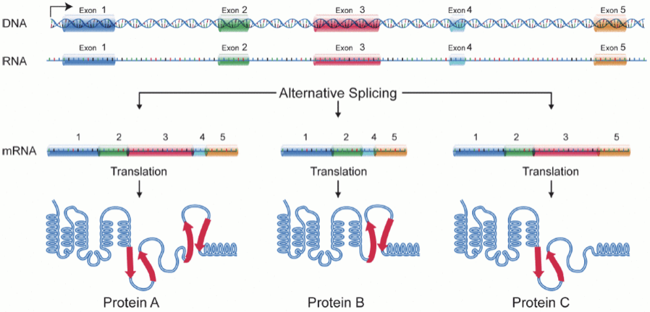
RNA splicing (a subset of which is called “alternative splicing”) is a process by which the exons of RNA are spliced in different ways, extracting certain exons or none at all, such that there are multiple versions of the same sequence (see Figure 2). This is often done naturally. The results of this process are unpredictable and cannot be definitively tied to any variant, and vice versa (Baralle et al, 2017). However, the sequence can be spliced in such a way that it causes helpful mutations or suppresses harmful mutations, which can result in an amplified positive effect (Lee et al, 2015).

On average, human genes have eight exons and seven introns each, so there’s a possibility for them to be spliced in similar but different ways (Lee et al, 2015). If the mRNA of opioid receptors from different locations (ex: some from the brain, some from the ileum) were spliced in different ways, such that different exons have a chance to work together and produce a unique effect, this could result in different levels of opioid tolerance depending on the mRNA’s location of origin, as well as why this is the case. OPRM1 is an ideal target for this experiment because it has an important role in the development of opioid addiction; specifically, the less the mRNA level of the OPRM1 gene in the promoter, the more the promoter hypermethylates the gene as a whole, thereby suppressing it entirely (Ebrahimi et al, 2017). Additionally, there is a precedent for examining alternative mRNA splices of the OPRM1 gene in mouse brains, via qPCR assays that quantify mRNA based on fluorescence (Xu et al, 2014).
Figure 2: Alternative splicing. Depending on which exons are spliced, the proteins are different and are expressed in different ways (Wikipedia).

II. Experiment

The goal of this experiment is to analyze the alternative splices of the OPRM1 region of opioid receptor promoters in the brain and ileum of a mouse to determine which combination of exons optimally reduces opioid tolerance. This will be done by first amplifying the mRNA of the OPRM1 gene in the mouse brain and ileum via PCR and analyzing those genes prior to tolerance testing via qPCR for composition, serving as an example of their splices pre-tolerance. Then they will be placed in empty cells and tested for tolerance with qPCR assays. Finally, the splices will be analyzed again with qPCR to determine which ones played a role in how quickly the mRNA achieved tolerance, and the composition of those splices. No actual splicing will be performed, as alternative splicing of an OPRM1 gene naturally produces a few dozen variants that can be analyzed (Xu et al, 2014).
II. A. RNA Splicing and Analysis
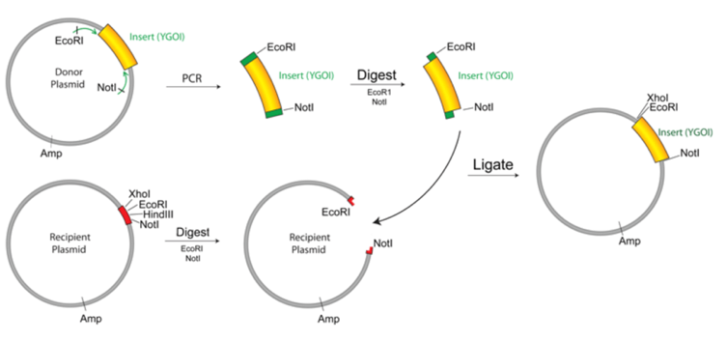
The procedure of manual RNA splicing consists of first amplifying the desired RNA via PCR, and then cloning it into a vector (see Figure 3), also via PCR. This process allows for directed RNA splicing, and thus direct gene manipulation (Refke et al, 2011). However, this process will not be conducted.

The reason for this process not being conducted in this experiment is because this experiment aims to establish a precedent based on naturally-occuring splices rather than create specific splice variants that may or may not affect tolerance. Analyzing the variants of alternative splicing will still show how splicing of OPRM1 affects opioid tolerance, because of the natural occurrence of splicing in the body.
Figure 3: Cloning into a vector. To carry out this procedure, run PCR first, then use restriction digests on the RNA and the receiving plasmid/vector, then isolate the RNA via gel purification, then fuse the RNA to the plasmid via RNA ligation, then properly introduce the RNA into the cell via transformation. This process is not RNA splicing, but it does permit RNA splicing to be directly performned (AddGene)

The variants will be analyzed via qPCR assays, which amplifies multiple sequences of RNA simultaneously and analyzes them for differences in expression. The reason for qPCR in this instance, rather than PCR, is because amplified RNA is tagged with fluorescence in qPCR, and the amount of fluorescence released during qPCR is directly proportional to the amount of RNA being amplified, which together results in the amplified RNA being easier to see at all stages (Čepin, 2017).

Prior to opioid tolerance testing, the splices of both mRNAswill be analyzed to see how many they are, their composition, and how they might change after tolerance to opioids is reached. After opioid tolerance testing, the splices of both mRNAs will be compared to the pre-OT splices (approximately similar to Figure 4) to see how they have changed as well as why, as well as to determine which splice most effectively reduced opioid tolerance.
Figure 4: Expression of 10 different RNA splices. Pre-opioid tolerance, Xu et al (2014, Fig S1) analyzed the expression of 10 selected RNA splices in the brain OPRM1 for four different groups of inbred mouse strains via qPCR (red: B6 mice, green: 129 mice, blue: SJL mice, brown: SWR mice)

II. B. Opioid Tolerance Testing In mRNA
The mRNA from the two regions will be injected with morphine and placed in empty cells that don’t have opioid receptors or anything else that might interfere with the experiment. They will then be tested for tolerance via a G-protein gamma assay that will assess how well the morphine-infused mRNA binds to G-protein receptors (Bidlack et al, 2004). Due to the prior qPCR, the mRNA’s presence will be indicated with fluorescence, and the less it is present, the more tolerant the mRNA is.

III. Discussion

Different RNA splices should result in different levels of opioid tolerance, and ideally, a few splices lead to tolerance being reached more quickly, while a few other splices lead to tolerance being reached either slowly or not at all. This does not necessarily mean that these splice causes these levels of tolerance, rather that the splices are more expressed at their respective levels of tolerance.

There are other ways to conduct a similar experiment, particularly in regards to the opioid receptor binding. There are other methods of investigating the binding, such as molecular docking, a type of virtual screening, which is a type of drug identification computational protocol. It would help me to assess the binding affinity of ligands to receptors in different binding positions based on scoring (Ellis). It would be efficient, but it does not take into account splice sites, which is the primary concern of my proposal.

While interpreting the splice expressions, it might be hard to choose which ones to highlight as most expressive, depending on how closely they all relate in terms of expression. And the experiment also only considers two regions of a particular mouse, the brain and the ileum, which means that differences in other anatomical locations are not the focus despite perhaps existing.

Opioid tolerance is a complex issue, particularly in the medical field with the opioid epidemic. Part of the reason for this epidemic is that medical professionals are not entirely sure how opioid tolerance works. If we can figure out how it works, and how to manipulate it, we can use this knowledge to help patients suffering from addiction by heightening their tolerance to a degree that the addiction could be caught before withdrawal takes effect.

References:
- Allouche, S; Noble, F; Marie, N (2014). Opioid receptor desensitization: mechanisms and its link to tolerance. Frontiers in Pharmacology, 5:280. <https://doi.org/10.3389/fphar.2014.00280>
- Johnson, KA; Lovinger, DM (2016). Presynaptic G Protein-Coupled Receptors: Gatekeepers of Addiction? Frontiers in Pharmacology, 10:264. <https://doi.org/10.3389/fncel.2016.00264>
- Xu, J; Lu, Z; Xu, M; Rossi, GC; Kest, B; Waxman, AR; et al (2014). Differential Expressions of the Alternatively Spliced Variant mRNAs of the µ Opioid Receptor Gene, OPRM1, in Brain Regions of Four Inbred Mouse Strains. PLoS ONE, 9(10): e111267. <https://doi.org/10.1371/journal.pone.0111267>
- Baralle, D; Buratti, E (2017). RNA splicing in human disease and in the clinic. Clin Sci, 131 (5):355-368. <https://doi.org/10.1042/CS20160211>
- Lee, Y; Rio, DC (2015). Mechanisms and Regulation of Alternative Pre-mRNA Splicing. Annual Review of Biochemistry, 84:291-323. <https://doi-org.proxy.library.vcu.edu/10.1146/annurev-biochem-060614-034316>
- Ebrahimi, G; Asadikaram, G; Akbari, H; Nematollahi, MH; Abolhassani, M; Shahabinejad, G (2017). Elevated levels of DNA methylation at the OPRM1 promoter region in men with opioid use disorder. The American Journal of Drug and Alcohol Abuse: Encompassing All Addictive Disorders, 44(2). <https://doi.org/10.1080/00952990.2016.1275659>
- Refke, M; Pasternack, SM; Fiebig, B; Wenzel, S; Ishorst, N; Ludwig, et al (2011). Functional analysis of splice site mutations in the humanhairless (HR) gene using a minigene assay. British Journal of Dematology, 165(5):1127-32. <https://doi-org.proxy.library.vcu.edu/10.1111/j.1365-2133.2011.10495.x>
- Čepin, U. (2017). Real-Time PCR (qPCR) Technology Basics. Biosistemika. <https://biosistemika.com/blog/qpcr-technology-basics/>
- Mischel, RA.; Dewey, WL.; Akbarali, HI. (2018) Tolerance to Morphine-Induced Inhibition of TTX-R Sodium Channels in Dorsal Root Ganglia Neurons Is Modulated by Gut-Derived Mediators. iScience, 2:193-209. <https://doi.org/10.1016/j.isci.2018.03.003>
- Kang, M; Mischel, RA; Bhave, S; Komla, E; Cho, A; Huang, C; et al (2017). The effect of gut microbiome on tolerance to morphine mediated antinociception in mice. Scientific Reports, 7: 42658. <https://doi.org/10.1038/srep42658>
- Ellis, CR; Kruhlak, NL; Kim, MT; Hawkins, EG; Stavitskaya, L. (2018). Predicting opioid receptor binding affinity of pharmacologically unclassified designer substances using molecular docking. PLoS ONE, 13(5): e0197734. <https://doi.org/10.1371/journal.pone.0197734>
- Bidlack J.M., Parkhill A.L. (2004). Assay of G Protein-Coupled Receptor Activation of G Proteins in Native Cell Membranes Using [35S]GTPγS Binding. G Protein Signaling: Methods in Molecular Biology, 237. <https://doi.org/10.1385/1-59259-430-1:135>

