BK Channel Clustering in Slo-1 mutants
By Dylan Lee

Alcohol abuse is a big problem in society. Alcoholism is thought to have a strong genetic basis at the same times we do not understand the molecular mechanisms by which alcohol causes intoxication. It has been useful to use C. elegans as model organism to study ethanol’s effect on a molecular level. There have been several proposed targets by which ethanol acts on the brain. One of the targets is a voltage gated potassium pump called the BK(Burger King Big Postassium) Channel.

slo-1(lf) and slo-1(T381I)

It is known through Davies et al 2003 that the BK channel is an ethanol target. The slo-1 null mutant otherwise known as the slo-1(lf) loss of function mutant is shown to produce worms that are resistant to ethanol. Through (Davis et al 2012) we know that there exists a single cytostolic residue at the 381st threonine that is responsible for increased ethanol tolerance in all ethanol tolerant slo-1 mutants. When aforementioned threonine is changed to an isoleucine worms express an ethanol resistant phenotype comparable to a slo-1(lf) BK Channel. The means by which this residue confers ethanol resistance on a worm is unknown.

The Role of Dystrophin

Dystrophin is a protein that is responsible for connecting membrane proteins in muscles cells to the cytoskeleton and anchoring membrane proteins in position. The BK Channel is commonly found on neuron and muscle cells. It has been observed by tethering GFP to the end of the BK Channel that the BK Channel is found in a clustered phenotype on neurons and muscle cells. Recently it has been shown that there exists a dystrophin mutation that effects the BK Channels position on neurons and muscle cells. The dystrophin mutation causes the BK Channel to lose its clustered phenotype. Worms with the aforementioned dystrophin mutation express an ethanol tolerance comparable to that of a slo-1(lf) mutant. See figure alpha from (Oh KH et al 2019)
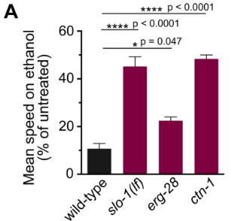
Figure alpha from (OH KH et al 2019)

Hypothesis
Does the 381st threonine play a role in the ability of the SLO-1 BK Channel’s interaction with Dystrophin?

Proposed Experimental Methods.
To observe the clustering phenotype of an ethanol resistant slo-1(T381I) mutant the following steps need to be taken. Worms(slo-1(cim105[slo-1::GFP])(Oh KH, Kim H) will be mutagenized using CRISPR Cas9 and short range homology directed repair. Microscopy will be used to observe the position of BK channels on the neurons and sacrolemma’s of the worms.

CRISPR Cas9( Methods)
CRISPR works by taking a generated marker (sgRNA) and using the marker as a guide to make a double stranded break using the Cas9 enzyme. For CRISPR Cas9 to make a double stranded cut Cas9 attaches to guide sgRNA. sgRNA is made up of two components crRNA and tracRNA. crRNA is an RNA strand that acts as a target for where to direct the location of the double stranded cut. tracRNA binds the crRNA to the Cas9 proteins that makes the double stranded cut. To select the location of the crRNA sequence we need to find a PAM or a short sequence that is either NGG or NCC that will be directly preceded in the 5’ direction by the template that will be used to make our crRNA. One codon upstream of our pam region will be where the double stranded break will occur fig2. The [peft-3::Cas9 + ttTi5605+sgRNA](Dickinson et al 2014) will be used to generate Cas9 and the sgRNA template we provided will bind to Cas9 and make our cut.
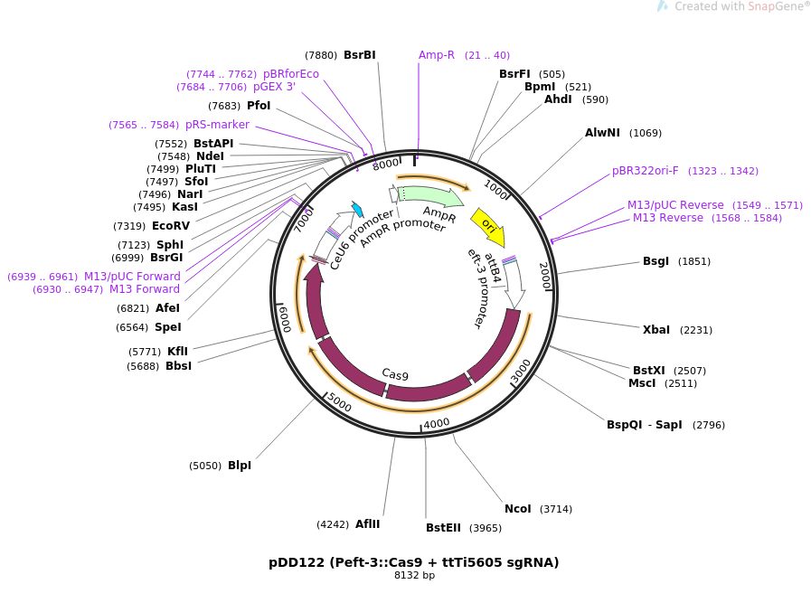

figure 1
The design of the plasmid used to insert Cas 9 into C. elegans genome.
(Dickinson et al 2014) see magnified figure 1 at the end

HDR(Homology Directed Repair)

To create the edits to the BK Channel. We are creating a cut 5’ upstream of the codon that codes for the 381st threonine (see figure 2 for the cut location). To create the cut we are transfecting our plasmid with cas9 into our C.elegans gonad. Cas9 will be produced and it will bind to the sgRNA that was introduced along with it and a cut will be made. Once the cut is made a single strand oligo sequence will be introduced as the repair template. The repair template has one edit. For short range HDR to occur a double stranded break needs to be made near(within 10bp) the site that is going to be repaired and a repair template need to be created for homologous recombination to occur. Once the break has been created and the repair template introduced homologous repair occurs and our edit is made.

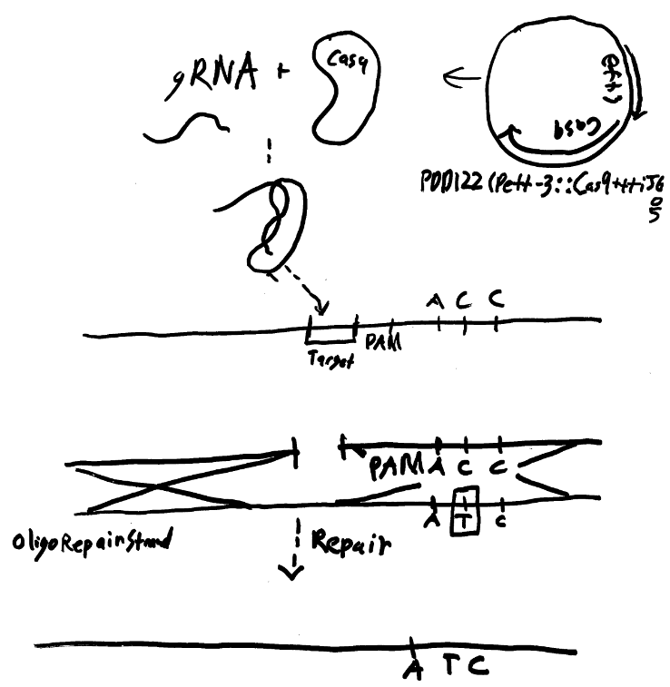

crRNA template = GAAGCACATAGTGGTCTGTG
CACATAGTGGTCTGTGGCCATATCATCTACGATTCGGTGTCCCATTTTN
ssDNA Oligonucleotide that will be used as a homology template
green = homology arms
blue = sites to be changed
fig 2
MICRO INJECTION
The Cas9 plasmid along with the ssDNA repair template and the sgRNA mentioned above will be injected using microinjection into the gonad (zygote) of a hermaphrodite worm slo-1(cim105[slo-1::GFP]).

PCR Screen
Once the worm P_{o} has been injected its progeny will be grown up and separated. The P_{o} worm will have edited zygotes and will not express the edit we want to see. What needs to occur is the worms need to express a homozygous slo-1(T381I). For this to happen the worms need to be separated and grown to the F₁ generation where all of the worms will be heterozygous for the change and then separated again and grown to the F₂ where ¼ of the worms will be homozygous for the edit. Once the F2 generation has been reached worms will be separated and allowed to lay eggs overnight. The f2 generation’s worm will be lysed and the DNA will be extracted.

To see if transgenesis was successful a screen of the animals using pcr will be carried out. To do this primers were created. A start primer was made based on the region that was being modified an end primer was made for a random region about 1000 bp down stream of start.
Figure 5
start primer : TGTGGCCATATCACC
end primer :taagaagaaaatcttaaaa
blue = mutation point

These primers create one product 1109 base pairs long ^{verified with biobike} in a wild type worm
If this product cannot be created from the progeny of the worm then we can say that transgenesis has taken place because our modification will have broken the region the start primer would have bound to. If this product can be created than we can be confident that transgenesis has not taken place.

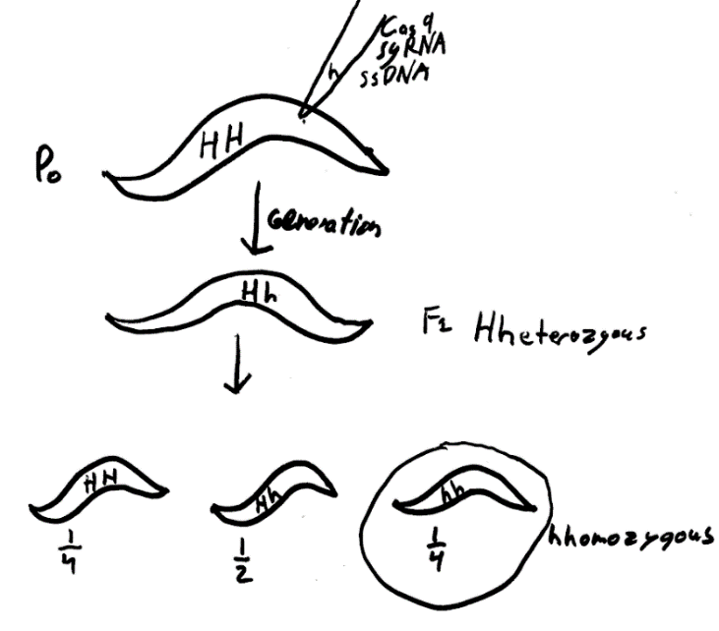

Microscopy
Once the animals are screened using PCR. The progeny of the animals that carry the T381I mutation will be grown into adults and microscopy will take place.

For Microscopy an animal will be moved under the microscope illuminated with blue light and then the the dorsal cord(nerve) the sacrolemma(muscle cell) and the egg laying nerve will be observed under magnification. The puncta that appear or do not appear should then be counted on each of the different areas over a box 150 pixels long.
This process will be repeated with wild type(slo-1(cim105[slo-1::GFP]) worms and with ctn-1
ctn-1(eg1167)I; slo-1(cim105)V mutants as mentioned in (Oh KH et al 2019). If the worms match more closely the ctn-1(eg1167) mutants then it can be confirmed that the 381st threonine interacts with dystrophin in some way. If the worms match the slo-1(cim105[slo-1::GFP]) worms then than it can be confirmed that the 381st threonine doesn’t interact with dystrophin.

Strains and plasmids used
slo-1(cim105[slo-1::GFP])(Oh KH et al 2019)
ctn-1(eg1167)I; slo-1(cim105)V (Oh KH et al 2019)
Peft-3::Cas9 + ttTi5605 sgRNA Dickinson et al 2014

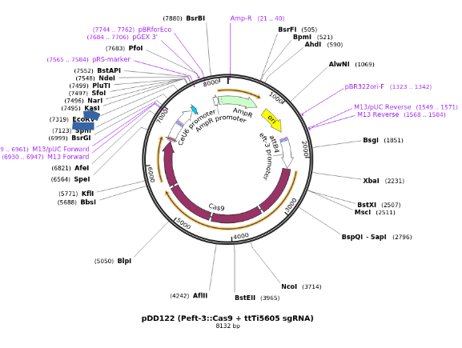

Works cited

Davies AG, Pierce-Shimomura JT, Kim H, et al. A Central Role of the BK Potassium Channel in Behavioral Responses to Ethanol in C. elegans. Cell. 2003;115(6):655-666. doi:10.1016/s0092-8674(03)00979-6.

Davis SJ, Scott LL, Hu K, Pierce-Shimomura JT. Conserved single residue in the BK potassium channel required for activation by alcohol and intoxication in C. elegans. J Neurosci. 2014;34(29):9562–9573. doi:10.1523/JNEUROSCI.0838-14.2014

Dickinson DJ, Ward JD, Reiner DJ, Goldstein B. Engineering the Caenorhabditis elegans genome using Cas9-triggered homologous recombination. Nat Methods. 2013;10(10):1028–1034. doi:10.1038/nmeth.2641

Oh KH, Kim H. BK channel clustering is required for normal behavioral alcohol sensitivity in C. elegans. Sci Rep. 2019;9(1):10224. Published 2019 Jul 15. doi:10.1038/s41598-019-46615-9

5 https://benchling.com/protocols/wTQojorb/option-1-clone-grnas-into-plasmids

