Comparison of FGL2 protein and IGFBP2 protein in order to create a new antibody for Glioblastoma

- Introduction

Cancer is a disease that is very common among people but also a disease that is very hard to cure. Most cancer starts as low-grade gliomas (LGG) and end up as high-grade gliomas (HGG), basically meaning that stage 1 & 2 cancer develops into stage 3 & 4 cancer. It is not different for glioblastoma (Fig.1). Glioblastoma is a type of cancer which is one of the most common brain tumors in adults. Many people are not familiar with this term since brain tumor/cancer is not a type of cancer that many people talk about. However, it is important to make sure cancer cells do not spread to the glioma. Once the cancer cells spread to the glioma it is extremely hard to cure since the brain is a fragile part of the body and once damaged it does not heal. For this reason, it is almost impossible for neurosurgeons to completely remove the tumor.
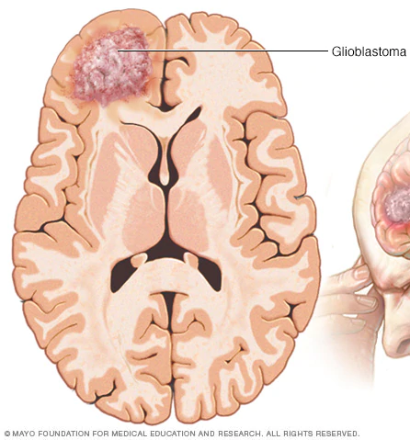
Fig 1. Glioblastoma location
Usually starts at the cerebrum (the largest part of your brain) and spreads from there. Glioblastoma makes their own supplies and grows.

1.1 FGL2 Protein Experiment

Fibrinogen-Like Protein 2, also called FGL2 proteins, is known to contribute to negative regulatory activity exhibited by Treg cells. FGL2 degenerates low-grade glioma (LGG) into high-grade glioma (HGG), simply meaning that stage 1&2 cancer will develop into stage 3&4 cancer. It also makes the glioma more immunosuppressive and suppresses the immune system. It is also found that tumor progression and FGL2 expressions have a direct relationship to each other. With these characteristics, scientists figured that maybe blocking the FLG2 protein may lead to a new treatment for glioblastoma.

The scientist then organized and experiment to test their hypothesis. In the experiment, they modeled the mice to grow tumors in a specific part of the brain. Then they took the mice and divided them into two groups, the control and experimental group. The control group was injected with IgG antibodies, a commonly used antibody since it is commonly found in the blood and body fluid, and the experimental group was injected with anti-FGL2 antibodies.

1.2 CD44 Receptors & Treg Cells

Throughout the experiment, scientists compared the CD44 receptors and Treg cells in the two groups to determine if their hypothesis was correct.

CD44 receptors are a type of transmembrane protein, also known as P-glycoprotein 1 (Fig.2). They are commonly found near cancer cells/tumors and act as a marker for cancer stem cells. Simply said, the more cancer cells present means more CD44 receptors present. It is also stated that CD44 receptors take a big role in cancer because of the fact that they can control the formation of blood vessels. This is an important role because cancer requires angiogenesis. Angiogenesis is the formation of new blood vessels which means they help with spreading the cancer cells throughout the body which is the characteristic CD44 receptors carry (Fig.3).

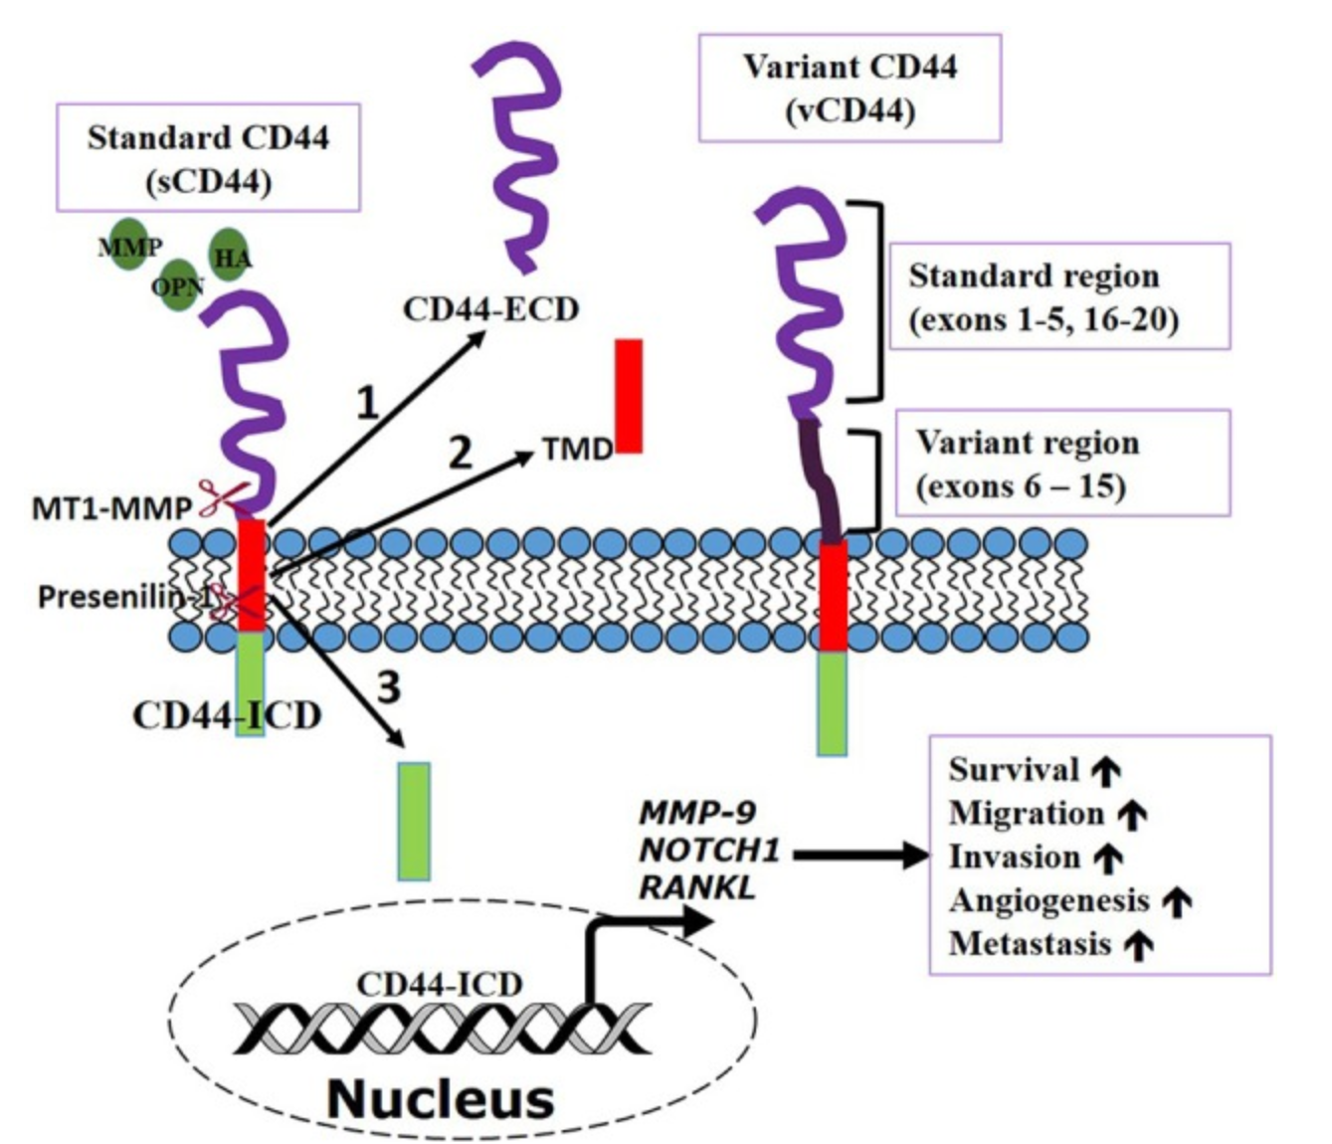
Fig2. CD44 structure Fig3. CD44 function
A transmembrane protein. ECD(purple): extracellular domain;
TMD(red): transmembrane domain/
hydrophobic residue;
ICD(green): activate transcription important for metastasis (spreading of cancer cell)

Treg cells are known as suppressor T cells. They are also known to be immunosuppressive and usually suppresses induction of effector T cells meaning they suppress T cells from doing their job. It also prevents autoimmunity meaning that the immune system recognizes the body’s tissue and organs as a foreign substance and attacks it. The more Tregs present, the faster the tumor grows.

1.3 Result for the FGL2 Experiment

Through the experiment, the scientists noticed that CD44 receptors and Treg cells both showed more in the control group than the experimental group. The results from the experiment supported their hypothesis that FGL2 proteins helps tumor progression. However, FGL2 is not the only protein that boosts tumor progression in the brain. There is a similar protein called Insulin-Like Growth Factor Binding Protein 2 (IGFBP2) associated with tumor progression and also found that high level of this protein promotes tumor progression.

- The Experiment

2.1 Goal

The goal of the experiment is to determine the similarities between the two proteins, FGL2 and IGFBP2, and decide whether making and antibody for IGFBP2 would be useful to stop tumor progression. The experiment will be looking at the CD44 receptors and Tregs present in the tumor after injecting the anti-IGFBP2 antibodies.

2.2 Effectiveness of IGFBP2 and modeling the mice

In order to see if the IGFBP2 protein plays the same role as the FGL2 protein, before injecting antibodies, the experiment will make a control group and an experimental group where the control group is injected with glioma cells and the experimental group injected with glioma cells and IGFBP2 protein. They inject the cells by drilling a guide screw then injecting the cells through a syringe(Fig4). Then using a regular graph where the y-axis is survival percent and the x-axis is the days, the two groups will show the survival days. It is expected that the experimental group has a shorter life span than the control group which supports the fact that IGFBP2 plays similar role as FGL2 in boosting tumor progression.
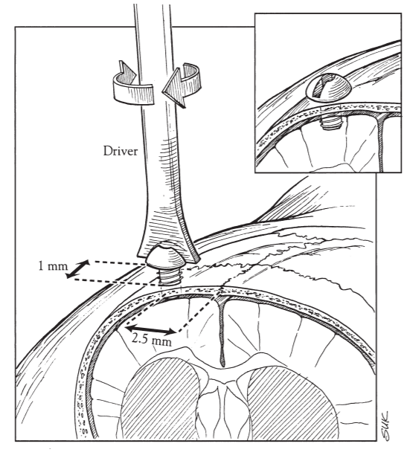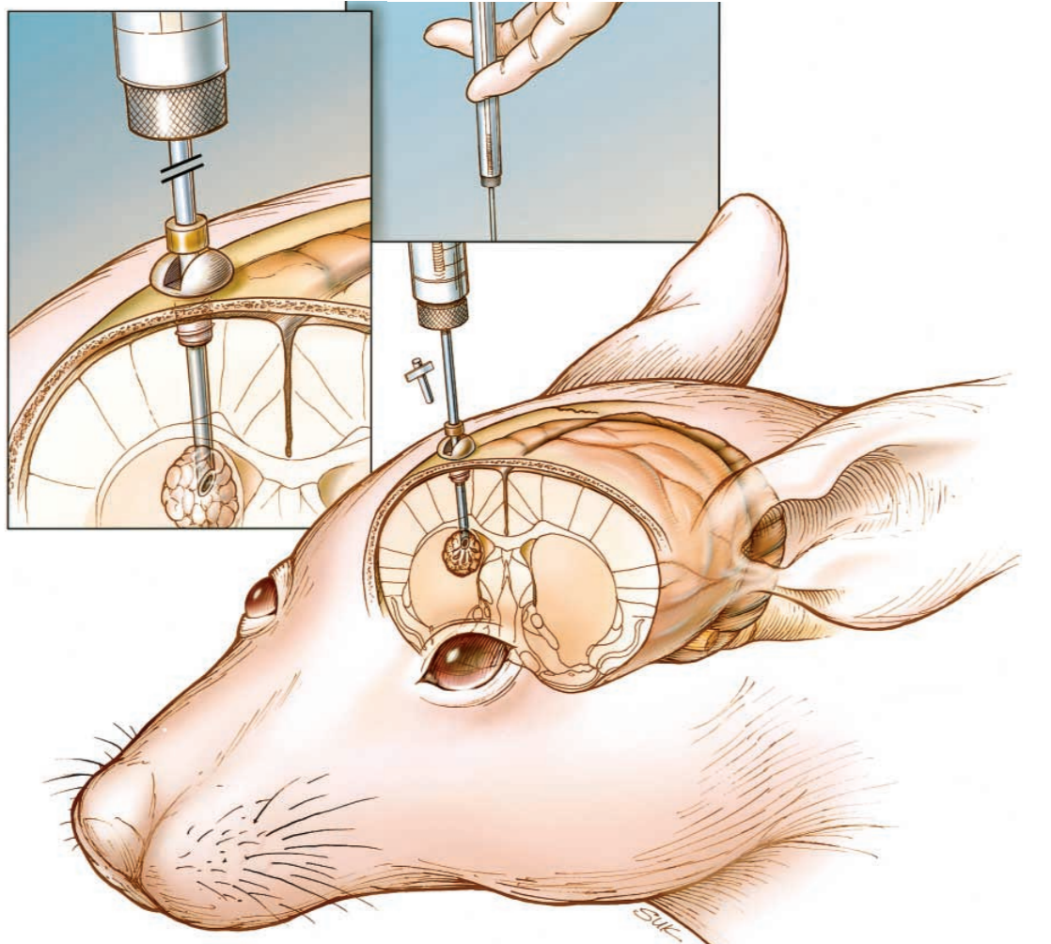
Fig 4. Injecting Glioma cells into the control and experimental group
First drilling a guide screw into the skull through the brain to the specific area then injecting the glioma cells to the control group, glioma cells + FGL2 proteins into the experimental group.

Once the IGFBP2’s effectiveness is proven, two new groups will be made. Both groups will be injected with glioma cells and IGFBP2 proteins but the control group will be treated with IgG antibodies and the experimental group will be treated with anti-IGFBP2 antibodies.

2.3 Measure CD44 receptors

Using western blotting (Fig 5), often used to separate a specific protein, to determine the protein level will help measure the CD44 levels present in the tumor.

The proteins that are mixed will eventually separate by the size and then producing a band for each protein separated using gel electrophoresis. Then using an antibody, specific for the protein of interest, to isolate the specific protein (Fig 6). After this process only one band should be present and the thickness of the band will help to determine how much of the specific protein is present.
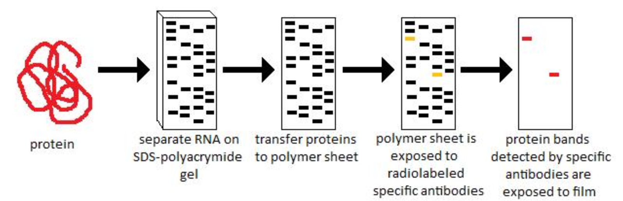
Fig 5. Western Blotting
This method is used when finding a specific protein in a mixed protein. During the process, gel electrophoresis is used with antibodies to divide the proteins by size. Eventually, the bands left will be the specific protein and the band size determines the amount of protein present

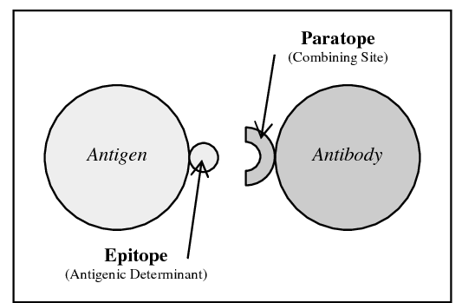
Fig 6. Antigen-Antibody Reaction
How the antibodies are used to determine the specific protein. Epitope is part of the antigen that is recognized by the antibody. Paratope is a part of the antibody and attaches itself to the epitope.

2.4 Measure Tregs

For measuring Treg cells(also called CD4+ T cells), flow cytometry (Fig 7) was used. Before inserting the cell into the nozzle, it will be dyed using fluorochrome. once the cell is inserted, it will form a line and pass through the laser one by one. The laser will then make lights bump off from the cell to determine the wavelength and will be collected by the sensors according to the specific fluorochrome (Fig 8).
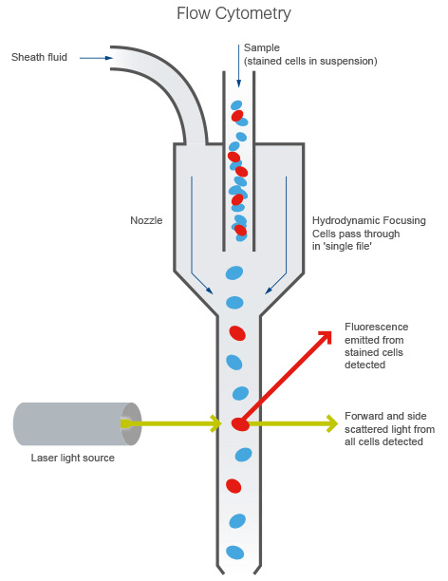
Fig 7. Flow Cytometry
The fluorochrome can be made by using specific antibodies for specific proteins so that every antibody/protein will have its own color/wavelength.

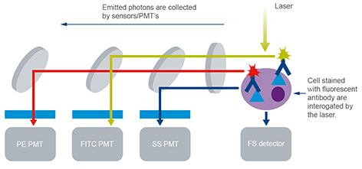
Fig 8. How specific cells are collected
This step is showing how the antibodies are stained and depending on the stain the sensors sort the cells.

Then a graph will be plotted by the computer. It shows the number of Treg cells present in the cell. The x-axis is the CD4+ protein and the y-axis represents the FoxP3 protein. The reason the upper right part of the graph is what we use to determine the number of Treg cells is because Treg cells represent a high percentage of this protein and is one of the most reliable markers for Treg cells. FoxP3 expressions are usually restricted to CD4 proteins which makes having higher CD4 proteins present more favorable for Treg cells(Fig 9).

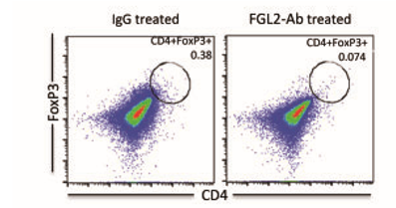
Fig.9 Graph from Flow Cytometry
Treg cells present are read by the amount of dots present on the upper right corner. It is also said that CD4+ T cells are another name for Treg cells.

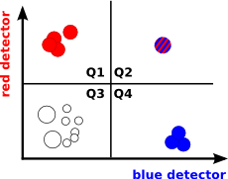
Fig 10. How to read the graph
Like an ordinary graph, the upper right has the most of both the x and y-axis whereas the lower left has the least or none of the two.

Discussion / Expected Outcome

The CD44 levels in the experimental group is expected to be lower than the control group. Since IGFBP2 protein is similar to FGL2 protein, it is most likely that the CD44 levels will decrease. Blocking this protein will decrease the tumor growth and the number of cancer cells which will lead to less CD44 receptors present.

The Tregs are expected to accumulate more in the control group than the experimental group. CD4+FoxP3 Treg cells are necessary for the suppressive activity of the immune system. The experimental group will have less tumor progression and less cancer cells present which means the immune system will not have to work as much, which also means that the Treg cells have nothing to suppress and therefore be less present in the experimental group.

Reference

Mentor - Suyun Huang; Paul M. Corman Chair in Cancer Research; Department of Human and Molecular Genetics

Liu, Y., Song, C., Shen, F., Zhang, J., & Song, S. W. (2019). IGFBP2 promotes immunosuppression associated with its mesenchymal induction and FcyRIIB phosphorylation in glioblastoma. Seoul: Jung Weon Lee. doi: September 27, 2019

Latha, K., Yan, J., Yang, Y., & Rao, G. (2018, May 21). The Role of Fibrinogen-Like Protein 2 on Immunosuppression and Malignant Progression in Glioma. Retrieved November 12, 2019, from.

FGL2. (2019, March 20). Retrieved from https://en.wikipedia.org/wiki/FGL2.

Mahmood, T., & Yang, P.-C. (2012, September). Western blot: technique, theory, and trouble shooting. Retrieved from https://www.ncbi.nlm.nih.gov/pmc/articles/PMC3456489/.
Li, Z., Li, D., Tsun, A., & Li, B. (2015, February 16). FOXP3 regulatory T cells and their functional regulation. Retrieved from https://www.nature.com/articles/cmi201510.

Corthay, A. (2009, October). How do regulatory T cells work? Retrieved from https://www.ncbi.nlm.nih.gov/pmc/articles/PMC2784904/.

Chen, C., Zhao, S., Karnad, A., & Freeman, J. W. (2018, May 10). The biology and role of CD44 in cancer progression: therapeutic implications. Retrieved from https://link.springer.com/article/10.1186/s13045-018-0605-5.

Ha, T.-Y. (2009, December). The role of regulatory T cells in cancer. Retrieved from https://www.ncbi.nlm.nih.gov/pmc/articles/PMC2816955/.

Tanaka, A., & Sakaguchi, S. (2016, December 20). Regulatory T cells in cancer immunotherapy. Retrieved from https://www.nature.com/articles/cr2016151.

Senbanjo, L. T., & Chellaiah, M. A. (2017, March 7). CD44: A Multifunctional Cell Surface Adhesion Receptor Is a Regulator of Progression and Metastasis of Cancer Cells. Retrieved from https://www.ncbi.nlm.nih.gov/pmc/articles/PMC5339222/#B25.

Definition: Autoimmunity (for Parents) - Nemours KidsHealth. (n.d.). Retrieved from https://kidshealth.org/en/parents/autoimmunity.html.

Flow cytometry. (2019, October 25). Retrieved from https://en.wikipedia.org/wiki/Flow_cytometry.

Structural Biochemistry/Proteins/Western Blotting. (n.d.). Retrieved from https://en.wikibooks.org/wiki/Structural_Biochemistry/Proteins/Western_Blotting.

Brownlee, J. (1970, January 1). Figure 1 from Antigen-Antibody Interaction: Semantic Scholar. Retrieved from https://www.semanticscholar.org/paper/Antigen-Antibody-Interaction-Brownlee/ebd56bfe52bb8b3a7ad31265033df805475b712e/figure/1.

Introduction to flow cytometry. (2019, December 1). Retrieved from https://www.abcam.com/protocols/introduction-to-flow-cytometry.

Fiser, K. (n.d.). Flow cytometry - graphs. Retrieved from http://www.bioinformin.net/cytometry/flow_plots.php.

