A Possible Treatment Method of Malignant Breast Cancer Using
Modified Adeno-Associated Virus 2 and the Nur77 Gene.
I. Introduction
Cancer is a condition that can be found all over the world and is the second leading cause of death among humankind. Within the range of locations non-benign tumors can develop, breast tissue is the most common, second only to the skin. In the United States alone, there are 334,200 people diagnosed with, and 42,260 killed by, breast cancer in any given year. Treatment options for the conditions have come very far, but there are still 17% of individuals who succumb to it within ten years of diagnosis.¹ All cancerous cells can be simplified to two main attributes, excessive cellular division and inadequate rates of apoptosis, or programmed cell death.²
The Nur77 nuclear receptor is often a major factor in both of these defining characteristics of a cancerous growth. This is due to its dual function in the cell.³ In a normal cell, Nur77 binds to specific nucleotide sequences upstream from genes and mediates the expression of the gene.^{4,5} It is able to bind to different nucleotide sequences by forming heterodimers with other nuclear receptors, or a homodimer with itself.⁵ Overexpression of this protein leads to overexpression of cellular replication genes, making the cell replicate at a much higher rate than normal.^{6,10} Nur77 is also a potent inducer of apoptosis, but only when it has been moved from the inside of the nuclear envelope to the outer mitochondrial membrane.⁷ This can only happen under very specific conditions, which are often not found in cancerous cells.^{8,9} In this sense, Nur77 contributes to both the excessive division and the lack of apoptosis in a non-benign tumor. Therefore, though modification to make the Nur77 receptor target the mitochondria naturally, apoptosis could be encouraged in cancerous cells.
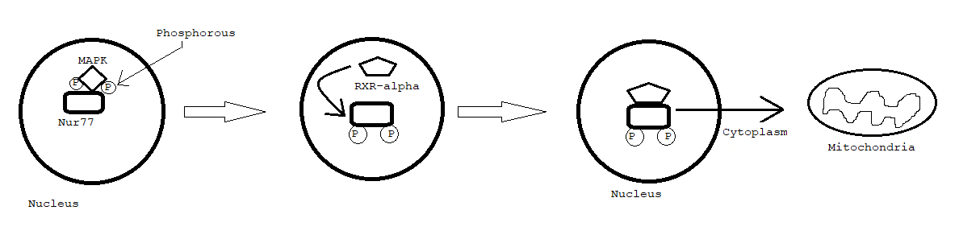
The conditions in which Nur77 is able to leave the nuclear membrane relies on the function of multiple other proteins. The first step to enable egress from the nuclear envelope is its phosphorylation status. Without being phosphorylated, the receptor is unable to initiate transfer from the nucleus to the cytoplasm, as it is not able to permeate the nuclear membrane. Upon phosphorylation, Nur77 binds to RXR-alpha and leaves the nucleus. However, RXR alpha is able to dimerize with Nur77 without phosphorylation and does so in the nucleus to express certain genes.²⁰ The process of phosphorylation is mediated by mitogen-activated protein kinase and protein kinase B pathways, which are often rendered ineffective or insufficient in a cancerous cell.^{11,12} Once the Nur77 receptor has been phosphorylated, it binds with retinoid X receptor alpha (RXR-alpha) to be able to leave. This is because RXR-alpha is the primary transport partner or Nur77 and is critical to the movement of the heterodimer from the nucleus to the cytoplasm after phosphorylation.^{8,9} Thus Nur77 can only begin the process of inducing apoptosis once phosphorylation and heterodimerization with RXR alpha have been attained.
Figure 1: A diagram depicting the steps taken to allow for nuclear export of Nur77 (Adapted from figure 8 of ref. 11)
Once Nur77 has reached the mitochondria, it is extremely effective at causing controlled cell death. Upon reaching the outer membrane, it binds onto the B-cell lymphoma-2 protein (Bcl-2). Upon doing so, it initiates irreversible conformational change of the Bcl-2 structure.¹³ After modification, Bcl-2 alters the permeability of the outer membrane of the mitochondria, releasing the cytochrome C protein from the intermembrane space into the cytoplasm. After its release, it activates the caspase family of proteases, which is believed to be the first step in apoptosis induction. ^{13,14}
By modifying an adenovirus to contain the Nur77 gene with a mitochondrial targeting sequence, the receptor could be made to move towards the mitochondria rather than the nucleus after expression. This is necessary because the Nur77 receptor will naturally move to the interior of the nuclear envelope upon creation, so targeting the region in which it can induce apoptosis has the potential to have a notable impact on the rate of apoptosis in treated regions. Through use of PCR and viral plasmid modification, a virus can be made that could be effective in the treatment of tumors.
II. Experiment
The experimental procedure can be broken into five parts: Nur77 gene isolation and preparation, plasmid creation, virus growth, treatment of cancerous cells in test mice, and a post treatment procedure to prevent or limit the spread of the virus to healthy cells. Through careful trials with variable levels of dosage and infection periods, the optimal methodology of treatment using this method could be determined. This process will be conducted using modified adenovirus.
Gene isolation
The first step in obtaining the Nur77 gene is to remove the introns. This will make the sequence removed by PCR later more compact and efficient, because it won’t have the non-coding regions. To do this, an mRNA copy of the mouse genome needs to be obtained. Roughly 25 mg of mouse tissue will be mixed into two mL of trizol reagent.²¹ That solution will be strongly mixed for a minute, then centrifuged for a minute as well. The sample will be incubated for five minutes at around 20 degrees Celsius, then will receive 0.4 mL of chloroform and sealed. The sealed tube will be shaken by hand for three minutes, then incubated again for 15 minutes around 5 degrees Celsius.²² The solution will have separated into different layers, with the RNA being in the uppermost aqueous layer. This will be pipetted out of the container and into another containing 1 mL of isopropyl alcohol. The alcohol solution will be incubated for ten minutes at about 20 degrees Celsius, then centrifuged for ten minutes to precipitate the RNA sample.²² It should come out as a gel-like “pellet” at the bottom of the container. The isopropyl alcohol solution will be extracted, leaving the pellet at the bottom. The RNA sample will be washed with 2 mL of 25% water, 75% ethanol. The sample will be mixed and centrifuged one more time. The extracted RNA pellet will be air-dried for roughly five minutes, then dissolved into water.²¹ At this point, an mRNA copy of the mouse genome has been isolated and must be turned to cDNA.
The cDNA creation process begins with the formation of a primer-RNA mix solution. It will consist of 0.5 microliters of random hexamer primers, 0.5 microliters of oligo primers, one microliter of dNTP mix to provide general nucleotides for sequence creation.²⁵ A second solution for the buffer and enzymes is made, with the following items being added in order: two microliters of cDNA synthesis buffer²³, 4microliters of MgCl₂, 2 microliters of 0.1 M dithiothreitol (DTT)²⁶, one microliter of RNaseOut²⁷, one microliter of Superscript III. This will allow the RNA sequence to remain stable and be reverse transcribed by the reverse transcriptase present in Superscript III.²⁸ Each of these solutions will be combined and given 10 minutes to incubate. At this point, the solution should contain cDNA extracted from the original mouse tissue composed solely of exon.
PCR of the Nur77 gene will begin with the acquisition of primers. Since the sequence of Nur77 has been determined already, The primers can be ordered from one of a few companies to contain the specific sequences required. The forward strand primer will be identical to the first 17 nucleotides of the forward strand, so as to avoid the possibility of the primer binding elsewhere. The sequence of the forward primer is GAGCCCCAGTGCAGGAG. The backwards strand primer needs to be complementary to the forward strand, so its sequence would be TTATCTGTACAACT.²⁴ Once these primers are procured with taq polymerase and more dNTP if necessary. A solution of cDNA will be heated to 95 degrees Celsius for 15-30 seconds to force the hydrogen bonds between the chains to break, forcing the DNA to become temporarily unwound and single stranded. The solution will then be cooled to roughly 60 degrees Celsius and the primers will be added, allowing them to bind to the correct sites. After one minute, the taq polymerase and dNTP samples will be added and the solution heated to 72 degrees Celsius, causing the production of two long strands of DNA that contain the Nur77 gene and everything following it in the direction of the primers transcription.²⁹ This process is repeated twice more before two independent copies of the Nur77 double stranded DNA is isolated, and from this point on their number will grow exponentially.³⁰ After 30 rounds of PCR cycles, the solution will be almost entirely consistent of the isolated and cloned Nur77 gene.
Plasmid creation
Before the plasmid can be created, Nur77 must be modified with two sequences. The first sequence to be added is the first 23 amino acids of cytochrome oxidase subunit 8 (COX8), a mitochondrial targeting sequence (MTS) that will cause the Nur77 receptor to move towards the mitochondria rather than the nucleus upon expression.¹⁶ It can be isolated using PCR as well, although after isolating the cytochrome oxidase gene another set of PCR cycles will likely need to be conducted with shorter primers to isolate the specific subunit. This subunit will be connected to Nur77 by combining them in a solution with t4 DNA ligase. Once the MTS is ligated onto the gene, all that’s left is the addition of BamHI inverted terminal repeat sequences (ITRs). These sequences are short palindromic portions of DNA that provide a binding site for the BamHI gene to cut, allowing the gene sequence to have identical end sequences to the openings in the plasmid and be incorporated effectively. The primer has a forward sequence of GGATCC, with the point of cleavage between the two guanines.³¹ The plasmid I am going to use is called pShuttle-CMV. It is an adenovirus plasmid produced by Addgene.³¹ At position 5148 in the plasmid sequence is the restriction site for BamHI, so by combining the Nur77 and pShuttle-CMV solutions and adding BamHI restriction enzyme, I can cut the sequences at the designated spots. This will be shortly followed with T4 DNA ligase to reseal the plasmids, with many of them containing the Nur77 gene.
Virus development
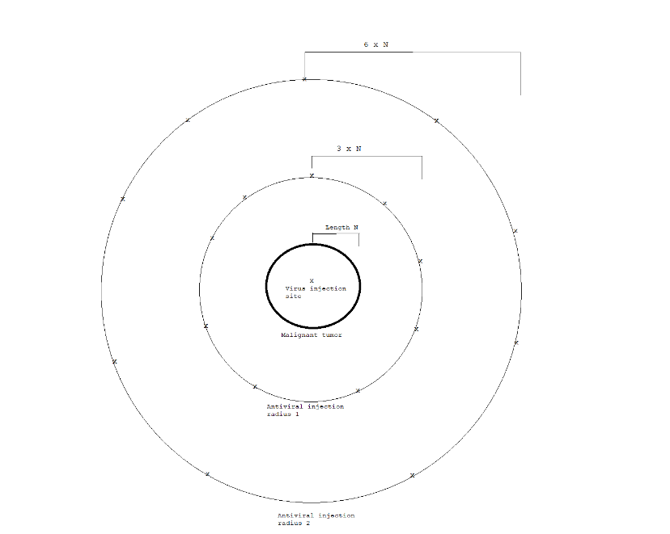
The actual unit of viral treatment will be grown using an E. Coli strand pregrown with an adenovirus forming plasmid already incorporated. This is a product also sold by Addgene entitled AdEasier-1 cells.³² Growing these cells with the modified pShuttle-CMV plasmid within will allow for the creation of functional viruses containing a plasmid that does not hold all the information required for viral replication. These cells will be grown in a petri dish with luria broth.³³ Upon substantial cell replication, a sample of the e. coli will be lysed and the viruses inside filtered out using a filter with openings small enough for the virus to enter, but not small enough for the e. coli to travel through.³⁴ Upon isolation of the virus, treatment testing can be initiated.
Part 2: Treatment
The treatment process requires multiple trials using different quantities of viral serum and different incubation periods. Tumor-prone mice will be purchased to be the subject of these tests.³⁵ In a given trial, the dosage of the virus given with remain constant. The injection will be made and immediately followed by injections of antiviral medications in the surrounding tissues to prevent the uncontrolled spread of the cell death-inducing virus. The size of the radii for antiviral injection will be determined by tumor radius N. at 3N, a circle of antiviral injections that inhibit viral binding potential on the host cells, while the injections at 6N will inhibit the virus itself. Two sample groups will be taken, one with the control treatment and one with the experimental treatment. In each sample group, the subjects will be divided into groups that wait steadily increasing amount of time before the post treatment procedure is initiated. The results will be recorded, and the next trial will begin by doing the same process but with uniformly higher doses for all subjects.
Figure 2: Injection method intended to minimalize unintended cell death and maximize treatment effectiveness. Each X in the antiviral injection radii indicates an injection point.
Part 3: Post-treatment procedure
The purpose of the post-treatment procedure is to further reduce the risk of unnecessary cell loss as a result of the virus. Upon completion of their trial, the subject will be given a steady dose of glucocorticoids to antagonize the Nur77 receptor and inhibit its function. This will temporarily slow the rate of apoptosis in the organism while they are given a heavy dose of high-grade antivirals to be sure there is no more of the modified virus in the body. The effectiveness of the treatment will be monitored by observing its effect on cancer growth, which will be done by monitoring tumor growth rate and Ki-67 levels. These are common ways that cancer researchers monitor the growth of the condition over time.
III. Discussion
If all goes well in this experiment, the viral treatment should be able to cause severe rates of apoptosis in the malignant tumors while causing minimal damage to the healthy tissues of the body. Precisely targeted treatment and aggressive protective measures have potential to cause widespread cancerous cell death in a very similar way to radiation or chemotherapy, but could leave the patient in a much better post-treatment physical state, improving their day-to-day life. Any level of human testing with something like this is almost entirely certain to be years away from the initial trials. However, such a treatment could prove exceptionally effective as well as improve a given patients general quality of life as they struggle with their affliction.
While it is nice to consider the possibilities associated with this experiment going perfectly, such an occurrence is rarely the case in life. There are possible complications that can arise from this process that would need to be considered as they occur, since its impossible to know exactly what will come of the trials.
It is agreed that RXR is a transport partner in the movement of Nur77 from the nucleus to the cytoplasm. However, my research has indicated that the presence of RXR-alpha at the actual time of binding to bcl-2 is not entirely known. Should Nur77 require RXR-alpha to be able to bind to bcl-2, a second adenovirus could be developed that includes the genes for both of them, equipped with mitochondrial targeting sequences. This virus could be created in an almost identical manner to my experimental procedure, but might need a different restriction enzyme and ITR to incorporate RXR-alpha into a different point on the plasmid. Upon another round of testing, increased treatment effectiveness might be indicative of the necessity of the heterodimer, not just Nur77 alone.
A major aspect of the experiment that needs to be effective is the post-treatment procedure. Because a fixed, non-replicative amount of virus will be introduced, there is the possibility of dilution of the effect should the treatment be transported throughout the body, rather than contained in the tumor. If the antivirals aren’t effective enough, or if the virus spreads throughout the body faster than expected, non-cancerous cell death rates could spike while the effects on the tumor will be diminished. Such a scenario would obviously be detrimental to the subject, so the isolation of the treatment is just as vital as its removal afterwards.
While this issue would obviously render the concept more than unsatisfactory for the treatment of humans, the line itself seems a bit blurry. That is to say, at what point is there two much unintended cell death? Chemotherapy is a widely used method to treat cancer and wreaks havoc on the patients whole body, not just the cancerous cell lines. Should the success of the experiment be based off of its cancer-cell-death to normal-cell-death ratio in comparison to that of other treatment options? If it were to be effective at causing increased apoptosis in both cell types, is it something that shouldn’t be considered an option, or should it be a more aggressive yet dangerous option? Questions of morality like these are going to accompany any treatment or research with the potential to cause harm. Ultimately it is impossible to reach a conclusion on the matter without more information. To answer those questions, the experiment would need to be conducted and the results analyzed thoroughly.
This experiment, like many others, has many places in which it could go wrong. Undoubtedly, there are bound to be more issues that weren’t even considered in this proposal that might surface when conducting the experiment. However, conducting such a study could provide an effective treatment alternative for breast cancer that could raise survivability rates and lower relative patient discomfort.

IV. Bibliography
- “Breast Cancer - Statistics.” Cancer.Net, 22 Aug. 2019, www.cancer.net/cancer-types/breast-cancer/statistics.
- “Apoptosis.” Merriam-Webster, Merriam-Webster, www.merriam-webster.com/dictionary/apoptosis.
- Niu, Gengming, et al. “Dual Roles of Orphan Nuclear Receptor TR3/Nur77/NGFI-B in Mediating Cell Survival and Apoptosis.” International Review of Cell and Molecular Biology, 2014, pp. 219–258., doi:10.1016/b978-0-12-800177-6.00007-4.
- Wilson, T E, et al. “The Orphan Receptors NGFI-B and Steroidogenic Factor 1 Establish Monomer Binding as a Third Paradigm of Nuclear Receptor-DNA Interaction.” Molecular and Cellular Biology, vol. 13, no. 9, 1993, pp. 5794–5804., doi:10.1128/mcb.13.9.5794.
- Maira, Mario, et al. “Heterodimerization between Members of the Nur Subfamily of Orphan Nuclear Receptors as a Novel Mechanism for Gene Activation.” Molecular and Cellular Biology, vol. 19, no. 11, 1999, pp. 7549–7557., doi:10.1128/mcb.19.11.7549.
- Holmes, William F, et al. “Early Events in the Induction of Apoptosis in Ovarian Carcinoma Cells by CD437: Activation of the p38 MAP Kinase Signal Pathway.” Oncogene, vol. 22, no. 41, 2003, pp. 6377–6386., doi:10.1038/sj.onc.1206694.
- Chang, Li-Fu, et al. “Overexpression of the Orphan Receptor Nur77 and Its Translocation Induced by PCH4 May Inhibit Malignant Glioma Cell Growth and Induce Cell Apoptosis.” Journal of Surgical Oncology, vol. 103, no. 5, 2011, pp. 442–450., doi:10.1002/jso.21809.
- Zhang, Xiao-Kun. “Targeting Nur77 Translocation.” Expert Opinion on Therapeutic Targets, vol. 11, no. 1, 2006, pp. 69–79., doi:10.1517/14728222.11.1.69.
- Cao, X., et al. “Retinoid X Receptor Regulates Nur77/Thyroid Hormone Receptor 3-Dependent Apoptosis by Modulating Its Nuclear Export and Mitochondrial Targeting.” Molecular and Cellular Biology, vol. 24, no. 22, 2004, pp. 9705–9725., doi:10.1128/mcb.24.22.9705-9725.2004.
- Delgado, Evan, et al. “High Expression of Orphan Nuclear Receptor NR4A1 in a Subset of Ovarian Tumors with Worse Outcome.” Gynecologic Oncology, vol. 141, no. 2, 2016, pp. 348–356., doi:10.1016/j.ygyno.2016.02.030.
- Han, Y-H, et al. “Regulation of Nur77 Nuclear Export by c-Jun N-Terminal Kinase and Akt.” Oncogene, vol. 25, no. 21, 2006, pp. 2974–2986., doi:10.1038/sj.onc.1209358.
- Chen, H.-Z., et al. “Akt Phosphorylates the TR3 Orphan Receptor and Blocks Its Targeting to the Mitochondria.” Carcinogenesis, vol. 29, no. 11, 2008, pp. 2078–2088., doi:10.1093/carcin/bgn197.
- Lin, Bingzhen, et al. “Conversion of Bcl-2 from Protector to Killer by Interaction with Nuclear Orphan Receptor Nur77/TR3.” Cell, vol. 116, no. 4, 2004, pp. 527–540., doi:10.1016/s0092-8674(04)00162-x.
- Winoto, Astar. “Faculty of 1000 Evaluation for A Short Nur77-Derived Peptide Converts Bcl-2 from a Protector to a Killer.” F1000 - Post-Publication Peer Review of the Biomedical Literature, 2008, doi:10.3410/f.1123269.585912.
- Wei, Lei, et al. “Analysis of Codon Usage Bias of Mitochondrial Genome in Bombyx Moriand Its Relation to Evolution.” BMC Evolutionary Biology, vol. 14, no. 1, 2014, doi:10.1186/s12862-014-0262-4.
- Yu, H., et al. “Gene Delivery to Mitochondria by Targeting Modified Adenoassociated Virus Suppresses Leber's Hereditary Optic Neuropathy in a Mouse Model.” Proceedings of the National Academy of Sciences, vol. 109, no. 20, 2012, doi:10.1073/pnas.1119577109.
- Watson, M A, and J Milbrandt. “The NGFI-B Gene, a Transcriptionally Inducible Member of the Steroid Receptor Gene Superfamily: Genomic Structure and Expression in Rat Brain after Seizure Induction.” Molecular and Cellular Biology, vol. 9, no. 10, 1989, pp. 4213–4219., doi:10.1128/mcb.9.10.4213.
- Manfredi, Giovanni, et al. “Rescue of a Deficiency in ATP Synthesis by Transfer of MTATP6, a Mitochondrial DNA-Encoded Gene, to the Nucleus.” Nature Genetics, vol. 30, no. 4, 2002, pp. 394–399., doi:10.1038/ng851.
- “301. An Efficient Production Method for Dual Recombinant AAV Vectors.” Molecular Therapy, vol. 22, 2014, doi:10.1016/s1525-0016(16)35314-x.
- Wansa, K. D. Senali Abayratna, et al. “The Activation Function-1 Domain of Nur77/NR4A1 Mediates Trans-Activation, Cell Specificity, and Coactivator Recruitment.” Journal of Biological Chemistry, vol. 277, no. 36, 2002, pp. 33001–33011., doi:10.1074/jbc.m203572200.
- RT-PCR Protocol . The Wellcome Trust Sanger Institute, 2007.
- “What Is PCR (Polymerase Chain Reaction)?” Facts, The Public Engagement Team at the Wellcome Genome Campus, 25 Jan. 2016, www.yourgenome.org/facts/what-is-pcr-polymerase-chain-reaction.
- Harris, Kyle, and Allison Nairn. Protocol for CDNA Synthesis and QRT-PCR. 12 Apr. 2007.
- “Mus Musculus Nuclear Receptor Subfamily 4, Group A, Member 1 (Nr4a1).” National Center for Biotechnology Information, U.S. National Library of Medicine, www.ncbi.nlm.nih.gov/nuccore/NM_010444.2.
- “DNTP.” DNTP - The School of Biomedical Sciences Wiki, teaching.ncl.ac.uk/bms/wiki/index.php/DNTP.
- “Dithiothreitol (DTT) Applications You Must Know: AG Scientific Blog.” AG Scientific, Inc., agscientific.com/blog/2019/05/dithiothreitol-dtt-applications/.
- “RNaseOut.” RNaseOUT, www.thermofisher.com/order/catalog/en/US/adirect/lt?cmd=catDisplayStyle&DispStyle=SingleLevelCategory&catKey=101&OP=filter&filterDispName=RNaseOUT&filterType=1&filter=ft_1601%2Ff_68501%2A.
- “SuperScript™ III Reverse Transcriptase.” Thermo Fisher Scientific - US, www.thermofisher.com/order/catalog/product/18080044#/18080044.
- “What Is PCR (Polymerase Chain Reaction)?” Facts, The Public Engagement Team at the Wellcome Genome Campus, 25 Jan. 2016, www.yourgenome.org/facts/what-is-pcr-polymerase-chain-reaction.
- Team, Editorial. “Polymerase Chain Reaction (PCR) : Principle, Procedure, Components, Types and Applications.” LaboratoryInfo.com, 28 Jan. 2019, laboratoryinfo.com/polymerase-chain-reaction-pcr/.
- “PShuttle-CMV (Plasmid #16403).” Addgene, www.addgene.org/16403/.
- “AdEasier-1 Cells (Strain) (Bacterial Strain #16399).” Addgene, www.addgene.org/16399/.
- Lessard, Juliane C. “Growth Media for E. Coli.” Methods in Enzymology, Academic Press, 31 Oct. 2013, www.sciencedirect.com/science/article/pii/B9780124200678000118.
- “Viral Filters.” Bacterial/Viral Filters, www.teleflex.com/en/usa/productAreas/respiratory/productGroups/passive-humidification/products/filters/.
- “Featured JAX® Mice for Cancer Research.” The Jackson Laboratory, www.jax.org/jax-mice-and-services/solutions-by-therapeutic-area/oncology/spontaneous-and-inducible-tumor-development.

