Measurement of Recurrence in TNBC cells containing the BRCA1 gene.
Preksha Jerajani

Introduction
Cancer has become one of the most studied and feared form of disease for the past few decades. Of all the cancers that have been studied or are being studied, breast cancer in females accounts for about 23% of the total cancer case (Kumar et al., 2016). When it comes to therapeutics of the breast cancer there are three categories of breast cancer that are based on cellular markers, the first being the estrogen receptor or progesterone receptor positive, second is the human epidermal growth factor receptor 2 (HER2) positive which can be with/without the estrogen receptor(ER) and progesterone receptor(PR) positivity and lastly the triple negative breast cancer which does not express ER/PR and does not amplify HER2. Currently there is no standardized treatment options for TNBC (triple negative breast cancer) (Kumar et al., 2016). When the tumors are tested for the TNBC they are usually negative for ER, PR and HER2 and instead show a basal cluster which includes basal cytokeratin’s and epidermal growth factor receptor.
Furthermore, TNBC accounts for about 10-20% of breast cancer (Kumar et al., 2016). Triple negative breast cancer is usually seen in females under the age of 50 and most of them are African American. This form of aggressive breast cancer also has a higher cancer or recurrence during the 1st and 3rd year after diagnosis and is known to have a shorter survival following the first event of metastatic compared to other forms of breast cancer (Kumar et al., 2016).
Even though there is no targeted treatment, chemotherapy is still a big option when it comes to triple negative breast cancer. However, some if not most of the cells do not go through apoptosis which would lead to the death of the tumorous cells. However, the cells become senescent. The chemotherapeutic drug prefers to bind to the beta subunit of tubulin with higher affinity and enhances the polymerization of tubulin to stable microtubules (Kavanagh et al. 2017). As this occurs, depolymerization cannot take place and the cells cannot form the right mitotic spindle and this results in the cells being arrested in the G2/M phase of mitosis. This phenomenon leads to an alternative route called therapeutic induced senescence (TIS) (Kavanagh et al. 2017). These cells are metabolically active but cannot proliferate. Senescence is usually tested for by the use of SA-β-Galactosidase staining which only stains senescent calls as seen in Figure 1.
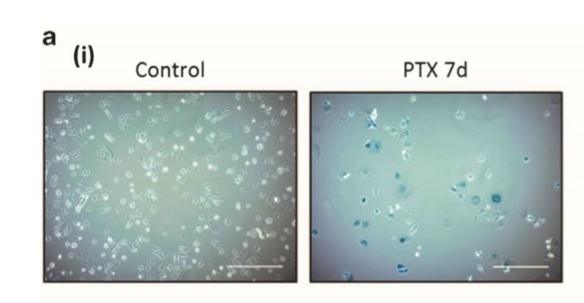
Figure 1: SA-β-Galactosidase staining. The control does not show the blue color staining, while the PTX 7d (7-day treatment) shows cells that are blue. The control does not have any senescent cells because SA-β-Gal only stains senescent cells. The PTX (chemotherapeutic) treated cells do show senescence because they have blue stained cells (adapted from ref. 5).

Mutations have been a big part of cause and research when it comes to breast cancer. BRCA1 is a breast cancer receptive gene that is part of the DNA repair pathway. Mutation in this gene presents a high risk of breast cancer. BRCA 1 and BRCA 2 gene mutations account for about five percent of all breast cancer cases. In women with triple negative breast cancer, the majority of tumors show a BRCA 1 mutation (Wong-Brown et al. 2015). A focus on this gene could give insights as to if and when the gene is manipulated out taken out of the equation, how do the tumor cells react considering this a major gene contributing to the onset of tumorous cells leading to breast cancer.
Focusing on the genes and the mutations that affect the onset of cancer, there are systems that have been around for a long time and have been studied thoroughly by a lot of researchers could be used to test out different hypothesis in the cancer world. CRISPR-associated protein Cas9 system is originally a bacterial defense mechanism that has been reprocessed as an RNA-guided DNA targeting platform for genome editing, epigenetic modulation, etc. Jiang et al. in the paper talk about the CRISPR loci (a particular position) that is widely distributed in the genome that provides acquired immunity against foreign genetic elements (Jiang et al., n.d.). This is associated with Cas9 which is a large multifunctional DNA endonuclease. An endonuclease is an enzyme which cleaves a polynucleotide chain by separating nucleotides other than the two end nucleotides (Jiang et al., n.d.). This Cas9 enzyme works with a single guide RNA (sgRNA) which is a single RNA molecule that contains a 17-20 nucleotide complementary sequence to the target DNA sequence with a tracrRNA (trans-encoded RNA) sequence which serves as a binding platform for Cas9 (Jiang et al., n.d.).
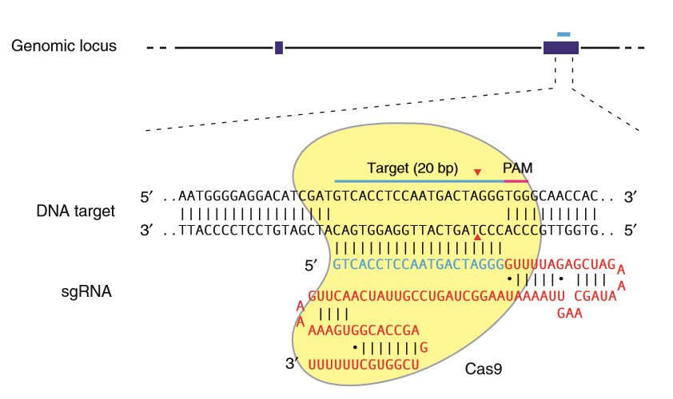
Figure 2: sgRNA and Cas9 interaction. The illustration shows the mechanism of how Cas9 and the 20 base pair sequence come together at the target sequence and work on a specific genomic locus (adapted from ref. 7)

Triple negative breast cancer is aggressive and the survival rate after recurrence is extremely low. BRCA 1 gene mutation is commonly seen in women with triple negative breast cancer, therefore the purpose of this experiment is to use sgRNA and the CRISPR-Cas9 system to knockout the BRCA 1 mutated gene to see effects on the cells that show senescence through SA-β-Galactosidase staining and cell count.

Experiment
The goal of this experiment is to determine whether knocking out the BRCA1 gene from the triple negative breast cancer cell culture will let the cells remain in senescence or will the knockout of the gene cause the cells to lose the blue stain which is sign that the cells are no longer senescent and that they can now proliferate. If the cells remain in senescence, then the cells will stain blue when β-Galactosidase is added to the cell culture. These cells will be counted, and a graph will be made at the end to show a comparison between the controls and the treatment groups.
- Gathering and Testing the cell line
The cell culture preparation is important so that the rest of the experiment goes smoothly. The cell line used in this experiment will be a triple negative breast cancer cell line that is Cas9 inducible, Yang et al. in the paper uses cell line MDA-MB-231. These cell lines will be kept and grown in multiple wells, and a few wells will go through no treatment and will be named as the control while the other cells will go through chemotherapy. The cells are incubated at 37 degrees Celsius, 15% CO2 and L-15 medium (Yang et al., 2019). The cell cultures will be given a chemotherapeutic drug either PTX or doxorubicin and after a 7 to 10-day period both the control cell culture and the treated cell culture will go through SA-β-Gal staining to see if senescence has been achieved (Kavanagh et al. 2017). If the cell cultures that were treated with the chemotherapeutics show blue staining, then they do show senescence which means that the chemotherapy worked. These cell are ready to go through with the knockout and eventually cell counting.
- BRCA 1 specific SgRNA infection
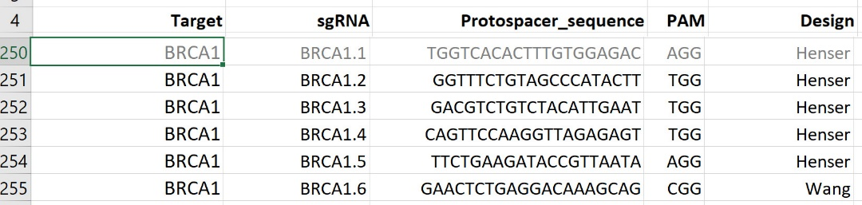
Figure 3: BRCA1 gene in the sgRNA library pool. This is an excerpt from the sgRNA library showing the target, the ~20 base pair sgRNA sequence with the PAM sequence. The design column shows who constructed the sgRNA sequence (adapted from ref. 8).
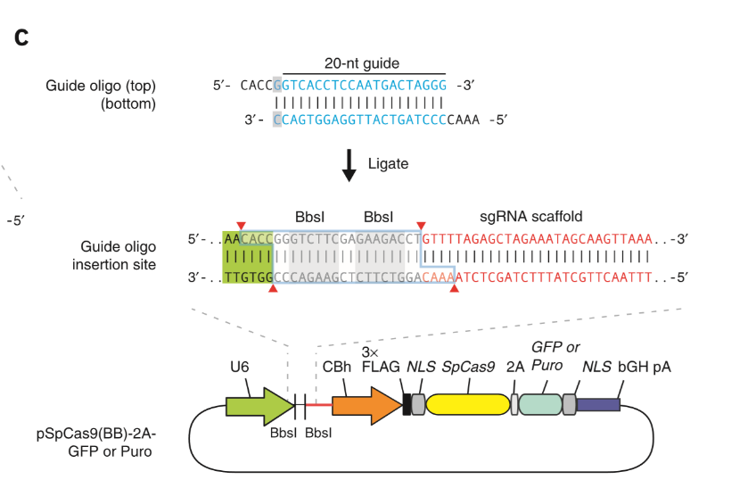
Figure 4: Plasmid-based Delivery. the plasmid is an example of a type of plasmid that can be used to deliver the sgRNA to the appropriate site. This will happen with the happen with the help of Cas9, the scaffold for binding the sgRNA and the PAM sequence.

Henser-Brownhill et al. created a sgRNA library that targeted epigenetic regulators and this library included the sgRNA that targeted the BRCA1 gene. When these sgRNA’s were assessed for their activity, 87% of the sgRNAs induced detectable insertions and deletions (Henser et al., 2017). The designs column in the figure above there are two names Henser and Wang. The results of the assessment also showed that the algorithm used by Wang could outperform the Henser with respect to editing efficiency. We can use the plasmid-based sgRNA delivery system to knock out the BRCA1 gene. This system allows the expression plasmid to be constructed which will work with a pair of partially complementary oligonucleotides (Ran et al. 2013). This pair encodes for 20-nucleotides guide sequence which is seen above in Figure 4. This sequence is then annealed and ligated into the plasmid that was constructed (Ran et al. 2013). Which has Cas9 and the remainder of the sgRNA. According to Henser et al. the induction of this system took 14 days to show knocking out of a gene (Henser et al., 2017). During this time, they will be monitored by SA-β-Gal staining so that they can be monitored for changes in senescence of the cells. Then these results will be graphed in continuum to Figure 5.
- CRISPR-Cas9 Knockout
There are three types of CRISPR systems but Ann Ran et al. mentions type two CRISPR system which is that system using Cas9, the crRNA and tracrRNA which make up the single guide RNA. The Cas9 endonuclease binds to the tracrRNA because it is the binding sequence in the sgRNA. Once the Cas9 and the sgRNA are secure they must find the 5’-NGG PAM sequence. The PAM sequence is on the target DNA sequence, it is a protospacer adjacent motif and is varying depending on the CRISPR system (Ran et al. 2013). This sequence helps the Cas9 nuclease cut the target sequence and is generally found 3-nt downstream from the cut site. Once the PAM sequence on the target DNA is recognized the complementary sequence is checked to see if it matches if it does then the Cas9 proceeds to make a double stranded break in the sequence, this break causes the target sequence to be knocked out (Ran et al., 2013). The cells will recognize this break and will go through non-homologous end-joining, which is a prominent DSB repair pathway (Bétermier et al. 2014). This method was used by Yang et al. to knockout CXCR4 and CXCR7 using the CRISPR-Cas9 technique. These genes were found in TNBC cells and were knocked out using sgRNA sequences which were selected by a monoclonal technique.

Once the CRISPR-Cas9 technique with the sgRNA showed 80% confluence the cell cultures were tested to see if the knockout of the two genes was successful. Yang et al. used PCR to screen for knockout (Yang et al. 2019). The cells DNA was extracted and was amplified using PCR. This amplified product was then sequenced to see if the knockout was successful. The primers that they used were from Genechem Company (Yang et al. 2019). The PCR was conducted at 94 degrees Celsius for five minutes which was followed by 94 degree Celsius for 30 seconds, 55 degrees for 30 seconds, and 72 degrees Celsius for 40 seconds for 34 cycles and finally at 72 degrees Celsius for 5 minutes. Then the PCR product was put onto agarose gel electrophoresis to detect target band and then the product was sent for sequencing (Yang et al. 2019).

This method can be used to aid in knocking out the BRCA1 gene, and to check if BRCA1 gene was indeed knocked out we can use the PCR method to get the sequence after the product of the PCR was sent for sequencing and we compared to the regular sequence and the new sequence to see if the knockout was achieved. If the knockout is achieved, then we move on to the staining and monitoring of the cells to see if there is loss of senescence or not.

- β-Galactosidase Test
Senescent cells contain β-Galactosidase which is an enzyme that catalyzes the hydrolysis of β-glycosidic bonds between a hemiacetal group and a hydroxyl group. This reaction occurring at the pH of 6 specifically causes the senescent cells to stain blue. This is why the specific β-Galactosidase test used in this case is the senescent associated (SA) – β- Galactosidase test. This test is a known biomarker for seeing if cells are senescent.
The staining kit is readily available so using that kit the cell cultures will be stained (blue), and the cultures will be kept at 37 ͦ C for about 12-16 hours (Itahana et al. 2013). Once the staining is complete the cell cultures will be photographed using a microscope and a program called cellSens Standard. If enough cells have not been photographed in the cell culture for significant data collection, then the cell culture will be counted using a physical counter and the microscope so that there is significant data. The total number of cells in the plate will be counted as well as the number of cells that have turned blue. After the count is complete the data collected will be graphed as seen in Figure 5.

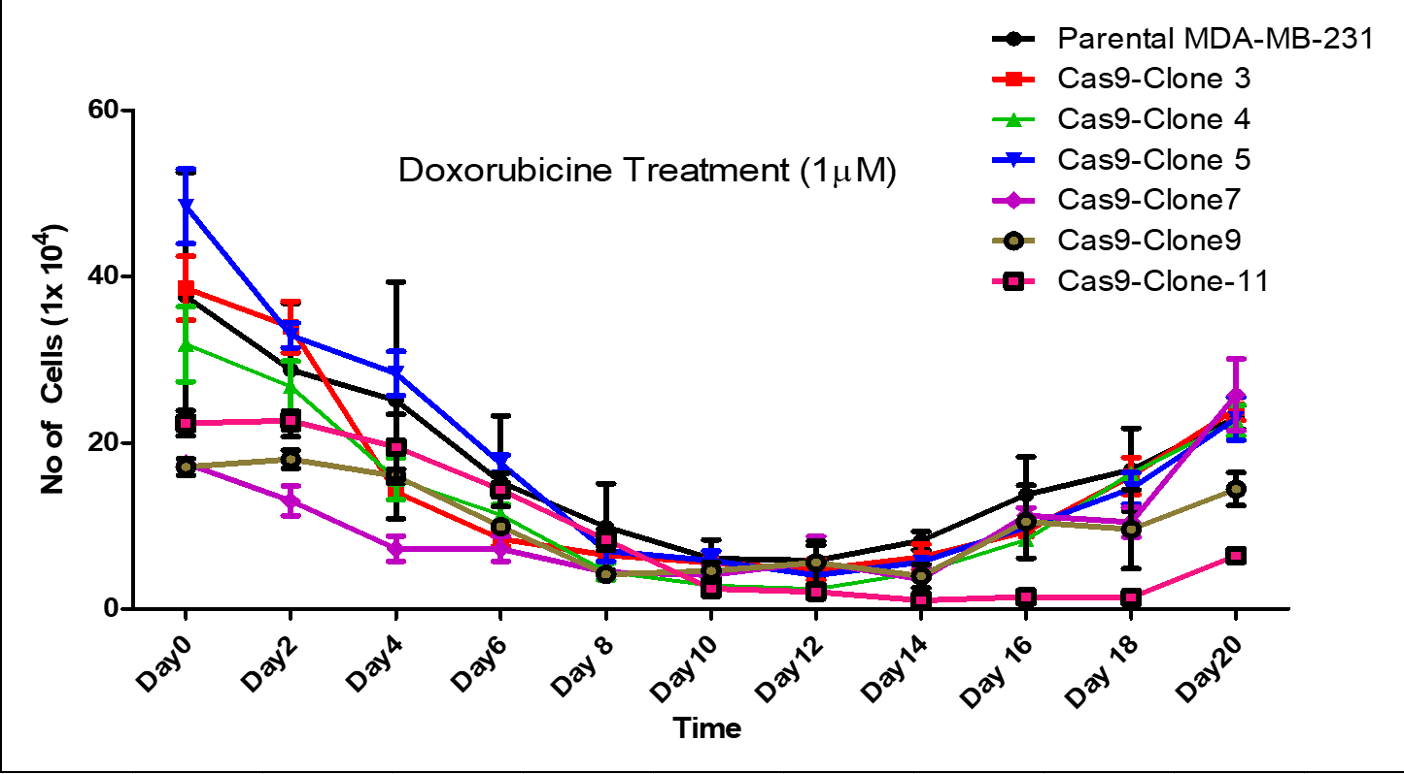

Figure 5: Growth curve. This is a graph showing the number of cells in a culture over a period of 20 days. The different lines correspond to different cell lines that were tested over time. (adapted from Joseph Landry’s growth curve results)

Discussion
If the CRISPR-Cas9 with the sgRNA system is successful in knocking out the BRCA1 gene in these TNBC cells, then there should be an increase or decrease in the number of cells in the cell culture that remain senescent. I predict that the knocking out of this gene will cause the cells to remain in senescence meaning that more than 80% of the cells will still show the blue stain due to the SA-β-Galactosidase sating (Itahana et al. 2013). With them remaining in senescence the time to recurrence may be delayed considering I was also seeing if there was an earlier onset of recurrence through Figure 5.
The problem with this is that I am focusing on one of many genes and epigenetic regulators that affect the onset of tumors. The fact that there are so many pathways for the onset triple negative breast cancer, the knocking out of one gene may not be sufficient to see changes in the recurrence of the tumorous cells through counting. As seen in the figure below the BRCA genes do make up the majority of the genes that are expressed when it comes to breast cancer as a whole while the other genes have a lower significant gene presence, however when it comes to research it is important to work and test out this system on multiple genes.

Figure 6 : Breast cancer gene distribution. The pie chart illustrates the some of the most significant genes that affect breast cancer. BRCA 2 is the most significant at 52.3% gene presence in breast cancer, while in second and third place genes PALB2 and a tie between BRCA1 and RAD5ID is seen (adapted from ref. 6).

Even with the problem of not knowing the effect of other epigenetic regulators, I think that if this study shows significant data to see if changing/knocking out a gene that is essential to the outcome of tumor cells, it can help further this form of research in the field of triple negative breast cancer. There is so much research on the beginning stages of cancer and how the chemotherapeutics that are used in the treatment process of cancer. However, there is little to no research on the recurrence of cancer especially when it comes to the such an aggressive form of breast cancer. This research is as important because the recurrence of triple negative breast cancer is known to have worse survival rates when it recurs after going through chemotherapy. The treatment is also not very targeted in the case of triple negative breast cancer when compared to the other forms of cancer such as ovarian, skin and others. Studying genes and the knockout with a highly specific system that has been used multiple times in all forms of research can help guide the next steps in solving some of these major issues.

References
- Itahana, K., Itahana, Y., & Dimri, G. P. (2013). Colorimetric detection of senescence-associated β galactosidase. Methods in molecular biology (Clifton, N.J.), 965, 143–156. doi:10.1007/978-1-62703-239-1_8
- Kumar, P., & Aggarwal, R. (2016). An overview of triple-negative breast cancer. Archives of Gynecology and Obstetrics, 293(2), 247-269. https://link-springer-com.proxy.library.vcu.edu/content/pdf/10.1007/s00404-015-3859-y.pdf
- Wong-Brown, M., Meldrum, W., Carpenter, C., Clarke, J., Narod, J., Jakubowska, E., . . . Scott, S. (2015). Prevalence of BRCA1 and BRCA2 germline mutations in patients with triple-negative breast cancer. Breast Cancer Research and Treatment, 150(1), 71-80.
- Jiang, F., & Doudna, J. (n.d.). CRISPRCas9 Structures and Mechanisms. Annual Review of Biophysics, 46(1), 505-529.
- Kavanagh, E. L., Lindsay, S., Halasz, M., Gubbins, L. C., Weiner-Gorzel, K., Guang, M., … McCann, A. (2017). Protein and chemotherapy profiling of extracellular vesicles harvested from therapeutic induced senescent triple negative breast cancer cells. Oncogenesis, 6(10), e388. doi:10.1038/oncsis.2017.82
- Wang, Y. A., Jian, J. W., Hung, C. F., Peng, H. P., Yang, C. F., Cheng, H. S., & Yang, A. S. (2018). Germline breast cancer susceptibility gene mutations and breast cancer outcomes. BMC cancer, 18(1), 315. doi:10.1186/s12885-018-4229-5
- F Ann Ran, Patrick D Hsu, Jason Wright, Vineeta Agarwala, David A Scott, & Feng Zhang. (2013). Genome engineering using the CRISPR-Cas9 system. Nature Protocols, 8(11), 2281-2308.
- Henser-Brownhill, T., Monserrat, J., & Scaffidi, P. (2017). Generation of an arrayed CRISPR-Cas9 library targeting epigenetic regulators: from high-content screens to in vivo assays. Epigenetics, 12(12), 1065–1075. doi:10.1080/15592294.2017.1395121
- Yang, M., Zeng, C., Li, P., Qian, L., Ding, B., Huang, L., … Wu, W. (2019). Impact of CXCR4 and CXCR7 knockout by CRISPR/Cas9 on the function of triple-negative breast cancer cells. OncoTargets and therapy, 12, 3849–3858. doi:10.2147/OTT.S195661
- Bétermier, M., Bertrand, P., & Lopez, B. S. (2014). Is non-homologous end-joining really an inherently error-prone process?. PLoS genetics, 10(1), e1004086. doi:10.1371/journal.pgen.1004086

