Role of a putative transcription factor Zbtb14 on
production of treacle protein in mice

Introduction
Treacher Collins Syndrome (TCS) is an autosomal disorder that mainly affects craniofacial development [1]. This syndrome is rare and occurs in approximately 1 out of 50,000 births [2]. TCS is characterized by deformities with various severities of the ears, eyes, cheekbones, midface, and jaw and leads to complications with breathing, sight, hearing, and speech [3] (Fig 1). Although TCS is not currently curable, symptoms can be managed with reconstructive surgery, therapy, and assistive devices [3].
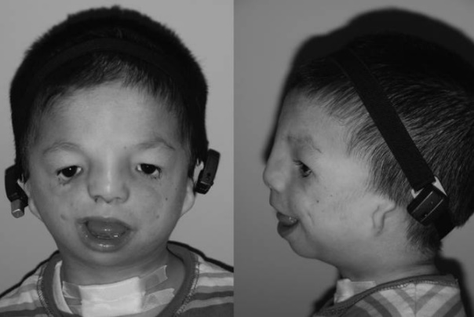
This syndrome is named after Dr. Edward Treacher Collins who described its main features. This syndrome is caused by mutations found in three known genes, TCOF1, POLR1C, and POLR1D, but mainly in TCOF1 [4]. The human TCOF1 gene is located on chromosome 5q32 and encodes the protein treacle [5]. These mutations lead to premature stop codons on that TCOF1 allele. There was a possibility that the mutated treacle protein interfered with the biological functioning of the full-length treacle. However, this truncated treacle was shown not to interfere at all with the full-length protein expressed from the normal Tcof1 allele [6]. Deletion of one Tcof1 allele in mouse resulted in embryos with severe defects in craniodevelopment leading to death [7]. Low levels of treacle lead to abnormal development and increased apoptosis of cephalic neural crest cells [8]. Thus, the lack of sufficient full-length treacle, not the presence of mutated treacle, leads to TCS. These studies supported the haploinsufficency theory for TCOF1 where one chromosome does not produce the full-length protein which can lead to defects in growth and development resulting in deformities like those of TCS.
Figure 1: Characteristics of Treacher Collins Syndrome include deformation of the ears, eyes, cheekbones, midface, and jaw. Figure from Chang and Steinbacher (2012).
Treacle is heavily involved in embryonic craniofacial development and influence the bones and tissues of the face. Because of the localization of treacle to the nucleolus, a small region inside of the nucleus where rRNA is produced, there was a theory that treacle may be involved in rRNA production. Because rRNA is essential for translation, this would mean that treacle may directly or indirectly affect ribosome formation during craniofacial development. Hayano et al (2003) showed that there are interactions between treacle and pNop56, a component of a ribonucleoprotein complex that methylates pre-rRNA [9]. A later study showed that treacle is involved in mammalian ribosomal DNA (rDNA) gene transcription [10]. Unfortunately, other functions of the gene product of TCOF1 are largely unknown.
It is commonly known that mouse genomes are similar to human genomes. A study by Shows and Shiang (2008) found many putative transcription binding factors on the Tcof1 (TCOF1 homolog) promoter with mutagenesis [11]. In plasmids, they fused the Tcof1 promoter to the luciferase gene so the expression of luciferase would depend on the Tcof1 promoter. Inactivation of one of the putative transcription factors sites, Zbtb14 (formerly called Zfp161), led to a ~2.6 fold increase of the expression of luciferase compared to the control expression in p19 embryonic carcinoma mouse cells (Fig. 2). This was repeated in HEK293 human kidney cells which resulted in a ~7.5 fold increase in luciferase expression. Zbtb14 may not directly or indirectly influence Tcof1 expression.
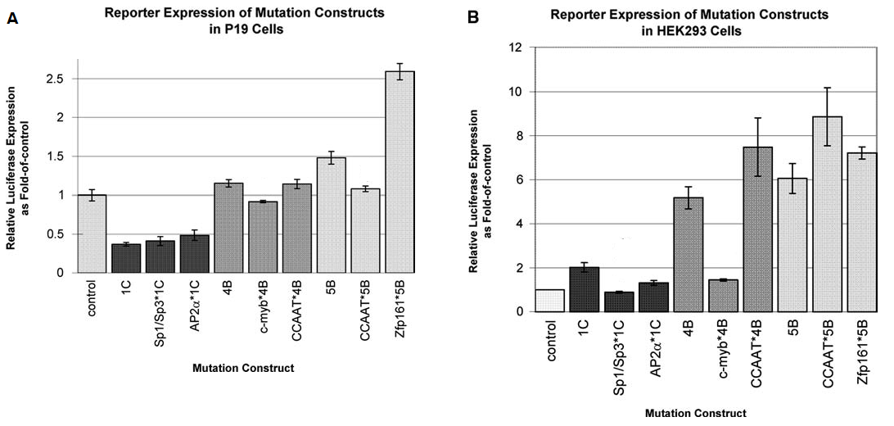
Even though many genetic alterations causing TCS have been discovered, the mechanism underlying its pathogenesis and the function of treacle remain largely unknown. It is important to understand that studying normal cellular mechanisms and pathways will lead to discoveries in the abnormal cellular mechanisms and pathways. Only by knowing what is normal can one figure out what is abnormal. Since Zbtb14 is already discovered to be a putative transcription binding factor, exploring the results of decreasing Zbtb14 can lead to further discoveries about the regulation of Tcof1 in mice and thus TCOF1 in humans. The central question is: if the expression of Zbtb14 decreases, will the level of Tcof1 expression increase?
Figure 2: The inactivation of putative transcription binding factor sites on the relative expression of luciferase in mouse P19 embryonic carcinoma cells and in HEK293 human kidney cells. Figure from Shows and Shiang (2008).
Experiment
The knockout of a gene, in this case Zbtb14, can contribute to the gene’s functional analysis. Knowing that the transcription factor Zbtb14 is a putative transcription binding factor for the Tcof1 promoter [11], this experiment will aim to determine if Zbtb14 does indeed repress the expression of Tcof1 in a live animal. By using conditional knockout techniques in order to vary the production of Zbtb14 in Wnt1 expressing cells to target neural crest cells, the expression of Tcof1 can be observed by whole mount in situ hybridization. Some cells may require more Zbtb14 and some cells may require a different transcription binding factor in order to regulate the expression of Tcof1. Whole mount in situ hybridization will also indicate where in the embryo Zbtb14 might be a more important or less important factor in the regulation of Tcof1. If the regulation of Tcof1 is dependent on Zbtb14 then comparing the Tcof1 expression from the conditional knockout mice and the control mice should show in increase in Tcof1 expression in the conditional knockout mice.
Gene knockout is a permanent way to inactivate a gene. This technique has given valuable information on the biologic function of a gene of interest [12, 13]. However, total knockout of a gene can have deadly effects on the mouse [14]. Gene knockouts can be developmentally lethal so that the resulting embryos cannot grow into adult mice. The severity of the resulting phenotype can lead to death of the mouse before the effects of the knockout are observable on a target tissue. A solution to this is to utilize conditional knockout, so the gene will only be knocked out in specific tissues, not in the entire organism [14]. Thus, the effects of the knockout will be visible in the target tissues. The traditional technique for conditional gene knockout is to use the Cre-lox system [13]. A most efficient method to create these mice is to use CRISPR which uses Cas9 to insert loxP sites in Tcof1 [13].
In order to knockout a gene, two loxP sites will need to be inserted in noncoding sequences on each side of the first exon of the gene. CRISPR uses the Cas9 enzyme in order to break both strands of DNA near a specific target sequence, PAM site. After the loxP sites are inserted, Cre recombinase will induce recombination to remove the exon entirely from the genome which will inactivate the gene. In this study, a Wnt1/Cre mouse purchased from the Jackson Laboratory will be used where Cre gene is downstream the Wnt1 promoter. Wnt1 is associated with midbran development as well as craniofacial development in the embryo [15]. Because of its critical role in embryonic development, Wnt1 has been used in many studies like Lewis et al. (2014) [16] in order to study craniofacial development. Cre will form a dimer and induce recombination at the loxP sites. With the recombination, the targeted exon is removed from the genome and is later degraded by the cell.
An example of this procedure is a 2018 study where Bi et al. made conditional knockout mice with CRISPR [17]. The authors were trying to determine if conditional gene knockout for myomixer, a small conserved protein expressed during muscle formation, directly or indirectly alters the fusion of satellite cells in muscle cells of mice. They used CRISPR Cas9 as well as homology directed repair in order to insert loxP sites around Myomixer exons. These mice were crossed with Pax7/Cre mice so that Cre recombinase was controlled by the Pax7 promoter which is involved in muscle formation and development. They visualized the effects of the knockout with immunohistochemistry which visualized the expression of laminin, myosin, and desmin in areas of tibialis anterior muscles (Fig. 3). They then compared the immunohistochemistry tissue and the result of knockout of these exons was the decreased expression of genes involved in muscle differentiation and regeneration.
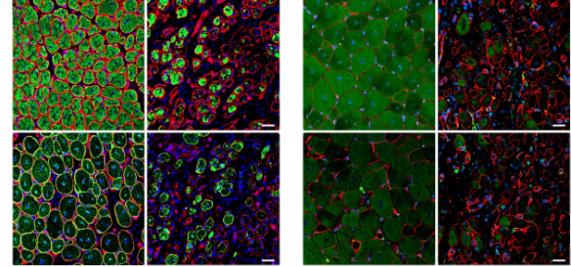
Figure 3: Immunohistochemistry of the proteins laminin (red), myosin (green), and desmin (blue) on tibialis anterior muscle cross-sections 7 days (left) and 14 days (right) after an injury. Figure from Bi et al. (2018).
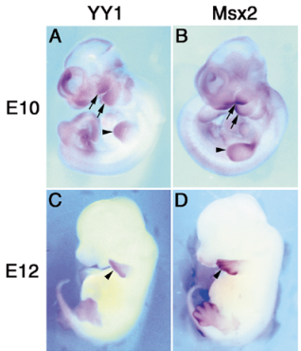
Tan et al. (2002) used whole mount in situ hybridization in order to determine where in the mouse embryos YY1 and MSX2 were expressed (Fig. 4) [18]. Using a database, they synthesized digoxygenin labeled riboprobes complementary to their gene of interest with T7 and T3 promoters. Alkaline phosphatase along with the substrates 5-bromo-4-chloro-3-indolyl phosphate and nitroblue tetrazolium (BCIP/NBT) caused blue-purple precipitate. In E10 (embryonic day 10) and E12 embryos, YY1 and Msx2 are co-expressed in mostly the same areas, the mouse limb and branchial arches, of the mice. This data suggests that these two genes may be interacting with each other and may be involved in the same morphoregulatory events.
Conditional Knockout
Conditional knockout via CRISPR will be used to vary the expression of Zbtb14.
There will need to be two breaks, one on each side of the exon to be removed from the genome, and thus two PAM sites are needed. Information from a program was used to create two specific sgRNA (single guide RNA) sequences, which are made of crRNA (CRISPR RNA) which guides Cas9 to the target sequence for cleavage and tracrRNA (trans-activating crRNA) which is a stem loop structure that will bind to Cas9. By inputting the target gene (Zbtb14) as well as the organism of interest (Mus musculus) into Pubmed gene database, the gene of interest was selected and its NCBI RefSeq and Ensemble gene IDs were identified (NM_001356282.1 and ENSMUST00000062369.13). Ensemble was used to obtain he coordinates of the exon and introns (Fig. 5). A computer program (Benchling) was used to find the target sequences as well as the PAM sites (NGG) for the two crRNAs. On mouse chromosome 17, the target sequence before the first exon was GCGACAGCGAGCGTCTGTAGCGG at coordinate 69383251 and the target sequence after the first exon is ATGCATGTTTGAATATCGGACGG at coordinate 69385119 (Fig. 6 & 7). These sequences were chosen because they had high on-target scores, based how efficient a sgRNA is at guiding Cas9 to the correct spot [19], and high off-target scores, based on the sgRNA’s DNA targeting specificity [20] (Fig. 6 & 7).
Figure 4: Whole mount in situ hybridization visualization of the genes YY1 and Msx2 during significant morphoregulatory events. Figure from Tan et al. (2002).
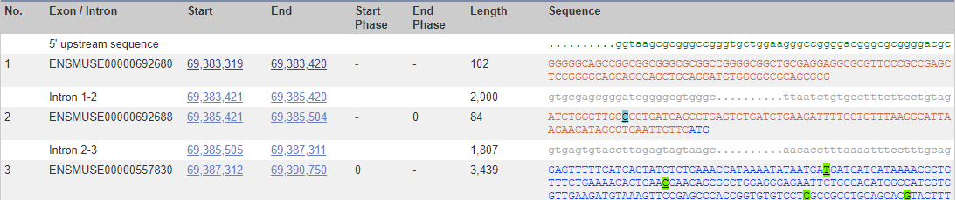
The sgRNAs will guide the Cas9 enzyme to the targeted PAM sites in the mouse genome. An oligo, an artificial DNA molecule used to carry genetic material into the cell, was created which will be inserted between the breaks and included homology arms with the loxP sites, ATAACTTCGTATAATGTATGCTATACGAAGTTAT, surrounding the exon of interest. Benchling was utilized again in order to obtain this oligo sequence (Fig. 8). This sequence can be purchased and synthesized at facility and amplified with PCR. A vector will be purchased and will have the encode sequences for Cas9 as well as for the tracrRNA and crRNA. After the vector undergoes in vitro transcription, Cas9 mRNA, the sgRNAs (the two crRNAs annealed to tracrRNAs), and the oligo will be injected into the one-cell stage mice embryo which will then be transplanted into surrogate mothers.
Figure 5: From Ensembl, transcript ID ENZMUST00000062369.13 (highlighted in pale blue) was used in order to obtain the exon and intron start and end coordinates.
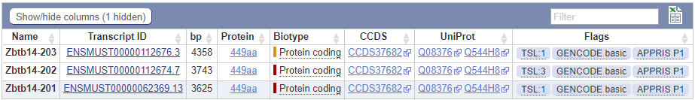

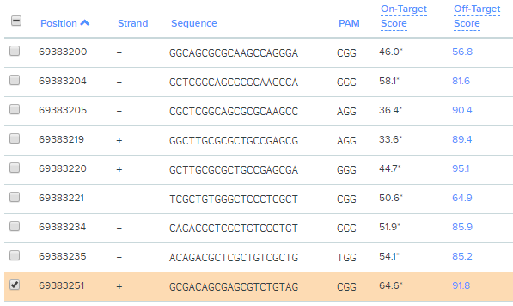
Figure 6: GCGACAGCGAGCGTCTGTAGCGG is the target sequence before the first exon with CGG as its PAM site.

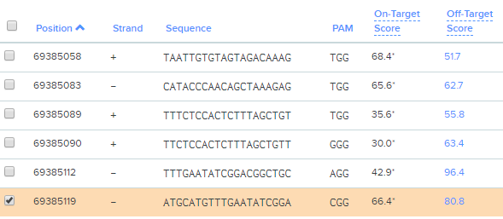
Figure 7: ATGCATGTTTGAATATCGGACGG is the target sequence after the first exon and before the second exon with CGG as its PAM site.

Figure 8: Oligo with homology arms (green circles), sgRNA target sequences (orange), loxP sites (pink), and first exon (red).
Once inside the embryo, Cas9 mRNA will be translated into protein and will bind to one of the sgRNAs. Once Cas9 finds the genome sequence that is complementary to the gRNA, it will break both strands of the DNA at the PAM site. Due to the different gRNAs, Cas9 will break the DNA on either side of the exon. The insertion sequence, the vector, will be inserted by homology directed repair resulting in loxP sites surrounding the first exon (Fig. 9).
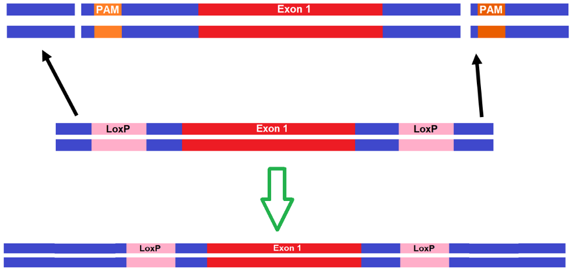
Figure 9: Homology directed repair resulting in loxP sites surrounding the first exon.
However, there is a chance that the insertion may occur in the Zbtb14 gene of both chromosomes, one chromosome, or neither chromosomes. The offspring will be ear punched in order to genotype them using Polymerase Chain Reaction and gel electrophoresis.
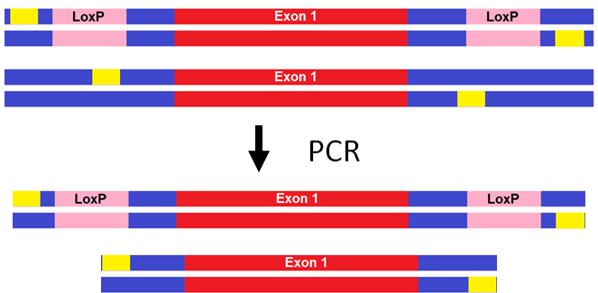
Figure 10: PCR on DNA with correctly inserted loxP sites and without loxP sites resulting in a longer and shorter strand, respectively. Yellow boxes indicate the target sequences for the forward and reverse primers.
PCR processes take place inside a test tube with a buffer solution, polymerase, primers aimed to surround the DNA sequences with and without loxP sites, the mouse’s genetic material, and deoxynucleotides. The primers were found using Benchling which, once given the regions where the primers needed to be, gave a list of primers based on penalty scores which took into account GC content, melting temperature, and redundancy. Lower scores indicate more efficient primers. The forward primer was GGGCGGGTGCTCGAGAAAGG and the reverse primer was GGCTGATCAGGGGCAAGCCA (Fig. 11).
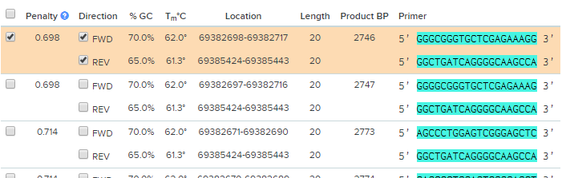
Figure 11: The forward and reverse sequences marked by the red highlight will be used for PCR.
There are three main steps to PCR: 1) denaturation, 2) annealing, and 3) extension. Denaturation involves heating up the DNA molecules to around 95ºC, the temperature which unwinds and separates the two strands of DNA. Annealing involves primers. By cooling the test tube to ~50ºC, the primers are able to hybridize to the complementary DNA sequences. The third step, extension, involves heating up the test tube so polymerase can attach and use the free nucleotides to extend the primer sequences using the mouse DNA strand as a template. By repeating these steps, the sequence between the primers will be amplified as seen with figure 12.
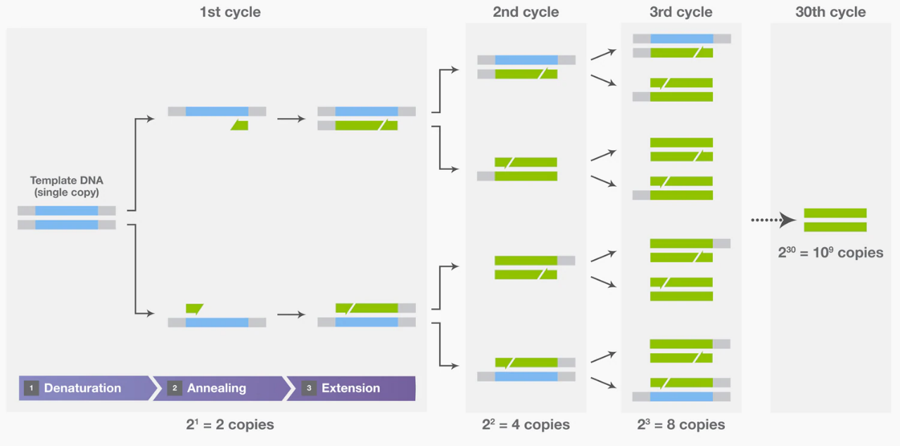
Figure 12: Amplification of the target DNA resulting from the repeating three steps of PCR. Figure obtained from ThermoFisher PCR Basics

Gel electrophoresis will show whether the loxP sites were inserted. The amplified sequences are loaded into the gel wells on the anode side of the gel. Since DNA is negatively charged, when current is run through the gel, the sequences are drawn across the gel towards the positive end, where the cathode is. Thus, the fragments are separated by size as seen by figure 13.

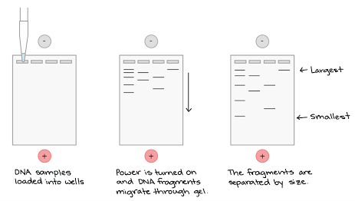
Figure 13: Separation of DNA samples by fragment size in gel electrophoresis
Longer strands, with the loxP sites, travel more slowly than the shorter strands, without the loxP sites, do. Mice homozygous for both loxP sites will display the longest fragments on the gel, the heterozygous mice will display both the longest and shortest fragments, and the homozygous for the wild type will display only the shortest fragments on the gel. Mice with only 1 loxP site inserted will be intermediate size. Thus, mice that are homozygous for both loxP sites, heterozygous, and homozygous for without loxP sites can be identified.
After verification for germline transmission, the homozygous floxed mouse with correctly inserted loxP sites and a Wnt1/Cre-expressing mouse will be crossed in order to produce mice with both Cre and the floxed exon (Fig. 14). This mating should produce 50% Zbtb14^{loxP/+, Cre/+} and 50% Zbtb14^{loxP/+, +/+}. Cre will lead to recombination at the loxP sites and these embryos will get rid of the target exon and thus inactivate the gene Zbtb14.
Zbtb14^{loxP/loxP} X Wnt1^{Cre/+}
loxP
+
+  Cre | loxP/+  Cre/+
+  + | loxP/+  +/+
50% Zbtb14^{loxP/+, Cre/+}
50% Zbtb14^{loxP/+, +/+}
Figure 14: The cross between Zbtb14^{loxP/loxP, +/+} and Zbtb14^{+/+,Cre/+} to produce 50% Zbtb14^{loxP/+, Cre/+} and 50% Zbtb14^{loxP/+, +/+}.
If Zbtb14^{loxP/+, Cre/+} are viable then they will be crossed with the homozygous floxed mouse Zbtb14^{loxP/loxP, +/+} and will produce offspring with varying levels of Zbtb14 (Fig. 15). There should be 50% mice with the wild phenotype, 25% with half Zbtb14 production, and 25% with no Zbtb14 production. PCR and gel electrophoresis should reveal which mice has which phenotype.
Zbtb14^{loxP/+,Cre/+} x Zbtb14^{loxP/loxP, +/+}
 | loxP  Cre | loxP  + | +  Cre | +  +
loxP  + | loxP/loxP  Cre/+ | loxP/loxP  +/+ | +/loxP  Cre/+ | +/LoxP  +/+
loxP  + | loxP/loxP  Cre/+ | loxP/loxP  +/+ | +/loxP  Cre/+ | +/LoxP  +/+
loxP  + | loxP/loxP  Cre/+ | loxP/loxP  +/+ | +/loxP  Cre/+ | +/LoxP  +/+
loxP  + | loxP/loxP  Cre/+ | loxP/loxP  +/+ | +/loxP  Cre/+ | +/LoxP  +/+
50% wild: Zbtb14^{loxP/+, +/+} and Zbtb14^{loxP/loxP, +/+} normal production of Zbtb14
Zbtb14^{+/+}
25% Zbtb14^{loxP/+, Cre/+} half Zbtb14 production
Zbtb14^{+/-}
25% Zbtb14^{loxP/loxP, Cre/+} no Zbtb14 production
Zbtb14^{-/-}
Figure 15: Cross between Zbtb14^{loxP/+,Cre/+} x Zbtb14^{loxP/loxP, +/+} resulting in 50% offspring with wild type phenotype (Zbtb14^{loxP/+, +/+} and Zbtb14^{loxP/loxP, +/+}), 25% offspring with half Zbtb14 production (Zbtb14^{loxP/+, Cre/+}), and 25% offspring with no Zbtb14 production (25% Zbtb14^{loxP/loxP, Cre/+}).
Whole mount in situ hybridization
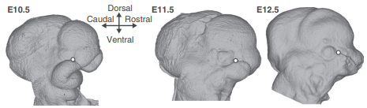
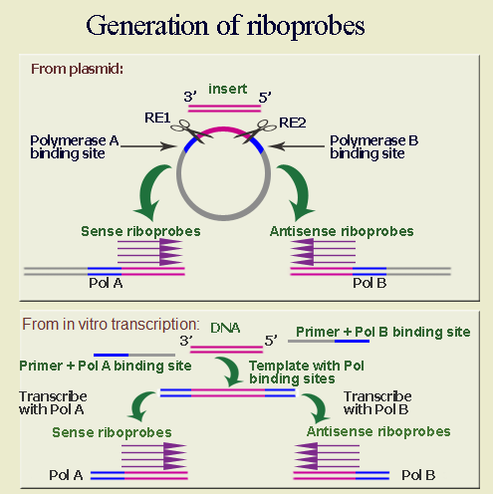
Whole mount in situ hybridization will be utilized in order to qualitatively observe the expression levels of Tcof1 as a result of the altered production of Zbtb14. The embryos from the last cross will be used to determine if Zbtb14 does affect Tcof1 production. 10.5 to 12.5 (E10.5-E12.5) days after mating from that cross, these embryos will be used for this procedure because craniofacial development occurs quickly during this time [18] (Fig. 16). Riboprobes complementary to the target sequence will be made. The first 500 bp of only the coding sequences of Tcof1 will be obtained from a database and primers will be synthesized. The PCR product of the Tcof1 sequence amplified from mouse cDNA along with ligase will allow for the insertion of a desired sequence of DNA into a commercially available vector plasmid (BlueScript) with two RNA polymerase sites, T7 and T3 (Fig. 17). In one copy of the plasmid, a restriction enzyme cleaves the DNA between the inserted sequence and one of the RNA polymerase sites. In another copy of the plasmid, a different restriction enzyme cleaves the DNA between the inserted sequence and the other RNA polymerase site. In vitro transcription of the resulting linearized DNA sequences in a test tube along with T7 or T3 RNA polymerase and free floating ribonucleotides, with the uracil ribonucleotides labeled with digoxygenin leads to the synthesis of sense and antisense riboprobes. DNase degrades the DNA sequence so all that will remain are the riboprobes.
Figure 16: Mouse embryonic development E10.5-12.5 where craniofacial development occurs rapidly. Figure from Percival et al. (2014).
To fix the embryos, formaldehyde is added to a container with the embryos from the last cross. Formaldehyde crosslinks all the proteins in the cells together and inactivates them. This prevents the proteins from interfering. The embryos are washed of excess formaldehyde and proteinase K will then poke holes into the cell membrane. Riboprobes and antibodies conjugated to alkaline phosphatase are added to the solution and flow into the cells through the holes. The riboprobes hybridize to the complementary strands of Tcof 1 mRNA in the cells. The antibodies bind to the digoxygenin on the riboprobes. Then substrates 5-bromo-4-chloro-3-indolyl phosphate and nitroblue tetrazolium (BCIP/NBT) are added into the mixture. With the substrates, the alkaline phosphatase catalyzes reactions that produces a blue-purple precipitate that is visible with a light microscope. Thus, the precipitate is located only in areas where Tcof1 was expressed in the embryos. The embryos with Zbtb14 knockout will be compared to the wild type embryo to determine if Zbtb14 does affect Tcof1 expression (Fig. 18).
Figure 17: Making riboprobes requires the insertion of the target sequence between T7 RNA Polymerase (A) binding site and T3 RNA Polymerase (B) binding site. Restriction enzymes (RE) are used to separate the sense and the antisense template strands.
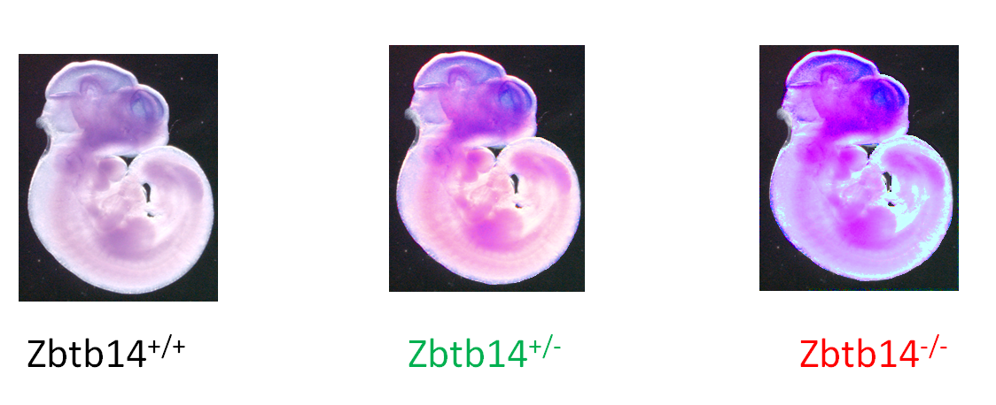
Figure 18: Potential results of the whole mount in situ hybridization showing the treacle expression with varying levels of Zbtb14 production.
Discussion
If the experiment proceeds as expected, it should be clear if Zbtb14 affects Tcof1 expression. There needs to be at least one founder mouse with correct loxP sites with germline transmission to mate together. Also, the differences in the Tcof1 expression levels should be clear when comparing the staining of the embryos. If the Zbtb14 does strongly affect Tcof1 expression [11], then the observations of Tcof1 expression should be easy to compare and contrast. There should be more Tcof1 expression in heterozygote Zbtb14^{+/-} mice than in wild type Zbtb14^{+/+} and even more Tcof1 expression in homozygous Zbtb14^{-/-} than in heterozygous mice. This would be the best possible results (Fig. 18). Certain regions can also be compared in order to indicate where Zbtb14 might have more of an impact on the Tcof1 expression.
Interpretation of the expected results would lead to the possibility of Zbtb14 directly or indirectly influencing Tcof1 expression. If the knockout of Zbtb14 does lead to increase expression of Tcof1 in the embryos, then Zbtb14 may indeed directly or indirectly repress Tcof1. However, it is not known if Zbtb14 directly binds to the Tcof1 promoter of if it influences another protein to repress Tcof1. Further study would need to be done to determine if Zbtb14 directly effects the expression by binding to the Tcof1 promoter as suspected in Shows and Shiang (2008).
However, since this is a hypothetical experiment, theoretical results may differ from reality. With CRISPR (Clustered Regularly Interspaced Short Palindromic Repeat) techniques, there could be off target mutations which may affect the expression of another gene which actually affect Tcof1 expression. A possible solution to this would be to sequence the entire mice genomes which would be time consuming. The target gene may act in a non-cellular autonomous manner so that even a little Zbtb14 can fully rescue the phenotype [21]. Additionally, the riboprobes may have trouble getting into the cells which would result in little to no staining. The riboprobes may also not only bind to its intended target but also to other mRNAs which would lead to background staining, staining in areas where Tcof1 is not expressed. A possible solution to this is to perform more washes and raise the heat of hybridization to break apart the less specific hybridization matches. Another problem may be that the Tcof1 promoter may not be sensitive enough to the transcription binding factor Zbtb14 so there would not be much change in Tcof1 expression in the whole mount in situ hybridization embryos.
The benefit to understanding whether Tcof1 does repress Tcof1 expression is that it leads to better understanding of the mutation of Tcof1 leading to Treacher Collins Syndrome in humans. It will also be an important experiment to evaluate the potential of Zbtb14 to be a potential target to help treat this syndrome in the womb.

References
- Dixon MJ, Dixon J, Raskova D, Le Beau MM, Williamson R, Kinger K, Landes GM. (1992) Genetic and physical mapping of the Treacher Collins syndrome locus: refinement of the localization to chromosome 5q32-33.2, Human Molecular Genetics 1(4): 249–253 DOI: 10.1093/hmg/1.4.249
- Sakai D, Trainor PA. (2009). Treacher Collins syndrome: unmasking the role of Tcof1/treacle. The international journal of biochemistry & cell biology, 41(6), 1229–1232. DOI:10.1016/j.biocel.2008.10.026
- Chang CC, Steinbacher DM. (2012). Treacher Collins Syndrome. Seminars in Plastic Surgery 26(2): 83-90. DOI: 10.1055/s-0032-1320066
- Sanchez E, Laplace-Builhé B, Mau-Them FT, Richard E, Goldenberg A, Toler TL, Guignard T, Gatinois V, Vincent M, Blanchet C, Boland A, Thérèse M, Deleuze J, Olaso R, Nephi W, Lüdecke H, Verheij J, Moreau-Lenoir F, Denoyelle F, Riviere J, Laplanche J, Willing M, Captier G, Apparailly F, Wieczorek D, Collet C, Djouad F, Genevieve D. (2019) POLR1B and neural crest cell anomalies in Treacher Collins syndrome type 4. Genetics in Medicine: 1-10 DOI:10.1038/s41436-019-0669-9
- Dixon MJ, Dixon J, Raskova D, Le Beau MM, Williamson R, Klinger R, Landes GM. (1992). Genetic and physical mapping of the Treacher Collins syndrome locus: refinement of the localization to chromosome 5q32-33.2. Human Molecular Genetics 1(4): 249-253. DOI: 10.1093/hmg/1.4.249
- Isaac C, Marsh KL, Paznekas WA, Dixon J, Dixon MJ, Jabs EW, Meier UT. (2000). Characterization of the Nucleolar Gene Product, Treacle, in Treacher Collins Syndrome. Molecular Biology of the Cell 11(9): 3060-3071. DOI: 10.1091/mbc.11.9.3061
- Dixon J, Brakebusch C, Fässler R, Dixon MJ. (2000) Increased levels of apoptosis in the prefusion neural folds underlie the craniofacial disorder, Treacher Collins syndrome. Human Molecular Genetics 9(10):1473-80. DOI: 10.1093/hmg/9.10.1473
- Dixon J, Brakebusch C, Fassler R, Dixon MJ. (2000). Increased levels of apoptosis in the prefusion neural folds underlie the craniofacial disorder, Treacher Collins syndrome. Human Molecular Genetics 9(10): 1473-1480. DOI: 10.1093/hmg/9.10.1473
- Hayano T, Yanagida M, Yamauchi Y, Shinkawa T, Isobe T, Takahashi NJ. (2003) Proteomic analysis of human Nop56p-associated pre-ribosomal ribonucleoprotein complexes. Possible link between Nop56p and the nucleolar protein treacle responsible for Treacher Collins syndrome. Biological Chemistry 278(36):34309-19. DOI: 10.1074/jbc.M304304200
- Valdez BC, Henning D, So RB, Dixon J, Dixon MJ. (2004). The Treacher Collins syndrome (TCOF1) gene product is involved in ribosomal DNA gene transcription by interacting with upstream binding factor. Proceedings of the National Academy of Sciences of the United States of America 101(29): 10709-10714. DOI: 10.1073/pnas.0402492101
- Shows KH, Shiang R (2008). Regulation of the mouse Treacher Collins syndrome homolog (Tcof1) promoter through differential repression of constitutive expression. DNA and Cell Biology 27:589-600. DOI: 10.1089/dna.2008.0766
- Kuhn R, Schwenk F. (2003). Conditional Knockout Mice. Transgenic Mouse 209: 159-185. DOI: 10.1385/1-59259-340-2:159
- Chen L, Ye Y, Dai H, Zhang H, Zhang X, Wu Q, Zhu Z, Spalinskas R, Ren W, and Zhang W. (2018.) User-Friendly Genetic Conditional Knockout Strategies by CRISPR/Cas9. Stem Cells International 2018: 1-10. DOI: 10.1155/2018/9576959
- Hall B, Limaye A, Kulkarni AB. (2009). Overview: Generation of Gene Knockout Mice. Current Protocols Cell Biology 44 (1): 19.12.1-19.12.17. DOI: 10.1002/0471143030.cb1912s44
- Lewis AE, Vasudevan HN, O’Neill AK, Soriano P, Bush JO. (2013). The widely used Wnt1-Cre transgene causes developmental phenotypes by ectopic activation of Wnt signaling. Development Biology 379(2): 229-234. DOI: 10.1016/j.ydbio.2013.04.026.
- Lewis AE, Vasudevan HN, O'Neill AK, Soriano P, Bush JO. (2013). The widely used Wnt1-Cre transgene causes developmental phenotypes by ectopic activation of Wnt signaling. Development Biology 379(2):229–234. DOI:10.1016/j.ydbio.2013.04.026
- Bi PP, McAnally JR, Shelton JM, Sanchez-Ortiz E, Bassel-Duby R, Olson EN (2018). Fusogenic micropeptide Myomixer is essential for satellite cell fusion and muscle regeneration. Proceedings Of The National Academy Of Sciences Of The United States Of America 115: 3864-3869. DOI: 10.1073/pnas.1800052115
- Tan DP, Nonaka K, Nuckolls GH, Liu YH, Maxson RE, Salvkin HC, Shum L. (2002). YY1 activates Msx2 gene independent of bone morphogenetic protein signaling. Nucleic Acids Research 30 (5): 1213-1223. DOI: 10.1093/nar/30.5.1213
- Doench JG, Fusi N, Sullender M, Hegde M, Vaimberg EW, Donovan KF, Smith I, Tothova Z, Wilen C, Orchard R, Virgin HW, Listgarten J, Root DE. (2016). Optimized sgRNA design to maximize activity and minimize off-target effects of CRISPR-Cas9. Nature Biotechnology 34(2): 184–191. DOI: 10.1038/nbt.3437
- Hsu PD, Scott DA, Weinstein JA, Ran FA, Konermann S, Agarwala V, Li Y, Fine EJ, Wu X, Shalem O, Cradick TJ, Marraffini LA, Bao G, Zhang F. (2013) DNA targeting specificity of RNA-guided Cas9 nucleases. Nature Biotechnology 31(9): 827–832. DOI: 10.1038/nbt.2647
- Percival CJ, Green R, Marcucio R, Hallgrimsson B. (2014). Surface landmark quantification of embryonic mouse craniofacial morphogenesis. BMC Developmental Biology 14(31): 1-12. DOI: 10.1186/1471-213X-14-31
- Kwan K (2002). Conditional Alleles in Mice: Practical Considerations for Tissue-Speciﬁc Knockouts. Genesis 32: 49-62. DOI: 10.1002/gene.10068

