Endothelial permeability in the blood brain barrier: Identifying a potential mechanism between HIF-1 and Apold 1

Muskan Bansal

Molecular Biology through Discovery

12/9/2019

Endothelial permeability in the blood brain barrier: Identifying a potential mechanism between HIF-1 and Apold 1

Introduction
The blood brain barrier (BBB) is the strictly selective physiological regulator between the central nervous system (CNS) and circulating blood. The BBB functions to create a chemically stable microenvironment for the CNS, as it consists largely of post-mitotic, excitatory nerve cells. The BBB acts as a strict control system to protect the brain by tightly regulating the movements of ions, molecules and cells while protecting the tissues from toxins, pathogens [1]. The strict selection of molecules into the brain prevents the uptake of over 98% of large-molecule and small-molecule drugs that could assist in neuronal function restoration, making it difficult to treat neurological injuries and diseases through the BBB [2]. Thus, efforts to understand the properties of the BBB are continuously increasing in the scientific community to be able to improve noninvasive techniques of increasing permeability of the brain.
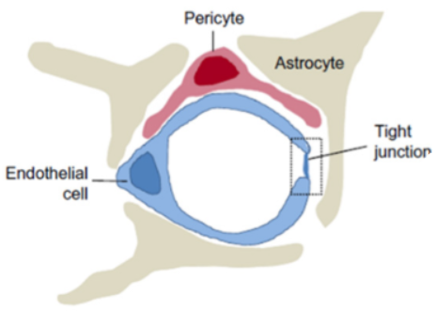
The BBB is formed by a monolayer of brain endothelial cells (ECs) with tight junction complexes (TJ) residing between the Ecs [3]. Brain pericytes, involved in structural stability and regulation of the blood vessels, and astrocytic end-feet, which are critical to maintaining the TJ complex, but believed to not have a barrier function in the mammalian brain, surround the ECs [4].
Figure 1: Cellular constituents forming the Blood Brain Barrier (BBB). Brain microvascular endothelial cells, pericytes and astrocytes form the BBB. Endothelial cells line the cerebral vasculature creating a wall. Specialized tight junctions between endothelial cells regulate the entrance of chemical and biological entities. Figure adapted from Figure 1 of Reference 3.
As ECs form the basic structure of the BBB in mammals, along with the TJ complex, it is important to understand both the specific roles of ECs and TJs in the brain. BBB endothelial cells have very low permeability due to the TJs. TJ complexes ensure stringent regulation of CNS homeostasis by restricting diffusion between endothelial cells and cells within the circulating blood [4]. Extensive research has been done on the mechanisms on the formation of TJs by homophilic cell-cell adhesion and junctional adhesion molecules, but there is limited research in mechanisms that allow for changes in brain endothelial permeability [5]. Brain endothelial permeability can be affected by the stretch and shrinkage of endothelial cells and by other inflammatory mediators, some of which have been experimentally tested [6,7].

Experimental evidence supports the hypothesis that the invasive opening of the BBB leads to neuronal dysfunction and damage that can result in neurological disease [7]. One such stimulus that is a major cause or consequence of injury is hypoxia. Hypoxia is when the body or a region of the body is deprived of adequate oxygen supply at the tissue level. To ensure that cells may be able to survive in hypoxic conditions, they must be able to switch from aerobic to anaerobic metabolism until oxygen levels are restored. The brain itself uses a great degree of physiological resources [1],needing both oxygen and glucose. Thus, a rapid change in environmental and local O₂ levels may result in negative consequences to the CNS homeostasis and BBB integrity, making hypoxia one of the leading causes of a cerebrovascular event leading to BBB breakdown [9]. The effects of hypoxia have been evidenced to alter localization of key junction proteins and increase paracellular permeability after exposure to brain endothelial cells [10].

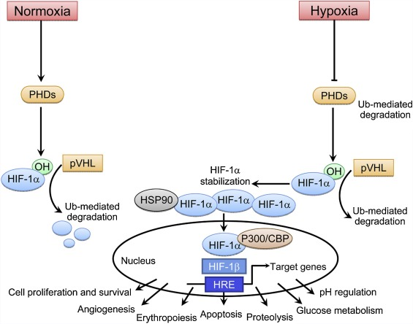
Hypoxia induces a variety of signaling pathways that are mediated by a family of transcription factors known as hypoxia inducible factors (HIFs). Of the 3 known members of the HIF family, HIF-1 is considered the master regulator of the hypoxic response resulting in the activation of many endogenous mechanisms (see Figure 2) by transcriptional activation of specific target genes [9,10]. HIFs are heterodimeric transcription factors that consist of an oxygen dependent α subunit (HIF-α) found in the cytoplasm and an oxygen independent aryl hydrocarbon receptor nuclear translocation (ARNT also known as HIF-β) found in the nucleus [11,12]. In the presence of oxygen or a normal state (normoxia), the HIF-α subunit will be ubiquitized and degraded by the enzyme prolyl hydroxylase (PHDs). In the case of hypoxia, the loss of oxygen inhibits PHDs and HIF-α accumulates and is transported to the nucleus to bind to ARNT. This creates a HIF protein which binds to the hypoxic response element and promotes target genes [9,11,12]. Of the hypoxia factors, these factors also create target genes that assist in cell proliferation, glucose metabolism and apoptosis enhancing production of a variety of molecules such as endothelial growth factor, adhesion molecules, etc [10].
Figure 2: Hypoxia inducible factor 1 alpha pathway). In the presence of oxygen, HIF-1a is degraded. In the lack of oxygen, HIF-1a is stabilized and accumulation leads to transcription of genes necessary for cell survival, angiogenesis, regulation,etc. This pathway causes potential disruption to the blood brain barrier. Figure adapted from Figure 2 of Reference 8.

The role of HIF-1 can be described as a double-edged sword. HIF-1 is largely considered to be essential for cell survival and has been reported to protect neurons from apoptosis by target pro-survival genes such as VEGF and Epo. Neuron-specific knockout of HIF-1-α increased tissue damage and reduced survival in mice with induced artery occlusion. Several research cases have shown that proapoptotic family members increase after HIF-1 is used to mediate hypoxia and brain-specific knockdown of HIF-1-α was neuroprotective. Thus HIF-1 can activate transcription factors and signaling pathways that are both pro-death and pro-survival functions depending on duration, pathological stimuli and cell type. BBB integrity compromised by hypoxia has been shown in many findings, though the possible mechanism for barrier dysfunction remain unknown [9]. HIF-1 and vascular endothelial growth factor (VEGF) has been identified as a possible mediator of barrier disruption though no research has been done on the role of HIF-2 or 3 [9,12]. Upregulation of endothelial molecules can lead to transmigration across the endothelium enhancing vascular damage, though this has not been researched very well. As hypoxia plays a role in opening the blood brain barrier by creating pathways with many survival instincts, it is important to identify mechanisms related to hypoxia inducible factors that directly impact vascular damage. Identifying such mechanisms could allow better controlled understanding of hypoxia inducible factors’ role in increasing BBB permeability as a target to introduce drugs non-invasively into the brain.

One possible gene to study is Apoliopoprotein L domain containing 1 (Apold 1 also known as Verge). Verge is an immediate early gene identified to be rapidly induced by hypoxia in cerebral ECs. Studies provide precedent that Apold1 can be induced in endothelial cells by membrane receptor signaling pathways by in-vitro testing and is induced by hypoxia tested in mice, though the mechanism itself is unknown [13]. In research done by Roszkowski and associates testing the effects of acute stress on Apold 1 gene expression and the blood-brain barrier, Apold 1 was identified to play a critical role in orchestrating the vascular response for acute stress and regulate BBB permeability under stressful conditions. The correlation between Apold 1 and BBB permeability could not be drawn due to a lack of an appropriate Apold 1 antibody and time [14]. Interestingly, Roszkowski notes that the use of forced swim experiments to stimulate stress amongst mice did not test to see if the HIF pathways was triggered, as a forced swim experiment could possibly cause temporary oxygen deficiency, hypoxia, for mice. Alternate research studies have shown hypoxia-induced gene expression of Apold 1 in the hippocampus, retina tissue, brain, and placenta, though none of these studies proved that Apold 1 was regulated through the hypoxia induced pathway. Thus it is possible that Apold 1 have altered gene expression due to the activation of HIFs and could possibly play a role in impacting vascular damage in ECs. Studies show that Apold 1 could have a role in regulating cellular response to cope with reduced oxygen levels. Thus the purpose of this experiment is to identify if there exists a potential mechanism between HIF and Apold 1 specific to cerebral epithelial cells that may impact the blood brain barrier.
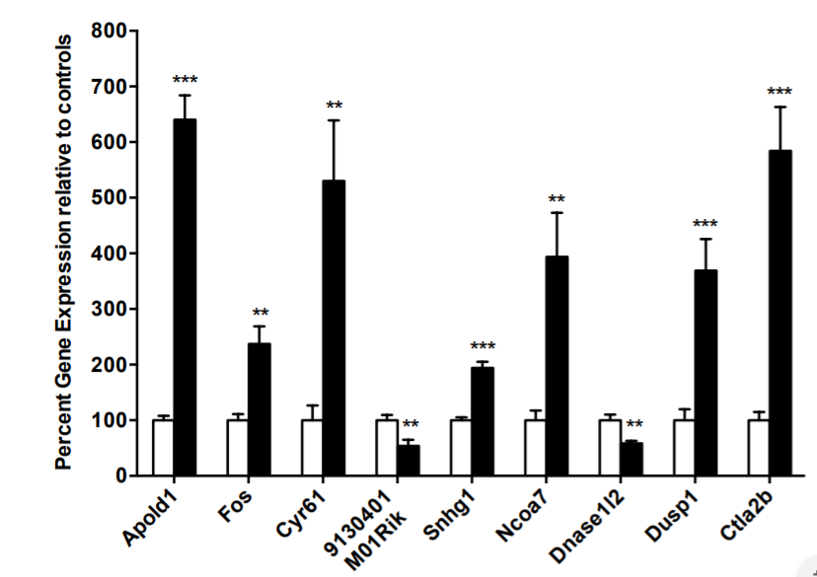
Figure 3: Altered Gene Expression due to Acute Stress. Apold 1 has one of the highest gene expression after 6 minute of forced swimming in female mice to simulate forced stress. Figure adapted from Figure 8 of Reference 14.
Experiment
This experiment aims to (1) measure the expression of Apold 1 upon overexpression of HIF-1-α in cerebral endothelial cells and (2) identify the impact of HIF-1-α and Apold 1 overexpression or lack of expression on endothelial cell homology and viability to draw understanding to how it could possibly impact the BBB permeability. In-vitro assays will be used as Apold 1 has not been knocked out of mice so the impacts of such KO is unknown. Using evidence that Apold 1 is overexpressed in the cases of hypoxia, this experiment will allow us to determine if Apold 1 is upregulated directly due to hypoxia induced factor-1 or identify if Apold 1’s overexpression is due to an alternative mechanism. As Roszkowski’s research also suggests that Apold 1 could possibly be involved in regulating cellular response to cope with reduced oxygen levels, this experiment will also allow us to clarify the role of Apold 1 in endothelial cells during hypoxia [14].

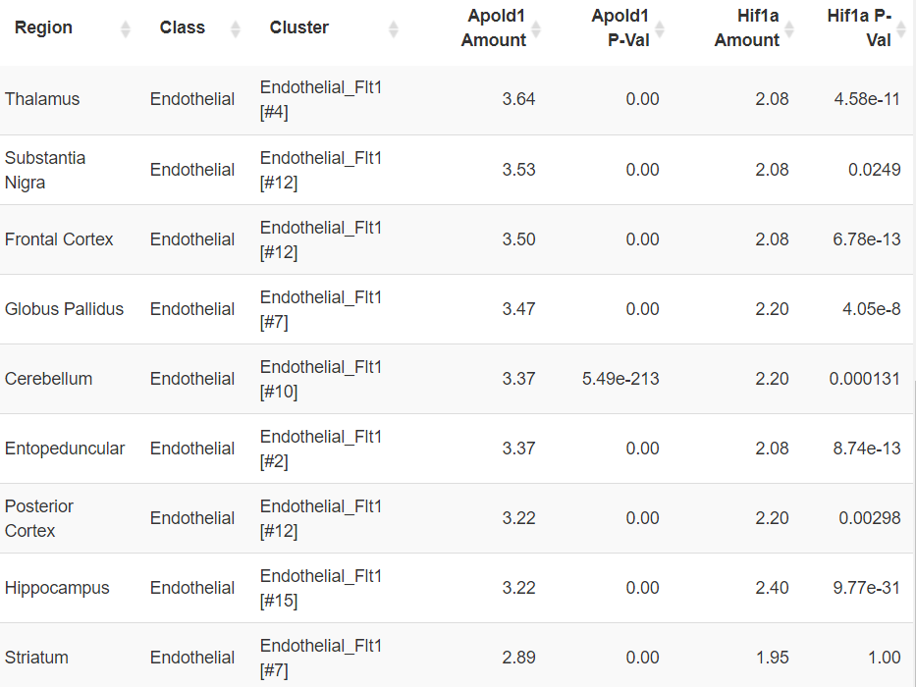
Confirming Genes in Endothelial Cell Line and identifying possible HRE Promoter on Apold 1
To determine whether both Apold 1 and HIF-1 genes are found in cerebral endothelial cells, DropViz, a computational tool which clusters RNA transcripts found in different mouse cell types was used to identify if both genes were observed in cerebral endothelial cells [28]. Data showed that both Apold 1 and Hif-1A are highly expressed in endothelial cells found in the brain as can be observed in the cluster table in Reference 1.
It is also important to identify if there is a possible hypoxia response element (HRE) promoter transcription binding site located upstream the Apold 1 gene. If no promoter site exists, HIF-1a cannot possibly impact Apold 1 gene expression. To do so, I obtained the HIF-1a ChIP-Seq/Homer. ChIP sequenceing is a method that identifies binding sites for DNA-associated protein and Homer is a tool that analyzes the probability of the genetic sequence for binding. An image of the HIF-1a Motif (HIF-1a(bHLH)/MCF7-HIF1a-ChIP-Seq(GSE28352)/Homer (Motif 152) )is provided as Figure 4 [29]. Next to identify if the promoter motif could possible be found upstream Apold 1, the Eukaryotic Promoter Database was used to identify promoter binding site 500 to 100 base pairs upstream Apold 1. The sequence retrieval tool provided the following data. As highlighted, a very similar motif to the Hif-1a homer was identified (Figure 4). There exists a potential HRE bind site upstream Apold 1.
>FP009104 Apold1_1 :+U EU:NC; range -499 to 100.
GGGTCACATGCTTCAGCTACTTACATCCCCACAAAGCTCTTTGAAAAGGACCATGAGTGG
CTGTATCGATCATAATTAAGTTTTCCGGTCCCTCCTATTTCTTTTTAAAAATGATTTTCT
GATGGAGTCCTCTCAAAGAAACACTATAATTGGGCAGCCTGGGGCATGTGGGAAAGCCTC
CCCCGATGGCGTCAGTAGCTATTCTCAGGAGAGGAAAGGCAGGGTATCCCCACTGGGAGA
TGACAGCACTTGTTTCAAGTTGGGGAAGAGCCTGTGGTTCTCTTCCTGCGTTTGGAGGGG
AAAGCGAACACACAATATTCATTTCCTAAATACGGGACGTGCTTTGCCAGCGTCTCTTTT
TCCAACATGTCATATCCTGGCCGAAGGCAGCAGGGGTCAGGGCAGGAAACAGCAGCTTCT
CAGAATGAGACAAGGCTTTCCCAGAGCCGTCATTGGCTCCTGGGAGCTATAAAGTATGCT
CGTCCAGAAACAGTCTCCCACTTTTCTTCCTGGAGGCCAGAGTGAAGGGTAAGTGGGGAG
TCCGAGGGATGTGTCTGCAATGGGATTGGTGATATCGGGGTCAACTCTCGAGGCGTCATG
Reference 1: Cluster Table of Apold 1 and Hif-1a in Cerebral Endothelial Cells Cluster Table shows amound of Apold 1 and Hif1a found in endothelial cells.

Figure 4: Homer Motif of Hif1a Motif is used to identify if promoter that allows Hif1a to bind to a DNA sequence possibly exists upstream Apold 1 gene. Figure from Source 29

HIF-1a is further considered a potential transcription factor for Apold 1 by an ARCHS4 analysis of Apold 1 which predicts that the HIF1A_ChIP-Seq_MCF-7 gene set is the 21st potential transcription factor for Apold 1 with a z-score of 1.09897. This is approximately one standard deviation from the mean at approximately 86% likelihood [31].

Extract Cerebral Endothelial Cells from Mice
To study cerebral endothelial cells in-vitro, it is important to isolate cells while maintaining key characteristics to study in-vitro. An isolation and cultivation protocol developed by Assmann and his associates, will be used in this protocol, though other methods such as purchasing through a third-party sources, such as Cell Biologics, is possible [15].

Creating a Knockout (KO) Cell Line through CRISPR/Cas 9
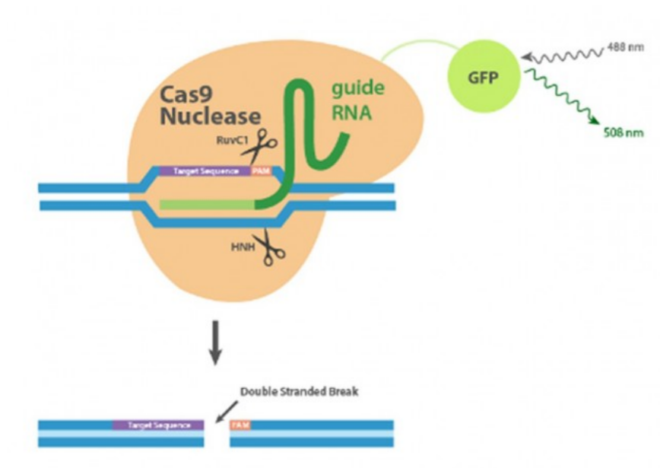
In order to identify the role of Apold 1 on cerebral endothelial cells survival and phenotypic alteration, Apold 1 will be knocked out of mouse cerebral endothelial cells (creating Apold KO cells) using the CRISPR/Cas9 protocol. Clustered regulated interspersed short palindromic repeats (CRISPR) is gaining popular technique to modify a targeted gene. The technique uses CRISPR-associated protein 9 (Cas 9), uses a guide RNA(gRNA), consisting of a scaffold sequence necessary for Cas-binding and a user-defined 20 nucleotide spacer, is used to induce a double stranded break in a specific gene. The two requirements for a genomic target on any 20 nucleotide DNA sequence is that it must be unique to the rest of the genome and immediately adjacent to a protospacer adjacent motif (PAM). The PAM sequences depends on which Cas protein is used.
Figure 5: CRISPR/Cas9 Nuclease Cas9 nuclease with GFP binds to target site and induces a double stranded break. Repair is made via non homologous end joining repair pathway which is error prone and insertions and deletions lead to possible disrupt gene functions. Figure from Source 26.

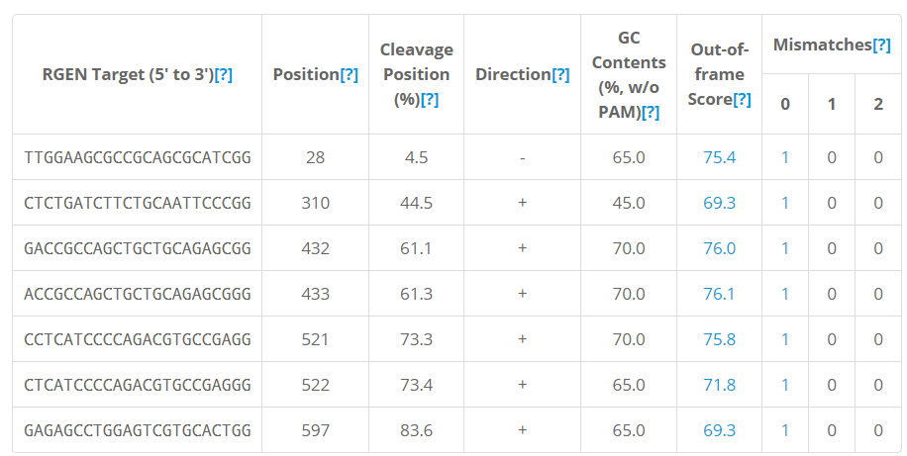
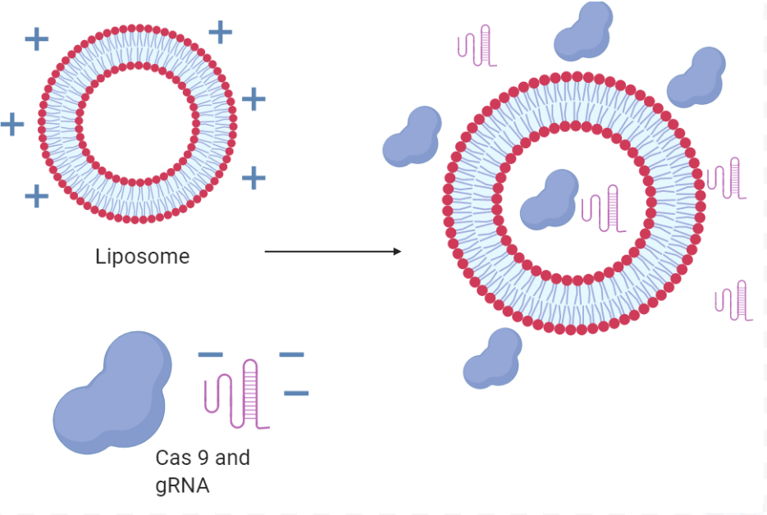
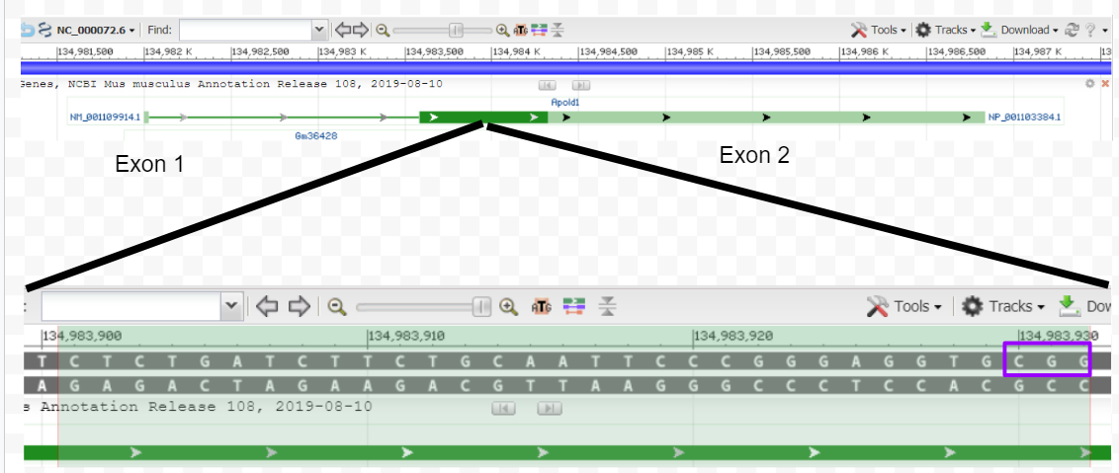
First, it is necessary to identify a viable sgRNA in the Apold 1 gene in Mus Musculus (mouse). I searched for this gene using a CAS-designer tool which is a tool that quantifies possible sgRNA strands reading both the upper and complementary strands [17]. The possible sgRNA was refined based on GC content between 30% and 70%, Out-of-frame score above 66% and no off-target mismatches (Reference 2). As it is important to avoid target sites close to the C terminus and the N terminus of the protein to maximize the chances of creating a non-functional allele, it is best to select the Rgen Target from Reference Table (1) that is positioned towards the beginning or the center of the sequence[16]. For the case of this proposal, one RNA sequence, CUCUGAUCUUCUGCAAUUCC, will be selected as the gRNA for one of the Targets proposed in Reference 2: CTCTGATCTTCTGCAATTCCCGG. Note the PAM sequence: “NGG” or in this case “CGG” is removed when making the RNA sequence as the Cas9 gene can recognize the PAM sequence to know where to bind and cut. A vial can be prepared by a 3rd party source.
Reference 2: Possible CRISPR Sequences . Sequences determined by CAS-Designer and selected for based on maximizing for the best outputs.
Figure 6: Diagram of DNA Target using CRISPR to create Apold 1 Knockout Apold 1 Gene in Mice consists of 2 exons. The first exon is very short, thus the more appropriate target is somewhere at the start of the 2nd exon. The target is selected at the beginning because a frame shift mutation towards the end may not knock out Apold 1 Sourced from Genbank

To transfect the cerebral endothelial cells, a CRISPR/Cas 9-GFP Nuclease NLS ribonucleoprotein bought through Genescript will be transfected using lipid mediate transfection reagents (Figure 5). This method, using Lipofectamine RNAiMAX, was selected over other transfection methods because off-target mutations rarely occur because RNP delivery is transient, Transfection is easier because Cas9-NLS bypasses transcription and translation and the assay is DNA-free so there is no risk of DNA integration. The main negative to lipid-mediated transfection is that transfection efficiency is lower than most other methods. The following steps are recommended in the protocol optimized by Diagenode. (1) Cells should be grown to 30-70% confluency to obtain 240,000 cells per mL, (2) one tube with the RNP complex and and one tube with the lipids (Lipofectamine) should be set up, (3) the RNP complex and Lipofectamine should be mixed and incubated to insert the RNP complex into the lipids, (4) Transfect cell line by adding transfection complex to cells [27].
Figure 6: Lipid-Mediated Transcription using Lipofectamine Lipids will form micellar structures called liposomes because this is energy favorable. In some cases, a liposome will form around Cas9 and gRNA which will be transfected into target cells. The liposome fuses with the cellular membrane to release the package within it- in this case Cas9 and gRNA. Hand proposed diagram based on protocol from Reference 27.

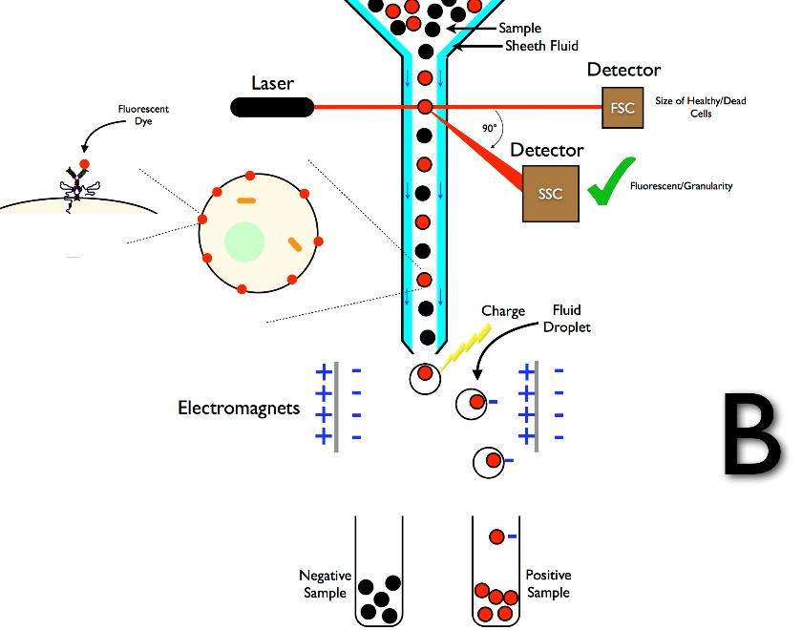
The cell line will be stabilized and sorted through flow cytometry based on a c-terminal-linked GFP tag on the Cas-9 Nuclease to create a homogenous population of ECs that contain Cas 9 nucleases inside them. There is a green florescent protein tag on the Cas 9 nuclease of the cell. The laser (Figure 5) will detect a florescence tag based on a deflection and return of a different wavelength. The cells with the florescence are slightly negatively charged and this separates the cells with the Cas 9 nuclease in them. The cell line with the plasmid will again stabilize and be spotted in separate assays to allow proliferation. One thing we must note, is that though CRISPR technique is used to create a mutation, this may or may not create a knockout line. To test an Apold KO function, we can confirm the level of Apold 1 through Western blot. The knocked out function will be confirmed through Western Blot technique [7] to assess the level of Apold 1 protein using an Anti-APOLD1 antibody, for example ab105079 supplied by abcam [13]. Western blotting uses specific antibodies to identify proteins that have been separated based on size by gel electrophoresis [24]. Western Blots use antibodies to bind to a specific target protein to visualize its presence. The anti-Apold1 antibody referenced from abcam binds to Apold 1. To visualize, a secondary antibody, in this specific case, Anti-Rabbit IgG will bind to the primary antibody. This secondary has a IR Dye fluorescence marker at 800nm wavelength that can be detected using an infrared camera. A Li-Cor camera could be used for imaging the western blot. (Reference Figures 1 and 2: https://www.licor.com/documents/kkkzpho630s4rgck244ydr4i1b1fo4qx) To identify cells as a knockout, there should be no fluorescence marked in the band where Apold 1expression would be seen in a Western Blot.
Figure 8: Fluorescence Based Cell Sorting . A laser source scatters forward and side light through cells passing one cell at a time. Cells are separated by charge where positive samples separate from negative samples.
Creating a HIF-1-α Plasmid for Transient Overexpression in cerebral ECs
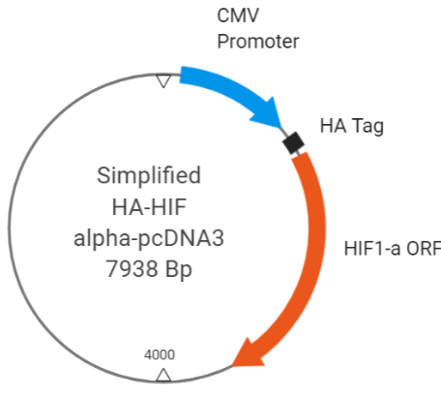
An HA tagged- HIF1-alpha- pcDNA 3 plasmid could be purchased from Addgene to overexpress HIF-1- α. A pcDNA 3 vector is designed for high level constitutive expression in a variety of mammalian cells. A cytomegalovirus (CMV promoter) enhancer is used for high- level expression. An HA-tag is a widely used epitope tag in protein expression vectors as it allows for detection and immunoisolation of proteins. The transfection method of HA-HIF alpha-pcDNA3 will be using lipid mediated transfections as described with transfecting Cas 9 nuclease and gRNA in attempt to make a stable KO cell line.
Figure 9 : Simplified HIF-1 alpha Plasmid: Plasmid simplified to show important sites on plasmid including the promoter, HA tag and HIF-1-alpha
.

Measuring Expression levels of Apold 1, HIF-1 and other Targets through RT-qPCR
Real-time Quantitative Polymerase Chain reaction (RT-qPCR), amplified all mRNA transcripts in cells to quantify the products. All mRNA transcripts in sample and synthesizes it into a complementary DNA strand. The primers can be amplified by (1) Denaturing all double stranded DNA into separate strands by heat, (2) annealing the DNA primer sequences to hybridize onto corresponding regions and (3) binding DNA polymerase and copying the strand. Thus, the sequences are amplified by repetition and quantified by using a double stranded fluorescence marker [22]. By comparing fluorescence, expression level can be determined and quantified statistically. Quantification can be done using a color detecting system such as SYBR Green I, which is a double stranded marker that increase florescence as more DNA is produced per cycle. Fluorescence is measured after each cycle and plotted. After reaching a minimum threshold value, the plot of samples can be compared.

For specific primers that bind to Apold 1, we must make two primers one for the forward and the other for the reverse strand. The primer must be built from 5’ to 3’, bind to the 3 prime end of the sequence, and is approximately 20 nucleotides long. Another condition is that we want our primer to anneal to the ends. So we want to have stronger bonds at the ends to keep our primers attached to each strand. Cytosine and Guanine form 3 bonds, whereas Adenine and Tyrosine form 2 bonds. It would be better if the ends of the primers had Cytosine and Guanine nucleotides. GC content is also recommended to be over 50%, as G and C’s form stronger bonds and those primers are more likely to anneal. For Apold 1, the following primers were identified. Forward: (5’ to 3’) GCCCGCTTCTTCTCCATGCC. This strand was chosen based on the start of the second exon. It is 20 nucleotides long, with ends that have G and Cs’ with the GC content over 50%. Backwards: (5’ to 3’) GCGCCACAAACCCTTTCG. This is 18 nucleotides long, with G and Cs’ at the ends with over 50% GC content. The location is towards the end of the 2nd exon in Apold 1 in mice.

Live Cell Fluorescence Imaging
Plated endothelial cells can also be visualized by in an Incucyte Zoom system after being labelled with Yo-Yo-1, a death marker, which will capture images ever 1 to 2 hours to visualize cell life in the study models. It provides for both qualitative and quantitative evidence to understand the phenotype of the endothelial cell lines when Apold 1 is knocked out.

Experimental Design
Four test cases will be developed to account for testing and controls. To measure the expression of Apold 1 upon overexpression of HIF-1-α in cerebral endothelial cells, control EC cells will be grown in assays and transfected with AVV-HIF-1-α while remaining in a hypoxic state with 1% oxygen which can be controlled by an incubator [23]. A control with no added HIF-1-α will need to be used to measure basal expression levels. To identify the impact of HIF-1-α and Apold 1 overexpression or lack of expression on cerebral endothelial cell life, Apold 1 KO cells with AVV-HIF-1-α will be observed. This can be visualized with either live cell imaging or a cell proliferation assay after a set amount of time to measure endothelial cell growth and death. A control with no added HIF-1-α will need to be used to compare cell growth and variation.

Discussion
Th purpose of this experiment was to first understand how knocking out the Apold 1 gene would impact the morphology of the endothelial cell as Apold 1 has been suggested to protect vascular response to hypoxic conditions. Thus, a loss of the Apold 1 gene would cause a morphological change in endothelial shape and cause cellular damage in hypoxic conditions. Should this experiment meet the hypothesis, the expression levels of Apold 1 when HIF-1-α is overexpressed in cerebral Ecs should increase. The loss of Apold 1 should disrupt the cerebral ECs cell and an overexpression of AVV-HIF-1-α should result in quicker cell death if Apold 1 plays a role in regulating cellular response to cope with reduced oxygen levels. If the morphology of Apold 1 KO cells alter in the presence of hypoxia factors, there must be other proteins that are interacting with Hif-1a. If in case, Apold 1 is not upregulated by HIF-1-α overexpression, Apold-1 may be induced by another hypoxia-induced factor and it would do well to test the other alpha subunits within the transcription family. If all test cases are eliminated, then there may be an alternate, confouding mechanism that upregulates Apold 1 in a hypoxic condition.

This data would give valuable insight into the molecular mechanisms of HIF-1-α and Apold 1. It is important to look at the limitations of this experiment design. Creating a stable KO cell line is difficult and there is potential that a KO of Apold 1 in brain endothelial cells will result in cell death. Targeting transcription sites for Apold 1 by making microRNA is an alternative method of creating a knock out cell line that may be tested. It is important to note that this experiment serves as a powerful first step to identifying a potential mechanism that could explain more traits about the blood brain barrier. Based on data from this experiment, understanding both HIF-1 and Apold 1s’ role in cerebral endothelial cells could bring us closer to understanding non-invasive mechanisms of opening the blood brain barrier to increase drug targeting neurogeneration in the brain.
References
- Daneman, Richard, and Alexandre Prat. “The Blood–Brain Barrier.” Cold Spring Harbor Perspectives in Biology, vol. 7, no. 1, Jan. 2015, doi:10.1101/cshperspect.a020412.
- Pardridge, W. M. (2005). The blood-brain barrier: Bottleneck in brain drug development. NeuroRX, 2(1), 3–14. doi: 10.1602/neurorx.2.1.3
- Jiang, L., Li, S., Zheng, J., Li, Y., & Huang, H. (2019). Recent Progress in Microfluidic Models of the Blood-Brain Barrier. Micromachines, 10(6), 375. doi: 10.3390/mi10060375
- Ballabh, P., Braun, A., & Nedergaard, M. (2004). The blood–brain barrier: an overview. Neurobiology of Disease, 16(1), 1–13. doi: 10.1016/j.nbd.2003.12.016
- Cerutti, C., & Ridley, A. J. (2017). Endothelial cell-cell adhesion and signaling. Experimental Cell Research, 358(1), 31–38. doi: 10.1016/j.yexcr.2017.06.003
- Abbott, N. J., & Revest, P. S. (1991). Control of brain endothelial permeability. Cerebrovasc Brain Metab Rev, 3, 39–72.
- Zlokovic, B. V. (2011). Neurovascular pathways to neurodegeneration in Alzheimers disease and other disorders. Nature Reviews Neuroscience, 12(12), 723–738. doi: 10.1038/nrn3114
- Curtis, K. K., Wong, W. W., & Ross, H. J. (2016). Past approaches and future directions for targeting tumor hypoxia in squamous cell carcinomas of the head and neck. Critical Reviews in Oncology/Hematology, 103, 86–98. doi: 10.1016/j.critrevonc.2016.05.005
- Ogunshola, O. O., & Al-Ahmad, A. (2012). HIF-1 at the Blood-Brain Barrier: A Mediator of Permeability? High Altitude Medicine & Biology, 13(3), 153–161. doi: 10.1089/ham.2012.1052
- Koto, T., Takubo, K., Ishida, S., Shinoda, H., Inoue, M., Tsubota, K., … Ikeda, E. (2007). Hypoxia Disrupts the Barrier Function of Neural Blood Vessels through Changes in the Expression of Claudin-5 in Endothelial Cells. The American Journal of Pathology, 170(4), 1389–1397. doi: 10.2353/ajpath.2007.060693
- Biol Med., Yale J. Hypoxia-Inducible Factor (HIF)-1 Regulatory Pathway and Its Potential for Therapeutic Intervention in Malignancy and Ischemia. 2007.
- Almodovar, C. R. D., Lambrechts, D., Mazzone, M., & Carmeliet, P. (2009). Role and Therapeutic Potential of VEGF in the Nervous System. Physiological Reviews, 89(2), 607–648. doi: 10.1152/physrev.00031.2008
- Regard, J. B. (2004). Verge: A Novel Vascular Early Response Gene. Journal of Neuroscience, 24(16), 4092–4103. doi: 10.1523/jneurosci.4252-03.2004
- Roszkowski, M. (2014). The effects of acute stress on Apold1 gene expression and blood-brain barrier permeability. Research Gate. doi: 10.13140/RG.2.2.17849.47204
- Assmann, J., Müller, K., Wenzel, J., Walther, T., Brands, J., Thornton, P., … Schwaninger, M. (2017). Isolation and Cultivation of Primary Brain Endothelial Cells from Adult Mice. Bio-Protocol, 7(10). doi: 10.21769/bioprotoc.2294
- CRISPR Guide. (n.d.). Retrieved from https://www.addgene.org/guides/crispr/.
- CRISPR RGEN Tools. (n.d.). Retrieved from http://www.rgenome.net/.
- Körbelin, J., Dogbevia, G., Michelfelder, S., Ridder, D. A., Hunger, A., Wenzel, J., … Trepel, M. (2016). A brain microvasculature endothelial cell‐specific viral vector with the potential to treat neurovascular and neurological diseases. EMBO Molecular Medicine, 8(6), 609–625. doi: 10.15252/emmm.201506078
- Takara Bio-Home. (n.d.). Retrieved from https://www.takarabio.com/.
- CRISPR/Cas9-Knockout Plasmids. (n.d.). Retrieved from https://www.bio-connect.nl/crispr-cas9-knockout-plasmids/cnt/page/4136.
- Gibson Assembly Cloning. (n.d.). Retrieved from https://www.addgene.org/protocols/gibson-assembly/.
- Real-Time Polymerase Chain Reaction. (n.d.). Retrieved from
- Inhibition of HIF is necessary for tumor suppression by ... (n.d.). Retrieved from https://www.cell.com/cancer-cell/fulltext/S1535-6108(02)00043-0.
- Western Blot Protocol. (n.d). Retrieved from https://www.abcam.com/protocols/general-western-blot-protocol
- Titration of Yoyo-1. (n.d) Essence Biosciences https://www.essenbioscience.com/media/uploads/files/8000-0210-A00_Supplemental_data_CellPlayer_96-Well_Kinetic_Cytotoxicity.pdf
- Gene Snipper Cas 9 GFP NLS (n.d) Biovision https://www.biovision.com/gene-snippertm-cas9-gfp-nls-19081.html
- Transfection of CRISPR/Cas9 Nuclease NLS ribonucleoprotein (RNP) into adherent mammalian cells using Lipofectamine® RNAiMAX. Protocol by Diagenode. https://www.diagenode.com/files/protocols/Cas9-NLS-protocol.pdf
- Saunders A*, Macosko E.Z*, Wysoker A, Goldman M, Krienen, F, de Rivera H, Bien E, Baum M, Wang S, Bortolin L, Goeva A, Nemesh J, Kamitaki N, Brumbaugh S, Kulp D and McCarroll, S.A. 2018. Molecular Diversity and Specializations among the Cells of the Adult Mouse Brain. 2018. Cell. 174(4) P1015-1030.E16
- http://homer.ucsd.edu/homer/motif/HomerMotifDB/homerResults/motif152.info.html
- Apold 1. Eukaryotic Promoter Database. SIB https://epd.epfl.ch/cgi-bin/get_doc?db=mmEpdNew&format=genome&entry=Apold1_1
- Apold1 ARCHS4 https://amp.pharm.mssm.edu/archs4/gene/APOLD1#correlation

