Regulating Crp protein levels with the use of sRNA
Jada Wilson
Bnfo 300
2019
Introduction
Decades ago a plague caused by the bacterium Yersinia pestis emerged. This plague was known as the Bubonic plague which was responsible for the death of millions of people across Europe, Asia and Africa. This plague is spread by infected flea bites or by direct contract. Although there is wide access to antibiotics in the 21st century if left untreated death or serious illness could occur. 100 Just in the year 2010-2015 cases had reduced to less than 1000 but in the Africa were medicine isn’t as readily available more than 1,000 cases of plague were reported(CDC 2018) .
The infection ultimately leads to death because once the infection has broken into the respiratory tract an immune response is blocked in the lungs. This causes a transition into a phase of high inflammation. During infection Y. pestis survives in the varying conditions by making changes in the expression of the certain sets of genes. There is a protein known as the cyclic AMP receptor protein(CRP) which regulates transcription of many genes. One gene in particular that it activates is pla , a enzyme activator. This gene works in conjunction with a coactivator cAMP, which acts as a catalyst to increase transcription speed, to bind to the CRP promoter region. As stated by Zhan et. al. In E. coli the CRP is directly regulated by its cAMP-CRP complex which can directly repress its own genes. The gene that encodes for the small protein known as Hfq plays an important role in regulating gene expression. This protein is a mRNA-binding protein. This protein is said to help regulate CRP synthesis with help from a hfq-binding small RNA (sRNA). In an experiment done by Lathem et al determine that Hfq promotes Crp synthesis and the Fig1. below shows that hfq cant bind to the target mRNA strand on its own. An sRNA was used to occupy the complementary strand by binding to the sRNA to free up the target sequence. In the picture where there is a rectangle around 4 codons RBS means ribosomal binding site which is the place in the sequence that hfq wishes to bind. The CCC sequence below is the complementary strand that has to be bound.

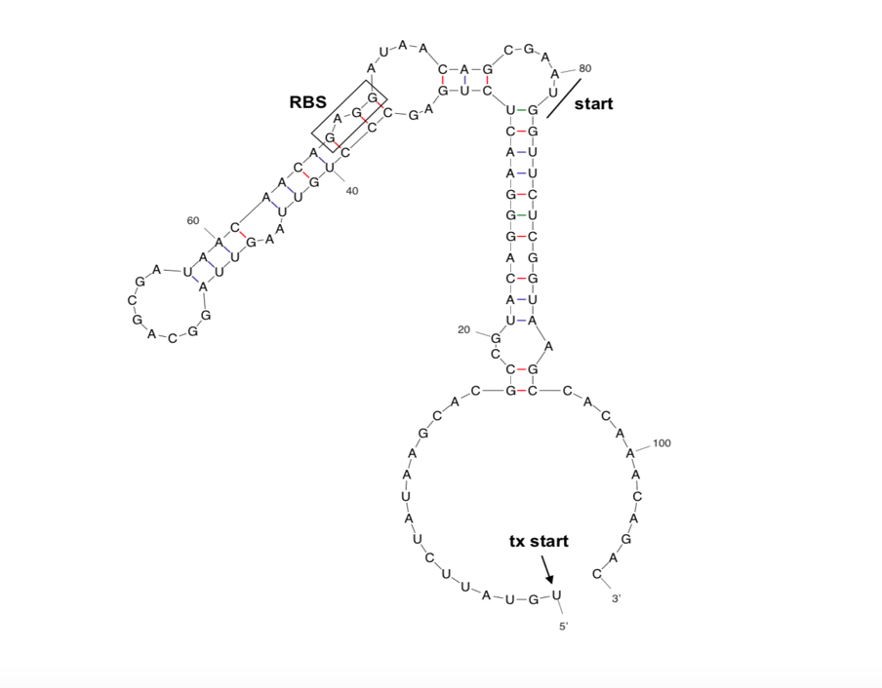
Fig1. A prediction for what the structure of Y. pestis crp 5’ UTR and proximal coding regions would look like . RBS stands for ribosomal-binding site which would be bound by an hfq protein and an sRNA. Transcription start indicated by arrow and translation start indicated by black

Lathem et al hypothesized that hfq promotes Crp synthesis through posttranscriptional regulation of the 5’ UTR or proximal region. The hfq is said to be assisted with this promotion by a sRNA but not much is known about how the sRNA is directly affects crp synthesis.
This experiment will answer the question whether the sRNAs used in conjunction with the hfq chaperone protein helps regulate CRP protein synthesis.

Experiment
This experiment will prove whether sRNAs affect Crp synthesis by analyzing the interactions between the hfq and sRNAs. A northern blot will test will also help with the conclusion of whether the addition, or deletion of certain sRNAs would cause destabilization of the crp. protein synthesis.

Microarray
Wild type and mutated crp grown in medium and isolated to get total RNA. The gene expression profiles were then compared between the two strains. The samples were marked with probes that have a dye on them then synthesized. The ratio of mRNA levels for each gene were calculated and then analysized by computer software(Sharma, C.M. et al., 2011).

Northern Blot
The RydB, mRNA and Hfq were all amplified by PCR. Once the cultures were centrifuged and separated a mixture was added that would allow the separation of an aqueous and an organic layer. Absorbance was measure then the RNA was sent through urea -polyacrylamide gel electrophoresis (Berry, K.E. et. al 2018)

Discussion
In a similar experiment done by Salvail et. al. the effects were noted when a mutated RyhB sRNA (RyhB1) was used. Salvail wanted to see if the decrease in strength of the binding would cause them to not to base pair. Just a little back story the RyhB post-transcriptionally regulates the expression of the cirA. In order to examine the effects done on the cirA levels a northern blot test was performed . These results showed that the total accumulation was the same for the wild type and mutated allele except the only difference was that the expression totals differed in the first 15 mins. The mutated allele didn’t allow for any cirA expression after 15 minutes. This experiment suggests that we should get approximately the same accumulation results for crp as seen in cirA.

References

Lathem, W. W. et. al. “Posttranscriptional Regulation of the Yersinia pestis Cyclic AMP Receptor Protein Crp and Impact on Virulence”. mBio, 5(1), pp.e01038–13. (2014)

Salvail, H. et al., 2013. Antagonistic functions between the RNA chaperone Hfq and an sRNA regulate sensitivity to the antibiotic colicin. EMBO Journal, 32(20), pp.2764–2778.

Berry, K.E. & Hochschild, A., 2018. A bacterial three-hybrid assay detects Escherichia coli Hfq-sRNA interactions in vivo. Nucleic acids research, 46(2), p.e12.

Santiago-Frangos, A. et al., 2016. C-terminal domain of the RNA chaperone Hfq drives sRNA competition and release of target RNA. Proceedings of the National Academy of Sciences of the United States of America, 113(41), pp.E6089–E6096.

Fröhlich, Kathrin Sophie et al. “A small RNA activates CFA synthase by isoform-specific mRNA stabilization.” The EMBO journal vol. 32,22 (2013): 2963-79. doi:10.1038/emboj.2013.222

Sharma, C.M. et al., 2011. Pervasive post‐transcriptional control of genes involved in amino acid metabolism by the Hfq‐dependent GcvB small RNA. Molecular Microbiology, 81(5), pp.1144–1165.

