The effects of mutations on the functionality of the HCN4 channel
Mentor: Lei Zhou, PhD

I Introduction:
Sinus bradycardia can be defined as a heart rate that is lower than 60 beats per minute. Asymptomatic sinus bradycardia is generally harmless and most often a signal of good physical conditioning. On the other hand, symptomatic sinus bradycardia such as sick sinus syndrome can lead to fatigue, chest pain, and shortness of breath. This condition is characterized by heart arrhythmias, which are caused by a dysfunction in the sinus node of the heart. Since sinus bradycardia can be inherited this shows that it can be because of something genetic (Reference 10)
Hyperpolarization-activated cyclic nucleotide-gated (HCN) ion channels are voltage gated and ligand-activated integral membrane proteins that contribute to pace-making activity in cardiac cells (Reference 10). They are occasionally referred to as pacemaker cells because they generate rhythmic activity within heart cells. A unique feature of HCN channels that distinguishes them from other voltage gated channels is that the HCN channel pore opens in response to hyperpolarizing voltages instead of depolarizing voltages (Reference 11). Hyperpolarization occurs when the membrane potential of the cell becomes more negative due to an efflux of potassium (Reference 7). Therefore, the HCN channel is inhibited by an influx of Na+. The HCN4 channel is composed of 6 trans-membrane domains and a pore-forming loop—the P domain—located between transmembrane domains S5 and S6, acting as the ion conducting pore and selectivity filter ( Reference 11). HCN channels are regulated by the binding of cyclic nucleotides such as cAMP, cGMP, or cCMP. The binding of cyclic nucleotides lowers the threshold potential of HCN channels thereby activating them.
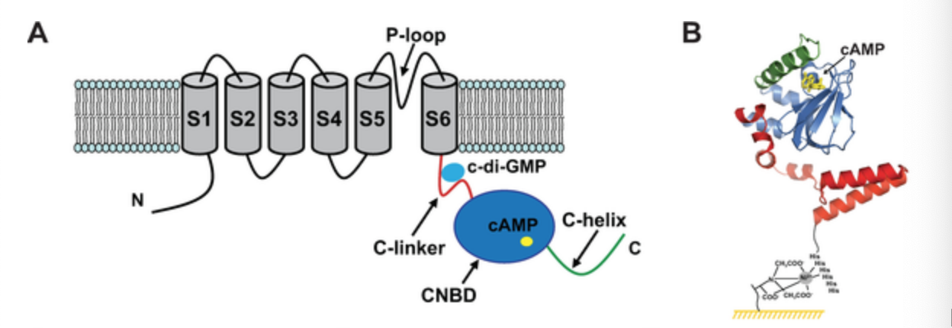
Figure 1: Structure of the HCN channel with cAMP binding site. Adapted from Table 1 of Reference 8

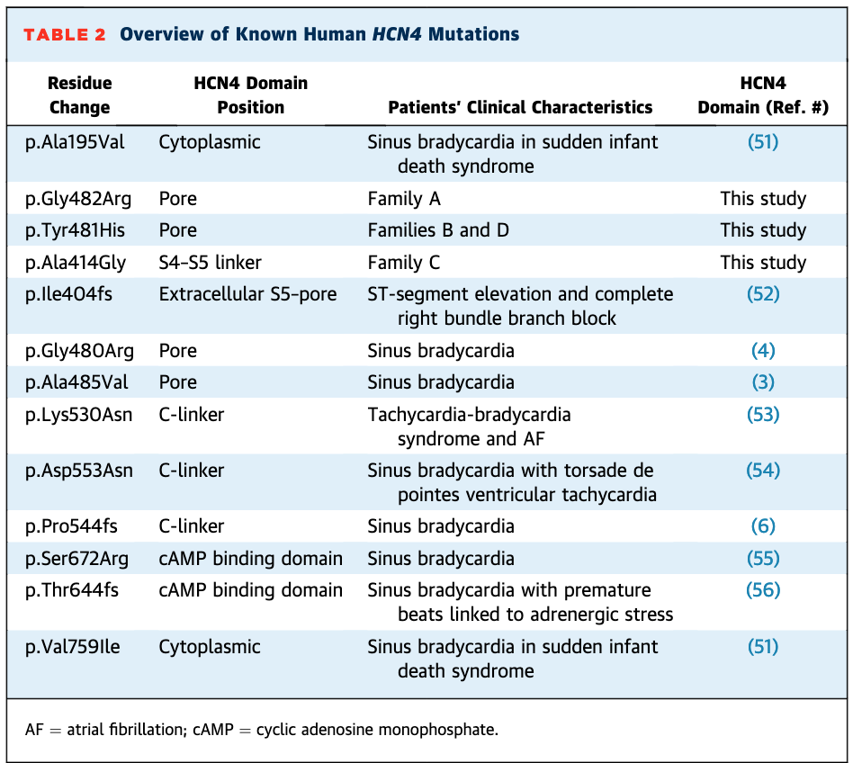
HCN channels are responsible for generating the pacemaker “funny” current that plays a crucial role in modulating the rhythm of the heart (Reference 6). HCN4 channels are the main isoform that are expressed within the sinoatrial node (Reference 11). The funny current is a mixed sodium–potassium current that activates upon hyperpolarization at voltages in the diastolic range, normally from −60/−70 mV to −40 mV (Reference 6) . When the end of the sinoatrial action potential is reached, the membrane repolarizes below the I_{f} threshold, -40 mV. The funny current is then activated and supplies inward current which causes diastolic depolarization. This method mechanism allows the funny current to control the activity of the sinoatrial myocytes and therefore the cardiac rate. The pacemaker current (I_{f}) that is located in the sinoatrial-node myocytes determines the slope of the diastolic depolarization of pacemaker cells and therefore has a crucial role in the generation and autonomic regulation of the sinus rhythm and rate (Reference 6).
Sinus bradycardia has been linked to mutations in the HCN4, SCN5A, and ANK2 genes (Reference 11). The focus of this proposal will be mutations located in the HCN4 channel. Figure 2 depicts all known mutations that are found within the HCN4 channel. They all involve a change from one amino acid residue to another. Different amino acids have different hydrophobic and hydrophilic properties that can impact how the channel will respond to an influx or efflux of charged ions.
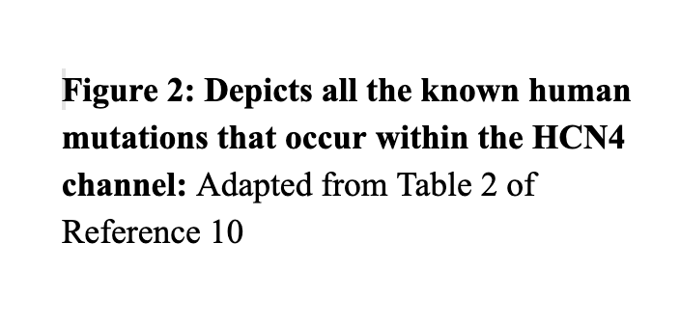
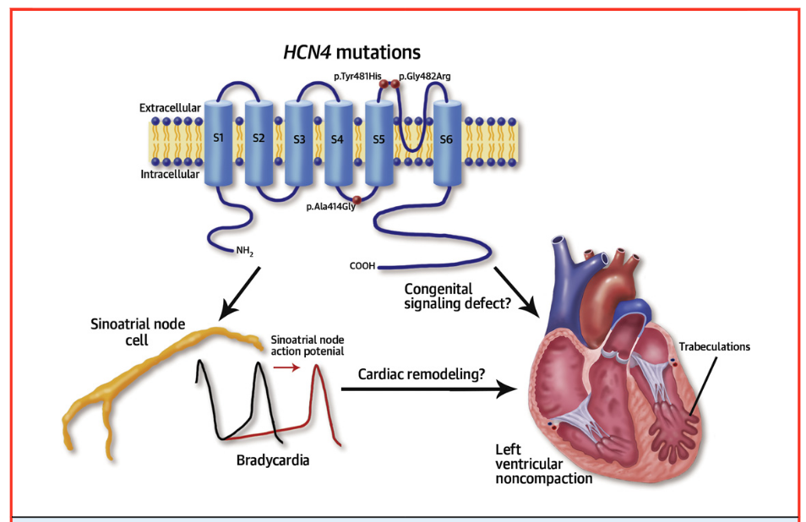
Mutations within the hHCN4 gene causes mutant channels to become activated at more negative voltages when compared with wild-type channels (Reference 11). This leads to less current being supplied during diastolic depolarization, which leads to a slowing of the heart rate. Diastolic depolarization occurs during the transition from the max diastolic potential (-70 mV) to the threshold potential, -40 mV (Reference 7). The threshold potential is the critical level that the membrane potential
is depolarized to initiate the action potential.
This transition is called the pacemaker phase and its duration governs how fast the heart beats (Reference 7).
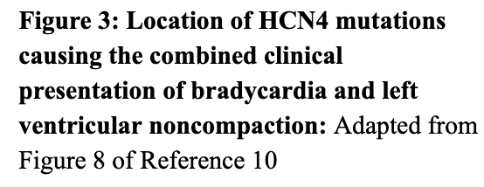
Mutant channels respond normally to cAMP binding but are activated at negative voltage when compared with wild type channels (Reference 11). For example, mutant channels open at -60 mV while wild-type channels open at -20 mV (Reference 10). This can be seen in Figure 4. The wild-type channels are more easily opened and are open longer than the mutated channel.
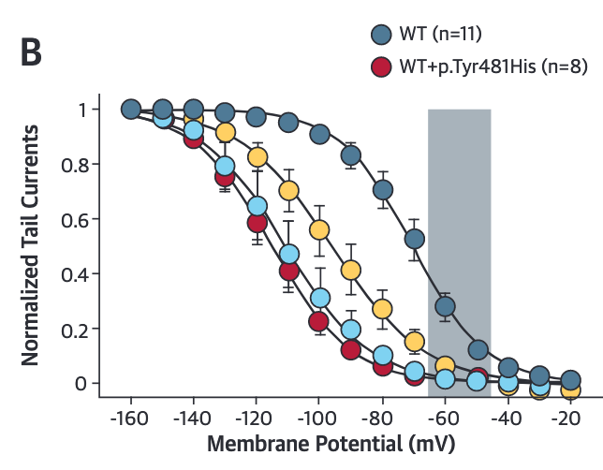
Figure 4 : Comparison of membrane potential in mV of wild-type and mutated channels: Adapted from Figure 7 of Reference 10

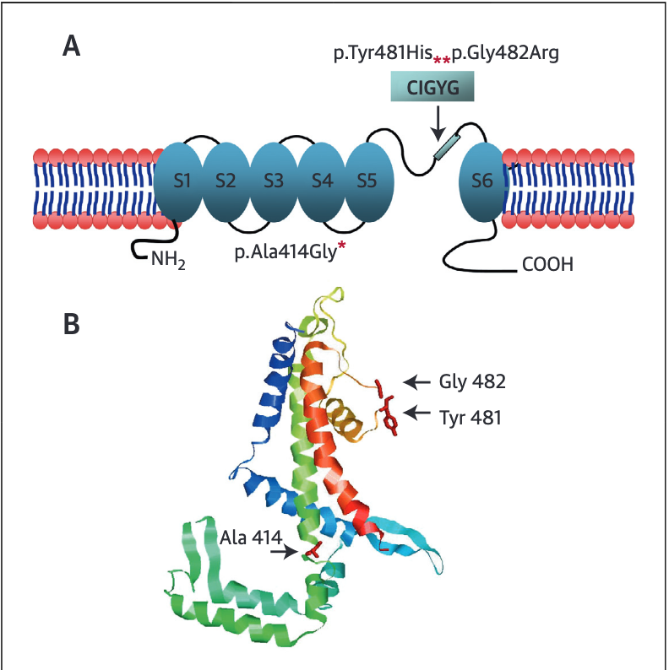

Mutations within the CIGYG region of the S5-S6 linkage region have been linked to bradycardia (Reference 10). The S5-S6 linkage region acts as the pore forming loop of the HCN4 channel. The S5-S6 region acts as the ion conducting pore and a selectivity filter (Reference 10). Mutations in this region will directly impact the selectivity of the channel since the pore itself is being affected. There have been two mutations that have been identified in this region, Tyr481His and Gly482Arg (Reference 10). Figure 5 shows the mutations and the CIGYG region where these mutations occur. This region
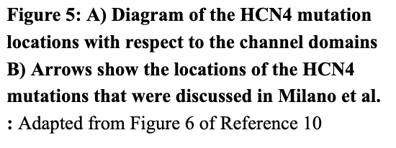
is highly conserved, which means that it has remained relatively unchanged far up the phylogenetic tree. These two mutations involve the mutation of an uncharged amino acid to charged amino acid. This changes the properties
of the amino acids from hydrophobic to hydrophilic.
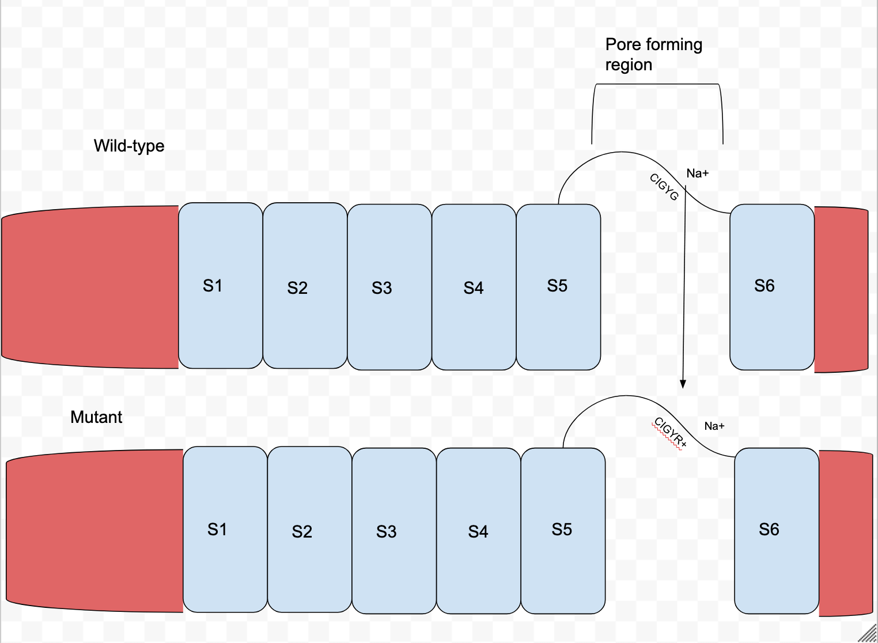
In both of the identified mutations, Tyr481His and Gly482Arg, uncharged, hydrophobic amino acids are mutated to a charged amino acid. Armstrong et al (2016) speculated that arginine side chains provide a potent barrier to the passage of ions within voltage gated channels. They tested this by causing mutations in a human skeletal muscle sodium channel cDNA clone through site-directed mutagenesis within human embryonic kidney cells. They engineered different mutations within the channel converting hydrophobic amino acids to charged arginine or lysine amino acids. They then measured peak levels of Na+ depolarization through patch clamp recordings. They found that in voltage-mediated transitions the positive side chains provide a barrier to the passage of ions. Bendahhou at el (2007) goes in depth in the opposite direction by focusing on how mutations from charged to uncharged amino acids can affect how voltage-gated sodium channels. They found that mutations from hydrophobic to charged amino acids can cause comparable or even larger shifts in activation and inactivation curves when compared to charged substitutions. A balance between hydrophobic and charged amino acid interactions are crucial for the overall function of the gate. Figure 6 diagrams how a charged amino acid mutation present in the CIGYG region may interfere with the movement of charged ions attempting to pass through the channel by charge repulsion. The original wild-type channel does not contain a charged amino acid and this may be the reason why ions are able to pass through easier.
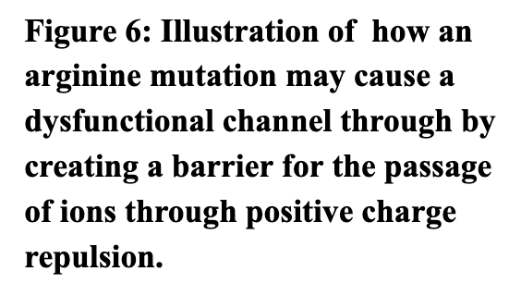
Mutations in this pore region have been limited to mutations that have gone from uncharged to positively charged and the results have shown that the function of the channel has decreased causing bradycardia. There have been no cytosine mutations discovered within the region. Cytosine is a negatively charged amino acid. The purpose of this proposal is to explore whether mutating the cytosine, present within the S5-S6 pore forming region, to an arginine will also cause a dysfunctional HCN4 channel.

II Experiment:
The overall goal of the experiment will be to compare the electrophysiology of Xenopus laevis oocytes with mutated human HCN4 channels with oocytes with wild-type human HCN4 channels. cRNA, one with the mutation and one without, will be created within E. Coli and injected within the nuclei of the frog oocytes. The oocyte that is expressing wild-type HCN4 channels will be the control group. The frog oocytes will then be allowed to go through the processes of translation to create functioning HCN4 channels and be measured through TEVC.

II Why Xenopus oocytes:
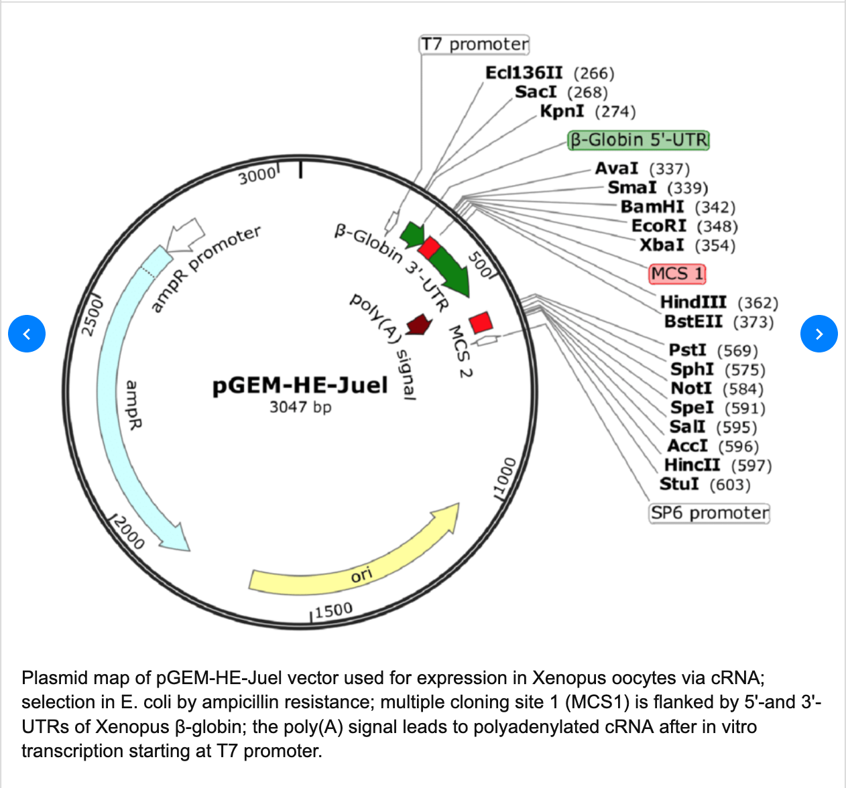
Xenopus oocytes have been used extensively to study ion channels in controlled in vivo experiments. A primary advantage of Xenopus oocytes is their cells do not express large numbers of ion channels and receptors, so exogenous proteins can be studied without endogenous interference (Reference 8). There are also advantages in the use of oocytes with respect to electrophysiology. The oocyte system is very well suited for the study of different mutations since injection and two-electrode voltage-clamping can be performed rapidly (Reference 8).

II Vectors and Site-directed mutagenesis:
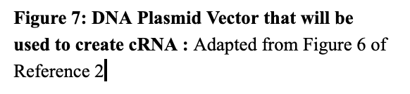
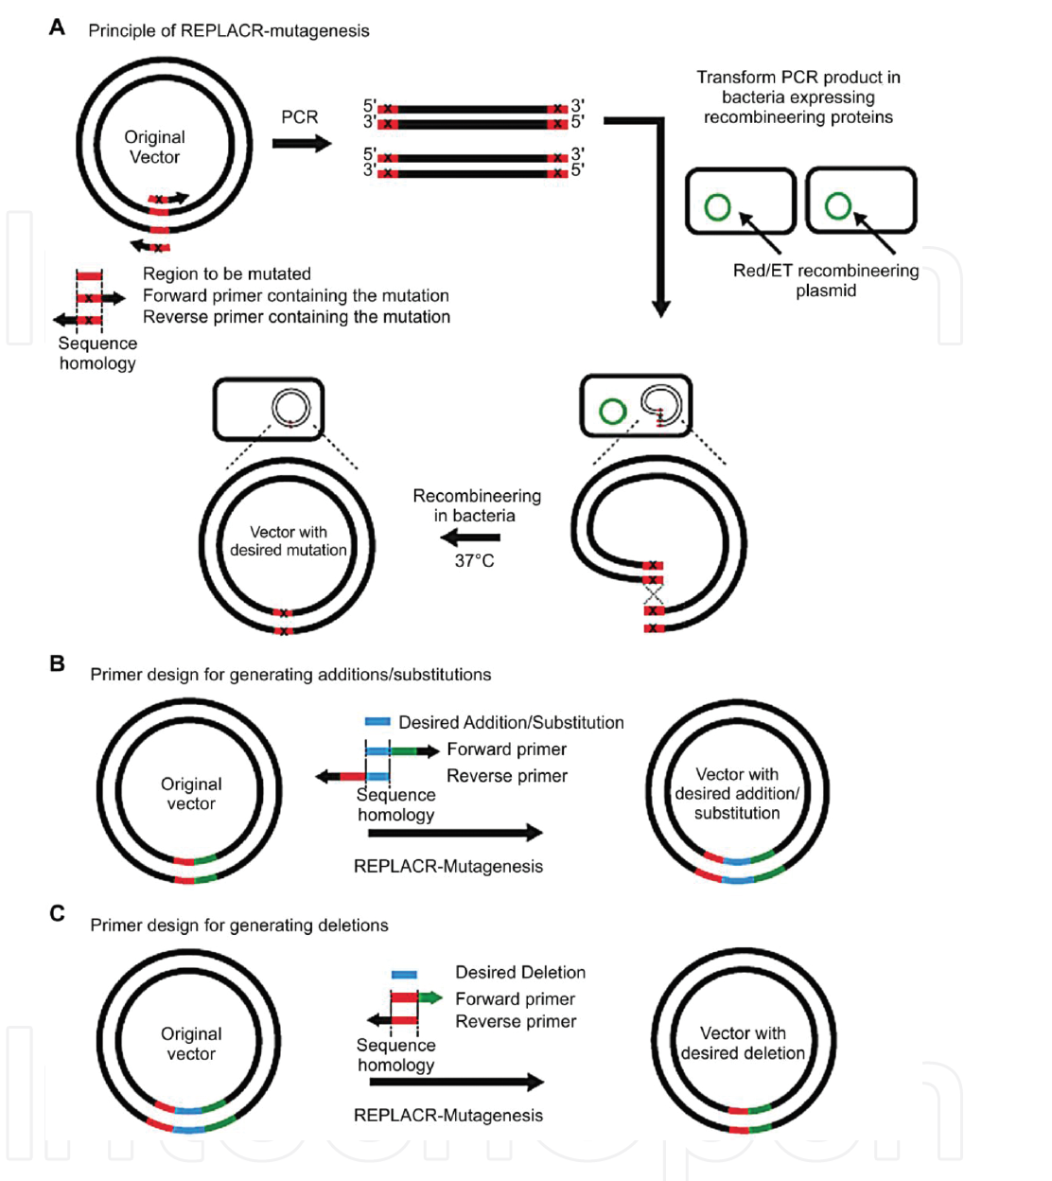
The first step in this experiment in this to use a viable vector that can successfully create complementary RNA that can be injected into the oocyte nucleus. The vector that will be used for this experiment will be pGEM-HE-Juel. The DNA plasmid template is readily available and has been used previously for expression in Xenopus oocytes (Reference 2) . Figure 7 depicts the structure of the vector and the T7 promoter region. Human HCN4 channel cDNA clone will be used as a template to engineer the mutation of cysteine to arginine by base substitution PCR that will change one uracil to a cytosine. The overall point mutation will cause a shift from UGU to CGU effectively creating the desired cRNA. Figure 8 depicts how base substitution functions in detail. The substitution is created by incorporating the desired nucleotide change in the center of the forward primer (Reference 5). At least 10 complementary nucleotides must be included on the 3-prime side of the mutation. The reverse primer must be designed so that the 5-prime ends of the two primers anneal back to back (Reference 5). The RNA promoter within the E.coli will then bind to the T7 region of the vector and begin transcription to create cRNA.

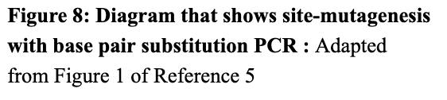
II In vitro injection into Xenopus oocyte:
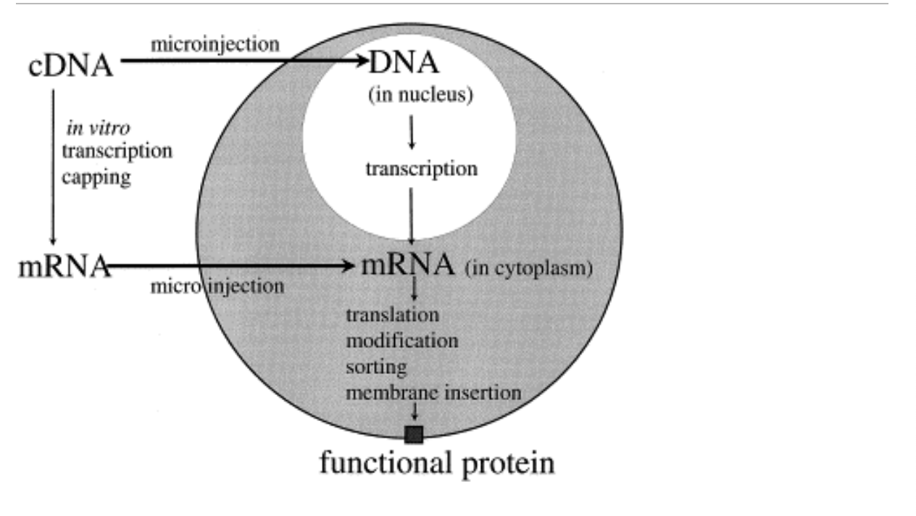

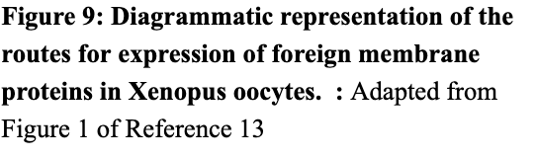

Once cRNA has been created the next step is to microinject cRNA into the nucleus of the oocytes. This step should be done for both the wild-type and mutant oocyte. The advantage of injecting DNA is that there is no need to perform in vitro transcription reactions, which saves both time and money (Reference 8). Cytoplasmic injection is rapid and simple procedure. All that is needed is a dissecting microscope, micromanipulator, and an injector (Reference 8). Figure 9 depicts how once the cRNA is injected translation is allowed to occur and the oocyte will begin to express the mutant or wild-type human HCN4 channel. Figure 10 depicts the overall microinjection setup that contains the dissecting microscope, micromanipulator, and the injector.
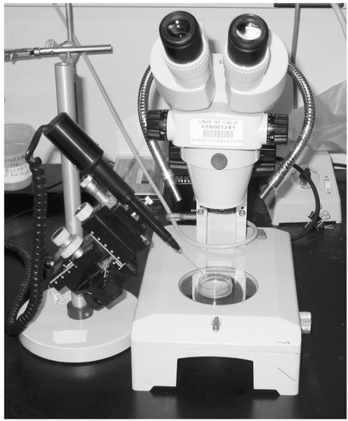

II Measuring electrophysiology with TEVC (two electrode voltage clamp):
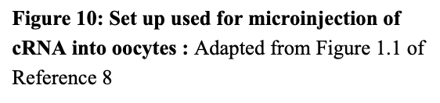
To compare both oocytes and the impact of the mutation on the HCN4 channel the electrophysiology of each set of oocytes will be measured. The method that will be used will be two-electrode whole cell voltage-clamp (TEVC). Whole cell voltage clamping of oocytes involves using two electrodes inserted into the oocyte with one measuring the internal potential of the oocyte and the other electrode being used to inject current (Reference 8). The large size of the oocyte makes this system possible since it contains enough room for both electrodes. The electrodes
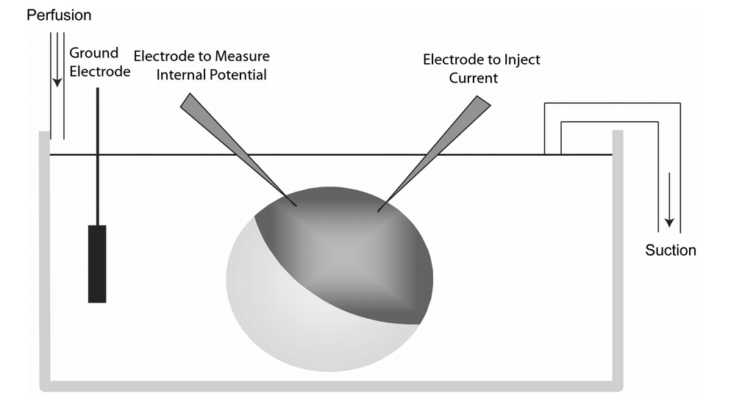
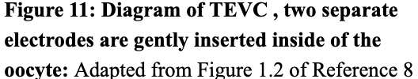
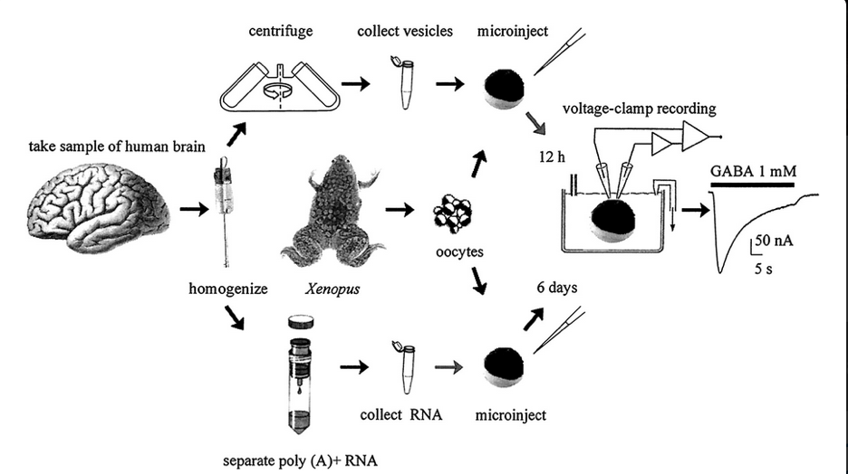
are made of glass and are filled with 3 M KCl solutions and have an electric resistance between .2 and 3 M (Reference 4). Ca²⁺ buffers are used to inhibit endogenous calcium currents ( Reference 4). The electrodes are then mounted on electrode-holders that contain a silver wire with a layer of AgCl₂ that allows the transmission of the signal from the KCl solution into the oocyte. To be able to visualize the oocytes, a stereomicroscope is equipped with a cold light source and is placed under the vibration isolation table beneath a Faraday cage ( Reference 4). The Faraday cage is used to reduce electronic noise. Oocyte impalement is done in clamp (controlled) mode and successful impalement is determined by reading the resting membrane on the amplifier display. A healthy non-injected oocyte should have a resting membrane potential of -40 mV ( Reference 4). Once both electrodes have been inserted, the amplifier is set in voltage clamp mode and the voltage-clamp feedback gain, which is used to compensate for membrane capacity, is increased to speed up the time response of the voltage clamp. Currents are then filtered and recorded using a digital converter and a computer. The activation curves for the HCN4 currents should be recorded under whole-cell conditions that are obtained by standard activation and deactivation protocols and analyzed with the Boltzmann equation, y =1/{1 +exp (V-V_{1/2} /s ) (Reference 11). Where y is the fractional activation, V is the voltage in millivolts, V_{1/2} is the half-activation voltage in millivolts, and s is the inverse slope factor in millivolts (Reference 11). Mean activation curves are obtained by fitting individual curves from each cell to the Boltzmann equation and averaging half-activation voltages and inverse slope factors (Reference 11). Figure 11 shows a diagram of TEVC in action with both electrodes present inserted within the oocyte. Figure 12 shows the entire experimental process from start to finish.

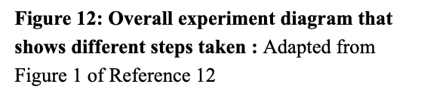

III Discussion:
The results of the experiment may show whether or not the point mutation would have a detrimental impact on the HCN4 channel, or it may show that there was no impact at all on the mutation. The experiment may show that a mutation from a cystine to an arginine makes the channels behave differently when compared to the wild-type channel. If the experimental results show that the mutant HCN4 does not responded correctly it may show that any mutations within the P-form region that contains the CIGYG region will lead to a heart arrhythmia. A limitation of this experiment is that it since there have been no experiments looking into the effects of a negative charge to a positive charged amino acid mutation within the HCN4 it is difficult to say how the channel will respond. Furthermore, it is not known whether the channel may even be able to function with a point mutation that causes a cystine to convert to an arginine.

References:

1) Armstrong, Craig T., et al. “Arginine Side Chain Interactions and the Role of Arginine as a Gating Charge Carrier in Voltage Sensitive Ion Channels.” Scientific Reports, vol. 6, no. 1, 2016, doi:10.1038/srep21759.
2) Baum, Michael. (2016). Transmembrane carriers of cardenolide-adapted leaf beetles (Coleoptera, CHRYSOMELIDAE). 10.13140/RG.2.2.27654.37444.
3) Bendahhou, Saïd, et al. “Role of Hydrophobic Residues in the Voltage Sensors of the Voltage-Gated Sodium Channel.” Biochimica Et Biophysica Acta (BBA) - Biomembranes, vol. 1768, no. 6, 2007, pp. 1440–1447., doi:10.1016/j.bbamem.2007.03.002.
4) Bianchi, Laura. “Heterologous Expression of C. Elegans Ion Channels in Xenopus Oocytes.” WormBook, 2006, doi:10.1895/wormbook.1.117.1.
5) Castorena‐Torres, Fabiola, et al. “Site‐Directed Mutagenesis by Polymerase Chain Reaction.” IntechOpen, IntechOpen, 14 Dec. 2016, www.intechopen.com/books/polymerase-chain-reaction-for-biomedical-applications/site-directed-mutagenesis-by-polymerase-chain-reaction.
6) Difrancesco, Dario, and Jeffrey S Borer. “The Funny Current.” Drugs, vol. 67, no. Supplement 2, 2007, pp. 15–24., doi:10.2165/00003495-200767002-00003.
7) Flynn, Galen E., and William N. Zagotta. “Insights into the Molecular Mechanism for Hyperpolarization-Dependent Activation of HCN Channels.” Proceedings of the National Academy of Sciences, vol. 115, no. 34, 2018, doi:10.1073/pnas.1805596115.
8) Goldin, Alan L. “Expression of Ion Channels in Xenopus Oocytes.” Expression and Analysis of Recombinant Ion Channels, 2006, pp. 1–25., doi:10.1002/3527608095.ch1.
9) Hayoz, Sebastien, et al. “Investigating Cyclic Nucleotide and Cyclic Dinucleotide Binding to HCN Channels by Surface Plasmon Resonance.” Plos One, vol. 12, no. 9, 2017, doi:10.1371/journal.pone.0185359.
10) Milano, Annalisa, et al. “HCN4 Mutations in Multiple Families With Bradycardia and Left Ventricular Noncompaction Cardiomyopathy.” Journal of the American College of Cardiology, vol. 64, no. 8, 2014, pp. 745–756., doi:10.1016/j.jacc.2014.05.045.
11) Milanesi, Raffaella, et al. “Familial Sinus Bradycardia Associated with a Mutation in the Cardiac Pacemaker Channel.” New England Journal of Medicine, vol. 354, no. 23, 12 Jan. 2006, pp. 2520–2520., doi:10.1056/nejmx060027.
12) Miledi, R., et al. “Expression of Functional Neurotransmitter Receptors in Xenopus Oocytes after Injection of Human Brain Membranes.” Proceedings of the National Academy of Sciences, vol. 99, no. 20, 2002, pp. 13238–13242., doi:10.1073/pnas.192445299.
13) Miller, A.j, and J.j Zhou. “Xenopus Oocytes as an Expression System for Plant Transporters.” Biochimica Et Biophysica Acta (BBA) - Biomembranes, vol. 1465, no. 1-2, 2000, pp. 343–358., doi:10.1016/s0005-2736(00)00148-6.

