Measurement of TGIF1 expression levels due to TGF-β overexpression
I. Introduction:

Pancreatic ductal adenocarcinoma (PDAC), the most common type of pancreatic cancer, is the fourth leading cause of cancer related death. PDAC is identified by the formation of ducts in the cell lining of the pancreas. By the time patients are diagnosed, it has already metastasized to other parts of the body. It’s estimated that the 5-year survival rate for PDAC is only 9%.

Kras is an oncogene that under certain circumstances has the ability to cause cancer. Hingorani et al (2003)² sought to understand if Kras played a role in PDAC. Previous research has shown that mutations in amino acid glycine 12 to aspartic acid in the Kras oncogene is common among pancreatic carcinomas, a type of cancer that starts in the lining of organs. In this study they identified that mice with Kras specific expression in the pancreas developed pancreatic intraepithelial neoplasia (panINs), a common characteristic of PDAC (Fig 1).
Fig 1. PDAC development
panINs are indicated by the yellow arrow.
Figure obtained from reference 1

In another study, Parash et al (2019)² sought to understand the role of MAPK mediated TGIF1 Phosphorylation in Kras driven PDAC (Fig 2). This experiment used immunohistochemistry to see the specific localization of a protein within a tissue sample. They found that when TGIF1 (a transcription factor that regulates the activity of certain genes) is deleted and Kras is expressed there is an increase in the formation of PDAC, which is identified by the formation of PanINs (Fig 1). This indicated that TGIF1 was a tumor suppressor when it is was not expressed, PDAC formation accelerated. When Kras was activated, TGIF1 was phosphorylated by MAPK, repressing its tumor suppressor function.
Fig 2. Activation of PDAC
Figure obtained from reference 1
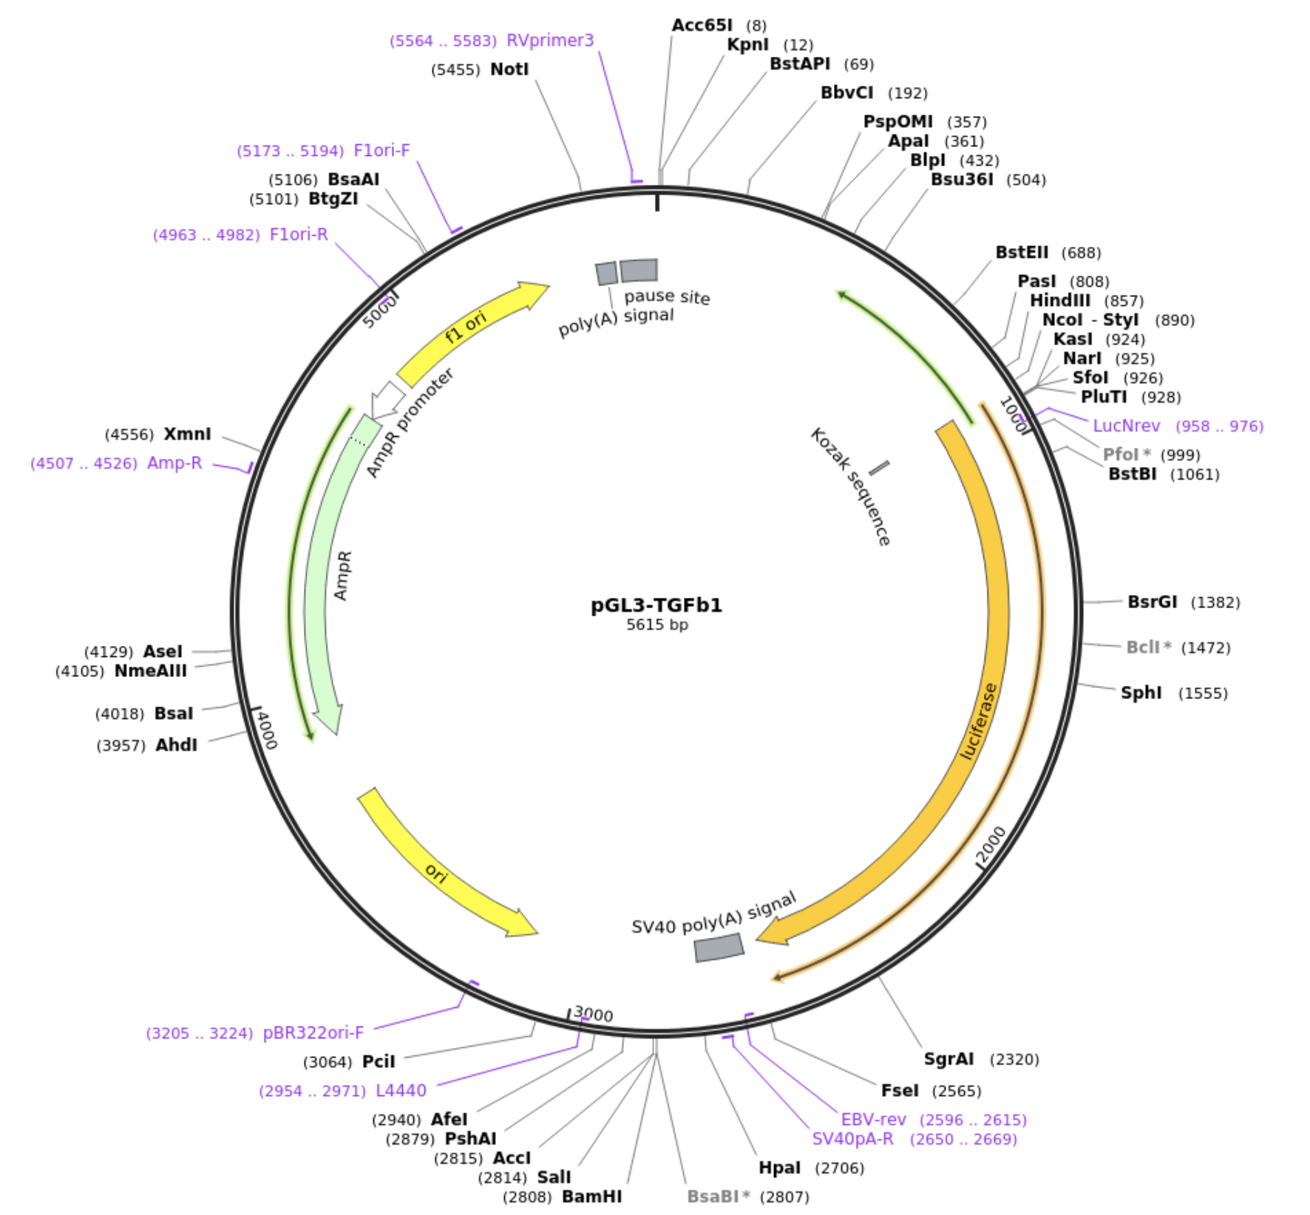
In another experiment they explored how TGF-β played a role in PDAC, TGF-β is a transcription factor that is involved in cell regulation. Their finding showed that TGF-β levels of expression were high during the final stages of PDAC, this indicated that it also interacts with TGIF1.

II. Experiment: The aim of this experiment is to measure the expression levels of TGIF1 in pancreatic cells of mice when there is an overexpression of TGF-β. This experiment will help determine if the overexpression of TGF-β represses TGIF1 as a tumor suppressor in PDAC. I would expect the expression levels of TGIF1 to decrease indicating that it has loss it’s ability as a tumor suppressor.

II.A TGF-β plasmid
In order to get clones of TGF-β, a plasmid needs to be constructed. A plasmid is a small circular double stranded piece of DNA, where a target gene can be inserted in order to create recombinant DNA (DNA assembled out of fragments). It then can be introduced to a bacterium, where it divides quickly, this makes it so that large amounts of the gene of interest can be produced.
Fig 3: TGF-β plasmid
Figure obtained from reference 3

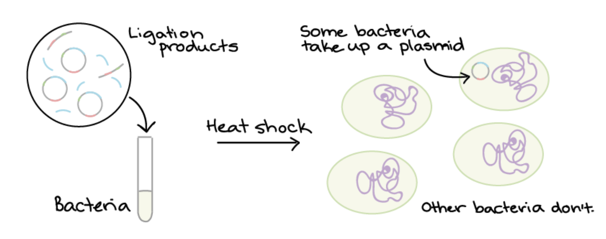
Yeh et al (2018)³ created a TGF-β plasmid (Fig 3), this plasmid can be ordered from Add gene. In order to get multiple copies of TGF-β, the plasmid first needs to be introduced into E. coli, this will be done through a process called transformation. During this process the TGF-β plasmids are mixed into E. coli. This mixture is then given a heat shock, not all of the E. coli will take up a plasmid (Fig 4). In order to see which E. coli takes up a plasmid, the mixture is put onto an antibiotic plate. All plasmids contain an antibiotic resistance gene, making it so that E. coli without a plasmid will not survive.

Fig 4: Bacterial transformation

II. B Polymerase chain reaction
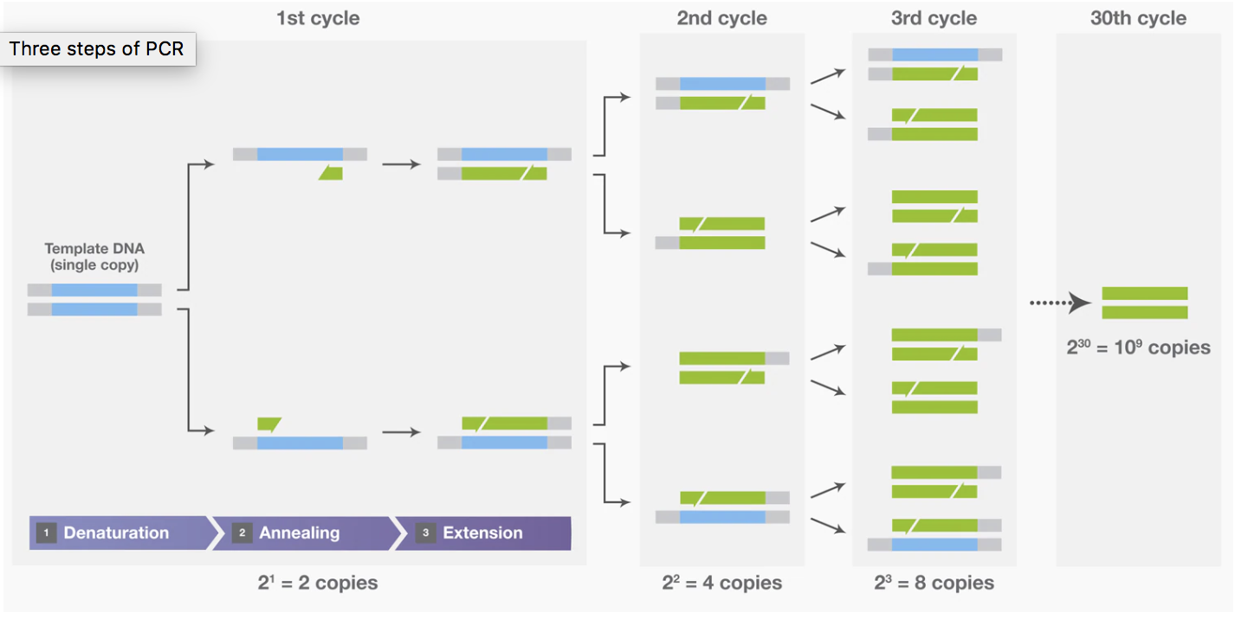
Polymerase chain reaction (PCR) is a process where the DNA sequence of interest is amplified to make millions of copies⁵. Three steps need to be repeated multiple times to get millions of copies of TGF-β (Fig 5).

Step 1 Denaturation: The two strands in DNA are separated by increasing the temperature of the mixture, breaking the hydrogen bonds between the two strands.
Fig.5 Polymerase chain reaction
Figure obtained from Thermo Fisher Scientific

Step 2 Annealing: Primers attach to each strand; this happens when the temperature is lowered.

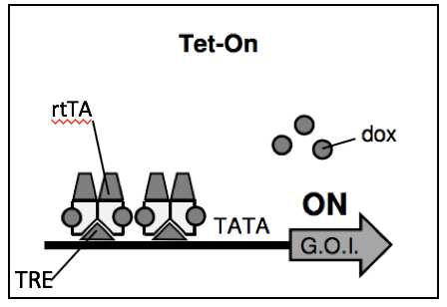
Step 3 Extension: New strands of DNA are made by DNA polymerase.

II.C Tet-On Doxycycline inducible system
The Tet-On doxycycline inducible system was used by Das et al (2016)⁴ to express their gene of interest, HIV-1 in human cells. This system was used as a method to induce gene expression where the transcription gene of interest was turned on in the presence of doxycycline, a tetracycline derivative. In the absence of doxycycline, gene expression was turned off. Das et al created a system where the binding of doxycycline to rtTA (reverse tetracycline transactivator) at the tetracycline response element allowed for the region to interact with the RNA polymerase at the promoter, thereby transcribing the downstream gene, HIV-1 (Figure 6). With this system they were able to turn off and on the expression of HIV-1.
Fig 6: Tet-On system
In the Tet-On system, doxycycline (dox), a tetracycline derivative, binds to the reverse tetracycline transactivator (rtTA) at the tetracycline response element (TRE). reverse tetracycline transactivator (rtTA) is a transcription factor that binds to the promoter region. When doxycycline binds to the rtTA, DNA is binded at the promoter. This allows for the gene of interest (G.O.I) to be expressed, HIV-1. Figure obtained from reference 4.

II.D Expression of TGF-β
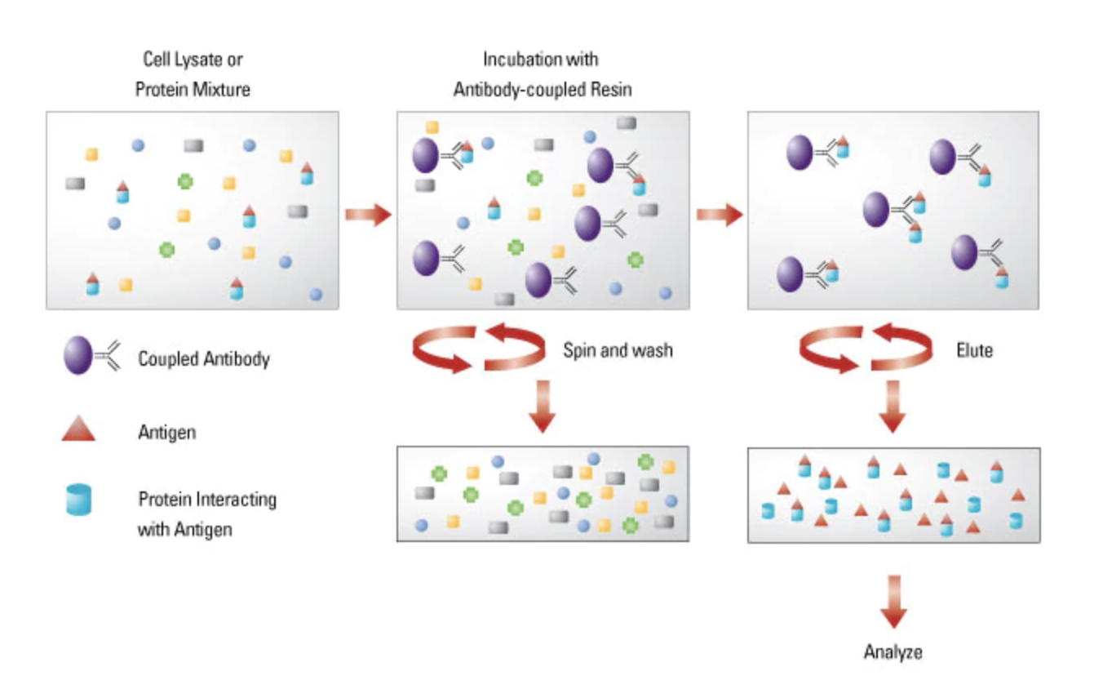
Using the Tet-On doxycycline inducible system, the expression of TGF-β in pancreatic cells can be induced. The DNA plasmids containing TGF-β will be transfected into panc-1 cells (pancreatic cells). In order to see if the overexpression of TGF-β inhibits the expression of TGIF1, there will need to be two experimental groups. The first group will have a TGF-β plasmid and doxycycline (Dox +). The second group will have a TGF-β plasmid and no doxycycline (Dox -). Two control groups will be made, with one containing an empty plasmid and doxycycline (Dox +), the other group will have an empty plasmid without doxycycline (Dox -). The purpose of having two control groups with empty plasmids is to see whether or not the plasmids with TGF-β are working.

II.E Measuring expression levels of TGIF1
Co-immunoprecipitation is a technique that is used to identify the protein-protein interactions between two proteins (Fig 7). To get the TGIF1 and TGF-β complex, anti-TGIF1 antibodies connect to beads that are in a mixture. The anti-TGIF1 antibodies have specific antigen binding sites that bind to a specific portion of TGIF1¹. The solution is then ultra-centrifuged, all of the beads that have the TGIF1 and TGF-β complex full down to the bottom, forming a pellet. This process is done for the experimental and control groups.
Fig.7: Co-immunoprecipitation
Figure obtained from Thermo Fisher Scientific
Western blot is a technique that allows for the detection of a specific protein. Parash et al (2019)¹ employed this technique to analyze the amount of TGIF1 protein expression. Protein samples were separated by molecular weight, this was done by gel electrophoresis⁶. Charged molecules were transported through an electrical field where the negatively charged proteins moved down towards the positive end. Proteins that were larger in size traveled down slowly in the electrical field. Due to how difficult it is to identify proteins while they are in a gel, the proteins were transferred to a membrane that allowed for protein detection. In order to prevent nonspecific antibody binding, blocking solution was applied. A primary anti-TGIF1 antibody then attached to TGIF1, in order to detect the protein of interest a secondary antibody connected to a fluorophore was attached to the primary anti-TGIF1 antibody. Since fluorophore conjugated antibodies were being used, the membrane was scanned by special equipment that detected and documented the fluorophore signal.
Fig. 8: Example western blot results
The imaging system scans for the presence of fluorophores, indicating where the target protein is. Black bands are shown as a result. If the band is dark, it indicates an increase in protein level. A light band indicates low protein level. Figure obtained from reference 1.

III. Discussion:

If this experiment is to be executed, the expression levels of TGIF1 between the two experimental groups should be significantly different when there is overexpression of TGF-β. For the experimental group where there are TGF-β plasmids and doxycycline (Dox+), we would expect to see a dark band for TGF-β, due to overexpression, and a light band for TGIF1 for the western blot. The light band would indicate that in the presence of TGF-β overexpression, the expression of TGIF1 is inhibited, this indicates that TGIF1 has loss it’s ability as a tumor suppressor. The second experimental group with TGF-β plasmids and no doxycycline (Dox-) would expect to have a light band for TGF-β and a dark band for TGIF1. This would indicate that when there is no overexpression of TGF-β, the expression of TGIF1 is not inhibited. Both control groups with empty plasmids that are Dox+ and Dox- are both expected to have the same light band for TGF-β since expression is not being induced, TGIF1 should have a dark band, expression is expected not to be inhibited. The results would indicate that the plasmids did work, because a plasmid without TGF-β inserted should not express TGF-β. If both empty plasmids from both control groups were exhibit TGF-β overexpression, that would mean that the plasmids did not work, results from the experimental groups would be invalid.

One of the pitfalls that might be encountered in this experiment is PCR. The plasmids that are being generated from PCR might not contain TGF-β. This could do be due to the millions of copies that are being generated during this process. In order to make sure that the PCR works and to make sure that the plasmids do contain TGF-β, gel electrophoresis can be done. This technique allows for DNA to be separated by their charge and size. A large band would mean that the PCR is successful, since it would mean that there is TGF-β overexpression.

It’s important to note that in this experiment the western blot targeted specific proteins that were in pancreas cells, among a mixture of other proteins. It’s difficult to interpret whether or not the overexpression of TGF-β is the reason why TGIF1 is inhibited. Overexpression of TGF-β can inhibit other genes that are upstream or downstream from either TGIF1 or TGF-β. Knowing that TGF-β overexpression inhibits TGIF1 as a tumor suppressor in PDAC can help further understand other mechanisms that activate the formation of pancreatic ductal adenocarcinoma.

References

- Parajuli, Parash, Purba Singh, Zhe Wang, Lianna Li, Sailaja Eragamreddi, Seval Ozkan, Olivier Ferrigno, Celine Prunier, Mohammed S Razzaque, Keli Xu, and Azeddine Atfi (2019). "TGIF1 Functions as a Tumor Suppressor in Pancreatic Ductal Adenocarcinoma." EMBO Journal 38.13
- Hingorani, Sunil R, Lifu Wang, Asha S Multani, Chelsea Combs, Therese B Deramaudt, Ralph H Hruban, Anil K Rustgi, Sandy Chang, and David A Tuveson (2005). "Trp53 R172H and Kras G12D Cooperate to Promote Chromosomal Instability and Widely Metastatic Pancreatic Ductal Adenocarcinoma in Mice." Cancer Cell 7.5: 469-83. Web.
- Yeh, Hsi-Wen, Hsu, En-Chi, Lee, Szu-Shuo, Lang, Yaw-Dong, Lin, Yuh-Charn, Chang, Chieh-Yu, Lee, Suz-Yi, Gu, De-Leung, Shih, Jou-Ho, Ho, Chun-Ming, Chen, Chian-Feng, Chen, Chiung-Tong, Tu, Pang-Hsien, Cheng, Ching-Feng, Chen, Ruey-Hwa, Yang, Ruey-Bing, and Jou, Yuh-Shan (2018). "PSPC1 Mediates TGF-β1 Autocrine Signalling and Smad2/3 Target Switching to Promote EMT, Stemness and Metastasis." Nature Cell Biology 20.4: 479-491. Web.
- Das, Atze, Tenenbaum, Liliiane, & Berkhout, Ben (2016). Tet-On Systems For Doxycycline-inducible Gene Expression. Current gene therapy, 16(3), 156–167. doi:10.2174/1566523216666160524144041
- Garibyan, L., & Avashia, N. (2013). Polymerase chain reaction. The Journal of investigative dermatology, 133(3), 1–4. doi:10.1038/jid.2013.1
- Lee, P., Costumbrado, J., Hsu, C., & Kim, Y. (2012). Agarose Gel Electrophoresis for the Separation of DNA Fragments. Journal of Visualized Experiments, (62), Journal of Visualized Experiments, 2012, Issue 62.

