Suha Minai
BNFO 300
The effect of RNA splicing
on opioid tolerance
I. Introduction

Opioids are strong pain relieving drugs used widely in medicine. The branch of medicine known as pharmacology studies the properties of them and other drugs. However, the price for their pain relief is that they’re highly addictive and can lead to problems down the road, especially when the body (specifically the receptors) lose the ability to interact with opioids due to overexposure.

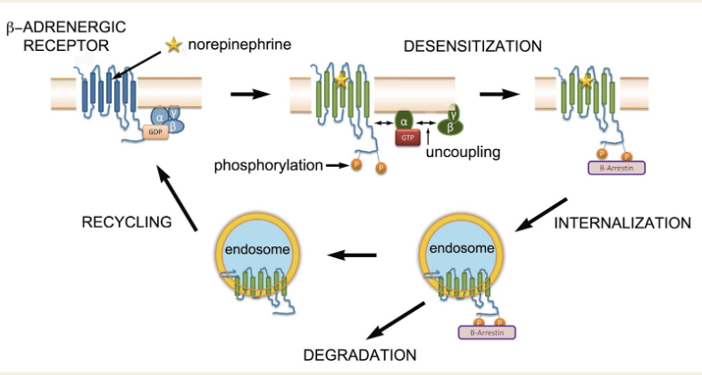
Opioid tolerance is regulated by a type of G-protein coupled receptors (GPCR) called opioid receptors, which are located on the surface of cells. Normally when opioids bind, the receptors send out a signal that prompts the release of dopamine, the incentive to consume opioids. However, as more opioids bind over time, the receptors eventually become desensitized and begin to sink further into the cell, which eventually results in a lack of dopamine, which leads to an increase in opioid intake, which leads to addiction (Allouche) (See Figure 1)

GPCRs, specifically opioid receptors, consist of an alpha, beta, and gamma subunit, and during desensitization, the beta subunit uncouples from the conjoined alpha and gamma subunits. But these receptors also proteins (Johnson), meaning that they are made of RNA (specifically mRNA, which is the main focus). And due to their monitoring of opioid tolerance, it would stand to reason that splicing the mRNA of those opioid receptors in different ways, especially in the OPRM1, could alter the levels of opioid tolerance, thereby allowing tolerance to be manipulated (Xu).
Figure 1: The receptors’ contribution to opioid tolerance. The binding of norepinephrine (an opioid) to the GPCR, results in the uncoupling of the beta subunit from the alpha and beta subunits, resulting in the receptor becoming desensitized, sinking further into the cell (internalization), and either be degraded or recycled.

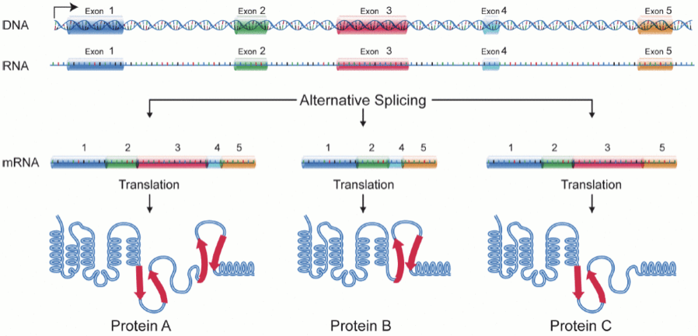
RNA splicing (also called “alternative splicing”) is a process by which the exons of RNA are spliced in different ways, extracting certain exons or none at all, such that there are multiple versions of the same sequence (see Figure 2). This is often done naturally. The results of this process are unpredictable and cannot be definitively tied to any variant, and vice versa (Baralle). However, the sequence can be spliced in such a way that it causes helpful mutations (splicing enhancers) or suppresses harmful mutations (splicing silencers), which can result in an amplified positive effect. (Lee)

On average, humans genes have eight exons and seven introns each, so there’s a possibility for them to be spliced in similar but different ways (Lee). If certain components of the OPRM1 promoter were to be spliced, such that different exons have a chance to work together and produce a unique effect, this could result in different levels of opioid tolerance that could be manipulated through one region. OPRM1 is an ideal target for this experiment because it has an important role in the development of opioid addiction (Ebrahimi), and there’s a precedent for examining alternative mRNA splices of this region in the brains of mice (Xu).
Figure 2: Alternative splicing. Depending on which exons are spliced, the proteins are different and are expressed in different ways.

II. Experiment

The goal of this experiment is to analyze the alternative splices of the OPRM1 promoter region of opioid receptors in the brains of mice to determine which combination of exons optimally reduces opioid tolerance. This will be done by first sequencing the mRNA of these regions in the mouse brain evia qPCR prior to tolerance testing, and analyzing those regions, serving as an example of their splices pre-opioids. Then tolerance testing (pelleting with morphine or placebo), will be performed. Finally, the mRNA will be sequenced again from the tolerant mice and analyzed to see which splices played a role in how fast the mice achieved tolerance. No actual splicing will be performed, as alternative splicing of OPRM1 naturally produces a few dozen variants that can be analyzed (Xu).

II. A. RNA Splicing and Analysis
The procedure of RNA splicing consists of first sequencing the desired RNA via PCR, and then cloning it into a vector (see Figure 3), also via PCR. This enables direct RNA splicing, allowing direct gene manipulation (Refke).

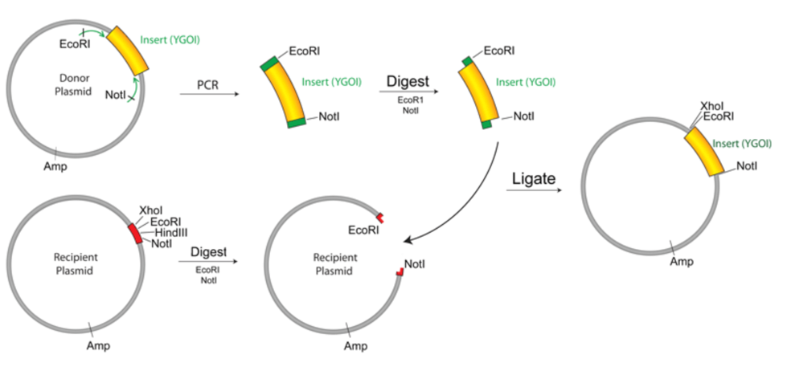
The reason for this process not being conducted in this experiment is because this experiment aims to establish a precedent rather than create something that could potentially kill the test subjects. Analyzing the variants of alternative splicing will still show how splicing of OPRM1 affects opioid tolerance, because of the natural occurrence of splicing in the body.
Figure 3: Cloning into a vector. To carry out this procedure, run PCR first, then use restriction digests on the RNA and the receiving plasmid/vector, then isolate the RNA via gel purification, then fuse the RNA to the plasmid via RNA ligation, then properly introduce the RNA into the cell via transformation (AddGene)

The variants will be analyzed via qPCR assays, which amplifies multiple sequences of RNA simultaneously and analyzes them for differences. The reason for qPCR in this instance, rather than PCR, is because amplified RNA is tagged with fluorescence in qPCR, and the amount of fluorescence released during qPCR is directly proportional to the amount of RNA being amplified, which together results in the amplified RNA being easier to see at all stages (Čepin).

Prior to opioid tolerance testing, the splices will simply be analyzed to see how many they are, their composition, and how they might change after tolerance to opioids is reached. After opioid tolerance testing, the splices will be compared to the pre-OT splices (approximately similar to Fig 4) to see how they have changed as well as why, as well as to determine which splice most effectively reduced opioid tolerance.
Figure 4: Expression of 10 different RNA splices. Pre-opioid tolerance, Xu et al analyzed the expression of 10 selected RNA splices in the brain OPRM1 for four different groups of inbred mouse strains (red: B6 mice, green: 129 mice, blue: SJL mice, brown: SWR mice

II. B. Opioid Tolerance Testing In Mice
The mice will be pelleted in a similar manner to the Mischel and Kang articles, but without vancomycin: morphine and saline (MP+SAL) and placebo and saline (PP+SAL). Due to vancomycin’s effects of lessening opioid tolerance, it would be an additional factor to take into account and may alter the splicing results or tolerance time in some way, hence its omission from this experiment.

The mice will be divided into groups based on whether they were pelleted with morphine or placebo. They will be tested for opioid tolerance until tolerance is reached.

III. Discussion

Different RNA splices should result in different levels of opioid tolerance, and ideally, a few splices leads to tolerance being reached more quickly, while a few other splices lead to tolerance being reached either slowly or not at all. This does not necessarily mean that these splice causes these levels of tolerance, rather that the splices are more expressed at their respective levels of tolerance.

There are other ways to conduct a similar experiment, particularly in regards to the opioid receptor binding. Investigating the binding itself is feasible, provided I could use molecular docking (a type of virtual screening, which is a type of drug identification computational protocol) to assess the binding affinity of ligands to receptors in different binding positions (Ellis). It would be efficient, but it does not take into account splice sites, which is the primary concern of my proposal.

While interpreting the splice expressions, it might be hard to choose which ones to highlight as most expressive, depending on how closely they all relate in terms of expression. Splicing can also be disrupted by cis- and trans-acting mutations, leading to disease, which would be a potential source of error.

Opioid tolerance is a complex issue, particularly in the medical field with the opioid epidemic. Part of the reason for this epidemic is that medical professionals are not entirely sure how opioid tolerance works. If we can figure out how it works, and how to manipulate it, we can use this knowledge to help patients suffering from addiction by heightening their tolerance to a degree that the addiction could be caught before withdrawal takes effect.

References:
- Allouche, S; Noble, F; Marie, N (2014). Opioid receptor desensitization: mechanisms and its link to tolerance. Frontiers in Pharmacology, 5:280. <https://doi.org/10.3389/fphar.2014.00280>
- Johnson, KA; Lovinger, DM (2016). Presynaptic G Protein-Coupled Receptors: Gatekeepers of Addiction? Frontiers in Pharmacology, 10:264. <https://doi.org/10.3389/fncel.2016.00264>
- Xu, J; Lu, Z; Xu, M; Rossi, GC; Kest, B; Waxman, AR; et al (2014). Differential Expressions of the Alternatively Spliced Variant mRNAs of the µ Opioid Receptor Gene, OPRM1, in Brain Regions of Four Inbred Mouse Strains. PLoS ONE, 9(10): e111267. <https://doi.org/10.1371/journal.pone.0111267>
- Baralle, D; Buratti, E (2017). RNA splicing in human disease and in the clinic. Clin Sci, 131 (5):355-368. <https://doi.org/10.1042/CS20160211>
- Lee, Y; Rio, DC (2015). Mechanisms and Regulation of Alternative Pre-mRNA Splicing. Annual Review of Biochemistry, 84:291-323. <https://doi-org.proxy.library.vcu.edu/10.1146/annurev-biochem-060614-034316>
- Ebrahimi, G; Asadikaram, G; Akbari, H; Nematollahi, MH; Abolhassani, M; Shahabinejad, G (2017). Elevated levels of DNA methylation at the OPRM1 promoter region in men with opioid use disorder. The American Journal of Drug and Alcohol Abuse: Encompassing All Addictive Disorders, 44(2). <https://doi.org/10.1080/00952990.2016.1275659>
- Refke, M; Pasternack, SM; Fiebig, B; Wenzel, S; Ishorst, N; Ludwig, et al (2011). Functional analysis of splice site mutations in the humanhairless (HR) gene using a minigene assay. British Journal of Dematology, 165(5):1127-32. <https://doi-org.proxy.library.vcu.edu/10.1111/j.1365-2133.2011.10495.x>
- Čepin, U. (2017). Real-Time PCR (qPCR) Technology Basics. Biosistemika. <https://biosistemika.com/blog/qpcr-technology-basics/>
- Mischel, RA.; Dewey, WL.; Akbarali, HI. (2018) Tolerance to Morphine-Induced Inhibition of TTX-R Sodium Channels in Dorsal Root Ganglia Neurons Is Modulated by Gut-Derived Mediators. iScience, 2:193-209. <https://doi.org/10.1016/j.isci.2018.03.003>
- Kang, M; Mischel, RA; Bhave, S; Komla, E; Cho, A; Huang, C; et al (2017). The effect of gut microbiome on tolerance to morphine mediated antinociception in mice. Scientific Reports, 7: 42658. <https://doi.org/10.1038/srep42658>
- Ellis, CR; Kruhlak, NL; Kim, MT; Hawkins, EG; Stavitskaya, L. (2018). Predicting opioid receptor binding affinity of pharmacologically unclassified designer substances using molecular docking. PLoS ONE, 13(5): e0197734. <https://doi.org/10.1371/journal.pone.0197734>

