A Possible Treatment Method of Malignant Breast Cancer Using
Modified Adeno-Associated Virus 2 and the Nur77 Gene.
I. Introduction
Cancer is a condition that can be found all over the world and is the second leading cause of death among humankind. Within the range of locations non-benign tumors can develop, breast tissue is the most common second only to the skin. In the United States alone, there are 334,200 people diagnosed with, and 42,260 killed by, breast cancer in any given year. Treatment options for the conditions have come very far, but there are still 17% of individuals who succumb to it within ten years of diagnosis.¹ All cancerous cells can be simplified to two main attributes, excessive cellular division and inadequate rates of apoptosis, or programmed cell death.²
The Nur77 nuclear receptor is often a major factor in both of these defining characteristics of a cancerous growth. This is due to its dual function in the cell.³ In a normal cell, Nur77 binds to specific pre-gene nucleotide sequences and mediates the expression of the gene.^{4,5} It is able to bind to different nucleotide sequences by forming heterodimers with other nuclear receptors, or a homodimer with itself.⁵ Overexpression of this protein leads to overexpression of cellular replication genes, making the cell replicate at a much higher rate than normal.^{6,10} Nur77 is also a potent inducer of apoptosis, but only when it has been moved from the inside of the nuclear envelope to the outer mitochondrial membrane.⁷ This can only happen under very specific conditions, which are often not found in cancerous cells.^{8,9} In this sense, Nur77 contributes to both the excessive division and the lack of apoptosis in a non-benign tumor. Therefore, though artificial production of Nur77 within the mitochondria, apoptosis can be induced within malignant cells.
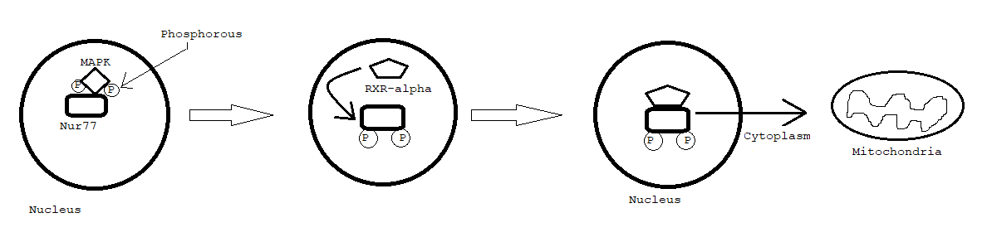
The conditions in which Nur77 is able to leave the nuclear membrane relies on the function of multiple other proteins. The first step to enable egress from the nuclear envelope is its phosphorylation status. Without being phosphorylated, the receptor is unable to initiate transfer from the nucleus to the cytoplasm at all because it cannot dimerize with RXR-alpha. The process is mediated by mitogen-activated protein kinase and protein kinase B pathways, which are often rendered ineffective or insufficient in a cancerous cell.^{11,12} Once the Nur77 receptor has been phosphorylated, it has to bind with retinoid X receptor alpha (RXR-alpha) to be able to leave. This is because RXR-alpha is the primary transport partner or Nur77 and is critical to the movement of the heterodimer from the nucleus to the mitochondria.^{8,9} Thus Nur77 can only induce apoptosis once phosphorylation and RXR-alpha protein binding are attained.
Figure 1: A diagram depicting the steps taken to allow for nuclear export of Nur77 (Adapted from figure 8 of ref. 11)
Once Nur77 has reached the mitochondria, it is extremely effective at causing controlled cell death. After penetrating the outer membrane, it binds onto the B-cell lymphoma-2 protein (Bcl-2). Upon doing so, it initiates irreversible conformational change of the Bcl-2 structure.¹³ After alteration, Bcl-2 binds to the outer membrane and increases its permeability, releasing the cytochrome C protein from the intermembrane space into the cytoplasm. After its release, it activates the caspase family of proteases, which is believed to be the first step in apoptosis induction. ^{13,14}
By extracting the DNA sequence of Nur77 and modifying it slightly, the sequence could be made compatible with the mitochondrial genetic code. This is necessary because mitochondrial ribosomes interpret three codons differently than a ribosome that might be found in the rough endoplasmic reticulum.^{15,16} Previous studies have been conducted using adeno-associated viruses (AAV) to target and modify mitochondrial genomes. Through use of commercially available mutagenesis kits the Nur77 gene sequence can be properly modified and incorporated into the virion of an AAV.¹⁶This experiment would test if AAV could be used effectively to cause isolated expression of the Nur77 gene directly in the mitochondria and initiate apoptosis in cancerous cells without the need to transport naturally produced Nur77 from the nucleus.

II. Experiment
The experiment would take place in three steps: modification of the viral genome, treatment of cancerous cells in test rats, and post-treatment procedure to prevent or limit the spread of the virus to healthy cells. Through careful trials with variable levels of dosage and infection periods, the optimal methodology of treatment using this method could be determined. This process will be conducted using adeno-associate virus 2 (AAV2).
Part 1: Virion modification
The first step of the experimental process is to isolate and replicate the DNA sequence encoding Nur77.¹⁶ This would be done using rat adrenal pheochromocytoma cells, similar to Watson and Milbrant. ¹⁷ From this point, the use of a mutagenesis kit is required. The kit allows for targeted point mutations at specific points, which would be used to make the nuclear DNA of Nur77 compatible with mitochondrial translation after it is transcribed. There are only three codons that need to be changed to make this possible: ATA must become ATC or ATT, TGA must become TGG, and AG(A/G) must become CG(A/G).¹⁵ such changes allow the amino acids directed by the nuclear code to be expressed in the mitochondria as well. After the sequence has been changed properly, A FLAG sequence will be ligated onto the N-terminus with an appended AGA to serve as a mitochondrial stop codon. The process of ligation uses enzymes provided by the mutagenesis kit and is used regularly throughout the plasmid creation process. Resulting sequence can be characterized as Nur77FLAG, and needs a viral DNA backbone to bind to. This backbone is called pTR-UF11, and becomes attainable after digesting in a solution containing restriction enzymes Xba1 and BamH1 to remove the GFP and NeoR genes. Nur77FLAG was also digested in the same solution to allow for directional cloning onto the AAV backbone, then ligated to form pTR-UF11-Nur77FLAG. pTR-UF11 is flanked by inverted terminal repeat sequences (ITRs) to allow for incorporation into the viral genetic code. This sequence was isolated and digested in restriction enzymes Kpn1 and Xba1 to remove the CMV enhancer and chicken beta-actin promoter to undermine the infectivity of the plasmid on its own, as well as its replication ability outside of the control of the experiment. The final ligation onto the plasmid before viral incorporation is the addition of the heavy strand promoter (HSP) that acts as a mitochondrial promoter. It was directionally ligated into the plasmid, yielding pTR-UF11-HSP-Nur77FLAG.¹⁶
Once the plasmid has been created and prepared to integrate into the virus, the viral DNA needs to be changed to target the mitochondria instead of the nucleus. To do this, a mitochondrial targeting sequence (MTS) must be created. This is done by combining the 23- amino acid presequence of the cytochrome oxidase subunit 8 (COX8) with the GFP targeting gene. The viral sequence with the eag1 binding site is digested in eag1, allowing COX8GFP to be ligated in the region containing the overlapping VP1 and VP2 capsid proteins genes.¹⁸ AAV2 has a protein shell created from three gene regions, VP1-3, so disrupting the sequence of two will help to prevent replication of the virus after treatment.¹⁶
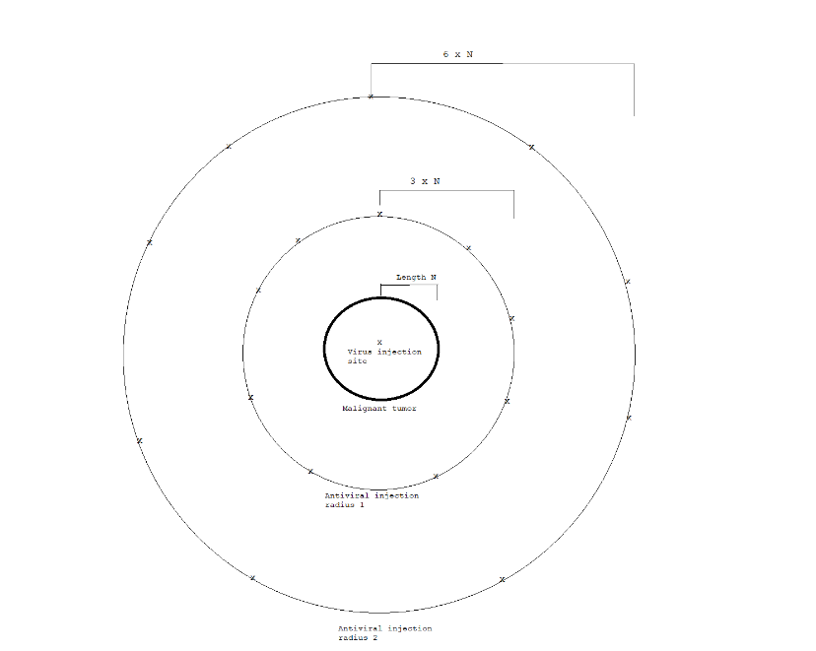
pTR-UF11-HSP-Nur77FLAG is ligated into the virus through plasmid transfection, being inserted closely behind the MTS.¹⁹ The ultimate product of this sequence is sc-HSP-ND4FLAG and a control group of normal virus DNA targeting the mitochondria called scAAV2-GFP.
Part 2: Treatment
The treatment process requires multiple trials using different quantities of viral serum and different incubation periods. In a given trial, the dosage of the virus given with remain constant. The injection will be made and immediately followed by injections of antiviral medications in the surrounding tissues to prevent the uncontrolled spread of the cell death-inducing virus. Two sample groups will be taken, one with the control treatment and one with the experimental treatment. In each sample group, the subjects (rats) will be divided into groups that wait steadily increasing amount of time before the post treatment procedure is initiated. The results will be recorded, and the next trial will begin by doing the same process but with uniformly higher doses for all subjects.
Figure 2: Injection method intended to minimalize unintended cell death and maximize treatment effectiveness. Each X in the antiviral injection radii indicates an injection point.
Part 3: Post-treatment procedure
The purpose of the post-treatment procedure is to further reduce the risk of unnecessary cell loss as a result of the virus. Upon completion of their trial, the subject will be given a steady dose of glucocorticoids to antagonize the Nur77 receptor and inhibit its function. This will temporarily slow the rate of apoptosis in the organism while they are given a heavy dose of high-grade antivirals to be sure there is no more of the modified virus in the body. The effectiveness of the treatment will be monitored by observing its effect on cancer growth, which will be done by monitoring tumor growth rate and Ki-67 levels. These are common ways that cancer researchers monitor the growth of the condition over time.

III. Discussion
If all goes well in this experiment, the viral treatment should be able to cause severe rates of apoptosis in the malignant tumors while causing minimal damage to the healthy tissues of the body. Precisely targeted treatment and aggressive protective measures have potential to cause widespread cancerous cell death in a very similar way to radiation or chemotherapy, but could leave the patient in a much better post-treatment physical state, improving their day-to-day life. Any level of human testing with something like this is almost entirely certain to be years away from the initial trials. However, such a treatment could prove exceptionally effective as well as improve a given patients general quality of life as they struggle with their affliction.
While it is nice to consider the possibilities associated with this experiment going perfectly, such an occurrence is rarely the case in life. There are possible complications that can arise from this process that would need to be considered as they occur, since its impossible to know exactly what will come of the trials.
A major aspect of the experiment that needs to be effective is the post-treatment procedure. Because a fixed, non-replicative amount of virus will be introduced, there is the possibility of dilution of the effect should the treatment be transported throughout the body, rather than contained in the tumor. If the antivirals aren’t effective enough, or if the virus spreads throughout the body faster than expected, non-cancerous cell death rates could spike while the effects on the tumor will be diminished. Such a scenario would obviously be detrimental to the subject, so the isolation of the treatment is just as vital as its removal afterwards.
While this issue would obviously render the concept more than unsatisfactory for the treatment of humans, the line itself seems a bit blurry. That is to say, at what point is there two much unintended cell death? Chemotherapy is a widely used method to treat cancer and wreaks havoc on the patients whole body, not just the cancerous cell lines. Should the success of the experiment be based off of its cancer-cell-death to normal-cell-death ratio in comparison to that of other treatment options? If it were to be effective at causing increased apoptosis in both cell types, is it something that shouldn’t be considered an option, or should it be a more aggressive yet dangerous option? Questions of morality like these are going to accompany any treatment or research with the potential to cause harm. Ultimately it is impossible to reach a conclusion on the matter without more information. To answer those questions, the experiment would need to be conducted and the results analyzed thoroughly.
This experiment, like many others, has many places in which it could go wrong. Undoubtedly, there are bound to be more issues that weren’t even considered in this proposal that might surface when conducting the experiment. However, conducting such a study could provide an effective treatment alternative for breast cancer that could raise survivability rates and lower relative patient discomfort.

IV. Bibliography
- “Breast Cancer - Statistics.” Cancer.Net, 22 Aug. 2019, www.cancer.net/cancer-types/breast-cancer/statistics.
- “Apoptosis.” Merriam-Webster, Merriam-Webster, www.merriam-webster.com/dictionary/apoptosis.
- Niu, Gengming, et al. “Dual Roles of Orphan Nuclear Receptor TR3/Nur77/NGFI-B in Mediating Cell Survival and Apoptosis.” International Review of Cell and Molecular Biology, 2014, pp. 219–258., doi:10.1016/b978-0-12-800177-6.00007-4.
- Wilson, T E, et al. “The Orphan Receptors NGFI-B and Steroidogenic Factor 1 Establish Monomer Binding as a Third Paradigm of Nuclear Receptor-DNA Interaction.” Molecular and Cellular Biology, vol. 13, no. 9, 1993, pp. 5794–5804., doi:10.1128/mcb.13.9.5794.
- Maira, Mario, et al. “Heterodimerization between Members of the Nur Subfamily of Orphan Nuclear Receptors as a Novel Mechanism for Gene Activation.” Molecular and Cellular Biology, vol. 19, no. 11, 1999, pp. 7549–7557., doi:10.1128/mcb.19.11.7549.
- Holmes, William F, et al. “Early Events in the Induction of Apoptosis in Ovarian Carcinoma Cells by CD437: Activation of the p38 MAP Kinase Signal Pathway.” Oncogene, vol. 22, no. 41, 2003, pp. 6377–6386., doi:10.1038/sj.onc.1206694.
- Chang, Li-Fu, et al. “Overexpression of the Orphan Receptor Nur77 and Its Translocation Induced by PCH4 May Inhibit Malignant Glioma Cell Growth and Induce Cell Apoptosis.” Journal of Surgical Oncology, vol. 103, no. 5, 2011, pp. 442–450., doi:10.1002/jso.21809.
- Zhang, Xiao-Kun. “Targeting Nur77 Translocation.” Expert Opinion on Therapeutic Targets, vol. 11, no. 1, 2006, pp. 69–79., doi:10.1517/14728222.11.1.69.
- Cao, X., et al. “Retinoid X Receptor Regulates Nur77/Thyroid Hormone Receptor 3-Dependent Apoptosis by Modulating Its Nuclear Export and Mitochondrial Targeting.” Molecular and Cellular Biology, vol. 24, no. 22, 2004, pp. 9705–9725., doi:10.1128/mcb.24.22.9705-9725.2004.
- Delgado, Evan, et al. “High Expression of Orphan Nuclear Receptor NR4A1 in a Subset of Ovarian Tumors with Worse Outcome.” Gynecologic Oncology, vol. 141, no. 2, 2016, pp. 348–356., doi:10.1016/j.ygyno.2016.02.030.
- Han, Y-H, et al. “Regulation of Nur77 Nuclear Export by c-Jun N-Terminal Kinase and Akt.” Oncogene, vol. 25, no. 21, 2006, pp. 2974–2986., doi:10.1038/sj.onc.1209358.
- Chen, H.-Z., et al. “Akt Phosphorylates the TR3 Orphan Receptor and Blocks Its Targeting to the Mitochondria.” Carcinogenesis, vol. 29, no. 11, 2008, pp. 2078–2088., doi:10.1093/carcin/bgn197.
- Lin, Bingzhen, et al. “Conversion of Bcl-2 from Protector to Killer by Interaction with Nuclear Orphan Receptor Nur77/TR3.” Cell, vol. 116, no. 4, 2004, pp. 527–540., doi:10.1016/s0092-8674(04)00162-x.
- Winoto, Astar. “Faculty of 1000 Evaluation for A Short Nur77-Derived Peptide Converts Bcl-2 from a Protector to a Killer.” F1000 - Post-Publication Peer Review of the Biomedical Literature, 2008, doi:10.3410/f.1123269.585912.
- Wei, Lei, et al. “Analysis of Codon Usage Bias of Mitochondrial Genome in Bombyx Moriand Its Relation to Evolution.” BMC Evolutionary Biology, vol. 14, no. 1, 2014, doi:10.1186/s12862-014-0262-4.
- Yu, H., et al. “Gene Delivery to Mitochondria by Targeting Modified Adenoassociated Virus Suppresses Leber's Hereditary Optic Neuropathy in a Mouse Model.” Proceedings of the National Academy of Sciences, vol. 109, no. 20, 2012, doi:10.1073/pnas.1119577109.
- Watson, M A, and J Milbrandt. “The NGFI-B Gene, a Transcriptionally Inducible Member of the Steroid Receptor Gene Superfamily: Genomic Structure and Expression in Rat Brain after Seizure Induction.” Molecular and Cellular Biology, vol. 9, no. 10, 1989, pp. 4213–4219., doi:10.1128/mcb.9.10.4213.
- Manfredi, Giovanni, et al. “Rescue of a Deficiency in ATP Synthesis by Transfer of MTATP6, a Mitochondrial DNA-Encoded Gene, to the Nucleus.” Nature Genetics, vol. 30, no. 4, 2002, pp. 394–399., doi:10.1038/ng851.
- “301. An Efficient Production Method for Dual Recombinant AAV Vectors.” Molecular Therapy, vol. 22, 2014, doi:10.1016/s1525-0016(16)35314-x.

