Role of a putative transcription factor Zbtb14 on
production of treacle protein in mice

Introduction
Treacher Collins Syndrome (TCS) is an autosomal disorder that mainly affects craniofacial development [1]. This syndrome is rare and occurs in approximately 1 out of 50,000 births [2]. TCS is characterized by deformities with various severities of the ears, eyes, cheekbones, midface, and jaw and leads to complications with breathing, sight, hearing, and speech [3] (Fig 1). Although TCS is not currently curable, symptoms can be managed with reconstructive surgery, therapy, and assistive devices [3].
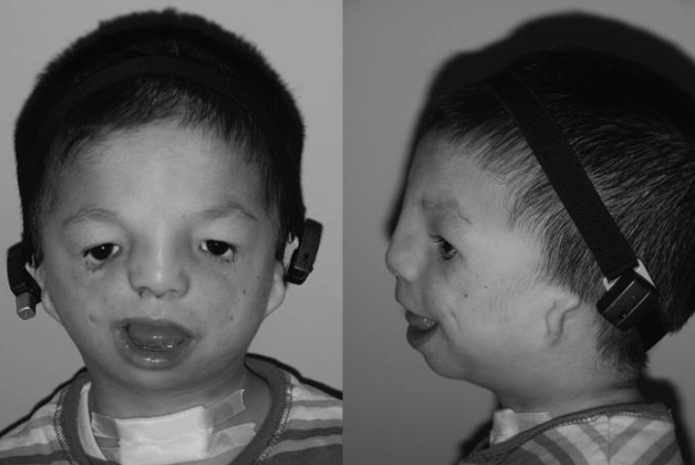
Figure 1: Characteristics of Treacher Collins Syndrome include deformation of the ears, eyes, cheekbones, midface, and jaw. Figure from Chang and Steinbacher (2012).
This syndrome is named after Treacher Collins but many others have had TCS in the past and have it now in the present. This syndrome is caused by mutations found in three known genes, TCOF1, POLR1C, and POLR1D, but mainly in TCOF1 [4]. The human TCOF1 gene is located on chromosome 5q32 and encodes the protein treacle [5]. These mutations lead to premature stop codons on that TCOF1 allele. There was a possibility that the mutated treacle protein interfered with the biological functioning of the full-length treacle. However, this truncated treacle was shown not to interfere at all with the full-length protein expressed from the normal Tcof1 allele [6]. Deletion of one Tcof1 allele in mouse resulted in embryos with severe defects in craniodevelopment leading to death [7]. Low levels of treacle lead to abnormal development and increased apotosis of cephalic neural crest cells [8]. Thus, the lack of sufficient full-length treacle leads to TCS, not the presence of mutated treacle, leads to TCS. These evidence supported the haploinsufficency theory for TCOF1 where one chromosome does not produce the full-length protein which can lead to defects in growth and development like in TCS.
Treacle is heavily involved in embryonic craniofacial development and influence the bones and tissues of the face. Because of the localization of treacle to the nucleolus, a small region inside of the nucleus where rRNA is produced, there was a theory that treacle may be involved in rRna production. Because rRNA is essential for translation, this would mean that treacle may directly or indirectly affect ribosome formation during craniofacial development. Hayano et al (2003) showed that there are interactions between treacle and pNop56, a component of a ribonucleoprotein complex that methylates pre-rRNA [9]. A later study showed that treacle is involved in mammalian ribosomal DNA (rDNA) gene transcription [10]. Unfortunately, other functions of the gene product of TCOF1 is largely unknown.
A study by Shows and Shiang (2008) found many putative transcription binding factors on the Tcof1 promoter with mutagenesis [11]. In plasmids, they ligated the Tcof1 promoter upstream the luciferase gene so the expression of luciferase would depend on the Tcof1 promoter. Inactivation of one of the putative transcription factors sites, Zbtb14 (formerly called Zfp161), led to a large increase of the expression of luciferase compared to the control expression in p19 embryonic carcinoma mouse cells (Fig. 2). However, even though the mouse genome is commonly known to be similar to human genome, there was not as large an increase of luciferase expression with inactivation of the putative Zbtb14 transcription factor binding site in HEK293 human kidney cells. This suggests that although mouse genomes are very similar to human genomes, Zbtb14 may not be as strong a repressor for Tcof1 or may be Zbtb14 may not directly or indirectly influence Tcof1 expression.
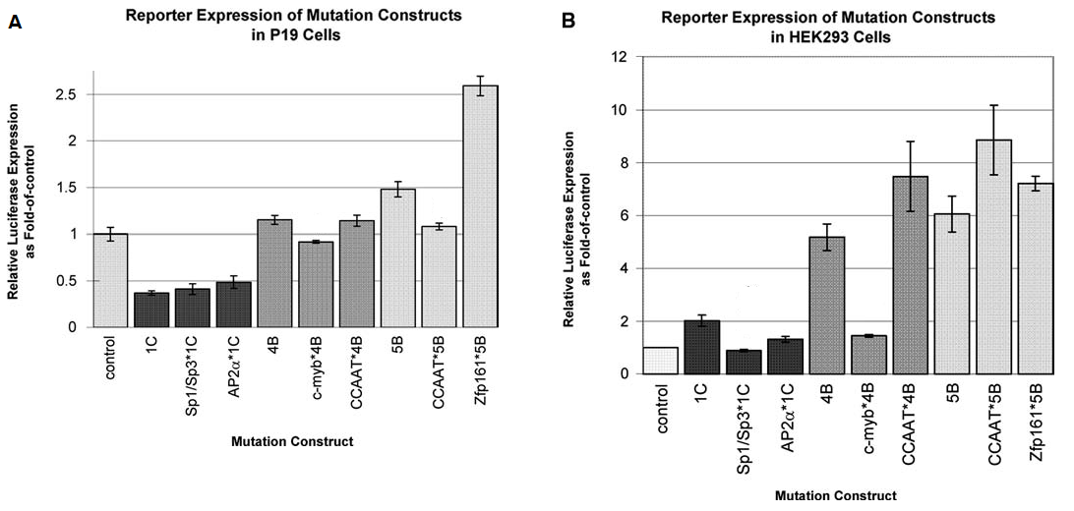
Figure 2: The inactivation of putative transcription binding factor sites on the relative expression of luciferase in mouse P19 embryonic carcinoma cells and in HEK293 human kidney cells.
Even though many genetic alterations causing TCS have been discovered, the mechanism underlying its pathogenesis and the function of treacle remain largely unknown. It is important to understand that studying normal cellular mechanisms and pathways will lead to discoveries in the abnormal cellular mechanisms and pathways. Only by knowing what is normal can one figure out what is abnormal. Since Zbtb14 is already discovered to be a putative transcription binding factor, exploring the results of decreasing Zbtb14 can lead to further discoveries about the regulation of Tcof1 in mouse and thus TCOF1 in humans. The central question is: if the expression of Zbtb14 decreases, will the level of Tcof1 expression increase?
Experiment
The knockout of a gene, in this case Zbtb14, can contribute to the gene functional analysis. Knowing that the transcription factor Zbtb14 is a putative transcription binding factor for the Tcof1 promoter [11], this experiment will aim to determine if Zbtb14 does indeed repress the expression of Tcof1. By using conditional knockout techniques in order to vary the production of Zbtb14 in the Wnt1 pathway, the expression of Tcof1 can be observed by whole mount in situ hybridization. If the regulation of Tcof1 is dependent on Zbtb14 then comparing the Tcof1 expression from the conditional knockout mice and the control mice should show in increase in Tcof1 expression in the conditional knockout mice.
Gene knockout is a permanent way to inactivate a gene. This technique has given valuable information on the biologic function of a gene of interest [12, 13]. However, total knockout of a gene can have deadly effects on the mouse [14]. Gene knockouts can be developmentally lethal so that the resulting embryos cannot grow into adult mice. The severity of the resulting phenotype can lead to death of the mouse before the effects of the knockout are observable on a target tissue. A solution to this is to utilize conditional knockout, so the gene will only be knocked out in specific tissues, not in the entire organism [14]. Thus, the effects of the knockout will be visible in the target tissues. The traditional technique for conditional gene knockout is to use the Cre-lox system, but this method is time consuming and its efficiency is low [13]. A more efficient method is to use CRISPR conditional knockout which uses the Cas9 to insert loxP sites before using Cre recombination [13].
In order to knockout a gene, two loxP sites will need to be inserted in noncoding sequences around the first exon of the gene. CRISPR uses the Cas9 enzyme in order to break both strands of DNA at a specific target sequence, PAM site. After the loxP sites are inserted, Cre will induce recombination to remove the exom entirely from the genome which will inactivate the gene using a specific pathway. In this study, a Wnt1/Cre mouse will be used where Cre gene is downstream the Wnt1 promoter. Wnt1 is associated with midbran development as well as craniofacial development in an embryo [15]. Cre will form a dimer and induce recombination at the loxP sites. With the recombination, the targeted exon is removed from the genome and is later degraded by the cell.
Bi et al. (2018) uses conditional knockout with CRISPR [16]. The authors were trying o determine if conditional gene knockout for myomixer directly or indirectly alters the fusion of satellite cells in muscle cells of mice. They used CRISPR Cas9 as well as homology directed repair in order to insert loxP sites around Myomixer exons. These mice were crossed with Pax7/Cre mice so that Cre recombinase was controlled by the Pax7 promoter which usually involved in muscle formation and development. They visualized the effects of the knockout with immunohistochemistry which visualized the expression of laminin, myosin, and desmin in areas of tibialis anterior muscles (Fig. 3). They then compared the immunohistochemistry tissue stainings and the result of knockout out these exons was the decreased expression of genes involved in muscle differentiation and regeneration.
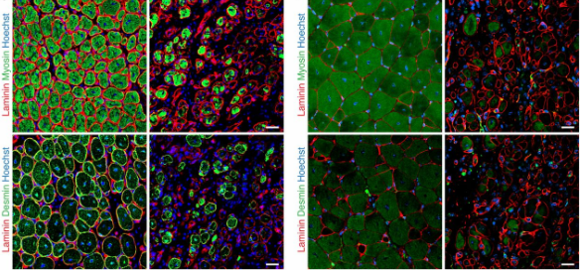
Figure 3: Immunohistochemistry of the proteins laminin, myosin, and desmin on tibialis anterior muscle cross-sections 7 days (left) and 14 days (right) after an injury.

Tan et al. (2002) used whole mount in situ hybridization in order to determine where in the mouse embryos YY1 and MSX2 were expressed (Fig. 4) [17]. Using a database, they synthesized digoxygenin labeled riboprobes complementary to their gene of interest with T7 and T3 promoters. Alkaline phosphatase along with the substrates nitro blue tetrazolium/5-bromo-4-chloro-3-indolyl phosphate caused blue-purple precipitate. In E10 and E12 embryos, YY1 and Msx2 are co-expressed in mostly the same areas, the mouse limb and branchial arches, of the mice. This data suggests that these two genes may be interacting with each other and may be involved in the same morphoregulatory events.
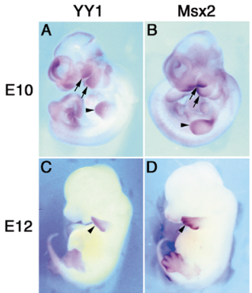
Figure 4: Whole mount in situ hybridization visualization of the genes YY1 and Msx2 during significant morphoregulatory events.

Conditional Knockout
Conditional knockout procedures will be used to vary the expression of Zbtb14 via CRISPR.
There will need to be two breaks, one on each side of the exon to be removed from the genome, and thus two PAM sites are needed. A computer program will need to utilized in order to identify PAM sites around the exon. Information from the program will be used to create specific sgRNA sequences including the PAM sites. The sgRNAs will guide the Cas9 enzyme to the targeted PAM sites in the mouse genome. A vector, a DNA molecule used to artificially carry genetic material into the cell, will be created which will be inserted between the breaks and will include the homology arms with the loxP sites surrounding the exon of interest. After the creation of the gRNAs for each side of the exon and the insertion sequence, Cas9 mRNA, the two gRNAs, and the insertion sequence will be injected into the one-cell stage mice embryo which will then be transplanted into surrogate mothers.
Once inside the embryo, Cas9 mRNA will be translated into protein and will bind to one of the sgRNAs. Once Cas9 finds the genome sequence that is complementary to the gRNA, it will break both strands of the DNA at the PAM site. Due to the different gRNAs, Cas9 will break the DNA on either side of the exon. The insertion sequence, the vector, will be inserted by homology directed repair resulting in loxP sites surrounding the first exon.
However, there is a chance that the insertion may occur in the Zbtb14 gene of both chromosomes, one chromosome, or neither chromosomes. The offspring will be ear punched in order to genotype them using Polymerase Chain Reaction and gel electrophoresis.
PCR processes take place inside a test tube with a buffer solution, polymerase, primers aimed to surround the floxed sequence, the mouse’s genetic material, and deoxynucleotides. There are three main steps to PCR: 1) degradation, 2) annealing, and 3) extension. Degradation involves heating up the DNA molecules to around 95oC, the temperature which unwinds and separates the two strands of DNA. Annealing involves primers. By cooling the test tube to 50oC, the primers are able to hybridize to the complementary DNA sequences. The third step, extension, involves heating up the test tube so polymerase can attach and use the free nucleotides to extend the primer sequences using the mouse DNA strand as a template. By repeating these steps, the sequence between the primers will be amplified as seen with figure 5.
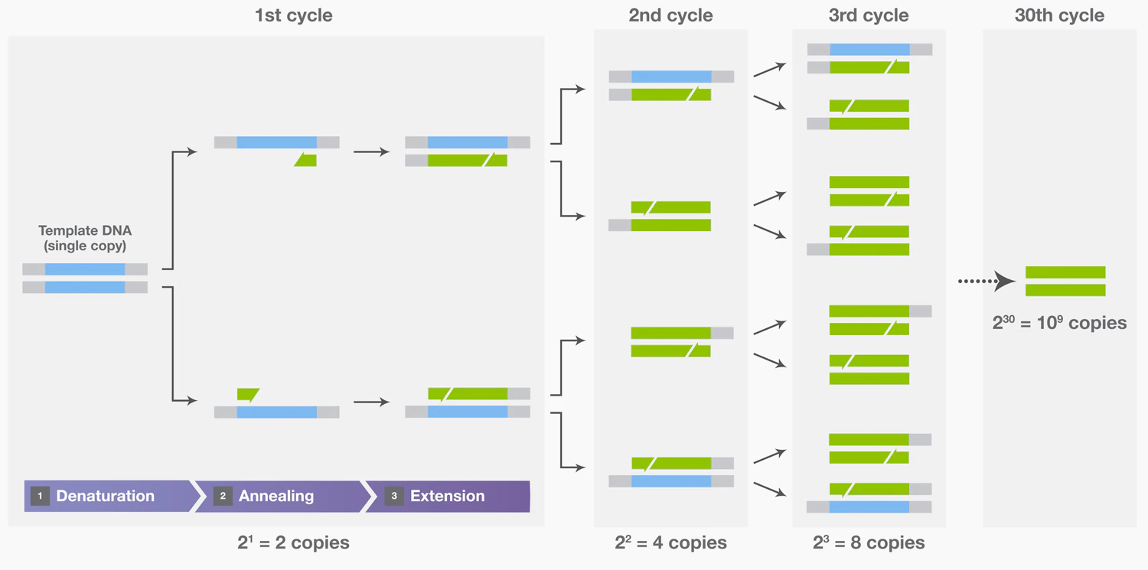
Figure 5: Amplification of the target DNA resulting from the repeating three steps of PCR. Figure obtained from ThermoFisher PCR Basics
Gel electrophoresis will show whether the loxP sites were inserted. The amplified sequences are loaded into the gel electrophoresis wells on the anode side of the gel. Since DNA is negatively charged, when current is run through the gel, the sequences are drawn across the gel towards the positive end, where the cathode is. Thus, the fragments are separated by size as seen by figure 6.
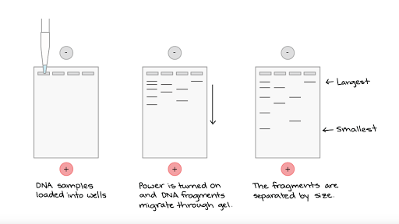
Figure 6: Separation of DNA samples by fragment size in gel electrophoresis
Longer strands, with the losP sites, travel more slowly than the shorter strands, without the loxP sites, do. Homozygous for loxP sites will display the longer fragments on the gel, the heterozygous mice will display both the longer and shorter fragments, and the homozygous for the wild type will display only the shorter fragments on the gel. Thus, mice that are homozygous for loxP sites, heterozygous, and homozygous for without loxP sites can be identified.
After verification for germline transmission, the homozygous floxed mouse with correctly inserted loxP sites and a Wnt1/Cre-expressing mouse will be crossed in order to produce mice with both Cre and the floxed exon (Fig. 7). This mating should produce 50% Zbtb14^{loxP/+, Cre/+} and 50% Zbtb14^{loxP/+, +/+}. Cre will lead to recombination at the loxP sites and these embryos will get rid of the target exon and thus inactivate the gene Zbtb14.
Zbtb14^{loxP/loxP}, +/+ x Zbtb14^{+/+,Cre/+}
 | loxP  + | loxP  + | loxP  + | loxP  +
+  Cre | loxP/+  Cre/+ | loxP/+  Cre/+ | loxP/+  Cre/+ | loxP/+  Cre/+
+  + | loxP/+  +/+ | loxP/+  +/+ | loxP/+  +/+ | loxP/+  +/+
+  Cre | loxP/+  Cre/+ | loxP/+  Cre/+ | loxP/+  Cre/+ | loxP/+  Cre/+
+  + | loxP/+  +/+ | loxP/+  +/+ | loxP/+  +/+ | loxP/+  +/+
50% Zbtb14^{loxP/+, Cre/+}
50% Zbtb14^{loxP/+, +/+}
Figure 7: The cross between Zbtb14^{loxP/loxP, +/+} and Zbtb14^{+/+,Cre/+} to produce 50% Zbtb14^{loxP/+, Cre/+} and 50% Zbtb14^{loxP/+, +/+}.
Crossing Zbtb14^{loxP/+, Cre/+} with the homozygous floxed mouse Zbtb14^{loxP/loxP, +/+} will produce offspring with varying production of Zbtb14 (Figure 8). There should be 50% mice with the wild phenotype, 25% with half Zbtb14 production, and 25% with no Zbtb14 production. PCR and gel electrophoresis should reveal which mice has which phenotype. Longer fragments will belong to mice that

Zbtb14^{loxP/+,Cre/+} x Zbtb14^{loxP/loxP, +/+}
 | loxP  Cre | loxP  + | +  Cre | +  +
loxP  + | loxP/loxP  Cre/+ | loxP/loxP  +/+ | +/loxP  Cre/+ | +/LoxP  +/+
loxP  + | loxP/loxP  Cre/+ | loxP/loxP  +/+ | +/loxP  Cre/+ | +/LoxP  +/+
loxP  + | loxP/loxP  Cre/+ | loxP/loxP  +/+ | +/loxP  Cre/+ | +/LoxP  +/+
loxP  + | loxP/loxP  Cre/+ | loxP/loxP  +/+ | +/loxP  Cre/+ | +/LoxP  +/+
50% wild: Zbtb14^{loxP/+, +/+} and Zbtb14^{loxP/loxP, +/+} normal production of Zbtb14
Zbtb14^{+/+}
25% Zbtb14^{loxP/+, Cre/+} half Zbtb14 production
Zbtb14^{+/-}
25% Zbtb14^{loxP/loxP, Cre/+} no Zbtb14 production
Zbtb14^{-/-}
Figure 8: Cross between Zbtb14^{loxP/+,Cre/+} x Zbtb14^{loxP/loxP, +/+} resulting in 50% offspring with wild type phenotype (Zbtb14^{loxP/+, +/+} and Zbtb14^{loxP/loxP, +/+}), 25% offspring with half Zbtb14 production (Zbtb14^{loxP/+, Cre/+}), and 25% offspring with no Zbtb14 production (25% Zbtb14^{loxP/loxP, Cre/+}).
Whole mount in situ hybridization
The embryos from the last cross will be used to determine if Zbtb14 does affect Tcof1 production. Riboprobes complementary to the target sequence will be made. The first 500 bp of only the coding sequences of Tcof1 will be obtained from a computer program and synthesized. PCR product of the Tcof1 sequence along with ligase will allow for the insertion of a desired sequence of DNA into a commercially available ribovector plasmid (BlueScript) between two RNA polymerase sites, T7 and T3 (Figure 9). In one copy of the plasmid, a restriction enzyme cleaves the DNA between the inserted sequence and one of the RNA polymerase sites. In another copy of the plasmid, a different restriction enzyme cleaves the DNA between the inserted sequence and the other RNA polymerase site. In vitro transcription of the resulting linearized DNA sequences in a test tube along with T7 and T3 RNA polymerases and free floating ribonucleotides, with the uracil ribonucleotides labeled with digoxygenin leads to sense and antisense riboprobes. DNase degrades the DNA sequence so all that will remain is the riboprobes.
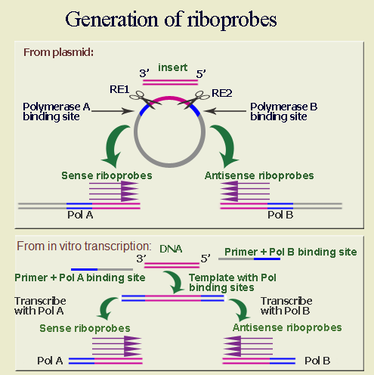
Figure 9: Making riboprobes requires the insertion of the target sequence between T7 RNA Polymerase (A) binding site and T3 RNA Polymerase (B) binding site. Restriction enzymes (RE) are used to separate the sense and the antisense template strands.
To fix the embryos, formaldehyde is added to a container with the embryos from the last cross. Formaldehyde crosslinks all the proteins in the cells together and inactivates them. This prevents the proteins from interfering. The embryos are washed of excess formaldehyde and proteinase K will then poke holes into the cell membrane. Riboprobes and antibodies conjugated to alkaline phosphatase are added to the solution and flow into the cells through the holes. The riboprobes hybridize to the complementary strands of Tcof 1 mRNA in the cells. The antibodies bind to the digoxygenin on the riboprobes. Then substrates 5-bromo-4-chloro-3-indolyl phosphate (BCIP) and nitroblue tetrazolium (NBT) are added into the mixture. With the substrates, the alkaline phosphatase catalyzes reactions that produces a blue-purple precipitate that is visible with a light microscope. Thus, the precipitate is located only in areas where Tcof1 was expressed in the embryos. The embryos with Zbtb14 knockout will be compared to the wild type embryo to determine if Zbtb14 does affect Tcof1 expression.
Discussion
If the experiment proceeds as expected, the expected results should occur. There needs to be at least two mice with correct loxP sites with germline transmission to mate together. Also, the differences in the Tcof1 expression levels should be clear when comparing the staining of the embryos. If the Zbtb14 does strongly affect Tcof1 expression [11], then the observations of Tcof1 expression should be easy to compare and contrast. There should be Tcof1 expression in heterozygote Zbtb14^{+/-} mice than in wild type Zbtb14^{+/+} and even more Tcof1 expression in homozygous Zbtb14^{-/-} than in heterozygous mice. This would be the best possible results.
Interpretation of the expected results would lead to the possibility of Zbtb14 directly or indirectly influencing Tcof1 expression. If the knockout of Zbtb14 does lead to increase expression of Tcof1 in the embryos, then Zbtb14 may indeed directly or indirectly repress Tcof1. However, it is not known if Zbtb14 directly binds to the Tcof1 promoter of if it influences another protein to repress Tcof1. Further study would need to be done to determine if Zbtb14 directly effects the expression by binding to the Tcof1 promoter as suspected in Shows and Shiang (2008).
However, since this is a hypothetical experiment, theoretical results may differ from reality. With CRISPR techniques, there could be off target mutations which may affect the expression of another gene which actually affect Tcof1 expression. A possible solution to this would be to sequence the entire mice genomes which would be time consuming. The target gene may act in a non-cellular autonomous manner so that even a little Zbtb14 can fully rescue the phenotype [18]. Additionally, the riboprobes may have trouble getting into the cells which would result in little to no staining. The riboprobes may also not only bind to its intended target but also to other mRNAs which would lead to background staining, staining in areas where Tcof1 is not expressed. A possible solution to this is to perform more washes and raise the heat of hybridization to break apart the less specific hybridization matches. Another problem may be that the Tcof1 promoter may not be sensitive enough to the transcription binding factor Zbtb14 so there would not be much change in Tcof1 expression in the whole mount in situ hybridization embryos.
The benefit to understanding whether Tcof1 does repress Tcof1 expression is that it leads to better understanding of the mutation of Tcof1 leading to Treacher Collins Syndrome in humans. It will also be an important experiment to evaluate the potential of Zbtb14 to be a potential target to help treat this syndrome in the womb.

References
- Dixon MJ, Dixon J, Raskova D, Le Beau MM, Williamson R, Kinger K, Landes GM. (1992) Genetic and physical mapping of the Treacher Collins syndrome locus: refinement of the localization to chromosome 5q32-33.2, Human Molecular Genetics 1(4): 249–253 DOI: 10.1093/hmg/1.4.249
- Sakai D, Trainor PA. (2009). Treacher Collins syndrome: unmasking the role of Tcof1/treacle. The international journal of biochemistry & cell biology, 41(6), 1229–1232. DOI:10.1016/j.biocel.2008.10.026
- Chang CC, Steinbacher DM. (2012). Treacher Collins Syndrome. Seminars in Plastic Surgery 26(2): 83-90. DOI: 10.1055/s-0032-1320066
- Sanchez E, Laplace-Builhé B, Mau-Them FT, Richard E, Goldenberg A, Toler TL, Guignard T, Gatinois V, Vincent M, Blanchet C, Boland A, Thérèse M, Deleuze J, Olaso R, Nephi W, Lüdecke H, Verheij J, Moreau-Lenoir F, Denoyelle F, Riviere J, Laplanche J, Willing M, Captier G, Apparailly F, Wieczorek D, Collet C, Djouad F, Genevieve D. (2019) POLR1B and neural crest cell anomalies in Treacher Collins syndrome type 4. Genetics in Medicine: 1-10 DOI:10.1038/s41436-019-0669-9
- Dixon MJ, Dixon J, Raskova D, Le Beau MM, Williamson R, Klinger R, Landes GM. (1992). Genetic and physical mapping of the Treacher Collins syndrome locus: refinement of the localization to chromosome 5q32-33.2. Human Molecular Genetics 1(4): 249-253. DOI: 10.1093/hmg/1.4.249
- Isaac C, Marsh KL, Paznekas WA, Dixon J, Dixon MJ, Jabs EW, Meier UT. (2000). Characterization of the Nucleolar Gene Product, Treacle, in Treacher Collins Syndrome. Molecular Biology of the Cell 11(9): 3060-3071. DOI: 10.1091/mbc.11.9.3061
- Dixon J, Brakebusch C, Fässler R, Dixon MJ. (2000) Increased levels of apoptosis in the prefusion neural folds underlie the craniofacial disorder, Treacher Collins syndrome. Human Molecular Genetics 9(10):1473-80. DOI: 10.1093/hmg/9.10.1473
- Dixon J, Brakebusch C, Fassler R, Dixon MJ. (2000). Increased levels of apoptosis in the prefusion neural folds underlie the craniofacial disorder, Treacher Collins syndrome. Human Molecular Genetics 9(10): 1473-1480. DOI: 10.1093/hmg/9.10.1473
- Hayano T, Yanagida M, Yamauchi Y, Shinkawa T, Isobe T, Takahashi NJ. (2003) Proteomic analysis of human Nop56p-associated pre-ribosomal ribonucleoprotein complexes. Possible link between Nop56p and the nucleolar protein treacle responsible for Treacher Collins syndrome. Biological Chemistry 278(36):34309-19. DOI: 10.1074/jbc.M304304200
- Valdez BC, Henning D, So RB, Dixon J, Dixon MJ. (2004). The Treacher Collins syndrome (TCOF1) gene product is involved in ribosomal DNA gene transcription by interacting with upstream binding factor. Proceedings of the National Academy of Sciences of the United States of America 101(29): 10709-10714. DOI: 10.1073/pnas.0402492101
- Shows KH, Shiang R (2008). Regulation of the mouse Treacher Collins syndrome homolog (Tcof1) promoter through differential repression of constitutive expression. DNA and Cell Biology 27:589-600. DOI: 10.1089/dna.2008.0766
- Kuhn R, Schwenk F. (2003). Conditional Knockout Mice. Transgenic Mouse 209: 159-185. DOI: 10.1385/1-59259-340-2:159
- Chen L, Ye Y, Dai H, Zhang H, Zhang X, Wu Q, Zhu Z, Spalinskas R, Ren W, and Zhang W. (2018.) User-Friendly Genetic Conditional Knockout Strategies by CRISPR/Cas9. Stem Cells International 2018: 1-10. DOI: 10.1155/2018/9576959
- Hall B, Limaye A, Kulkarni AB. (2009). Overview: Generation of Gene Knockout Mice. Current Protocols Cell Biology 44 (1): 19.12.1-19.12.17. DOI: 10.1002/0471143030.cb1912s44
- Lewis AE, Vasudevan HN, O’Neill AK, Soriano P, Bush JO. (2013). The widely used Wnt1-Cre transgene causes developmental phenotypes by ectopic activation of Wnt signaling. Development Biology 379(2): 229-234. DOI: 10.1016/j.ydbio.2013.04.026.
- Bi PP, McAnally JR, Shelton JM, Sanchez-Ortiz E, Bassel-Duby R, Olson EN (2018). Fusogenic micropeptide Myomixer is essential for satellite cell fusion and muscle regeneration. Proceedings Of The National Academy Of Sciences Of The United States Of America 115: 3864-3869. DOI: 10.1073/pnas.1800052115
- Tan DP, Nonaka K, Nuckolls GH, Liu YH, Maxson RE, Salvkin HC, Shum L. (2002). YY1 activates Msx2 gene independent of bone morphogenetic protein signaling. Nucleic Acids Research 30 (5): 1213-1223. DOI: 10.1093/nar/30.5.1213
- Kwan K (2002). Conditional Alleles in Mice: Practical Considerations for Tissue-Speciﬁc Knockouts. Genesis 32: 49-62. DOI: 10.1002/gene.10068

