Mouni Talari
BNFO300
Research Proposal
10 December 2017

The Upregulation of Ceramide Synthase 3 via PGJ2, INT131, and S26948 in Psoriatic Human Epidermal Keratinocytes and Normal Human Epidermal Keratinocytes
- Introduction
Psoriasis is a chronic autoimmune inflammatory disease that affects approximately 8 million people in the United States and more than 100 million people worldwide. It is a common skin condition during which skin cells are rapidly and prematurely replaced with new skin cells, causing buildup on the surface of the epidermis. This buildup of new skin cells forms scale-like rashes that cause irritation, itching, bleeding, and pain. Other symptoms of psoriasis include pitted and ridged nails, as well as stiff and swollen joints. Plaque psoriasis is the most common form of the disease and affects anywhere from 85-90% of people with psoriasis. When this form of psoriasis is untreated, it can turn into psoriatic erythroderma which involves extremely widespread inflammation and peeling or scaling of the skin. This form of psoriasis can be fatal, since the extreme irritation and peeling of the skin can disturb the body’s capacity to control temperature and perform barrier function.
The causes of psoriasis are still not completely understood, but can be attributed to a faulty immune system. The human body produces T cells which travel throughout the body in order to identify and attack foreign substances such as viruses and bacterial infections. In psoriasis-inflicted individuals, these T-cells fail to recognize that cells are healthy. This causes the production of more healthy cells, which form layers on top of the already existing, healthy cells. These overactive T cells, which suspect an infection or foreign body when one does not exist, can also cause the production of even more T cells to help protect the body against this supposed “infection”. As a result, these excess T cells cause a further, rapid increase in new skin cells, as well as redness and pus formation. They also travel through the bloodstream, causing blood vessels to expand, resulting in warmth and redness of the psoriatic skin lesions. This entire process becomes a positive feedback cycle, which does not cease until proper treatment is provided. In addition to T cell irregularities, psoriasis can also be hereditary; roughly 33% of people afflicted by psoriasis report a family history of the disease as well.
There are multiple forms of post-diagnostic treatments for psoriasis. The most common treatment is the use of topical corticosteroids. These corticosteroids reduce inflammation and lessen any burning, itching, or soreness associated with the lesions. However, corticosteroids can only be used to treat mild to moderate forms of psoriasis and can cause thinning of the epidermis with long term use. Recent studies have also shown that the body can also build up a resistance to topical corticosteroids over time. Another form of treatment is the usage of calcineurin inhibitors which reduce inflammation and Plaque buildup, but can potentially cause an increased risk of skin cancer and lymphoma. These medications can also only be used in small amounts in very small areas, such as around the eyes. Phototherapy (light therapy) uses natural or artificial UV light to treat mild to moderate forms of psoriasis. However, exposing the skin to ultraviolet radiation can cause skin cancer in the long term. Lastly, certain drugs known as biologics, such as Humira, Enbrel, and Stelara, can alter the immune system, treating moderate to severe psoriasis. However, these drugs must be used with caution since they can have strong and often deleterious side effects on the immune system, making users prone to infections.
Most treatments of this currently incurable disease that are utilized today are focused on symptomatic, post-diagnostic treatment, which produces several unwanted side effects. While there is ongoing research that emphasizes post-diagnostic treatments, research that focuses on preventative measures for psoriasis is severely lacking. Only recently has research begun on preventative measures such as gene therapy, which can result in a possible cure for this “incurable”, chronic disease.

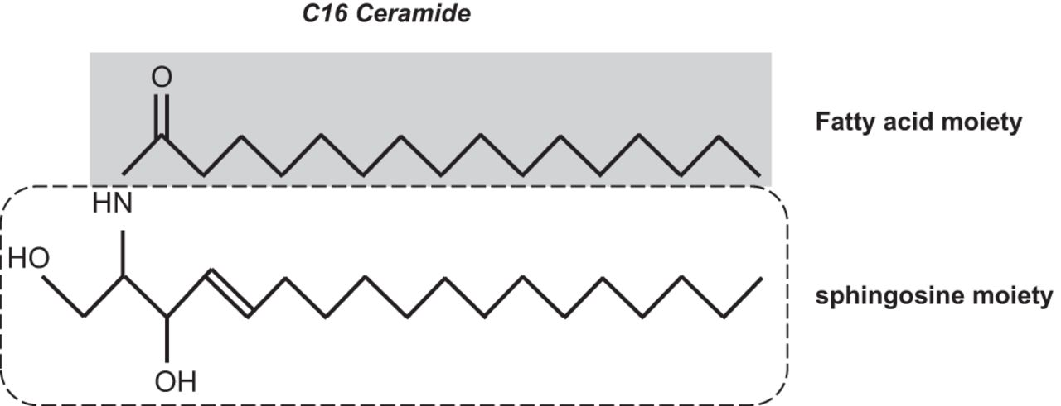
Ceramides are lipids that consist of a sphingosine and a fatty acid that varies in length. Their functions include various forms of cell signaling such as differentiation, proliferation, and programmed cell death or apoptosis. One of the most studied functions of ceramide molecules is its role as a proapoptotic molecule, which can be pertinent for its potential as a possible chemotherapeutic agent. However, ceramide also composes 50% of the stratum corneum layer of the epidermis in human skin and helps with the barrier function and water impermeability. Ceramides act as a protective layer against the epidermis to prevent excessive water loss due to evaporation. They also prevent the entry of microorganisms such as bacteria that can cause infections. Mammalian ceramides are synthesized by 6 known ceramide synthases (labeled CerS1 through Cers6). Of these 6 ceramides synthases, CerS3 (also referred to as longevity assurance homologue 3), synthesizes ceramides that have carbon chains longer than 24 carbons. These ceramides are found mainly in the skin and the testis, and are known to help maintain the barrier qualities of the skin. They are found most extensively in keratinocytes, and increase function during keratinocyte differentiation.
Figure 1. Structure of the C16 ceramide
Although there is copious evidence compiled over the past few years that suggests that psoriasis is mainly due to T-cell malfunction, recent studies have endorsed that pathogenesis of the disease may be influenced by the interruption of ceramide synthases. Interferon-gamma (INFγ) is a cytokine, which is a cell signaling protein produced by immune cells. The synthesis of this cytokine helps the mammalian immune system adapt and recognize viral and bacterial infections. INFγ homeostasis is needed in the body’s immune system, as downregulated or upregulated INFG genes (which code for INFγ) can cause either hypoactive or hyperactive autoimmune disorders. A study by Tawada et al revealed that increased levels of IFNγ have resulted in decreased levels of ceramide synthases, which is associated with psoriasis. This study also determined that the specific ceramide synthase involved in psoriasis was CerS3. Moreover, the specific ceramides which were found to have decreased levels in psoriasis were the C45-C48 ceramides (shown in graph (i) in Figure 2 below).
Figure 2. Percentages of various ceramides in psoriasis and atopic dermatitis. This experiment examined levels of healthy human keratinocytes (control), and compared certain ceramide levels in the control to ceramide levels in human keratinocytes affected by psoriasis and AD. Graph (i) shows that there is a significant decrease in the amount of the C45-C48 ceramides in psoriasis. The average percentage of ceramides45-48 in psoriasis was 16%, while the average level of those same ceramides was 32% in healthy human keratinocytes, indicating a correlation between lower levels of the aforementioned ceramides and psoriasis.
This study concludes that increased expression of the ING gene causes increased levels of IFNγ. When increased IFNγ levels were found in keratinocytes, the expression levels of CerS3 decreased by 52%. The reduction of CerS3 levels resulted in a decrease of ultra-long chain ceramides (ULCs), and low levels of these long chain ceramides were found in keratinocytes affected by psoriasis. With this sequential logic, it can be understood that increasing IFNγ decreases long chain ceramides. It would be useful to investigate whether or not the downregulation of the IFNγ encoding gene IFNG could result in an increase to normal ceramide production levels. However, due to the sensitive homeostatic nature of functional IFNγ cytokine production, it may be more suitable to attempt to increase levels of CerS3, thereby increasing levels of long chain ceramides despite having overexpressed IFNG. The increase of these long chain ceramides could potentially help improve or prevent psoriatic pathogenesis.
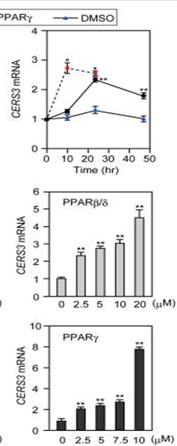
In a study conducted by Mizutani et al, eight different receptors were tested with their agonists to determine the resultant upregulation of CerS3. The CerS3 mRNA expression levels were analyzed using real time quantitative PCR. Of the eight receptors, the PPARγ receptor, when activated with its agonist (troglitazone), increased the expression levels of CerS3 the most, as can be seen in Figure 3. Treatment of the ligand troglitazone was also time and dose dependent. Figure 4 indicates that the troglitazone was most effective at the 10 µM dose—which is evident by the bottom graph—approximately ten hours after administration, which can be confirmed by the top graph.
Figure 4 (right). The effect of dose of ligands and time on expression levels of CerS3 mRNA
Figure 3. Receptors and mRNA expression levels of CerS3.
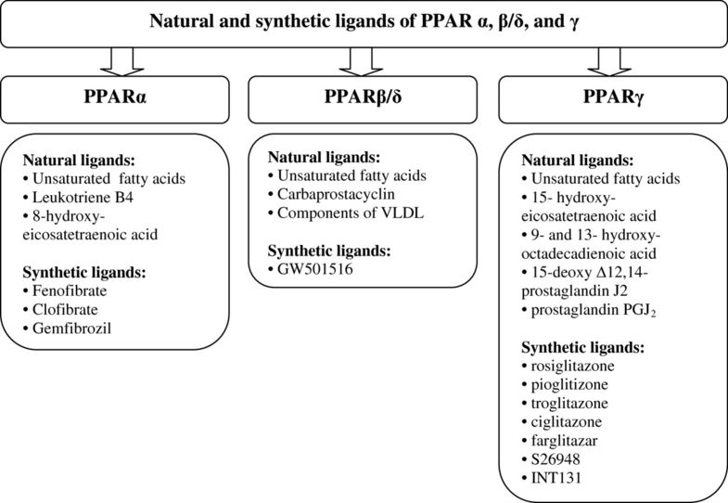
The study by Mizutani et al used troglitazone as an agonist for the PPARγ receptor. Troglitazone is an antidiabetic and anti-inflammatory drug which was prescribed for patients with diabetes mellitus type 2. However, this drug was withdrawn from markets in 2000 after it was found to induce hepatotoxicity in multiple patients. Many current ligands for PPARγ are also in the same class of drugs as troglitazone, known as thiazolidinediones (TZDs). Aside from hepatotoxicity, these drugs also have severe cardiovascular side effects, such as edema, CHF, and heart failure. A 2014 study by Grygiel-Górniak determined various ligands for the PPARγ receptor, which can be seen in Figure 5. Another downfall in the Mizutani et al study is that only the expression of the mRNA levels of CerS3 was measured. While this does indicate that CerS3 was upregulated, it does not confirm whether or not the RNA is being translated and if proteins are being produced. Moreover, it also does not confirm the enzymatic activity of those proteins. The goal of this experiment is to determine a suitable agonist that will upregulate ceramide synthase 3 without the associated side effects. This upregulation will be confirmed not only through the testing of RNA levels, but also through the testing of various production and expression of proteins.
Figure 5. Natural and synthetic ligands of PPARγ, as can be seen on the far right of the diagram.
- Experiment
The aim of this experiment would be to use three different agonists of the PPARγ receptor to determine if they upregulate ceramide synthase 3 in both psoriatic and non-psoriatic human epidermal keratinocytes. This will be done by administering a control dose of each drug to psoriatic human epidermal keratinocytes (PHEK) and normal human epidermal keratinocytes (NHEK). The resulting RNA levels produced from ceramide synthase 3 will be measured using real time PCR, followed by the detection of proteins that are produced via Western blot analysis, and the resulting enzymatic activity of these proteins will be confirmed via a ceramide synthase assay. This experiment will hopefully produce one agonist that increases the upregulation of ceramide synthase 3, which will be measured by using real time PCR, Western Blot analysis, and a ceramide synthase assay. This experiment will also compare the levels of upregulation of CerS3 in PHEK versus NHEK.
The PPARγ agonists that will be used in this experiment are PGJ2, INT131, and S26948. PGJ2, or prostaglandin J2 is a natural ligand that suppresses the inflammation response in cells. INT131 is a synthetic ligand which is currently in Phase I of clinical trials for use as anti-diabetic agent. Studies show that it has fewer side effects than troglitazone and does not cause hepatotoxicity or precursor symptoms of heart failure, such as edema. In a 2012 study by Yew et al, S26948 was shown to lower insulin in preclinical trials without any detectable effects on fluid retention and edema as well.
A control dosage (10 microliters) of each agent (PGJ2, INT131, S26948) will be administered to cultured PHEKs and NHEKs. Control groups of PHEKs and NHEKs without any drugs will also be cultured and tested. After 10 hours, which was found to be time of optimal efficacy of the troglitazone drug in the Mizutani et al study, the RNA levels of the cells will be measured using real time PCR.
IIA. Real Time PCR
Each set of cultured cells (PGJ2 in PHEK, INT131 in PHEK, S26948 in PHEK, unchanged PHEK, PGJ2 in NHEK, INT131 in NHEK, S26948 in NHEK, and unchanged NHEK) will be subjected to real time PCR (qPCR) to determine the resultant RNA levels in each of these experimental groups. The standard curve calculation method will be employed to compare the resultant RNA levels between each of the eight experimental groups.
The RNA from each of these groups will be isolated using an RNA isolation kit from the TaqMan Gene Expression Cells to C_{T} kit. This allows for expression analysis directly from the cultured cells without RNA purification. Following RNA isolation, primers provided by ta ceramide synthase 3 specific TaqMan kit will be added, and reverse transcription of RNA to cDNA will be performed. This reverse transcription of RNA to cDNA will make PCR analysis of ceramide synthase 3 RNA molecules possible. Polymerase chain reaction is then carried out following reverse transcription, which allows for the amplification of the cDNA. A fluorescent Taqman probe is used during PCR to detect cDNA as it is accumulated throughout the PCR process. The particular assay that will be used during this process is found in reference 21.
The results of the qPCR will be analyzed using relative quantification, which will help analyze and compare changes in the gene expression after administration of the drugs, and determine whether or not one of these groups showed increased mRNA levels (measured by cDNA) following drug administration. Relative quantification will show the change in the expression of mRNA levels interpreted as cDNA, which is accomplished by the reverse transcription of mRNA. Since cDNA is synthesized from mRNA, the levels of cDNA will represent the levels of mRNA produced by ceramide synthase 3. By performing relative quantification, we can determine if one or more of these drugs has effectively increased the expression levels of CerS3 mRNA, indicating that CerS3 has been upregulated.
IIB. Western Blot Analysis
Following real time PCR, a Western Blot analysis will be performed to determine whether or not the administration of the agonists is producing the ceramide synthase 3 protein.
A sample from each of the eight groups will be prepared using tissue homogenization so that all of the samples have equal compositions prior to analysis. Since the protein being investigated is ceramide synthase 3, and it has a molecular weight of 46 kDa, an agarose gel with a gel percentage of 12.5% will be used. Equal amounts of the sample will be loaded into the wells of SDS-PAGE along with a molecular weight marker. Gel electrophoresis will be run, and the separated proteins will be transferred to a membrane for imaging. Detection of the ceramide synthase 3 protein will be carried out by using a primary antibody. The primary antibody that will be used is LASS3 (longevity assurance homolog 3) polyclonal antibody. LASS3 is another label for ceramide synthase 3. This antibody will label any ceramide synthase proteins that have been separated during gel electrophoresis. The results of the Western Blotting from the different experiment groups can then be compared to analyze the protein levels following drug administration.
IIC. Ceramide Synthase Enzymatic Assay
The final step in this process is to perform a ceramide synthase assay to detect enzymatic activity, to confirm that the proteins that have been produced are functioning. The methods of this assay were explained in a study by Tidhar et al. This technique was developed to analyze ceramide synthase activity in a fast, reliable method. This method utilizes a fluorescent NBD sphingamine substrate to detect endogenous ceramide synthase activity from tissue homogenate. This is useful since tissue homogenate will already be prepared for the western blot analysis of this experiment. The assay is performed using an NBD sphingamine substrate to test the enzymatic activity of ceramide synthases by using an initial rate experiment. Large amounts of sphingamine are added to the ceramide synthase enzyme, and the kinetics of the enzyme-substrate intermediate are measured, as is the accumulation of the enzyme products. By running this assay, we can determine if ceramide synthase 3 is showing any increase in enzymatic activity following drug administration.
- Discussion
The results of these experiments should theoretically show that one or more of these agonists will increase the expression of CerS3 mRNA, confirm that the mRNA is producing proteins (through Western blotting) and validate appropriate enzymatic activity of ceramide synthase 3 (though the ceramide synthase enzymatic assay). Moreover, this experiment will also determine if there is a difference between administering the drug to PHEK versus NHEK. If one of these agonists do indeed significantly increase the expression of CerS3, then the potential for administration in a mouse xenograft model of psoriasis could be feasible. By doing this, we can see if the drugs diminish the effects of psoriasis, potentially developing a new treatment for this disease.
One major limitation of the experiment is that CerS3 has significant involvement in the testes for sperm formation and androgen production. CerS3 gene expression is highly upregulated during testicular maturation, in the same way it is highly regulated in keratinocyte differentiation. Increasing the expression of CerS3 could potentially bring about changes in juvenile testicular maturation, though these effects have not yet been researched. Increasing the expression of CerS3 may cause adverse effects in terms of testicular function.
Another limitation is the side effects of some of the PPARγ agonists. Most of these agonists are currently undergoing clinical trials to determine their efficacy in terms of controlling diabetes. The excess administration of these agonists may cause hypoglycemia or some of the other already known side effects, such as edema and increased risk of bladder cancer.
Above all of these, the administration of the agonists may not even result in an increase in CerS3 expression. This result would necessitate other agonists to be tested to evaluate if they can increase CerS3 expression. If none of these 3 agonists increase CerS3 mRNA expression significantly, then administration into a mouse xenograft model of psoriasis would be futile. Despite these limitations, if it can be determined that one of these agonists greatly increases the expression of ceramide synthase 3, which increases the production of ULC ceramides, it is probable that a new form of treatment for psoriasis can be developed.

- References
  - Gordon, K. B., Feldman, S. R., Koo, J. Y., Menter, A., Rolstad, T., & Krueger, G. (2005). Definitions of Measures of Effect Duration for Psoriasis Treatments. Archives of Dermatology, 141(1). doi:10.1001/archderm.141.1.82
  - Krueger, G. G., Feldman, S. R., Camisa, C., Duvic, M., Elder, J. T., Gottlieb, A. B., . . . Day, R. M. (2000). Two considerations for patients with psoriasis and their clinicians: Journal of the American Academy of Dermatology, 43(2), 281-285. doi:10.1067/mjd.2000.106374
  - Motta, S. (1994). Abnormality of water barrier function in psoriasis. Role of ceramide fractions. Archives of Dermatology, 130(4), 452-456. doi:10.1001/archderm.130.4.452
  - Levy M, Futerman AH. Mammalian ceramide synthases. IUBMB life. 2010. 62:347–356. doi: 10.1002/iub.314.
  - M.S. Wegner, S. Schiffmann, M.J. Parnham, G. Geisslinger, S. Grosch. The enigma of ceramide synthase regulation in mammalian cells. Progress in Lipid Research, 63 (2016), pp. 93-119
  - Tawada, C., Kanoh, H., Nakamura, M., Mizutani, Y., Fujisawa, T., Banno, Y., & Seishima, M. (2014). Interferon-γ Decreases Ceramides with Long-Chain Fatty Acids: Possible Involvement in Atopic Dermatitis and Psoriasis. Journal of Investigative Dermatology, 134(3), 712-718. doi:10.1038/jid.2013.364
  - Garidel P, Fölting B, Schaller I, Kerth A (2010). "The microstructure of the stratum corneum lipid barrier: mid-infrared spectroscopic studies of hydrated ceramide:palmitic acid:cholesterol model systems". Biophysical Chemistry. 150 (1–3): 144–156. doi:10.1016/j.bpc.2010.03.008.
  - Feingold KR (2007). "Thematic review series: skin lipids. The role of epidermal lipids in cutaneous permeability barrier homeostasis". Journal of Lipid Research. 48 (12): 2531–2546. doi:10.1194/jlr.R700013-JLR200.
  - Duan, J., Sugawara, T., Hirose, M., Aida, K., Sakai, S., Fujii, A., & Hirata, T. (2012). Dietary sphingolipids improve skin barrier functions via the upregulation of ceramide synthases in the epidermis. Experimental Dermatology, 21(6), 448-452. doi:10.1111/j.1600-0625.2012.01501.x
  - Mizutani, Y., Sun, H., Ohno, Y., Sassa, T., Wakashima, T., Obara, M., . . . Igarashi, Y. (2013). Cooperative Synthesis of Ultra Long-Chain Fatty Acid and Ceramide during Keratinocyte Differentiation. PLoS ONE, 8(6). doi:10.1371/journal.pone.0067317
  - Rabionet M, van der Spoel AC, Chuang CC, von Tümpling-Radosta B, Litjens M, Bouwmeester D, Hellbusch CC, Körner C, Wiegandt H, Gorgas K, Platt FM, Gröne HJ, Sandhoff R (2008). "Male germ cells require polyenoic sphingolipids with complex glycosylation for completion of meiosis: a link to ceramide synthase-3". J. Biol. Chem. 283 (19): 13357–69. doi:10.1074/jbc.M800870200.
  - Grygiel-Górniak, B. (2014). Peroxisome proliferator-activated receptors and their ligands: nutritional and clinical implications - a review. Nutrition Journal, 13(1). doi:10.1186/1475-2891-13-17
  - FDA August 4, 2011. FDA Drug Safety Communication: Updated drug labels for pioglitazone-containing medicines.
  - Ramot, Y., Mastrofrancesco, A., Camera, E., Desreumaux, P., Paus, R., & Picardo, M. (2015). The role of PPARγ-mediated signalling in skin biology and pathology: new targets and opportunities for clinical dermatology. Experimental Dermatology, 24(4), 245-251. doi:10.1111/exd.12647
  - Yew, T., Toh, S., & Millar, J. S. (2012). Selective Peroxisome Proliferator-Activated Receptor-γ Modulation to Reduce Cardiovascular Risk in Patients with Insulin Resistance. Recent Patents on Cardiovascular Drug Discovery, 7(1), 33-41. doi:10.2174/157489012799362359
  - Gudjonsson, J. E., Johnston, A., Stoll, S. W., Riblett, M. B., Xing, X., Kochkodan, J. J., . . . Elder, J. T. (2010). Evidence for Altered Wnt Signaling in Psoriatic Skin. Journal of Investigative Dermatology, 130(7), 1849-1859. doi:10.1038/jid.2010.67
  - https://www.thermofisher.com/us/en/home/life-science/pcr/real-time-pcr/qpcr-education/absolute-vs-relative-quantification-for-qpcr.html
  - https://www.thermofisher.com/order/catalog/product/AM1728?ICID=cvc-rna-cultured-cells-c3t1
  - https://www.thermofisher.com/us/en/home/life-science/pcr/real-time-pcr/real-time-pcr-applications/gene-expression-using-real-time-pcr.html
  - https://www.thermofisher.com/taqman-gene-expression/product/Hs00698859_m1?CID=&ICID=
  - Tidhar, R., Sims, K., Rosenfeld-Gur, E., Shaw, W., & Futerman, A. H. (2014). A rapid ceramide synthase activity using NBD-sphinganine and solid phase extraction. Journal of Lipid Research, 56(1), 193-199. doi:10.1194/jlr.d052001

