**Identifying the Conserved Residues of LapA that are Required for Protein-Protein Interactions**

BNFO 300

Aarthi Prakash

Mentor: Dr. Jitender Mehla

December 10, 2017

**Introduction**

With increasing numbers s of “superbugs” or bacteria that are resistant to more antibiotics, there is an increasing need for understanding the biological structure of them to find more efficacious treatment methods.

Gram negative bacteria have an outer membrane that is an asymmetric bilayer with an inner leaflet composed of phospholipids and an outer leaflet composed of lipopolysaccharide(LPS). In *Escherichia coli*, the LPS has six fatty acyl chains with many more sugars attached. When there are divalent cations, LPS molecules band together to give a gel barrier for gram negative bacteria and provide the ability to survive in harsh climates and to not allow antibiotics into the cell (Freinkman 2011). Previously, a study done by Mehla & Sood (2010) found that many morphological and physiological factors affected resistance in *Enterococcus faecalis.* Some of the mechanisms used included morphological changes from short, straight chained bacterial cells to cell aggregates for wild-type to resistant cells and a change from a more oval shape to a blunt, round shape as well. Changes in the phospholipid head group from amino-lacking to amino-containing phospholipid head groups were found to have increased in resistant cells showing that the membrane would be more polar compared to wild-type cells. The resistant cells also had an increased ratio of saturated to unsaturated fatty acids thereby making the cell membrane more rigid in the resistant variety. The cellular envelope also had alterations such as an increase in hydrophobicity for the resistant cell cultures (Mehla & Sood, 2010). These various features could all contribute to resistance in bacterial however possible targets of the membrane structure could be a more potent alternative for antibacterial development. Understanding the individual components of the membrane could provide better understanding of their role in resistance.

In *E. coli* most of the outer membrane proteins have been found to generally have a beta barrel structure which could contribute to the structure. This protective property has been found to be a determinant of virulence for certain bacterial strains and thereby an important factor to consider for therapeutic interventions against bacteria (Polissi 2014).

Lipopolysaccharides are essential for bacterial growth by causing major alterations to the membrane and thereby affecting the membrane properties. LPS has three main structural domains: Lipid A, a core oligosaccharide, and a highly variable O-antigen. (Polissi 2014). The individual LPS components tend to be toxic to the cell in uncontrolled quantities. Too little or too much can induce apoptosis and tend to be regulated by LPS assembly pathway enzymes such as LpxC and LpxD (Wong 2010).

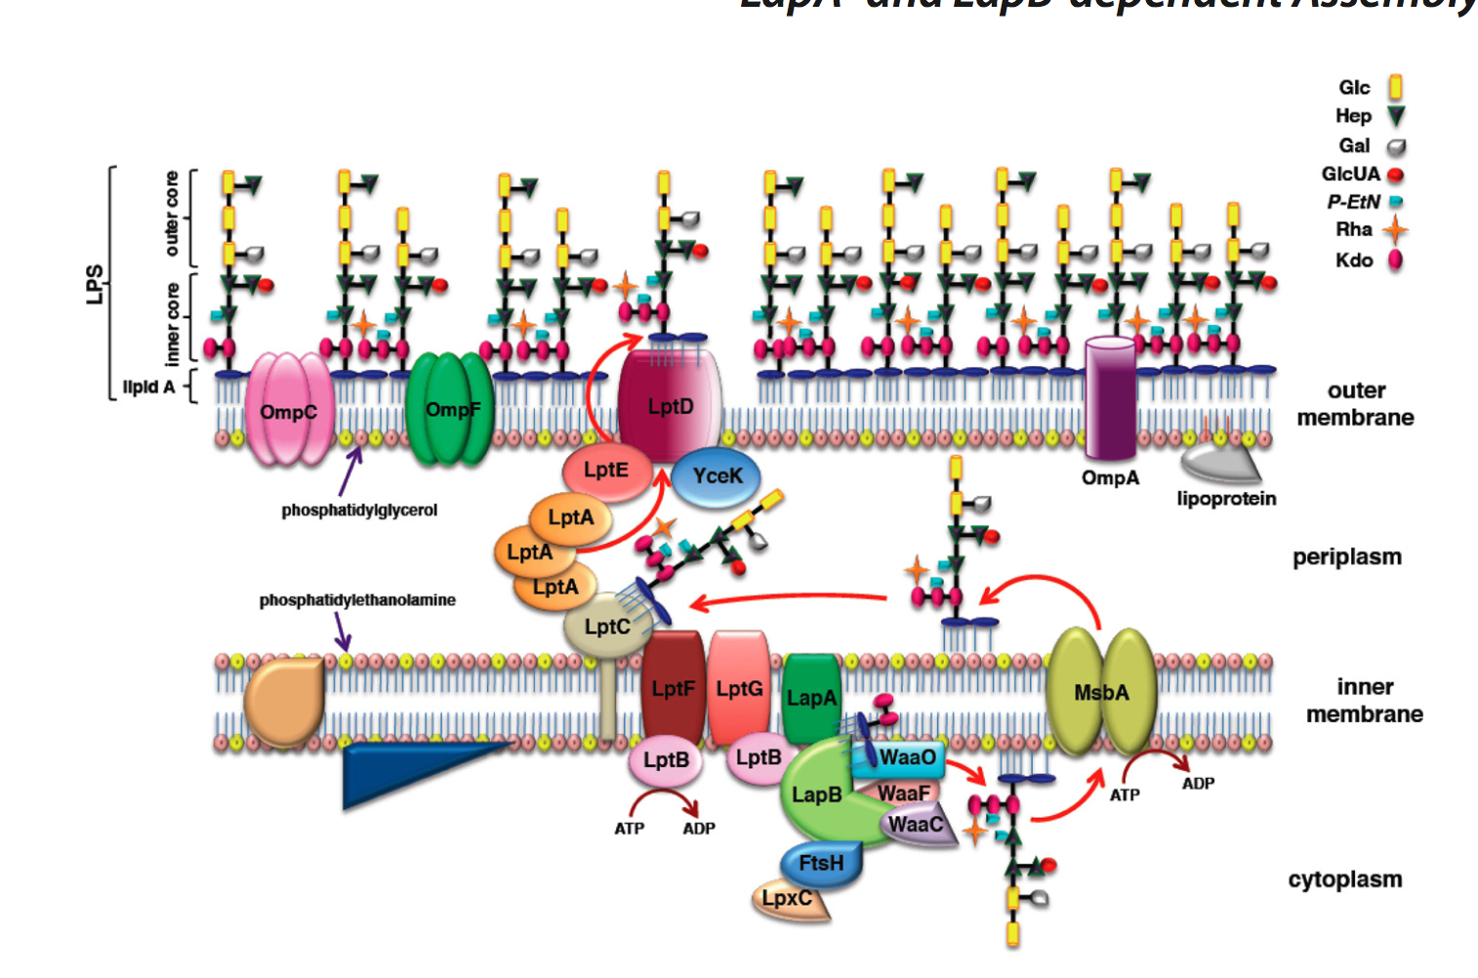

Fig 1. Proposed structure of the LPS assembly pathway by Mahalakshmi et al. (2014). LapA is possibly interacting with mlaD, lptC, lptF, and lptG as confirmed by previous experiments by Dr. Jitender Mehla.

LPS assembly is the biogenesis pathway important for developing the outer membrane structure. LPS is synthesized from the inner membrane then transported through the periplasmic space to the outer membrane. This particular pathway is well characterized however not so much about how these large molecules are then transported across the periplasm to the cell surface (Freinkman 2011). The assembly process begins with Lipid A is a lipid precursor that is produced by the fatty acetylation of UDP-N-acetylglucosamine, a nucleotide and sugar, by the LpxA enzyme (Mahalakshmi 2014). In *E. coli* the biogenesis process proceeds from lipid A that has two residues of 3-deoxy-**alpha-**D-manno-oct-2-ulosonic acid (Kdo) attached. This ensures the conversion of the tetraacyclated lipid to a hexaacetylated lipid. All of the intermediate synthesis steps involved are required for the viability of bacteria. Additional sugars are then added to support the growth of *E.coli* while minimizing the structural complexity necessary (Klein 2014).

There are two accepted models that describe LPS transport or export pathways: (1) a chaperone-mediated transit across the periplasm as well as (2) transenvelope bridge model spanning both the inner membrane and outer membrane. There are three subdivisions to LPS transport (Lpt) machinery: LptBFGC, LptA, and LptDE. The first model indicates that LptA would carry the LPS from the LptBFGC section and diffuse across the periplasm while protecting any exposed hydrophobic sections of the LPS. Ultimately, the LPS would travel from the LptBFGC to the LptDE by assistance of LptA. The second model suggests that a bridge-like structure is formed by the combination of individual cellular structures between the inner and outer membrane. This transport machinery is similar to efflux pump structures in other parts of the bacteria (Polissi 2014). Both are important steps in understanding and characterization of the LPS pathways and relate to the proposed structure in Figure 1 above.

One predicted component of this membrane pathway is Lipopolysaccharide Assembly Protein A (LapA), which is an inner membrane protein that is embedded into the inner membrane that provides a bridging aspect from constructed proteins to the outer membrane (Klein 2014). Despite having some significant effects by mutation analysis for *yciM* (LapB), *yciS*  (LapA) have not been well characterized. Understanding the structure and function relationship of LapA can provide new insights regarding its function in LPS assembly or outer cell envelope of gram negative proteobacteria..

LapA is a conserved membrane protein in proteobacteria. LapA was found to interact with MlaD, LptC, LptF and LptG, proteins. All four proteins are important proteins of LPS aseembly. Therefore, this proposal aims to determine the protein-protein interactions of LapA and it variants with the previously chosen proteins (MlaD, LptC, LptF, LptG) and to determine which conserved residues are essential to LapA for those protein-protein interactions.

**Experiment**

1. **Mutant Generation**



Fig **\*\*.** The multiple sequence alignment of the LapA gene in three bacterial species: *Vibrio cholerae* (VIBCL), *Escherichia Coli* (LAPA_ECOLI)*,* and *Yersinia pestis* (YERPA)*.* Two conserved regions of: FNYLLAQGE and STLL in the latter portion of the amino acid sequence will be targeted.

The mutant DNA sequences encoding specific mutants, will be synthesized as GeneArt strings (ThermoFisher pvt Ltd). These sequences will be cloned into pDNOR/Zeo using BP clonase reaction of Gateway cloning (Invitrogen). The ORFs were further sub-cloned into bacterial two hybrid vector (pUT18C) followed by co-transformation and screening for any loss in interactions against interacting proteins of LapA. The details of each method are provided below.

To identify the amino acid residues of LapA, mutants of LapA will be constructed. To identify the conserved residues of LapA, multiple sequence alignment was done as shown in the figure above. Two LapA gene constructs with deletions of the two larger conserved regions of the amino acid sequences: FNYLLAQGE and STLL will be generated using GeneArt Gene Synthesis (ThermoFisher Scientific). I will provide the gene sequences for both wild type LapA and mutated LapA sequences and receiving GeneArt strings. GeneArt strings is widely used method for cloing and mutagenesis studies these days specially for small genes. This method is more cost effective compared to site-directed mutagenesis kits. Thirteen other mutant genes will be generated using site-specific substitutions of each amino acid of the conserved regions with alanine except for the one alanine will be substituted with glycine. The alanine substitution/scanning method is widely used because alanine has no functional group and would probably not express the wild-type phenotype of the original amino acid (https://en.wikipedia.org/wiki/Alanine_scanning). The substation with glycine would also provide a similar effect to avoid return of phenotype to the protein. The entry clones of the interacting proteins (MlaD, LptC, LptF, and LptG) are available in the lab and will be used wherever required.

1. **Gateway Cloning**

The gene sequences (of WT and mutants) as GeneArt strings will be cloned into pDONR/Zeo gateway cloning vector (<https://www.thermofisher.com/order/catalog/product/12535035>) using BP clonase reaction step of Gateway cloning. Gateway cloning is preferred method and is more efficient and highly accurate compared to traditional cloning (<https://www.thermofisher.com/us/en/home/life-science/cloning/gateway-cloning.html>). The transformants with correct sequences were confirmed by sequencing at least 2 different clones. Further, the wild-type, deletions, and substitutions of gene sequences will be cloned in the pUT18 destination vectors and the four interacting proteins will be cloned into the pST25 destination vectors. The vectors are shown in the appendix Figures 1 and 2. Both of these vectors are used for bacterial two-hybrid screening methods.

The BP reaction utilizes attB and attP sites that are flanked on the gene product insert and the donor clone respectively. The reaction mixture of the kit catalyzes the reaction using BP clonase enzyme mix to generate the entry clone containing the gene of interest flanked by attL sites. This is demonstrated by Figure 2 below. The byproduct of the reaction is the ccdB gene that is excised from the donor.

The LR reaction is as shown in Figure 3 below. This reaction takes place between the attL sites flanked on the entry clone and the attR sites on the destination vector. This reaction is then catalyzed by the LR Clonase enzyme mix in which an expression clone with the gene flanked by attB sites is generated. The byproduct vector with the ccdB gene is excised from the destination vector and is cytotoxic to be easily eliminated. he expression clone generated upon LR cloning will be used for the bacterial two-hybrid screening experiment.

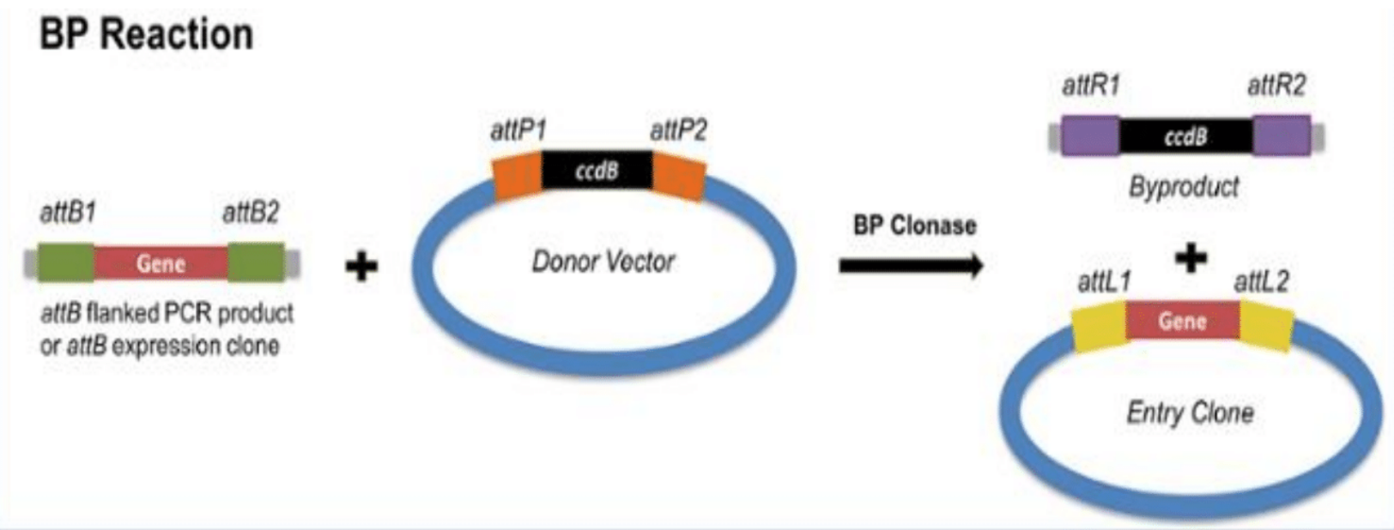

Fig 2. BP reaction of gateway cloning to get the gene of interest into an entry clone for further cloning (http://blog.addgene.org/plasmids-101-gateway-cloning).

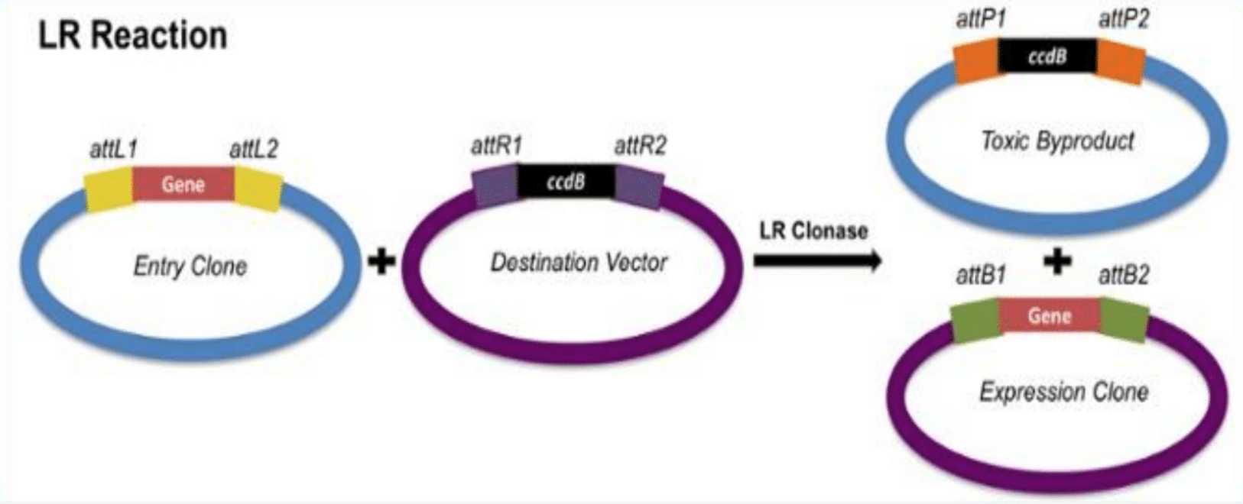

Fig 3. LR reaction of gateway cloning to directly move the gene from the entry clone to the destination vector for experimentation (http://blog.addgene.org/plasmids-101-gateway-cloning).

1. **Bacterial Chemical Transformation**

The following bacterial transformation protocol will be described as shown in Figure 4 below. The expression clones generated for each of the wild-types and mutant will be co-transformed into BTH101 *Escherichia coli* (E. coli) competent cells. These were made by using calcium incubated cells with heat shock to increase the permeability of the bacterial cells to the DNA vectors.

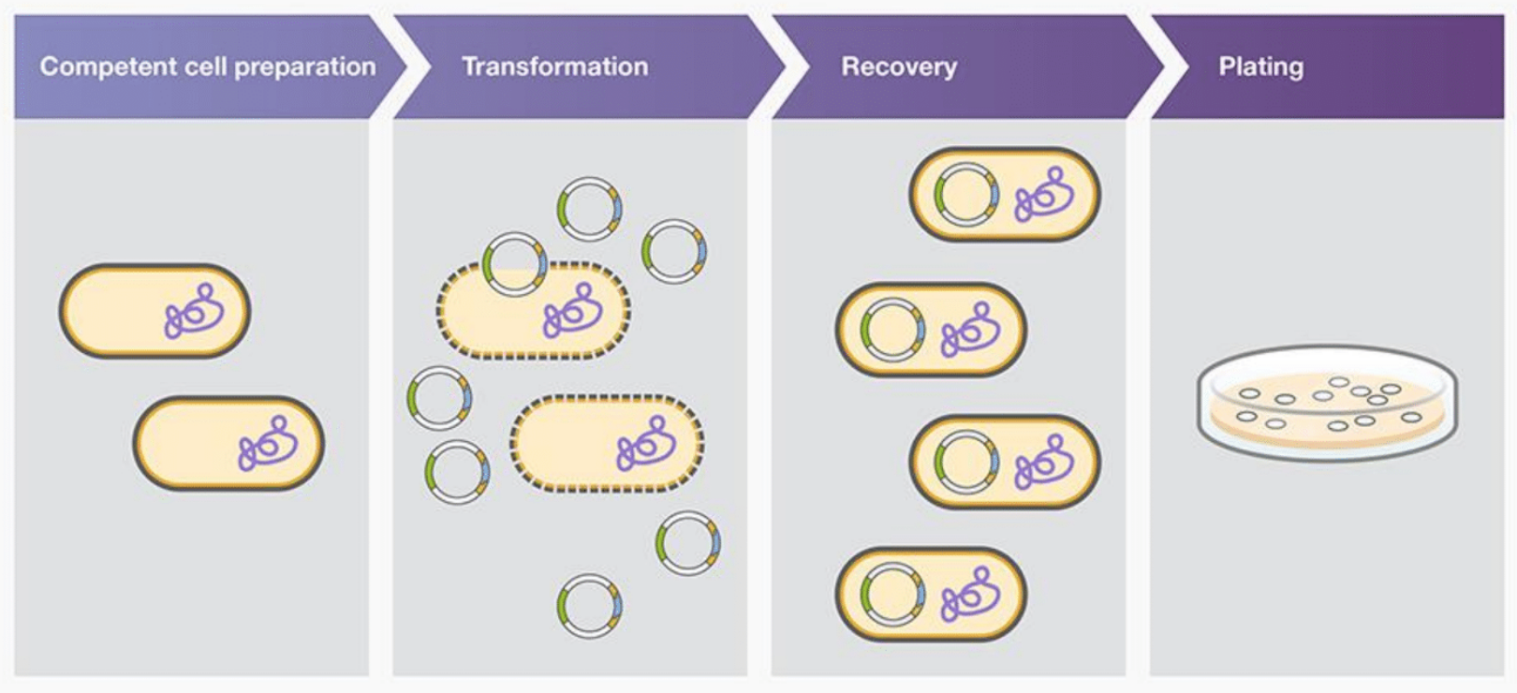

Fig 4. An overview of the bacterial transformation process (https://www.thermofisher.com/us/en/home/life-science/cloning/cloning-learning-center/invitrogen-school-of-molecular-biology/molecular-cloning/transformation/bacterial-transformation-workflow.html).

The transformation method will be a heat shock co-transformation method. Cells will be thawed on ice and handled gently to retain viability of the cells. The BTH101 cells will be mixed with the plasmid DNA required for the interaction, for example a LapA mutant and mlaD plasmid. After an incubation period, the cell mixture will be exposed to heat shock to transiently form pores on the bacterial cells and allow the plasmid DNA to get introduced to the cells. These cells will then be returned to ice to relieve the heat stress and close the pores. Following this the transformed cells will undergo a recovery period in which they are cultured in antibiotic-free liquid medium such as LB broth, for at least one cell division to allow expression of the antibiotic resistance genes (selectable marker) from the acquired plasmid. This recovery will improve cell viability and cloning efficiency for screening.

Once the cell cultures are prepared, they will be plated on LB agar with the ampicillin and spectinomycin, the selectable antibiotic resistance genes found in the pUT18 and pST25 destination vectors respectively to select the co- transformed cells. The cells will be evenly distributed and the plate will be dried before incubating overnight at 37 degrees Celsius. The cell culture plates will then be examined for colony formation and further screened for the desired plasmids and proper sequences. Once confirmed they will be subjected to bacterial two-hybrid screening.

1. **Bacterial Two-Hybrid Screening (B2H)**

The B2H system is the bacterial adenylate cyclase based two-hybrid system (BACTH) in which adenylate cyclase activity in E. coli is restored. Figure 5 illustrates the principle of the B2H system. The T18 and T25 domains of adenylate cyclase are essential for its activity. When intact, both domains work together, adenylate cyclase is full functional to produce cAMP synthesis however, when segregated the domains, the adenylate cyclase do not produce cAMP. When the domains are brought in close together, adenylate cyclase activity is restored, cAMP is generated, and an observable phenotypic change on indicator plates, MacConkey and LB/Xgal, will occur to show that both proteins are interacting with each other (Mehla et al., 2017).

A more precise image of the interacting proteins and the screening process is shown in Figure 6. On the MacConkey agar plate a positive interaction would have a red colony color and a negative interaction would have a clear colony color. On the LB/X-gal agar the positive interaction colonies would have a blue color and any negative interaction would have a white color. An M63/X-gal agar will not be used for this experiment as the previous two will be confirmation enough. Only McConkey and LB-X Gal screening will be used in my experiments.

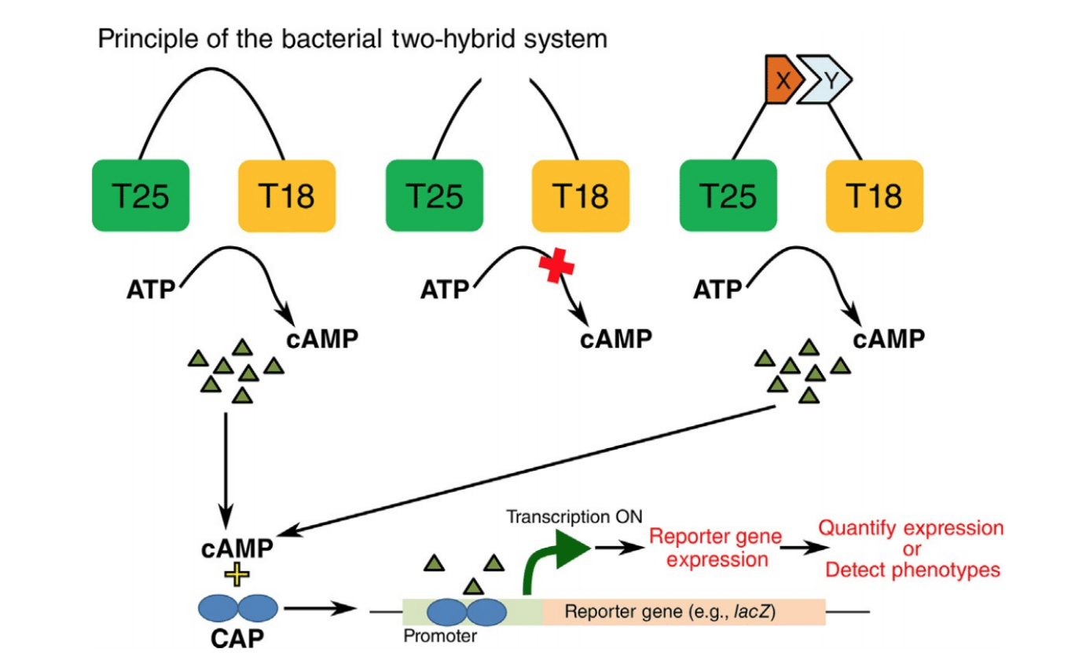

Fig 5. This image illustrates the principle of the bacterial two-hybrid system as described by Mehla et al., 2017.

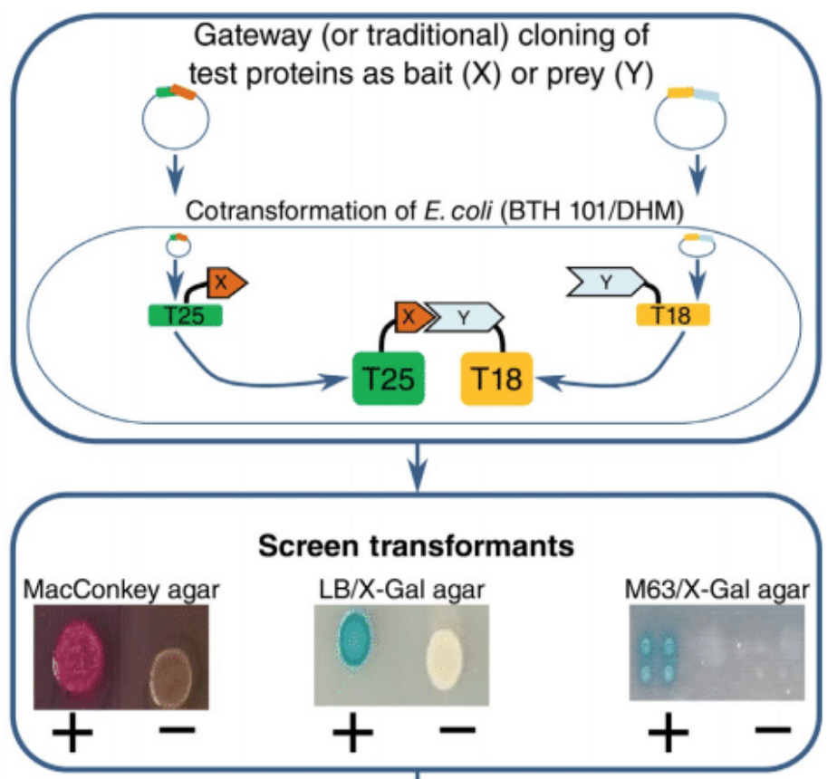

Figure 6. A broader image of the interaction as well as an example of the colony colors for interactions is shown. On the MacConkey plates, a positive interaction is denoted by red colonies and a negative interaction has clear colonies. On the LB/X-gal agar, a positive interaction will have blue colonies and a negative interaction will have white colonies. An M63/X-Gal agar indicator plate will not be used.

**Discussion**

The expected results (Fig 7) would include images of the interaction assays which would indicate the any loss of direct interactions of LapA and the variants with the interacting proteins. This will provide the potential residues which are involved in PPIs of LapA with LPS assembly proteins and provide insight into the associated mechanisms. Further comparison analysis with the known mutations will correspond to the interaction sites directly on the gene transcript. It is expected to find the involved amino acids and direct changes that correspond to the interaction sites being mapped.

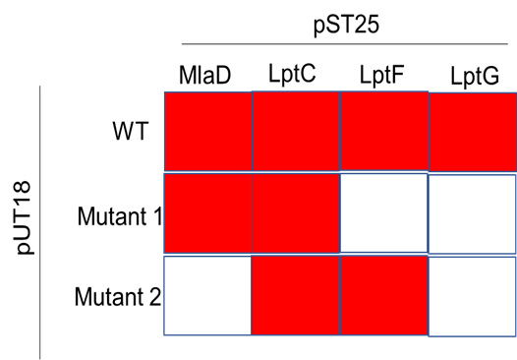

Figure 7. The figure is an example of what a MacConkey Plate would potentially look like with a positive interaction as red and negative interaction as clear, represented by white. The LB/X-gal results would have interaction colony colors of blue for a positive interaction and white for a negative interaction. Image courtesy of Dr. Jitender Mehla.

Some expected pitfalls include possible issues with the cloning vectors and properly getting the transformants of interest. This process is a bit tricky to pick out the correct clones due to the multiple clones involved in the reaction. This can be isolated through selection process by antibiotic resistance but can sometimes have false positives that do not contain the gene of interest.

Troubleshooting may be required when using the co-transformed bacteria such as altering quantities of the entry vector to the destination vector depending on copy number of the vectors. Multiple samples will be required through multiple transformations to attain the mutants of interest however failed co-transformation can be detected earlier with sequencing analysis and alternate methods of plasmid isolation. Also, to avoid false positives in Bacterial two screening, multiple clones, in atleast three independent experiments will be tested.

This study aims to determine the role of conserved amino acids of the LapA protein in its structure and function including protein-protein interactions. The study is limited to two conserved regions and don’t take care of other conserved residues and thus its possible that we don’t see any loss in PPIs. It is also possible that not even a single interaction will be detected in case of a mutant. This may be because of many factors such as true loss in PPIs, or loss in expression or membrane localization. It is also possible that mutant and interacting protein specific loss in PPIs will be seen specifically in case of single amino acid substituition. For example, its possible that one mutant1 don’t interact with LptF but still interact MlaD and LptC. LapA possibly may have multiple interaction sites and may have different roles in the LPS assembly system and may not be detected through this isolated approach. A future analysis approach would be to observe the possible multiple roles in the LPS assembly process by isolated sectional analysis of the interaction proteins. Another alternative approach could be by multiple mutational analysis looking at if two mutated proteins that are known for interaction be involved simultaneously in the biogenesis pathway. Both methodologies could provide insight into the involvement of multiple proteins in the LPS assembly pathway by indicating interactions in vivo with respect to an LPS molecule. Also, additional in vitro methods of detection of PPIs such as pull down assays can be used to test any loss in PPIs in vitro (<https://www.thermofisher.com/us/en/home/life-science/protein-biology/protein-biology-learning-center/protein-biology-resource-library/pierce-protein-methods/overview-protein-protein-interaction-analysis.html>).

**References**

Freinkman, E., Chng, S., & Kahne, D. (2011). The complex that inserts lipopolysaccharide into the bacterial outer membrane forms a two-protein plug-and-barrel. *Preceedings of the National Academy of Sciences, 108(6),* pp. 2486-2491. doi: 10.1073/pnas.1015617108

Frirdich, E., & Whitfield C. (2005). Lipopolysaccharide inner core oligosaccharide structure and outer membrane stability in human pathogens belonging to the Enterobacteriaceae. *Journal of Endotoxin Research, 11(3),* pp. 133-144. doi: [10.1179/096805105X46592](https://doi.org/10.1179/096805105X46592)

Gronow, S., & Brade, H. (2001). Lipopolysaccharide biosynthesis: which steps do bacteria need to survive?. *Journal of Endotoxin Research, 7(1),* pp. 3-22.

Klein, G., Kobylak, N., Lindner, B., Stupak, A., & Raina, S. (2014). Assembly of Lipopolysaccharide in *Escherichia coli* Requires the Essential LapB Heat Shock Protein. *Journal of Biological Chemistry, 289(21),* pp. 14829-14853. doi: 10.1074/jbc.M113.539494

Kotra, L.P., Golemi, D., Amro, N.A., Liu, G., Mobashery, S. (1999). Dynamics of Lipopolysaccharide Assembly on the Surface of *Escherichia coli. Journal of American Chemical Society, 121(38),* pp. 8707-8711. doi: 10.1021/ja991374z

Mahalakshmi, S., Sunayan, M.R., SaiSree, L., & Reddy, M. (2014). *yciM* is an essential gene required for regulation of lipopolysaccharide synthesis in *Escherichia coli.* *Molecular Microbiology, 91(1),* pp. 145-157. doi: 10.1111/mmi.12452

Mehla, J., Caufield, J.H., Sakhawalker, N., & Uetz, P. (2017). A Comparison of Two-Hybrid Approached for Detecting Protein-Protein Interactions. *Methods in Enzymology, 586,* pp. 333-358. doi: 10.1016/bs.mle.10.020.

Mehla, J., & Sood, S.K. (2010) Substantiation in *Entercoccus faecalis* of Dose-Dependent Resistance and Cross Resistance to Pore-Forming Antimicrobial Peptides by Use of a Polydiacetylene-Based Colorimetric Assay. *Applied and Environmental Microbiology,* 77(3), pp. 786-793. doi:10.1128/AEM.01496-10

Missiakas, D., Betton, J.M., & Raina, S. (1996). New components of protein folding in extracytoplasmic compartments of Escherichia coli SurA, FkpA, and Skp/OmpH. *Molecular Microbiology, 21(4),* pp. 871-884. doi: 10.1046/j.1365-2958.1996.561412.x

Polissi, A., & Sperandeo, P. (2014). The Lipopolysaccharide Export Pathway in *Escherichia coli:* Structure, Organization and Regulated Assembly of the Lpt Machinery. *Marine Drugs, 12,* pp. 1023-1042. doi: 10.3390/md12021023

Raetz, C.R.H., & Whitfield, C. (2002). Lipopolysaccharide Endotoxins. *Annual Review of Biochemistry, 71,* pp. 635-700. doi: 10.1146/annurev.biochem.71.1106001.135414

Ruiz, N., Kahna, D., & Silhavy, T.J. (2009). Transport of lipopolysaccharide across the cell envelope: the long road of discovery. *Nature Reviews Microbiology, 7(9),* pp. 677-683. doi: 10.1038/nrmicro2184

Sampson, B.A., Misra, R., & Benson, S.A. (1989). Identification and Characterization of a New Gene of Escherichia Coli K-12 Involved in Outer Membrane Permeability. *Genetics, 122(3),* pp. 491-501.