Inhibition of prion-like properties in alpha-synuclein using promazine derivatives
Shwetha Kochi
- Introduction
Parkinson’s Disease is a neurodegenerative disorder affecting motor function that develops gradually and worsens over time. The most common symptom known is the tremors, or shaking, of the limbs, often hands or fingers. However, late-stage Parkinson’s Disease results in complete loss of motor function. The fact that misfolded proteins and the creation of Lewy Bodies, or protein aggregates composed of misfolded alpha-synuclein, play a role in the mechanism of Parkinson’s Disease has been proposed and analyzed for a while, as this commonly known disease is characterized by the accumulation of alpha-synuclein aggregates in the axons of dopaminergic nerve cells in the substantia nigra and other parts of the central and peripheral nervous systems.²
Alpha-synuclein is a protein that is commonly found in many parts of the body. In the brain, it assists in vesicle formation to release dopamine in the synaptic cleft (between two neurons). When it becomes misfolded, it undergoes a conformational change from an alpha-helical state to an anti-parallel beta sheet state, which allows it to enter the blood brain barrier, and accumulate in the brain. This aggregation forms amyloid fibrils, or protein aggregates, that create Lewy bodies. Olanow & Brundin (2013) concluded that alpha-synuclein’s fibrils/aggregates are possibly taken up by the neuronal axons, transmitted from neuron to neuron, and promote misfolding of host alpha-synuclein, causing neuronal dysfunction and formation of Lewy bodies.¹ These findings are consistent with multiple other studies that conclude alpha-synuclein is a prion-like protein and Parkinson’s Disease is a prion-like disorder.^{1,2,3}
Prions are protein particles composed of irregularly folded proteins that infect regularly folded proteins, causing them to misfold. They cause this infection by misfolding into beta sheet rich conformations that act as a template to promote conformational changes in regularly folded or wild type protein. This infection causes a chain reaction that further leads to neurodegeneration. Moreover, these abnormal proteins can be passed on to unaffected nerve cells, extending the neurodegenerative process.¹
The most well-known prion protein is PrP^{Sc}, the misfolded form of PrP^{C}. Comparison studies between this prion protein and alpha-synuclein showed that both natively exist in the alpha-helix rich conformational state, but, when present in high concentration or near mutant forms, misfold to form beta-sheet rich conformational proteins. Both proteins are prone to aggregation in their mutant forms, whereas their native states are resistant to aggregation.⁴ No inhibitors have been found that prevent or resist this misfolding cascade of alpha-synuclein that results in the creation of Lewy bodies and neurodegeneration. However, multiple studies have been performed on PrP^{Sc} prions that have found potent inhibitors. Because this proposal is focused on studying prion effects that cause neurodegeneration, one main study that focuses on inhibitors that can cross the blood brain barrier will be discussed.
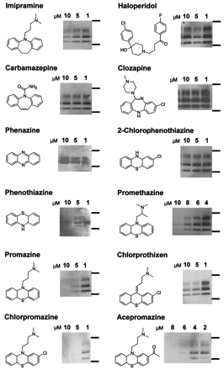
Korth, May, et al. (2001) report that tricyclic derivatives of acridine and phenothiazine show half-maximal inhibition of PrP^{Sc} formation in cultured cells infected chronically with prions.⁵ This study analyzed the inhibition of PrP^{Sc} using 12 different derivatives of phenothiazine and acrimidine: Imipramine, Haloperidol, Carbamazepine, Clozapine, Phenazine, 2-Chlorophenothiazine, Phenothiazine, Promethazine, Promazine, Chlorprothixen, Chlorpromazine, and Acepromazine. 9-substituted acridines were synthesized by reaction with 6,9-dichloro-2-methoxyacridine in phenol because the aliphatic side chains are important in mediating inhibition of prion formation. Neuroblastoma cells were infected with scrapie prions (PrP^{Sc}) and each inhibitor was introduced into each cell line after culturing. Cells were lysed after 80% confluency, and cell lysates were digested with Proteinase K because those that develop beta sheet conformations are resistant to Proteinase K. This allowed the scientists to confirm that the cell lines only contained the aggregated or misfolded prions. The lysates were centrifuged, and the pellets that were at the bottom of the centrifuge tube were removed from the supernatant. These pellets were suspended in buffer, and loaded onto the SDS-PAGE gel. The SDS-PAGE gel was run, and stained with Coomassie Blue to verify total protein content. The gel was introduced with a recombinant human anti-mouse prion protein monoclonal antibody (Fab fragment D13). The recombinant Fab fragment D13 antibody was used because D13 specifically binds to prion proteins. After introduction of the primary antibody and washing, a secondary horseradish peroxidase-labeled (HRP-labeled) Ab was introduced along with tetramethylbenzidine (TMB) membrane substrate. HRP-labeled antibodies bind specifically to primary antibodies and contain an enzyme called horseradish peroxidase. When the enzyme is bound with TMB, it produces a permanent dark blue or black color from the enzyme-substrate reaction, which creates the black bands that we see on the gel.
Figure 1: PrP^{Sc}-inhibiting effects of phenothiazine derivatives and other psychopharmacological substances. Gel results obtained for each inhibitor that was analyzed. All inhibitors were analyzed in multiple different concentrations. (Adapted from Ref 5)
The results from Figure 1 indicated that, at concentrations ranging from 1-10 micromolars, treatment with promazine, chlorpromazine, and acepromazine led to the disappearance of PrP^{Sc} in treated cells after 6-day treatments (lack of black bands as the concentration increased from 1 to 10 micromolars). This lack of black bands at 10 micromolar concentrations for Promazine, Chlorpromazine, and Acepromazine indicates that there are no more aggregated prion proteins left in the sample due to the inhibition by these drugs. Addition of dopamine to cultures of neuroblastoma cells in the presence of chlorpromazine did not reverse inhibition of PrP^{Sc} production. The tricyclic scaffold alone is not enough to inhibit the misfolded protein formation because phenazine, phenothiazine, and 2 chlorphenothiazine did not inhibit PrP^{Sc} formation. Black bands are still prominent from 1-10 micromolar for these three drugs on their respective gels. A side chain substituent on the central ring was necessary, as seen with the three derivatives that did produce inhibition: Promazine, Chlorpromazine, and Acepromazine.⁵
Because, as discussed briefly above, no promazine inhibitors have been studied that inhibit the prion effect found in alpha-synuclein, the aim of this study is to find such potent inhibitors that can cross the blood brain barrier, and resist this misfolding cascade that can lead to the formation of Lewy bodies in the substantia nigra and other regions of the brain, leading to and aiding in the progress of Parkinson’s Disease.
- Experiment
The aim of this experiment is to determine the potency of three different inhibitors on the prevention of aggregated alpha-synuclein (or prion like alpha synuclein formation) beginning with the overexpression of alpha-synuclein in E. coli (BL21) in order to produce large amounts of the protein of interest (alpha-synuclein). If large concentrations of protein are created, this leads to larger chances for mutation and conformational changes that cause the prion-like effect of alpha-synuclein which we are planning on inhibiting. This also increases our sample size of alpha-synuclein. After overexpression of alpha-synuclein in bacteria, the protein will be purified using anion exchange chromatography, in which all other bacterial components will be separated from the alpha-synuclein protein. The purified protein will then be forced to aggregate and form amyloid fibrils through protein misfolding cyclic amplification (PMCA). PMCA will result in the creation of chronically aggregated alpha-synuclein. This chronically aggregated alpha-synuclein will undergo anti-aggregation drug screening via an aggregation assay called Thioflavin T (ThT) Assay after the introduction of the three inhibitors. The ThT Assay, which will be discussed in more detail later, will provide results that indicate the potency of each inhibitor that will be analyzed in this study by showing how much aggregated alpha-synuclein each sample contains.
II.a Overexpression of Alpha-Synuclein
First, alpha-synuclein needs to be overexpressed in bacteria in order to produce large amounts of alpha-synuclein to analyze throughout the study. BL21 (DE3) is a strain of E. coli used in the overexpression of protein that carries a copy of the phage T7 RNA Polymerase gene and the lacI gene from the lactose operon that codes for the lac repressor (LacI). pET21a is a plasmid that carries a gene encoding human alpha-synuclein, the lacI gene (same as in the bacteria), and a T7 promotor region. When the bacteria are transformed with pET21a (transformation is explained below), the plasmid supplements, but does not replace, the bacterial genome.
Transformation is the process in which a bacterial cell of any kind (in this case, E. coli) takes up foreign DNA (in this case, pET21a) and expresses this genetic information. The four steps in the transformation process are: competent cell preparation, transformation, recovery, and plating. Premade competent cells of the BL21 (DE3) E. coli strain will be bought commercially, and will undergo transformation via heat-shock. E. coli cells will be mixed with pET21a and incubated on ice for about 15 minutes⁷. Heat shock will be performed at 37 degrees Celsius for 30 seconds, and returned to ice for 2-3 minutes. After transformation, cells will be recovered by culturing in liquid S.O.C. medium to express the gene from the pET21a. Cells will be plated thereafter.
After all the bacterial cells contain the plasmid’s genetic information, the E. coli T7 RNA Polymerase that transcribes the mRNA to make all the necessary proteins cannot recognize the promotor in front of the alpha-synuclein gene because the lac repressor (LacI) blocks the T7 RNA Polymerase from binding to the T7 promotor region. LacI can only be removed from the operator region, and stopped from blocking the T7 promotor region, in the presence of lactose. IPTG, a lactose derivative, is used to keep LacI from blocking T7 RNA Polymerase from binding to the promotor region. IPTG is not used in any metabolic pathways, so it won’t be broken down and used by the cell. This ensures that the concentration stays constant, making it more useful than lactose itself.
Once LacI can no longer bind to the operator, the T7 RNA polymerase protein is expressed, and binds to the T7 promoter region upstream from whatever gene was added to the plasmid (alpha synuclein, in this case). After binding to the T7 promotor region, RNA polymerase begins transcribing the alpha-synuclein in high numbers. Figure 2 gives a diagram of the mechanism that I described above in a generalized format. The bacterial genome shown is the BL21 (DE3) E. coli strain that will be used. The plasmid shown is the pET21a that will be used. The gene of interest in the plasmid will be human alpha-synuclein.
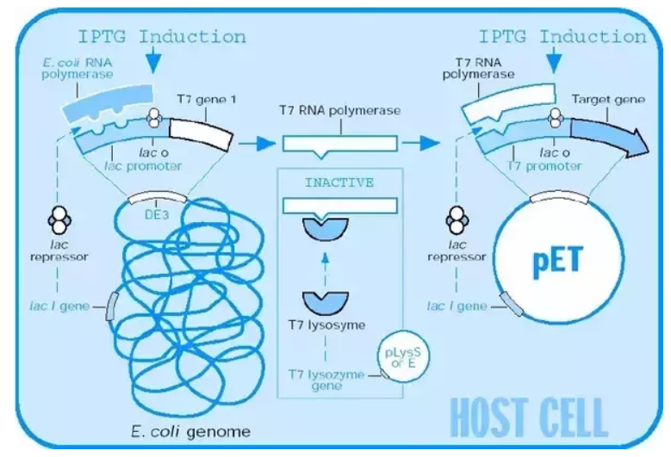
Figure 2: Mechanism of IPTG Induction in the BL21 (DE3) E. coli strain host cell. Adapted from Novagen pET expression manual.
II.b Alpha-synuclein Purification via Anion Exchange Chromatography
The bacterial cells expressing the alpha-synuclein gene that were plated earlier and harvested will be suspended in Tris/EDTA buffer, lysed at 4 degrees Celsius in order to break apart the cell membranes, and centrifuged. The alpha-synuclein will be purified from the lysate supernatant using anion exchange chromatography. Anion exchange chromatography follows the mechanism shown in Figure 3. Ion exchange chromatography separates ions based on charge, and can be separated into two types of exchange: anion and cation. Because alpha-synuclein is a largely negative charge, anion exchange chromatography will be employed. The negatively charged alpha-synuclein will bind to the cation surfaces while the rest of the cell components separate out. After collecting these extra components, the alpha-synuclein can be eluted with NaCl (salt solution). The Cl- ions from the salt solution will take the place of alpha-synuclein in the tube, and the alpha-synuclein will elute out of the column.
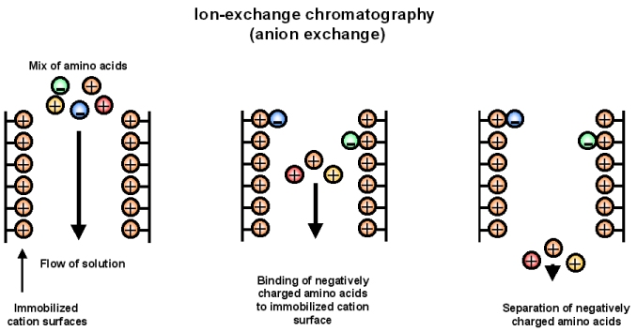
Figure 3: Mechanism of Anion-Exchange Chromatography. Adapted from LibreText Libraries.
After the alpha-synuclein is separated out, it will be concentrated and separated into 24 aliquots to be used in the upcoming experiment.
II.c Protein Misfolding Cyclic Amplification (PMCA)
In order to analyze whether an inhibitor prevents the aggregation and misfolding of alpha-synuclein, we must first create chronically aggregated alpha-synuclein that can be used for inhibitor testing. Herva, Zibaee, et al. (2014) developed a method in which the protein misfolding cyclic amplification technique, used for amplifying prion aggregates, was adapted to grow alpha-synuclein aggregates.⁷
PMCA follows the mechanism shown in Figure 4 below. The procedure will be carried out by subjecting purified alpha-synuclein to repeated cycles of sonication and incubation after separation of the purified alpha-synuclein into aliquots. In the beginning of the procedure, there will be large concentrations of recombinant alpha-synuclein (regularly folded protein) and a small concentration of misfolded alpha-synuclein. The mechanism behind why alpha-synuclein misfolds is still largely unknown, but it is suspected that overexpression of the protein can lead to mutations which cause the misfolding to occur. After the protein is sonicated, causing the aggregated alpha-synuclein to break apart, there is an increased surface area to which the regularly folded alpha-synuclein can bind and undergo a conformational change into the misfolded alpha-synuclein during incubation. After multiple cycles of this sonication and incubation, the result will be a group of chronically aggregated alpha-synuclein.
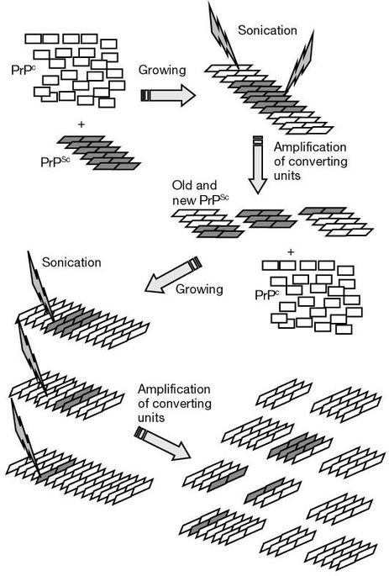
Figure 4: Mechanism of protein misfolding cyclic amplification (PMCA). Adapted from Ref 11.
II.d Introduction of Inhibitors to PMCA
The three inhibitors that will be studied in this experiment are promazine, chlorpromazine, and acepromazine. These derivatives of promazine were found to be most potent in inhibiting prion activity in the study performed by Korth, May, et al. (2001) and they are able to cross the blood brain barrier. The blood brain barrier is formed by tight junctions between endothelial cells that create a highly selective barrier between the brain and the rest of the body. These endothelial cells allow passage of water, a few certain gases, and lipid-soluble molecules by passive diffusion. They also allow passage of glucose and amino acids through selective, or active, transport. Because of this, the general rule is that the higher the lipophilicity (lipid-solubility) of a substance, the greater the diffusion across the blood brain barrier. Promazine, Chlorpromazine, and Acepromazine are all highly lipophilic (lipid-soluble) due to their aliphatic side chains, numerous hydrocarbons, and low polarities.
In order to find which concentration of these inhibitors would be most potent in inhibiting alpha-synuclein (assuming they do inhibit alpha-synuclein), we analyze two different concentrations of each inhibitor: one at 2 micromolars and one at 10 micromolars. These two concentrations were chosen due to that being the range in concentration that worked best in inhibiting prion activity in the study (Korth, May, et al. (2001)) that was discussed in detail in the introduction.⁵ The inhibitors will be diluted in DMSO to produce these two different concentrations, and will be introduced to the aliquots of PMCA alpha-synuclein.
The reaction mixtures will be performed in triplicate (3 mixtures total of 2 micromolar concentrations of inhibitors in triplicates + 3 mixtures total of 10 micromolar concentrations of inhibitors in triplicates + 2 control groups in triplicates = 24 reaction mixtures = 24 aliquots). There will be two control groups: one that contains just alpha-synuclein (in order to normalize the data generated) and one that contains just DMSO (in order to confirm that DMSO, the solution used to dilute the inhibitors, did not affect the alpha-synuclein PMCA).
II.e Thioflavin T Assay
5 microliters from each sample will be added to 495 microliters of Thioflavin T solution after the introduction of inhibitors and fluorescence will be measured using a spectrophotometer with 450 nm excitation and 480 nm emission settings (settings determined by study performed by Herva, Zibaee, et al. (2014))⁷. Thioflavin T is a benzathiole stain that binds to the beta sheet amyloid fibrils and fluoresces with binding. This assay was used as a measurement for aggregation and described in detail by Wolfe, et al. (2010) and Biancalana and Koide (2010)^{9,10}. Thioflavin T has free rotation of the carbon bond between the molecule’s rings causing electrons to remain in the stable state (instead of the excited state) when exposed to photons. This is why Thioflavin T is low in fluorescence when it’s not bound to anything. However, when it binds to amyloid fibrils, the molecule’s free rotation is destroyed and the molecule becomes locked in place, allowing electrons to freely enter their excited state when exposed to photons. This causes fluorescence to increase. % Thioflavin Signal/Fluorescence will be analyzed in order to determine which inhibitors are potent in inhibiting aggregation of alpha-synuclein. Samples will be incubated for 30 minutes. After 30 minutes, another ThT Assay will be performed in order to compare with the fluorescence at the beginning of the reaction.
The potency of the inhibitors analyzed will be confirmed by % ThT signals collected by the ThT assays performed at the beginning of the reaction and 30 minutes after incubation.
- Discussion
If the experiment follows the hypothesis that all three of the inhibitors will be successful in inhibiting alpha-synuclein aggregation, then the results will show that the % ThT signals will be low for all reaction mixtures in the assay done 30 minutes after incubation due to the decreased concentrations of aggregated alpha-synuclein binding to the Thioflavin T. From these results, I will be highly likely to draw a conclusion that the inhibitors do inhibit the aggregation of alpha-synuclein. However, there is also the possibility that these results will not be obtained, and, instead, there will be high % ThT signals indicating that the aggregated alpha-synuclein still exists in the same concentration level as before. This would indicate that the inhibitors were unsuccessful in inhibiting the aggregation of alpha-synuclein.
Once these inhibitors are analyzed with this study to determine if they are successful in resisting aggregation of alpha-synuclein, then future studies can be performed to better understand the mechanisms behind the inhibition. This can be done by Transmission Electron Microscopy or other forms of immunofluorescence or X-Ray Crystallography images can be taken of the aggregated alpha-synuclein and inhibitor reaction as time progresses. The images can be analyzed like a comic strip to see the mechanism occur first hand, if possible. These methods may or may not be viable. Regardless, the future studies that can be performed after this one will have the common goal of determining the mechanism behind which this inhibition occurs.
- References
1. Olanow, C. W., & Brundin, P. (2013). Parkinsons Disease and Alpha Synuclein: Is Parkinsons Disease a Prion-Like Disorder? Movement Disorders, 28(1), 31-40. doi:10.1002/mds.25373
2. Brundin, P., & Melki, R. (2017). Prying into the Prion Hypothesis for Parkinsons Disease. The Journal of Neuroscience, 37(41), 9808-9818. doi:10.1523/jneurosci.1788-16.2017
3. Prusiner, S. B. (2012). A Unifying Role for Prions in Neurodegenerative Diseases. Science,336(6088), 1511-1513. doi:10.1126/science.1222951
4. Bartels, T., Choi, J. G., & Selkoe, D. J. (2011). α-Synuclein occurs physiologically as a helically folded tetramer that resists aggregation. Nature,477(7362), 107-110. doi:10.1038/nature10324
5. Korth, C., May, B. C., Cohen, F. E., & Prusiner, S. B. (2001). Acridine and phenothiazine derivatives as pharmacotherapeutics for prion disease. Proceedings of the National Academy of Sciences,98(17), 9836-9841. doi:10.1073/pnas.161274798
6. Cornford, E. M., Young, D., & Paxton, J. W. (1992). Comparison of the blood-brain barrier and liver penetration of acridine antitumor drugs. Cancer Chemotherapy and Pharmacology,29(6), 439-444. doi:10.1007/bf00684844
7. Herva, M. E., Zibaee, S., Fraser, G., Barker, R. A., Goedert, M., & Spillantini, M. G. (2014). Anti-amyloid Compounds Inhibit α-Synuclein Aggregation Induced by Protein Misfolding Cyclic Amplification (PMCA). Journal of Biological Chemistry, 289(17), 11897-11905. doi:10.1074/jbc.m113.542340
8. Jakes, R., Spillantini, M. G., & Goedert, M. (1994). Identification of two distinct synucleins from human brain. FEBS Letters, 345(1), 27-32. doi:10.1016/0014-5793(94)00395-5
9. Biancalana, M., Koide, S. (2010). Molecular mechanism of Thioflavin-T binding to amyloid fibrils. Biochimica et Biophysica Acta – Proteins and Proteomics, 1804(7): 1405-1412.
10. Wolfe, L. S., Calabrese, M. F., Nath, A., Blaho, D. V., Miranker, A. D., & Xiong, Y. (2010). Protein-induced photophysical changes to the amyloid indicator dye thioflavin T. Proceedings of the National Academy of Sciences of the United States of America, 107(39), 16863–16868.
11. Saborio, G. P., Permanne, B., & Soto, C. (2001). Sensitive detection of pathological prion protein by cyclic amplification of protein misfolding. Nature, 411(6839), 810-813. doi:10.1038/35081095

