The Role of G_{βγ} in Adenylyl Cyclase Super Activation
Following Chronic Morphine Exposure
- Introduction

For decades, opioids have been used in health care as the primary pain reliever for chronic or severely debilitating pain. From morphine to street drugs such as heroin, opioids are available in pills, liquids, and shots and are extremely widespread and accessible.
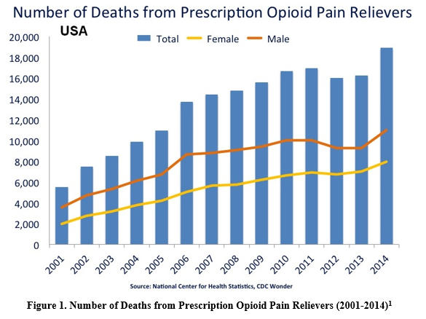
Drug overdose is now the leading cause of accidental death in the United States with over 50,000 drug overdose deaths in 2015, 32,000 of those relating to opioid overdose¹. As powerful and helpful opioids may be in a controlled health care setting, the risk of opioid abuse and dependency is relatively high compared to most drugs, with 23% of individuals using heroin once, forming an eventual opioid addiction.² Furthermore, the volume of total prescribed opioids has increased 600% from 1997 to 2007.³ Similarly, the prescribing rate for opioids among adolescents and young adults nearly doubled from 1994 to 2007.⁴
When attempting to understand the opioid abuse epidemic in the United States today, the tolerance and withdrawal effects that follow chronic opioid exposure must be discussed. Opioid’s have a high tolerance, meaning that the dose required one day to provide analgesic effects will be higher on the following days as the body becomes tolerant to the analgesic effects of opioids.⁵ Thus, those prescribed opioids feel the need to take more of their medication or seek medication through illegal avenues. Furthermore, when an individual ceases opioid use after chronic use, the withdrawal effects are severe and include vomiting, diarrhea, muscle aches and shaking, as well as suicidal ideations. These symptoms usually peak 2-3 days after the last dose, and usually take over a week to fully subside.⁶
Combined together, opioid tolerance and withdrawal symptoms are powerful agents leading to opioid drug abuse, leading researchers to look at the molecular pathways that mediate opioid tolerance and withdrawal. One of the proposed major mechanisms of tolerance and withdrawal is the cyclic AMP-protein kinase A (PKA) pathway. Sharma et al. (1975) first suggested the mechanism for tolerance through the cAMP-PKA pathway¹³. Sharma et al. hypothesized that the dependence and tolerance of opiates could be the result from an increase in adenylate cyclase, the enzyme responsible for cAMP creation, or the continued presence of an adenylyl cyclase effector that inhibits cAMP production initially, but with chronic morphine exposure, later leads to adenylate cyclase super activation leading to cAMP overshoot following opioid withdrawal. ⁷ This dependency and tolerance hypothesis came from the fact that it was known that adenylate cyclase converted ATP to cyclic AMP (cAMP), a secondary messenger molecule used to activate Protein Kinase A, which was responsible for activating a multitude of intracellular pathways that may be responsible for the creation of tolerance such as neurotransmitter release.^{5,7}
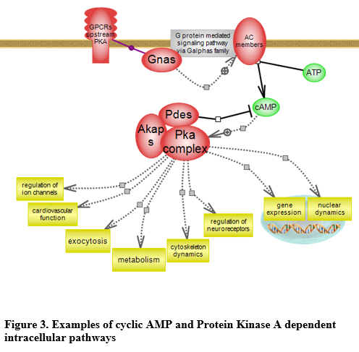
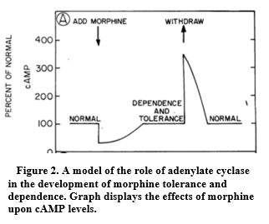
Figure 2⁷ from Sharma et al. outlines the hypothesized effect of opioid receptor binding on Adenylate Cyclase and cAMP levels that Sharma et al. set out to prove by exposing neuroblastoma x glioma hybrid cell cultures to morphine and measuring cAMP levels. The results showed that the addition of morphine inhibited cAMP levels by more than 90% throughout a 4-hour incubation period. This explained the acute effects of morphine, but the study also looked at incubation that lasted 48 hours. The results showed that after chronic opioid exposure, the addicted cells had built a tolerance to the morphine in 48 hours that allowed adenylate cyclase to create enough cAMP to return to basal levels. When naloxone, an opioid antagonist, was added cAMP greatly increased past the control levels, almost 500% greater. Sharma et al. suggested that while morphine inhibits the adenylate cyclase activity, over time the inhibition is masked by a compensatory increase in the activity of adenylyl cyclase that returns cAMP levels to basal levels acutely and ultimately causes cAMP overshoot after withdrawal or antagonist exposure.⁷ The overshoot of cAMP levels following withdrawal or exposure to an antagonist such as Naloxone causes PKA pathways, such as cardiovascular function and regulation of neurotransmitter receptors as depicted in Figure 3⁸, to lose their regulation and lead to the physiological withdrawal symptoms.⁵
This idea was furthered by Avidor-Reiss et al. (1996) who found that the adenylate cyclase inhibition was caused by Gα₀. Gα₀ is part of the G_{i} family of subunits, a subset of G_{α} subunits responsible for adenylate cyclase inhibition¹³. Table 1 offers an overview of the relevant G protein subunit families and their functions. Avidor-Reiss et al. sought to find which G_{i} subunits, including Gα₀, Gα_{i1}, Gα_{i2}, and Gαi_{3,}⁹ were involved in mediating acute morphine inhibition of adenylyl cyclase. Avidor-Reiss et al. found that only inhibition Gα₀ resulted in no adenylyl cyclase inhibition and thus no drop in cAMP levels.⁹ Thus adenylate cyclase inhibition is caused specifically by the Gα₀ subunit. Furthermore, Avidor-Reiss et al. (1996) suggested that super activation of adenylate cyclase after chronic morphine exposure might involve a secondary mechanism through G_{βγ} via a mechanism that remains to be determined.⁹

Table 1. Relevant G-Protein Families and Functions
G-protein subunit | Function
G_{αs} | Stimulates adenylate cyclase¹²
G_{αi} | Includes Gα₀, Gα_{i1}, Gα_{i2}, and Gαi_{3,} inhibits adenylate cyclase⁹
G_{βγ} | Scaffolding protein that activates or inhibits several protein kinases depending on the bound effector¹⁵

G_{βγ} is an essential subunit in the G-protein coupled receptor cascade and has two main states that provide different functions. The first state is when G_{βγ} is bound to G_{α.} G_{βγ} serves as a negative regulator preventing G_{α} subunits, such as Gα₀ inhibiting adenylate cyclase, from activating their pathways. When a ligand, such as morphine, binds to its GPCR related receptor, in this case, the μ-opioid receptor, G_{βγ} and the specific G_{α} subunit activated by the ligand, in this case Gα_{0,} separate. Once separated, both G_{βγ} and the accompanying G_{α} subunit participate in their own distinct signaling pathways.¹⁵
This proposal seeks to determine if adenylate cyclase super activation is mediated through the G_{βγ} subunit activation. The proposal also seeks to find if inhibition of G_{βγ} attenuates adenylate cyclase super activation and thus lack of cAMP overshoot.

- Experiment

The aim of this experiment is to determine if adenylate cyclase super activation is mediated through G_{βγ} stimulation of an unknown protein kinase that is suspected to phosphorylate and thus activate G_{αs}¹³, the stimulatory subunit for adenylyl cyclase, following chronic morphine exposure. This proposal also seeks to find if inhibition of G_{βγ} can cause attenuation of withdrawal by preventing adenylate super activation and thus preventing cAMP overshoot upon opioid withdrawal.
This experiment will be accomplished by measuring cAMP levels over time in a neuroblastoma x glioma hybrid cell culture exposed to morphine for 48 hours in order to create the control cAMP levels to be compared to. Then another neuroblastoma x glioma hybrid cell culture will be exposed to morphine for 48 hours in order to simulate chronic morphine exposure but will also have inhibited G_{βγ.} Both cell cultures will have their cAMP levels charted over time in order to find the time-dependent super activation of adenylate cyclase and to see whether or not adenylate cyclase super activation and thus cAMP overshoot can be attenuated following inhibition of the G_{βγ} subunit. Essentially, this experiment will allow the Gα₀ subunit to inhibit adenylate cyclase as usual in the first few hours of morphine exposure, as demonstrated in Avidor-Reiss et al. but will see whether or not the cAMP overshoot caused by chronic morphine exposure can be attenuated by inhibiting the G_{βγ} subunit.

Part A: Inhibition of the G_{βγ} subunit

Inhibition of the G_{βγ} subunit will be accomplished through the use of M119, a small molecule competitive inhibitor of the G_{βγ} subunit that binds to the G_{βγ} “hot spot” via a reversible noncovalent mechanism¹⁵. The G_{β} subunit belongs to a family of WD40 repeat proteins with a circular β-bladed propeller structure as seen in Figure 4¹⁵. WD40 repeat is a structural motif of 40 amino acids terminating in a tryptophan-aspartic acid (W-D) dipeptide¹⁷. This structure allows a broad range of proteins to bind to the center of the propeller structure known as the “hot spot”. M119 will be prepared as 50mM stocks in dimethyl sulfide¹⁴ and will be added to one of the neuroblastoma x glioma hybrid cell culture prior to exposure to morphine in order to inhibit G_{βγ}.
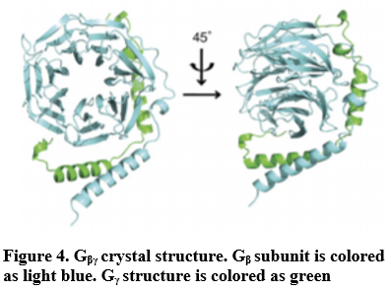

Part B: cyclic-AMP Assay

Cyclic-AMP will be measured through a cAMP assay as demonstrated by Gilman (1970). The neuroblastoma x glioma hybrid cell cultures from the plates are individually placed in a suspension and centrifuged, with each supernatant fraction being placed in an elution column to elute cAMP. Each dried sample was then assayed to measure cAMP. The assay uses cAMP dependent protein kinase along with an inhibitor of cAMP-dependent Protein Kinase that increased the affinity for cAMP in the kinase.¹⁰
The cAMP that was eluted is placed in the assay where it binds to the cAMP-dependent protein kinases that had already previously bonded to [H₃]cAMP, thus displacing the [H₃]cAMP. The amount of [H₃] cAMP that was displaced is measured through radioactivity and cross referenced with standard curves for the cAMP assay created by Gilman (1970), where different known quantities of cAMP were added and the displaced [H₃]cAMP was charted to create a standard curve.¹⁰ Figure 5¹⁰ shows the standard curve used for the cAMP assay.
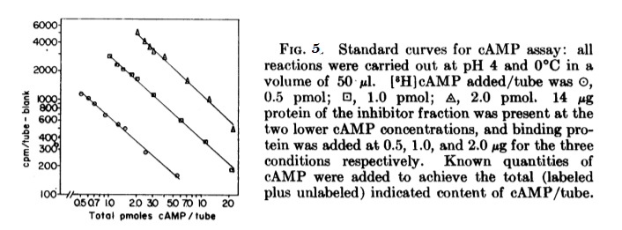

The neuroblastoma x glioma hybrid cells from both cultures will be exposed to chronic morphine for 48 hours, and will then be exposed to a Naloxone, opioid antagonist, in order to simulate withdrawal. The control group will be left exposed to the chronic morphine for the same time and will be exposed to an opioid antagonist at the same time as the G_{βγ} knockout cell culture. Each group will have their cAMP measured at various time intervals in order to create a cAMP accumulation chart similar to Figure 1⁷ from Sharma et al. (1975).

III. Discussion

The possible results are time-based graphs yielding the control cAMP measured levels to be compared to the time-based cAMP graph from the G_{βγ} inhibited neuroblastoma x glioma hybrid cells.
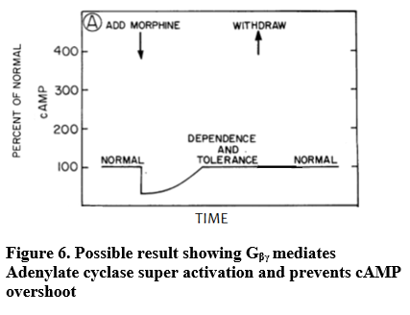
If G_{βγ} is involved in the mediation of adenylate cyclase super activation, then the time-based cAMP graph will show that the initial inhibition of cAMP returns to basal levels through μ-opioid receptor desensitization and downregulation¹⁶ but adenylate cyclase super activation and cAMP do not occur, as seen in Figure 6.
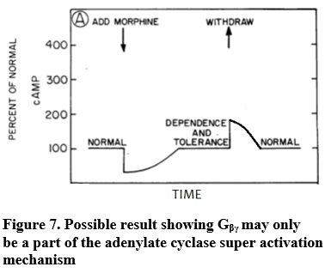
Another possible result is that the cAMP levels return to basal levels but the cAMP overshoot is only slightly decreased as seen in Figure 7, meaning that G_{βγ} is part of a secondary mechanism that contributes to adenylate cyclase super activation.
Furthermore, it is also possible that the knockout of G_{βγ} has no effect on adenylate cyclase super activation pathway and the cAMP levels will match those from the control cells as seen in Figure 8, showing no attenuation of cAMP overshoot. This would imply that G_{βγ} has no role in adenylate cyclase super activation.
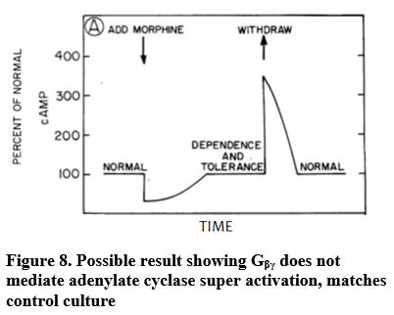
The implication from these possible results is that if cAMP overshoot and adenylate cyclase super activation never occur, then the main mechanisms for adenylate super activation following chronic opioid exposure is dependent on G_{βγ.} The exact mechanism would be yet to be determined but it would lean strongly towards G_{βγ} activating a downstream kinase that phosphorylates G_{αs}, the main activator of adenylate cyclase. This experiment would also serve to shed light on the time-dependent nature of adenylate super activation. Through a time-dependent graph, it may provide new information as to exactly when adenylate super activation starts.
There are a few drawbacks and issues with this experiment. First, the results of this experiment and new information on the G_{βγ} pathway and its effects on adenylate cyclase super activation may not have any immediate drug uses. Inhibition of G_{βγ} may likely lead to unintended side effects of PKA pathways through disruptive changes in the cAMP pathway, however, further information to the mechanism may lead to future research that is able to pinpoint a step in the mechanism that could be inhibited or treated without leading to severe side effects. Furthermore, it is unknown which opioid receptors this pathway may be specific to, if any, considering there are 3 main opioid receptors, the mu receptor, kappa receptor, and delta receptor.¹¹ In the case of this experiment, only the mu opioid receptor is being targeted by morphine. Furthermore, it is possible that the entire cAMP pathway, and more specifically adenylate cyclase super activation is mediated by multiple mechanisms that could be disrupted by the G_{βγ} leading us to draw inaccurate conclusions from the results.
Ultimately, this experiment seeks to provide results that shed light on the role of G_{βγ} in adenylyl cyclase super activation following chronic morphine exposure for future drug use that may lead to attenuation of cAMP overshoot and thus withdrawal symptoms, without losing the analgesic effects of morphine in order to provide safer use of morphine in health care.

References

1. National Institute on Drug Abuse. (2015). Drugs of Abuse: Opioids. Bethesda, MD: National Institute on Drug Abuse. Available at http://www.drugabuse.gov/drugs-abuse/opioids.

2. National Institute on Drug Abuse. (2014). Drug Facts: Heroin. Bethesda, MD: National Institute on Drug Abuse. Available at http://www.drugabuse.gov/publications/drugfacts/heroin.

3. Centers for Disease Control and Prevention Grand rounds: Prescription Drug Overdoses: A U.S. Epidemic. http://www.cdc.gov/mmwr/preview/mmwrhtml/mm6101a3.htm

4. Fortuna RJ, Robbins BW, Caiola E, Joynt M, Halterman JS. Prescribing of controlled medications to adolescents and young adults in the United States. Pediatrics. 2010;126(6):1108-1116. https://www.ncbi.nlm.nih.gov/pubmed/21115581

5. Bie, B et al “CAMP-Mediated Mechanisms for Pain Sensitization during Opioid Withdrawal.” Journal of Neuroscience 25.15 (2005): 3824–3832. doi:10.1523/jneurosci.5010-04.2005. https://www.ncbi.nlm.nih.gov/pubmed/15829634

6. U.S. National Library of Medicine: MedlinePlus. (2016). Opiate and Opioid Withdrawal. https://medlineplus.gov/ency/article/000949.htm

7. Sharma, S K, W A Klee, and M Nirenberg. “Dual Regulation of Adenylate Cyclase Accounts for Narcotic Dependence and Tolerance.” Proceedings of the National Academy of Sciences of the United States of America 72.8 (1975): 3092–3096. Print. https://www.ncbi.nlm.nih.gov/pmc/articles/PMC432926/

8. Medical College of Wisconsin. “Protein Kinase A (PKA) Signaling Pathway.”Rat Genome Database, Medical College of Wisconsin, https://www.rgd.mcw.edu/rgdweb/pathway/pathwayRecord.html?acc_id=PW:0000543

9. Avidor-Reiss, Tomer, et al. “Chronic Opioid Treatment Induces Adenylyl Cyclase V Superactivation.” Journal of Biological Chemistry, vol. 271, no. 35, 1996, pp. 21309–21315., doi:10.1074/jbc.271.35.21309. https://www.ncbi.nlm.nih.gov/pubmed/8702909

10. Gilman, Alfred G. “A Protein Binding Assay for Adenosine 3′:5′-Cyclic Monophosphate.” Proceedings of the National Academy of Sciences of the United States of America 67.1 (1970): 305–312. Print. https://www.ncbi.nlm.nih.gov/pmc/articles/PMC283204/

11. Feng, Yuan et al. “Current Research on Opioid Receptor Function.” Current Drug Targets 13.2 (2012): 230–246. Print. https://www.ncbi.nlm.nih.gov/pmc/articles/PMC3371376/

12. University College, London, United Kingdom, “G-Protein Alpha Subunit, Group S.” G-Protein Alpha Subunit, Group S . www.ebi.ac.uk/interpro/entry/IPR000367.

13. Chan, Patrick, and Kabirullah Lutfy. “Molecular Changes in Opioid Addiction: The Role of Adenylyl Cyclase and CAMP/PKA System.” Progress in Molecular Biology and Translational Science The Molecular Basis of Drug Addiction, 2016, pp. 203–227., doi:10.1016/bs.pmbts.2015.10.005.

14. Surve, Chinmay R., et al. “A Chemical Biology Approach Demonstrates G Protein Beta-Gamma Subunits Are Sufficient to Mediate Directional Neutrophil Chemotaxis.” Journal of Biological Chemistry, vol. 289, no. 25, July 2014, pp. 17791–17801., doi:10.1074/jbc.m114.576827.

15. Lin, Y., and A. V. Smrcka. “Understanding Molecular Recognition by G Protein Beta-Gamma Subunits on the Path to Pharmacological Targeting.” Molecular Pharmacology, vol. 80, no. 4, July 2011, pp. 551–557., doi:10.1124/mol.111.073072.

16. Law PY, Loh HH. delta-Opioid receptor activates cAMP phosphodiesterase activities in neuroblastoma glioma NG108-15 hybrid cells. Mol Pharmacol. 1993;43(5):684–693.

17. Neer EJ, Schmidt CJ, Nambudripad R, Smith TF (September 1994). "The ancient regulatory-protein family of WD-repeat proteins". Nature. 371 (6495): 297–300. doi:10.1038/371297a0

