Introduction
About 610,000 people die of cardiovascular disease in the United States every year (CDC. 2017). It is the leading cause of death in the United States and is responsible for 17% of the United States’ national health costs (Heidenreich, et al. 2011). It is imperative to find better and more effective solutions to combat Cardiovascular disease in the United States to save lives and money. One possible solution to combat Cardiovascular disease is to harness a form of heart regeneration similar to that of zebrafish and apply that to humans. Unfortunately, injury to the human heart does not regenerate but rather results in scarring (Laflamme and Murry. 2017). Unlike humans, many lower vertebrates, like zebrafish, when injured, are able to regenerate limbs, appendages or internal organs. The Zebrafish is a perfect model organism to use for this study because they are one of the few organisms that possess the unique ability of cardiac regeneration (Lepilina et al. 2006). Zebrafish hearts are able to fully regenerate following cardiac injury of which corresponds to a loss of approximately 20% of the total ventricular mass. In the low-pressure fish heart, this large wound is effectively sealed by an initial fibrin clot, which is gradually replaced by de novo regenerated heart tissue (Laflamme and Murry. 2017). Conveniently, zebrafish are also transparent in the embryo stage which makes it very easy to study heart development or heart regeneration. The T-box family of transcription factors is a group of genes that play important roles in development of both vertebrate and invertebrate embryos (Smith. 1999). These T-box genes take part in controlling gastrulation, development of limbs, and the development of the heart. Mutations in these transcription factors are known to cause heart defects and can inhibit development (Horb et al. 1999). There are about 14 different t-box genes. This study will focus only on the t-box gene, tbx5, because it has already been extensively studied and known to be one of the few t-box genes expressed in developing of the heart, tbx20 being the other.
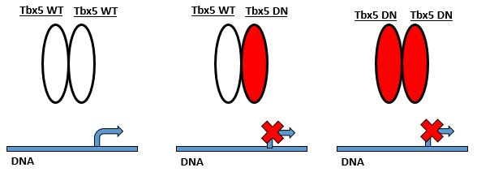
A dominant negative mutation is a type of mutation that alters the protein so that it interferes with the function of the wild-type protein (Veitia. 2007). Tbx5 normally forms a dimer where it can then bind to DNA and turn on transcription genes (Figure 1A.). A tbx5 dominant negative protein will interfere with the
C.

B.

A.

Figure 1.

wild-type protein by competing for binding of DNA regulatory elements, inhibiting target genes expression (Figure 1B. and Figure 1C.). This strategy of using a tbx5 Dominant Negative (tbx5DN) has been proven effective at inhibiting the function of tbx5 (Horb and Thomsen, 1999; Rallis, Charalampos, et al., 2003).
Tbx5 is directly involved in the initiation of vertebrate limb and heart development (Takeuchi, et al). The expression of the tbx5DN before development of the heart can begin would kill the zebrafish (Smith. 1999; Garrity, et al., 2002). Before the tbx5DN can be expressed, the zebrafish need to survive till the adult stage which is about 60 days post fertilization (dfp). Therefore a process called Cre-lox recombination will be used to temporally control of when the tbx5DN is expressed. In this study, through the use of the tbx5DN, we will determine if the transcription factor, tbx5, is necessary for zebrafish myocardial regeneration in response to surgical injury.
Experiment
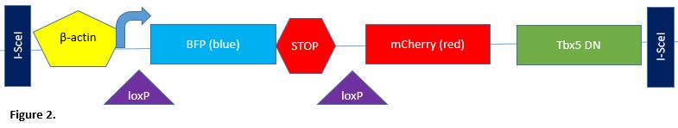
Heterozygous zebrafish which contain the cmlc2-creEr(T2) transgene and wild-type zebrafish embryos to generate the tbx5DN trangene will be purchased from the Zebrafish International Research Center. The tbx5DN will be created identically to the tbx5DN that was created in Horb and Thomsen (1999)’s experiment. In this paper the tbx5DN can be constructed using standard cloning procedures. This is done by removing the C-terminal region, which encodes a transcriptional activation domain in other T-domain proteins and replacing and ligating a repressor domain of the Drosophila Engrailed gene to the tbx5 sequence (Horb and Thomsen, 1999). Once the transgene has been constructed, standard molecular cloning techniques will be used to generate the final expression vector it is then injected into the zebrafish embryos thus obtaining the transgenic line (bactin2:loxP-mTagBFP-STOP-loxP-mCherry-tbx5DN). Due to the low frequency of transgenesis when circular plasmid DNA alone is injected into the one-cell stage embryo, the transgene construct is designed with recognition sites for I-SceI and co-injected with this enzyme (Figure 2.). I-SceI is a meganuclease that cuts both strands of the DNA at its recognition site, maintaining it in linear form and thus increasing the transgenesis frequency (Thermes, et al., 2002). The tbx5DN transgenic line of zebrafish can be identified by the blue fluorescent protein (BFP) that is part of the transgenic line. BFP is a protein that will cause the embryo to give off a blue fluorescence.
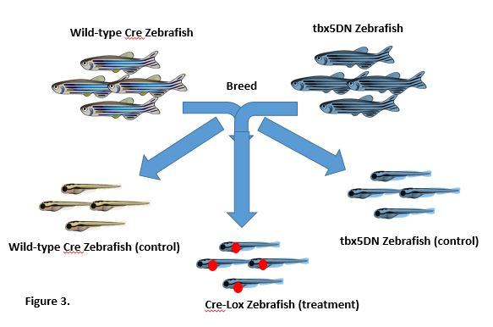
The cmlc2-CreER(T2) transgene line is made up of the Cardiac Myosin Light Chain 2(cmlc2) and promoter is what drives the CreER(T2) expression, gives spatial control and restricts Cre to the heart. However, this process can only be achieved through the distribution of the hormone, 4-hydroxytamoxifen (4HT). CreER(T2) is retained by the Heat Shock Protein 90 (hsp90) in the cytosol until 4HT is added to the water. Hsp90 is a chaperone protein that is required for stability and function of many activated or expressed signaling proteins. The ER(T2) in CreER(T2) is the hormone binding domain of the estrogen receptor, which causes the fusion protein (CreER(T2)) to be regulated in the same way as the native estrogen receptor. However, ER(T2) is a modification of the native estrogen receptor in that it has a greater affinity towards the hormone, 4HT. This modification will allow the 4HT hormone to outcompete endogenous estrogen and bind to the transgenic line.
As shown in Figure 3., the offspring are then separated into three categories: cmlc2-creEr(T2) zebrafish (Wild-type Cre zebrafish), tbx5DN zebrafish, or a combination of both (Cre-Lox Zebrafish). The Wild-type Cre zebrafish and tbx5DN zebrafish will serve as the control groups. The Cre-Lox zebrafish will serve as the treatment group. An attempt to induce the combined traits zebrafish to express the tbx5DN will then be performed through cre-lox recombination.

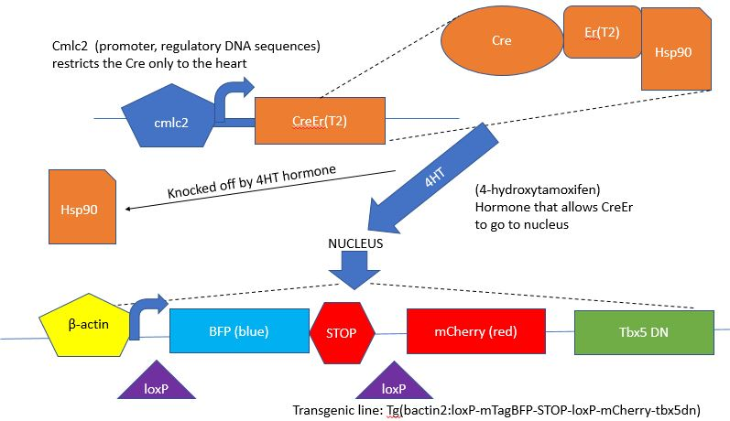
Cre-lox Recombination is a process that functions at the chromosomal level. The protein, Cre, binds to the loxP sites which then excises or removes the STOP sequence, allowing the tbx5DN to be expressed.
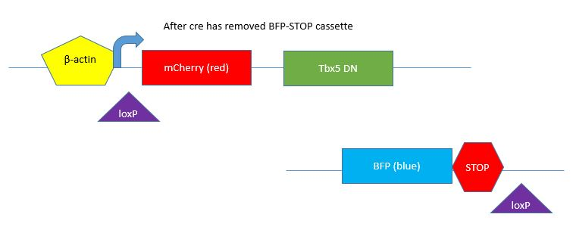
The CreER(T2) will be confined to the cytosol unless the 4HT hormone is present. Because of this, we can achieve temporal control by choosing to wait 60 days to let the fish reach the adult stage and fully develop their hearts before adding the 4HT hormone into the water. When 4HT is added into the water, the hsp90 protein dissociates from CreEr(T2) which allows the CreEr(T2) to enter the nucleus, excise the loxP sites, remove the stop cassette, then induce the expression of tbx5DN. This then allows the experimentation on adult zebrafish heart regeneration without them dying before the experiment can be carried out.
Figure 4.

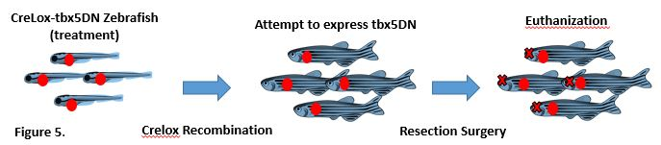
After the tbx5DN protein has been expressed, ventricular resection surgeries will be conducted to surgically injure the heart. About 20% of the ventricular muscle will be taken from the

apex with iridectomy scissors (Lepilina, et al. 2006). We will then allow the fish 1-2 months to attempt to regenerate the cardiac muscle and then proceed to look for regeneration or scarring of the myocardial tissue. The zebrafish will first be euthanized by immersion in MS-222 (tricaine) at 2 g/L water. To prevent any decomposition of the organs, the heart will be fixed by perfusing or flushing the heart with phosphate buffered formalin for 24 hours. Before the tissue can be viewed under a slide, cryosectioning will be performed. The temperature of the tissue will first be equilibrated to the temperature of the cryostat which is about -20°C. The tissue will then be placed onto the cryostat specimen disk. Sections of about 5 µm thick will be cut, placed on a Fisher Superfrost slide, and dried overnight at room temperature (RT). The slides will then fixed by immersion in cold acetone (-20°C) for 2 minutes, air dried at RT and proceed to be stained. Acid Fuchsin-Orange G staining and immunofluorescence will be performed on 10-12 µm cryosections. This then enables the ability to distinguish the difference between muscle and collagen. This is illustrated in Figure 6. All animal procedures will be performed in accordance with Virginia Commonwealth University guidelines.

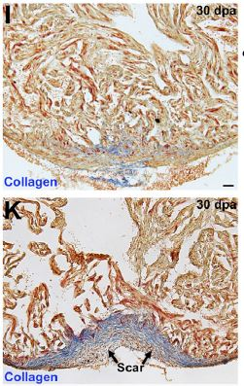
Discussion
A
After the experiment, one of two things can occur. If the resected hearts scar instead of regenerating, this indicates that tbx5 is necessary for myocardial regeneration. If the resected hearts regenerate sucessfully when expressing the tbx5DN, this indicates that tbx5 is not necessary for myocardial regeneration.
From the Gupta experiment, we can predict that when the tbx5DN is expressed within the juvenile zebrafish, their hearts do not develop properly and causes the zebrafish survival rate to drop. Figure 6. illustrates sections of the 30 days post amputation (dpa) ventricular wall. Figure 6A. represents the control (non-induced zebrafish), whereas Figure 6A. represents what might be observed in an induced zebrafish that expresses tbx5DN. The Gupta paper researchers found that the control zebrafish had their ventricular walls intact after 30 dpa. Contrast to the control group, the induced fish developed scarring on the ventricular wall. If this result is present after the experiment has been conducted then tbx5 is necessary for heart regeneration in response to surgical injury. If this is not seen after the experimental procedure, then we know that tbx5 is not necessary for regeneration. A potential problem with this experiment could be the possible difference between expressing a tbx5DN versus a conditional knockout of tbx5. This is the way this experiment would have been conducted in mice, instead of using cre-lox to induce expression of a transgene one could use it to induce excision of the endogenous gene, if that gene is flanked by loxP sites. It's straightforward to modify the endogenous gene in this way in mice, but the methods for doing this in zebrafish and xenopus haven't been worked out yet. This is why people use the dominant negative approach in those particular organisms. Another potential problem is if the conditional knockout approach was conducted in zebrafish and a different result from the dominant negative approach emerged. Tbx5DN might be inhibiting tbx5, however, tbx20, another t-box gene that shares some target genes with tbx5 could be the gene required heart regeneration.
B
Figure 6. Gupta et al, 2013

References
Heidenreich, Paul A., et al. "Forecasting the future of cardiovascular disease in the United States a policy statement from the American heart association." Circulation 123.8 (2011): 933-944.
Lepilina, Alexandra, et al. "A dynamic epicardial injury response supports progenitor cell activity during zebrafish heart regeneration." Cell 127.3 (2006): 607-619.
CDC. Heart disease facts. CDC, 10 Aug. 2015. Web. 11 Jan. 2017.
Horb M. E., Thomsen G. H. (1999). Tbx5 is essential for heart development. Development 126, 1739 1751.
Veitia RA. “Exploring the molecular etiology of dominant-negative mutations.” Plant Cell. 19 (2007): 3843–3851.
Takeuchi, Jun K., et al. “Tbx5 and Tbx4 trigger limb initiation through activation of the Wnt/Fgf signaling cascade” Development. 130 (2003): 2729-2739.
Laflamme, Michael A., and Charles E. Murry. “Heart Regeneration.” Nature 473.7347 (2011): 326 335. PMC. Web. 28 Apr. 2017.
Gupta V, Gemberling M, Karra R, Rosenfeld GE, Evans T, Poss KD. “An Injury-Responsive Gata4 Program Shapes the Zebrafish Cardiac Ventricle.” Curr. Biol. 23 (2013): 1221–1227.
Smith, Jim. "T-box genes: what they do and how they do it." Trends in Genetics 15.4 (1999): 154-158.
Rallis, Charalampos, et al. “Tbx5 is required for forelimb bud formation and continued outgrowth” Development. 130 (2003): 2741-2751.
Thermes, Violette, et al. “I-SceI meganuclease mediates highly efficient transgenesis in fish” Mechanisms of Development. 118 (2002): 91-98.
Thummel, Ryan, et al. “Cre-Mediated Site-Specific Recombination in Zebrafish Embryos” Developmental Dynamics. 233 (2005): 1366-1377.
Garrity, Deborah, et al. “The heartstrings mutation in zebrafish causes heart/fin Tbx5 deficiency syndrome” Developmental and Disease. 129 (2002): 4635-4645.

