Examining the Role of Verapamil on Protein Kinase C Activity in Diabetic Mice Hepatic Cells

By Samhitha Dhandamudy, 12/10/2017

Introduction:

Type 2 diabetes is a chronic disease, which happens when the body is unable to process blood sugar properly for a long period of time. The liver is responsible for maintaining glucose homeostasis but with type 2 diabetes, more glucose is secreted into the bloodstream than absorbed (Ahmed, Pelletier et al, 2015).

Protein kinase C has many isoforms or isozymes depending upon location, the isoform that will be seen for its activation is called protein kinase c epsilon. A pkc assay will be done to measure absorbance or activation after calcium channel blocker Verapamil is given to the liver cells of mice. Then Western Blot testing will be done to identify the pkc epsilon (Hofmann, Gopalakrishna et al, 1998). All protein kinase c’s donate a phosphate from ATP to specific amino acids on a protein and that phosphate attaches to a substrate on the protein. In other words, they are a family of enzymes that regulate the function of alternative proteins through phosphorylating hydroxyl groups of serine-threonine amino acid residues. The reason pkc epsilon is being given importance is because this is the isoform of pkc that would get in the liver. (Samuel, Liu et al, 2007).

There have been evidence from other studies that show another calcium channel blocker drug called Felodipine has been used to test for pkc activation in smooth muscle cells and it activated the pathway (Sutherland, Walsh et al, 1998). Verapamil along with drugs like nifedipine and diltiazem were shown to inhibit the pkc epsilon pathway in the pancreas (Sunaga, Ogihara et al, 1990). Verapamil also inhibited protein kinase c activation in human retinal pigment epithelial cells (Hofmann, Gopalakrishna et al 1998). Different calcium channel blockers affect the pkc epsilon pathway in different ways either by inhibiting it or activating it. Whether the pkc pathway gets activated or not depends on the location of the pkc isoform and how the calcium channel blocker interacts with it.

The liver cells of diabetic mice will be used to see if calcium channel blocker used in the liver will activate or inhibit the pkc pathway. If Verapamil inhibits the pkc epsilon pathway in the liver, then that means that hepatic glucose levels will decrease otherwise if Verapamil activates the pkc epsilon pathway, it means that the hepatic glucose levels will increase (Samuel, Liu et al, 2007). The goal of this experiment is to show how calcium channel blocker Verapamil will affect the pkc epsilon pathway to observe whether glucose levels will increase or decrease.

Methods:

To measure PKC activation, conduct the in vitro assay in the liver cells after adding 100 micrograms/mL of calcium channel blocker Verapamil (Fernandes, Barone et al, 2016). Do the kinase reaction (or phosphorylation) where kinase is added to ATP and a phosphate from ATP gets attached to the substrate. Then add a phospho-substrate antibody to do substrate level phosphorylation. The phospho-substrate should be attached to the substrate with the protein attached. Then add the secondary antibody-HRP conjugate. Then substrate with protein attached, also has phospho-substrate antibody and secondary HRP attached. Then TMB substrate is added and the absorbance is measured at 450 nm, which is the ideal amount in order to obtain a higher reading (Abnova, n.d.). Secondary antigens bind to the primary antibody to assist in detection, sorting and purification of target antigens. To allow detection, the secondary antibody must have specificity for the antibody species and isotype of the primary antibody being used and is generally conjugated. TMB is used to stain and it stains the secondary HRP conjugate (“Protein Kinase C Activity Assay Kit”, 2009).

The phospho-substrate is used to do phosphate level phosphorylation. The secondary antibody-HRP is used to bind to the primary antibody to help in finding, sorting, and purifying target antigens. In order for detection to occur, the secondary antibody must have specificity for the antibody species and isotype of the primary isotype being used and generally is conjugated. Horseradish peroxidase is being used specifically because it has a high turnover rate, which allows generation of strong signals in a short time span. I chose 100 micrograms/mL because it is a higher dose and will be better able to test for activation of the pkc epsilon pathway.

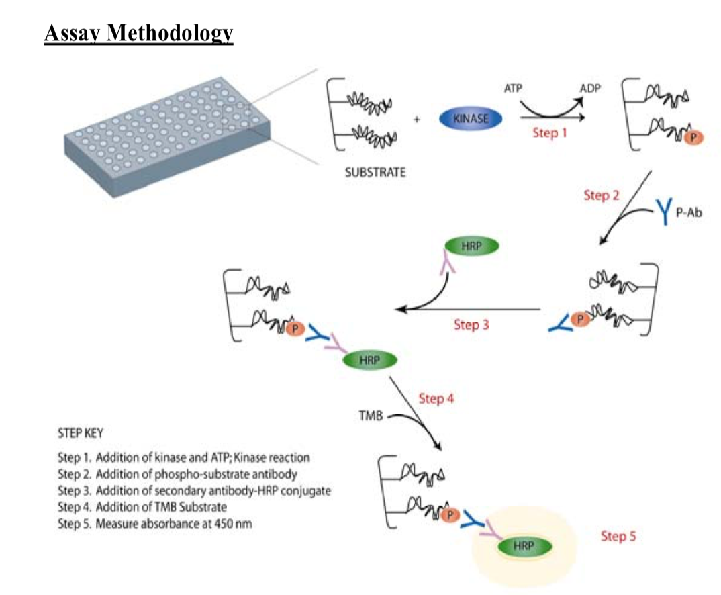
Figure 1

Western Blot testing will be done to identify specific proteins from a complex mixture of proteins extracted from cells through gel electrophoresis. Western blotting is the best technique to use in this experiment because it can detect specific proteins like protein kinase c epsilon. In this technique, three steps are involved. The first step is to separate by size and then transfer to a solid apparatus followed by marking the target protein using a proper primary and secondary antibody (HRP) to visualize. Protein kinase c epsilon needs to be identified and this technique is the best way to identify it (Lin, Law et al 2012). Protein kinase c epsilon is the protein that is associated with the liver.

Discussion:

The results could possibly show that the pkc pathway has not been activated by the calcium channel blocker drug Verapamil which means that hepatic glucose levels are going to lower and the hepatic liver cells would not indicate presence of type 2 diabetes. The pkc epsilon pathway has been inhibited by Verapamil in the pancreas and in human retinal pigment epithelial cells. So this result will not be surprising in hepatic liver cells of diabetic mice. Another experiment can be done with other calcium channel blockers, to see if they are able to inhibit the protein kinase c epsilon pathway in the liver and thus lower hepatic glucose levels. If hepatic glucose levels do get lowered, then that means calcium channel blockers can be given to treat type 2 diabetes. Some limitations in this experiment could be not giving enough calcium channel blocker to the diabetic hepatic liver cells and mixing substitute reagents or materials from other assays.

References:

Mahmood, T., & Yang, P.-C. (2012). Western Blot: Technique, Theory, and Trouble Shooting. North American Journal of Medical Sciences, 4(9), 429–434. http://doi.org/10.4103/1947-2714.100998

Kaiser, J. P., Beier, J. I., Zhang, J., Hoetker, J. D., von Montfort, C., Guo, L., … Arteel, G. E. (2009). PKCε plays a causal role in acute ethanol-induced steatosis. Archives of Biochemistry and Biophysics, 482(1-2), 104–111. http://doi.org/10.1016/j.abb.2008.11.004

Lin, H.-Y., Law, P.-Y., & Loh, H. H. (2012). Activation of Protein Kinase C (PKC)α or PKCε as an Approach to Increase Morphine Tolerance in Respiratory Depression and Lethal Overdose. The Journal of Pharmacology and Experimental Therapeutics, 341(1), 115–125. http://doi.org/10.1124/jpet.111.188235

Ahmed, M. S., Pelletier, J., Leumann, H., Gu, H. F., & Östenson, C.-G. (2015). Expression of Protein Kinase C Isoforms in Pancreatic Islets and Liver of Male Goto-Kakizaki Rats, a Model of Type 2 Diabetes. PLoS ONE, 10(9), e0135781. http://doi.org/10.1371/journal.pone.0135781

Stephan Hofmann a,b, Rayudu Gopalakrishna, Usha Gundimeda, Toshinori Murat a,b, Christine Spee, Stephen J. a,b  David R. Hinton* a Doheny Eye Institute and the b Departments of Ophthalmology c Pathology and d Cell and Neurobiology, University of Southern California School of Medicine, Los Angeles, CA, U.S.A. (Received Seattle 20 October 1997 and accepted in revised form 13 February 1998)

Katsuyoshi Sunaga and Masahiko Ogihara*
GroupofBiochemicalPharmacologyF,acultyofPharmaceuticaSlciences, JosaiUniversity1,-1,KeyakidaiS,akado,Saitama350-02,Japan
AcceptedDecember7,1989

Activation Of Protein Kinase C By The Dihydropyridine Calcium Channel Blocker, Felodipine CINDY SUTHERLAND and MICHAEL P. WALSH*
Department of Medical Biochemistry, Faculty of Medicine, University of Calgary, Calgary, Alberta, Canada T2N 4Nl (Received 28 September 1988; accepted 2 November 1988)
Protein Kinase C Assay Activation Kit, Assay Designs, 7/6/2009

Human PKC Super Family Kinase Assay Kit, n.d.

Fernandes G, Barone A, Dziak R (2016) E ects of Verapamil on Bone Cancer Cells In Vitro J Cell Biol Cell Metab 3: 013.

