**Discovery of a Possible Connection Between *cln3* and *cisd2* Genes Through Notch Signaling.**

**I. Introduction**

Wolfram syndrome, a neurodegenerative disease, is a genetic disease that has an autosomal-recessive inheritance.1 Wolfram syndrome is associated with diabetes insipidis, a condition in which the body has difficulty processing fluids as a result of a hormone abnormality.1, 2 This results in unbalanced salt and water metabolism. Wolfram syndrome also causes diabetes, damage to optic nerves eventually leading to blindness and sensorineural deafness, deafness caused by nerve damage in the inner ear.1 It can also cause psychiatric illness and renal-tract abnormalities.1, 2

*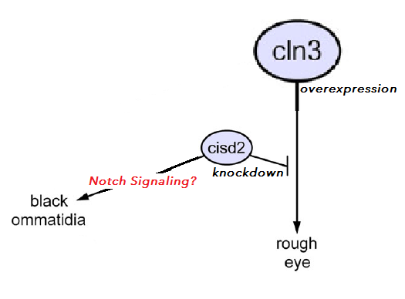CISD2* is a gene found in humans that, when mutated, is known to cause Wolfram syndrome.1 *CISD2* recessive mutations are believed to be a cause Wolfram Syndrome 2.1,3 *CISD2* produces proteins that localize to the endoplasmic reticulum (ER) and the mutation of *CISD2* causes Ca2+ imbalance, this imbalance causes an increased amount of ER and mitochondria contact.1, 3 Thereby causing dysfunction in the mitochondria, a possible cause of some of the problems associated with Wolfram syndrome 2.1,3 The complete function of *CISD2* is still unknown therefore, there is still much to learn about this gene and its mutations.1,3

*CLN3* is another gene with neurological problems associated with it; *CLN3* is the gene whose mutation causes Batten disease.4 Batten disease is a neurodegenerative disease that begins in children around 5-7 years old with retinal degeneration.4 It leads to seizures, loss of motor skills and mental ability; death normally occurs by 25 years of age.4 The *CLN3* gene codes for a multi-spanning, hydrophobic transmembrane protein.4 Though the function of this particular protein is unknown, it is known that *CLN3* expression directly correlates with the amount of activity in the notch pathway.4 When *CLN3* is overexpressed the activity in the notch pathway is decreased.4 The notch pathway is a signaling pathway, a cell-to-cell, contact-dependent, signaling mechanism used for cells to communicate with each other. Notch signals sent between cells can create molecular differences which would eventually determine cell fate, or the type of cell it will become.6 This particular pathway is important in development and therefore mutations in this receptor lead to abnormalities in development.5,6,7 Notch by directing cell fate is one of the tools needed to build an organism from a single cell.6

Fig 1a. It is known that cln3 overexpression in flies causes rough eye. Cisd2 knockdown by itself does nothing to change phenotype but when both happen it causes black ommatidia, it is unknown why however; what the cause of the black ommatidia is.

Modified from Fig 7 of Jones et al. (2014) 1

Because *CLN3* and *CISD2* both are genes whose mutations lead to neurogenerative disorders, it would be greatly useful to study these genes, however, because studying genes in humans leads to obvious complications another way to study these genes would be necessary. Flies and humans have amazingly similar genes both for *CISD2* and *CLN3*. *CG1458* in flies was identified as the best match for the human *CISD2* gene.1 *CG1458* has a similar size to *CISD2* and their predicted proteins were determined to be 46% identical and 68% similar in primary amino acid sequence.1 There is also a gene in flies *CG5582* that shares a highly conserved sequence with human gene *CLN3.*4Therefore due to these similarities, no other significant matches with other fly proteins and to stress the connection between the human and fly genes, *CG1458* shall be denoted as *cisd2* and fly gene *CG5582(CLN3* in humans) shall be denoted *cln3*.1, 4

Jones et al (2014) found a connection between *cln3* and *cisd2*. They found that a particular eye phenotype that appeared in flies with overexpression of *cln3* was worsened in flies that also had *cisd2* knocked down.1 Gene knockdown is a way to silence genes or prevent them from being expressed; *cisd2* was knocked down using RNAi transgenes expressed using a *Gal-4-UAS* system. They blocked *cisd2* from being expressed in flies with overexpression of *cln3*. Black spots on the eyes of the flies caused by the *cln3* overexpression was significantly increased in size and amount, with the *cisd2* knockdown. These results indicate that these two genes interact with each other. They speculated that one possibility is that *cln3* mediated notch signaling may be important for manifesting the phenotype. *cln3* and *cisd2* genes and their function may somehow be molecularly connected to each other, through this pathway. The experiment in this proposal is to test if this possibility is true.

It was found by Tuxworth et al (2009) that when *cln3* was overexpressed the activity on the notch signaling pathway decreased.4 When *cln3* was overexpressed in Jones et al (2014) experiments the notch pathway activity should have been decreased and possibly exacerbated when *cisd2* was knocked down. Therefore, my experiments will measure the effect of rescuing notch signaling, by expressing notch while simultaneously overexpressing *cln3,* which would normally cause a decrease in notch activity, to determine if the phenotype can be rescued. By doing this I will determine whether notch signaling is the common link between these two genes, and therefore the cause of the phenotype (Fig 1a).

**II. Experiment**

This experiment is going to determine whether the rescue of notch signaling in flies with *cln3* overexpression affects the eye phenotype and compare that to flies with *cln3* overexpression alone. Eventually, I also hope to test flies with notch signaling knockdown and *cisd2* knockdown, then compare that to notch and *cisd2* knockdown alone. If these two genes are connected via the notch signaling pathway I would expect that the phenotype seen with *cln3* overexpression to lessen in severity or for no phenotype to appear; I then would expect the same phenotype as *cln3* overexpression if notch was knocked down and a more severe phenotype when notch and *cisd2* were knocked down if these two are connected through this pathway.

Gal4-UAS system (gene knockdown)

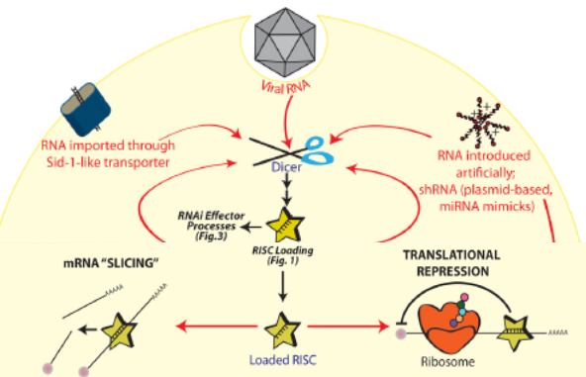In order to manipulate expression of the genes, I will use the Gal4-UAS system also used in experiments by Jones et al (2014).1 The Gal4-UAS system allows for targeted gene expression, selective activation of any cloned gene.9 I will be using this system to knockdown *cisd2,* rescue or knockdown the notch receptor and to overexpress *cln3.* To knockdown or rescue the notch receptor I will be knocking down or overexpressing the *notch* gene.12, 13 Gal4-UAS can be used to overexpress a gene if an entire gene sequence is inserted into the system. It can also be used to knockdown gene expression if RNA interference transgenes are inserted into the system.

Figure 1. Show the RNAi transgenes system to knockdown genes

Fig. Based on and created from fig 1 and fig 3 from Pratt, A., & Macrae, I. (2009)

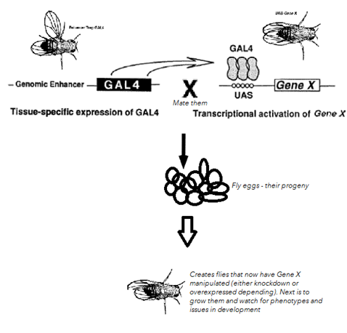RNA interference transgenes (RNAi transgenes) are DNA where single-stranded RNA can be transcribed from either the endogenous genome or a researcher inserting a specific sequence to transcribe a dsRNA hairpin. This then is processed through the RNA-induced silencing complex (RISC). The dsRNA is processed and guides the RISC to the complementary RNA. RISC can then silence the targeted genes by either directly attaching to the mRNA and cleaving the mRNA or attaching to the mRNA and repressing the translation of the mRNA when it enters the ribosome.10

The Gal4-UAS system also allows the selective knockdown or overexpression to be tissue or cell-specific patterns.9 GAL4 a transcriptional activator in yeast can be used as a transcriptional activator in flies if the promoters have GAL4 binding sites. The genes need to be responsive to GAL4 so a vector containing five GAL4 binding sites was designed, by Brand et al (1993).9 Genes could then be subcloned into this vector. This is known as the Upstream Activation Sequence or the UAS.9 Using this system I can subclone any sequence behind a GAL4 binding site, activate the target gene only in cells where GAL4 is expressed. This system allows for observation of the effect on development (it affects phenotype). 9

Figure 2. Shows procedure for creating genomes of flies, then having them mate. The progeny should have the desired gene manipulated.

Refurbished/edited fig 1 graphic from paper Brand, A.H. and Perrimon, N. (1993)

Two groups of flies will be needed per experimental trial, group one will have the Gal-4 behind the Genomic Enhancer specific to the eye for the targeted genes – *cln3* or *cisd2* RNAi transgene depending on which trial it is for. Another group (group 2) of flies will have the UAS inserted before the targeted gene to be overexpressed or section of gene to be knockdown. Flies with Gal-4 and UAS inserts can be purchased from labs.1 These two groups of flies will be mated together and the progeny of these flies will have the gene overexpressed or knocked down depending on which was initiated for that experiment, see Figure 2. These flies will have the targeted gene either knocked down or overexpressed. The Gal4-UAS knockdown, part of gene inserted, will cause the creation of RNA that once in the cytoplasm the RISC will take it and create RNAi that will block that the gene or protein expression. Or, if the whole gene is inserted, then it will overexpress it. These flies can then be monitored during development for any phenotypical abnormalities, specifically the eyes in this particular experiment, because the eyes will be the target of this manipulation.

|  |  |
| --- | --- |
| **Experiment** | **Expected Results** |
| Experiment set 1 | |
| *cln3* overexpression with notch rescue | No phenotype |
| *cln3* overexpression(control) | Mild Phenotype |
| *Notch* overexpression (control) | No phenotype |
| Experiment set 2 | |
| *Notch* knockdown and cisd2 knockdown | Severe phenotype |
| *cisd2* knockdown (control) | No phenotype |
| *Notch* knockdown (control) | Mild phenotype |
| Table 1. Table of experiments and predicted outcomes. | |

Jones el al (2014) also used the Gal4-UAS system to manipulate *cisd2* expression in their experiments to find if there was a connection between the two genes expression or lack of expression. They used the Gal4-UAS system to make two RNA interference transgenes that would manipulate *cisd2* expression.1 They created two transgenes that through immunoblot and qRT-PCR tests were shown to have a reduction of expression of *cisd2*.1 I will use this same system to rescue notch and to knockdown notch and *cisd2* in my experiments.

The specific knockdowns will be created using the Gal4-UAS system and the flies can be purchased from the Bloomington Stock Center.1 For my experiment I will likely reuse the Gal4-UAS drivers used by Jones et al (2014) in regards to *cisd2*, the *da-Gal4* driver, I will also reuse the *cisd2* UAS RNAi transgenes.1 For *cln3* over expression I shall also reuse the same overexpression strain *UAS-cln3* no. 4.1 Finally for the rescue and knockdown of notch new transgenes will need to be constructed and used with the GAL4 drivers.

I plan to do two groups of experiments, the first will consist of *cln3* overexpression with notch rescue. Then as control I will do flies with only *cln3* overexpression in one group and only notch rescue, or overexpression, in another group. The controls will allow me to compare and compensate for any effects not related to the combination of *cln3* knockdown and notch rescue.

The second group of experiments would be to knockdown notch signaling and knockdown of *cisd2.* As a control and comparison, I would also have a group of flies with just *cisd2* knockdown and a group with just notch knockdown (Table 1).

|  |  |  |  |  |
| --- | --- | --- | --- | --- |
|  |  |  |  |  |
| Normal eye, no abnormality | None: eye morphology has changed slightly but no appearance of black ommatidium. | Mild: A couple of small black ommatidium in the eye. | Medium: One or two clusters of black ommatidium in the eye | Severe: Multiple clusters of black ommatidium in the eye. |
| Table. 2 (adapted from Fig 3 in Jones et al.)1 Scale used for measuring the black ommatidium phenotype in the flies. Based on similar system from Jones et al. | | | | |

The particular phenotype that I will be looking for is in the round optical components that make up the eye of a fly, called ommatidium. Each ommatidium is normally bright red in color. Lessened function of these genes causes individual ommatidium to become black, likely as a result of cell death. The number of ommatidium that turn black determine the severity of the phenotype. A similar scale to the one used in Jones et al. (2014) experiment will be used; None – no black v, Mild – a few scattered black ommatidium, Medium – one or more patches of black ommatidium, severe – black ommatidium clusters throughout the eye (Table 2).

**III. Discussion**

I expect the result if there is no phenotype when the *cln3* is overexpressed and notch signaling is rescued. I would then want to see a mild phenotype with *cln3* overexpression alone (control) and no phenotype with notch overexpression (control). For experiment set 2 I would want to see a severe phenotype with notch and cisd2 knockdown together. For cisd2 knockdown alone (control) I would expect no phenotype. And for notch knockdown alone (control) I would expect a mild phenotype. These results would show that *cisd2* and *cln3* are connected via this notch signaling and that the hypothesis was correct. See Table 1 and Table 2. If the phenotype is not as expected then it’s possible they are just connected via a different kind of signaling like JNK.4

The biggest setback for this experiment would be if the results are inconclusive. Then that means that notch signaling isn’t the connection, there are multiple other routes that would need investigating then if that is the case. One possible issue is that off-target effects may result in a false-positive from using RNAi, however this is unlikely due to the precision of this method.9, 11 Another possible issue is that, because of the developmental control these genes have, unless the genes are only manipulated in one specific area, the eye in this case, the flies may not survive development for us to observe phenotypical changes.6, 9, 12 This should be controlled by Gal4 precision as well since it be focused in the eye.9

Regardless of these problems knowing how these genes function, together and separately, is key in our understanding of genetics. It may help shed light on how other genes work together, helping us to understand genetic diseases and our own genetic code just a little bit more. Perhaps in the future genetic disease and resulting deaths and suffering will be a thing of the past.

**IV. References**

1. Jones, M., Amr, S., Ferebee, A., Huynh, P., Rosenfeld, J., Miles, M., . . . Grotewiel, M. (2014). Genetic studies in Drosophila and humans support a model for the concerted function of CISD2, PPT1 and CLN3 in disease. *Biology Open,* *3*(5), 342-52.
2. Vani, N. (2010). Wolfram Syndrome. *Apollo Medicine,* *7*(1), 51-53.
3. Rouzier, Moore, Delorme, Lacas-Gervais, Ait-El-Mkadem, Fragaki, . . . Paquis-Flucklinger. (2017). A novel CISD2 mutation associated with a classical Wolfram syndrome phenotype alters Ca 2+ homeostasis and ER-mitochondria interactions. *Human Molecular Genetics,* *26*(9), 1599-1611.
4. Tuxworth, RI., Vivancos, V., O’Hare, MB., Tear, G. (2009). Interactions between the juvenile Batten disease gene, CLN3, and the notch and JNK signaling pathways. *Human Molecular Genetics*, *18(4),* 667-678.
5. Borggrefe, T., & Oswald, F. (2009). The Notch signaling pathway: Transcriptional regulation at Notch target genes. *Cellular and Molecular Life Sciences,* *66*(10), 1631-1646.
6. Artavanis-Tsakonas, S., Rand, M., & Lake, R. (1999). Notch signaling: Cell fate control and signal transduction in development. *Science (Washington),* *284*(5415), 770-776.
7. Greenwald, I. (2012). Notch and the awesome power of genetics. *Genetics,* *191*(3), 655-69.
8. Kidd, S, Kelley, M R, & Young, M W. (1986). Sequence of the notch locus of Drosophila melanogaster: Relationship of the encoded protein to mammalian clotting and growth factors. *Molecular and Cellular Biology,* *6*(9), 3094-108.
9. Brand, A.H. and Perrimon, N. (1993). Targeted gene expression as a means of altering cell fates and generating dominate phenotypes. *Development,* 118, 401-415.
10. Pratt, A., & Macrae, I. (2009). The RNA-induced Silencing Complex: A Versatile Gene-silencing Machine. *Journal Of Biological Chemistry,* *284*(27), 17897-17901.
11. Schulz, J., David, G., & Hassan, B. (2009). A novel method for tissue-specific RNAi rescue in Drosophila. *Nucleic Acids Research,* *37*(13), E93.
12. Xu, T., Rebay, I., Fleming, R., Scottgale, T., & Artavanistsakonas, S. (1990). THE NOTCH LOCUS AND THE GENETIC CIRCUITRY INVOLVED IN EARLY DROSOPHILA NEUROGENESIS. *Genes & Development,* *4*(3), 464-475.
13. Ellisen, Bird, West, Soreng, Reynolds, Smith, & Sklar. (1991). TAN-1, the human homolog of the Drosophila Notch gene, is broken by chromosomal translocations in T lymphoblastic neoplasms. *Cell,* *66*(4), 649-661.