Amanda Atrash
Disruption of NDEL1 via knockdown of DISC1 stunts dendritic spine structure in the hippocampus region of mice
- Introduction
Schizophrenia is a chronic, debilitating mental disorder that currently affects around 1% of the world’s population. Symptoms vary throughout individuals, however, they are all categorized in about the same three categories: positive, negative, and cognitive. Examples of positive symptoms include hallucinations and delusions, while negative symptoms are more along the lines of social withdrawal and lack of motivation. Lastly, cognitive symptoms include impairment of memory and attention. Because of the wide, variety of symptoms, many patients have high rates of homelessness, violence, and suicide (World Health Organization). These prognoses seriously impact the economy and society - costing upwards of $62 billion dollars per year (Ellaithy et al., 2015). It is for this reason that the World Health Organization ranks this disorder among the top 10 causes of disability in the world (Ellaithy et al., 2015).
While schizophrenia is such a prevalent and debilitating mental illness to individuals and the population, most drug therapy aimed at treating schizophrenia does a very poor job. While typical antipsychotic drugs are effective against positive symptoms, they also demonstrate a limited efficacy against negative symptoms and cognitive impairments - which have been shown to contribute to functional impairment and predict poor prognosis (Ellaithy et al., 2015, Moreno et al., 2011). These drugs were introduced into clinical practice in the early 1900s and despite the increasing research on schizophrenia, they have not changed much in their chemical structure since then. The limitations of the presently available drugs underscore the need for identification of new antipsychotic compounds aiming at new molecular targets.
One such target, that has been heavily studied, is Disrupted-in-Schizophrenia-1, a gene-encoding protein that is identified as a genetic risk factor across a spectrum of psychiatric disorders. DISC1 is present at the intersection of several neurodevelopmental pathways and acts as a scaffold - binding a number of other proteins together, which have all been shown to be independent risk factors for major mental illnesses as well (Duan et al., 2007, Soares et al., 2011, Bradshaw, 2017). Recent studies have suggested a link between DISC1 genotypes and elements of neurocognitive function (Duan et al., 2007). However, much about DISC1’s full primary sequence and secondary structure is currently known, and thus represents a challenge to drug target (Soares et al., 2011).
Soares et al. (2011) were able to determine partial sections of the protein sequence through a variety of bioinformatics programs. Through their results, they were able to get a better understanding of the N-terminus, which is typically referring to the free amine group located at one end of the protein and is regarded as the start of the protein. The N-terminus, they found is mostly disordered - meaning that the sequences fail to self-fold into it’s fixed 3D structure. They know this through submission of DISC1 sequence regions into the meta Protein DisOrder prediction system (Soares et al., 2011). DISC1’s C-terminus is, on the opposite side, primarily composed of coiled-coils and alpha helices. The C-terminus of a protein is the other end of a protein, located near the carboxyl group. Coiled-coils refer to regions that are coiled together, similar to strands of rope. Soares et al. (2011) note that most of the work regarding the secondary structure of DISC1 has been done here, yet even then not much is fully understood. Many of the binding partners bind to DISC1 within its C-terminus, so if looking to target a protein complex, focusing on the C-terminus region within DISC1 would be ideal.
One of DISC1’s many binding partners includes Nuclear Distribution Element-like 1 (NDEL1). NDEL1 is a centrosomal protein that is involved in mitosis, neuronal migration, neuroplasticity, and neurogenesis during brain development (Burdick et al., 2008, Bradshaw, 2017). Neural plasticity refers to the brain’s ability to make changes to itself throughout its lifetime, in response to experience. A recent study has demonstrated that NDEL1 expression is decreased in the hippocampus region of those suffering with schizophrenia (Burdick et al., 2008). This suggests that the plasticity of the brain, or it’s ability to adapt, can lead to changes in cognition and behavior. Cognitive deficits, such as those talked about above as a symptom of schizophrenia, may then be a result and consequence of deficits in neural plasticity (Keshavan et al., 2015, Voineskos et al., 2013). As well, an intact NDEL1-DISC1 interaction has been shown to be critical to multiple developmental processes such as neural outgrowth (Nicodemus et al., 2010, Voineskos et al., 2013). Both of these aspects suggest the importance of NDEL1 and DISC1 in understanding a new aspect and relationship in schizophrenia.
While there have been some studies examining the relationship between NDEL1 and DISC1, much still has to be studied and understood. Does knockdown of one protein affect the function of the other? How does the knockout of the protein lead to changes in plasticity and changes in the formation of dendrites in the brain? The purpose of this experiment is to answer similar questions by testing whether disruption of DISC1 impacts the function of NDEL1 in the spine formation of the hippocampus region.

- Experiment
The aim of this experiment is to understand the relationship between the proteins NDEL1 and DISC1 in the development of the spine structure in the hippocampus region of the brain. Samples of the mutant protein DISC1 will be injected inside adult mice through viral mediation to gather and measure the dendritic spine growth and formation within the hippocampus region. In these samples, DISC1 will be disrupted to test how it’s silence impacts the function of NDEL1, a protein known to play a role in neurogenesis. I would expect that the level of spine formation within the hippocampus be similar to that with a NDEL1 knockout, i.e. under conditions that would negatively impact the cell.

  - Co-immunoprecipitation
Co-immunoprecipitation assay is a quantitative biochemical technique used to assay protein-protein interactions by employing specific antibodies to capture and pull down proteins that are bound to a specific target protein. This method was employed by Moreno et al. (2012) to detect an hemagglutinin (HA)-tagged mGlu2, or Metabotropic glutamate 2, receptor with an anti-HA antibody by capturing a c-Myc-tagged 5-HT2A receptor with an anti-c-Myc antibody. 5-HT2A belongs in the serotonin receptor family, as 5-HT stands for 5-hydroxy-tryptamine, which is serotonin. Moreno et al. (2012) were studying the relationship between mGlu2 receptors and 5-HT2A receptors in hopes of understanding if these two receptors formed, or were apart of, a larger protein complex. By tagging the mGlu2 receptor with HA and the 5-HT2A with c-Myc, Moreno et al. (2012) were able to make the identification of these two receptors through co-immunoprecipitation easier. Instead of having to grab the antibodies for each of their specific receptors, they were able to make use of the antibodies for the tags they used. Co-immunoprecipitation assays will be performed following standard protocols as previously described by Moreno et al. (2012) for the purpose of confirming that these two are in a protein complex, and to help connect that any results we see are due to the messing of this protein complex.
Co-immunoprecipitation works by utilizing antibodies, or large Y-shaped proteins, and using them as tags on the proteins of interest. In Moreno et al. (2012), the antibodies were used to tag the serotonin 2A receptor, 5-HT2A. By tagging this integral protein, they were able to detect if mGlu2 was in a relationship with the 5-HT2A receptor in cells. Similarly, in our experiment, an antibody anti-DISC1 would be used to test whether there is a protein-protein interaction between DISC1 and NDEL1.
In Kamiya et al. (2006), the antibodies used against DISC1 were raised in rabbits against amino acids 360-374 of rodent DISC1 and affinity-purified. The antibody for DISC1, then, would be rabbit polyclonal anti-DISC1 antibody and will be purchased online. After collecting samples of the hippocampus region of adult mice brains - the region known to have high expressions of DISC1 and be involved in memory and cognitive function, we will solubilize them with 2% Sodium dodecyl sulfate (SDS) buffer, and incubate them with the anti-DISC1 antibody (Austin et al., 2004, Ericsson and Nistér, 2011). The samples would also be incubated with protein A/G beads (Figure 1). Protein beads are vital for co-immunoprecipitation as they make the tagged-proteins heavier than the other proteins in the cell, and will then pull down the proteins to form a precipitate through centrifugation. There are various protein bead types out there. Protein A/G beads are utilized as these beads bind to both immunoglobulin antibodies that protein A beads would bind to as well as protein G. Together, they bind to number of polyclonal antibodies, making them ideal for binding the broadest range of antibodies from a number of mammalian samples. For this reason, Protein A/G beads tend to be utilized for co-immunoprecipitation, and were utilized in Moreno et al. (2012). These beads will also be purchased online through Thermo Fisher Scientific.
After the sample has been incubated with the anti-DISC1 antibody and the protein beads and centrifuged, the sample will be run through a Western blot. Moreno et al. (2012), also utilized a Western blot to identify the proteins in their complex. The Western blot will begin with a gel electrophoresis which will separate the proteins by size. Then, they will be moved to a membrane that will later be incubated with antibodies for the target protein that we are looking to identify. The membrane used will be a polyvinylidene difluoride membrane as it provides better mechanical support and allow the blot to be reprobed and stored (Mahmood, T., & Yang, P.-C., 2012). Through our earlier steps, we will know DISC1 is involved in the protein complex that has been pulled down from the co-immunoprecipitation. Thus, we will use NDEL1 specific antibodies to confirm that there is a relationship between the two proteins and that they are involved in the same complex. The antibody for NDEL1 is mouse monoclonal antibody, clone OTI1G10 and will be purchased online. To prevent this primary antibody from binding with the membrane nonspecifically, 5% BSA will be used as a blocker. After the Western Blot is run and washed, the signal it produces will be captured on film and developed in a dark room. This signal will be produced by the primary antibody and the secondary antibody that will be added to detect and report the primary antibody. Horseradish peroxidase (HRP) will be attached to the secondary antibody, and through the addition of luminol, HRP will emit a light (Fig 2). This light will allow us to capture our results.

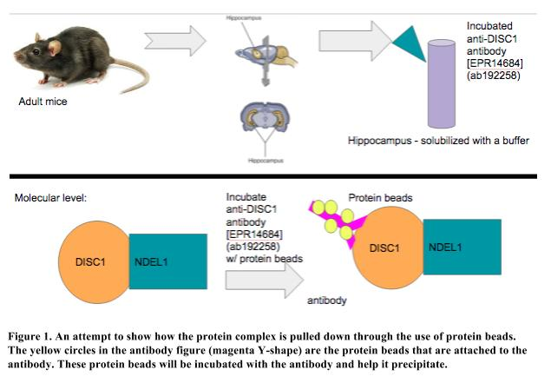

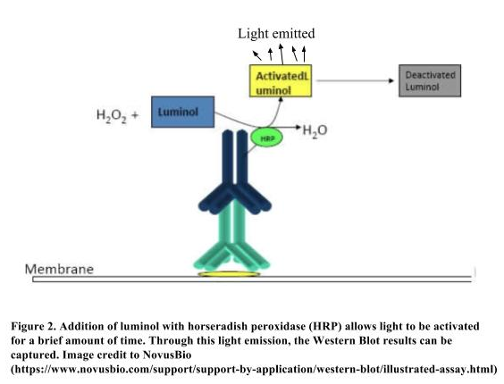

  - Knockdown of DISC1
The knockdown of DISC1 in the NDEL1-DISC1 protein-protein relationship will occur to understand how DISC1 impacts NDEL1 and spine formation. The original plan was to knockout the NDEL1 protein, however, further research has shown that knockout of NDEL1 can lead to embryonic lethality and is not viable for life (Sasaki et al., 2005). This is primarily due to the various roles NDEL1 plays in modulate dynein function, coupling of the centrosome and nucleus during neuronal migration, and in determining neuronal positioning (Sasaki et al., 2005, Toth et al., 2008). NDEL1 would also not have been ideal to knockout or knockdown due to our understanding of the role it plays in neural growth. Since we understand how vital this protein is in dendrite growth, it would be more beneficial to understand how DISC1’s relationship with NDEL1 affects its function.
DISC1 serves a number of functions in the cell and is involved in a number of protein complexes, as stated earlier. For this reason, a complete knockout of DISC1 also serves as an issue for the cell (Jaaro-Peled, 2009).
Instead of completely silencing the protein, a knockdown of DISC1 will occur via RNA interference (RNAi). RNAi uses a sequence specific genes of RNA to silence a gene by degrading the mRNA strand and prohibiting proteins to form. In mammalian cells, gene silencing occurs through the addition of short, interfering RNA (siRNA) or short hairpin RNA (shRNA) that are specific to the mRNA that needs to be silenced (Kleinhammer et al., 2010). These siRNA induce the RNA-induced Silencing Complex (RISC) to then degrade the mRNA and thus silence the gene (Figure 3). However, a problem occurs for when the protein goes to be translated again - if there is no more siRNA or shRNA in the cell to silence the gene expression, the protein will be expressed again. This issue is solved, however, through the use of vectors. Vector transcripts can be created and integrated into the genome to allow for permanent gene silencing in the organism. The transcripts are comprised of a specific mRNA sequence that will be silenced and its complementary strand. These vectors are driven by the enzyme RNA polymerase III, which acts similar to a dicer in that it breaks down the double stranded RNA (Kleinhammer et al., 2010). These transcripts will form shRNAs in a stem-loop structure that will form together with the RISC complex to degrade the mRNA and thus, silence the gene.
Permanent gene silencing occurs by the integration of the shRNA transgenes into the genome (Kleinhammer et al., 2010). Kamiya et al. (2005) employed this method when they knocked down DISC1 to explore its relationship with another receptor. A vector system for shRNA for mice and rat DISC1 was used to suppress the protein. They had produced seven shRNA plasmids through PCR-based mutagenesis protocol and chose to use the strong suppression plasmid and the milder suppression plasmid to complete the interference. The RNA sequences corresponding to the DISC1 sequence for the siRNA and the shRNA were from Dharmacon RNA Technologies (Lafayette, CO). For the purposes of our experiment, we will utilize the same sequences. To look as close as we can to knockout of DISC1 through knockdown, the stronger suppression plasmid will be used. The sequence for this is: 5′-GGCAAACACTGTGAAGTGC-3′ (Kamiya et al., 2005).
For this experiment, the plasmids will be injected into adult mice to knockdown the DISC1 protein. The plasmids were introduced to the mice through a Mouse Neuron Nucelofector Kit (Amaxa, Gaithersburg, MD) in Kamiya et al. (2005), and the same kit will be used here. To create the plasmids, the mRNA sequence to target is needed, as well as the complementary of that target. The RNA polymerase III termination sequence, as well as a promoter element at the 5’ end are also needed in the plasmid construct. This will allow the polymerase to recognize the vector and allow RISC to be activated. Although this is a knockdown of the protein, the efficiency of gene silencing through transgenic mice has shown to achieve high levels of knockdown and is found to be very similar to its knockout counterparts (Kleinhammer et al., 2010). Through this knockdown of DISC1, and the co-immunoprecipitation method employed earlier,
  - Confocal Imaging
Estimation of dendritic spine structure will occur through confocal imaging. This method was employed by Ge et al. (2005) to acquire images of a spine analysis. Images were acquired on a Zeiss LSM 510 META multiphoton confocal system (Carl Zeiss). Neurons were randomly selected. To analyze the dendrites, three-dimensional reconstructions were made for each neuron that had been illuminated through the Z-series stacks of confocal images. Z-series stacks, and confocal imaging, work by taking multiple snapshots of the dendrites at different optical sections.The confocal system changes its position slightly to acquire a stack of photos of the dendrites, and this allows us to use computer programs to construct 3-D images of the dendrites. Ge et al. (2005) used NIH ImageJ through Neuron J plugin to analyze these images. The total dendritic length, distance from cell body, and branch number of each neuron was analyzed. A similar analysis will be done in this experiment. Ge et al. (2005) completed analysis for dendritic complexity by counting the number of dendrites that had crossed circles that were 5 μm intervals from the cell nucleus. A similar method will be employed here to conduct confocal imaging and analysis

- Discussion
If all goes well, the confocal images of the spine formation will exhibit clear differences between DISC1 knockdown and no DISC1 knockdown. Similar to the results exhibited from Ge et al. (2005), the confocal images hope to show an increase of stubby and thin dendritic spines (Figure 4). These results may lead me to the conclusion of the importance in NDEL1 in schizophrenia and the importance of DISC1 in NDEL1 function, ultimately leading me to suggest a possible new drug therapy that targets these two proteins. Unfortunately, those perfect results are not guaranteed - and even more so, if they were, much more research would need to be done focusing on finding more information on DISC1 and NDEL1 separately.
Another result that could present is that there is no dendritic spine changes - or, that it is actually more ‘mushroom’ dendritic observances seen in those with the knockdown of DISC1. The first results - of no change or difference - would be disheartening in that it would show this relationship is not important or vital for schizophrenia. However, it will still bring us closer to where we started. The other set of results, that the knockdown actually positively impacts spine formation in the hippocampus region would be more so revolutionary since the evidence thus far does not suggest that. Ultimately, though, it would lead to a bigger conversation on the relationship between these two proteins and schizophrenia, which could serve as insight on what is still to come.
Interpreting these results, too will be difficult. A majority of these results are qualitative-based, which makes it much harder to be objective. As you can see from Figure 4, interpreting results from confocal imaging specifically, can be a little more difficult. It adds room for bias in being able to look at the image and seeing the outcome you want. While they have various systems and programs in place to assist with this, so as to stay objective in science, it can still be a little more difficult to truly know that your results are what you think they are.
Despite these possible problems and results, DISC1 and NDEL1 are important proteins that can help us learn more about schizophrenia and neuroplasticity within the brain. With appropriate attention, they can open doors to new drug therapies that may help those suffering with schizophrenia in bettering their prognosis. These advancements would not only save our economy money, but also give thousands of people the opportunity to live better, more full lives.

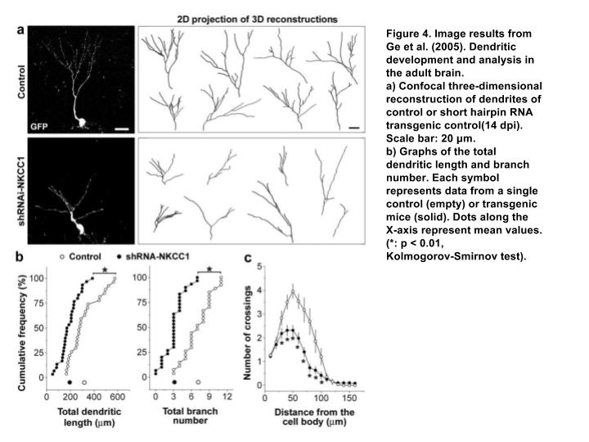

- References

Austin, C.P., Ky, B., Ma, L., Morris, L.A., Shughrue, P.J. 2004. Expression of disrupted-in-schizophrenia-1, a schizophrenia-associated gene, is prominent in the mouse hippocampus throughout brain development. Neuroscience, 124(1): 3 - 10. (http://www-sciencedirect-com.proxy.library.vcu.edu/science/article/pii/S0306452203008649)

Bradshaw NJ. 2017. The interaction of schizophrenia-related proteins DISC1 and NDEL1, in light of the newly identified domain structure of DISC1. Communicative & Integrative Biology, 10(4):e1335375. doi:10.1080/19420889.2017.1335375.
(https://www.ncbi.nlm.nih.gov/pmc/articles/PMC5595412/)

Burdick, Katherine E., Atsushi Kamiya, Colin A. Hodgkinson, Todd Lencz, Pamela DeRosse, Koko Ishizuka, Sarah Elashvili, Hiroyuki Arai, David Goldman, Akira Sawa, Anil K. Malhotra; Elucidating the relationship between DISC1, NDEL1 and NDE1 and the risk for schizophrenia: Evidence of epistasis and competitive binding . Hum Mol Genet 2008; 17 (16): 2462-2473. doi: 10.1093/hmg/ddn146 (https://academic-oup-com.proxy.library.vcu.edu/hmg/article/17/16/2462/article)

Ellaithy, A., Younkin, J., Gonzalez-Maeso, J., & Logothetis, D. E. (2015). Positive Allosteric Modulators of Metabotropic Glutamate 2 Receptors in Schizophrenia Treatment. Trends in Neurosciences, 38(8), 506–516. http://doi.org/10.1016/j.tins.2015.06.002 (https://www.ncbi.nlm.nih.gov/pmc/articles/PMC4530036/)

Ericsson C., Nistér M. (2011) Protein Extraction from Solid Tissue. In: Dillner J. (eds) Methods in Biobanking. Methods in Molecular Biology (Methods and Protocols), vol 675. Humana Press, Totowa, NJ (https://link.springer.com/protocol/10.1007%2F978-1-59745-423-0_17)

González-Maeso, J., Ang, R., Yuen, T., Chan, P., Weisstaub, N. V., López-Giménez, J. F., … Sealfon, S. C. (2008). Identification of a Novel Serotonin/Glutamate Receptor Complex Implicated in Psychosis. Nature, 452(7183), 93–97. http://doi.org/10.1038/nature06612 (https://www.ncbi.nlm.nih.gov/pmc/articles/PMC2743172/)

Jaaro-Peled, Hanna. 2009. Chapter 9 - Gene models of schizophrenia: DISC1 mouse models. Progress in Brain Research, 179(1), 75 - 86. Doi: 10.1016/S0079-6123(09)17909-8
(http://www-sciencedirect-com.proxy.library.vcu.edu/science/article/pii/S0079612309179098?via%3Dihub)

Kamiya, Atsushi , Toshifumi Tomoda, Jennifer Chang, Manabu Takaki, Caixin Zhan, Masahiko Morita, Matthew B. Cascio, Sarah Elashvili, Hiroyuki Koizumi, Yasukazu Takanezawa, Faith Dickerson, Robert Yolken, Hiroyuki Arai, Akira Sawa. 2006. DISC1–NDEL1/NUDEL protein interaction, an essential component for neurite outgrowth, is modulated by genetic variations of DISC1. Hum Mol Genetics, 15 (22): 3313-3323. doi: 10.1093/hmg/ddl407 (https://academic-oup-com.proxy.library.vcu.edu/hmg/article-lookup/doi/10.1093/hmg/ddl407)

Keshavan, M., Mehta, U., Padmanabhan, J., & Shah, J. 2015. Dysplasticity, metaplasticity, and schizophrenia: Implications for risk, illness, and novel interventions. Development and Psychopathology, 27(2), 615-635. doi:10.1017/S095457941500019X (https://www-cambridge-org.proxy.library.vcu.edu/core/services/aop-cambridge-core/content/view/AE08336AE162A272E6AF9F404E87D1AF/S095457941500019Xa.pdf/dysplasticity_metaplasticity_and_schizophrenia_implications_for_risk_illness_and_novel_interventions.pdf)

Kleinhammer, Aljoscha, Wurst, Wolfgang, and Kühn, Ralf. 2010. Chapter Twenty - Gene Knockdown in the Mouse Through RNAi. Methods in Enzymology, 477: 387-414.
(http://www-sciencedirect-com.proxy.library.vcu.edu/science/article/pii/S0076687910770208?via%3Dihub#fig0002)

Kurita, M., Holloway, T., García-Bea, A., Kozlenkov, A., Friedman, A. K., Moreno, J. L., & ... Buxbaum, J. D. (2012). HDAC2 regulates atypical antipsychotic responses through the modulation of mGlu2 promoter activity. Nature Neuroscience, 15(9), 1245-1254. doi: 10.1038/nn.3181 (http://www.nature.com/neuro/journal/v15/n9/full/nn.3181.html)

Lai, S. R., Andrews, L. G., & Tollefsbol, T. O. 2008. RNA Interference Using a Plasmid Construct Expressing Short-Hairpin RNA. Methods in Molecular Biology (Clifton, N.J.), 405, 31–37. http://doi.org/10.1007/978-1-60327-070-0_4
(https://www.ncbi.nlm.nih.gov/pmc/articles/PMC2423213/#FN1)

Li, W., Zhou, Y., Jentsch, J. D., Brown, R. A. M., Tian, X., Ehninger, D., … Cannon, T. D. (2007). Specific developmental disruption of disrupted-in-schizophrenia-1 function results in schizophrenia-related phenotypes in mice. Proceedings of the National Academy of Sciences of the United States of America, 104(46), 18280–18285. http://doi.org/10.1073/pnas.0706900104 (https://www.ncbi.nlm.nih.gov/pmc/articles/PMC2084334/)

Moreno, J. L., Kurita, M., Holloway, T., López, J., Cadagan, R., Martínez-Sobrido, L., … González-Maeso, J. (2011). Maternal influenza viral infection causes schizophrenia-like alterations of 5-HT2A and mGlu2 receptors in the adult offspring. The Journal of Neuroscience : The Official Journal of the Society for Neuroscience, 31(5), 1863–1872. http://doi.org/10.1523/JNEUROSCI.4230-10.2011 (https://www.ncbi.nlm.nih.gov/pmc/articles/PMC3037097/)

Mahmood, T., & Yang, P.-C. (2012). Western Blot: Technique, Theory, and Trouble Shooting. North American Journal of Medical Sciences, 4(9), 429–434. http://doi.org/10.4103/1947-2714.100998 (https://www.ncbi.nlm.nih.gov/pmc/articles/PMC3456489/)

Moreno, J. L., Muguruza, C., Umali, A., Mortillo, S., Holloway, T., Pilar-Cuéllar, F., … González-Maeso, J. (2012). Identification of Three Residues Essential for 5-Hydroxytryptamine 2A-Metabotropic Glutamate 2 (5-HT2A·mGlu2) Receptor Heteromerization and Its Psychoactive Behavioral Function. The Journal of Biological Chemistry, 287(53), 44301–44319. http://doi.org/10.1074/jbc.M112.413161 (https://www.ncbi.nlm.nih.gov/pmc/articles/PMC3531745/)

Nicodemus, K.K., Callicott, J.H., Higier, R.G. et al. 2010. Evidence of statistical epistasis between DISC1, CIT and NDEL1 impacting risk for schizophrenia: biological validation with functional neuroimaging. Hum Genetics, 127: 441. doi:10.1007/s00439-009-0782-y (https://link.springer.com/article/10.1007/s00439-009-0782-y)

Sasaki, S., Mori, D., Toyo-oka, K., Chen, A., Garrett-Beal, L., Muramatsu, M., … Hirotsune, S. (2005). Complete Loss of Ndel1 Results in Neuronal Migration Defects and Early Embryonic Lethality. Molecular and Cellular Biology, 25(17), 7812–7827. http://doi.org/10.1128/MCB.25.17.7812-7827.2005 (https://www-ncbi-nlm-nih-gov.proxy.library.vcu.edu/pmc/articles/PMC1190282/)

Soares, D. C., Carlyle, B. C., Bradshaw, N. J., & Porteous, D. J. (2011). DISC1: Structure, Function, and Therapeutic Potential for Major Mental Illness. ACS Chemical Neuroscience, 2(11), 609–632. http://doi.org/10.1021/cn200062k (https://www.ncbi.nlm.nih.gov/pmc/articles/PMC3222219/)

Toth C, Shim SY, Wang J, Jiang Y, Neumayer G, Belzil C, et al. (2008) Ndel1 Promotes Axon Regeneration via Intermediate Filaments. PLoS ONE 3(4): e2014. https://doi.org/10.1371/journal.pone.0002014 (http://journals.plos.org/plosone/article?id=10.1371/journal.pone.0002014#s4)

Voineskos, D., Rogasch, N.C., Rajji, T. K., Daskalakis, Z. (2013). A Review of Evidence Linking Disrupted Neural Plasticity to Schizophrenia. Canadian journal of psychiatry. PubMed, 58(2), 86 - 92. doi : 10.1177/070674371305800205 (https://www.researchgate.net/publication/235739948_A_Review_of_Evidence_Linking_Disrupted_Neural_Plasticity_to_Schizophrenia)

