- Introduction
One of the major problems in the outcome of treating cancer is that certain cancer cells cannot be killed with treatments such as, irradiation, chemotherapy, and immunotherapy. To help with this problem we could start by introducing an agent that will be able to kill these cancer cells more efficiently. Potentially, one way to achieve this is to introduce a protein called ERAP2 to cancer cells. ERAP2 is an enzyme that stands for endoplasmic reticulum aminopeptidase 2 and is located on chromosome 5 (Andres et al, 2010). Enzymes are proteins that change other proteins without changing themselves. ERAP2 is responsible for trimming peptides in the endoplasmic reticulum to an appropriate size so it can bind to the MHC class I molecule (Saveanu et al, 2005). Lymphocyte activation will be discussed later and the MHC class I molecule is a crucial component for lymphocyte activation.
The ERAP2 gene has two isoforms, ERAP2-K and ERAP2-N. The main difference between ERAP2-N and ERAP2-K is that ERAP2-N trims peptides165 times faster than ERAP2-K (Evnouchidou et al, 2012). K and N result from a point mutation in the ERAP2 gene when nucleotide G changes to nucleotide T in the location single nucleotide polymorphism (SNP) rs2549782 (Vanhille, 2013). When this point mutation occurs, it results in a single amino acid change where lysine (G) changes into argentine (T). Evnouchidou et al (2012) mention this point mutation can change the trimming capabilities of ERAP2 because ERAP2-N (arginine) trims peptides 165 times faster than ERAP2-K (lysine).
Most cells express ERAP2, so a melanoma cancer cell was chosen to test if ERAP2-N, which trims peptides faster than K, will induce a better immune response. Fruci et al (2006) mention that this particular melanoma cell MRN-1 expresses low amounts of ERAP2. The purpose of this experiment is to introduce more ERAP2 into the melanoma cancer cell MRN-1, either K or N, and see which isoform induces a better immune response by determining which isoform potentially activates more natural killer and T-cells.
Figure 1: Shows melanoma cell line MRN-1 expresses low amounts of ERAP2 (Fruci et al 2006)
- Experiment
As I mentioned before, melanoma cancer cell MRN-1 expresses low amounts of the ERAP2 gene. When ERAP2 is expressed it only expresses the K isoform because the N isoform cannot genetically be expressed. Inside the cell, the nucleotide T (arginine) always travels with the nucleotide G (lysine). Every time the T nucleotide travels with the G nucleotide, it is able to go through transcription but is not able to go through translation because it results in early mRNA degradation, which prevents the T nucleotide (N isoform) to be expressed. Since the melanoma cancer cell MRN-1 expresses low levels of ERAP2, a plasmid that carries ERAP2-N will be introduced to MRN-1.
The goal of this experiment is to measure and compare the lymphocyte activation level when they are stimulated with the melanoma cell MRN-1, in the presence of ERAP2-N, ERAP2-K, or both.
Part A. Introduction of ERAP2-N into MRN-1
Following the protocol in Alistair et al (2001) MRN-1 cells will be plated in the appropriate media and will be left overnight in temperature of 37º C. ERAP2-N will be introduced to MRN-1exogenously by the method of transfection using a pTracer plamid CMV2. Before the plasmid is transfected, Zugene or Lippofection will be injected into the cell to loosen up the cell wall. The ptracer plasmid contains the ERAP2-N gene, a mammalian promoter region and a red fluorescent protein (RFP). The mammalian promoter region has transcription factors that will help activate gene expression. When the cell is put under UV light, the cells will light up red and that will confirm that ERAP2-N is expressed in MRN-1.
Part B. Lymphocyte activation assay and flow cytometry analysis
Before lymphocyte activation assay is performed, PMBC isolation method is used to extract lymphocytes by using gradient separation (isolate peripheral blood monocytes which include NK cells and T-cells
In order for lymphocyte activation to occur, proteins need to transport to the surface of the cell by binding to the MHC class I molecule from the endoplasmic reticulum. Proteins start in the cytoplasm of the cell but are too big to bind to the MHC class I molecules. Next proteomes in the cytoplasm cut the proteins but the amino acids are still too long to bind the MHC class I molecule. A transporter protein called TAP helps transport the proteins from the cytoplasm to the ER. This is where the role of ERAP2 comes in. In the ER, ERAP2 trims the amino acids to 8-9 amino acids, which is an appropriate amount to bind to the MHC class I molecule so it can go to the surface of the cell. This is when lymphocyte activation can potentially occur.
Fig 2: Lymphocyte activation assay procedure. The figure shows MRN-1 that will be transfected with the pTracer plasmid CMV-2. Adapted from Eun Lee’s lab.
Lymphocyte activation assay will be used to measure and compare the natural killer cell/T-cell activation level against ERAP-N and ERAP2-K expressed in MRN-1. Flow cytometry analysis will quantify lymphocyte activation and count all the activated natural killer and T cells.
Figure 3: Flow cytometry method (http://www.thyrocare.com/Fluorescence-flow-cytometry.html

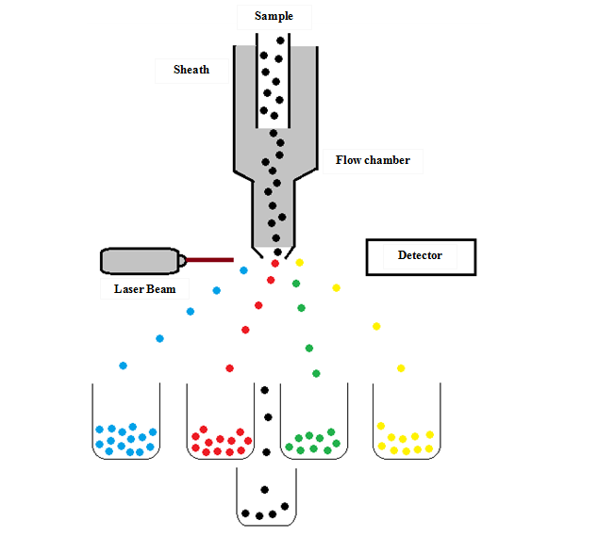
Lymphocytes are white blood cells that are part of the immune system. Lymphocytes include natural killer cells, T-cells, and B-cells. Natural killer cells are immune cells that that can kill cancer cells and T-cells help the body fight cancer. When the body is trying to fight off an infection, lymphocyte activation occurs.
For lymphocyte activation assay, only T-cells and natural killer cells will be measured. Natural killer cells/T-cells in ERAP2-N will be measured and compared with the natural killer cells/T-cells in ERAP2-K.
- Discussion
There can be three possible results of this experiment: exogenously introduced ERAP2-N induces more natural killer cells/T-cells compared to ERAP2-K, ERAP2-K induces less activated natural killer cells/T-cells compared to ERAP2-N, or ERAP2-N and ERAP2-K have the same amounts of activated natural killer cells/T-cells. The purpose of this experiment is to determine which isoform of ERAP2-K or N, induces a better immune response. This will be determined by quantifying the activated natural killer cells/T-cells in each isoform. More activated natural killer and T-cells mean that potentially more cancer cells are killed. The hypothesis for this experiment is that ERAP2-N can potentially induce a better immune response due to their ability to trim peptides 165 times faster than ERAP2-K.
Evnouchidou et al (2012) mentioned that ERAP2-N trims peptides at a faster rate, about 165 times more than ERAP2-K. This can alter with the activation of the natural killer cells and T-cells. If ERAP2-N trims peptides at a faster rate than ERAP2-K, it may have provide a better immune response than ERAP2-K because if peptides are being trimmed at a faster rate that may trigger more natural killer cells and T-cells.
One potential pitfall that could maybe skew the results is when the ERAP2-N is transfected into the melanoma cancer cell; it could transfect a higher amount. So when the cancer cell with the ERAP2-N is compared with the cancer cell with ERAP2-K, the results may not be accurate since we can’t determine how much ERAP2-N to transfect. Having a cell line with neither K nor N would have been more ideal because then the cell line would go through each step for each isoform and the results would be more accurate.

References
- Lee E.D., Endoplasmic Reticulum Aminopeptidase 2, a common immunological link to adverse pregnancy outcomes and cancer clearance, In Placenta, Volume 56, 2017, Pages 40-43, http://www.sciencedirect.com/science/article/pii/S0143400417301972
- Johnson, M. P. et al (2009). The ERAP2 gene is associated with preeclampsia in Australian and Norwegian populations. Human Genetics, 126(5), 655–666. https://www.ncbi.nlm.nih.gov/pmc/articles/PMC2783187/
- Fruci, D. et al (2006). Expression of Endoplasmic Reticulum Aminopeptidases in EBV-B Cell Lines from Healthy Donors and in Leukemia/Lymphoma, Carcinoma, and Melanoma Cell Lines. Journal of immunology. 176. 4869-79. 10.4049/jimmunol.176.8.4869. http://www.jimmunol.org/content/176/8/4869.long
- Alistair J. et al. Westwood, Inhibition of antigen transport by expression of infected cell peptide 47 (ICP47) prevents cell surface expression of HLA in choriocarcinoma cell lines, In Journal of Reproductive Immunology, Volume 50, Issue 1, 2001, Pages 19-40, http://www.sciencedirect.com/science/article/pii/S0165037800000887
- Andrés, Aida M. et al. “Balancing Selection Maintains a Form of ERAP2 That Undergoes Nonsense-Mediated Decay and Affects Antigen Presentation.” Ed. Takashi Gojobori. PLoS Genetics 6.10 (2010): e1001157. PMC. Web. 26 Nov. 2017. https://www.ncbi.nlm.nih.gov/pmc/articles/PMC2954825/
- Evnouchidou, I. et al. “A Common SNP in ER Aminopeptidase 2 Induces a Specificity Switch That Leads to Altered Antigen Processing.” Journal of immunology (Baltimore, Md. : 1950) 189.5 (2012): 2383–2392. PMC. Web. 26 Nov. 2017. https://www.ncbi.nlm.nih.gov/pmc/articles/PMC3530405/
- Vanhille, D. L. et al (2013). A novel ERAP2 haplotype structure in a Chilean population: implications for ERAP2 protein expression and preeclampsia risk. Molecular Genetics & Genomic Medicine, 1(2), 98–107. https://www.ncbi.nlm.nih.gov/pmc/articles/PMC3769221/
- Saveanu, L., et al., Concerted peptide trimming by human ERAP1 and ERAP2 aminopeptidase complexes in the endoplasmic reticulum. Nat Immunol, 2005. 6(7): p. 689-97.https://www.nature.com/articles/ni1208
- May, L., et al., Performance of the whole-blood stimulation assay for assessing innate immune activation under field conditions. Cytokine, 2009. 45(3): p. 184-9. http://www.sciencedirect.com/science/article/pii/S1043466608008363?via%3Dihub
- Tanioka, T., et al., Human leukocyte-derived arginine aminopeptidase. The third member of the oxytocinase subfamily of aminopeptidases. J Biol Chem, 2003. 278(34): p. 32275-83. 13. http://www.jbc.org/content/278/34/32275.long

