Antirepressor Identification in Bacillus Bacteriophage phiCM3

I. Introduction

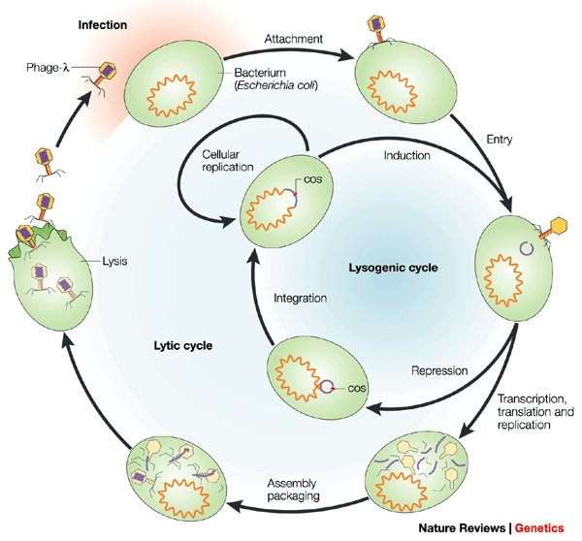
Since viruses infect all types of life, the prokaryotes are not immune from it. Viruses called bacteriophages, or phages, infect bacteria. There are two life cycles of phages, the lysogenic cycle and the lytic cycle. In the lytic cycle, the aim of the phage is to infect, rapidly reproduce inside of the host cell, and then kill the cell by causing it to lyse. When the host cell breaks open, all of the phages that were reproduced inside of the cell are released into the environment, and, in return, find more cells to infect. In the lysogenic cycle, the phage infects the cell, and then incorporates into the bacterium’s chromosome, making the host express phage genes that are not typically expressed by that bacterium (Figure 1). The phage’s genetic information is then passed down to daughter cells, maintaining the lysogenic state in the reproduced cells.²
Figure 1. The lytic and lysogenic life cycles of phages.
Adapted from Ref. 1.

During transcription, RNA polymerase binds to the promoter region of the gene’s DNA, and converts the DNA to mRNA, which is later used to produce proteins from the gene. During this process, a repressor protein can bind to the operator site to block transcription. When this happens, the repressor prevents RNA polymerase from moving down the sequence and transcribing the gene. However, some phages have an antirepressor protein that can either beat out the repressor protein and bind to the DNA at the operator site to promote transcription, or it can bind directly to the repressor protein, making the repressor protein unable to bind to the operator site. Transcription in phages can, also, control which life cycle the phage takes. When the repressor protein is present, transcription stops, which means that the phage undergoes the lysogenic cycle. On the other hand, when the antirepressor is present, transcription continues, and the phage undergoes the lytic cycle.

It has become very common in recent years to rely on genome annotations to find the functions of certain proteins, even though most argue that genome annotations are often incorrect.⁴ Genome annotation is exactly what Yuan et al (2014) relied on to classify and characterize the genome of bacteriophage phiCM3, and to make assumptions on whether proteins were highly conserved or not. According to the article, the antirepressor protein in phiCM3 is highly conserved compared to other proteins that might have adapted to be more suitable in their environment.⁵ This protein, gp37, was annotated as an antirepressor because of its conservation and its similarity to other proteins that have also been annotated as antirepressor proteins. The purpose of this proposed experiment is to test if the genome analysis is correct, and the protein, gp37, is in fact the antirepressor of phiCM3.

II. Experiment

The aim of this experiment is to determine if the genomic analysis of phiCM3 was correct in identifying the antirepressor of the phage. In order to determine the antirepressor experimentally, the repressor first needs to be identified, and experimentally verified. However, the repressor protein was not identified in Yuan et al (2014), therefore, bioinformatics analysis will have to be performed on the genome in order to find the promoter region, operator, and a putative repressor protein to test.

II.A. Building the Expression Vectors to Test the Repressor
First, the repressor protein must be identified. This will be done by geographically locating potential genes on phiCM3’s genome, relative to the location of the putative antirepressor (gp37). These potential genes will be run through the BLASTP database to test for HTH (helix-turn-helix) DNA binding motif domain matches, or other similar DNA binding motifs. HTH DNA binding motifs are a common characteristic in repressor proteins since the repressor protein binds to the DNA at the operator site. After the putative repressor gene is found, the promoter region and operator should be directly upstream.

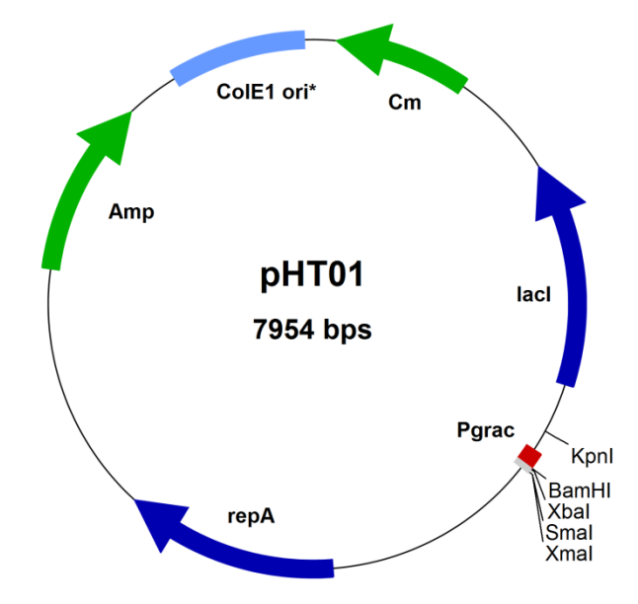
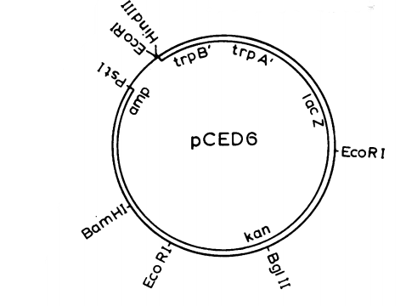
Once the putative repressor protein, promoter region, and operator are found, it will all need to be cloned into an expression vector for testing. The pHTO1 plasmid will be used to clone the repressor protein at the BamHI site (Figure 3).⁷ The cloning will be done through a simple isothermal reaction in a test tube, better known as Gibson Assembly. During Gibson Assembly, the exonuclease “chews” back the DNA on the 5’ end of the strand on two overlapping DNA sequences, creating single-stranded DNA fragments that can anneal. This means that the DNA sequence from the plasmid and the fragment encoding the putative repressor will have to overlap by 15-20 nucleotides. Then DNA polymerase fills in any missing nucleotide gaps, followed by DNA ligase covalently joining the strand of the repressor gene to the plasmid.⁸
Figure 3.
pHT01 Bacillus subtilis expression vector. The repressor gene will be cloned at the BamHI site, along with the promoter and operator. Adapted from Ref. 7.

pCED6 Bacillus subtilis expression vector. The promoter will be added at the HindIII site in such a way that the site will be reconstituted upstream, but destroyed downstream. Notice the lacZ gene is already on this plasmid. Adapted from Ref. 10.

A second plasmid, pCED6, will be configured in a way which the promoter and operator are added in at the HindIII site, while downstream HindIII site will is destroyed so that the plasmid can be reopened at that particular site, and reconfigured for the later part of this experiment (Figure 3).¹⁰ The reporter gene that will be used in this experiment, lacZ, is already present in the pCED6 plasmid.

Before ONPG testing is performed, a quick plating of phiCM3 and the plasmid with the repressor protein will be performed. If the plasmid blocks phage plating in the presence of IPTG, then it is likely that the putative repressor is in fact the repressor. This technique can be used as a quick way to make sure that there is enough evidence to further test the gene.

II.B. IPTG Induction and ONPG Testing of the Repressor
When lacZ is transcribed, it produces a compound known as β-galactosidase, or B-gal for short. Thankfully, B-gal activity in the cell is relatively easy to quantify. It requires inducing transcription by using IPTG, Isopropyl β-D-1-thiogalactopyranoside. In this scenario, IPTG would bind to the lacI repressor protein encoded by the pHT01 plasmid, allowing transcription to start at the Pgrac promoter, thereby, transcribing and producing the putative repressor proteins. In turn, these repressor proteins should bind to the added operator on the pCED6 plasmid, effectively halting transcription of the lacZ gene.⁹ This means that there should be little to no B-gal activity. To quantify the amount of B-gal activity, toluene will be added to the medium that contains the cells in IPTG, which will disrupt the cell membranes just enough to allow ONPG (ortho-Nitrophenyl-β-galactoside) to diffuse into the cells. In the presence of B-gal, ONPG is cleaved in half, producing one galactose molecule, and one ONP molecule. While ONPG and galactose are both colorless, ONP is yellow. Therefore, if lacZ is transcribed and expressed, we are looking for a yellow color in the test tube, which should happen in the absence of IPTG since IPTG will allow for the repressor protein to be produced. Therefore, for the repressor experiment, the ideal result is ONPG-, or little to no yellow color shown (Fig 4). The optical density will then be measured at 420 mμ and 600 mμ, and then the Miller Units will be calculated. Ideally, the calculation will give close to 1 MU. The experimental procedure is outlined in the following paragraph.
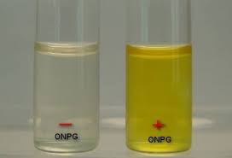
Figure 4. ONPG - vs. ONPG + results. Adapted from Ref. 13.
Once both expression vectors have been configured properly, the plasmids will be introduced into Bacillus subtilis cells, and the cells will be allowed to replicate. Next, four mediums will be made, two of which will contain IPTG, while the other two do not. Other than IPTG, the mediums will be the same. The four cultures will be left overnight to take up the IPTG, and the next day, they will be subcultured into fresh media of the composition as used previously. The cultures will be aerated until OD₆₀₀ of 0.28-0.70 is reached. The cultures will be put in an ice bath for 20 minutes, and then the cell density will be recorded via the spectrophotometer at 600 mμ. Aliquots of the cultures will then be added to an assay medium, better known as Z buffer. A drop of toluene will also be added to the tubes, which will help disrupt the membranes enough for ONPG to diffuse into the cells. After about 40 minutes in a rotor at 37°C, the tubes will be placed in a brief water bath at a slightly lower temperature, about 28°C. Then, ONPG will be added to each tube, and gently shaken. The reaction time will be recorded. ^{11,12,13} The optical density of each tube will be tested at 420 mμ and 600 mμ. The data will then be used to determine the Miller Units of the reaction using the below equation, where t stands for reaction time, and v stands for volume of the culture used in the assay.¹⁶

Figure 5. Miller Units Formula. Adapted from Ref. 16.

II.C. Testing the Antirepressor
Much like the repressor protein, the antirepressor will have to be added to a plasmid, however, the repressor will also have to be present. To do this, the pCED6 HindIII site will be reopened, and the repressor gene, along with the Pgrac promoter on the pHT01 plasmid will be added after amplification. The Pgrac promoter is added because it is the lac promoter, and IPTG will initiate transcription at this promoter. The antirepressor gene will then be added to the pHT01 expression vector at the BamHI site (Figure 3).^{7,10} The expression vectors will be added to Bacillus subtilis cells as before, and the cells will be allowed to replicate. Transcription will then be measured with IPTG induction and ONPG testing, using the same experiment outlined above.^{11,12,13} However, when testing the antirepressor, the ideal result would be a yellow color, or ONPG+, shown. After the optical density is recorded at 420 mμ and 600 mμ, the Miller Units will be calculated, and the result should be close to 1000 MU, meaning a high B-gal activity.

II. Discussion

After all is said and done, the ideal results would show that the annotation was correct in identifying the highly conserved antirepressor of phage phiCM3. For this to happen, the results of experiment should show that repressor gene is ONPG negative, meaning that the repressor held off transcription and expression of the lacZ gene, and there was little to no β-galactosidase activity. Furthermore, this would mean that after undergoing the same ONPG test, the antirepressor should be ONPG positive. This would result in the yellowing of the antirepressor solution due to increased β-galactosidase activity since lacZ would be expressed.

The ideal results almost rarely happen the first try. Most of the potential problems with this experiment would be with the annotations being incorrect. In the case that the repressor annotation was found to be incorrect, meaning that transcription occurred in the presence of the repressor gene, a new putative repressor gene would need to identified, and tested. This could also be the case for the antirepressor gene, and the solution would be the same. There could also be problems with the expression vectors, for some reason, which would mean that new expression vectors would need to be found, however incompatibility problems are unlikely since the antibiotic resistance parts and the origins of replication were both checked to ensure compatibility. Hopefully, none of these problems arise.

In the future, if this experiment is successful, the mechanism of the antirepressor could be identified in a similar experiment to Susskind et al. (1975), in which the authors hypothesized that the antirepressor was similar to cro in phage lambda, in the sense that the antirepressor binds to DNA instead of to the repressor. Similarly, the putative antirepressor in phage phiCM3 has homology to a domain that is known to bind to DNA, therefore, it is logical to hypothesize that the mechanism for the antirepressor is also similar to that of the cro protein in lambda, even though cro and antirepressor proteins are not the same.^{14,15} However, there is still a chance that the putative antirepressor may not actually be the antirepressor of the phage. Therefore, once the antirepressor is found, it may bind to the repressor protein instead, in which an experiment could be done to test this mechanism as well.

Phages have played an important role in the field of molecular biology so far, giving us insights into transcription and translation. Further studying of the antirepressors of phages could help us gain insight as to why some phages bind to the repressor protein and why others bind directly to the DNA to allow transcription. This would allow us to find out why there are multiple antirepressor mechanisms, and what environmental conditions caused these different mechanisms. By continuing these experiments, we can continue to use phages as tools to understand how all types of life work.

References:

- Campbell, Allan. "Opinion: The future of bacteriophage biology." Nature Reviews Genetics 4.6 (2003): 471-77. Web. <http://www.nature.com/nrg/journal/v4/n6/full/nrg1089.html>.
- Madsen, PL, AH Johansen, K. Hammer, and L. Brondsted. "The Genetic Switch Regulating Activity of Early Promoters of the Temperate Lactococcal Bacteriophage TP901-1." Journal of Bacteriology 181.24 (1999): 7430-438. Web. <https://www.ncbi.nlm.nih.gov/pubmed/10601198>.
- Takeda, Y., A. Folkmanis, and H. Echols. "Cro regulatory protein specified by bacteriophage lambda. Structure, DNA-binding, and repression of RNA synthesis." Journal of Biological Chemistry 252.17 (1977): 6177-183. Web. <https://www.ncbi.nlm.nih.gov/pubmed/330523?dopt=Abstract>.
- Koonin, E.V.; Galperin, M.Y. (2003). Sequence - Evolution - Function: Computational approaches in comparative genomics. Dordrecht: Springer Science+Business Media.
- Yuan, Y., M. Gao, Q. Peng, D. Wu, P. Liu, and Y. Wu. "Genomic analysis of a phage and prophage from a Bacillus thuringiensis strain." Journal of General Virology 95.Pt_3 (2014): 751-61. Web. <http://jgv.microbiologyresearch.org/content/journal/jgv/10.1099/vir.0.058735-0#tab2>.
- Fogg, P. C. M., Rigden, D. J., Saunders, J. R., McCarthy, A. J. & Allison, H. E. (2011). Characterization of the relationship between integrase, excisionase and antirepressor activities associated with a superinfecting Shiga toxin encoding bacteriophage. Nucleic Acids Res 39, 2116–2129.
- Molecular Biotechnology. "Bacillus sibtilis Expression Vectors." MoBiTec
GmbH (2017): n. pag. Web. <http://www.mobitec.com/cms/products/bio/04_vector_sys/bacillus_subtilis_expression.html?pdf=Bacillus_subtilis_Expression_Vectors-Handbook>.
- Gibson D.G., Young L., Chuang R.Y., Venter J.C., Hutchison 3rd C.A., Smith H.O. Enzymatic assembly of DNA molecules up to several hundred kilobases. Nat. Methods. 2009;6:343–345.
- Hansen, Knudsen, and Sorensen. "The effect of the lacY gene on the induction of IPTG inducible promoters, studied in Escherichia coli and Pseudomonas fluorescens." Current Microbiology 36.6 (1998): 341-47. Web. <https://www.ncbi.nlm.nih.gov/pubmed/9608745>.
- Donnelly, C E, and A L Sonenshein. “Promoter-Probe Plasmid for Bacillus Subtilis.” Journal of Bacteriology 157.3 (1984): 965–967. Print.
- Borralho T, Chang Y, Jain P, Lalani M, Parghi K: “Lactose induction of the lac operon in Escherichia coli B23 and its effect on the o-nitrophenyl β-galactoside assay.” Journal of Experimental Microbiology and Immunology 2002, 2: 117-123. Print.
- Nahary et al., 2009. “Isolation of scFvs that inhibit the NS3 protease of hepatitis C virus by a combination of phage display and a bacterial genetic screen.” Methods Mol. Biol., 562 (2009), pp. 115–132. Print.
- Pradhan, Prasil. "ONPG (o-Nitrophenyl-β-D-Galactopyranoside) test: Principle, Procedure, Result and Interpretation." Microbiology and Infectious Diseases, 27 Apr. 2016. Web.
- Iyer LM, Koonin EV, Aravind L. Extensive domain shuffling in transcription regulators of DNA viruses and implications for the origin of fungal APSES transcription factors. Genome Biol. 2002;3:RESEARCH0012
- Susskind MM, Botstein D. Mechanism of action of Salmonella phage P22 antirepressor. J. Mol. Biol. 1975;98:413–424.
- Olmez-Hanci, T., I. Arslan-Alaton, D. Dursun, B. Genc, D. G. Mita, M. Guida, and L. Mita. "Degradation and toxicity assessment of the nonionic surfactant Triton™ X-45 by the peroxymonosulfate/UV-C process." Photochem. Photobiol. Sci. 14.3 (2015): 569-75. Web. <http://pubs.rsc.org/en/Content/ArticleHtml/2015/PP/c4pp00230j>.

