Treating Ischemia and Reperfusion Injury by Inhibiting AIM2 in order to restore function of Cardiomyocytes
Ankita Thakur, Stefano Toldo

Introduction

Acute Myocardial Infarction (AMI), more commonly known as a heart attack, is a problem that affects over 700,000 Americans every year. Heart attacks most commonly occur due to blockages in the coronary arteries, either by blood clots, plaque build up, or coronary artery spasms. This causes loss of viable myocardium, or heart tissue, which leads to heart failure (HF) and death. Regardless of the reason of occlusion, the blockage leads to the inability of nutrition and, most importantly, oxygen to reach the cardiac cells, which causes the myocardial ischemia and cell death.
Right now, the standard approach to reduce the mortality and HF after AMI acute myocardial infarction is reperfusion of the area, through reopening of blocked coronary artery. Reperfusion helps re-establish the coronary blood flow and saves the cells at risk. However, a problem arises when reperfusion does occur. New reactive oxygen species (ROS) reacts with byproducts of the dying cell, which causes further injury in that cell. Therefore, the benefits of reperfusion are partially lost due to the reperfusion-associated injury. At the cellular level, when the cell is initially injured during ischemia, the electron transport chain (ETC) is damaged due to previous oxygen depletion. This results in increased production of ROS. An increase in ROS and mitochondrial calcium ions (Ca2+) can lead to the opening of the mitochondrial permeability transition pore (MPT). The opening of the MPT can, and more likely than not, compromises the energetics of the cell. As a consequence of this change in ion homeostasis and ATP deficiency due to the ischemia, the cell dies. However, as the cell is dying and ATP and other damage associated molecular patterns (DAMPs) are released from the dying cell triggers, the formation of the inflammasome, a multiprotein complex that is made by a sensor component, an adaptor/scaffold protein (usually the protein ASC) and an effector enzyme (e.g. caspase-1). The sensors are intracellular receptors that display a different specificity for a wide range of agonists (pathogens or DAMPs). When the sensor is activated, it triggers the formation of the inflammasome, and through direct or adaptor-mediated interaction with caspase-1 leads to the formation of the active complex. Caspase-1 is an enzyme that is responsible for the production of pro-inflammatory cytokines of the interleukin-1 family of cytokines. Therefore, its activation initiates and propagates the inflammatory response. Furthermore, sustained caspase-1 activity leads to a new form of inflammatory cell death termed pyroptosis. Inflammasomes are involved in the pathogenesis of several diseases, where the production of cytokines initiate pyroptosis, which leads to the organ impairment. This has been seen in inflammatory bowel disease, osteoarthritis and in organ ischemia.Following AMI, caspase-1 activity is elevated, and deletion of caspase-1 is protective. However, caspase-1 inhibitors have been developed but have shown unwanted side effects. In addition, because caspase-1 is a common component of several inflammasomes,targeting a specific sensor may lead to a narrower therapeutic effect and reduced adverse effects.
Absent in Melanoma 2 (AIM2) is one inflammasome sensor that recognizes double stranded DNA (dsDNA) in the cytoplasm. In fact, when the DNA of a virus or of a bacteria is detected by AIM2 it leads to the formation of the AIM2 inflammasome. AIM2 recognizes cytoplasmic dsDNA of viral or bacterial origin in a sequence-independent manner. While this is happening, the pyrin domain at the N-terminal of AIM2 binds to the pyrin domain of ASC (apoptosis-associated speck like protein containing a carboxy-terminal CARD). The CARD at the C-terminal of ASC binds to the CARD of procaspase-1.
Following AMI, the mitochondrial DNA (mtDNA) from damaged mitochondria enters the cytoplasm of the cells in the ischemic area and its limitrophe.
Since mtDNA can induce the activation of AIM2, the hypothesis was formulated around this information: The mtDNA binds AIM2, which leads to the formation of the inflammasome, activation of caspase-1, and an exacerbation of the inflammatory response, which in the bigger picture leads to an increase in cell death and myocardial dysfunction.

(**I did not have enough time immediately to procure an image that covered everything explained previously and one that showed a protein binding to double-stranded DNA, however, I will try to insert a few graphics before my final submission**)

Experiment

The overview of the experiment is to focus on three main parts. Firstly, we will define a AIM2 knock-down (KD) strategy to reduce the myocardial levels of AIM2 using systemic injection of siRNA in wild type (wt) mice. We will test different doses of a specific AIM2 siRNA or a scrambled control siRNA to measure the AIM2 expression in the heart at several time intervals (24, 48 72 or 96 hours). In this way we can determine for how long an effective dose of siRNA reduces the expression of AIM2 in the heart in vivo.
Second, we will measure the effects of inhibition of AIM2 signaling on the activation of the inflammasome in an in vivo model of AMI. We will use a knock-out (KO) mouse and the KD. In total we will use 6 groups of mice:
- sham control (Surgery but no AMI)
- wt mice with AMI (mice with coronary artery ligation for 30 minutes followed by 24 hours of reperfusion)
- KO mice sham control
- KO mice with AMI
- KD mice sham control
- KD mice with AMI
(NOTE: THE KO MOUSE IS SOLD BY JACKSON LABORATORIES.)

The hearts of these mice will be collected to measure the activity of caspase-1. This experiment will help to define whether AIM2 contributes to the activation of caspase-1 following AMI. The two independent approaches (KO vs KD) will serve as two independent methods to assess the role of AIM2 post-AMI.
Third we will assess the effects of AIM2 inhibition on the cardiac function and the infarct size. Using the same groups that we have used above, we will measure the heart function in vivo, using echocardiography, and the cell death, using the triphenyl tetrazolium chloride staining. This experiment will define whether the AIM2 inflammasome has a pathophysiological role in the heart following AMI.

- Reduction of Myocardial Levels of AIM2
Mezzaroma et al. in “The inflammasome promotes adverse cardiac remodeling following acute myocardial infarction in the mouse” (2011) detail how they used gene silencing to inhibit caspase-1 activity. They administered short interfering RNAs directed to cryopyrin or P2X7 - a gene encoding for a purinergic receptor for ATP - and from that they were able to observe no increase in caspase-1 activity after 72h after coronary artery ligation surgery. There was a scrambled (nontargeted) siRNA model used as well, and this had none of the effects observed with the directed siRNAs. The siRNAs (directed and scrambled) were both purchased from Santa Cruz. The siRNAs were administered systemically, through intraperitoneal injection. The dose was previously validated, which was a mix of 0.45 mg/kg (noted as high-dose) with an equal volume of siPORT amine (Ambion).
Mezzaroma et al. performed Western Blot to observe the levels of their target protein after silencing cryopyrin and P2X7. The target protein was apoptosis speck-like protein containing a caspase domain (ASC). A Western blot was performed using commercially available antibodies from Sigma-Aldrich. Samples were taken from heart sections that were paraffin embedded and formalin-fixed, but before they were used they were deparafinned and rehydrated. The heart slides were blocked with 1% normal swine serum in TBS for 15 minutes, but after antigen retrieval with 0.01 M citrate buffer (pH 6.0) for 20 min. In order for the specific inflammasome from the specific cell-type (cardiac) to show, they used a double immunofluorescence technique. The cells would be incubated after antigen retrieval, and they had primary antibody for cryopyrin, ASC, or caspase-1 overnight at 4℃, all from Sigma-Aldrich. The slides then had antigoat or antirabbit Alexa Fluor 594- or 488-conjugated secondary antibody applied for 4 h at room temperature. The slides were then again incubated overnight at 4℃ with primary antibody for ASC, caspase-1, cardiac actin , CD45, S100A4, caveolin-1. Again, after this incubation, secondary antibody was applied for 4 hours at room temperature. The slides were counterstained using 4′,6- diamidino-2-phenylindole (DAPI) 1:20,000 for 5 min and then coverslipped with SlowFade Antifade (both Invitrogen). Negative controls with nonspecific IgG were run in parallel. After the tests were run, they generated images using ImageJ software. The results are shown in Fig 3.
We plan to use similar methods in terms of the addressing the first objective of the experiment. However, instead of targeting cryopyrin or P2X7, we will target the AIM2 gene, also known as PYHIN4. The AIM2 expression at each time benchmark will be monitored by Western Blot, as explained above. However, instead of using the primary antibodies for cryopyrin and ASC, we will use antiAIM2 antibody (ab93015), available from AbCam. Samples will also be collected at 24, 48 72 or 96 hours in order to notice when inhibition wears off, essentially.

B. Measuring Effects of AIM2 Signaling Inhibition on Inflammasome Activation

As stated above, the effect of AIM2 signalling on the activation of the inflammasome will be measured by observing caspase-1 activity levels. Mezzaroma et al. (2011) used Western blot again to measure these levels in two steps. First, they measured pro-caspase-1 levels with SYBR-green real-time PCR from Applied Biosystems. The samples were prepared by collecting the hearts 3 and 7 days after the surgery. They were then homogenized in RTL buffer, from Qiagen, using lysing matrix D beads, from MP Biomedicals. Total mRNA was extracted using RNeasy extraction kit (Qiagen) and was converted to cDNA using the reverse transcription kit (Applied Biosystems). After this, the real-time PCR is run, using the noted primers: caspase-1 forward 5′-TCCGCGGTTGAATCCTTTTCAGA-3′; caspase-1 reverse 5′-ACCACAATTGCTGTGTGTGCGCA-3′ and GAPDH forward 5′-ACTGAGCAAGAGAGGCCCTA-3′; GAPDH reverse 5′-TGTGGGTGCAGCGAACTTTA-3′
The second step was to monitor caspase-1 activity by monitoring caspase-1 protein levels using Western blot. Samples were taken at each time benchmark indicated and frozen immediately with liquid nitrogen. These were the following steps Mezzaroma et al. took to run the Western blot for caspase-1:
The samples were homogenized using RIPA buffer (Sigma-Aldrich) containing a mixture of protease inhibitors (Sigma-Aldrich) and were centrifuged at 16,200 × g for 20 min. The supernatants were collected and the protein contents were quantified using the Bradford assay. Fifty micrograms of proteins for each sample were analyzed by Western blot. Proteins were denatured for 10 min at 97 °C and subjected to SDS/PAGE in 15% acrylamide gels to allow for separation of the bands. The proteins were then transferred onto nitrocellulose membranes and incubated with a rabbit polyclonal antibody (C4851; Sigma-Aldrich) that hybridizes with both pro- and cleaved caspase-1 (p20). A mouse anti–β-actin monoclonal antibody (clone C-2; Sigma-Aldrich) was used for the normalization following enhanced-chemiluminescence (ECL) analysis and autoradiography. The protein bands were compared by densitometric analysis (Scion Image) and the results were adjusted to the β-actin quantity in the samples. Caspase-1 activity in clarified homogenates of heart tissue was determined in the whole hearts collected at different time points (1, 6, and 24 h and 3, 7, and 14 d) after surgery (n = 4–6 per time point) and immediately frozen in liquid nitrogen. The activity was determined by cleavage of a fluorogenic substrate (CaspACE; Promega. From each sample, 75 μg of proteins were used for the assay according to the supplier’s instructions. The fluorescence was measured 60 min later and was expressed as arbitrary fluorescence units produced by 1 μg of sample per min (fluorescence/μg/min) and shown as fold change compared with sham.

We will be using this same approach in order to study the caspase-1 levels in response to AIM2 inhibition, which should have occurred due to the gene silencing in 6 groups of mice, as described above. The mice will be prepared using similar protocol as Marchetti et al. (2014) First, myocardial ischemia will be induced in the mice surgically, and then the mice will also be exposed to a set time of reperfusion (24 hours). After being anesthetized with 50-70 mg/kg of pentoarbital through a tube that was passed from the mouth into the trachea, the mice were put in the left decubitus position. After having the side exposed, they were subjected to left thoracotomy, pericardiectomy, and ligation of proximal left coronary artery. The coronary artery was released after 30 minutes. The sham models were formed by conducting the same surgery minus the coronary artery ligation. After the opening of the artery after 30 minutes, the mice were reperfused with either the therapeutic agent (100mg/kg in 0.05mL), DMSO solution (vehicle, 0.05mL), or NaCl 0.09% solution (0.05mL, control). The mice were also exposed to either of these solutions 30 minutes before surgery, and then reperfused every 6 hours for 3 doses. They were then sacrificed at 24 hours. Caspase-1 activity is then measured as mentioned above with the extractions from frozen samples of these hearts.

C. Assess Effects of AIM2 Inhibition on Cardiac Function and Infarct Size

As mentioned above, we will measure the heart function in vivo, using echocardiography, and the cell death, using the triphenyl tetrazolium chloride staining, in order to understand whether the AIM2 inflammasome has a pathophysiological role in the heart following AMI. Abbate et al. used a transthoracic echocardiogram on all animals before the surgery and 7 days after the surgery just before the sacrifice. On the mice, they performed a Doppler echocardiography with the Vevo770 imaging system (VisualSonics Inc, Toronto, Ontario, Canada). This is how Abbate et al. detailed the steps of the echocardiograph:
The transducer was positioned on the left anterior side of the chest. The heart was first imaged in the 2-dimensional mode in the short-axis view of the left ventricle. The M-mode cursor was positioned perpendicular to the anterior and posterior wall to measure left ventricular (LV) end-diastolic and end-systolic diameters (LVEDD and LVESD, respectively). According to the American Society of Echocardiography recommendations,11 M-mode images were then obtained at the level of the papillary muscles below the mitral valve tip. In the mouse, apical 4- and 5-chamber views also were obtained to measure transmitral flow, left ventricular outflow, and transaortic flow velocities. LV fractional shortening (FS) was calculated as follows: FS(LVEDDLVESD)/LVEDD100. Ejection fraction was calculated with the Teichholz formula. Transmitral and left ventricle outflow tract pulsed Doppler flow spectra were obtained from the apical view. Measurement of the outflow tract flow was performed. Isovolumetric contraction (ICT) and relaxation (IRT) times and ejection time (ET) were measured. LV outflow tract (LVOT) flow velocity–time integral (AoVTI) also was measured. These data were used to calculate the Tei index (Tei indexICT IRT/ET)12 and cardiac output (COAoVTI(LVOT diameter/ 2)2heart rate, where LVOT was measured as the cross-sectional area in the parasternal long-axis view). In humans, a higher Tei index is associated with both systolic and diastolic dysfunction and worse outcomes.12 The allocation to different treatments was random, and the investigator performing and reading the echocardiogram was blinded to the treatment. (Abbate 2008)

The second step, the measurement of cell death, requires staining, as illustrated by Marchetti et al.
In order to perform the infarct size staining, the heart was quickly removed after sacrifice and mounted on a Langendorff apparatus. The coronary arteries were perfused with 0.9% NaCl containing 2.5 mM CaCl2. After the blood was washed out, the ligated coronary artery was closed again, and approximately 1 ml of 1% Evans blue dye (Sigma Aldrich) was injected as a bolus into the aorta until the heart ‘not-at-risk’ turned blue. The heart was then removed, frozen, and cut into 6 transverse slices from apex to base of equal thickness (approximately 1 mm). The slices were then incubated in a 10% TTC isotonic phosphate buffer (pH 7.4) at room temperature for 30 min. The infarcted tissue (appearing white), the risk zone (red), and the non-risk zone (blue) were measured by computer morphometry using Image Pro Plus 6.0 software (Media Cybernetics, Silver Spring, MD). (Marchetti 2014)

Discussion

After performing the aforementioned experiments, there are certain results that are hoped to be obtained, especially the establishment of any link of AIM2 inhibition with heart cell function after ischemia.
In terms of the AIM2 silencing, or the knocking out, it is important to see that AIM2 expression is reduced. Additionally, it is important to see how long siRNAs can inhibit AIM2 expression. This is significant in that most living organisms are not naturally occuring with AIM2 knockout. Therefore, it is important to see the work of scattered and directed siRNAs in vivo to see how effective they would be as an inhibitor as opposed to the use of pharmacological drugs.
The next expectation is to define whether AIM2 contributes to the activation of caspase-1 following AMI. It is expected that caspase-1 activity is reduced in response to the reduction of AIM2 expression. The the results from the Western blots should show reduced caspase activity in the models with AMI. In the overall picture, this would be noted by the improvement in heart function and reduction of cell death after reperfusion due to lack of pyroptosis in the area affected during ischemia, linking AIM2 to AMI in the pathology.
Although the hope is for the tests to yield clear results that would help to form conclusions, however there may be some issues that may arise. There may be other factors that weigh in on the pyroptotic response of the cell other than the AIM2 inflammasome, skewing the overall result of the reduced cell death and improved heart function. Additionally, it may be a possibility that the inhibition of AIM2 expression does not confirm the inability of inflammasome to assemble. This means that other inflammasome receptors other than AIM2 should be tested.
The final hopes for this proposal is that it would show that the use of siRNAs is sufficient to inhibit AIM2 long enough to allow for reduced injury during reperfusion and increased cell recovery. This may, in the long run, lead to the development of specific AIM2 inhibitors that could be used to reduce AIM2 activity following AMI. This would help to reduce injury in the heart after reperfusion, which would ultimately reduce infarct size in patients of AMI.

References

Abbate A, et al. (2008) Anakinra, a recombinant human interleukin-1 receptor antagonist, inhibits apoptosis in experimental acute myocardial infarction. Circulation 117:2670–2683

Buja, L.M. (2005) Myocardial ischemia and reperfusion injury. Cardiovascular Pathology, 14. 170-175. doi:10.1016/j.carpath.2005.03.006

Hausenloy, D., Yellon, D. (2013) Myocardial ischemia-reperfusion injury: a neglected therapeutic target. The Journal of Clinical Investigation, 123(1) : 92–100. doi:10.1172/JCI62874

Jabir, M., Hopkins, L., Ritchie, N., Ullah, I., Bayes, H., Li, D., Tourlomousis, P., Lupton, A., Puleston, D., Simon, A., Bryant, C., and Evans, T. (2015) Mitochondrial damage contributes to Pseudomonas aeruginosa activation of the inflammasome and is downregulated by autophagy. Autophagy, 11(1). pp. 166-182. http://dx.doi.org/10.4161/15548627.2014.981915

Lian, Q., Xu, J…..Geng, M. (2017) Chemotherapy-induced intestinal inflammatory responses are mediated by exosome secretion of double-strand DNA via AIM2 inflammasome activation. Springer Nature: Cell Research. 1-17. doi:10.1038/cr.2017.54

Mangino, M.J, Tian, T., Lindell, S.L. (2012). Ezring functionality and ischemia-reperfusion (I/R) injury in transplantation. The FASEB Journal, 26: 56.7. Retrieved from: http://www.fasebj.org/content/26/1_Supplement/56.7.short

Marchetti, C., Chojnacki, J., Toldo, S.,...Abbate, A. (2014) A novel pharmacologic inhibitor of the nlrp3 inflammasome limits myocardial injury following ischemia-reperfusion in the mouse. J Cardiovasc Pharmacol. 63(4): 316–322. doi:10.1097/FJC.0000000000000053.

Mezzaroma, E., Toldo, S.,....Abbate, A. (2011) The inflammasome promotes adverse cardiac remodeling following acute myocardial infarction in the mouse. PNAS, 108(49). 19725-19730. doi:10.1073/pnas.1108586108.

Ming Man, S., Karki, R., Kanneganti, T. (2016) AIM2 inflammasome in infection, cancer, and autoimmunity: Role in DNA sensing, inflammation, and innate immunity. European Journal of Immunology, 46. 269-280. DOI: 10.1002/eji.201545839

Murphy, E., Steenberg, C. (2008) Mechanisms underlying acute protection from cardiac ischemia-reperfusion injury. Physiology Review, 88. 581-609. doi:10.1152/physrev.00024.2007.

Toldo, S., Arrosa, J.F.,...Quader, M. (2016) Determination of optimal coronary flow for the preservation of “donation after circulatory death” heart. Circulation, (134): A18989. Retrieved from: http://circ.ahajournals.org/content/134/Suppl_1/A18989

Toldo, S., Marchetti, C.,..., Abbate, A. (2016) Inhibition of NLRP3 inflammasome limits the inflammatory injury following myocardial ischemia–reperfusion in the mouse. International Journal of Cardiology, 209: 215-220. doi: http://dx.doi.org/10.1016/j.ijcard.2016.02.043

Trankle, C., Thurber, C.J., Toldo, S., Abbate, A. (2016) Mitochondrial membrane permeability inhibitors in acute myocardial infarction: still awaiting translation. JACC: Basic To Translational Science, 1(6): 524-535. doi: http://dx.doi.org/10.1016/j.jacbts.2016.06.012

Protocols:
http://docs.abcam.com/pdf/protocols/general-western-blot-protocol.pdf

https://www.thermofisher.com/content/dam/LifeTech/Documents/PDFs/PG1503-PJ9169-CO019861-Update-qPCR-Handbook-branding-Americas-FLR.pdf

Protocol Image:
http://www.abcam.com/ps/pdf/protocols/Western_blot_diagram.pdf

AIM2 Knockout Availability:
https://www.jax.org/Strain/UrlAsPDF/013144

Appendix

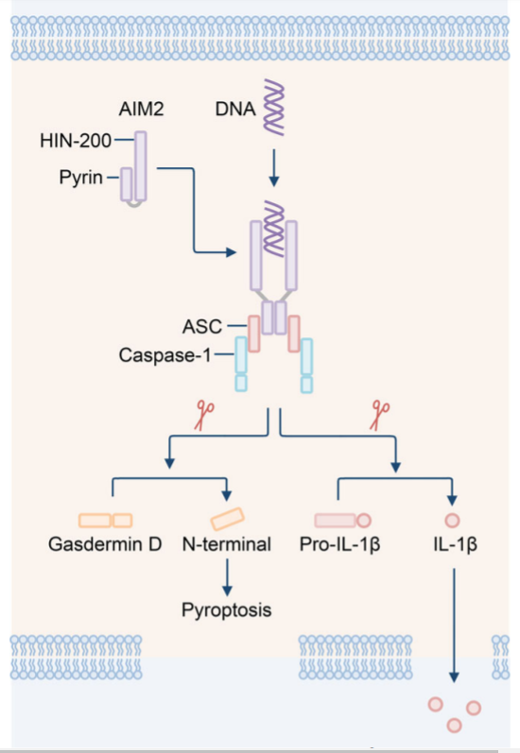
Fig. 1: AIM2 and the initiation of inflammasome

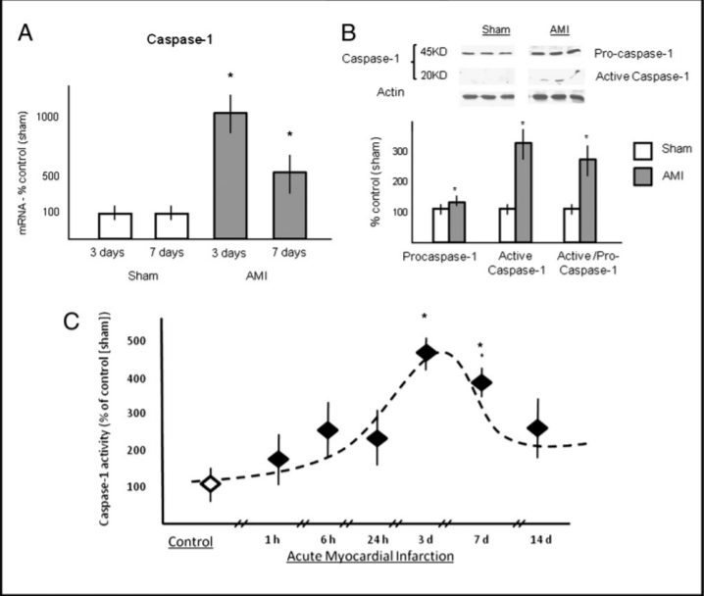
Fig. 2: Caspase-1 activation in AMI. A) Caspase-1 mRNA levels measured in real-time PCR in AMI and sham models; B) Procaspase-1 & caspase-1 levels shown through Western blot in AMI and sham models; C) Caspase-1 activity at different time points after AMI

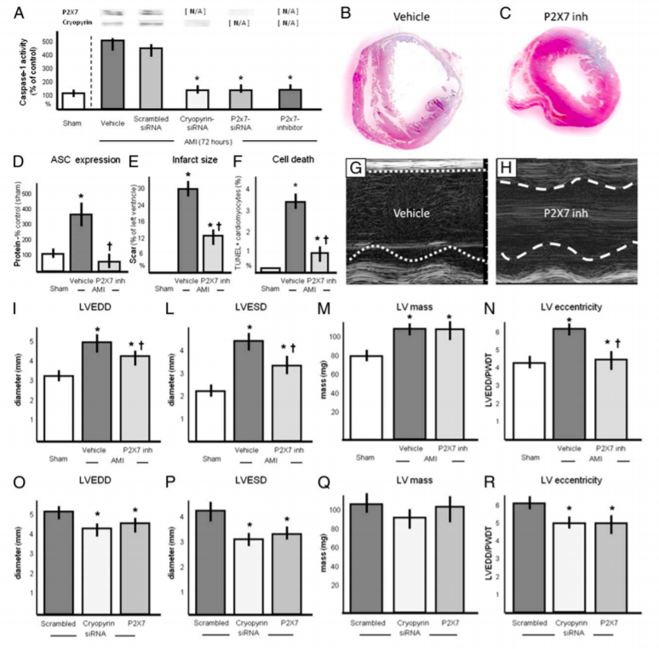
Fig. 3: Cryopyrin & P2X7 interventions in AMI.

