Activation of the Ryanodine Receptor (UNC-68)

and the Success of Neuronal Regeneration

Introduction

In the mature mammalian central nervous system (CNS), axon regeneration is extremely limited after injuries such as stroke, spinal cord injury, or brain injury. Central nervous system axons do not spontaneously regenerate after injury, but peripheral nervous system axons readily regenerate, allowing recovery of function after peripheral nerve damage (Huebner and Strittmatter 2010). Cellular environments and trophic factors promote the regeneration of adult mammalian CNS neurons (Kromer and Cornbrooks 1987). The two major classes of CNS regeneration inhibitors are the myelin-associated inhibitors (MAI) and the chondroitin sulfate proteoglycans (CSPGs). Typically, these molecules limit axon regeneration, but by interfering with their function, some degree of growth in the adult CNS can be achieved (Huebner and Strittmatter 2010). The injured neurons sometimes fail to regrow because of the inhibitory milieu in which they reside as well as a loss of the intrinsic growth capacity of the neurons.
Regulated calcium levels play a huge role in neuronal repair. Localized calcium that is released from the endoplasmic reticulum via the ryanodine receptor (RyR) channels is crucial in stimulating initial regeneration following traumatic damage (Sun et al., 2014). Ryanodine receptors are located in the endoplasmic reticulum and are responsible for the release of Ca²⁺ in neuronal cells, cardiac muscle, and skeletal muscle (Lanner et al. 2010). There are three major forms of the ryanodine receptor, which are all found in different tissues and participate in different signaling pathways involving calcium release from the endoplasmic reticulum. RyR1 is expressed in skeletal muscle, RyR2 is expressed in heart muscle and in neurons, and RyR3 is expressed in the brain. Unc-68 is a gene that encodes for a ryanodine receptor, it is orthologous to the human gene RYR2. Caenorhabditis elegans is a relatively new model for the study of axon regeneration (Bejjani and Hammarlund 2012). Using laser axotomy, which is a technique that allows for precise axon severing, of single neurons in C. elegans, it was found that a loss-of-function mutation of unc-68/RyR impedes the outgrowth of the regenerating neuron (Sun et al., 2014).
Mutations in RYR2 in humans have been associated with catecholaminergic polymorphic ventricular tachy-cardia (CVPT) which is a disorder that results in abnormal heart rhythm (Kannankeril et al., 2006). Previously, the relationship between RyR2 function and CVPT was studied by developing knock-in mice with the human disease associated RyR2 mutation R176Q. The native amino acid in this position is arginine. In vitro experiments revealed that the R176Q mutation resulted in altered RyR2 function. It was found that significantly higher incidence of spontaneous, nontriggered Ca²⁺ oscillations was observed in RyR2^{R176Q/+} cardiac muscle cells compared with wild-type muscle cells (Kannankeril et al., 2006). This is an indication that mutation of the RyR2 can lead to increased activity of the ryanodine receptor. In this experiment, we want to find out if increased activity of the ryanodine receptor might improve axon regeneration in the C. elegans system since decreased ryanodine receptor activity impedes regeneration (Sun et al., 2014).

Methods

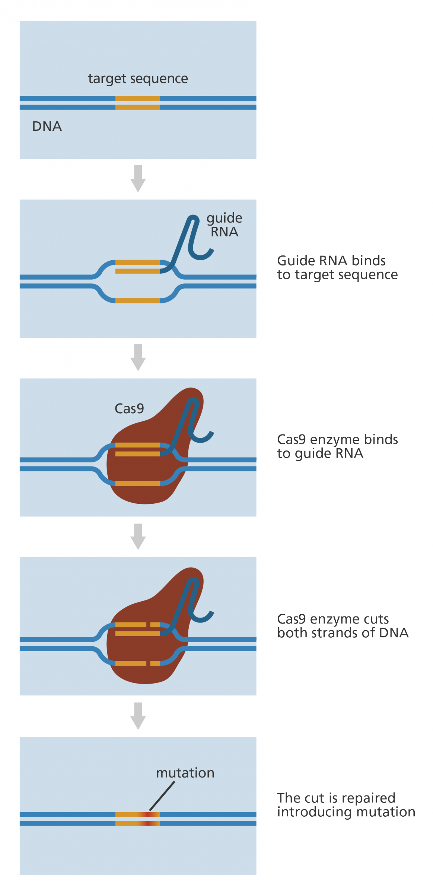
The CRISPR/Cas9 complex consists of two important molecules that introduce a mutation into the DNA. The first molecule is the Cas9 enzyme which acts like a pair of “molecular scissors” that can cut the two strands of DNA at a specific location so that DNA can be added. The second molecule is guide RNA (gRNA) which consists of about 20 base pairs long which “guides” Cas9 to cut at the right location in the genome. Once the cut is made on both strands of the DNA, the cell recognizes that the DNA is damaged and tries to repair it. This is when changes to one or more genes is introduced in the genome of a cell of interest. Figure 1 shows the basic outline of CRISPR/Cas9 design.
The nucleotide coding sequence for unc-68 and the amino acid sequence for UNC-68 was obtained from wormbase.org. The nucleotide coding sequence was translated online using the ExPASy tool to obtain an alignment of the nucleotide sequence with the protein sequence. This alignment was then compared with the human RYR2 protein using BLAST to find the corresponding arginine in question which in humans is R176. The codon for the arginine in question (position 169) was located and 40 nucleotides from either side was used to create a screen for CRISPR-Cas9 guide RNAs (gRNA). A search for guide RNAs was performed on the website http://crispr.mit.edu. The nucleotide sequence that surrounds the arginine codon was the target sequence and C. elegans was selected as the target genome. The results provide me with a guide sequence that allows the enzyme to cut where I specify it to. I
Figure 1: Basic outline of CRISPR/Cas9 formation
chose guide 1 which has a quality score of 98 and the PAM site is 3 nucleotides away from the codon that is being changed. Figure 2 shows the alignment of the guide RNA with the unc-68 nucleotide sequence and shows the arginine at position 169.
Figure 2: Alignment of guide RNA and DNA sequence of unc-68
Cas9 can be easily expressed in C. elegans by injecting an expression plasmid (Dickinson et al., 2013). It is then important to choose the Cas9 target site, and it is best to choose a site as close as possible to where the desired modification will be made. Once the region has been identified to be targeted, the next step is to identify the guide sequence (gRNA) within the target region. The gRNA sequence in this experiment is “GAAGGAGAAAAGGTGCGCGTCGG”. Once a guide sequence has been selected, it must be cloned into an appropriate sgRNA vector. A U6 promoter is required for plasmid-based expression in C. elegans and the U6 promoter requires a G residue as the first base of the sgRNA sequence to initiate transcription. In order to produce a genome edit, homology directed repair (HDR) is used which is less efficient than non-homologous end joining pathway, but generates modifications in the presence of an exogenously introduced repair template. HDR can be performed using single-stranded DNA oligonucleotides (ssODN) as repair templates. The ssDNA repair templates carries the genome modification, which in this case, the desired mutation involves changing the codon for arginine (“CGC”) at position 169 to a codon for glutamine (“CAG”). The ssDNA repair template is around 70 bp long that aligns with the region of interest. This change in unc-68 is predicted to create a gain-of-function mutation based on the equivalent human mutation (R176Q).
Figure 3: Repair Template that shows the codon with mutation.
To identify the CRISPR modification, Co-CRISPR will be used. Co-CRISPR is a screening strategy that uses a visible phenotype at one locus to identify potential edits at a second locus (Dickinson et al., 2013). The two loci are edited simultaneously, the locus of interest and an unlinked marker locus that produces a visible phenotype. For co-CRISPR to work well, the desired modification needs to occur with high efficiency relative to the marker mutation. The most effective marker mutation is the gain-of-function dpy-10. In this case, the locus of interest is the unc-68 gene and the unlinked locus is the dpy-10 gene. If we know that the dpy-10 gene has been edited (which can be seen because it changes the visual appearance of the animals), then there is a much higher chance that the unc-68 gene will also have been edited. PCR is performed to amplify just the region of unc-68 we care about, and then the PCR fragment is sequenced to examine potential edits to the DNA sequence.
The gonads of wild-type C. elegans will be injected with plasmids that allow for germline expression of sgRNAs that target the dpy-10 and unc-68 genes, a plasmid that expresses the Cas9 enzyme and two ssODNs, one to edit the dpy-10 gene, the other to edit the unc-68 gene. F₁ progeny of the injected animals that show a newly induced dpy-10 mutant phenotype will be isolated and allowed to produce F₂ self-progeny before DNA is isolated from them. A PCR product will be amplified from the DNA of each of these animals that spans the unc-68 region containing the R169 codon. This PCR product will then be sequenced to determine if successful DNA editing has occurred in each particular animal. The F₂ progeny of F₁ animals that show heterozygous R169Q conversion are then screened using the same PCR method to identify animals carrying homozygous R169Q conversion edits. Once isolated, the unc-68(R169Q) mutants will be crossed to wild-type worms to generate homozygous unc-68(R169Q) mutants that no longer carry the induced dpy-10 mutation.
Next, these mutants will undergo laser axotomy to test the hypothesis which is that increased activity of the ryanodine receptor will improve axon regeneration in C. elegans. These mutants will be compared to the non-mutant control worms to see if regeneration is more successful or not. A femtosecond laser will be used to snip the axons. In a previous study, it was shown that different neuronal types in C. elegans have different capacities for regeneration (Gabel et al., 2008). In this experiment, we will focus on the AVM mechanosensory neuron. The success rate for wild-type animals of the AVM mechanosensory neuron appears to be 90% (Sun et al., 2014). The axon length of regenerating neurons will be quantified 24 hours after surgery. Axon lengths will be calculated as the actual contour length between the cell body and axon termini, by tracing the axon through a three-dimensional image stack.

Discussion
Axon regeneration after traumatic injury of the adult nervous system is a major challenge to clinical neuroscience. In C. elegans different neuronal types exhibit different capacities for regeneration. Neurons in the worm's head tend not to regenerate after axotomy, but neurons in the body reliably regenerate. If the hypothesis is supported, the unc-68 mutant worms should show more success in regeneration than the non-mutant control worms after laser axotomy within 24 hours. It is predicted that this experiment will be successful and that will show that the gain-of-function mutation in unc-68 does in fact lead to a more successful axon regeneration rate than the non-mutant controls.
If it is successful, this could be a huge finding for treating spinal injuries in humans. According to the National Spinal Cord Injury Statistical Center, researchers have estimated that, as of 2015, 12, 500 new SCI occur each year and between 240,000 and 337,000 people are currently living with SCI in the United States. This can be reduced dramatically if humans could be treated using the same mutation using CRISPR in cells that need to regenerate.

References
- Huebner, A. E., and Strittmatter, M.S. 2009. Axon Regeneration in the Peripheral and Central Nervous Systems. Results and problems in cell differentiation 48(1): 339 – 351.

- Cheah, M., and Andrews, R. M. Targeting cell surface receptors for axon regeneration
in the central nervous system. Neural Regeneration Research 11(12): 1884 – 1887.

- Sun, L., Shay, J., McLeod, M., Roodhouse, K., Chung, H.S., Clark, M.C., Pirri, K.J. Alkema, J.M., and Gabel, V.C. 2014. Neuronal regeneration in C. elegans requires subcellular calcium release by ryanodine receptor channels and can be enhanced by optogenetic stimulation. The Journal of neuroscience: the official journal of the Society for Neuroscience, 34(48): 15947-56.

- Bejjani, E. R., Hammarlund, M. 2012. Neural Regeneration in Caenorhabditis elegans. Annual Review of Genetics 46(1): 499-513.

- Lanner, J. T., Georgiou, D. K., Joshi, A. D., & Hamilton, S. L. 2010. Ryanodine Receptors: Structure, Expression, Molecular Details, and Function in Calcium Release. Cold Spring Harbor Perspectives in Biology, 2(11).

- Kromer, F.L., and Cornbrooks, J.C. 1987. Identification of Trophic Factors and Transplanted Cellular Environments That Promote CNS Axonal Regeneration. Annals of the New York Academy of Sciences 32(1).

- Vukcevic, M., Zorzato, F., Keck, S., Tsakiris, A.D., Keiser, J., Maizels, M.R., and Treves, S. Gain of function in the immune system caused by a ryanodine receptor 1 mutation. Journal of Cell Science 126(15): 3485 – 3492.

- Dickinson, D. J., and B. Goldstein. 2016. CRISPR-Based Methods for Caenorhabditis Elegans Genome Engineering. Genetics 1(5): 885-901.

- Gabel, V.C., Antoine, F., Chuang, F.C., Samuel, D.A., and Chang, C. 2008. Distinct cellular and molecular mechanisms mediate initial axon development and adult-stage axon regeneration in C. elegans. Development 135(1): 1129 – 1136.

